| REVIEWING FORM I-9 SECTION 1 |
New Employee to Complete

The steps in this process should be used for reviewing the information the employee enters in Section 1 of the Form I-9 to ensure that all required fields are filled out correctly. There can be no blank required fields. The steps in this process only refers to staff employees and fiscal year (FY) academic employees who have the same start date and service date. If you are working with an Academic Year (AY) employee please refer to the academic job aid.

Step | Action
1. | Employee Profile  The Employee Profile is where basic information about the newly hired employee is  entered and validated in Tracker by the I-9 Transactor. After you complete the  required fields on the Employee Profile section.  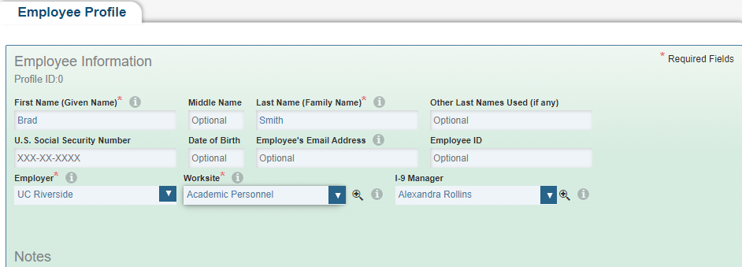  Click the green Save/Create I-9  You can Save/Create I-9 which will launch Section 1 of an I-9.  Save will save the Employee Profile and allow you to add a new I-9 later or create a  New Remote Access Form I-9.  Cancel will cancel your changes.  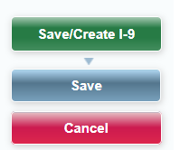  There are three ways to create a new Form I-9 record in the Tracker I-9 system. Click  Continue after you choose the appropriate option.  Note: The Profile ID will be generated with or without a start date.  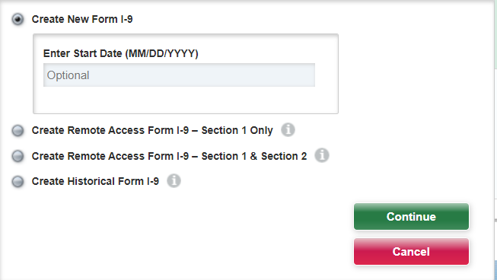
Section 1 Data – Employee Name and Identification

Employees must complete and sign Section 1 of Form I-9 no later than the
first day of employment, but not before accepting a job offer.

- The employee completes each field except for Social Security #.
  - U.S Social Security Number (Optional). Providing a Social Security number is voluntary on Form I-9 unless the employee is participating in E-Verify. If the employee is participating in E-Verify and employee has applied for a Social Security number, this field is left blank until the Social Security number is received.

- All fields are required or must be declared N/A. Employees must enter “N/A” if they do not have a middle initial or Other last Names Used
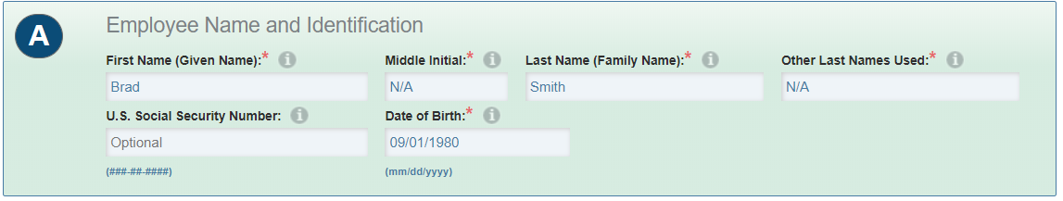

3. | Employee Address and Contact Information  This set of fields is for entering the following information as provided by the  Employee. N/A must be entered if Apt# is not applicable.  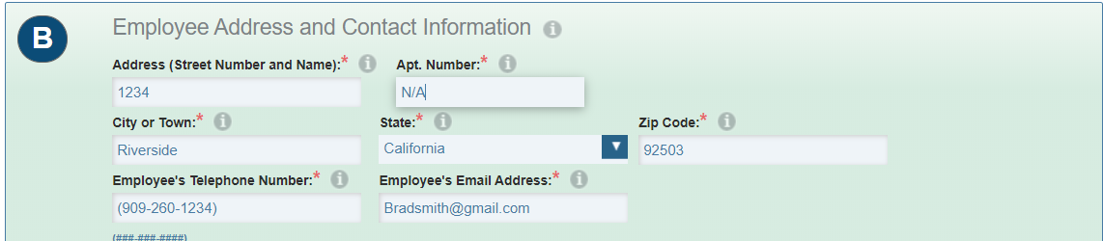
4. | Employee Employment Status  A box must be selected to attest citizenship or immigration status.  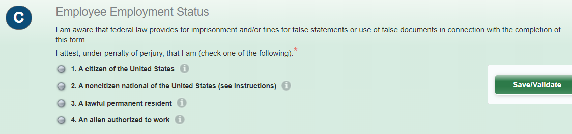
5. | Electronic Signature  Ensure the employee signs and dates Section 1 no later than their start date. The  electronic signature is the recommended way to process, store, and track I-9  records electronically at UCR.  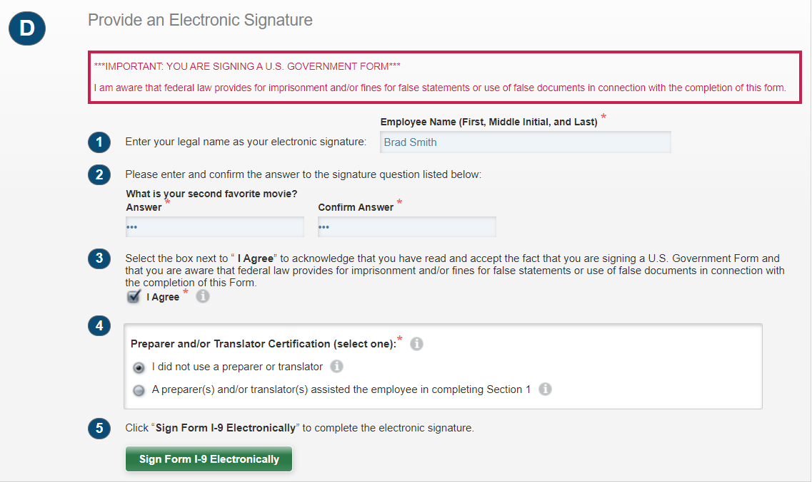  The purpose of the paper signature option is to allow entry of existing paper Form  I-9 data into the Tracker I-9 system.

