| COMPLETING FORM I-9 SECTION 2 |
UCR DEPT/SSC TO COMPLETE

The steps in this process should be used when completing the Form I-9 Section 2 in Tracker.
As the employer, it is important that Section 2 of the I-9 record
is signed by the employer representative within three days of the employee start date.

Note: The HR Worksite ID must be included in Position in UCPath to ensure Tracker integration occurs

Step | Action
1. | Employer Review and Verification.  Employers must examine evidence of identity and employment authorization in  Section 2 within three business days of the date employment begins.  - Review and record the document title(s), issuing authority(ies), document number(s), and expiration date(s) if any.  - Enter the employee's first day of employment, confirm the business name and address, and then save and validate.  - Review Sections 1 and 2 and then use the Electronic process to sign and verify.
2. | Section 2: Employment Verification Documents  In Section 2 of the Form I-9, the employer is required to enter information related to  employment and eligibility. The I-9 transactor requests documentation from the  employee and enters the provided information.  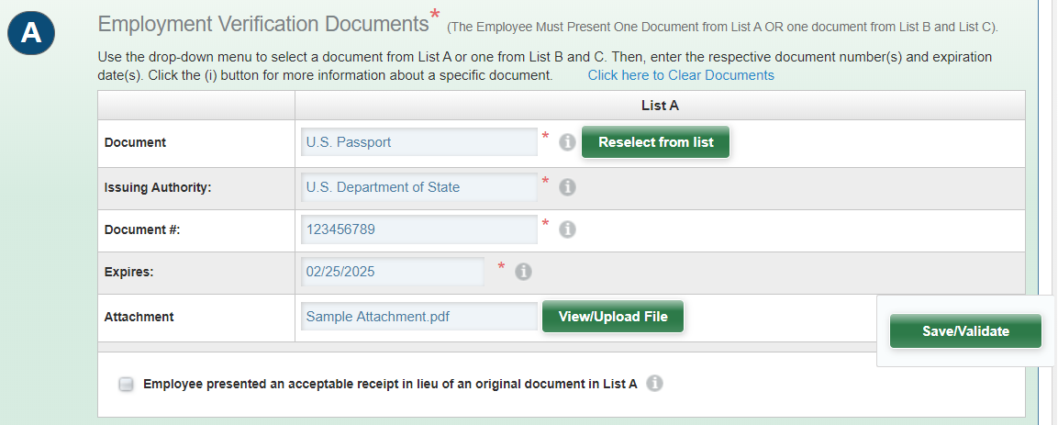
3. | Employment Information  Employer enter the following information:  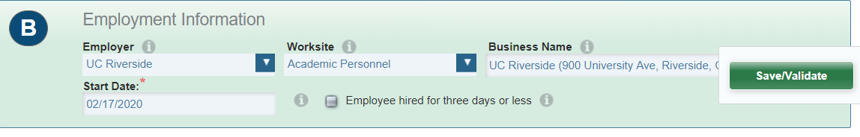
4. | Employer Electronic Signature  Section 2 of the I-9 record must be signed by the employer representative within three days of the employee start date.  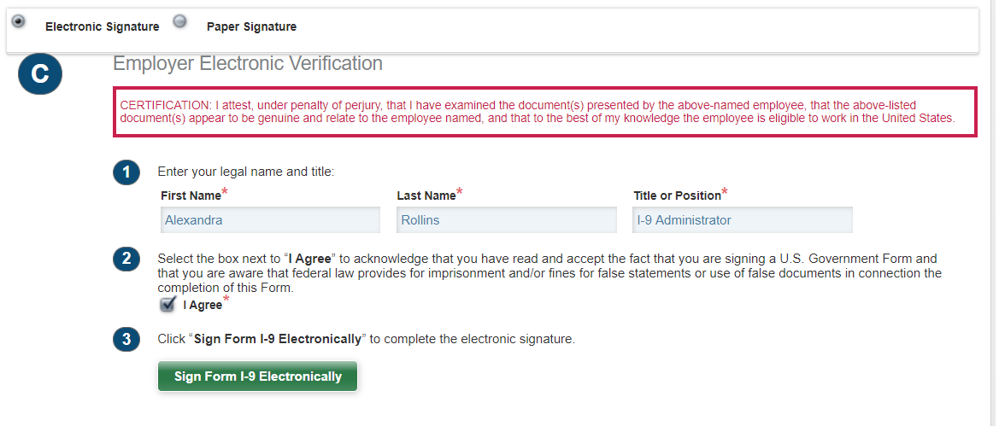
5. | 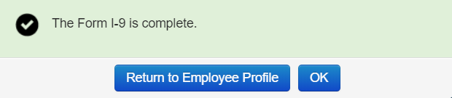  Form I-9 is complete

