Use this task to initiate a multi-row job data change PayPath transaction. The steps in this procedure can be used for academic and staff employees.

Navigation: PeopleSoft Menu > UC Customizations > UC Extensions > PayPath Actions Note: This page also may be available in Workcenter depending on your security access.

Step | Action
1. | After you navigate to the PayPath Actions component, the system displays the Find an Existing Value tab, which you use to search for the appropriate employee record.  Enter search criteria in one or more of the search fields on this page.
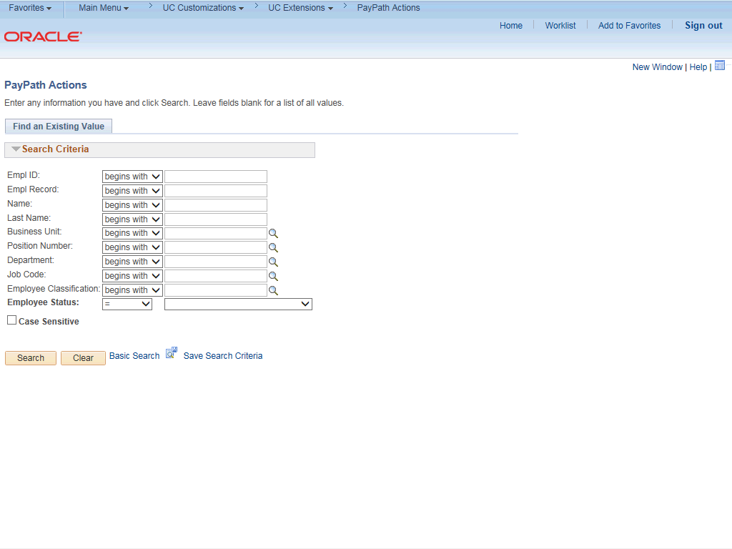

Step | Action
2. | Click in the Empl ID field.
3. | Enter the desired information into the Empl ID field.

Step | Action
4. | Click the Search button.
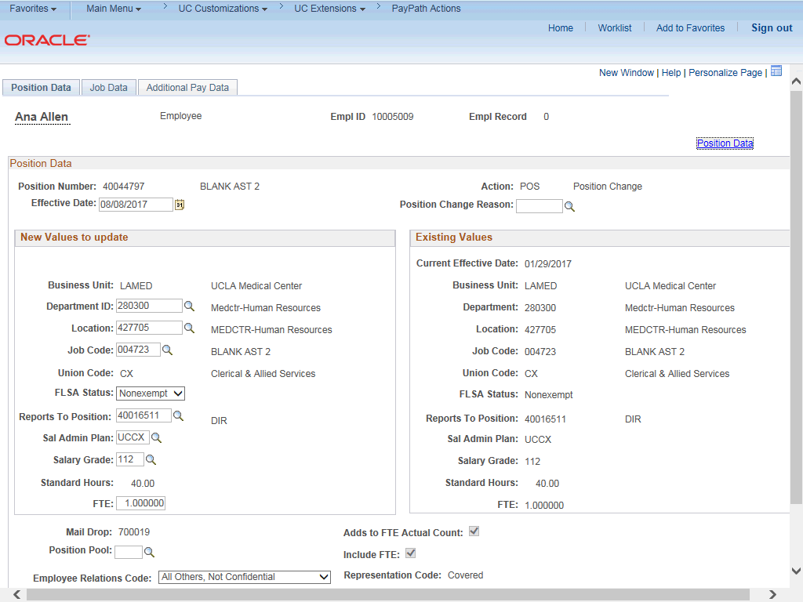

Step | Action
5. | The PayPath Actions page displays the Position Data tab. Navigate to the appropriate tab for the update you must enter. For this example, a job data change, navigate to the Job Data tab.
6. | Click the Job Data tab.

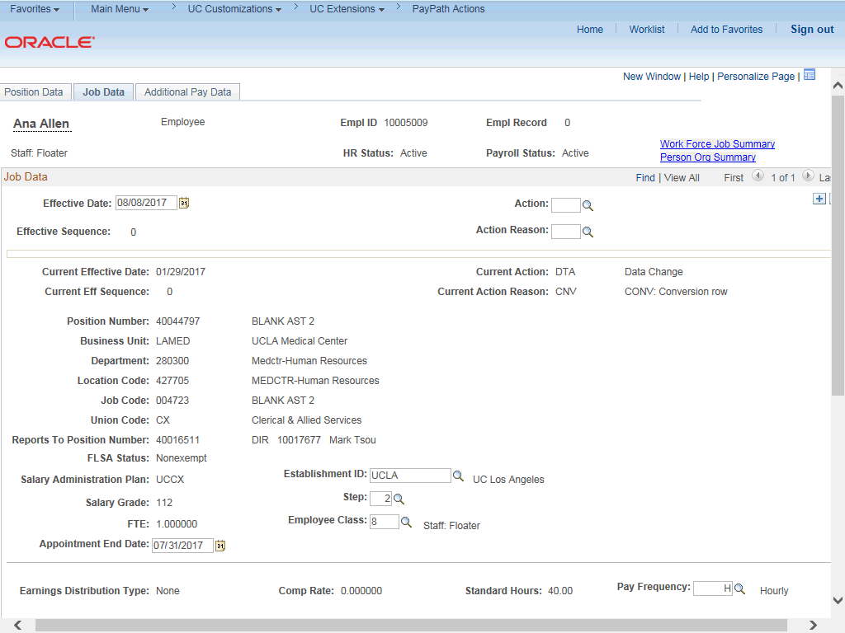

Step | Action
7. | This example demonstrates entering two job data changes for the same effective date. The first data change extends the appointment end date and the second data change gives the employee a merit increase.  Before entering the update, you must identify the Effective Date, Action and  Action Reason.
8. | The Effective Date field defaults to the system date (today's date). If needed, change the date to reflect the date the update should take effect.
9. | Click in the Effective Date field.
10. | Enter the desired information into the Effective Date field.
11. | Click in the Action field.
12. | Enter the desired information into the Action field.
13. | Click in the Action Reason field.
14. | Enter the desired information into the Action Reason field. For this example, enter EXT (extend appointment).

Step | Action
15. | Click in the Appointment End Date field.
16. | Enter the desired information into the Appointment End Date field.
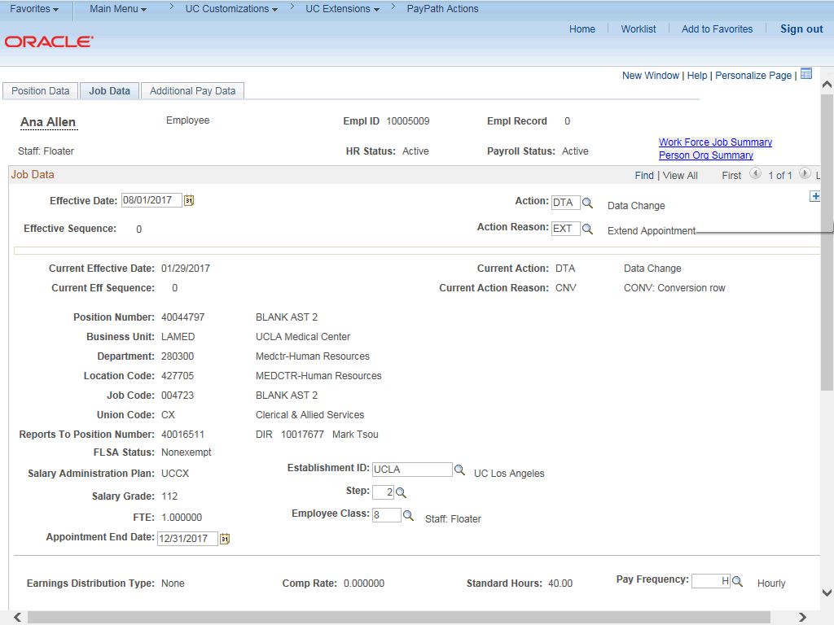

Step | Action
17. | Click the Add a new row button.

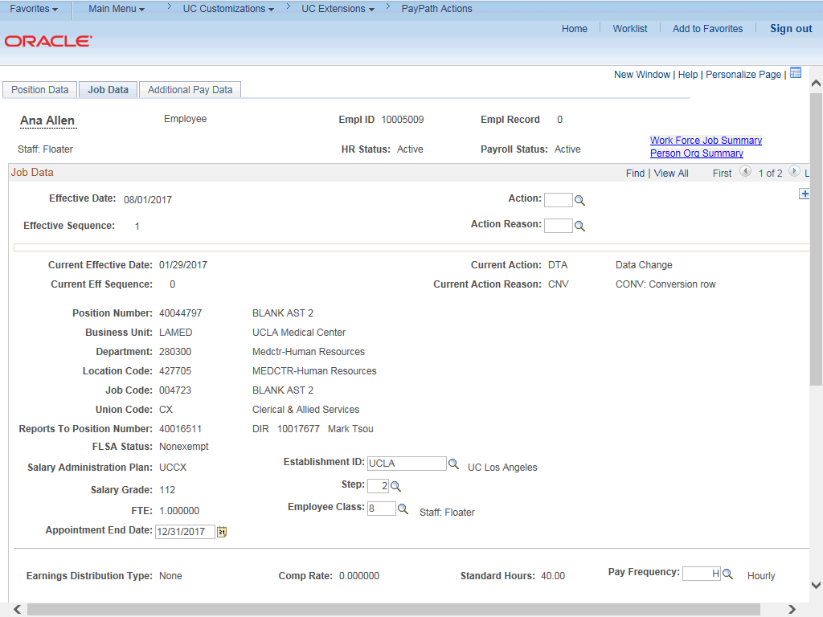

Step | Action
18. | The new data row displays the information from the previous row.
19. | Next, enter the information for the second job data change, a merit increase, on the new row.
20. | The Effective Date is copied from the previous row and cannot be changed.  The Effective Sequence displays 1, indicating it is the second action for the same effective date (the first sequence is 0).
21. | Click in the Action field.
22. | Enter the desired information into the Action field.
23. | Click in the Action Reason field.
24. | Enter the desired information into the Action Reason field.

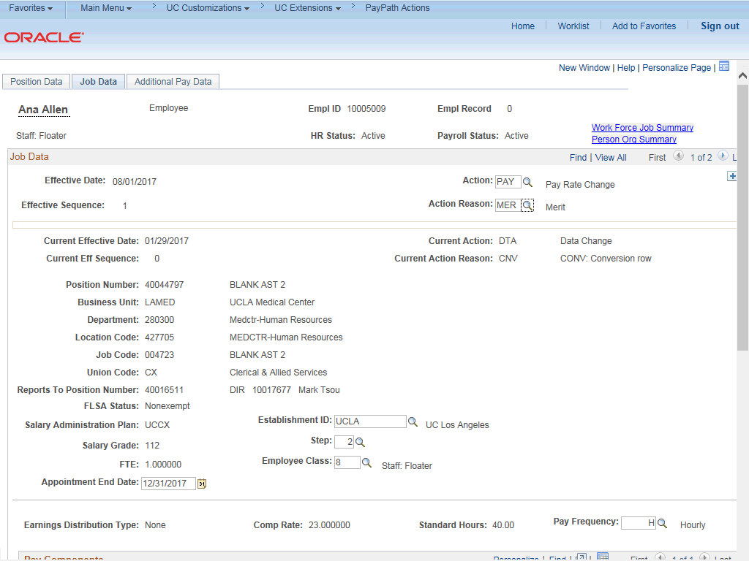

Step | Action
25. | Click the scroll bar.
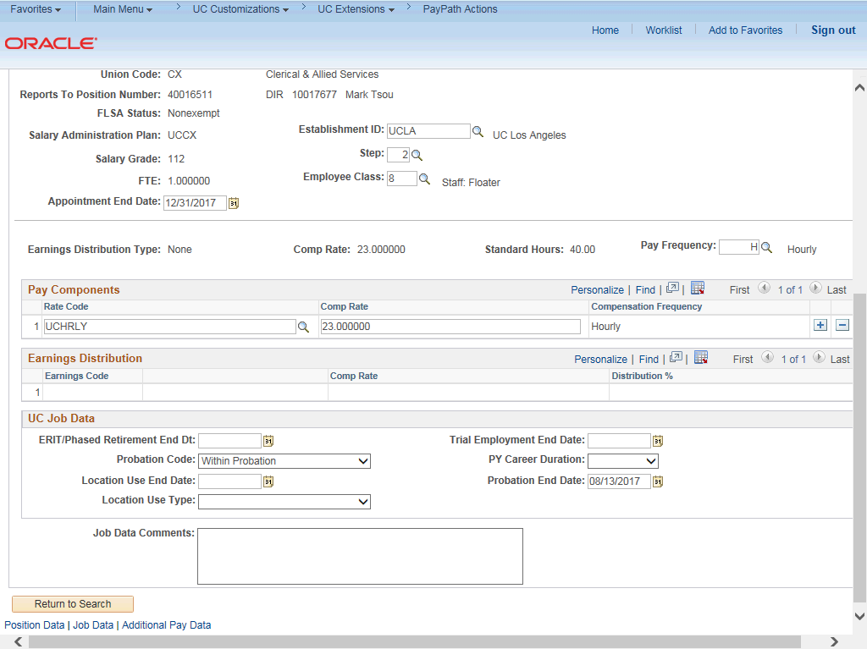

Step | Action
26. | Click in the Step field.
27. | Enter the desired information into the Step field.
28. | UCPath updates the Pay Components section based on the selected Step.
29. | For Job Data updates, enter a comment explaining the update. Click in the Job Data Comments field.
30. | Enter the desired information into the Job Data Comments field.
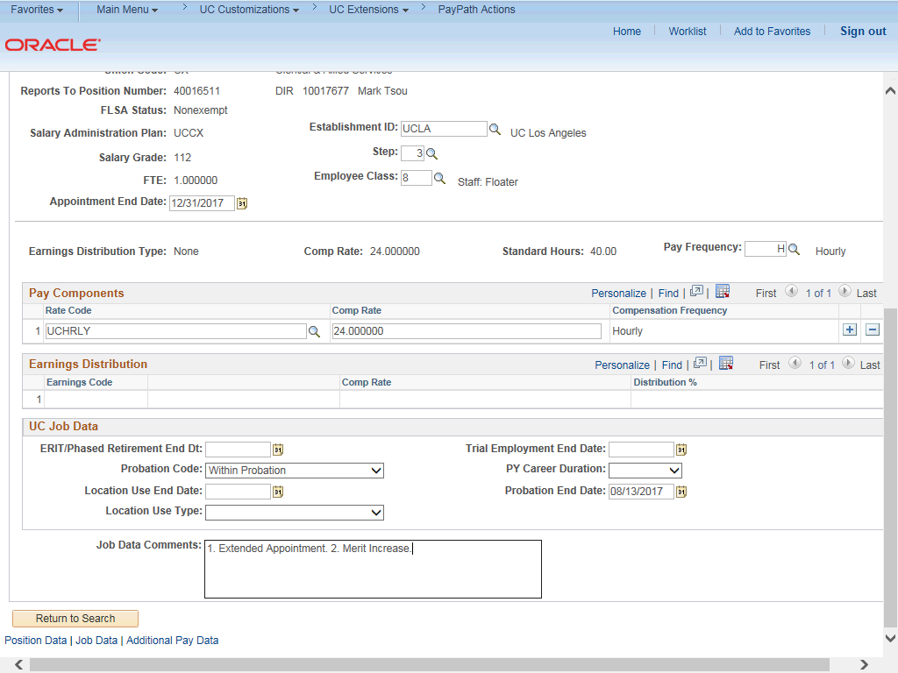

Step | Action
31. | Click the scroll bar.
32. | Click the Additional Pay Data tab.

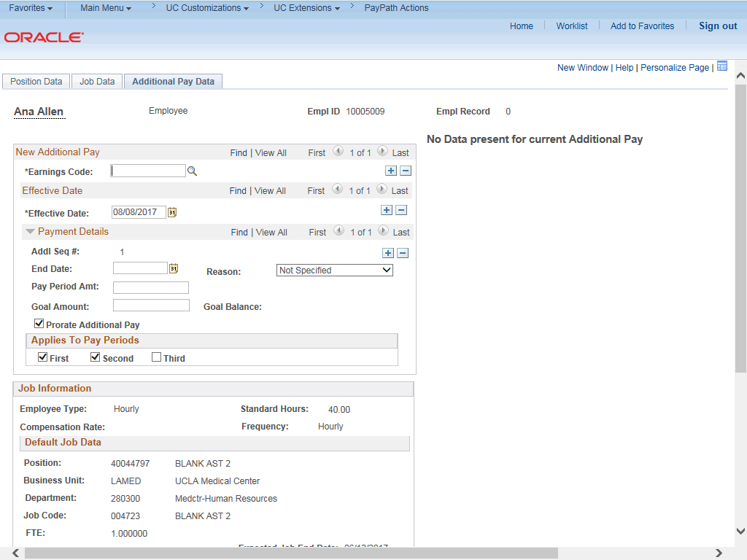

Step | Action
33. | Click the scroll bar.
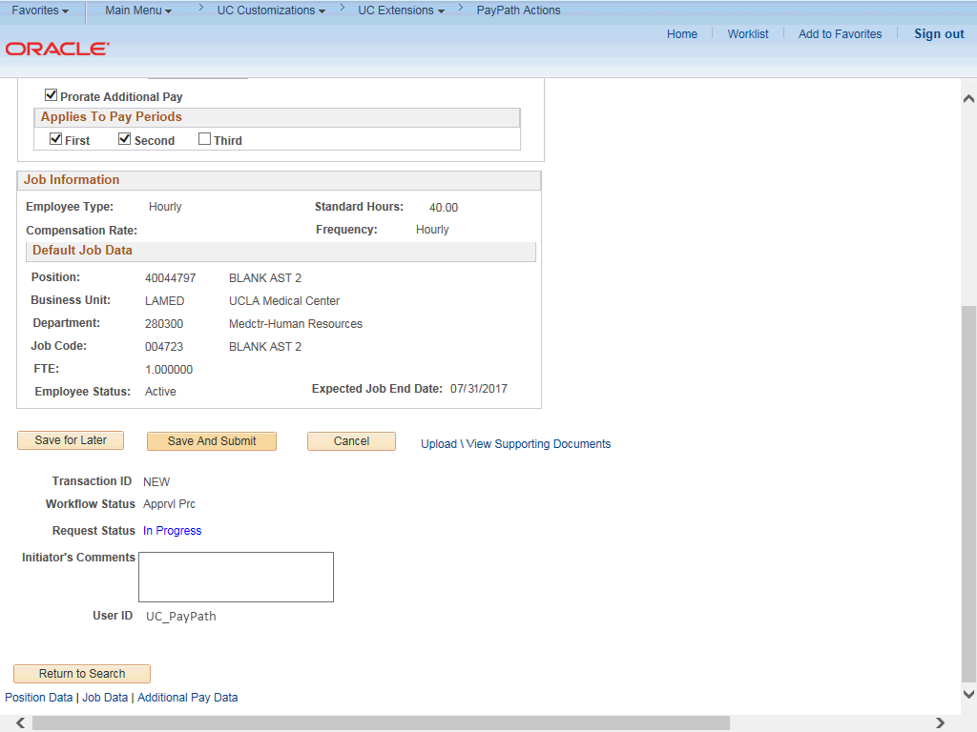

Step | Action
34. | Use the Upload \ View Supporting Documents link to attach supporting documentation, if applicable.
35. | Use the Initiator's Comments field, to further explain the transaction for the Approver, if applicable.
36. | Click the Save And Submit button.
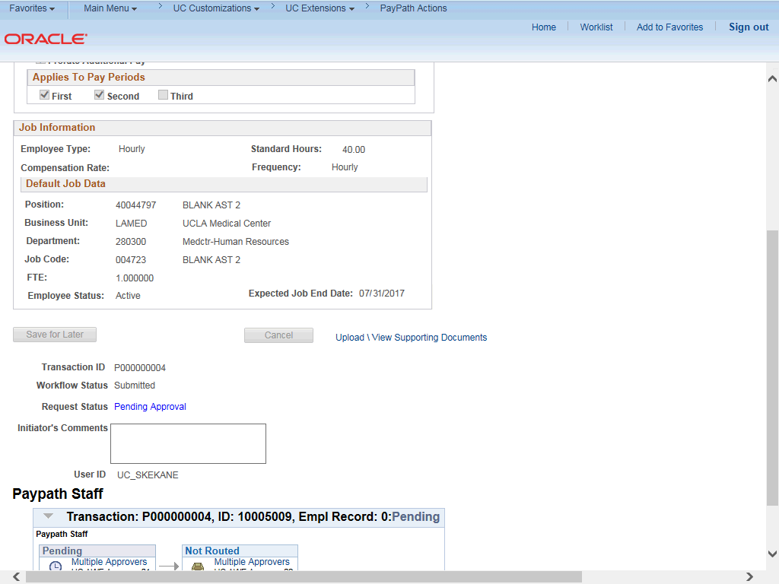

Step | Action
37. | The transaction is submitted for approval.
38. | You have initiated a multi-row job data change PayPath transaction.  End of Procedure.

