| Tracker/UCPath Integration |

The steps in the process outline how data from Tracker I-9 and UCPath properly integrate. It is important to ensure that specific fields are populated to ensure proper Integration between UCPath and Tracker I-9.

Note: The HR Worksite ID is located in Position data in UCPath and is required to be entered prior to placing an employee in the Position to ensure the I-9 integration process occurs correctly for both the Regular Hire and Pre-Hire Process below.

Step | Action
1. | Hire Type Process Description Tracker I-9 Integration  Regular Hire Tracker First The Employee Profile in Tracker I-9 is completed prior to submitting the UCPath Hire/Rehire Template The I-9 is completed before the Hire template The Tracker Profile ID must be manually entered on the Hire/Rehire template by the Template initiator to enable integration between UCPath and Tracker  Pre-Hire UCPath First The Hire/Rehire Template is completed before the Tracker I-9 Employee profile is completed The I-9 is completed after the Hire template The I-9 Transactor must enter the UCPath EMPL ID in the Tracker Profile to ensure integration between Tracker and UCPath.
2. | Tracker Profile ID  Once the Tracker Profile has been completed, the employee will be given a Tracker  Profile ID. This Profile ID must be entered in the UCPath Smart HR Template in the  Tracker Profile ID field to ensure proper system integration between Tracker and  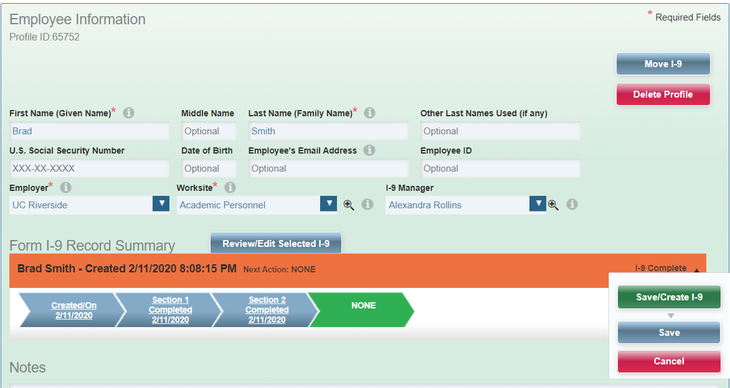  UCPath  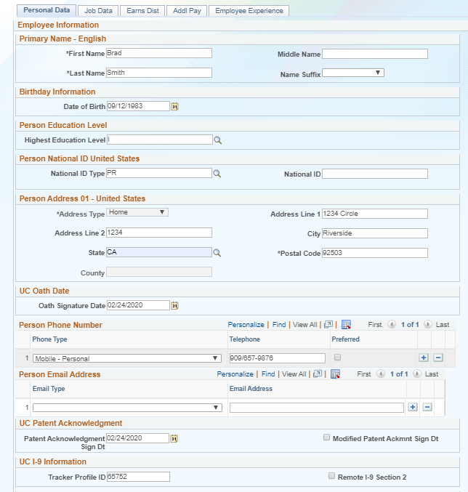
3. | If the Tracker Profile ID was not entered on the Smart HR template at the time of hire  the I-9 transactor must input the EMPL ID generated from UCPath in the Tracker  Profile to ensure integration.  