Job Aid: Request to Exceed Maximum Vacation Accrual Limit eForm

Overview of Required Steps

- The employee speaks to a Manager to make request to exceed maximum vacation accrual limit.

- The Manager has a Generic ServiceLink Form Initiator submit the request using the ServiceLink Generic form.

- The ServiceLink request is automatically routed to a point of contact in Business Financial Services (BFS). The request is reviewed at approved by BFS.

- Once the request is reviewed and approved, the BFS point of contact submits the Request to Exceed Maximum Vacation Accrual Limit eForm in UCPath.

- The Request to Exceed Maximum Vacation Accrual Limit eForm is automatically routed to the UCPath Center (UCPC), which reviews the form for completeness. If UCPC determines the form to be incomplete, it is sent back to the point of contact in BFS.

- Once the Request to Exceed Maximum Vacation Accrual Limit eForm is approved by UCPC, the exception is committed to UCPath.

Approve to move forward?
Submits Request to Exceed Maximum Vacation Accrual Limit eForm
UCPath Center
UCR
Employee
EMPLOYEE
UCR
UCPATH CENTER
Speaks to Manager to make request
Reviews and Approves request
Reviews form for completeness
Commits exception to UCPath
BN Production
BN Production
Yes
No
1
2
3
4
5
6

Business Use Case: Employee requests a vacation maximum exception.

Upon employee request of a vacation maximum exception, it is the responsibility of the employee’s department to initiate a Generic ServiceLink Form.

To initiate a Generic form request, the initiator must have been granted the ServiceLink Generic EACS role.

- The ServiceLink Initiator should navigate to the ServiceLink Portal - https://ucrsupport.service-now.com/ucr_portal and open a new Generic Request - https://ucrsupport.service-now.com/ucr_servicelink/generic.do

- Under the Request Information section, select “Payroll Adjustments – Request Hours or Accruals Adjustments” from the dropdown as the Transaction Type.

- The Effective Date is the date you want the action to take effect.

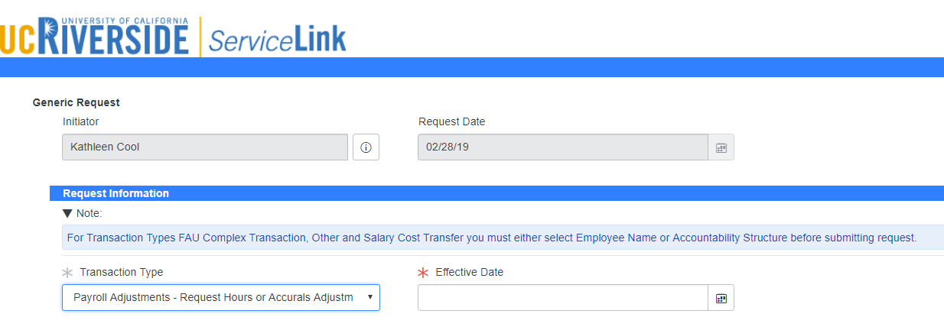
c.
b.

- Under the Employee Information section, enter the Employee’s Name (Last Name, First Name). The Position Number will default automatically. If the employee has more than one job, select the correct position from the dropdown menu for which the change is requested. The Employee First Name, Employee Last Name, Employee ID, Job Code, Job Description, Organization Code, Organization Description, Division Code, Division Description, Department Code, and Department Description will populate automatically based on the position selected.

- In the Comments section, enter a detailed description of the request.

d.
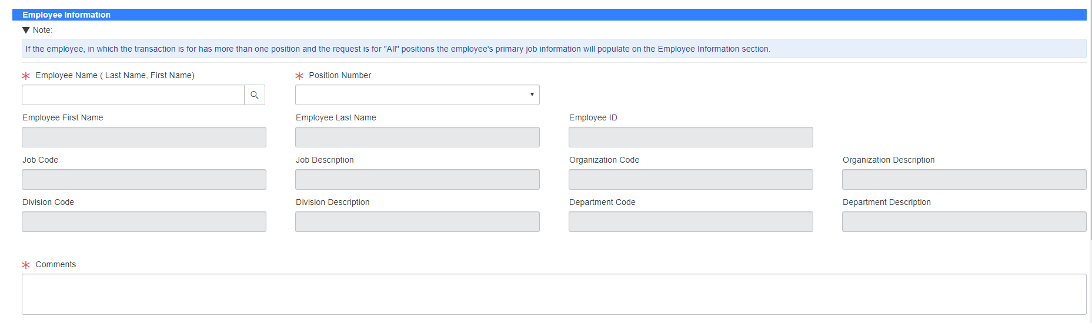
e.

- Attach documentation that supports your request.
- Click the Submit button.

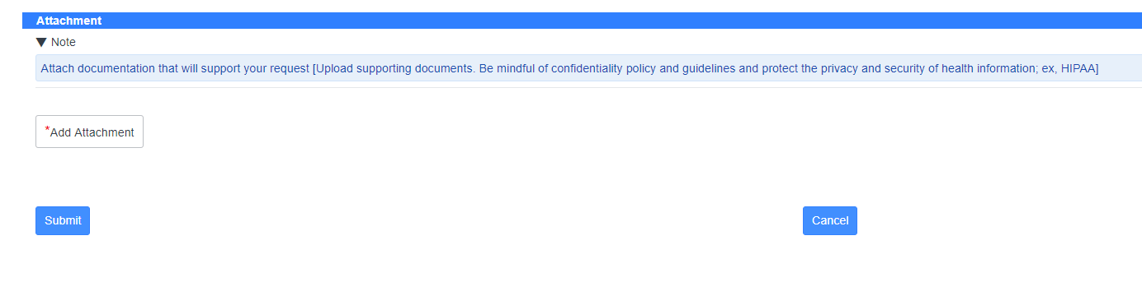
g.
f.

- The form will be automatically routed to a transactor in BFS. The RITM number generated by the system will help you track the status of the request as it is being transacted.

Submitting the Request to Exceed Maximum Accrual Limit eForm

Step 1 – Point of contact in BFS receives the ServiceLink Generic Form requesting to exceed maximum vacation accrual limit.

Step 2 – Point of contact in BFS reviews and approves the request. If the request is not approved, the ServiceLink Generic Form initiator is informed.

Step 3 – If the Request to Exceed Maximum Accruals Limit is approved, BFS Point of Contact submits the Request to Exceed Maximum Accrual Limit GT eForm in UCPath.

- The form is accessed through the Forms Library menu > Access Forms in UCPath.

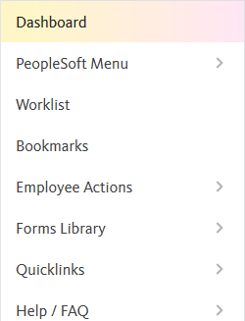
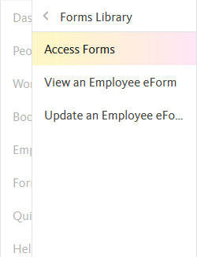
a.

Request to Exceed Maximum Vacation Accrual eForm

Step 4 – The Request to Exceed Maximum Vacation Accrual Limit GT eForm is located under the Accruals Management section of the Forms Library.*

*Only a few individuals at UCR have access to this GT eForm.

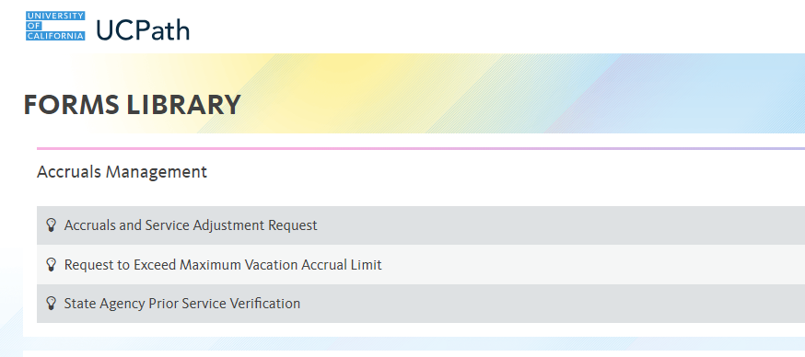
4.

- The Search By fields appear. You can search by Empl ID, Empl Record, Display Name and Department. If you are using the Display Name field, you may want to change the operator from the default “Begins With” to “Contains.” Search results will include Display Names that contains the data you entered rather than beginning by it. This will likely yield more results.

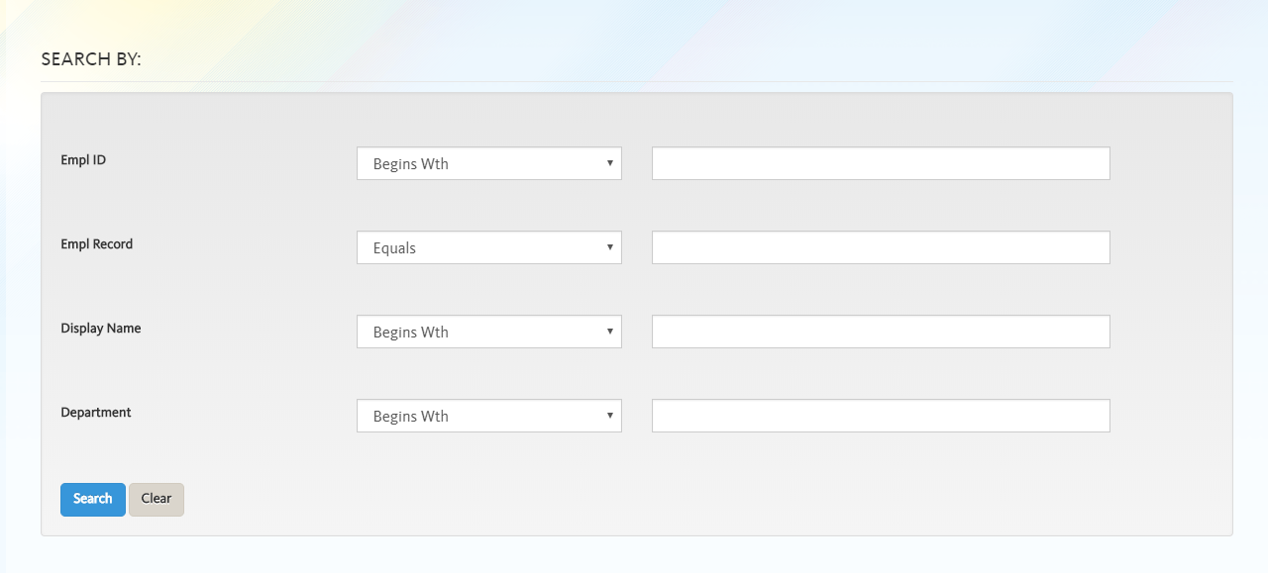
b.
a.

- Once you have entered your information in the chosen field(s), click the Search button.

- Search result(s) appear under the Search By section. If your search yields many results, use the Quick Filter to quickly filter results.

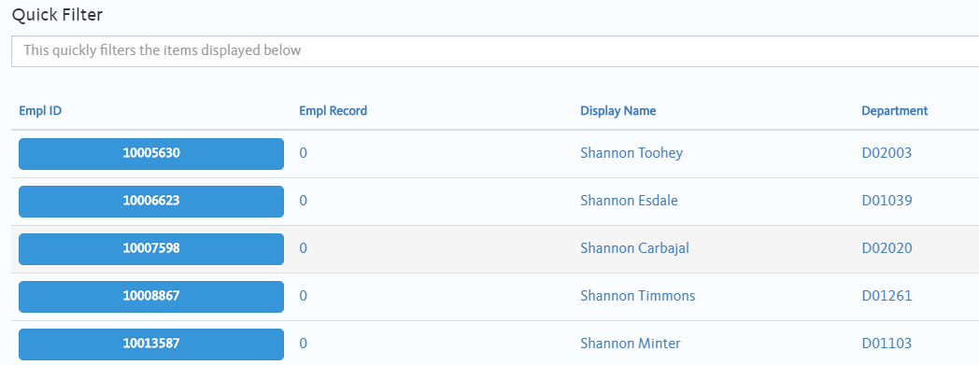
c.
d.

- To initiate an eForm for an employee, click on their Empl ID. The button will turn from blue to pick when selected.

- The Request to Exceed Max Vacation for the chosen employee will appear. Employee Information populates automatically based on Job Data.

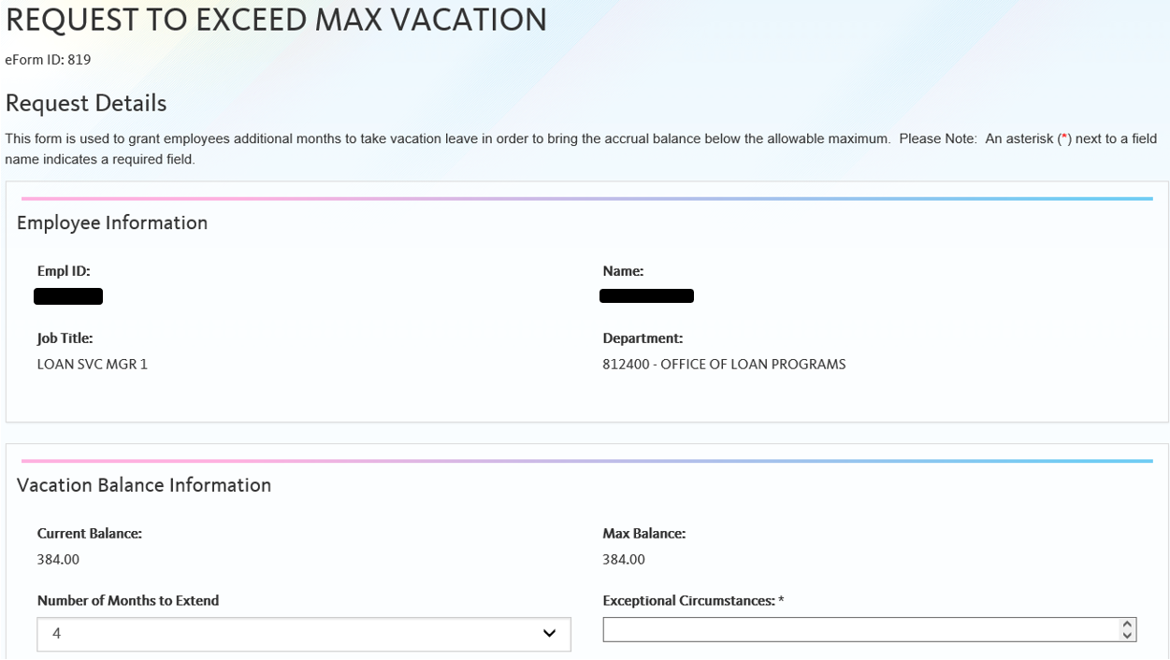
e.
g.
h.
f.

- The Vacation Balance Information section will show the employee’s Current Balance and Max Balance. This information is automatically populated.

- Under the Vacation Balance Information section, 4 will always default as the Number of Months to Extend. This can be changed to 1, 2, or 3 by selecting the appropriate value from the drop down.

- Comments explaining the reason for the request will need to be entered under the Exceptional Circumstances field. This field must be completed.

- Upcoming scheduled vacation and attachments can be entered. Neither of these fields are required.

- Comments can also be entered, but are also not required.

- Once the form has been filled, click the Submit button to submit to UCPC for review. To Save the form to submit at a later time, click the Save button. The form will then be available at a future data by going to Forms Library > Update an Employee eForm and searching for the employee.

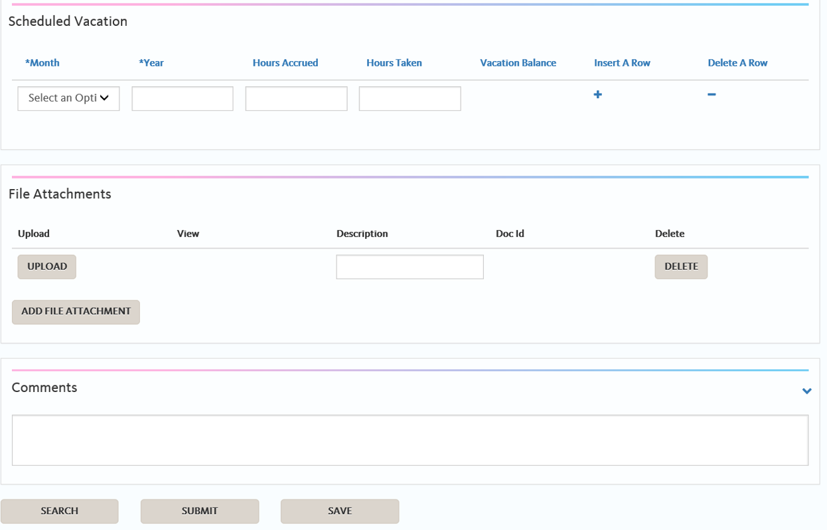
k.
j.
i.

What to Expect after Submitting the Exceed Maximum Vacation Accrual eForm

- If the eForm is not approved, it will be returned to the person who submitted the eForm (the Submitter) with comments and correction requirements.

  - The Submitter will receive an email notifying them that an eForm has been returned. The email will provide the user with a direct link to the form.

  - The returned eForm will also appear on the user’s worklist on UCPath online.

- Generally, the only reason that this form would not be approved by the UCPath Center is if the employee is nowhere near the max.

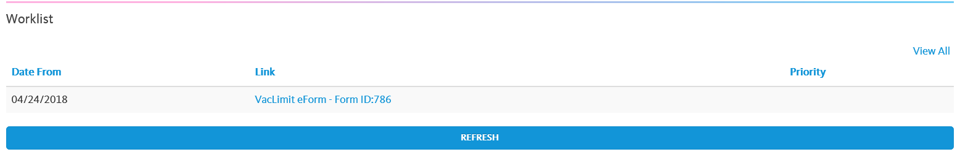

- If a prior accrual was lost/missed because the employee already reached the max, the Max Exception will automatically begin as of the 1st pay period in which an accrual was lost and the employee will retroactively accrue.

- Example: The following employee did not accrue for the pay period that ended 5/31/2018. If a Max Exception were requested for this employee, the exception would begin in that pay period and the employee would retroactively accrue.

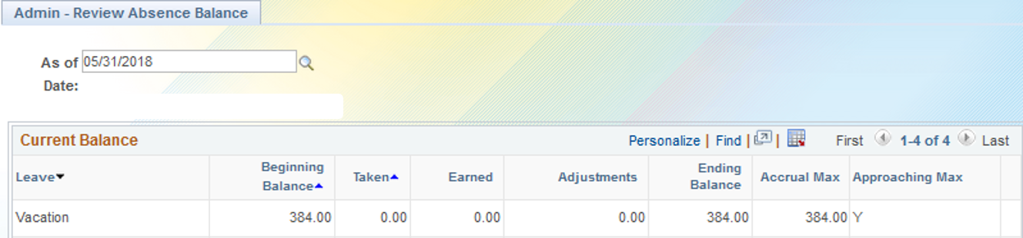

- Once the Vacation Max Exception is approved, the employee will see this change reflected on UCPath online after the next AM Process is completed. Please refer to the UCPath Production Processing Schedule.

- Vacation hours accrued over the employee’s maximum will be maintained in a separate ‘Additional Vacation' entitlement bucket.

- Employee will continue to use the “VAC” to report absences.

- The system has a built-in priority function that will subtract the reported absence from the 'Addl Vacation' balance before subtracting from the regular vacation balance.

