UCR To Be Process Design - Involuntary Offboarding
UCR Business Process Design
April 9, 2019
900 UNIVERSITY AVE. RIVERSIDE, CA 92521

Authors | Heidie Rhodes/Sonya Potter
Document Status | Final
Approval Status | Ready for Approval
Last Update | 5/29/2019

Contents
I.Document Change Log 2
II.Process Overview 2
Process Description 2
Design Authority 6
Policy, Procedures, Guidelines 6
Out of Scope 6
Academic Considerations 7
Staff Considerations 7
Assumptions & Decisions 8
III. Process Design 9
Overall Process Sequence 9
Roles Description 10
Inputs and Outputs 11
Performance Metrics 11
Process Context 12
IV. Detailed Design 12
Local System Impacts/Needs 12
Campus Change Impacts - Puja 12
V. Appendix A 13
VI. Document Signoff 13

I.Document Change Log
Use this table to summarize changes made to this document
Date | Editor | Summary of Changes
4/9/19 | Sonya Potter | Draft 1
5/7/19 | Sonya Potter | Draft 2

II.Process Overview
This section defines the overall scope and boundaries of the To-Be process design.

Process Description
Definition of Involuntary Termination - Offboarding
The involuntary termination process either starts when the Department/Org. decides to terminate or layoff an employee, or learns of the death of an employee. Involuntary terminations are processed for both staff and academic employees. There are benefits and payroll implications for involuntary terminations. These are dealt with in separate processes.
The process ends with the confirmation that the employee has been separated, all access to systems and facilities has been updated or terminated and all outstanding university and employee obligations related to compensation are settled. Lastly, the final payment information is transferred to the UCPath Center Payroll Production team.

While front-end processes and data collection may vary for involuntary terminations, layoffs, and deaths, the requests are all submitted through the same UCPath Termination Template.

Template Transactions – Action Reason Codes and Description for Involuntary Termination and Death
Template/Description/Action | Action Reason | Description
Template: UC_INVOL_TERM  Description: Involuntary Termination  Action: TER – Termination | Acad-Incompetent Performance | Academic Personnel Use. Used for termination of employee due to poor performance per APM 075
 | Acad – Presumptive Resignation | Academic Personnel Use. Used for when an appointee chooses not to return to his/her University appointment following the expiration of a leave of absence, or chooses to be absent from that appointment without obtaining prior approval for a leave. Per APM 700-30
 | Acad – Terminal Appointment | Academic Personnel Use. Used to terminate an academic appointee who did not receive tenure.
 | Appointment Expired | Used for the termination of an appointment with a fixed end date or expration of contract in accordance with terms of the contract or appointment
 | Death | Used to terminate employment due to death
 | Dismissal – Attendance | Used for termination due to employees excessive absences
 | Dismissal – Falsified App | Used for termination due to falsifying information on application
 | Dismissal – Misconduct | Used for termination due to misconduct
 | Dismissal – No Longer Cert/Lic | Used for termination due to lack of license or certificate
 | Dismissal – Lack of Performance | Used for termination due to poor performance
 | Do Not Protest (Settlement) | Used to terminate someone who has a settlement with the University. UCPath Center will not protest any UI claims if the employee has this action/reason code.
 | Do Not Rehire (Settlement) | Agreement/Settlement – Employee agrees not to return. See Appendix A for example
 | Involuntary Termination – Other | Used for termination for other reason(s)
 | Layoff – Rehire/Recall Rights | Used for indefinite Layoff – Rehire/Recall Rights
 | Layoff – Severance | Used for indefinite Layoff – Severance
 | Layoff – Reduce Sev, Reh/Recall | Used for indefinite Layoff – Reduced Severance and Preferential Rehire/Recall Rights
 | Medical Separation | Used for termination due to an employee who became unable to perform essential functions of his position due to a disability
 | Never Started Employment | Used for termination of an employee who never started employment. This is used to void the employment record rather than deleting it
 | No Longer Student | Used for termination of an employee who graduated or is no longer a student
 | Per Diem Release | Used to terminate an employee due to the end of a per diem appointment
 | Release fr Trial Emplmnt-Invol | Used for release from trial employement initiated by the university
 | Released During Probation | Used to terminate an employee due to not passing probation
 | Visa/Work Permit Expired | Used to terminate an employee due to expiration of Visa or Work Permit

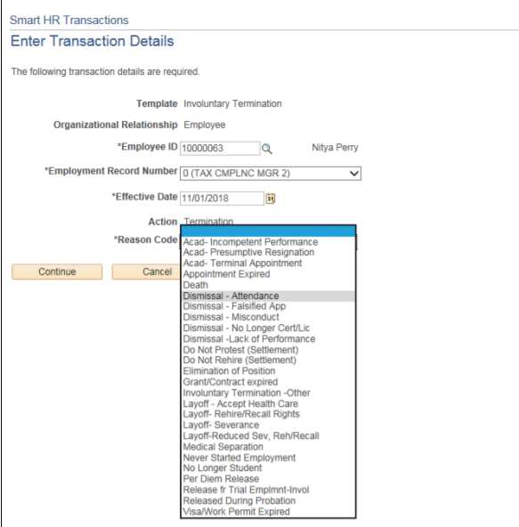

Design Authority
The following process owners and leads have decision-making authority over the design of this process deliverable and must review the final deliverable prior to approval by the ABSSC Leadership Council.
Functional Owners
- Academic Personnel - AVP Academic Personnel
- Human Resources - AVC Human Resources
- Business Financial Services – AVCP & Controller BFS (Final Payment)

Functional Leads
- Academic Personnel - AP Functional Lead
- Human Resources - HR Functional Lead
- Business Financial Services - BFS Functional Lead (Final Payment)
Operating Model
- This includes the roles and org structure for the future state
  - Roles
    - Central Offices (AP, BFS, HR)
      - Policy Implementation
      - Policy Owner
      - Process Owner
    - Transactional Unit
      - AP/HR Staff member as initiator
      - AWE Approver
    - Shared Service Center
      - Transacts final payment
    - UCPC
      - WFA Production
- Business process mapping for this phase will include
  - Central Offices
  - Transactional Unit
  - Shared Service Center
  - UCPC

Policy, Procedures, Guidelines
- Offboarding Checklist
- UCR Local Procedure on Separation Actions
Personel Policy 64 – Termination and Job Abandonment
- Collective Bargaining unit contract
- Leaving UC Employment

Out of Scope
The following are specifically out of scope for the as-is analysis:
- Final pay will be documented only as inputs/outputs: The Final Pay process begins with notification of a voluntary or involuntary termination from the University of California, and ends when final pay calculations are complete and final payments have been distributed to the employee. As part of the process, need to assess the terminated employee's job information, and the applicability of the 72- Hour Rule or specific Collective Bargaining Agreement that stipulates the timing of payout.
- Voluntary Termination: The process of Voluntary termination starts with the Employees decision to terminate an employment and ends with final payment information being transferred to the UCPath Center Payroll Production team. This process applies to both staff and academic employees. There are benefits and payroll implications of Voluntary terminations. These are dealt with in separate processes.
- Interlocation Transfer: The Interlocation Transfer process begins with a recruitment (where applicable) and ends with a transfer to the receiving location (which then includes benefits changes as applicable).The process applies to interlocation transfers (to a different location) and for both staff and academic employees. A hire and termination action is taken on the job records to move the employee from one location to the other without a break in service. An employee can transfer laterally, up, or down, each having slightly different implications. Benefits and payroll implications of transfers are dealt with in separate processes.

Academic Considerations
Below are the Academic Personnel Manual (APM) policies related to involuntary separations which can be found on the UCOP website, https://www.ucop.edu/academic-personnel-programs/academic-personnel-policy/:
- 075: Termination for Incompetent Performance
- 080: Medical Separation
- 133-20: Notice of Non-Reappointment
- 137: Non-Senate Academic Appointees/Term Appointments
- 145: Non-Senate Academic Appointees/Layoff and Involuntary Reduction in Time
- 150: Non-Senate Academic Appointees/Corrective Action and Dismissal
- 700-30: Presumptive Resignation Policy and Procedures
- 765: Death Payments
- Labor Contracts NEW LINK

Staff Considerations
- PPSM-60: Layoff & Reduction in Time from Professional & Support Staff Career Positions
  - UC Policy - http://policy.ucop.edu/doc/4010429
  - UCR Local Procedure - https://hr.ucr.edu/policies/policiesandcontracts/ppsm60pro.html
- PPSM-70:Complaint Resolution
  - UC Policy - https://policy.ucop.edu/doc/4010417/PPSM-70
  - Local procedure 70 is under review until June 30, 2019.
- UCR Local Procedure on Separation Actions
https://hr.ucr.edu/supervisor/labor/separation.html
- Leaving the University Post-Employment & Revolving Door Guidance
  - https://www.ucop.edu/general-counsel/_files/postemployment-coi.pdf

Assumptions & Decisions
This section describes the key assumptions and decisions made in relationship to this process design.
Description
Transactional Unit Approver have confirmed the Involuntary Termination and local procedures, documentation, consultations, and communications have taken place prior to submitting the request to the UCPath Center. In addition, applicable collective bargaining agreements, personnel policies and academic personnel policies have been followed
A Termination Template will be used to terminate an employee or report the death of an employee in UCPath. If the Transactional Unit has difficulty submitting the request they will need to contact the UCPath Center for assistance
For highly sensitive terminations that do not meet the documented standard process, Transactional Units will work with the UCPath Center HR/AP Support Manager
The Transactional Unit is responsible for entering the correct Action and Action Reason Code combination
In case of an employee’s death, Transactional Units should submit the contact information of the individual reporting the death and the survivor’s contact information in the Comments box within the Termination Template
In the case of Death, UCPath Center will terminate the employee from all jobs.
Settlement Agreements are part of CF.02 Settlement Agreements, and are outside of the scope for this. They will not be submitted along with the Termination Request
Final Pay information will be submitted by the Shared Service Center via the Final Pay Request and is a part of PY.05 Final Pay
The Transactional Unit will perform a check for multiple jobs and coordinate as needed prior to submitting a request
For employees with multiple jobs, a request terminates only the job selected for termination and will not affect the employee’s status in their other jobs. If the request is to terminate the employee from all of their jobs, separate termination forms would need to be submitted by the location for each job (except in the case of retirement, which is covered in Voluntary Termination)
The UCPath Center will change a separation Reason Code once it has been submitted, but prior to processing in the event of 1) a settlement or agreement between the employee and the Location, or 2) due to a bona fide error
Once a separation is processed, the UCPath Center will change a separation Reason Code in the event of 1) a formal settlement with the employee, or 2) due to bona fide error. Any changes after the separation will be handled directly in Job Data
The transactional units will maintain a valid separation checklist
The transactional units will manage and maintain their separation packets and retain documentation per the records retention policy and procedures
Enterprise Directory is updated 30 days after Staff termination, 90 days after Faculty Termination, and 180 days after Termination for Post-Docs. Affiliated have until the end date set up for them when the account was created. In all cases, the account can be immediately inactivated in the Enterprise Directory by a departmental Admin or ITS Super User

III. Process Design

Overall Process Sequence
The overall process sequence describes the major steps required to deliver the value of the process. It is the “Elevator Speech” to quickly and simply define its flow. This “Level 1” detail does not include the multiple variations.
To Be
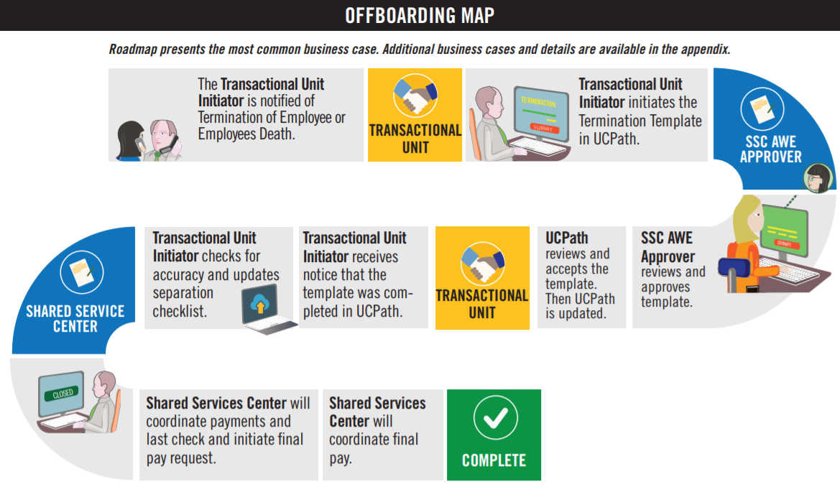

For complete map, consult the Involuntary Termination Infographic

Roles Description
The following are the roles required to successfully execute this process.
Role Name | Role Description
Employee | - Is informed from supervisor/department of termination  - Returns UC assets to department
Department | - Informs the Transactional Unit of the employee’s termination  - Fulfills offboarding department tasks such as:  - Coordination of return of assets  - Remove or revise system access
International Students and Scholars Office | - Is notified of the employee’s offboarding if the employee is a non-resident
ORG Authority | - Responsible for ensuring the appropriate policy is followed
Central Office | - Responsible for HR/AP process designs  - Provide subject matter expertise in technical/complex areas  - Interface with HR/AP business partners and institutional leadership  - APO is notified by AP directors of offboardings and deaths for academic positions
Transactional Unit | - Primary point of contact for managers and unit level leadership  - Represent the needs of the individual business unit  - Initiates UCPath Template for Involuntary Offboarding & Death  - Opens UCPath cases on behalf of employees when needed (see On Behalf Case Management Workbook)  - Monitors Transaction Status page for transaction status
Shared Services | - AWE Approver for transactions  - Transacts final pay  - Maintain performance metric spreadsheet (AWE denials & UCPC cancellations)
UCPath Center | - Processes Involuntary Termination templates  - Notifies initiator when transaction is canceled or approved  - Processes final pay per policy/bargaining unit contracts

Inputs and Outputs
Inputs are the decisions, data, documents required to initiate the overall process. Owners are the “suppliers” of those inputs.
Outputs are the data, documentation, records, reports, or experiences that the overall process is supposed to produce over the course of its execution. Customers are the recipients of those outputs.
Input/Output | Owner or Customer | Description
Input | Dept./Org. | Separation Packet
Input | Dept./Org. | Unemployment Insurance Termination Form
Input | Transaction Unit | Termination Template
Output | UCPath Updated | Employee displays as Terminated in UCPath
Output | UCPC | Beneficiary Care Coordinator Process if Applicable
Output | Department | Employee is removed from Enterprise Directory
Output | UCPC | Courtesy letter of access removal (UCPath Portal)

Performance Metrics
What is the proposed or aspirational performance metrics desired to measure the efficacy of the overall process. These can be leveraged from the as-is process, influenced by the UCPath processes or new metrics not currently measured.
Metric Type | Metric Description | Measurement Method
Duration | How long should it take to perform the overall process? | Cognos Report, internal SSC spreadsheets
Service | What is the desired level of customer satisfaction with the process? | Satisfaction Survey
Accuracy | What is the acceptable threshold for errors or re-work in the process? | Cognos Report, internal SSC spreadsheets
Efficiency | What time or financial resources are required to support the end-to-end process? | Cognos Report / Staffing Analysis

Process Context
Use this section to note clarifying information on steps in the mapped process (es) where needed to help explain reasoning behind changes to the as-is process. This is not a place to document a comprehensive listing of all activities related to each process step.
Process Name/Step | Context/Information | Is this a new step in the To-Be Process?
3a | The Transactional Unit will supply the Employee with Unemployment Insurance notices | No
3d | In the event of a death, UCPC Notifies Survivor that UCPath Center is aware and a Beneficiary Care Coordinator will contact them | No
16c | In the eventof a death, UCPC sends Survivor information from Template “Comments” box to Beneficiary Care Coordinator | No
13c | Shared Service Center will handle the final pay | No

IV. Detailed Design
With the exception of the parking lot, this section will be completed during the detailed design phase of the project

Local System Impacts/Needs
Placeholder for analysis of system needs, capabilities, gaps. Will leverage UCPath capability requirements and as-is process tools analysis as applicable
- EACS changes
- AWE changes
- ServiceLink changes
- Snapshot changes

Campus Change Impacts
Placeholder for change impacts as a result of the optimized process design.
See OCM Plan for Voluntary Termination/Retirement

V. Appendix A
Example of “Do Not Re-Hire Settlement”
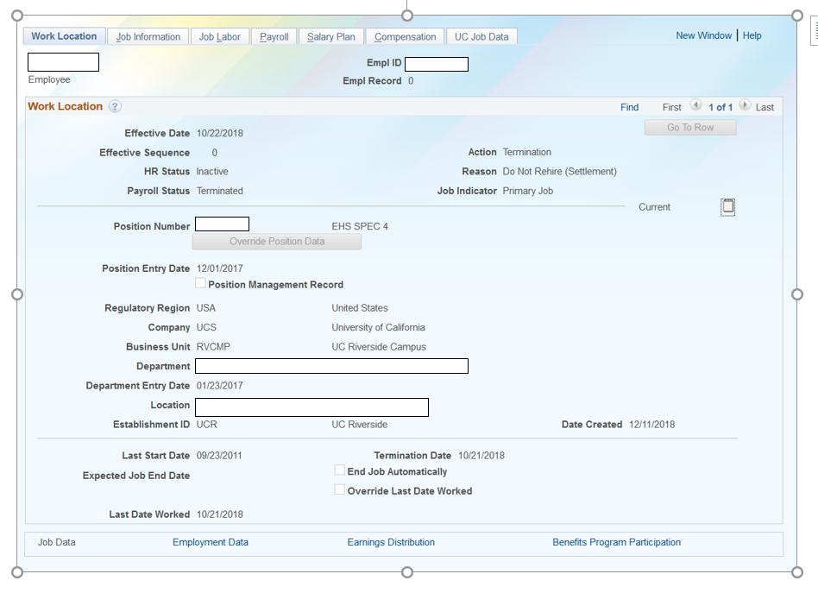

VI. Document Signoff
Use this table to list approvals for this document
Date | Approver | Status
Mm/dd/yyyy
Mm/dd/yyyy
Mm/dd/yyyy

