UCR To-Be Process Design
Business Process Design Onboarding PayPath EMPL Class 5, 9 and 10

August 26, 2019
14350 Meridian Parkway Riverside, CA 92518

Authors | Antonette Toney & Alexandra Rollins
Document Status | Draft
Approval Status | Ready for Approval
Last Update | 9/19/2019

Contents
I. Document Change Log 2
II. Process Overview 2
Process Description 2
Design Authority 5
Out of Scope 6
Assumptions & Decisions 6
III. Process Design 7
Overall Process Sequence 7
Roles Description 7
Inputs and Outputs 8
Performance Metrics 8
Process Context 9
IV. Detailed Design 9
Local System Impacts/Needs 9
Campus Change Impacts 9
V. Document Signoff 9

Document Change Log
Use this table to summarize changes made to this document
Date | Editor | Summary of Changes
8/15/19 | Alexandra Rollins | First Draft
8/30/19 | Alexandra Rollins | Added details about each Empl class and the unique attributes and tips for how to transact with each EMPL class
9/3/19 | Alexandra Rollins | Added to-be high level process and Infographic
9/4/19 | Alexandra Rollins | Added links to action reason codes and job codes
9/6/10 | Alexandra Rollins | Added PayPath attributes, updated infographic, added summer salary guidelines link, added benefits eligibility link, added GT eforms link, confirmed BFS process for when paycheck totals to zero, and process for correction file. Confirmed that EMPL class 10 in mostly monthly (M -1328  B -35)

Process Overview
This section defines the overall scope and boundaries of the To-Be process design.

Process Description
Definition of PayPath Position, Job and Recurring Additional Pay Changes
PayPath Actions is a custom component designed to streamline updates to employee data in UCPath. This component offers a one-stop for processing various types of position, job data and additional pay transactions. The following transactions are processed using PayPath Actions.

  - Position Data Changes
    - Position data changes can be made only for positions that have a single active incumbent.
  - Job Data Changes
    - The Job Data page is used for many types of job-related updates, which can be made independent of a position data change and also in conjunction with position data changes for academic promotions.
  - Recurring Additional Pay
    - PayPath Additional Pay can be used for recurring additional pay transactions where payments are paid over multiple, consecutive pay periods.
    - Recurring additional pay transactions entered in PayPath are routed for approvals and then transferred to a Payroll staging table to be processed automatically by UCPC Payroll additional pay batch upload process.

  - PayPath Attributes and Quirks
    - PayPath changes don’t commit to database right away for pay group, pay frequency, and additional pay changes. You won’t be able to transact on your current employee until approval is complete i.e. until pending transaction is approved
    - PayPath only shows you active employees
      - Does not show any POI’S (Views in Person Org Summary or the POI page)
      - Does not show CWR’s (Viewed in Job Data)
      - Does not show inactive employees (Viewed in Job Data)
    - Writes to database after approval, exception
      - Recurring pay
        - It has to be overnight before the earn code shows in additional pay because they need to wait one day before they trancsact and same for WOS
        - Everytime there is an update there is a benefits eligibility change
      - Pay frequency (pay group) batch overnight
    - Has to have an end date extended before a secondary transaction is entered
    - Sometimes will change percentage when something else is updated
  - PayPath Audit
    - Transactional Units are responsible for auditing all transactions for their accountability structure
    - POSSC, CITRUS and HARVEST will do a 2ND level audit on pay impacting types and will work with the transactional units on identified issues
    - RSSC will not be conducting a second level audit on pay impacting transactions
    - Transactional Units are responsible for auditing all transactions for their accountability structure
    - If there are inaccuracies Department/Org/Transactional Units are responsible for ensuring that they are fixed by either correcting them directly or by working with their SSC (per the on behalf of case management matrix or the transaction matrix)

  - EMPL Class 5 - Student Casual Restricted general description and attributes
    - Hourly, paid through TARS biweekly
      - Update for Americorp members, there has been a change and they are now monthly BYA
    - Less than 50% during academic year
    - Some are placed on short work break over the summer
    - Default to a non-exempt FLSA status
    - They don’t have benefits
    - Some are paid in recurring additional pay with no compensation on job
      - (Examples: Student activity officials, americorp members, recreational instructors etc.)
    - Concurrent jobs
      - Those with concurrent jobs with two biweekly jobs with same FLSA status
      - Nonexempt job with different FLSA statuses that need alignment
      - Those with biweekly and monthly jobs that requires alignment with the same FLSA
      - Those with multiple biweekly jobs with the same FLSA status
      - Multiples with the same pay cycle and a different FLSA status
      - Different pay cycles with the same of different FLSA status
      - Action Item – Alex/Lakesha insert Matrix in this section

  - Additional information transactors need to know to help manage these transactions:
    - If you are putting positon on a SWB. Putting them on a SWB on one record does not affect the other record. (Short Work Break Matrix)
    - Position Pool – Work Study
      - In the summer they are not eligible for work study so their appointments needs to end, they need to be placed in a separate position, or they should be placed on a SWB.
    - UCPC sends BFS various payroll queries, after Pay Confirm. These queries contain a list of employees whose paycheck totals zero (net or gross), and other types of specific information. This query lists all active employees who have a zero gross or zero net check. This could be due to benefits deductions or taxes and therefore is not an error but needs review.
    - There is a correction file that gets submitted from TARS to UCPath, and UCPC only gives locations about a day to do this. There is a quick turnaround time for this.
    - If they are not extended, they are automatically separated in the system. The end job automatic button doesn’t exisit for EMPL class 5 – Action Item – Confirm this

  - EMPL Class 9 - Academic Faculty general description and attributes
    - Reserved Abeyance (RES ABY) only if they have a concurrent 100% faculty administrative appointment
    - Monthly
    - Exempt
    - Eligible for full benefits
      - Not all are eligible for benefits because it depends on their percentage and number of hours
        - Ladder Faculty
        - Lectures
        - Instructional Faculty
  - Pay Mitigations/Accruals
    - All academics with end dates do not have job end automatically checked. Transactional units need to use the Job Record End Data (JRED) report to determine if academic appointee needs to be extended, terminated or placed on a short work break (SWB) per the SWB guidelines.
    - Fiscal Year (FY) faculty who received additional compensation require that vacation be deducted using a separate process using the GT eforms.
      - Link to GT eforms
    - Summer salary for faculty is processed via the APO guidelines. Summer Salary for faculty is paid through recurring additional or via a separate job
      - (Link to the AP documents for Summer Salary)
      - (Link to Summer Salary PayPath Transaction job aid)
    - Timesheets are provided to academic faculty that accrue vacation.
    - If a faculty is hired after instruction has started then the daily rate calculation is used to process compensation
      - Compensation needs to be calculated and provided in the comments section
      - The correct comp rate code has to be chosen
      - Academic appointment duration is not kept up to date and box can be ignored
      - (Link to Contract Pay Jod Aid)
  - Additional information transactors need to know to help manage these transactions:
- Make sure to monitor the end date using the job record end date monitoring report. These appointments need to be placed on a short work break or their appointment ends. If the appointment is not ended, it will result in overpayment.
  - Contact Person
    - Harvest - Transactional Unit Inititaor works with designated SSC transactor, SSC transactor will work with UCPath and employee directly.
    - RSSC - Transactional Unit will create a ServiceLink request and RSSC will process overpayment.
    - POSSC - Transactional Unit will create a ServiceLink request and POSSC will process overpayment.
    - CITUS – Follow up with Lorraine Cheng
  - EMPL Class 10 - Academic - Non Faculty general description and attributes
- Eligible for Short Work Break per the (SWB) matrix
- Most are monthly and some are hourly
  - Mostly 5AC (Academic Compensation)
  - 5MH group (Monthly hourly)
- Eligible for Benefits
  - This depends on FTE and length of the appointment. (Eligibility Guidelines Link)
  - Pay Mitigations
    - Summer salary positions fall in this category
    - Best practice is to confirm on the Paypath page if is not done correctly. If JED is incorrect, they have to submit a case to have it corrected and then they have to go into PayPath and set it up correctly for the next pay run.
    - 2019 – 2020 Salary Implementation Guidelines for base salary, off-scale and above scale.
  - Additional information transactors need to know to help manage these transactions:
    - Faculty are in this group even though the name of the group is called Non-Faculty (Action Item: Ask Sarah)
    - If they are faculty they have an EMPL class 9 record and have an EMPL class 10 record (Action Item: Ask Sarah)
      - If you are putting a job on a SWB. Putting the the job on a SWB on one record does not affect the other record. SWB is different than a leave, when you have a sabbatical you can put all the records on a sabbatical leave and for SWB you have to indicate what job it is for.

  - Job Codes
    - Job Code for EMPL Class 5, 9 and 10
  - Action Reason Codes
    - Staff
    - Academic

Design Authority
The following process owners and leads have decision-making authority over the design of this process deliverable and must review the final deliverable prior to approval by the ABSSC Leadership Council.
Functional Owners
- Academic Personnel – AVP Academic Personnel
- Human Resources – AVC Human Resources
Functional Leads
- Academic Personnel – AP Functional Lead
- Human Resources – HR Functional Lead
Operating Model Phase 2
- This includes the roles and org structure for the future State Processes
  - Roles
    - Transactional Unit/Org/ Department
      - Initiates PayPath updates
      - Transactional Unit is responsible for auditing all transactions
    - Shared Service Center
      - Approves PayPath Updates
      - SSC’s will do a 2nd level audit on select transaction types
    - Central Office
      - Reviews and responds to policy related questions
    - UCPC
      - Processes corrections when applicable
- Business process mapping for this phase will include
  - Employee
  - Transactional Unit/Dept/ORG
  - Central Office
  - Shared Service Center
  - UCPC

Out of Scope
This item is still under review:
- Mass PayPath Actions: Mass PayPath actions are still under review by Executive Director based on SSC recomendations.

Assumptions & Decisions
This section describes the key assumptions and decisions made in relationship to this process design.
Description
- Transactional Unit will initiate all PayPath updates for EMPL classes 5, 9 and 10
- All transactions have been reviewed and approved as required by policy, local procedures and guidelines
- Information input into UCPath aligns with the actions requested and approvals received
- Mass Paypath actions are still under review by executive director per SSC recommendations
- Transactional Units are responsible for auditing all transactions for their accountability structure
If there are inaccuracies Department/Org/Transactional Units are responsible for ensuring that they are fixed by either correcting them directly or by working with their SSC (per the on behalf of case management matrix or the transaction matrix)

Process Design

Overall Process Sequence
The overall process sequence describes the major steps required to deliver the value of the process. It is the “Elevator Speech” to quickly and simply define its flow. This “Level 1” detail does not include the multiple variations.
To-Be for Faculty Provost Admin
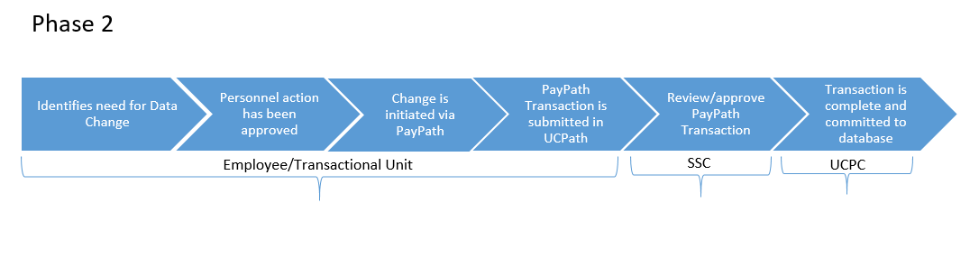

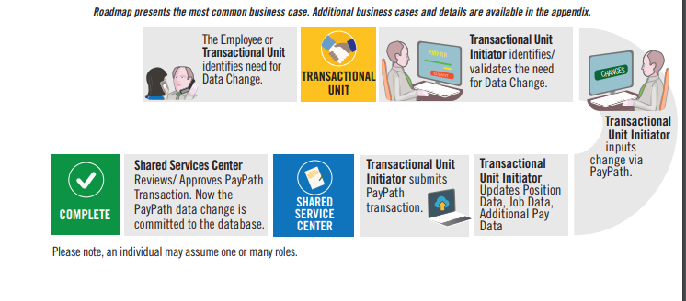

Roles Description
The following are the roles required to successfully execute this process.
Role Name | Role Description
Transactional Unit /Department/ORG | - Transactional Unit initiates PayPath Actions  - Transactional Unit resubmits PayPath Transaction when transaction has been denied by the SSC AWE Approver  - Transactional Unit is responsible for auditing all transactions  - Represent the needs of the individual Transactional Unit and ORG as appropriate
ORG Authority | - Responsible for ensuring the appropriate policy is followed
Shared Services | - Responsible for AWE approval  - SSCs will do a 2nd level audit on select transaction types
Central Office | - Responsible for process design, and policy guidelines  - Provide subject matter expertise in policy related questions
UCPath Center | - Processes corrections if applicable

Inputs and Outputs
Inputs are the decisions, data, documents required to initiate the overall process. Owners are the “suppliers” of those inputs.
Outputs are the data, documentation, records, reports, or experiences that the overall process is supposed to produce over the course of its execution. Customers are the recipients of those outputs.
Input/output | Owner or Customer | Description
Input | Transactional Unit | PayPath Updates
Output | SSC | PayPath Approvals

Performance Metrics
What is the proposed or aspirational performance metrics desired to measure the efficacy of the overall process. These can be leveraged from the as-is process, influenced by the UCPath processes or new metrics not currently measured.
Metric Type | Metric Description | Measurement Method
Duration | How long should it take to perform the overall process? | Internal reporting
Service | What is the desired level of customer satisfaction with the process? | Satisfaction Survey
Accuracy | What is the acceptable threshold for errors or re-work in the process? | Internal reporting
Efficiency | What time or financial resources are required to support the end-to-end process? | Staffing Analysis, internal reporting
Level of Service | Transactional experience of the department of what is working and what is not working | Satisfaction Survey

Process Context
Use this section to note clarifying information on steps in the mapped process(es) where needed to help explain reasoning behind changes to the as-is process. This is not a place to document a comprehensive listing of all activities related to each process step.
Process Name/Step | Context/Information | Is this a new step in the To-Be Process?
Step 10 | Transactional Units are responsible for auditing all transactions for their accountability structure If there are inaccuracies Department/Org/Transactional Units are responsible for ensuring that they are fixed by either correcting them directly or by working with their SSC (per the on behalf of case management matrix or the transaction matrix) | No
- Detailed Design
With the exception of the parking lot, this section will be completed during the detailed design phase of the project

Local System Impacts/Needs
Placeholder for analysis of system needs, capabilities, gaps. Will leverage UCPath capability requirements and as-is process tools analysis as applicable
- EACS changes
- ServiceLink changes
- Snapshot changes
- UCPath
  - These is a current bug in the system that does not allow attachments for PayPath.

Campus Change Impacts
Change impacts as a result of the optimized process design.
- The submission of template transactions for PayPath for EMPL Class 5, 9 and 10 will be initiated by the Transactional Units, which used to be done by the SSCs. PayPath Transactions will go through AWE approval in the SSCs
- Highlighted Changes:
  - Transactional Unit initiates and SSCs approves PayPath updates
  - Transactional Unit initiates and SSCs approve reccurring additional pay

Document Signoff
Use this table to list approvals for this document
Date | Approver | Status
Mm/dd/yyyy
Mm/dd/yyyy
Mm/dd/yyyy

