Use this task to initiate an extension for a short work break. The steps in this procedure can be used for academic or staff employees.

Navigation: PeopleSoft Menu > UC Customizations > UC Extensions > PayPath Actions Note: This page also may be available in Workcenter depending on your security access.
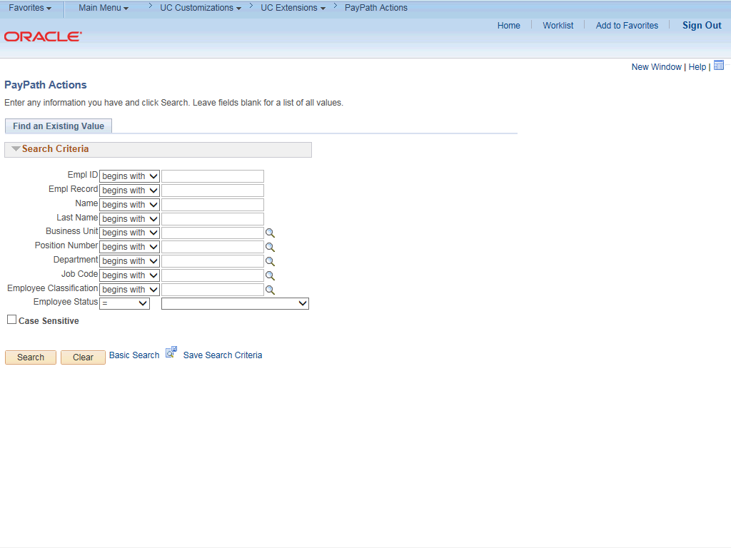

Step | Action
1. | After you navigate to the PayPath Actions component, the system displays the Find an Existing Value tab, which you use to search for the appropriate employee record.  Enter search criteria in one or more of the search fields on this page.
2. | Click in the Empl ID field.
3. | Enter the desired information into the Empl ID field.
4. | Click the Search button.

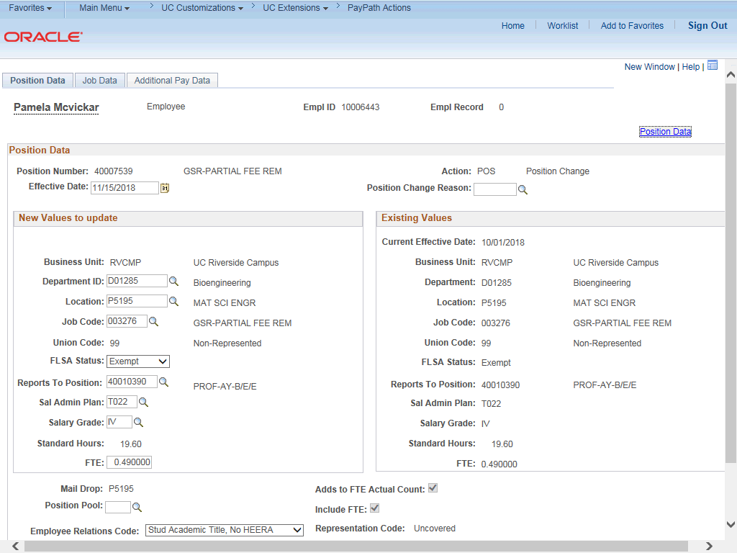

Step | Action
5. | The PayPath Actions page displays the Position Data tab. Navigate to the appropriate tab for the update you must enter. For this example, an extension for a short work break, navigate to the Job Data tab.
6. | Click the Job Data tab.

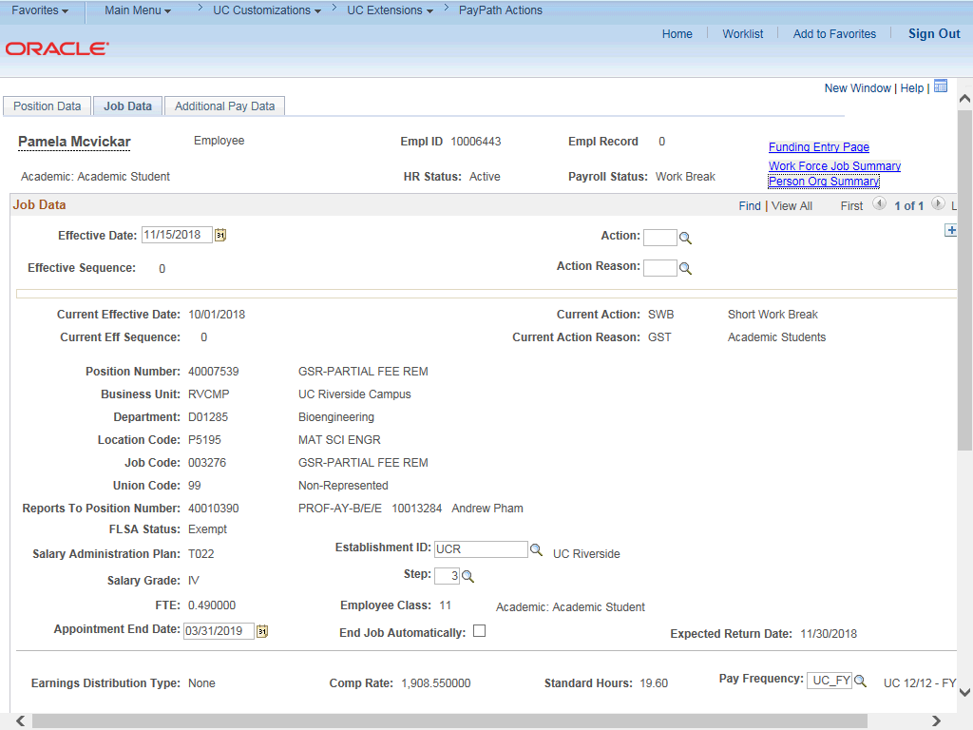

Step | Action
7. | Before entering the update, you must identify the Effective Date, Action and  Action Reason.
8. | The Effective Date field defaults to the system date (today's date). If needed, change the date to reflect the date the extension should take effect.  For this example, accept the default.
9. | Click the Look up Action button.

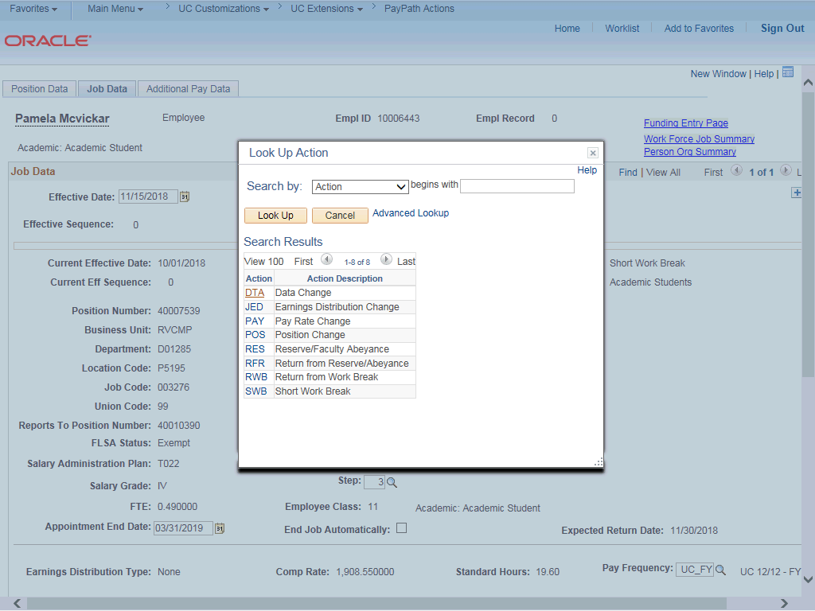

Step | Action
10. | Select the appropriate action.  Click the DTA (Data Change) link.
11. | Click the Look up Action Reason button.

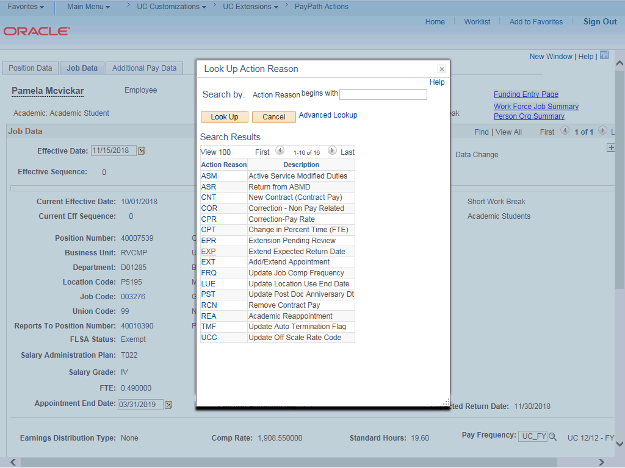

Step | Action
12. | Select the appropriate action reason.  Click the EXP (Extend Expected Return Date) link.
13. | Review the Appointment End Date field. If present, this date should not be prior to the Expected Return Date for the short work break.  If the Appointment End Date is before the Expected Return Date, then you must first extend the Appointment End Date (Effective Seq 0) then add a row to extend the short work break (Effective Seq 1).
14. | In this example, the Appointment End Date is after the new Expected Return Date. No change is needed for the Appointment End Date field.  Click in the Expected Return Date field.
15. | Enter the desired information into the Expected Return Date field.

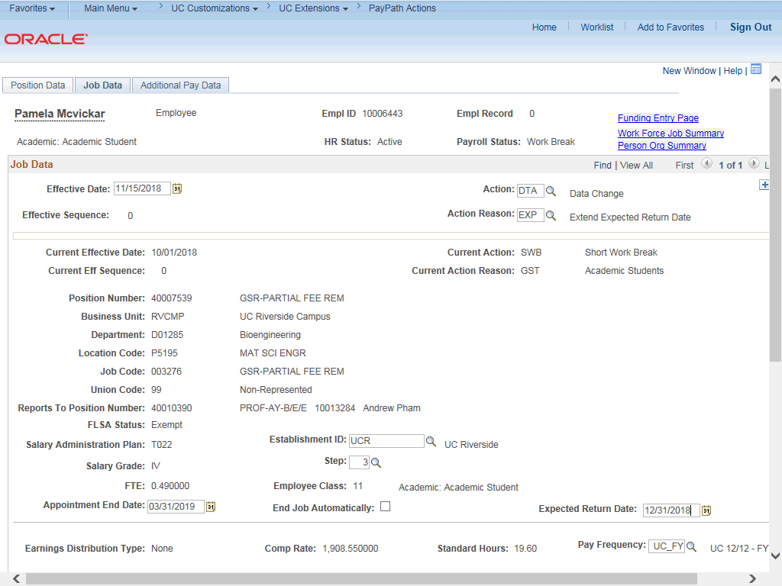

Step | Action
16. | Click the Additional Pay Data tab.
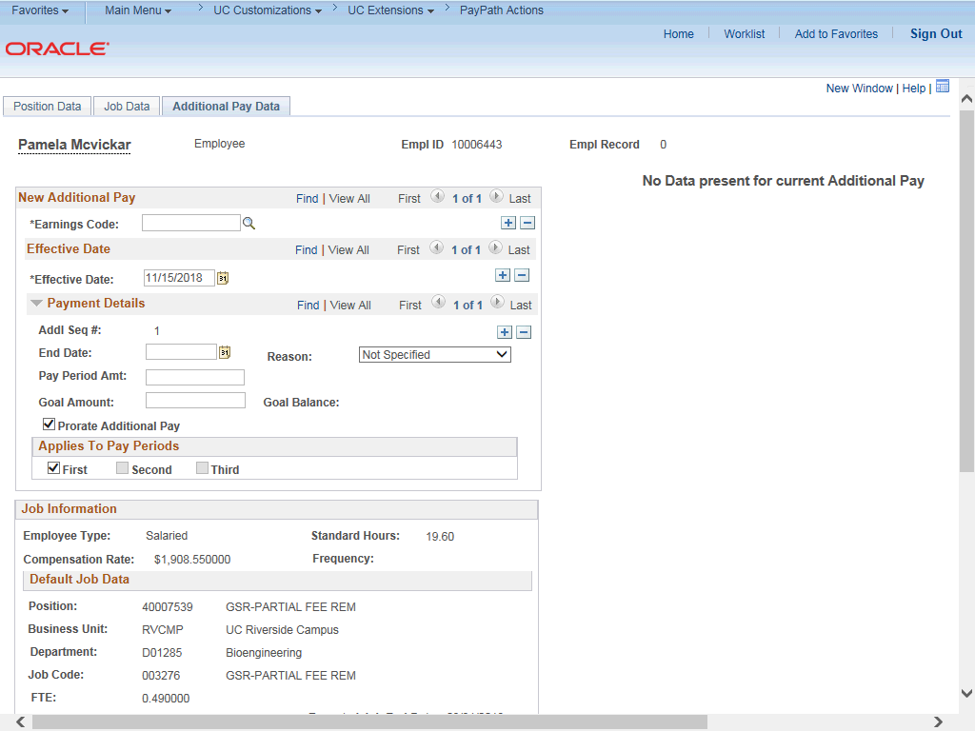

Step | Action
17. | Click the scroll bar.
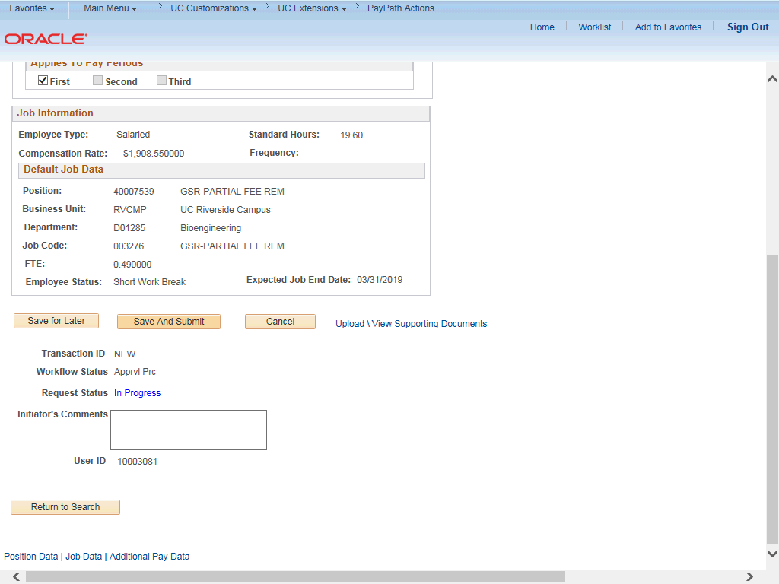

Step | Action
18. | Use the Supporting Documents link to attach supporting documentation, if applicable.
19. | Use the Initiator's Comments field, to further explain the transaction for the Approver, if applicable.
20. | Click the Save And Submit button.

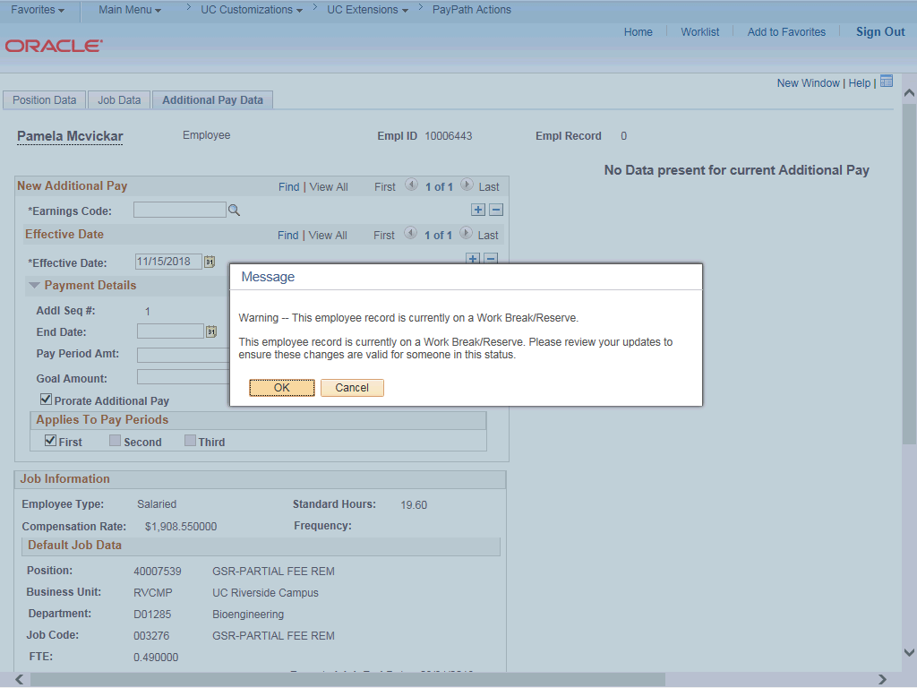

Step | Action
21. | A warning message appears. Click the OK button.

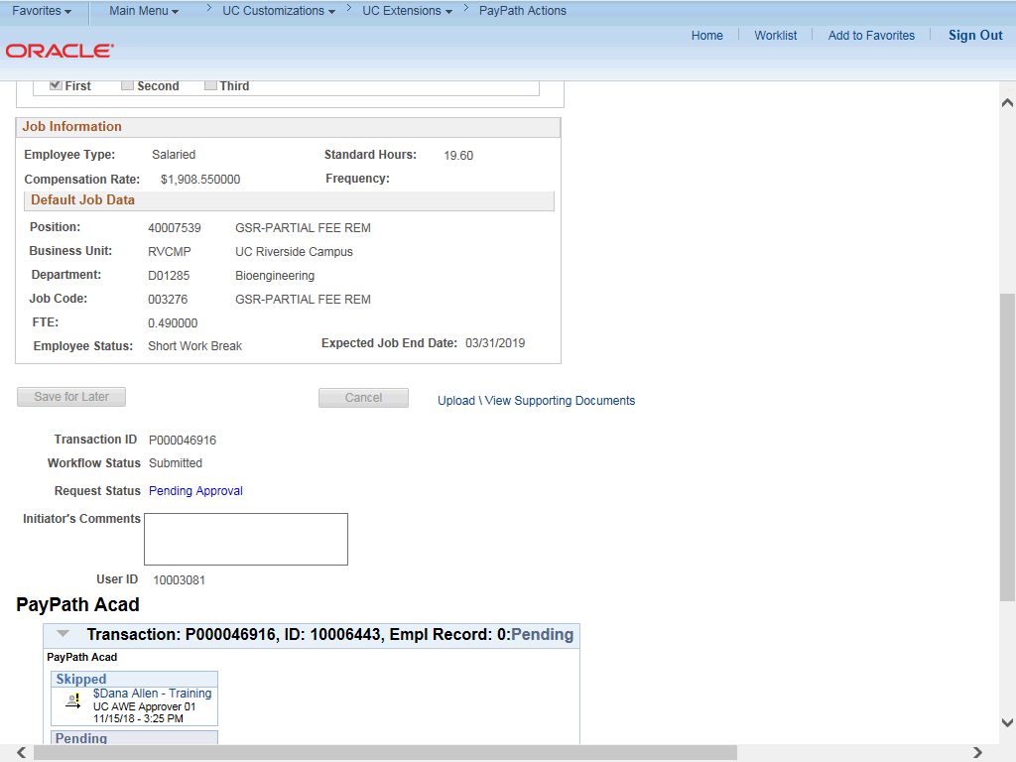

Step | Action
22. | The transaction is submitted for approval.
23. | You have initiated an extension for a short work break.  End of Procedure.

