Use this task to initiate a position data change PayPath transaction. This example demonstrates a department transfer within the same position. The steps in this procedure can be used for academic or staff employees.

Navigation: PeopleSoft Menu > UC Customizations > UC Extensions > PayPath Actions Note: This page also may be available in Workcenter depending on your security access.
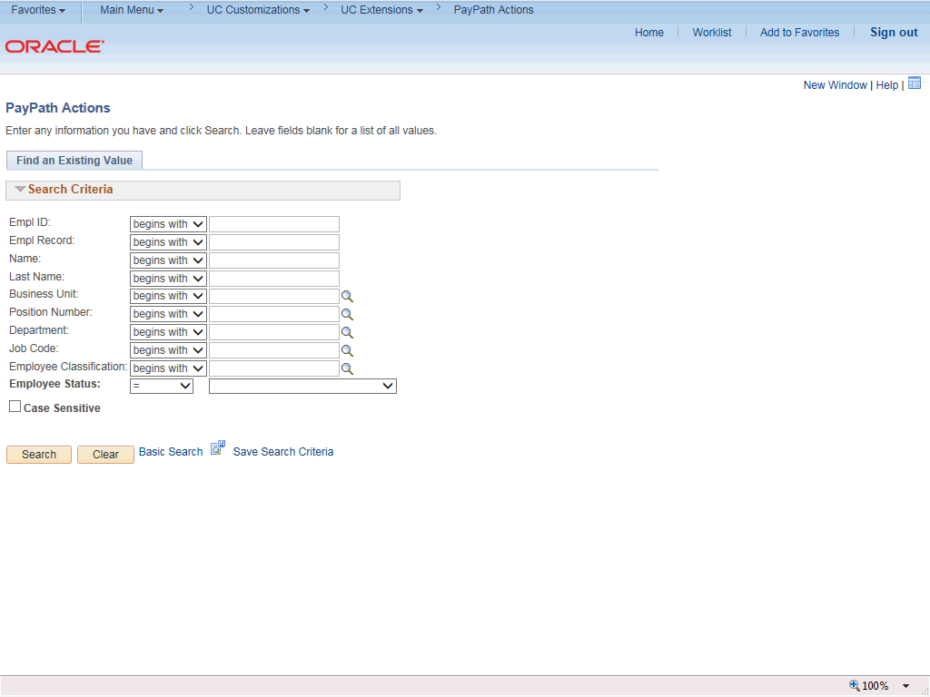

Step | Action
1. | After you navigate to the PayPath Actions component, the system displays the Find an Existing Value tab, which you use to search for the appropriate employee record.  Enter search criteria in one or more of the search fields on this page.
2. | Click in the Empl ID field.
3. | Enter the desired information into the Empl ID field.
4. | Click the Search button.

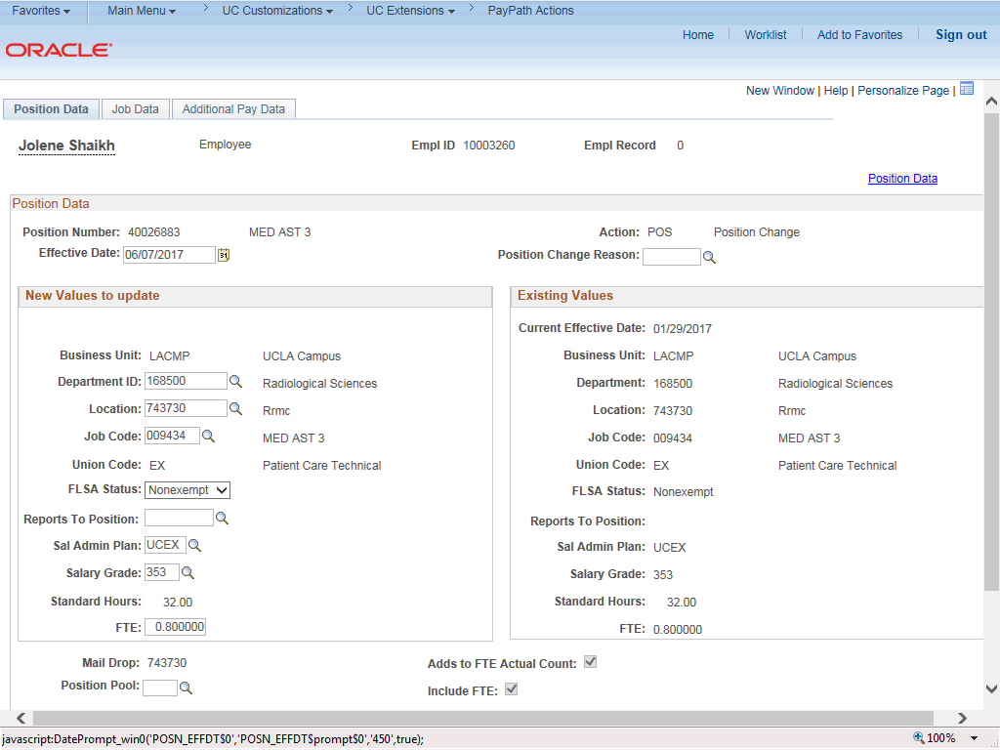

Step | Action
5. | The PayPath Actions page displays the Position Data tab. Navigate to the appropriate tab for the update you must enter. For this example, a department transfer, stay on the Position Data tab.
6. | Before you enter the update, you must identify the Effective Date and  Position Change Reason.
7. | The Effective Date field defaults to the system date (today's date). If needed, change the date to reflect the date the update should take effect.  Click in the Effective Date field.
8. | Enter the desired information into the Effective Date field.
9. | Click the Look up Position Change Reason button.

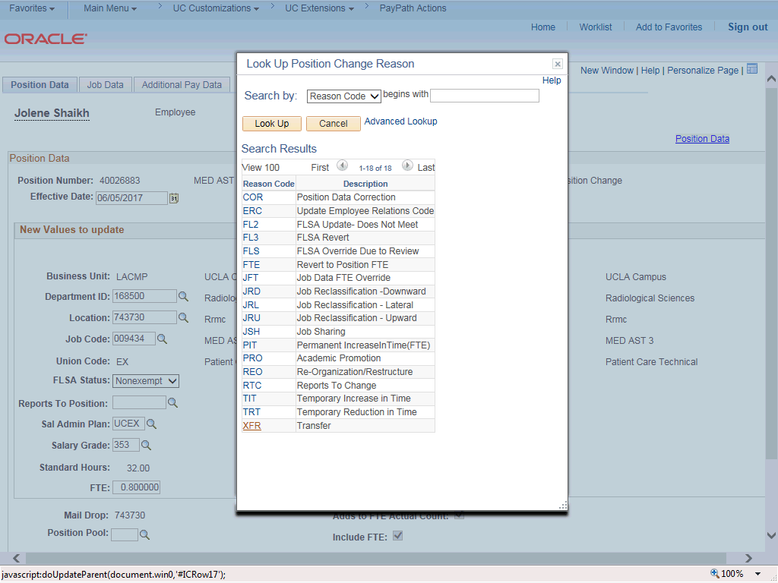

Step | Action
10. | For this example, select the Transfer code. Click the XFR list item.
11. | Enter the new Department ID for the transfer. Click in the Department ID field.
12. | Enter the desired information into the Department ID field.
13. | The Location field automatically updates based on the selected Department ID.

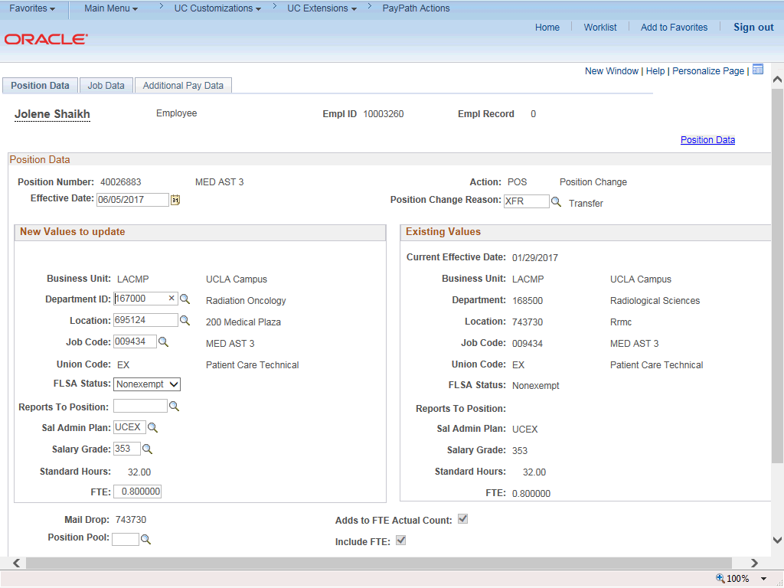

Step | Action
14. | Click the Job Data tab.
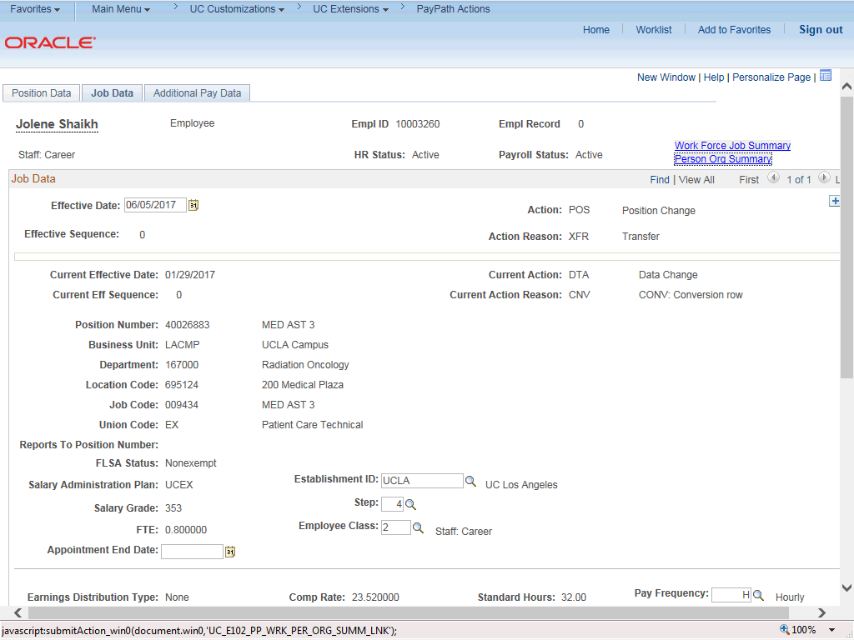

Step | Action
15. | Notice a new Job Data row has been added that includes the update from the Position Data tab. The new row includes the Effective Date, Action and Action Reason from the position data update, as well as the new Department and Location Code.
16. | Click the Additional Pay Data tab.
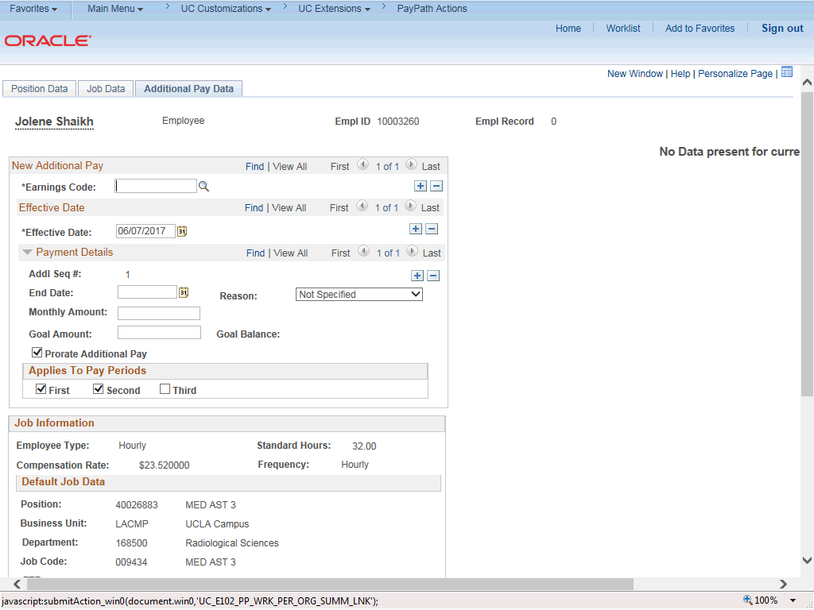

Step | Action
17. | Click the scroll bar.

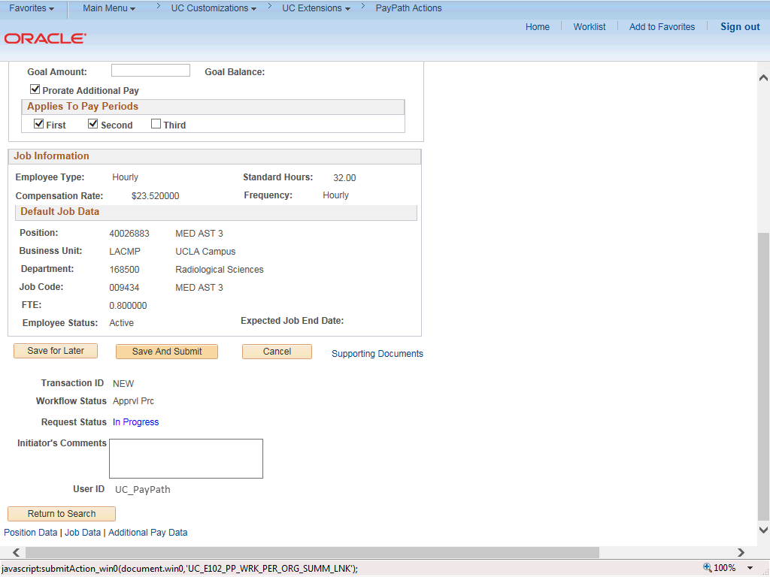

Step | Action
18. | Use the Supporting Documents link to attach supporting documentation, if applicable.
19. | Use the Initiator's Comments field, to further explain the transaction for the Approver, if applicable.
20. | Click the Save And Submit button.

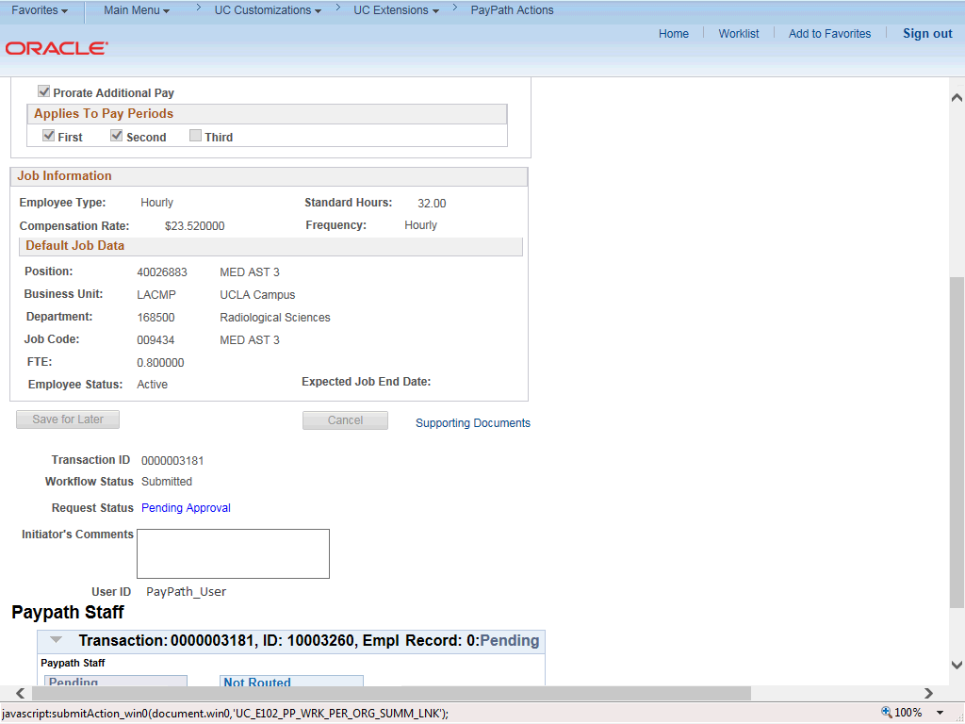

Step | Action
21. | The transaction is submitted for approval.
22. | You have initiated a position data change PayPath transaction.  End of Procedure.

