Use this task to initiate a Job Data FTE override PayPath transaction. This action makes the Position FTE and Job Data FTE independent so that the Position FTE does not update Job Data FTE. This example demonstrates a temporary change in Job Data FTE and applies to either staff or academic employees.

Navigation: PeopleSoft Menu > UC Customizations > UC Extensions > PayPath Actions Note: This page also may be available in Workcenter depending on your security access.
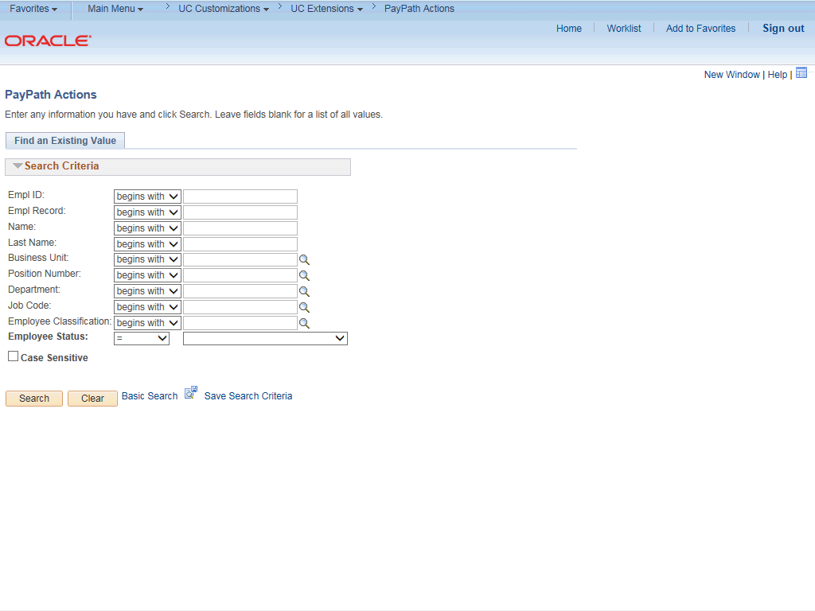

Step | Action
1. | After you navigate to the PayPath Actions component, the system displays the Find an Existing Value tab, which you use to search for the appropriate employee record.  Enter search criteria in one or more of the search fields on this page.
2. | Click in the Empl ID field.
3. | Enter the desired information into the Empl ID field.
4. | Click the Search button.

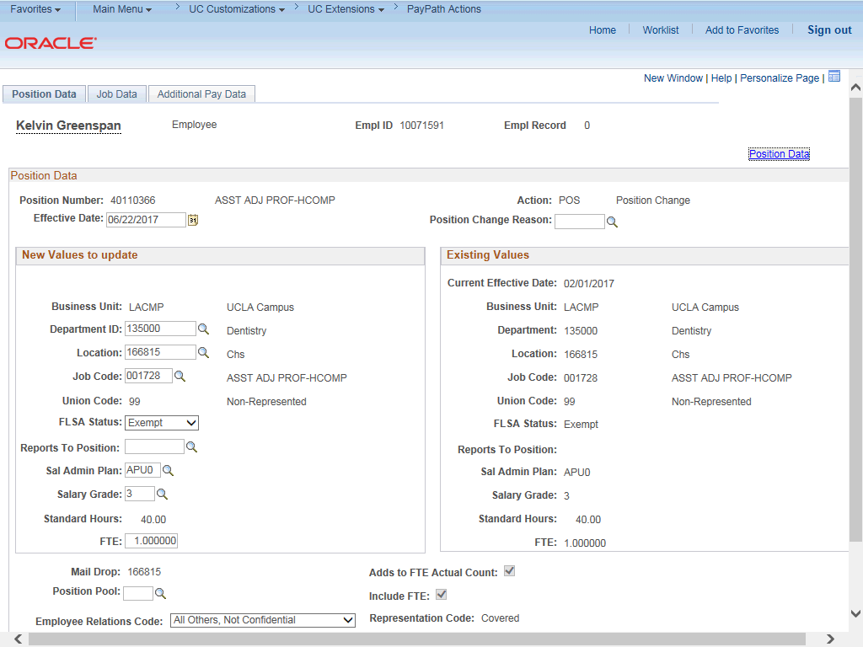

Step | Action
5. | The PayPath Actions page displays the Position Data tab. Navigate to the appropriate tab for the update you must enter. For this example, a position change, stay on the Position Data tab.
6. | Notice, the current FTE value for the Position is 1.0. By default, UCPath automatically copies the FTE value entered on the Position to the Job Data FTE. In this example, the employee is reducing their FTE temporarily so you can disconnect the automatic update from Position to Job Data so that the Job Data FTE can be temporarily changed without changing the Position FTE.
7. | When the Include FTE check box is selected the FTE value is automatically copied from Position to Job Data. This check box is selected by default and is view-only. When you enter the proper Position Change Reason code on this page, the check box becomes editable. When you clear the check box, the FTE values on Position and Job Data are independent of each other.
8. | Before you enter the update, you must identify the Effective Date and  Position Change Reason.
9. | The Effective Date field defaults to the system date (today's date). If needed, change the date to reflect the date the update should take effect.  For this example, accept the default.
10. | Click in the Position Change Reason field.

Step | Action
11. | Enter the desired information into the Position Change Reason field.
12. | After you enter the Job Data FTE Override value in the Position Change Reason  field, the Include FTE check box becomes editable.
13. | Click the Include FTE option to clear the check box.
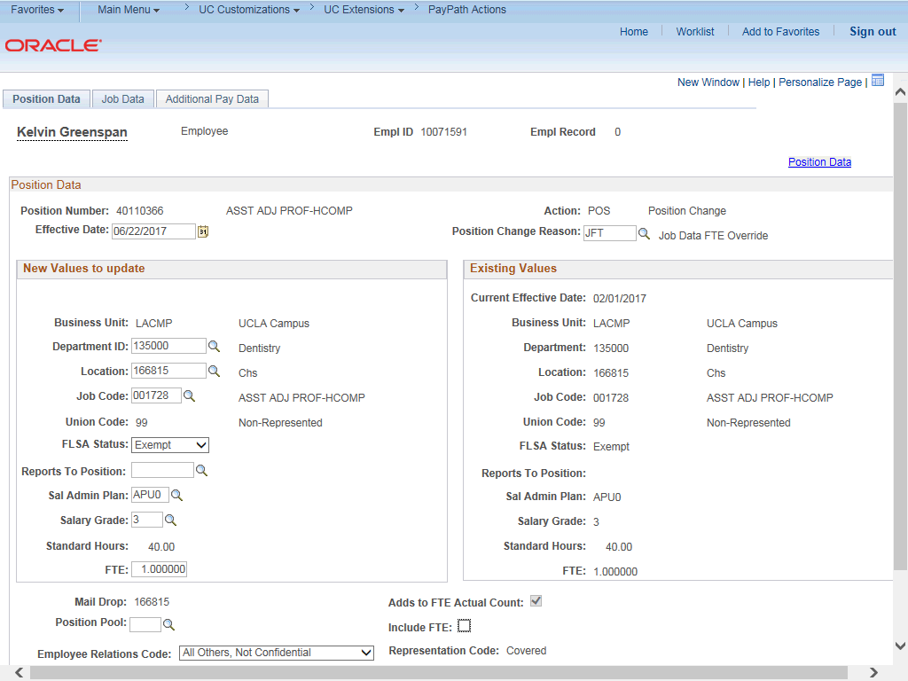

Step | Action
14. | Click the Job Data tab.

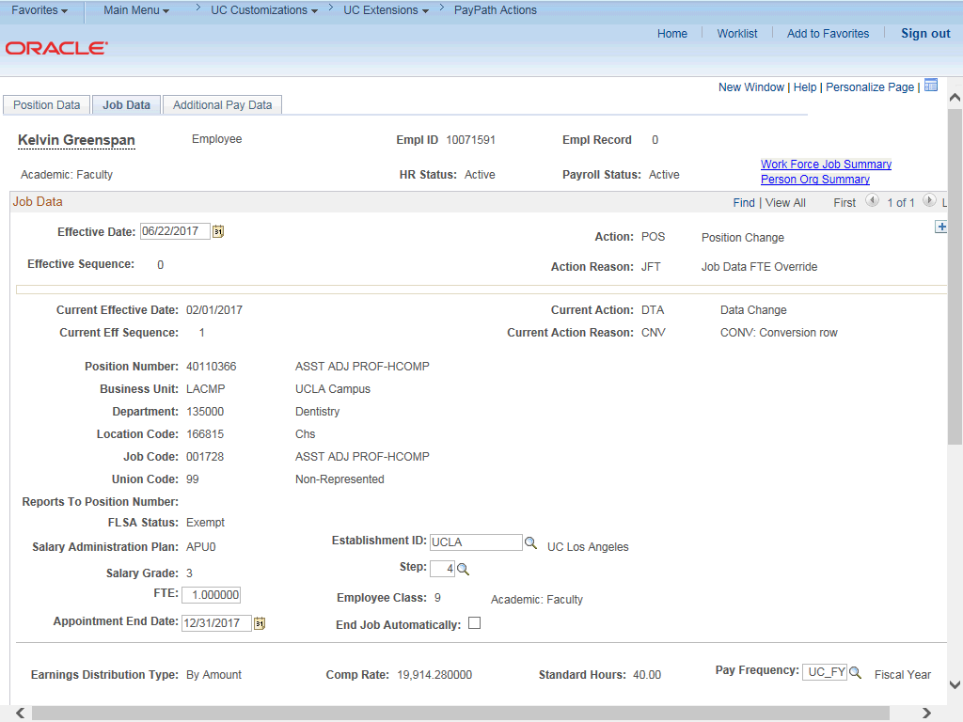

Step | Action
15. | UCPath automatically inserts the position Action and Action Reason on the Job Data page.
16. | Click the scroll bar.
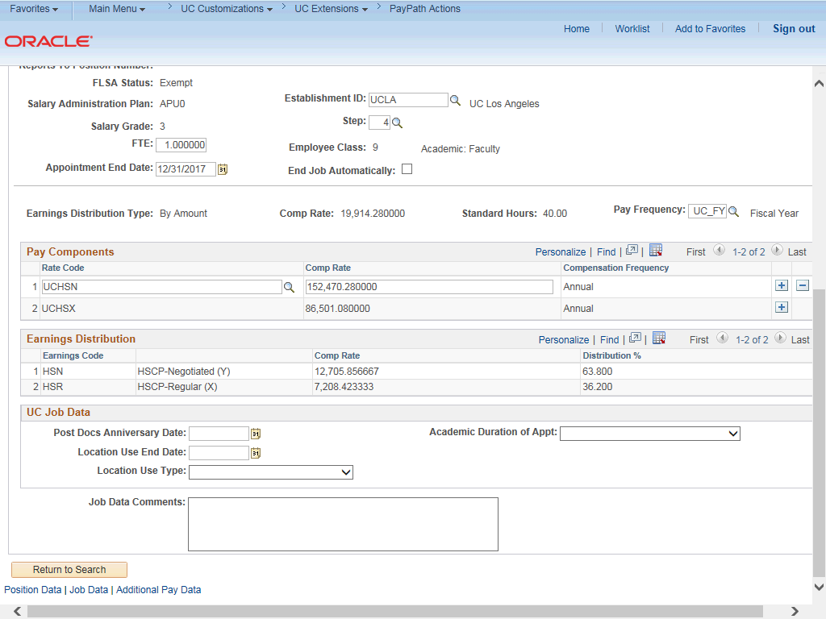

Step | Action
17. | Notice the Comp Rate, Standard Hours, and Earnings Distribution fields currently display information based on a 1.0 FTE.
18. | Notice the Job Data FTE field is now editable because it is no longer controlled by the Position FTE.  Click in the FTE field.
19. | Enter the desired information into the FTE field.
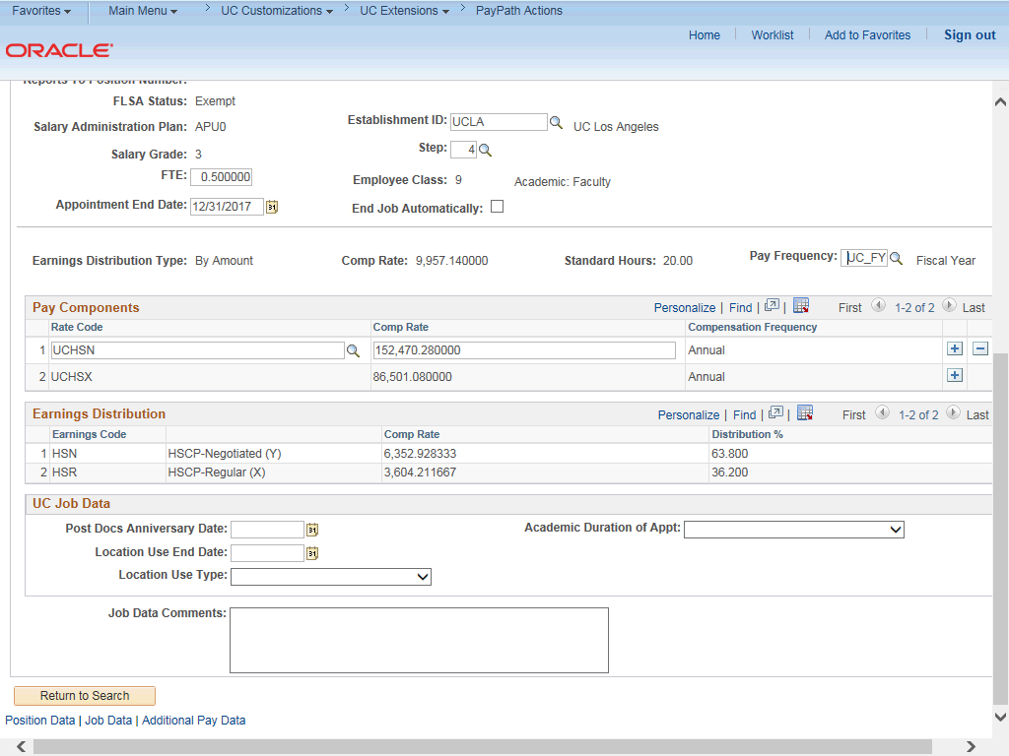

Step | Action
20. | Now that the Job Data FTE has been changed, the Comp Rate, Standard Hours  and Earnings Distribution fields display information based on the updated FTE.
21. | For Job Data updates, enter a comment explaining the update. Click in the Job Data Comments field.
22. | Enter the desired information into the Job Data Comments field.

Step | Action
23. | Click the scroll bar.
24. | Click the Additional Pay Data tab.
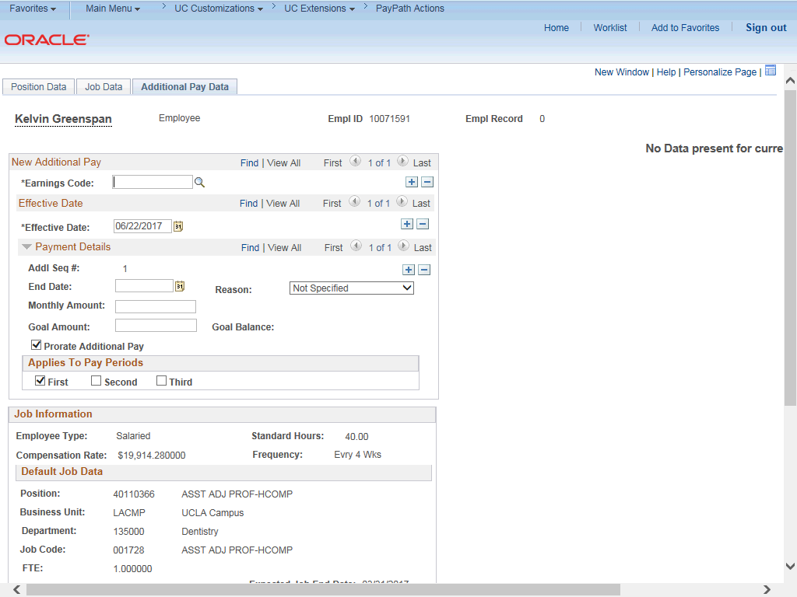

Step | Action
25. | Click the scroll bar.

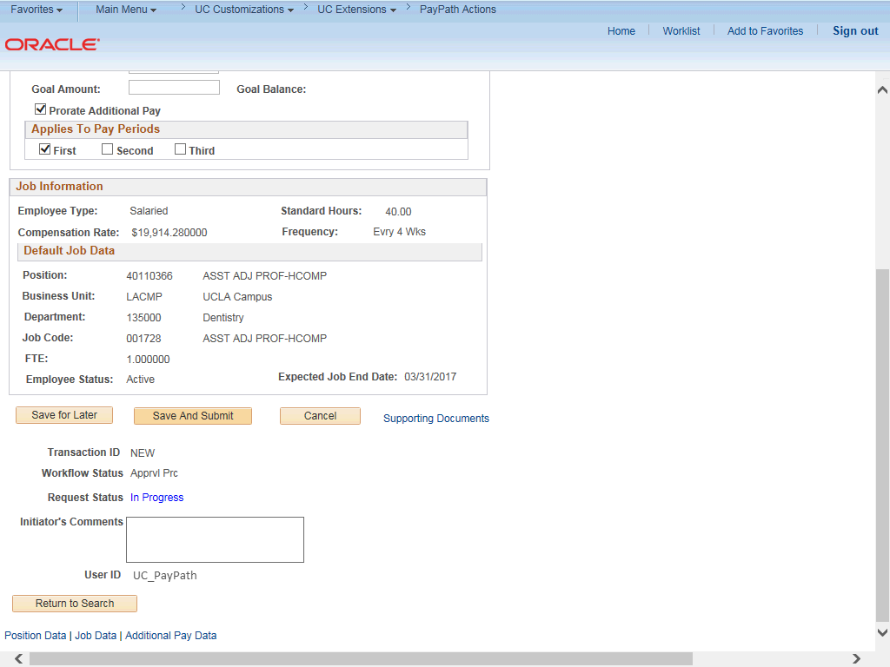

Step | Action
26. | Use the Supporting Documents link to attach supporting documentation, if applicable.
27. | Use the Initiator's Comments field, to further explain the transaction for the Approver, if applicable.
28. | Click the Save And Submit button.

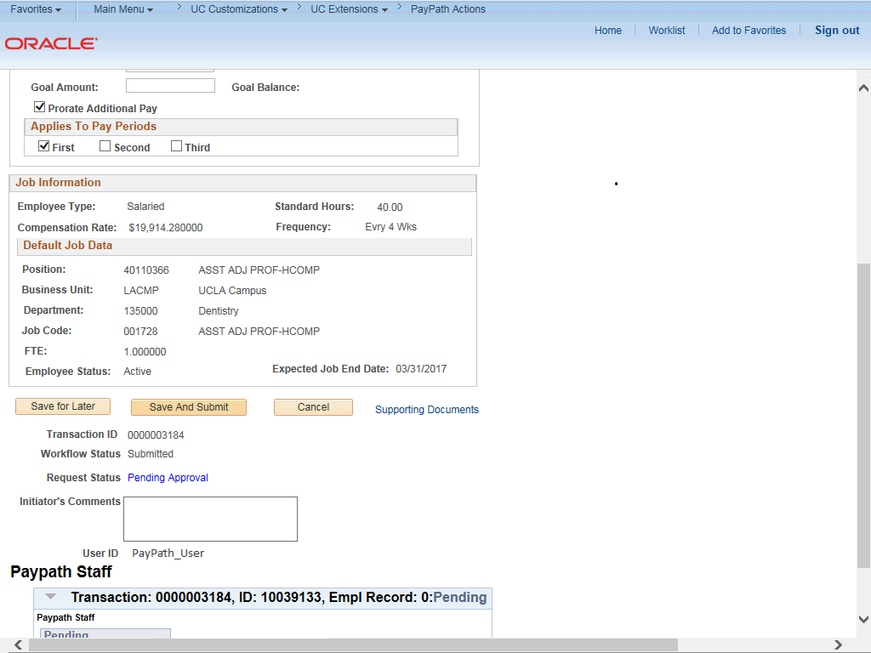

Step | Action
29. | The transaction is submitted for approval.
30. | You have initiated a Job Data FTE override PayPath transaction.  End of Procedure.

