Use this task to initiate a position data change, job data change and an additional pay change PayPath transaction for staff employees.

Navigation: PeopleSoft Menu > UC Customizations > UC Extensions > PayPath Actions Note: This page also may be available in Workcenter depending on your security access.
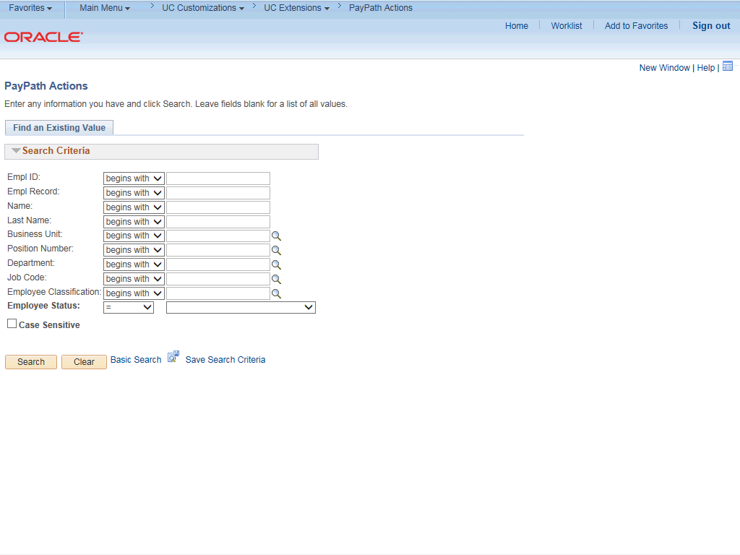

Step | Action
1. | After you navigate to the PayPath Actions component, the system displays the Find an Existing Value tab, which you use to search for the appropriate employee record.  Enter search criteria in one or more of the search fields on this page.
2. | Click in the Empl ID field.
3. | Enter the desired information into the Empl ID field.
4. | Click the Search button.

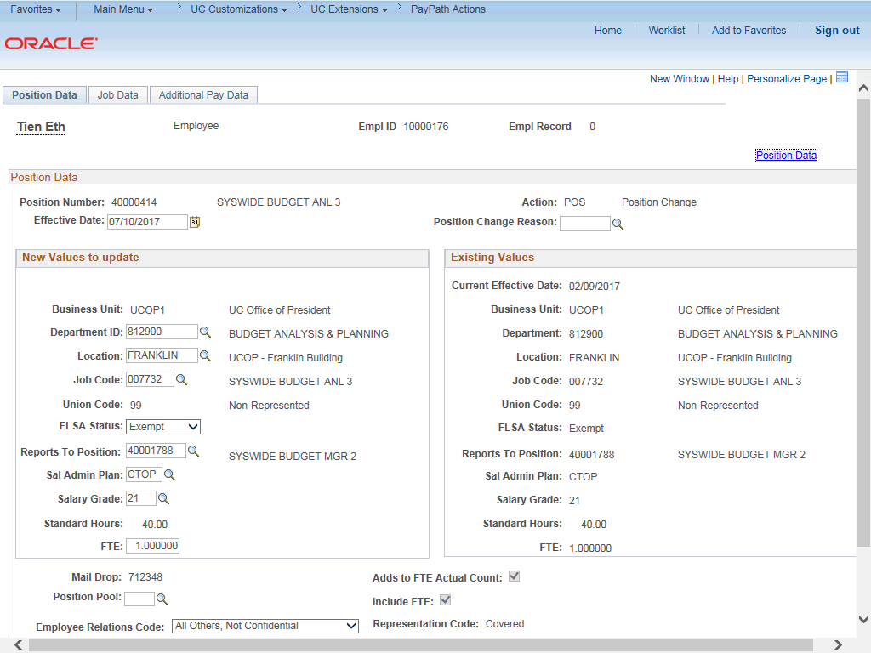

Step | Action
5. | The PayPath Actions page displays the Position Data tab. Navigate to the appropriate tab for the update you must enter. For this example, a position data and job data change with additional pay, stay on the Position Data tab.
6. | Before you enter the update, you must identify the Effective Date and  Position Change Reason.
7. | The Effective Date field defaults to the system date (today's date). If needed, change the date to reflect the date the update should take effect.  Click in the Effective Date field.
8. | Enter the desired information into the Effective Date field.
9. | Click in the Position Change Reason field.
10. | Enter the desired information into the Position Change Reason field.
11. | Enter the Job Code for the promotion. Click in the Job Code field.

Step | Action
12. | Enter the desired information into the Job Code field. For this example, enter  000282.
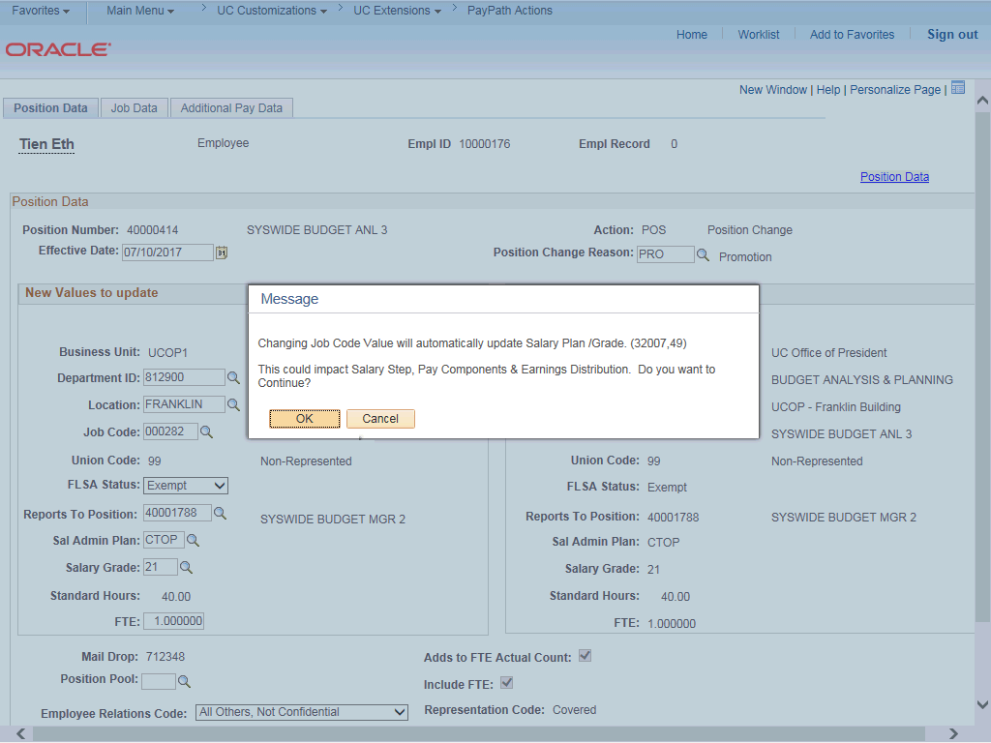

Step | Action
13. | UCPath displays a message indicating that the salary plan and grade will be updated. You may need to change step, pay components or earnings distribution information.  Click the OK button.
14. | The Salary Admin Plan and Salary Grade fields are updated based on the selected job code. Because there is only one Salary Admin Plan and one Salary Grade for this job code, UCPath automatically populates the fields. For other examples, you may need to select the correct values.

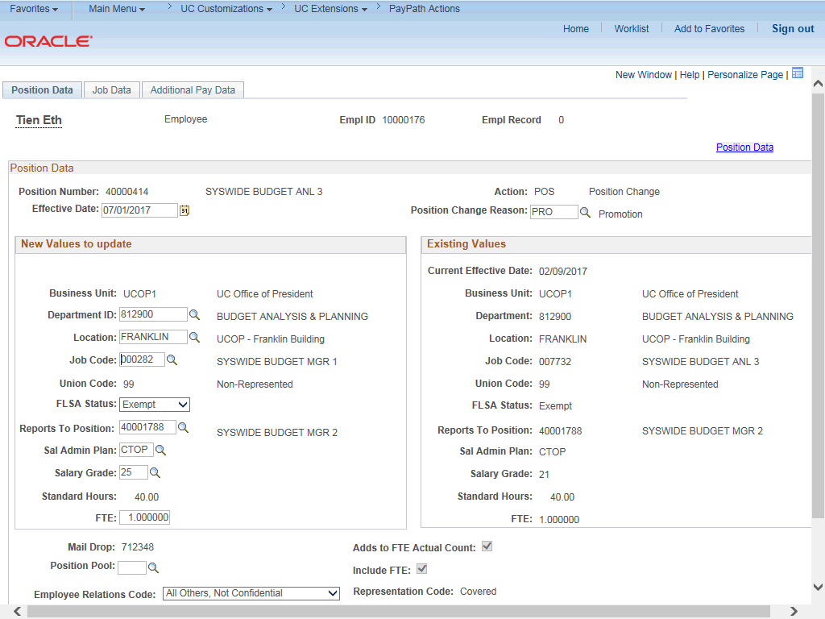

Step | Action
15. | Click the Job Data tab.
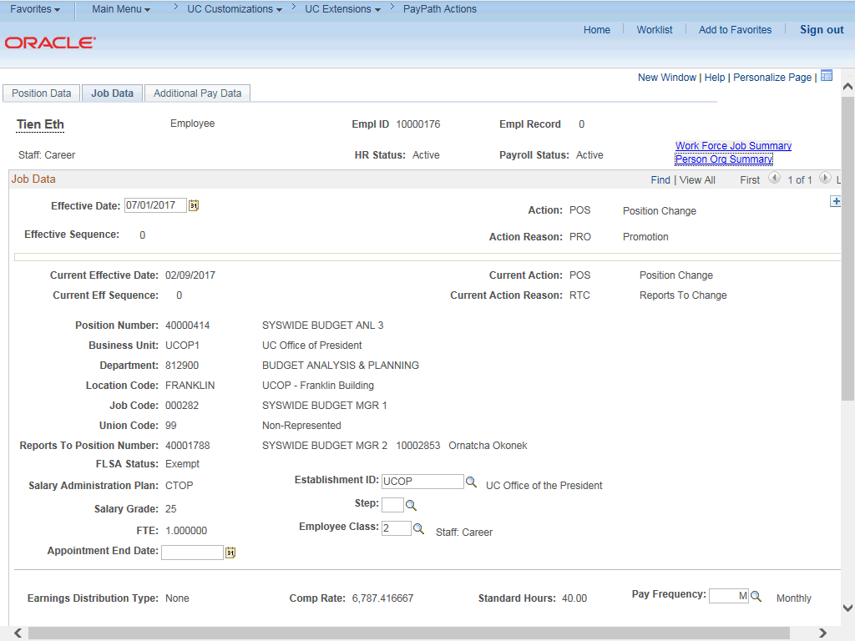

Step | Action
16. | Notice a new Job Data row has been added that includes the update from the Position Data tab. The new row includes the Effective Date, Action and Action Reason from the position update.
17. | The updated Job Code, Salary Administration Plan and Salary Grade also appear.
18. | Add a row to enter a pay increase. Click the Add a new row button.
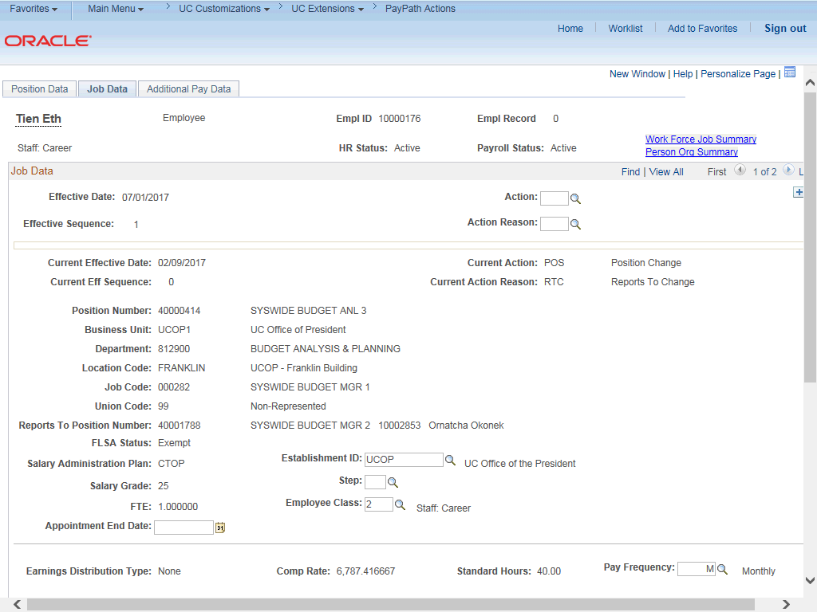

Step | Action
19. | A new row displays with the same Effective Date, but a new Effective Sequence  of 1. (The Effective Sequence of the previous row is 0).
20. | Click in the Action field.
21. | Enter the desired information into the Action field.
22. | Click in the Action Reason field.

Step | Action
23. | Enter the desired information into the Action Reason field.
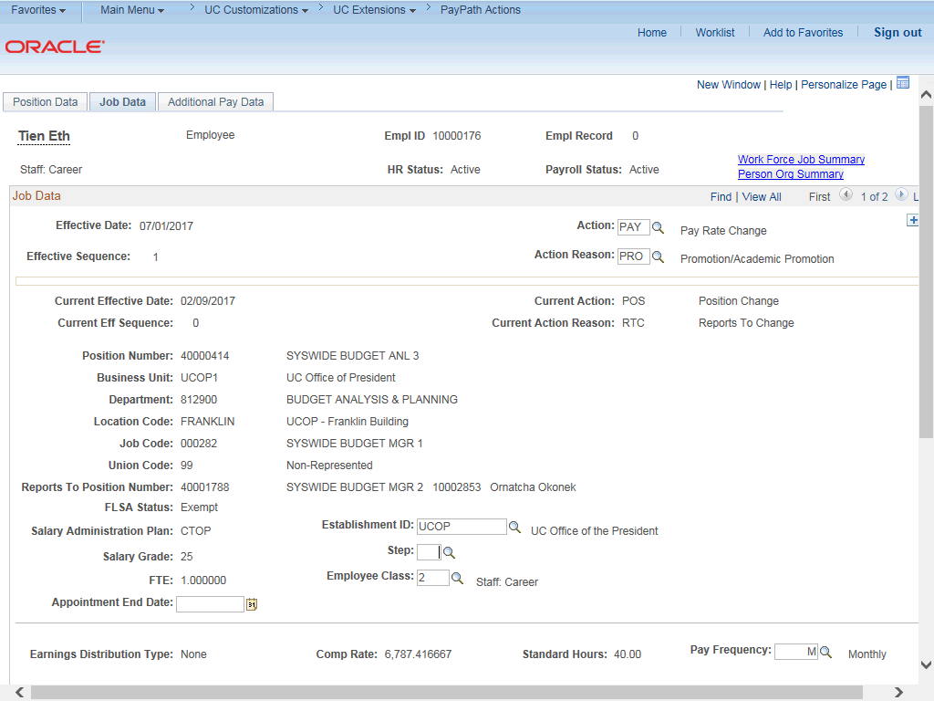

Step | Action
24. | Click the scroll bar.

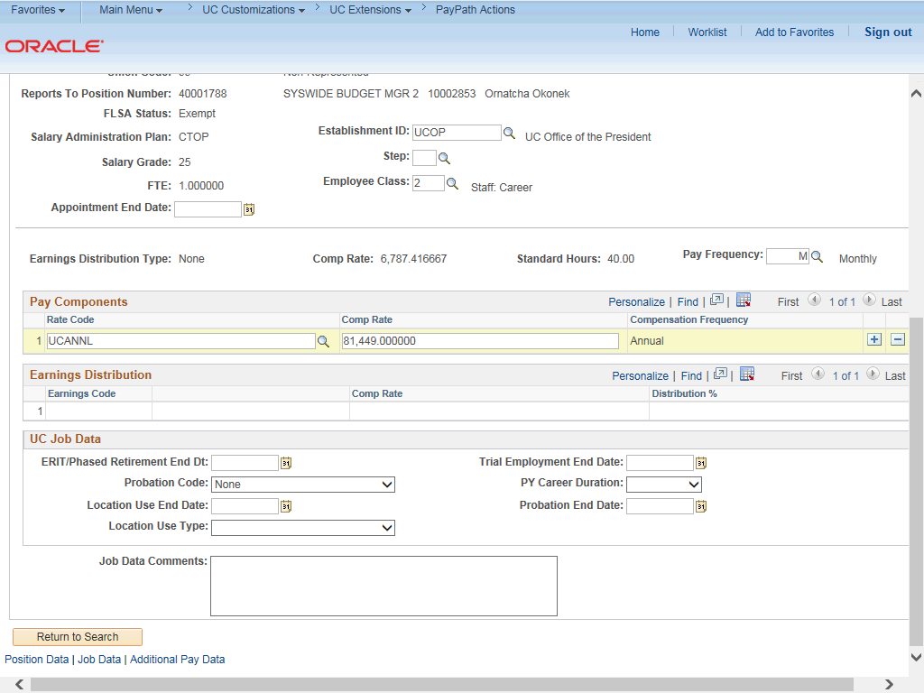

Step | Action
25. | Click in the Comp Rate field.
26. | Enter the desired information into the Comp Rate field.
27. | Click in the Job Data Comments field.
28. | Enter the desired information into the Job Data Comments field.

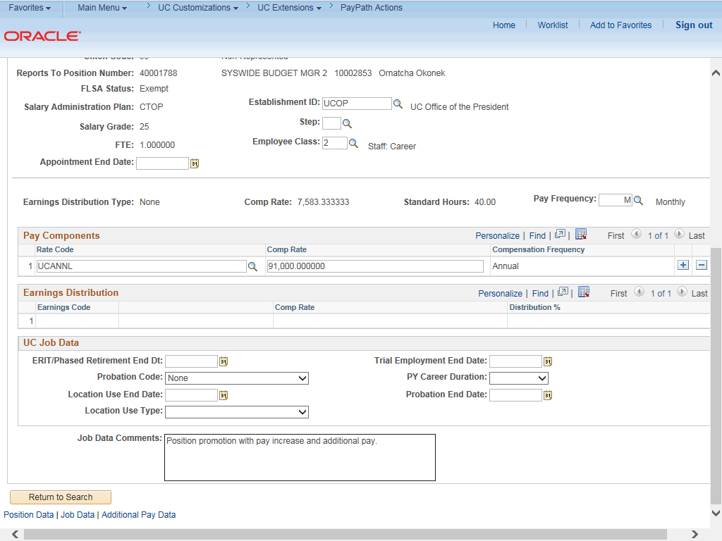

Step | Action
29. | Click the scroll bar.
30. | Click the Additional Pay Data tab.

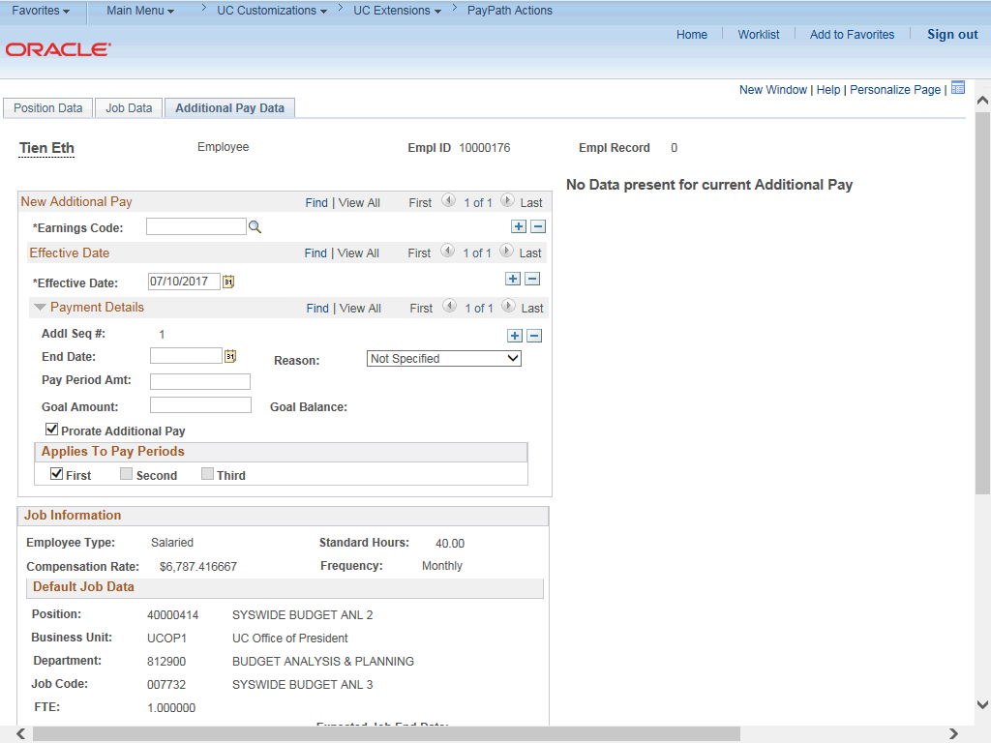

Step | Action
31. | Use the Additional Pay Data page to enter specific information about the payment.  New Additional Pay is entered on the left. If the employee has existing additional pay, it appears on the right. This employee has No Data present for current Additional Pay.
32. | Enter the Earnings Code, Effective Date and Pay Period Amount for the additional pay.  For one-time and recurring payments, enter a Goal Amount or End Date. The additional payment stops when the goal amount or end date is reached.
33. | Click the Look up Earnings Code button.

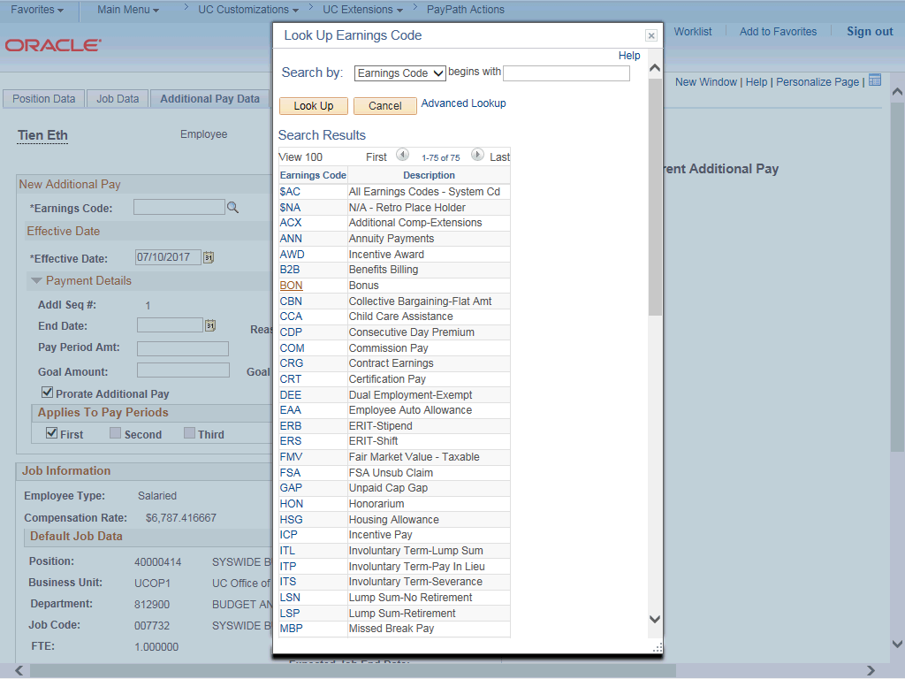

Step | Action
34. | The Earnings Codes that appear are based on the earnings program tied to the employee's paygroup. Select the appropriate Earnings Code.  For this example, click the CCA (Child Care Assistance) list item.
35. | The Effective Date field defaults to the system date (today's date). If needed, change the date to reflect the first day of the pay period that the additional pay should begin.  Click in the Effective Date field.
36. | Enter the desired information into the Effective Date field.
37. | Enter the per pay period amount of the additional pay. Click in the Pay Period Amt field.
38. | Enter the desired information into the Pay Period Amt field.

Step | Action
39. | The system continues to pay the amount indicated in the Pay Period Amt field until the End Date or Goal Amount is reached.  Click in the End Date field.
40. | Enter the desired information into the End Date field.
41. | Accept the default for the Applies to Pay Periods check boxes.  The First check box is selected for monthly employees. The First and Second check boxes are selected for biweekly employees. For biweekly employees, you may select which pay period(s) the additional pay should be paid.
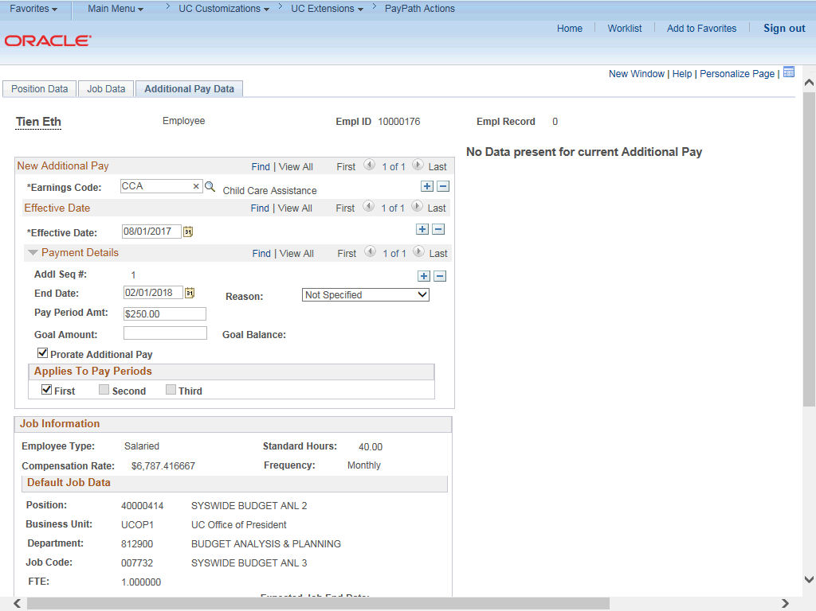

Step | Action
42. | Click the scroll bar.

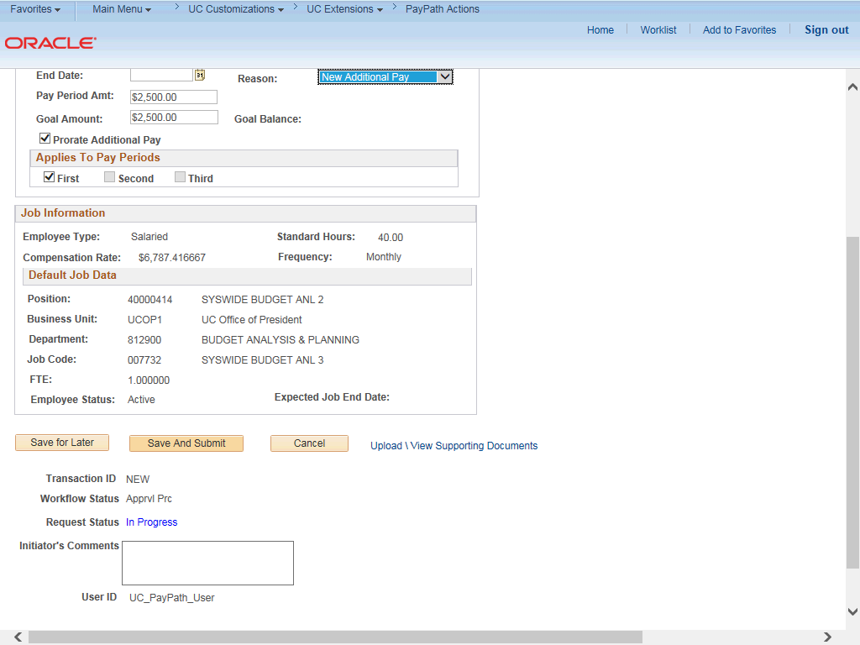

Step | Action
43. | Use the Upload \ View Supporting Documents link to attach supporting documentation, if applicable.
44. | Use the Initiator's Comments field, to further explain the transaction for the Approver, if applicable.
45. | Click the Save And Submit button.

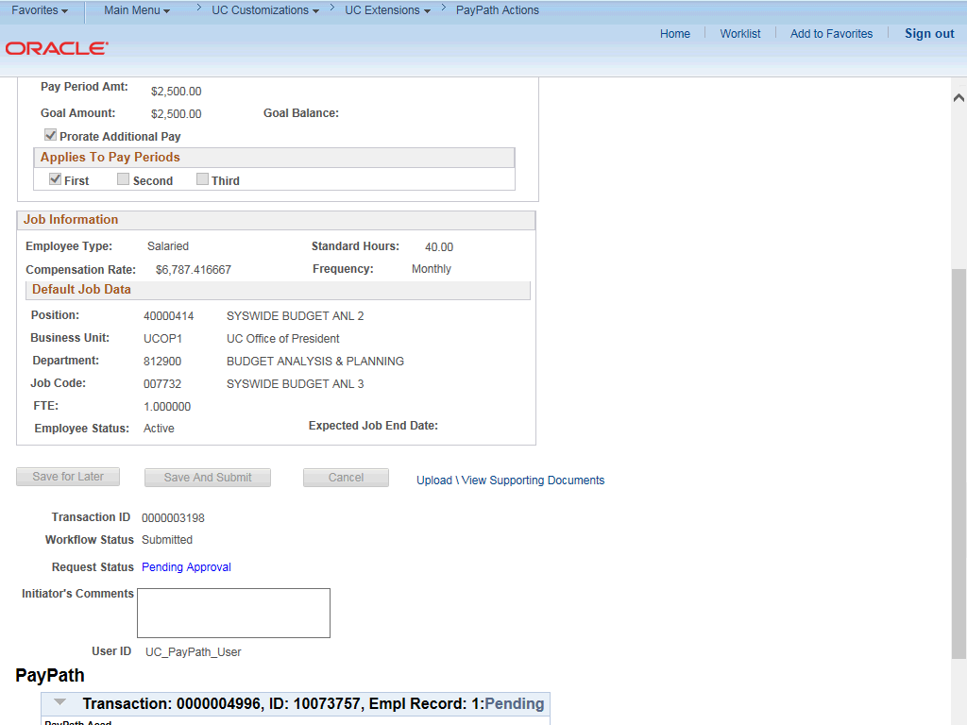

Step | Action
46. | The transaction is submitted for approval.
47. | You have initiated a position data change, job data change and an additional pay change PayPath transaction.  End of Procedure.

