Use this task to initiate a position data change, job data change and an additional pay change PayPath transaction for academic employees.

Navigation: PeopleSoft Menu > UC Customizations > UC Extensions > PayPath Actions Note: This page also may be available in Workcenter depending on your security access.
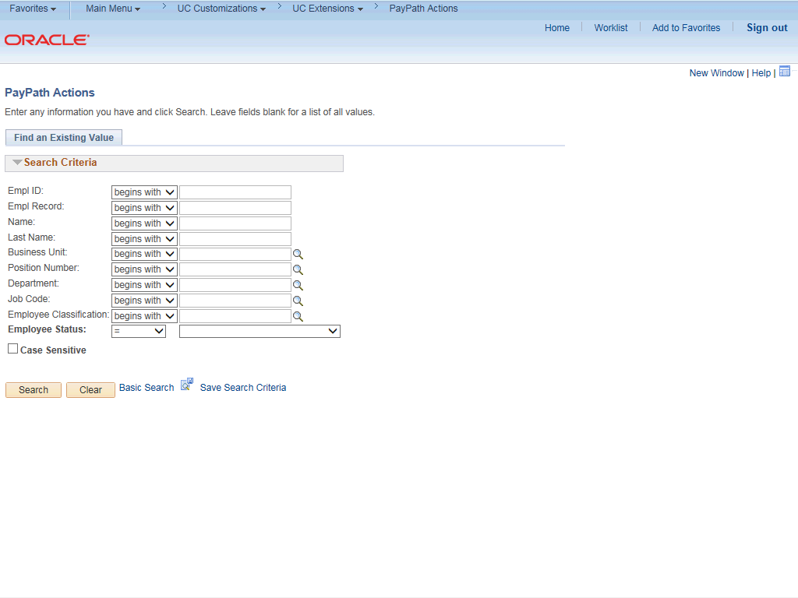

Step | Action
1. | After you navigate to the PayPath Actions component, the system displays the Find an Existing Value tab, which you use to search for the appropriate employee record.  Enter search criteria in one or more of the search fields on this page.
2. | Click in the Empl ID field.
3. | Enter the desired information into the Empl ID field.
4. | Click the Search button.

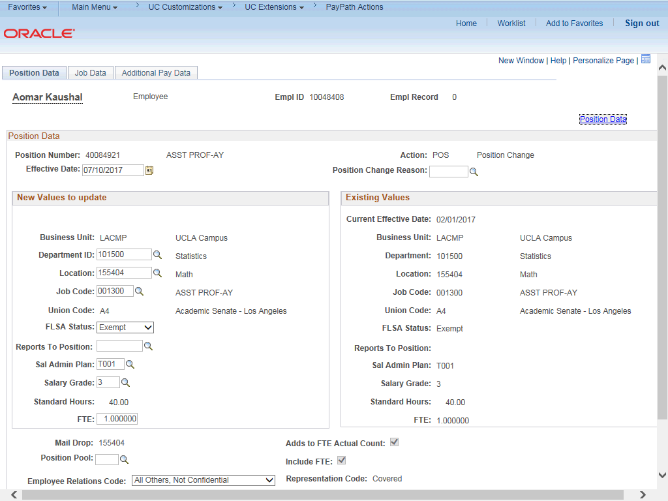

Step | Action
5. | The PayPath Actions page displays the Position Data tab. Navigate to the appropriate tab for the update you must enter. For this example, a position data and job data change with additional pay, stay on the Position Data tab.
6. | Before you enter the update, you must identify the Effective Date and  Position Change Reason.
7. | The Effective Date field defaults to the system date (today's date). If needed, change the date to reflect the date the update should take effect.  Click in the Effective Date field.
8. | Enter the desired information into the Effective Date field.
9. | Click the Look up Position Change Reason button.

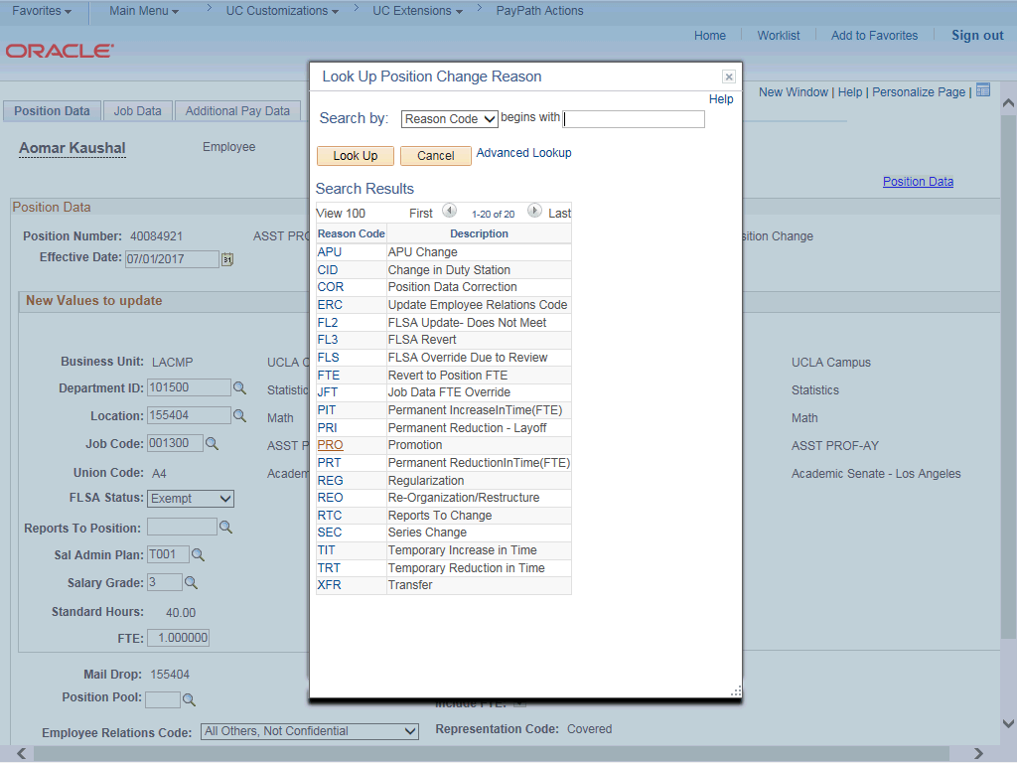

Step | Action
10. | For this example, select the Promotion code. Click the PRO list item.
11. | Enter the Job Code for the promotion. Click in the Job Code field.
12. | Enter the desired information into the Job Code field.

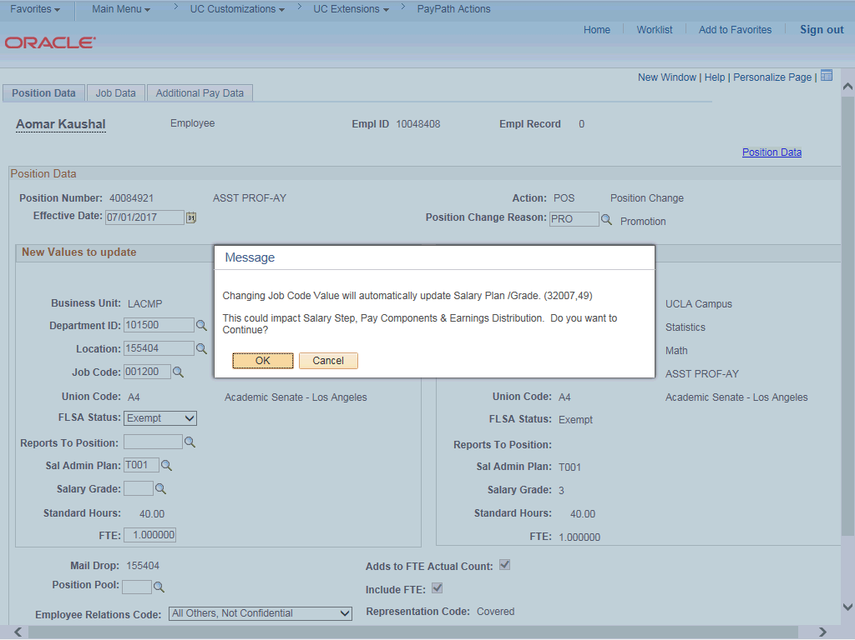

Step | Action
13. | UCPath displays a message indicating that the salary plan and grade will be updated. You may need to change step, pay components or earnings distribution information.  Click the OK button.
14. | UCPath automatically updates the Salary Admin Plan and Salary Grade fields based on the selected job code.  If the Salary Admin Plan/Salary Grade have a salary step component configured and you or UCPath changes the Sal Admin Plan/Salary Grade fields, the Step and compensation information is removed from the Job Data tab.
15. | Because there is only one Salary Admin Plan for this job code, UCPath automatically populates the field. For other examples you may have to enter the plan.
16. | UCPath did not populate the Salary Grade field because there is more than one option available. Select the appropriate value from the list of options.  If there is only one salary grade, UCPath automatically populates the field.
17. | Click the Look up Salary Grade button.

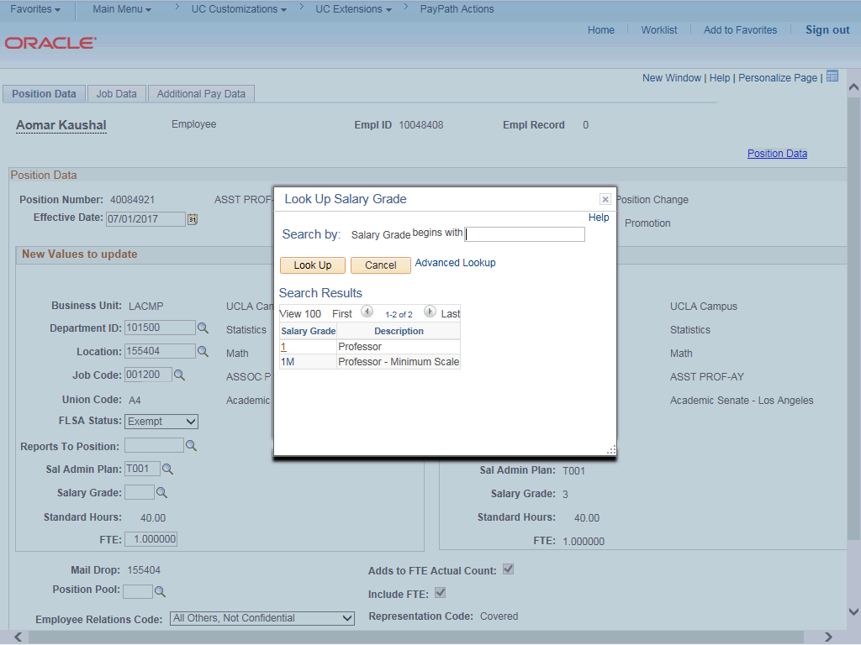

Step | Action
18. | Select the appropriate Salary Grade code. For this example, click the 1 link.

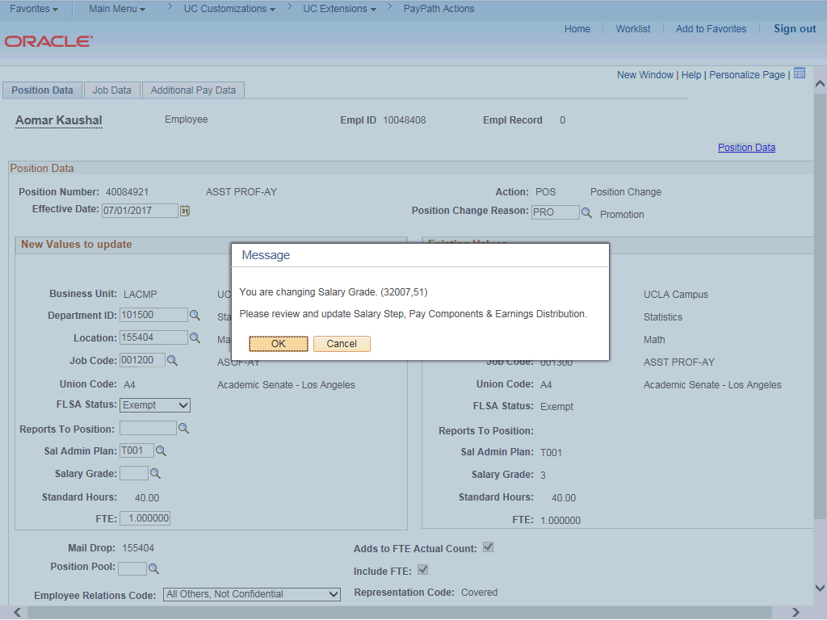

Step | Action
19. | UCPath displays a message that you may need to update the step, pay components or earnings distribution.  Click the OK button.
20. | Click the Job Data tab.

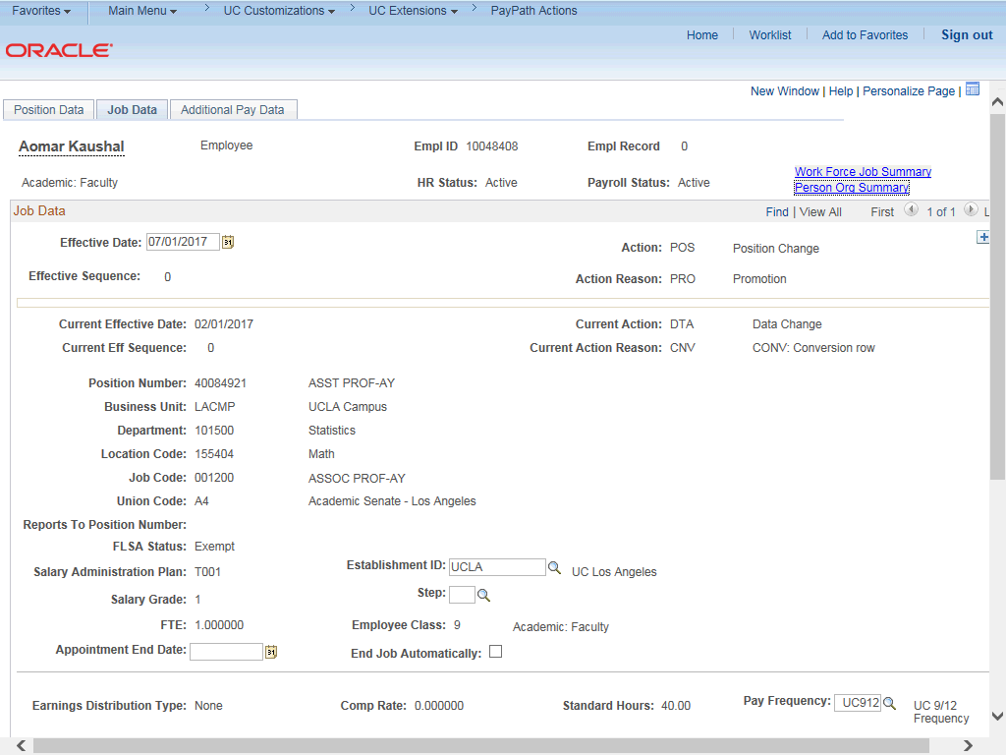

Step | Action
21. | Notice a new Job Data row has been added that includes the update from the Position Data tab. The new row includes the Effective Date, Action and Action Reason from the position update.
22. | The updated Job Code, Salary Administration Plan and Salary Grade also appear.
23. | To complete the promotion, the new Step must be entered for the new job. After you enter the step, UCPath automatically updates the compensation information.  Click the Look up Step button.

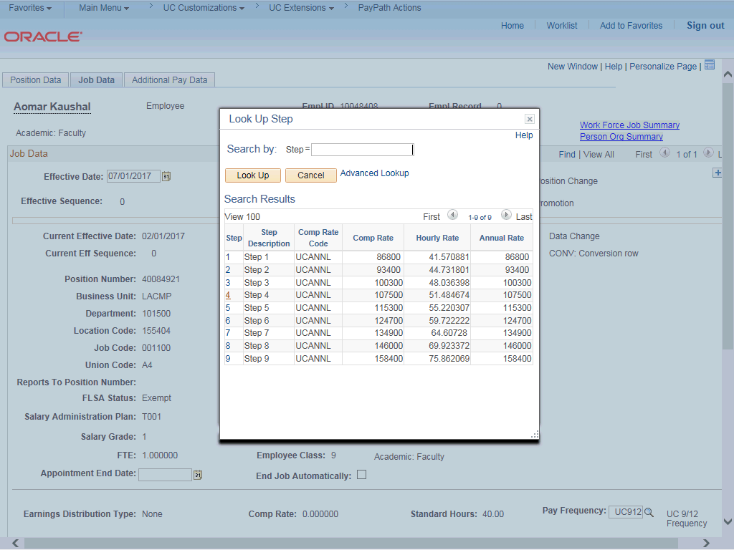

Step | Action
24. | Select the appropriate step.  For this example, click the 1 list item.

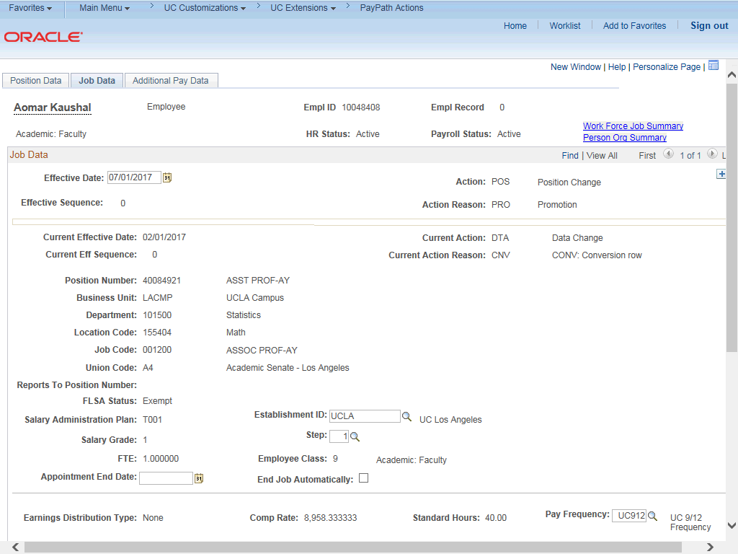

Step | Action
25. | UCPath automatically updates the compensation information.
26. | Next, add a row to update the Post Doc Anniversary Date. Click the Add a new row button.

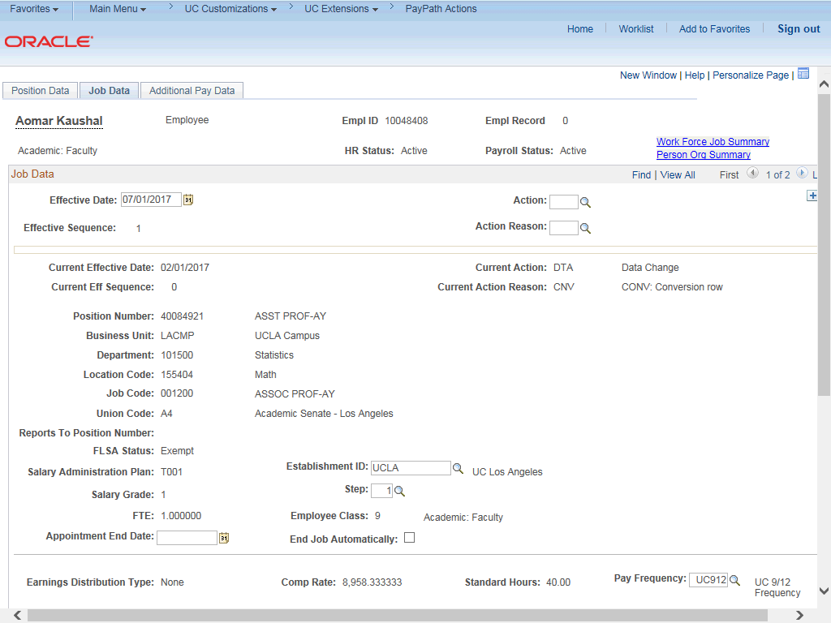

Step | Action
27. | A new row appears with the same Effective Date, but a new Effective Sequence  of 1. (The Effective Sequence of the previous row is 0).
28. | Click the Look up Action button.

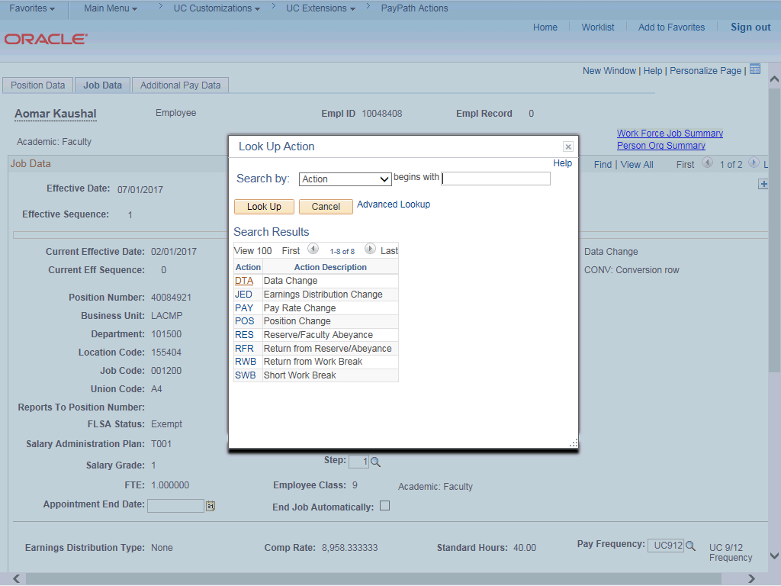

Step | Action
29. | For this example, select the Data Change code. Click the DTA list item.
30. | Click the Look up Action Reason button.

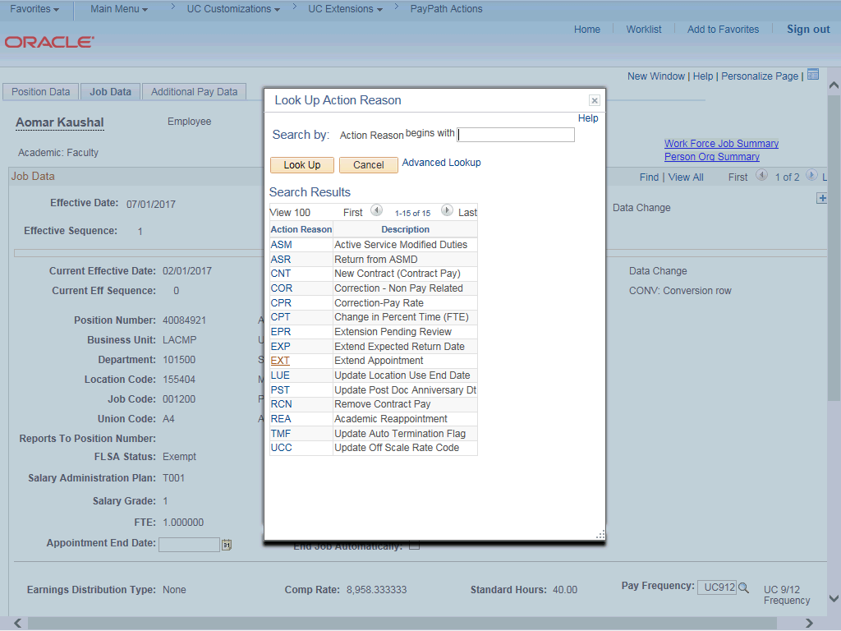

Step | Action
31. | For this example, select the Update Post Doc Anniversary Dt code. Click the PST link.

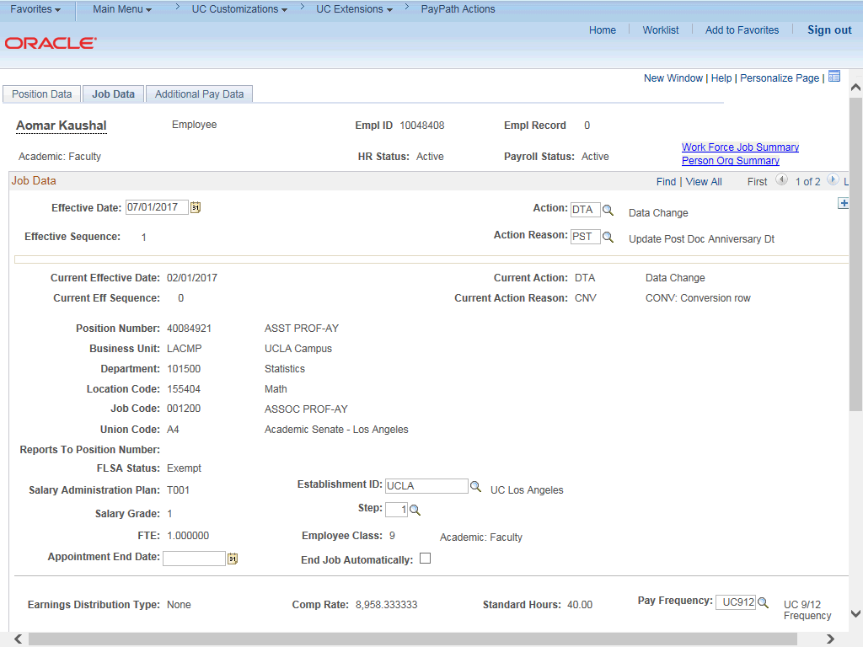

Step | Action
32. | Click the scroll bar.
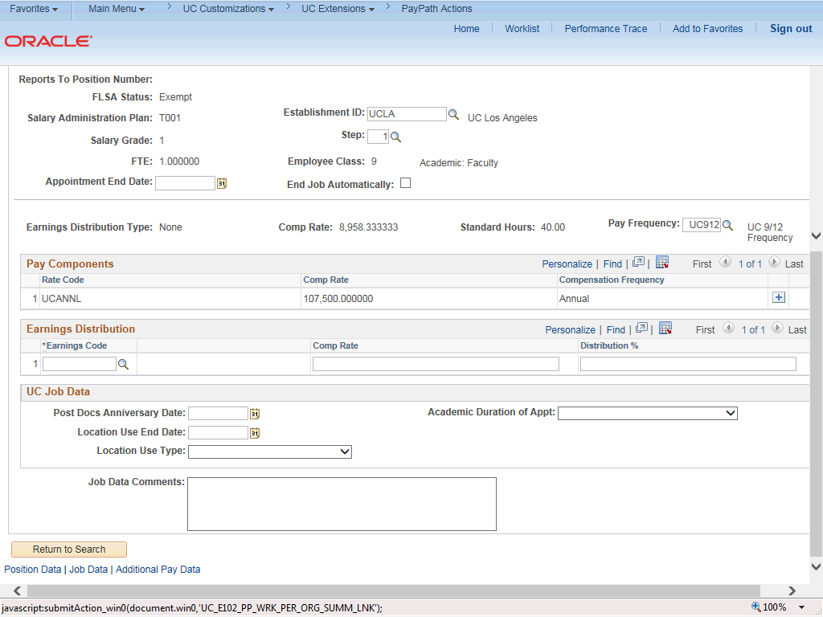

Step | Action
33. | Click in the Post Docs Anniversary Date field.

Step | Action
34. | Enter the desired information into the Post Docs Anniversary Date field.

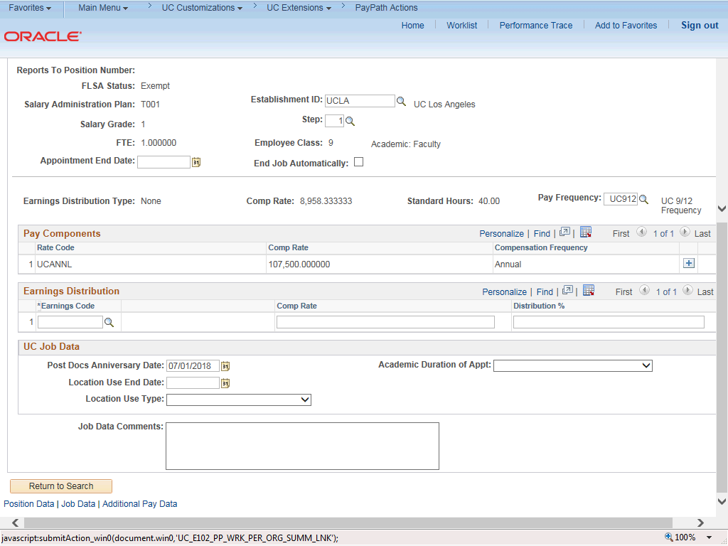

Step | Action
35. | Click in the Job Comments field.

Step | Action
36. | Enter the desired information into the Job Comments field.
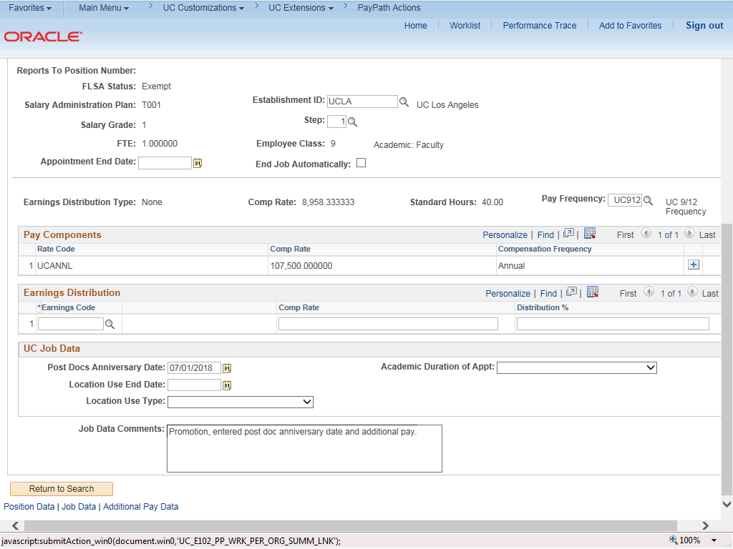

Step | Action
37. | Click the scroll bar.
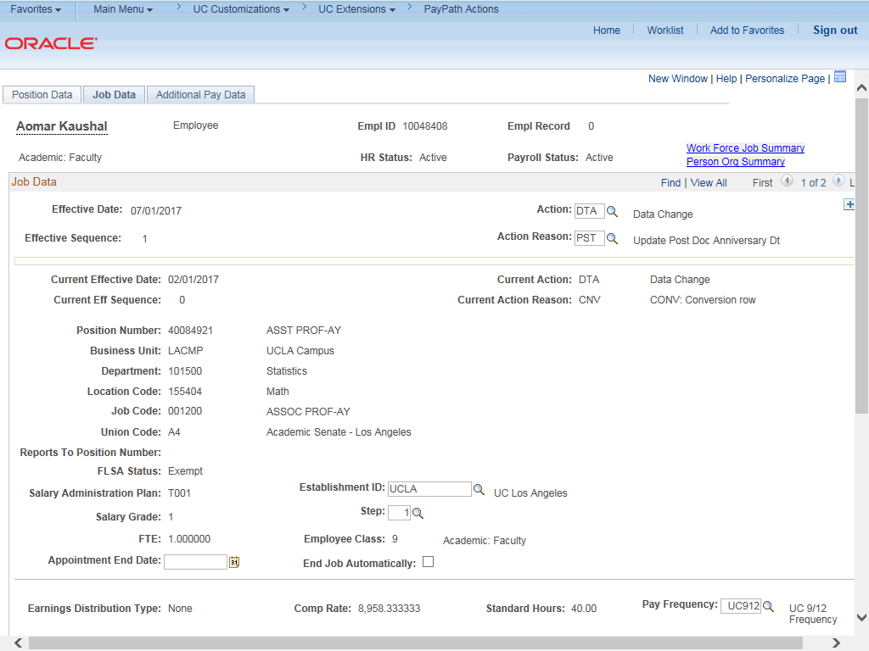

Step | Action
38. | Click the Additional Pay Data tab.

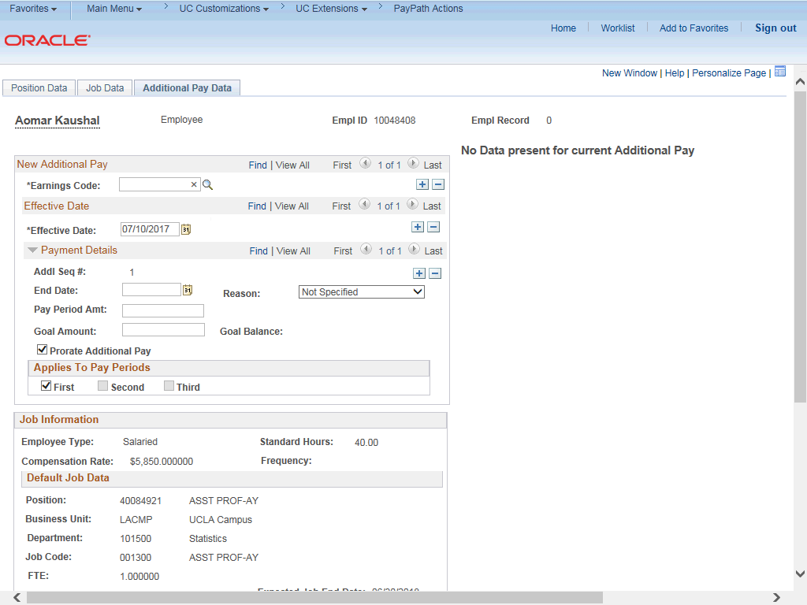

Step | Action
39. | Use the Additional Pay Data page to enter specific information about the payment.  New Additional Pay is entered on the left. If the employee has existing additional pay, it appears on the right. This employee has No Data present for current Additional Pay.
40. | Enter the Earnings Code, Effective Date and Pay Period Amount for the additional pay.  For one-time and recurring payments, enter a Goal Amount or End Date. The additional payment stops when the goal amount or end date is reached.

Step | Action
41. | Click the Look up Earnings Code button.
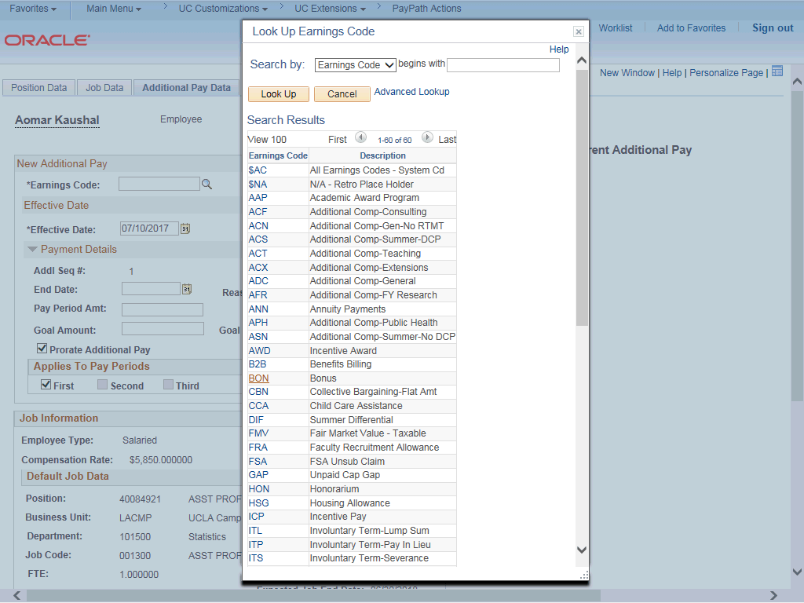

Step | Action
42. | For this example, click the ADC (Additional Comp-General) list item.
43. | The Effective Date field defaults to the system date (today's date). If needed, change the date to reflect the first day of the pay period that the additional pay should begin.  Click in the Effective Date field.
44. | Enter the desired information into the Effective Date field.
45. | Enter the per pay period amount of the additional pay. Click in the Pay Period Amt field.
46. | Enter the desired information into the Pay Period Amt field.
47. | The system continues to pay the amount indicated in the Pay Period Amt field until the Goal Amount is reached.  Click in the Goal Amount field.
48. | Enter the desired information into the Goal Amount field.
49. | Click the button to the right of the Reason field.
50. | Select the appropriate Reason.  For this example, click the Negotiated Change list item.
51. | Accept the default for the Applies to Pay Periods check boxes.  The First check box is selected for monthly employees. The First and Second check boxes are selected for biweekly employees. For biweekly employees, you may select which pay period(s) the additional pay should be paid.

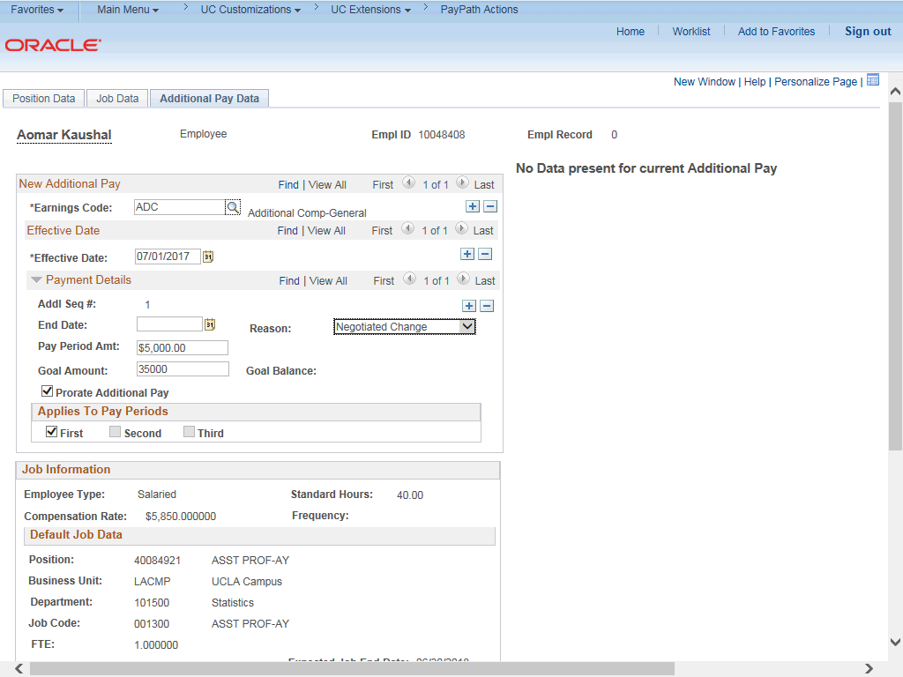

Step | Action
52. | Click the scroll bar.
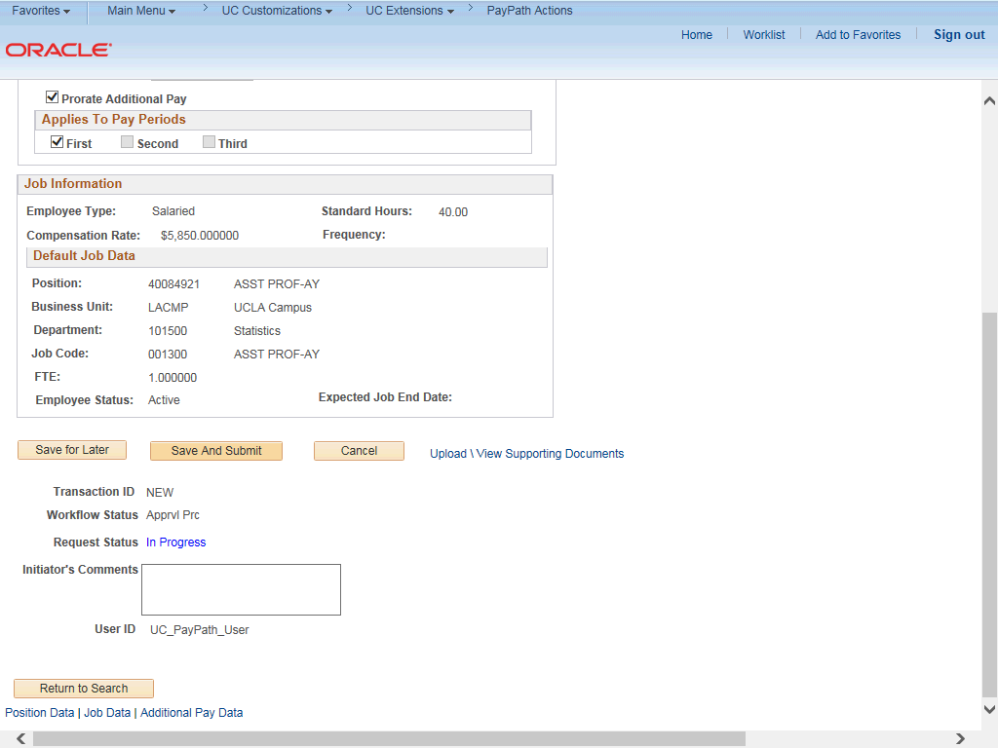

Step | Action
53. | Use the Upload \ View Supporting Documents link to attach supporting documentation, if applicable.
54. | Use the Initiator's Comments field, to further explain the transaction for the Approver, if applicable.
55. | Click the Save And Submit button.
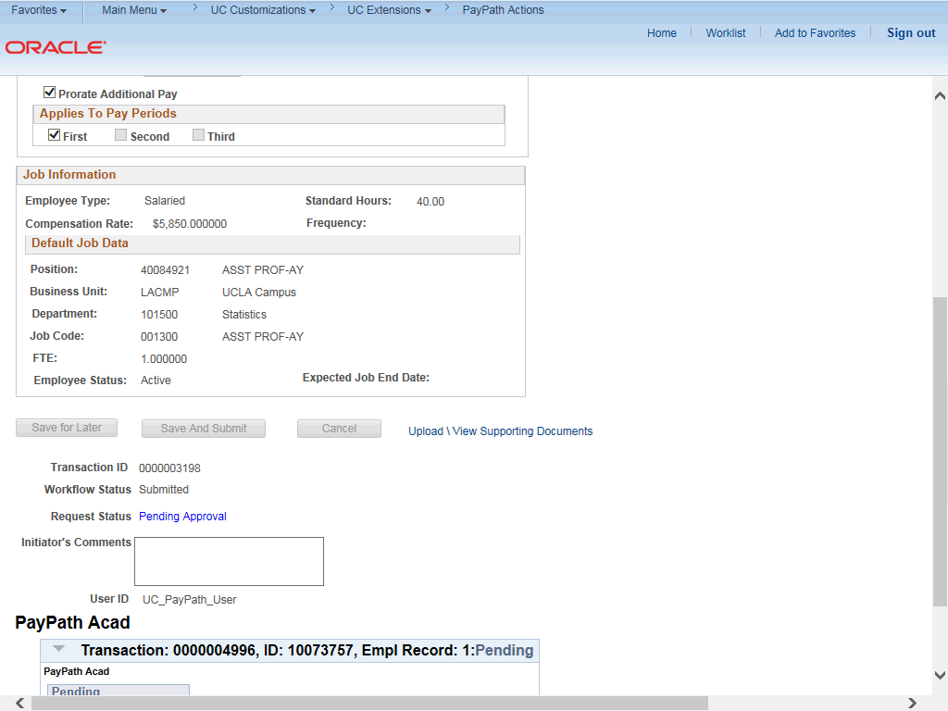

Step | Action
56. | The transaction is submitted for approval.
57. | You have initiated a position data change, job data change and an additional pay change PayPath transaction.  End of Procedure.

