Use this task to initiate a job data change and an additional pay PayPath transaction for academic employees.

Navigation: PeopleSoft Menu > UC Customizations > UC Extensions > PayPath Actions Note: This page also may be available in Workcenter depending on your security access.
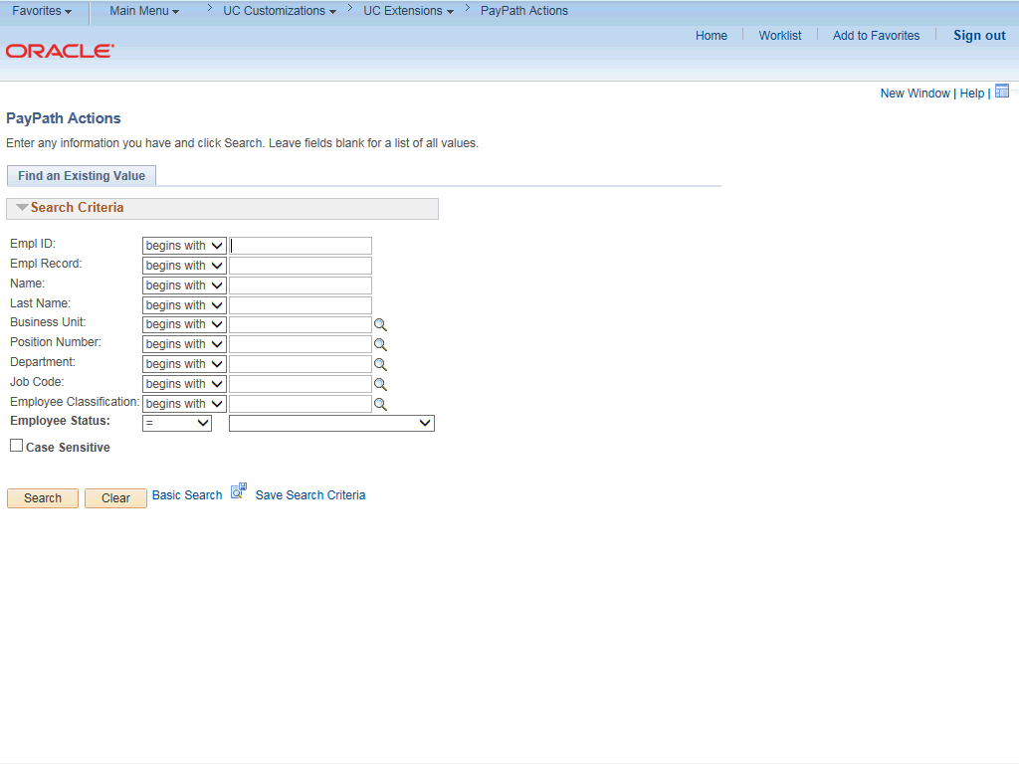

Step | Action
1. | After you navigate to the PayPath Actions component, the system displays the Find an Existing Value tab, which you use to search for the appropriate employee record.  Enter search criteria in one or more of the search fields on this page.
2. | Click in the Empl ID field.
3. | Enter the desired information into the Empl ID field.
4. | Click the Search button.

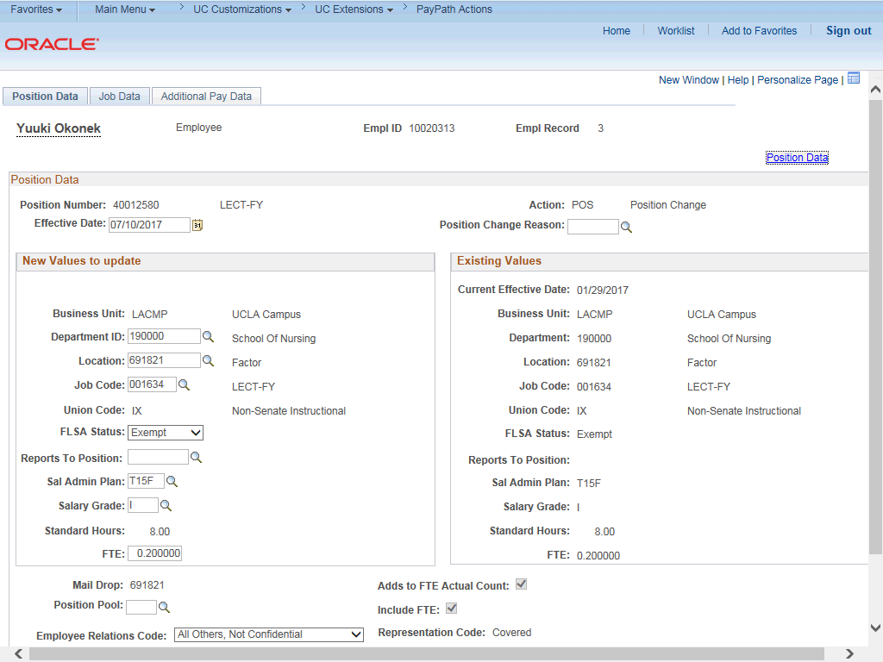

Step | Action
5. | The PayPath Actions page displays the Position Data tab. Navigate to the appropriate tab for the update you must enter. For this example, a job data change with additional pay, navigate to the Job Data tab.
6. | Click the Job Data tab.

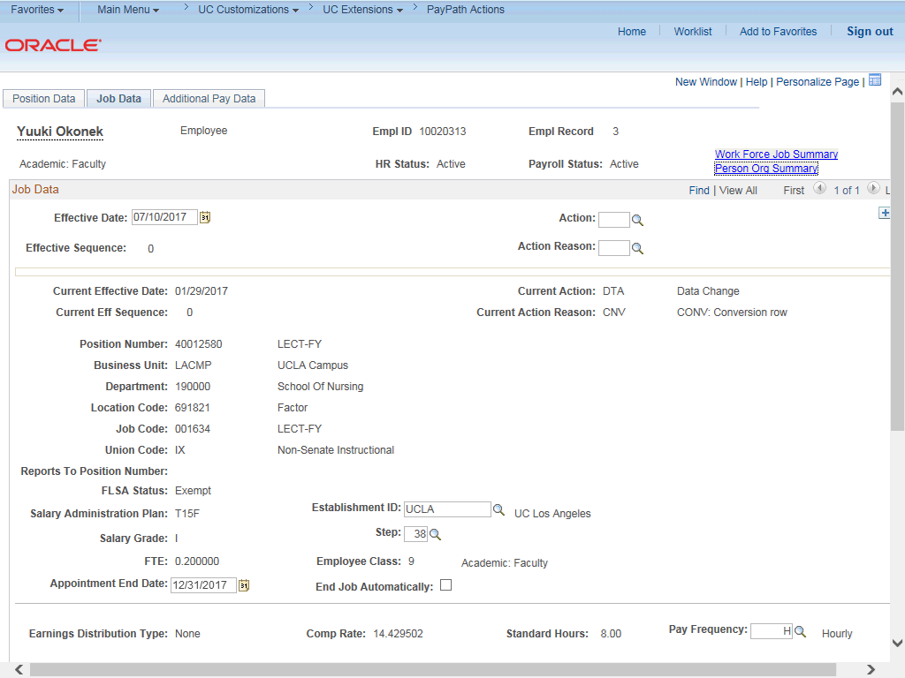

Step | Action
7. | Before entering the update, you must identify the Effective Date, Action and  Action Reason.
8. | The Effective Date field defaults to the system date (today's date). If needed, change the date to reflect the date the update should take effect.  For this example, accept the default.
9. | Click in the Action field.
10. | Enter the desired information into the Action field.
11. | Click in the Action Reason field.
12. | Enter the desired information into the Action Reason field.

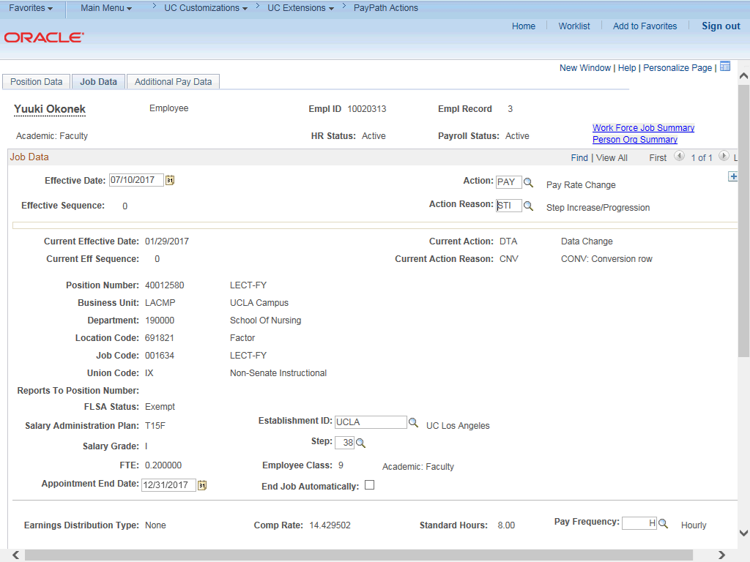

Step | Action
13. | Click the scroll bar.
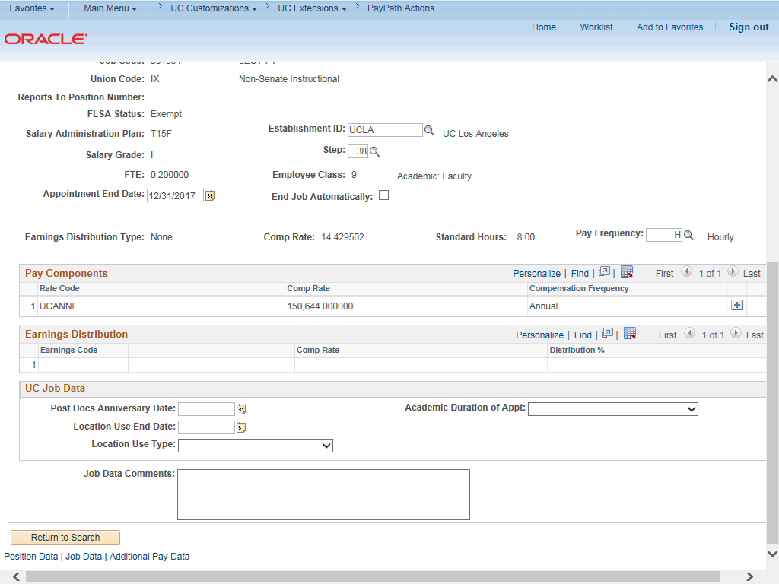

Step | Action
14. | Click in the Step field.
15. | Enter the desired information into the Step field.
16. | After the step is entered, UCPath automatically updates the compensation information.
17. | For Job Data updates, enter a comment explaining the update. Click in the Job Data Comments field.
18. | Enter the desired information into the Job Data Comments field.
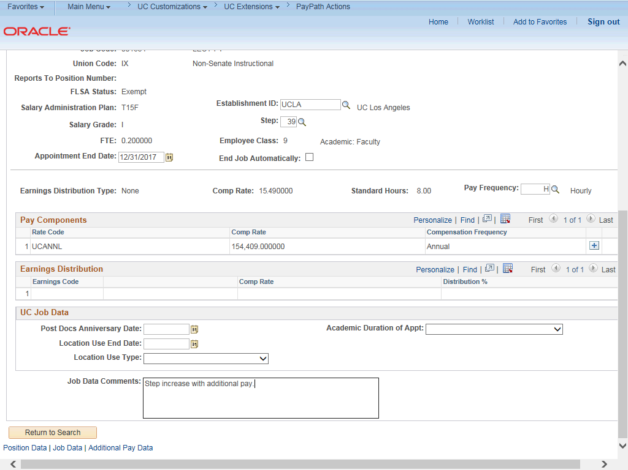

Step | Action
19. | Click the scroll bar.
20. | Click the Additional Pay Data tab.

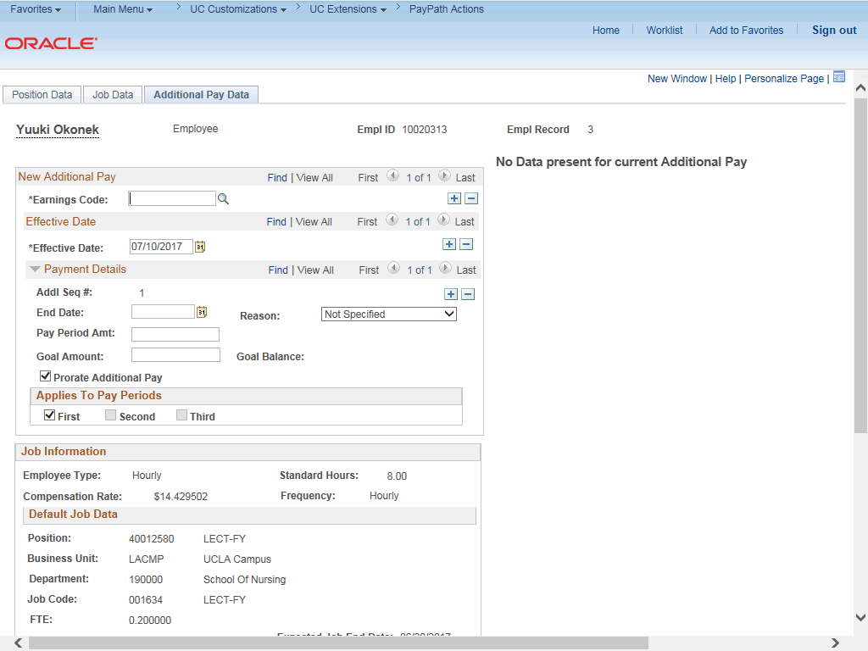

Step | Action
21. | Use the Additional Pay Data page to enter specific information about the payment.  New Additional Pay is entered on the left. If the employee has existing additional pay, it appears on the right. This employee has No Data present for current Additional Pay.
22. | Enter the Earnings Code, Effective Date and Pay Period Amount for the additional pay.  For one-time and recurring payments, enter a Goal Amount or End Date. The additional payment stops when the goal amount or end date is reached.
23. | Click the Look up Earnings Code button.

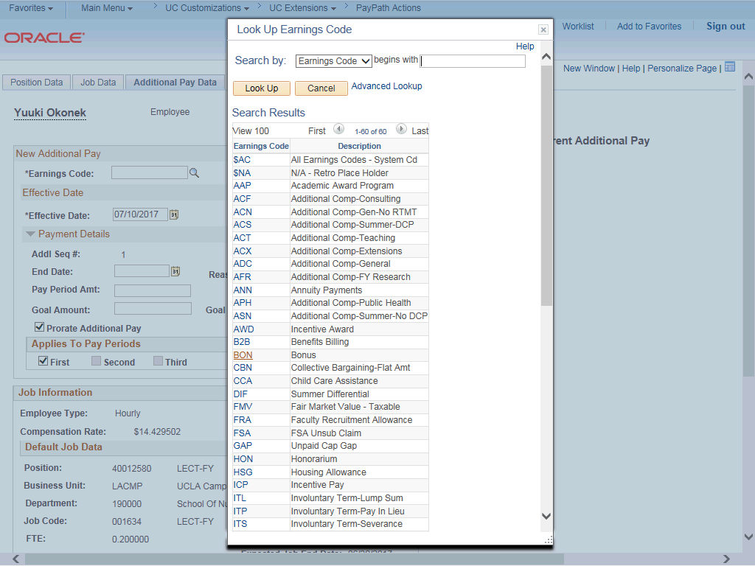

Step | Action
24. | The Earnings Codes that appear are based on the earnings program tied to the employee's paygroup. Select the appropriate Earnings Code.  For this example, click the ADC (Additional Comp-General) list item.
25. | The Effective Date field defaults to the system date (today's date). If needed, change the date to reflect the first day of the pay period that the additional pay should begin.  Click in the Effective Date field.
26. | Enter the desired information into the Effective Date field.
27. | Enter the per pay period amount of the additional pay. Click in the Pay Period Amt field.
28. | Enter the desired information into the Pay Period Amt field.

Step | Action
29. | The system continues to pay the amount indicated in the Pay Period Amt field until the Goal Amount is reached.  Click in the Goal Amount field.
30. | Enter the desired information into the Goal Amount field.
31. | Click the button to the right of the Reason field.
32. | Select the appropriate Reason.  For this example, click the Academic Advancement list item.
33. | Accept the default for the Applies to Pay Periods check boxes.  The First check box is selected for monthly employees. The First and Second check boxes are selected for biweekly employees. For biweekly employees, you may select which pay period(s) the additional pay should be paid.
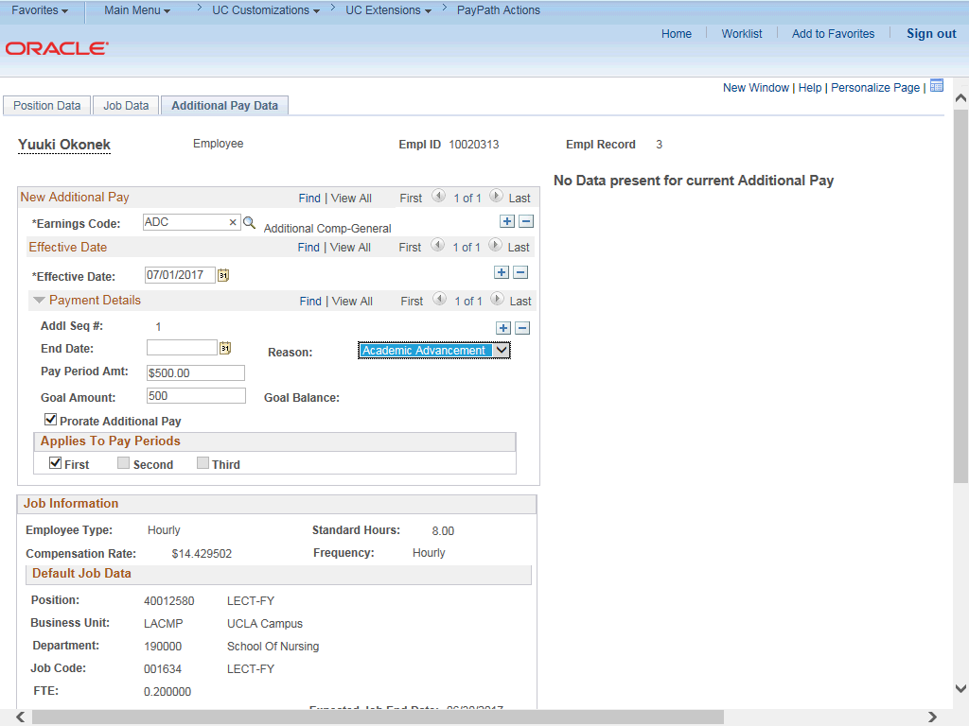

Step | Action
34. | Click the scroll bar.

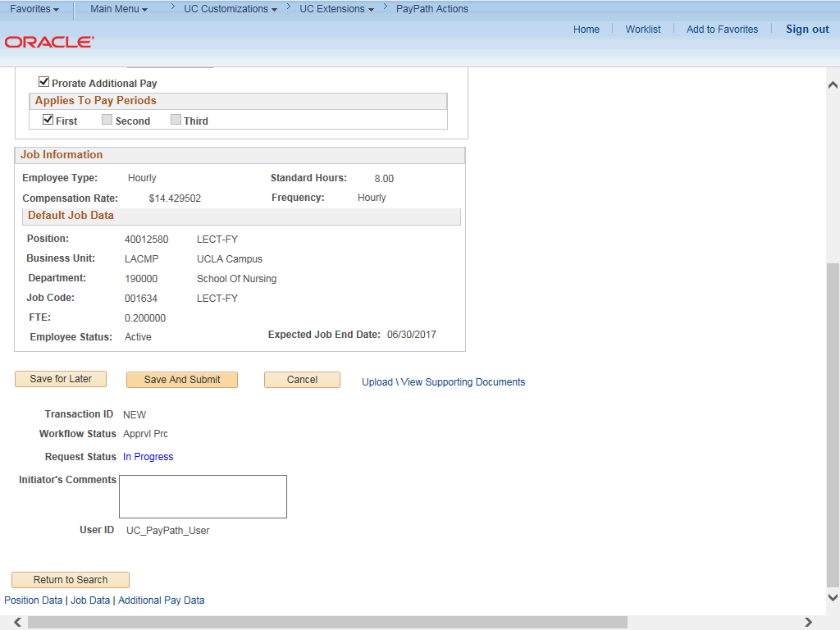

Step | Action
35. | Use the Upload \ View Supporting Documents link to attach supporting documentation, if applicable.
36. | Use the Initiator's Comments field, to further explain the transaction for the Approver, if applicable.
37. | Click the Save And Submit button.

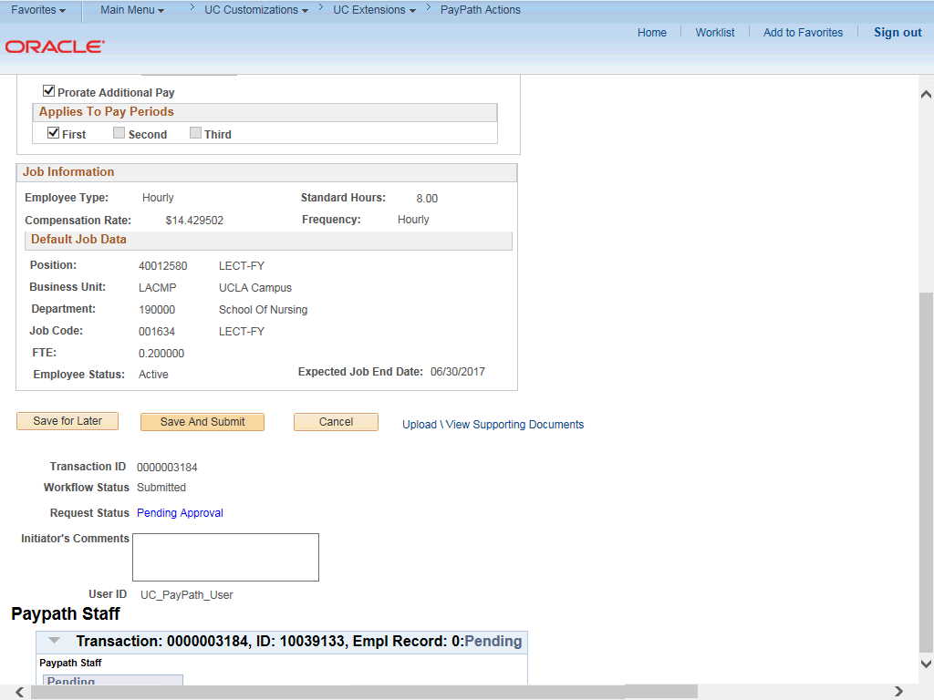

Step | Action
38. | The transaction is submitted for approval.
39. | You have initiated a job data change and an additional pay PayPath transaction.  End of Procedure.

