Use this task to initiate a position data change and job data change PayPath transaction. This example demonstrates a promotion and pay rate change for a staff employee.

Navigation: PeopleSoft Menu > UC Customizations > UC Extensions > PayPath Actions Note: This page also may be available in Workcenter depending on your security access.
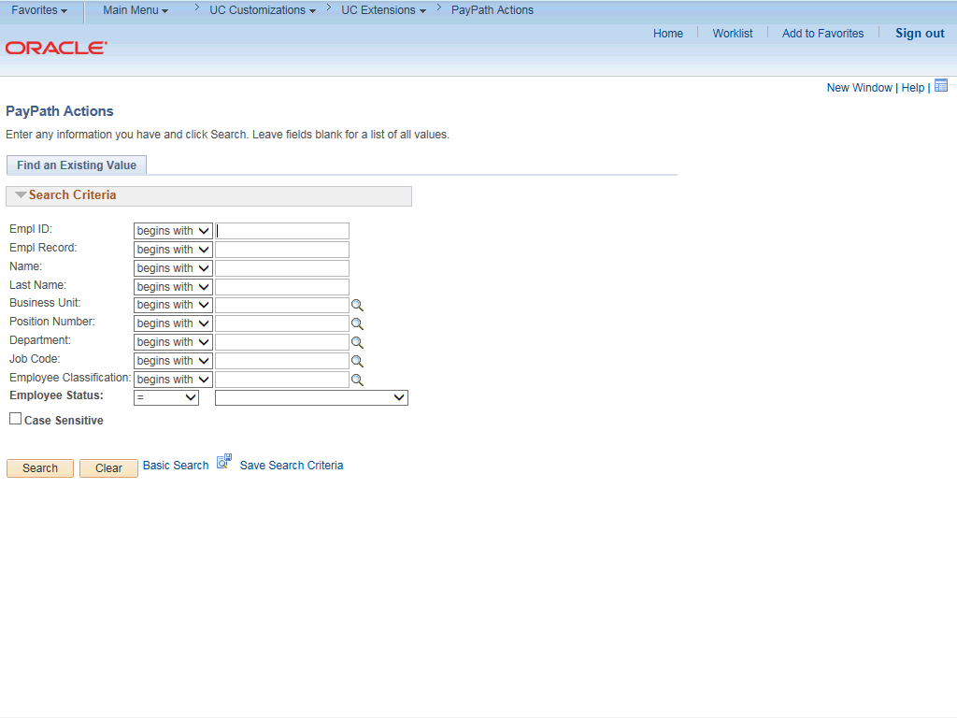

Step | Action
1. | After you navigate to the PayPath Actions component, the system displays the Find an Existing Value tab, which you use to search for the appropriate employee record.  Enter search criteria in one or more of the search fields on this page.
2. | Click in the Empl ID field.
3. | Enter the desired information into the Empl ID field.
4. | Click the Search button.

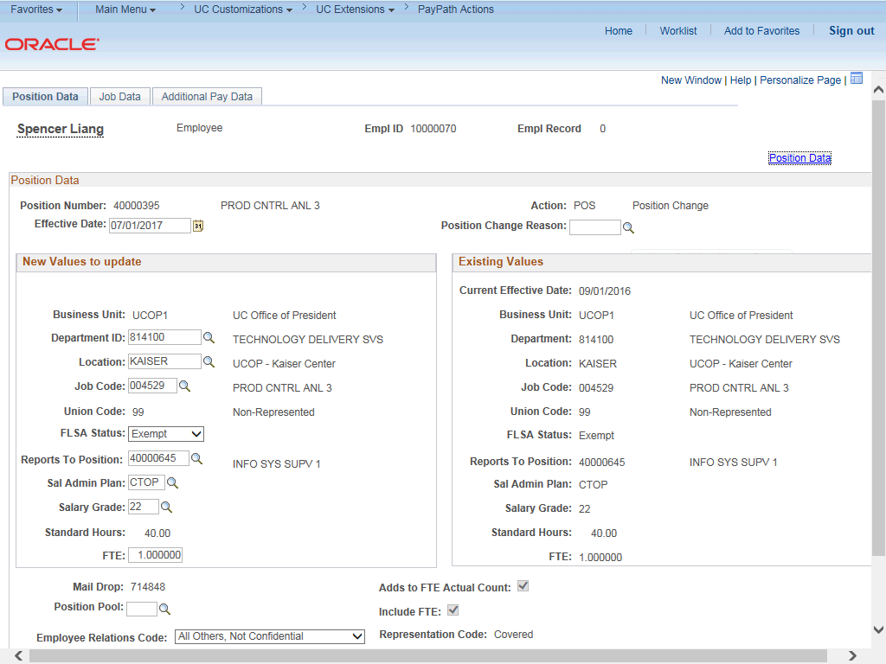

Step | Action
5. | The PayPath Actions page displays the Position Data tab. Navigate to the appropriate tab for the update you must enter. For this example, a position data and job data change, stay on the Position Data tab.
6. | Before you enter the update, you must identify the Effective Date and  Position Change Reason.
7. | The Effective Date field defaults to the system date (today's date). If needed, change the date to reflect the date the update should take effect.  For this example, accept the default date.
8. | Click in the Position Change Reason field.
9. | Enter the desired information into the Position Change Reason field.
10. | Enter the Job Code for the promotion. Click in the Job Code field.
11. | Enter the desired information into the Job Code field.

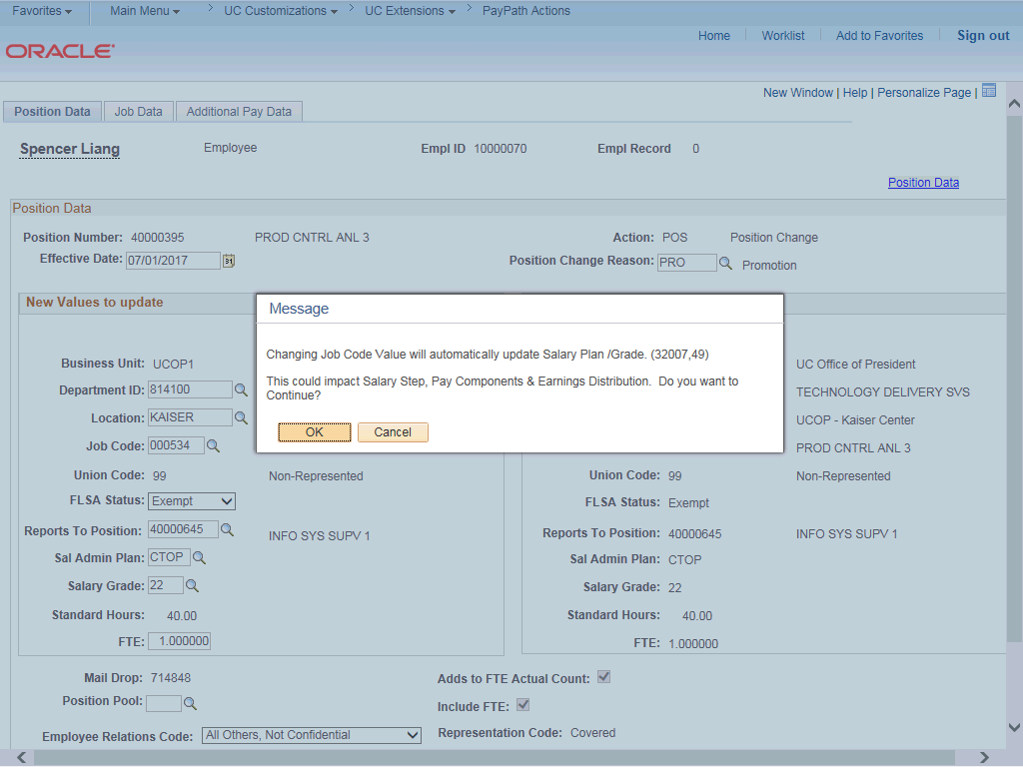

Step | Action
12. | UCPath displays a message indicating that the salary plan and grade will be updated. You may need to change step, pay components or earnings distribution information.  Click the OK button.
13. | Because there is only one Salary Admin Plan and one Salary Grade for this job code, UCPath automatically populates the fields. For other examples you may have to enter the plan and/or grade.

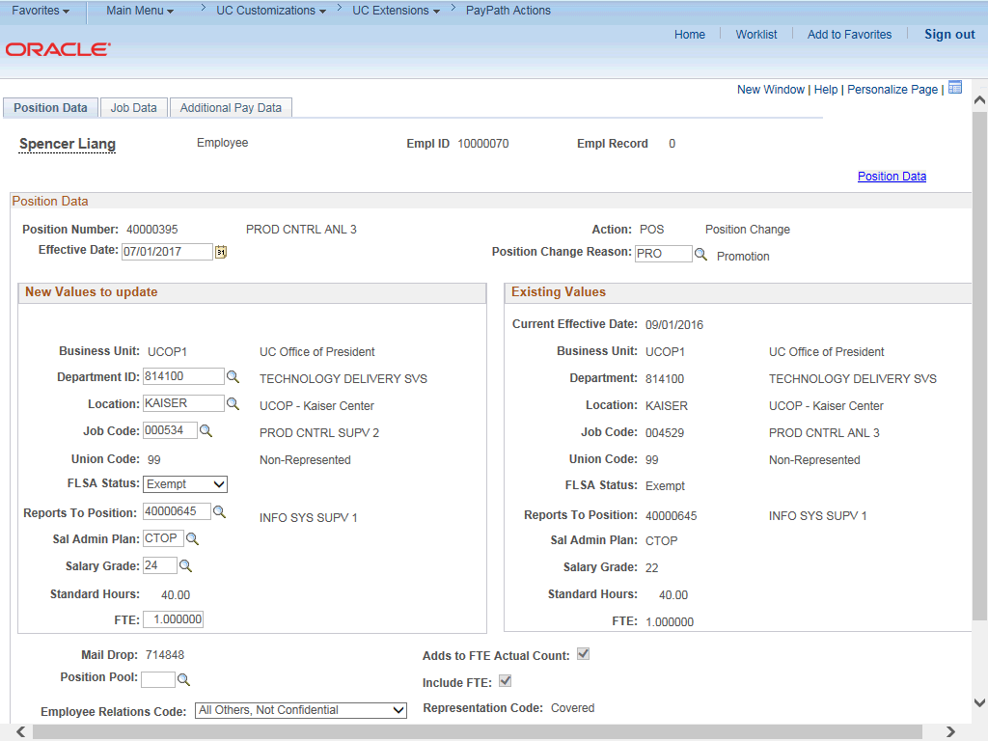

Step | Action
14. | Click the Job Data tab.
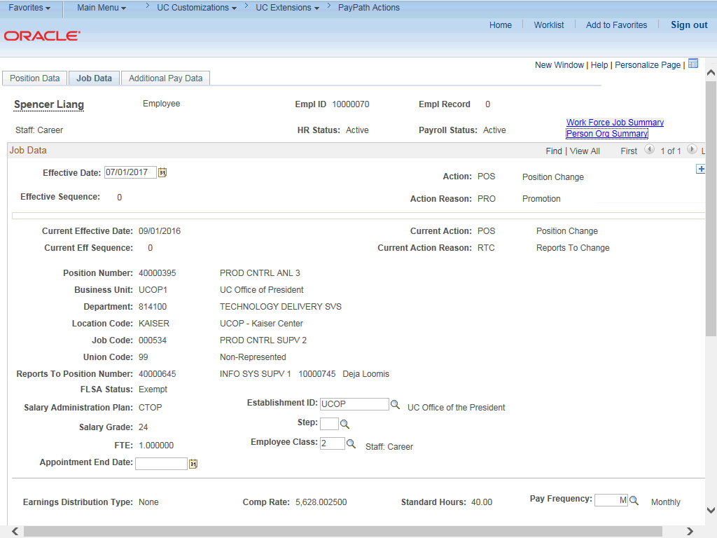

Step | Action
15. | Notice a new Job Data row has been added that includes the update from the Position Data tab. The new row includes the Effective Date, Action and Action Reason from the position update.
16. | The updated Job Code, Salary Administration Plan and Salary Grade also appear.
17. | Add a new row to enter the pay change for the promotion. Click the Add a new row button.
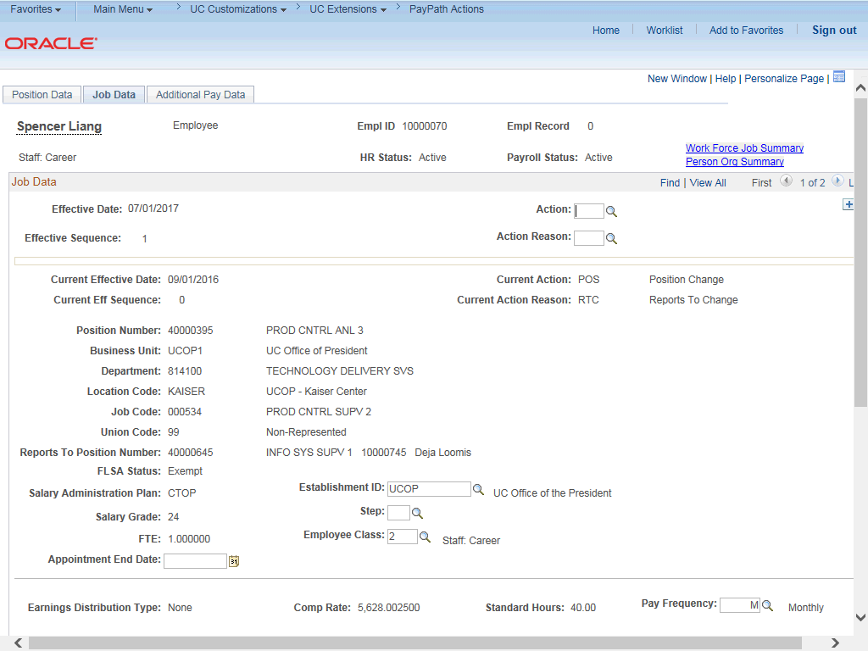

Step | Action
18. | A new row appears with the same Effective Date, but a new Effective Sequence  of 1. (The Effective Sequence of the previous row is 0).
19. | Click in the Action field.
20. | Enter the desired information into the Action field.
21. | Click in the Action Reason field.

Step | Action
22. | Enter the desired information into the Action Reason field.
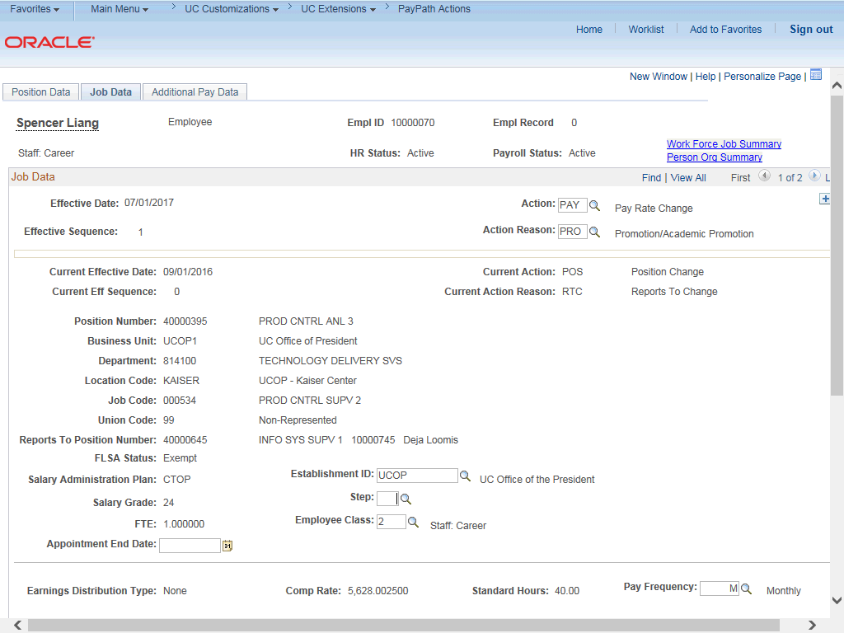

Step | Action
23. | Click the scroll bar.

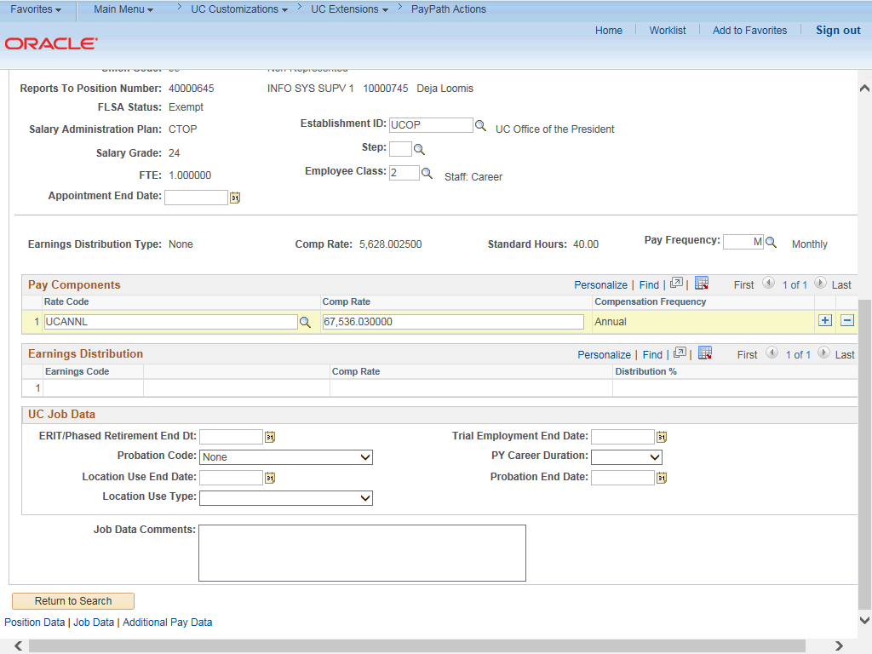

Step | Action
24. | Click in the Comp Rate field.
25. | Enter the desired information into the Comp Rate field.
26. | Click in the Job Data Comments field.
27. | Enter the desired information into the Job Data Comments field.

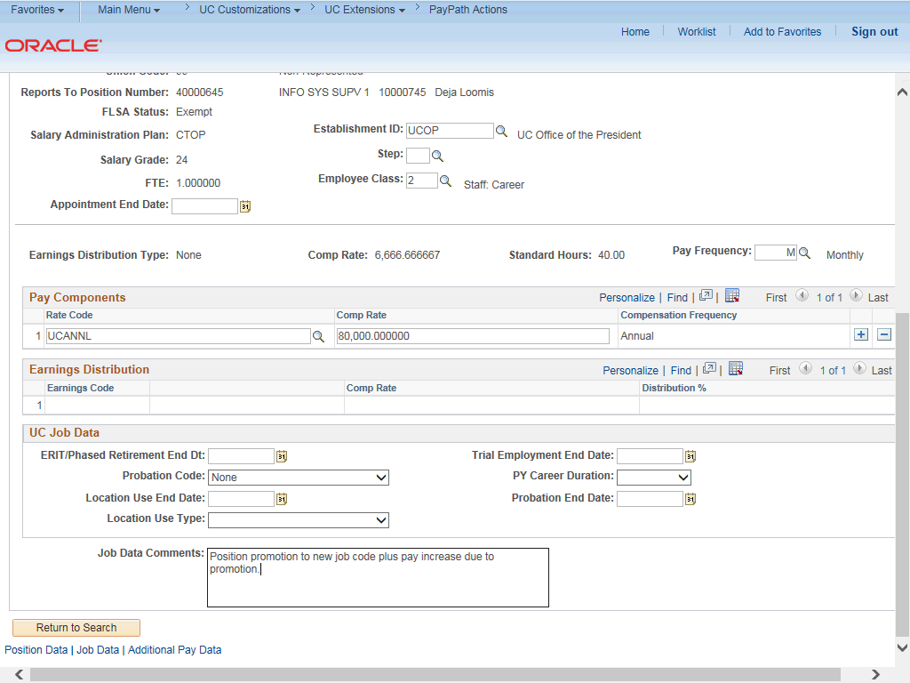

Step | Action
28. | Click the scroll bar.
29. | Click the Additional Pay Data tab.

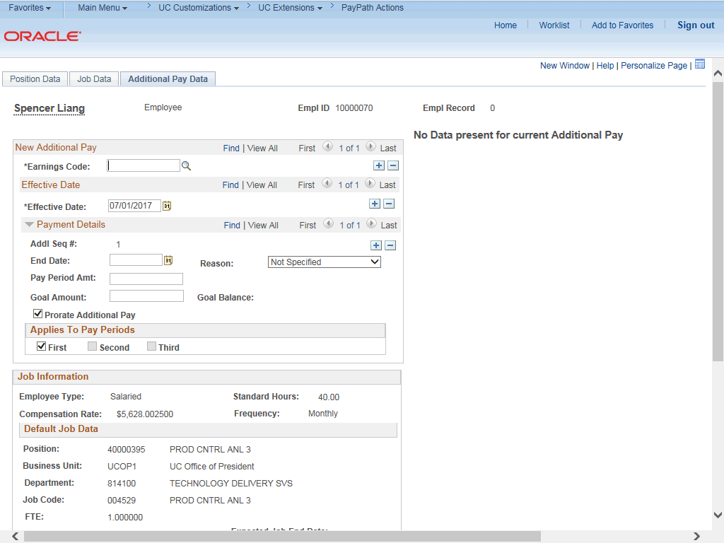

Step | Action
30. | Click the scroll bar.
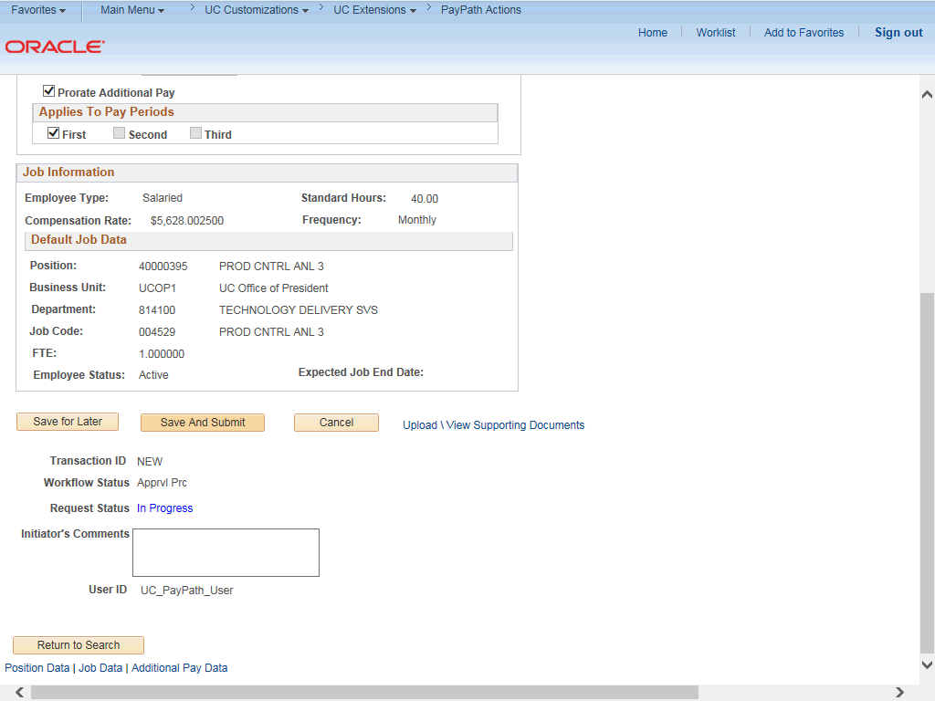

Step | Action
31. | Use the Upload \ View Supporting Documents link to attach supporting documentation, if applicable.
32. | Use the Initiator's Comments field, to further explain the transaction for the Approver, if applicable.
33. | Click the Save And Submit button.
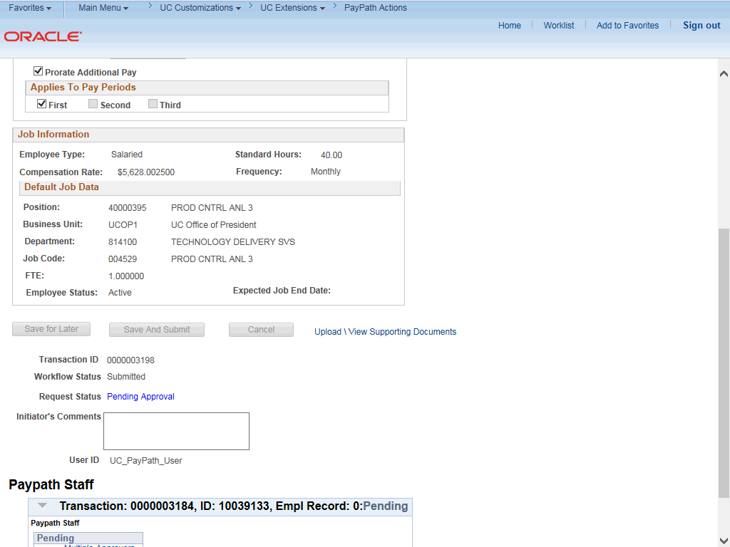

Step | Action
34. | The transaction is submitted for approval.
35. | You have initiated a position data change and job data change PayPath transaction.  End of Procedure.

