Use this task to initiate a position data change and job data change PayPath transaction. This example demonstrates a promotion and pay rate change for an academic HSCP employee.

Navigation: PeopleSoft Menu > UC Customizations > UC Extensions > PayPath Actions Note: This page also may be available in Workcenter depending on your security access.
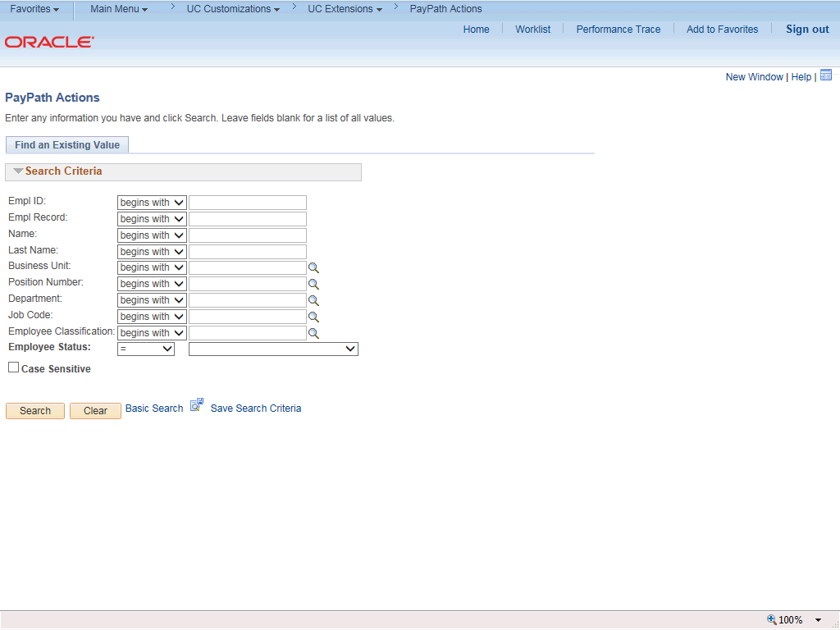

Step | Action
1. | After you navigate to the PayPath Actions component, the system displays the Find an Existing Value tab, which you use to search for the appropriate employee record.  Enter search criteria in one or more of the search fields on this page.
2. | Click in the Empl ID field.
3. | Enter the desired information into the Empl ID field.
4. | Click the Search button.

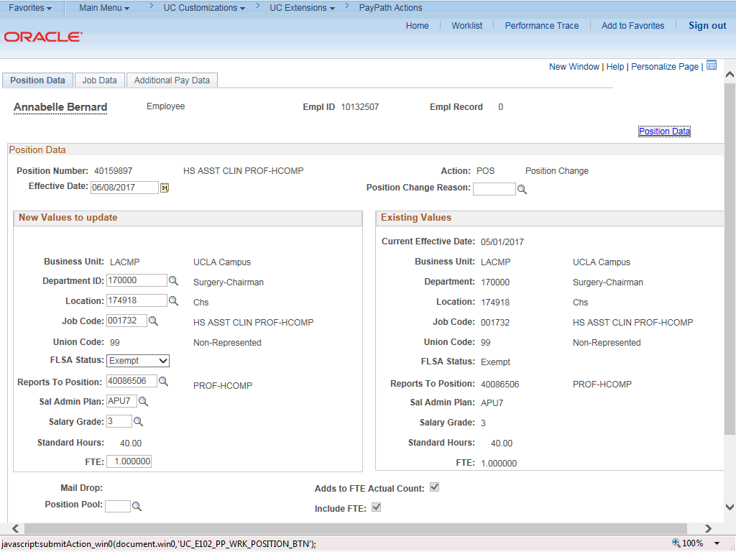

Step | Action
5. | The PayPath Actions page displays the Position Data tab. Navigate to the appropriate tab for the update you must enter. For this example, a position data and job data change, stay on the Position Data tab.
6. | Before you enter the update, you must identify the Effective Date and  Position Change Reason.
7. | The Effective Date field defaults to the system date (today's date). If needed, change the date to reflect the date the update should take effect.  Click in the Effective Date field.
8. | Enter the desired information into the Effective Date field.
9. | Click the Look up Position Change Reason button.

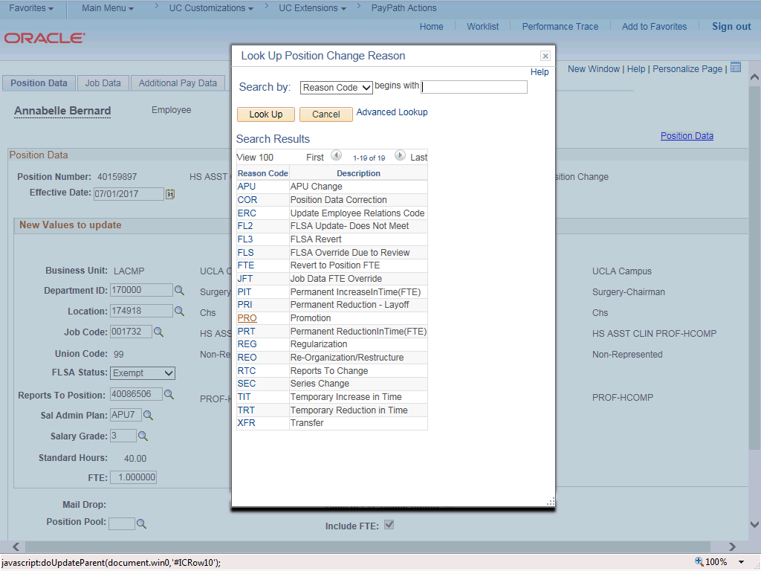

Step | Action
10. | For this example, select the Promotion code. Click the PRO list item.
11. | Enter the Job Code for the promotion. Click in the Job Code field.
12. | Enter the desired information into the Job Code field.

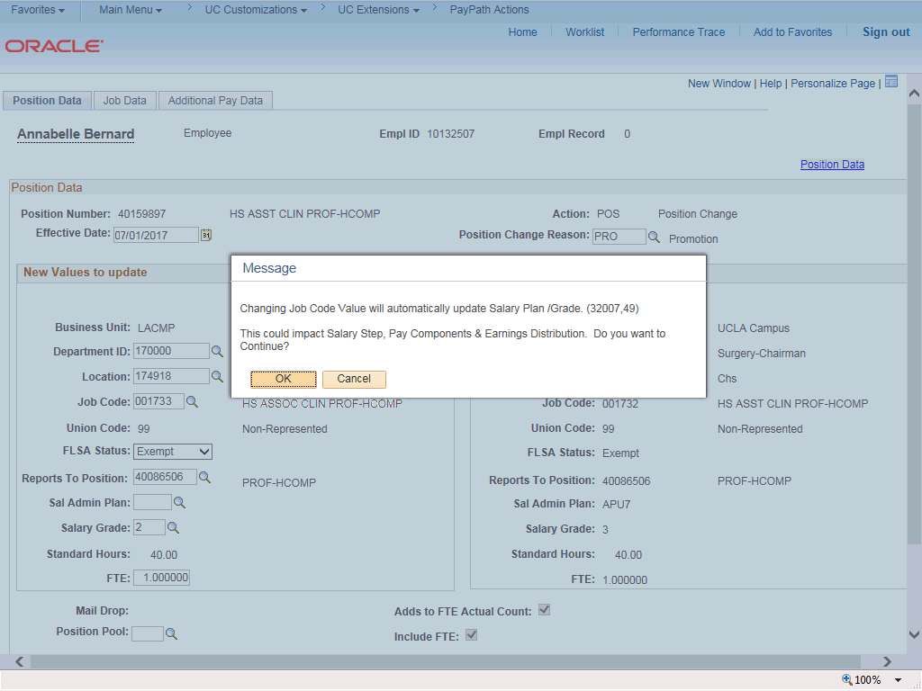

Step | Action
13. | UCPath displays a message indicating that the salary plan and grade will be updated. You may need to change step, pay components or earnings distribution information.  Click the OK button.
14. | UCPath automatically updates the Salary Admin Plan and Salary Grade fields based on the selected job code.  If the Salary Admin Plan/Salary Grade have a salary step component configured and you or UCPath changes the Sal Admin Plan/Salary Grade fields, the Step and compensation information is removed from the Job Data tab.
15. | Because there is only one Salary Grade for this job code, UCPath automatically populates the field. For other examples you may have to enter the grade.
16. | UCPath did not populate the Sal Admin Plan field because there is more than one option available. Select the appropriate value from the list of options.  If there is only one salary admin plan UCPath automatically populates the field.
17. | Click the Look up Sal Admin Plan button.

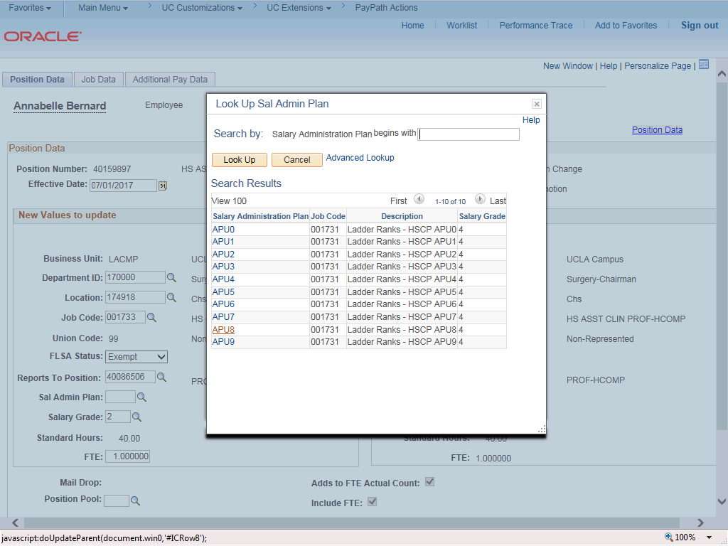

Step | Action
18. | Select the appropriate Salary Admin Plan. For this example, click the APU8 link.

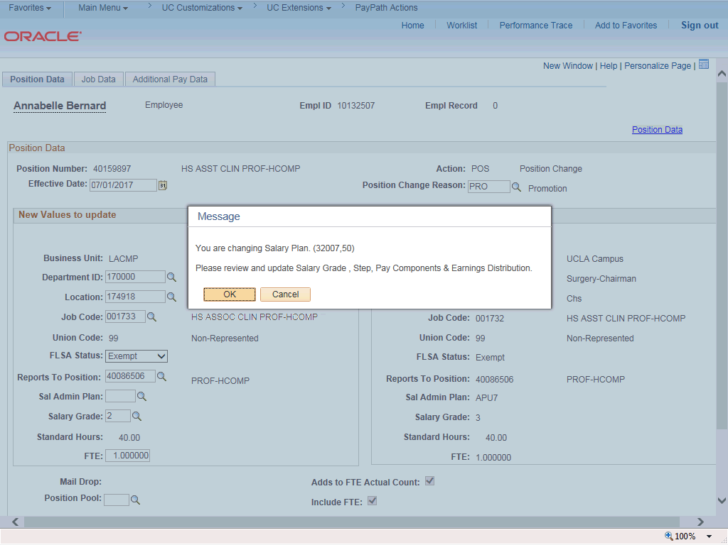

Step | Action
19. | UCPath displays a message that you may need to update the step, pay components or earnings distribution.  Click the OK button.

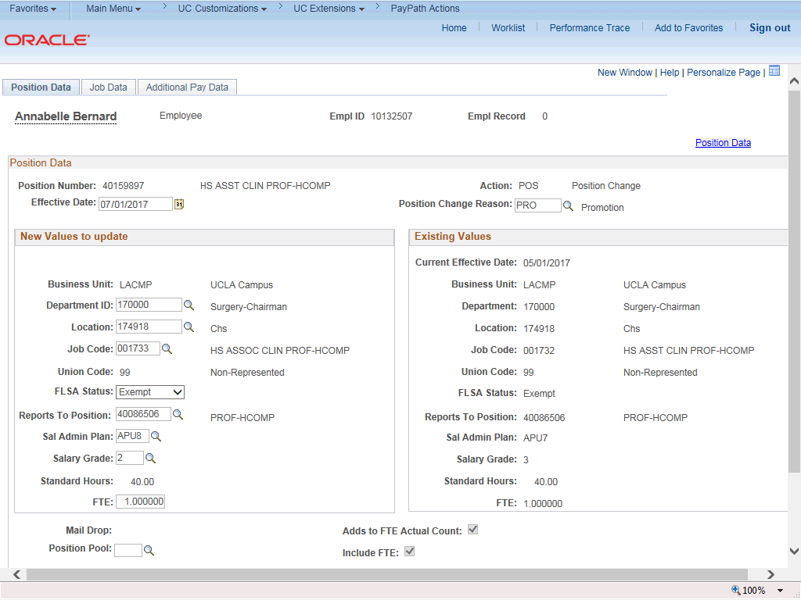

Step | Action
20. | Click the Job Data tab.
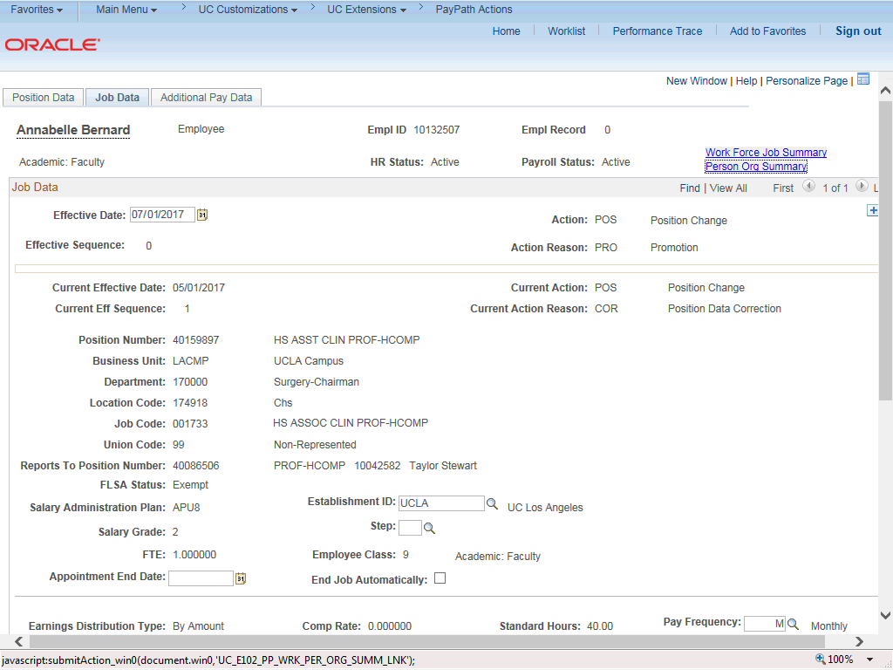

Step | Action
21. | Notice a new Job Data row has been added that includes the update from the Position Data tab. The new row includes the Effective Date, Action and Action Reason from the position update.
22. | The updated Job Code, Salary Administration Plan and Salary Grade also appear.
23. | Click the scroll bar.
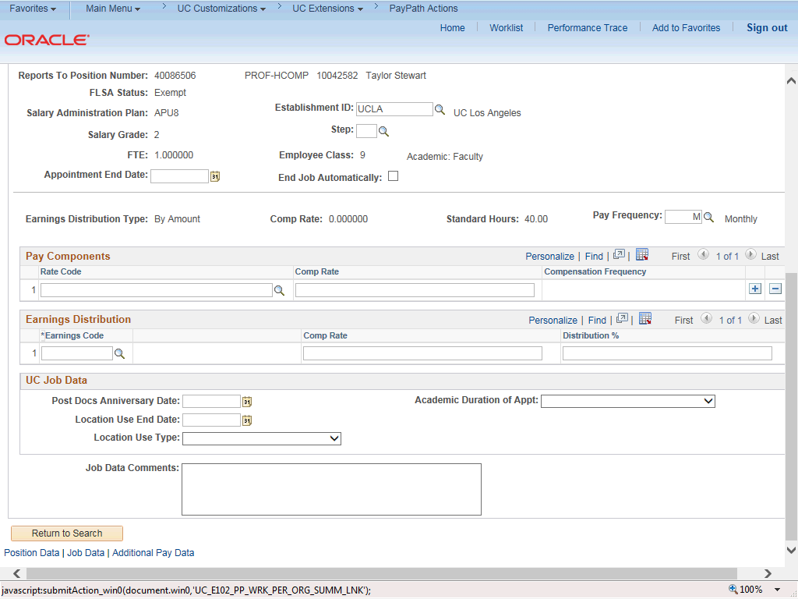

Step | Action
24. | To complete the promotion, the Step must be entered for the new job. After you enter the step, UCPath automatically enters the compensation information.  Click in the Step field.
25. | Enter the desired information into the Step field. For this example, enter 1.

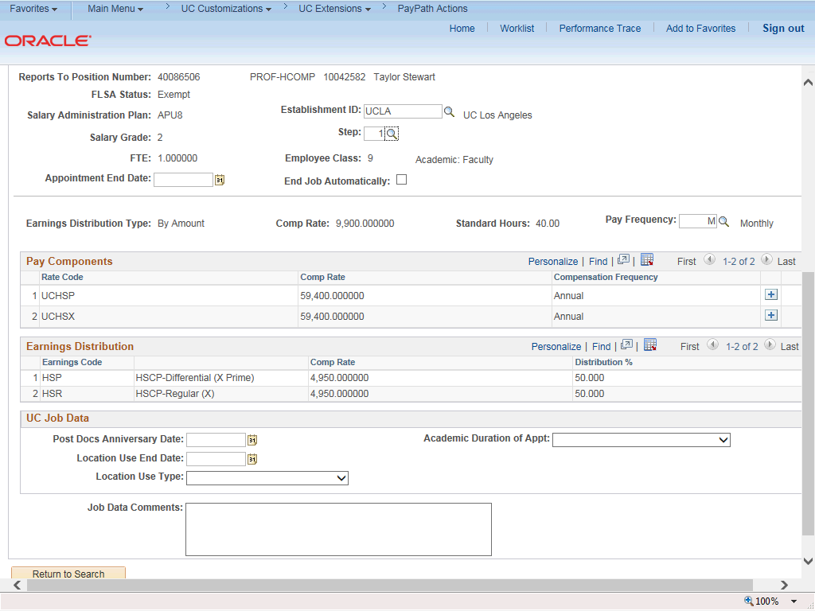

Step | Action
26. | UCPath automatically updates the Pay Components and Earnings Distribution  sections.
27. | For Job Data updates, enter a comment explaining the update. Click in the Job Data Comments field.
28. | Enter the desired information into the Job Data Comments field.

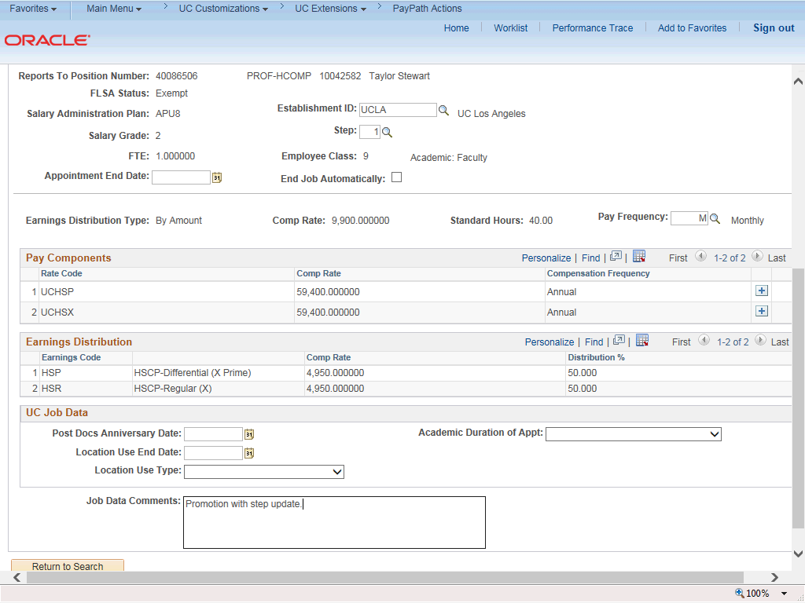

Step | Action
29. | Click the scroll bar.
30. | Next, add a new Job Data row to enter a new Y component of pay. Click the Add a New Row button.

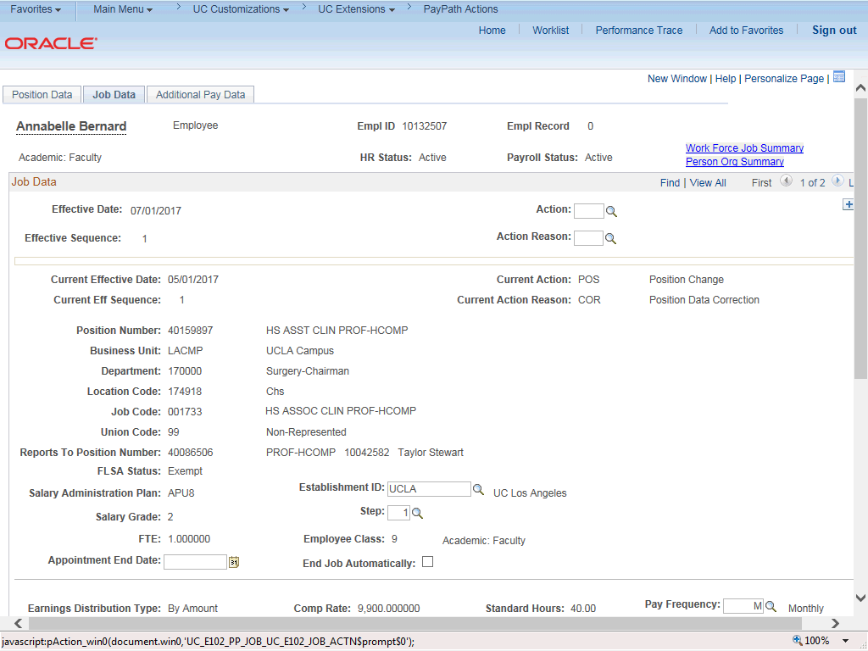

Step | Action
31. | A new row appears with the same Effective Date, but a new Effective Sequence  of 1. (The Effective Sequence of the previous row is 0).
32. | Click the Look up Action button.

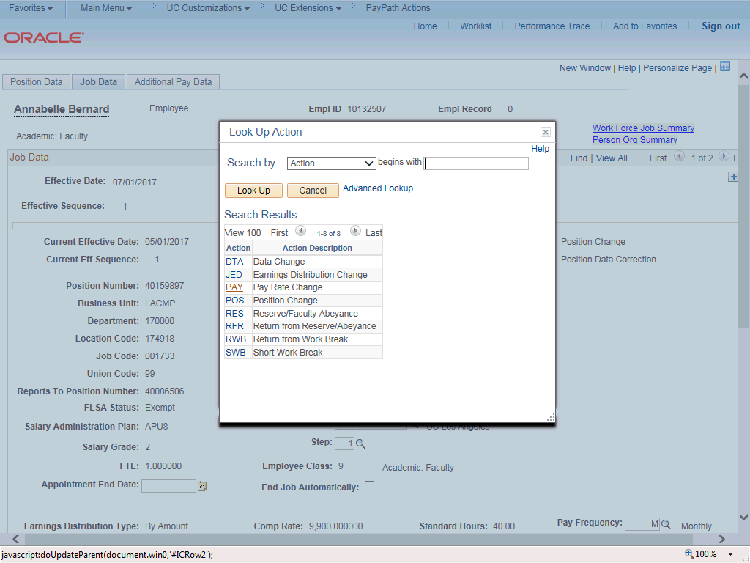

Step | Action
33. | For this example, select the Pay Rate Change code. Click the PAY list item.
34. | Click the Look up Action Reason button.

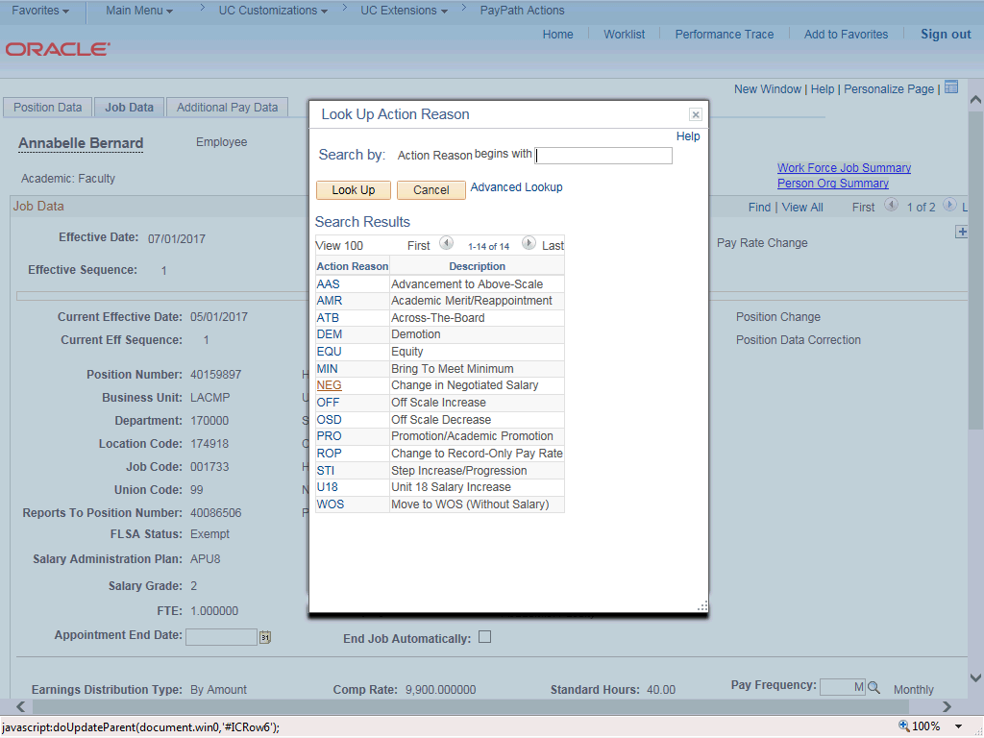

Step | Action
35. | For this example, select the Change in Negotiated Salary code. Click the NEG list item.

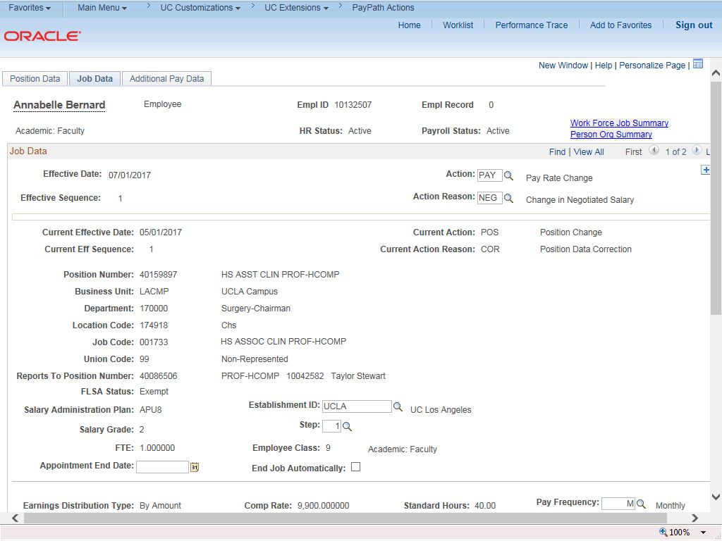

Step | Action
36. | Click the scroll bar.
37. | In the Pay Components section, add a new row for the Y component of pay. Click the Add a New Row button.

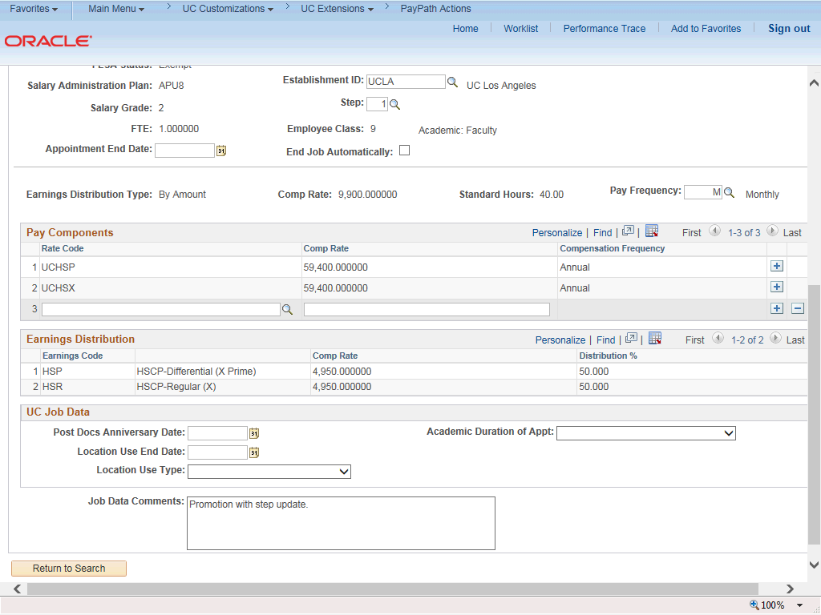

Step | Action
38. | Enter the desired information into the Rate Code field.
39. | Press [Tab] to update the earnings distribution based on the new UCHSY rate code.

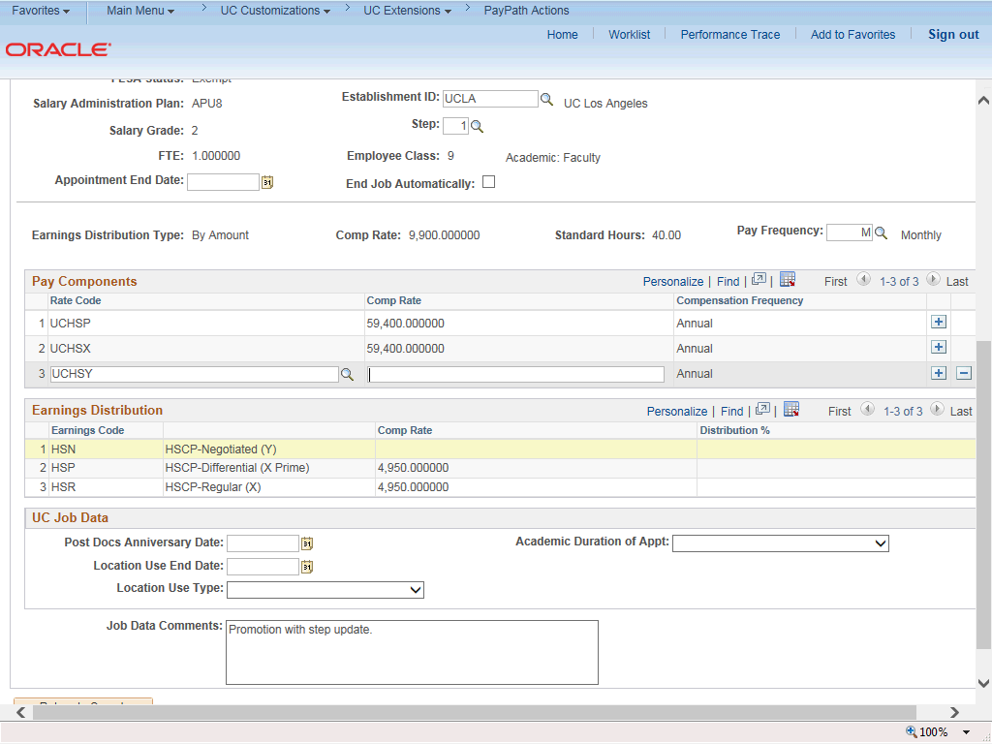

Step | Action
40. | UCPath automatically adds a new earnings distribution for HSCP-Negotiated (Y).
41. | Enter the desired information into the Pay Components Comp Rate field.
42. | Press [Tab] to update the earnings distribution Comp Rate.

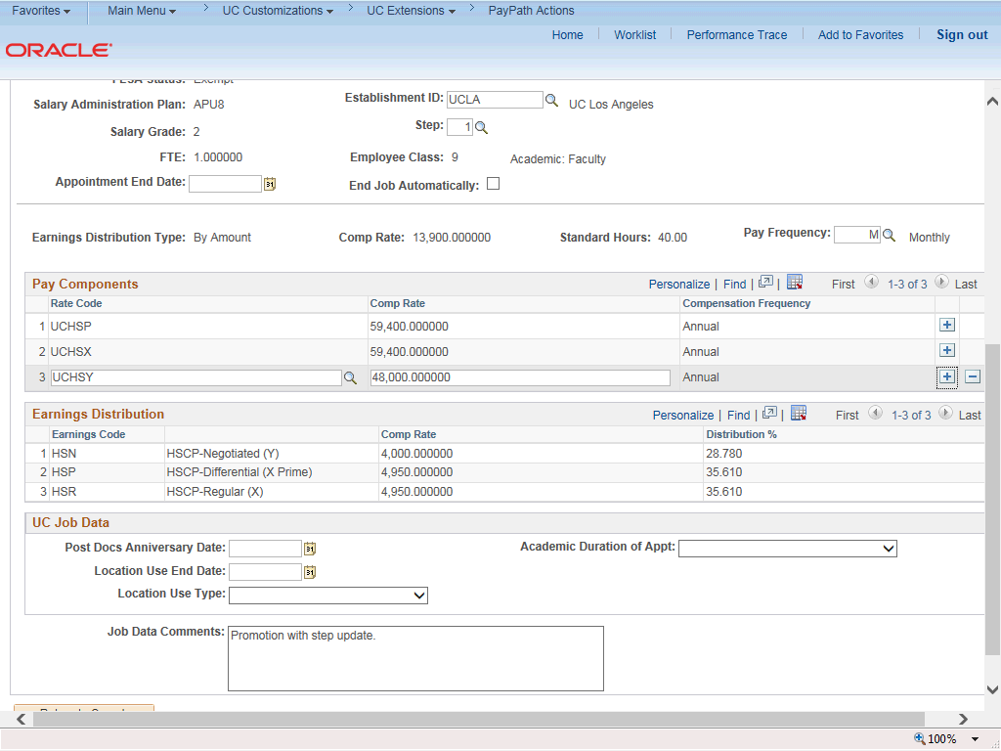

Step | Action
43. | UCPath automatically adds the Earnings Distribution Comp Rate for earn code  HSCP-Negotiated (Y).
44. | Click in the Job Data Comments field.
45. | Add the additional change information into the Job Data Comments field.

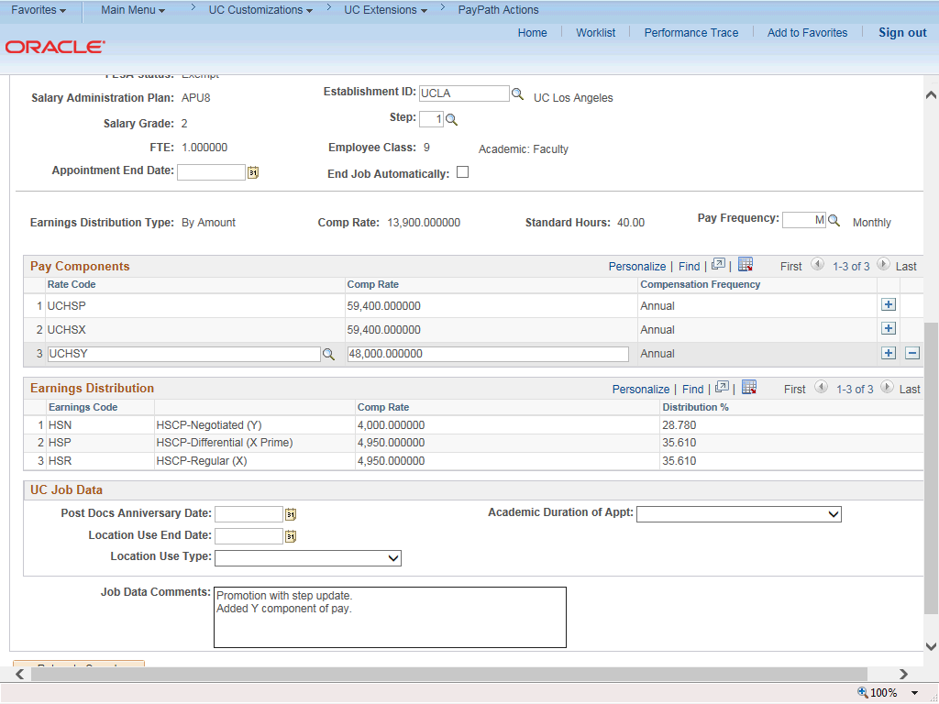

Step | Action
46. | Click the scroll bar.
47. | Click the Additional Pay Data tab.

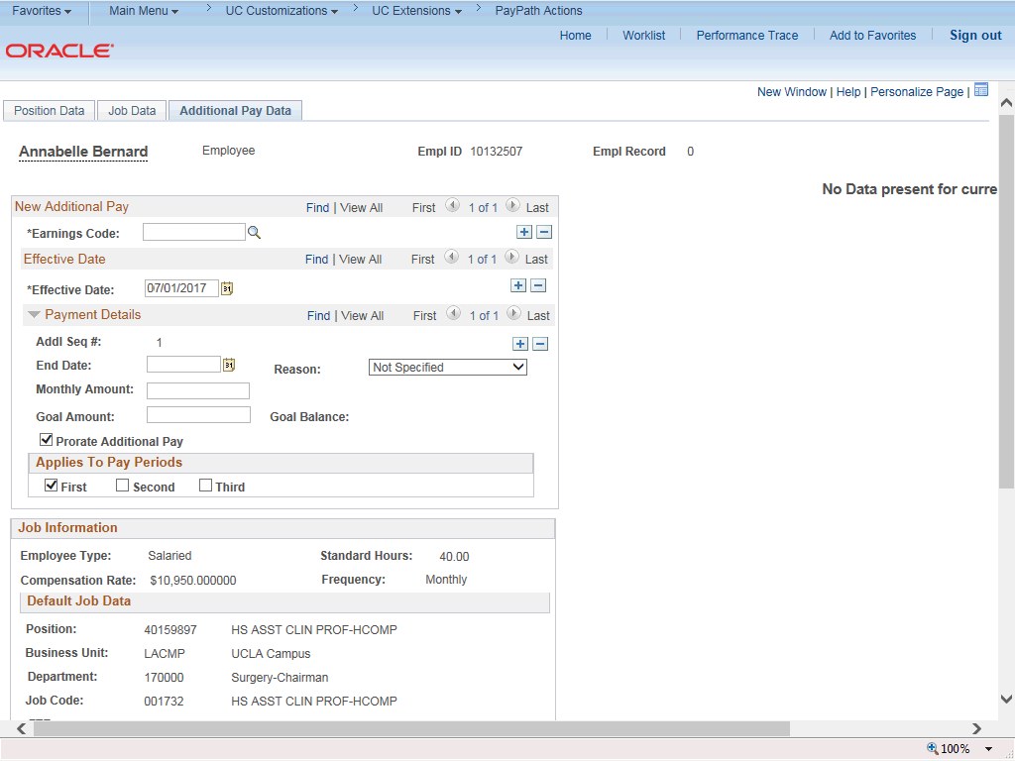

Step | Action
48. | Click the scroll bar.
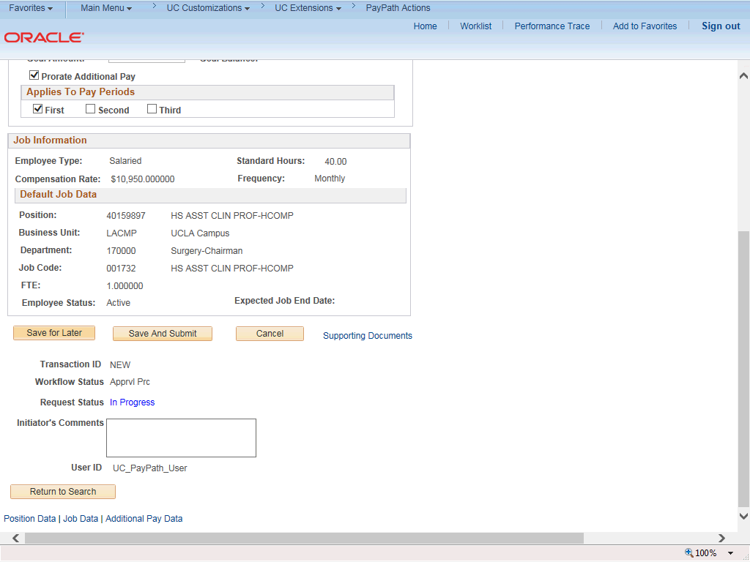

Step | Action
49. | Use the Supporting Documents link to attach supporting documentation, if applicable.
50. | Use the Initiator's Comments field, to further explain the transaction to the Approver, if applicable.
51. | Click the Save and Submit button.
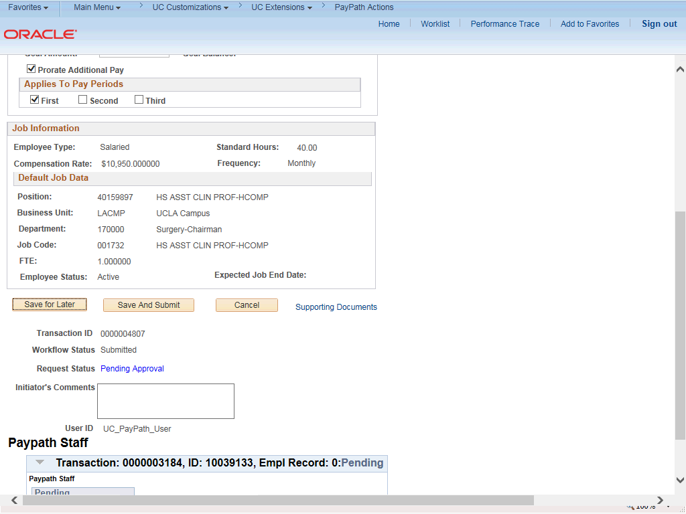

Step | Action
52. | The transaction is submitted for approval.
53. | You have initiated a position data change and job data change PayPath transaction.  End of Procedure.

