Use this task to initiate a retroactive additional pay PayPath transaction for academic or staff employees.

Navigation: PeopleSoft Menu > UC Customizations > UC Extensions > PayPath Actions Note: This page also may be available in Workcenter depending on your security access.
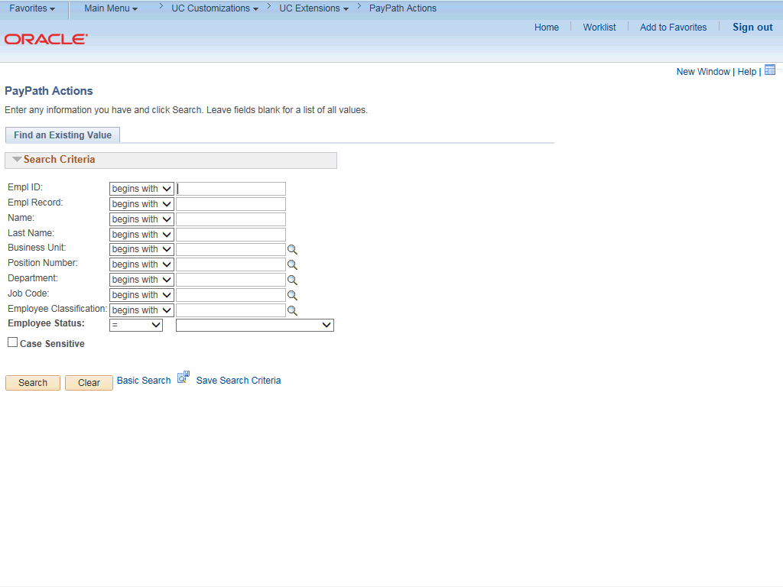

Step | Action
1. | After you navigate to the PayPath Actions component, the system displays the Find an Existing Value tab, which you use to search for the appropriate employee record.  Enter search criteria in one or more of the search fields on this page.
2. | Click in the Empl ID field.
3. | Enter the desired information into the Empl ID field.
4. | Click the Search button.

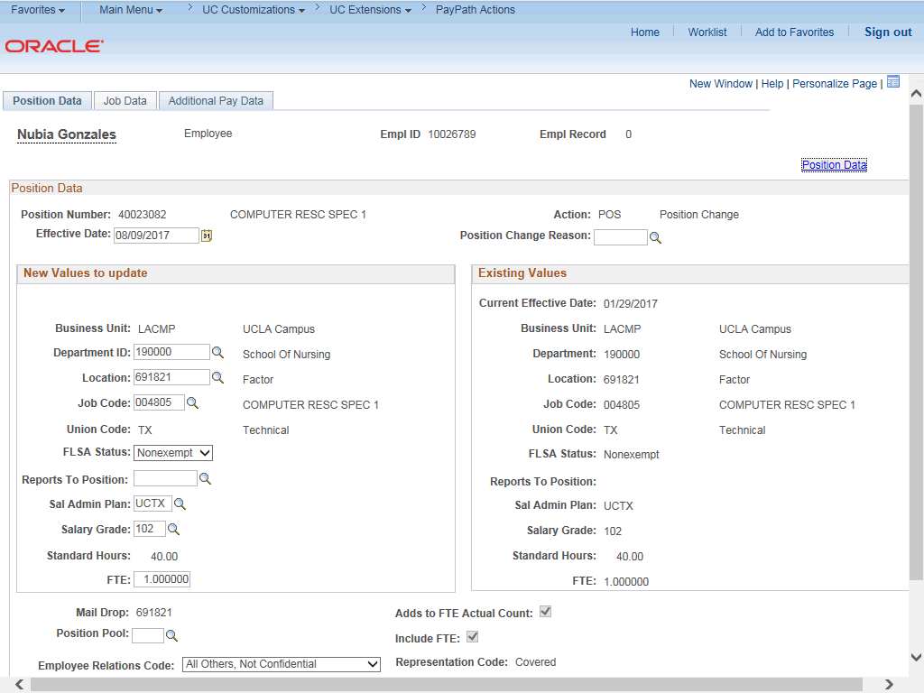

Step | Action
5. | The PayPath Actions page displays the Position Data tab. Navigate to the appropriate tab for the update you must enter. For this example, initiating retroactive additional pay, navigate to the Additional Pay tab.
6. | Click the Additional Pay Data tab.

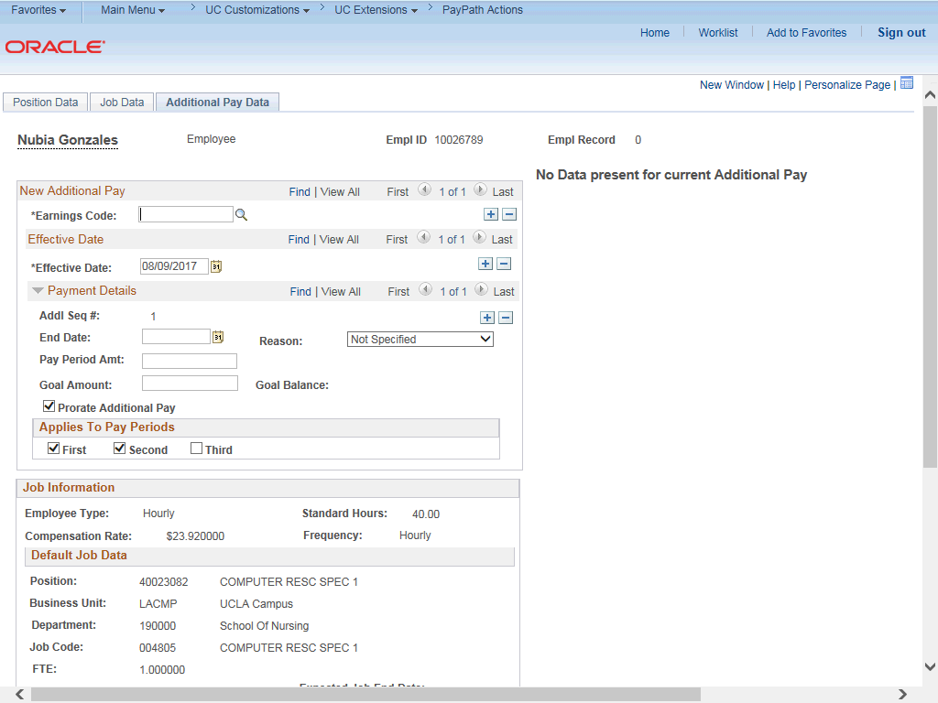

Step | Action
7. | Use the Additional Pay Data page to enter specific information about the retroactive payment.  New Additional Pay is entered on the left. If the employee has existing  additional pay, it appears in the Current Additional Pay section on the right. This employee has No Data present for current Additional Pay.
8. | Enter the Earnings Code, Effective Date and Pay Period Amount for the additional pay.  For one-time and recurring payments, enter a Goal Amount or End Date. The additional payment stops when the goal amount or end date is reached.
9. | Click the Look up Earnings Code button.

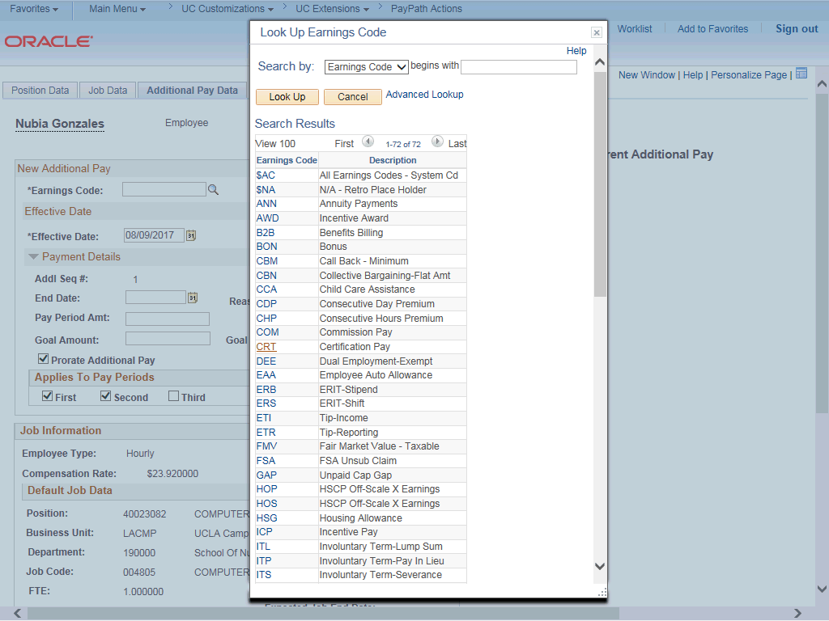

Step | Action
10. | The Earnings Codes that appear are based on the earnings program tied to the employee's paygroup. Select the appropriate Earnings Code.  For this example, click the CCA (child care assistance) list item.
11. | The Effective Date field defaults to the system date (today's date). If needed, change the date to reflect the first day of the pay period that the additional pay should begin. To enter a retroactive date, select a pay period date that has already been paid.  Click in the Effective Date field.
12. | Enter the desired information into the Effective Date field.
13. | Click the button to the right of the Reason field.
14. | Click the Retroactive Change list item.

Step | Action
15. | Enter the monthly amount of the additional pay. The system automatically calculates the amount as needed for each prior paycheck, provided the employee was paid in the prior pay period(s) and the Earnings Code selected is configured as a retro eligible earnings code  Click in the Pay Period Amt field.
16. | Enter the desired information into the Pay Period Amt field.
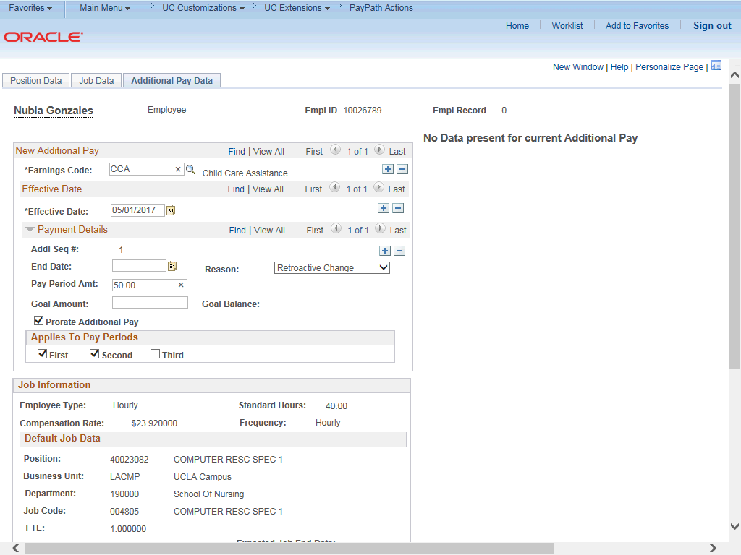

Step | Action
17. | Click in the Goal Amount field.

Step | Action
18. | Enter the desired information into the Goal Amount field.
19. | Accept the default for the Applies to Pay Periods check boxes.  The First check box is selected for monthly employees. The First and Second check boxes are selected for biweekly employees. For biweekly employees, you may select which pay period(s) the additional pay should be paid.

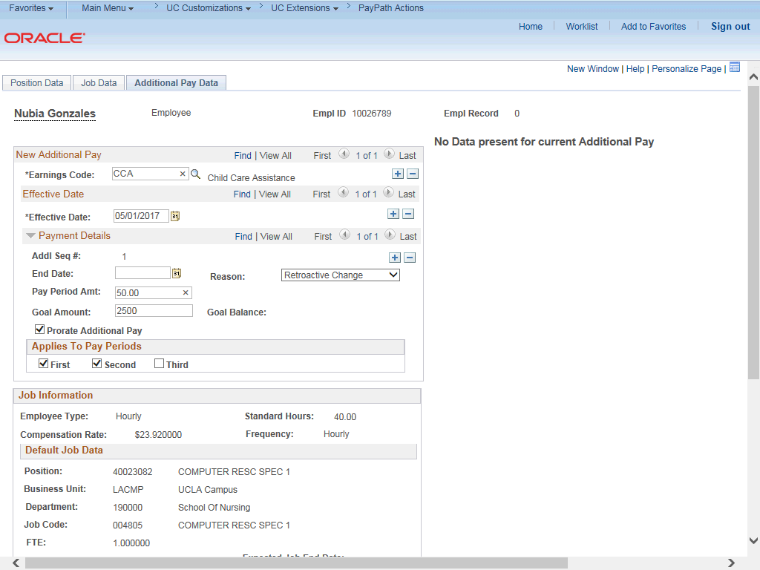

Step | Action
20. | Click the scroll bar.
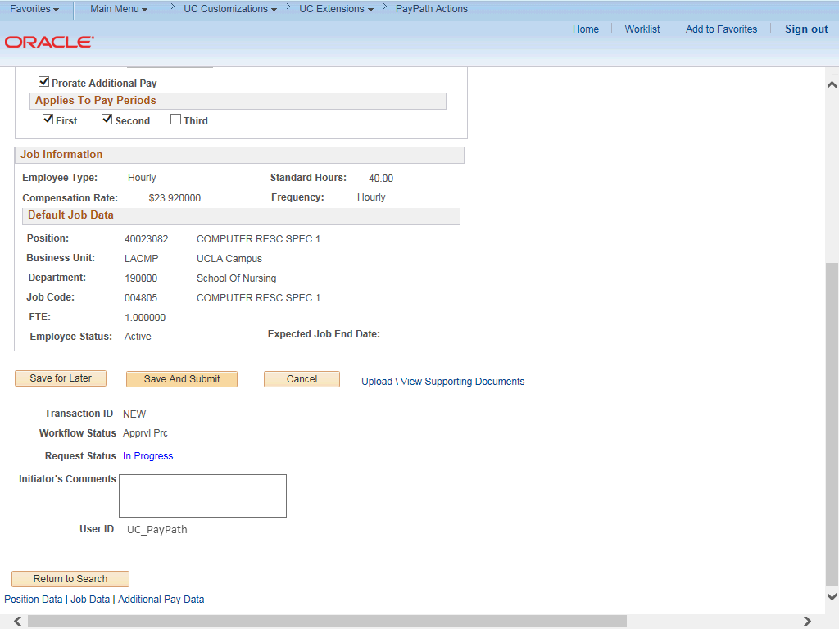

Step | Action
21. | Use the Upload \ View Supporting Documents link to attach supporting documentation, if applicable.
22. | Use the Initiator's Comments field, to further explain the transaction for the Approver, if applicable.
23. | Click the Save And Submit button.
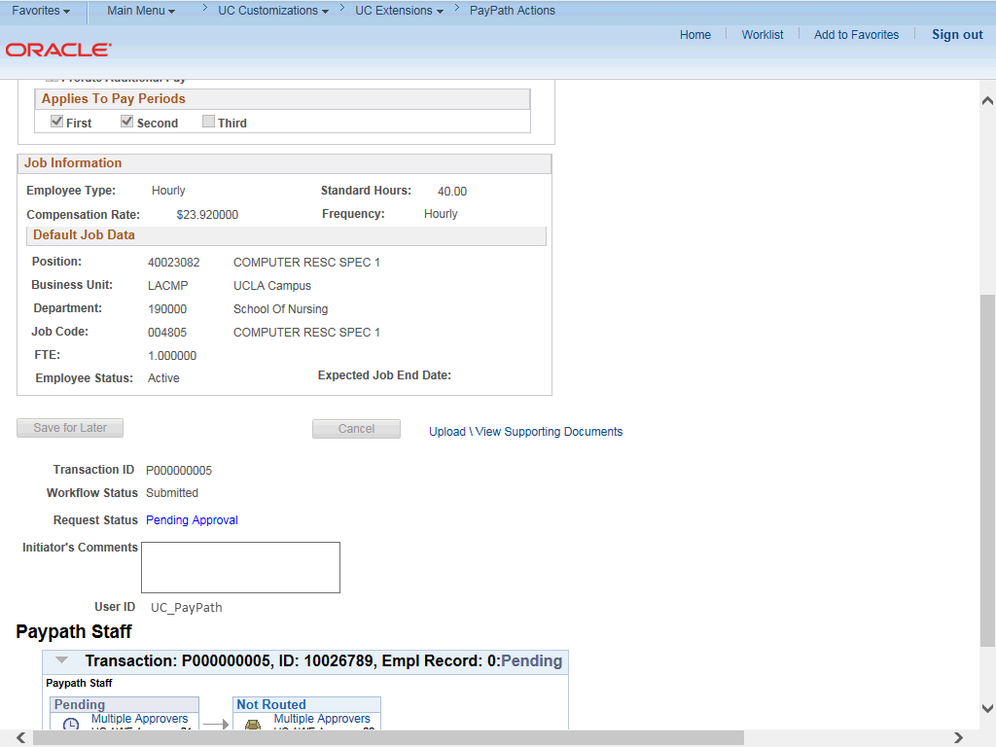

Step | Action
24. | The transaction is submitted for approval.
25. | You have initiated a retroactive additional pay PayPath transaction.  End of Procedure.

