Use this task to update an existing recurring additional pay PayPath transaction for staff and academic employees.

Navigation: PeopleSoft Menu > UC Customizations > UC Extensions > PayPath Actions Note: This page also may be available in Workcenter depending on your security access.
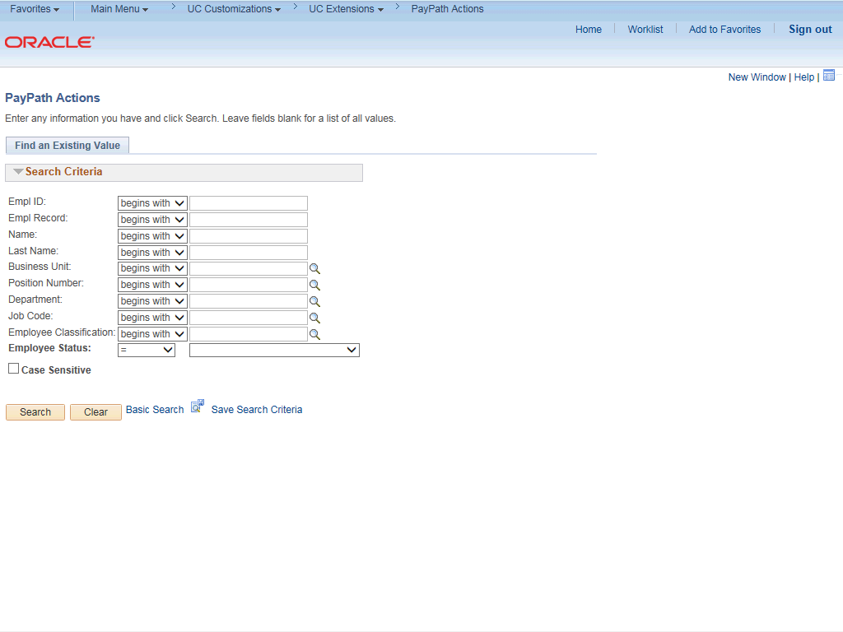

Step | Action
1. | After you navigate to the PayPath Actions component, the system displays the Find an Existing Value tab, which you use to search for the appropriate employee record.  Enter search criteria in one or more of the search fields on this page.
2. | Click in the Empl ID field.
3. | Enter the desired information into the Empl ID field.
4. | Click the Search button.

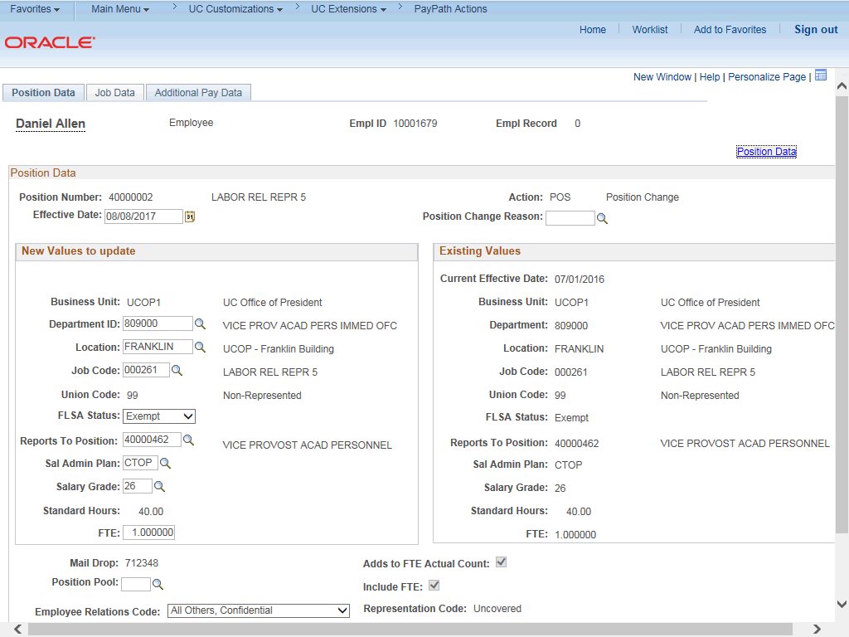

Step | Action
5. | The PayPath Actions page displays the Position Data tab. Navigate to the appropriate tab for the update you must enter. For this example, an update to additional pay, navigate to the Additional Pay Data tab.
6. | Click the Additional Pay Data tab.

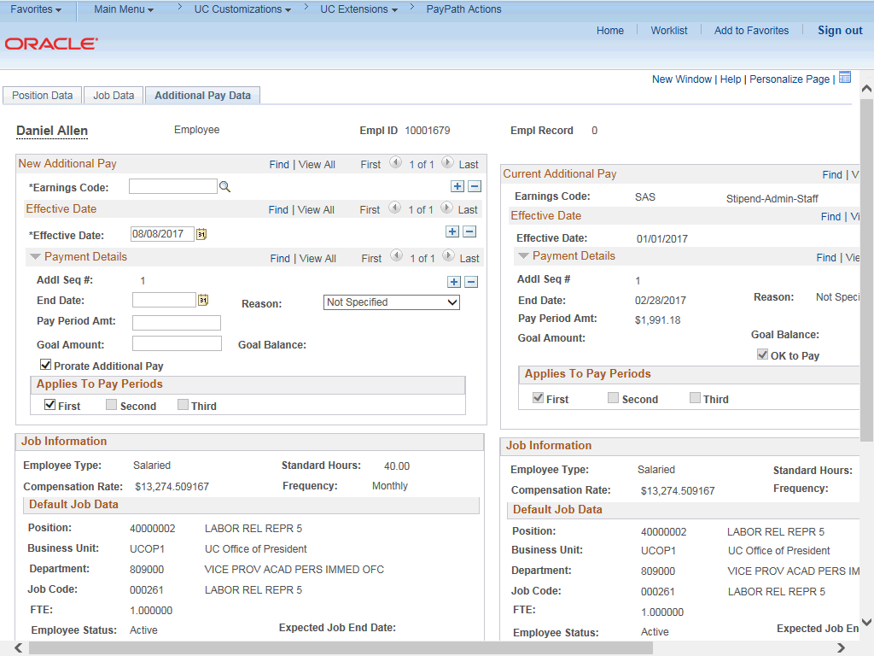

Step | Action
7. | Use the Additional Pay Data page to enter specific information about the payment.  New Additional Pay is entered on the left. If the employee has existing additional pay, it appears in the Current Additional Pay section on the right.
8. | Enter the Earnings Code, Effective Date and Pay Period Amount for the additional pay.  For one-time and recurring payments, enter a Goal Amount or End Date. The additional payment stops when the goal amount or end date is reached.
9. | Enter the same Earnings Code as the current additional pay. In this example, the current code is SAS.  Click in the Earnings Code field.
10. | Enter the desired information into the Earnings Code field.

Step | Action
11. | The update must have an Effective Date that is after the current additional pay  Effective Date and before current additional pay End Date (if one exists).  When an Effective Date is entered and is within this range, the Override Data  button will appear.  In this example, the current Effective Date is 01/01/2017 and the End Date is 02/28/2017.  Click in the Effective Date field.
12. | Enter the desired information into the Effective Date field.
13. | After you enter the Earnings Code and the Effective Date, the current additional pay information populates the new additional pay section and the Override Data button appears.
14. | Click the Override Data button to open the fields for edit.
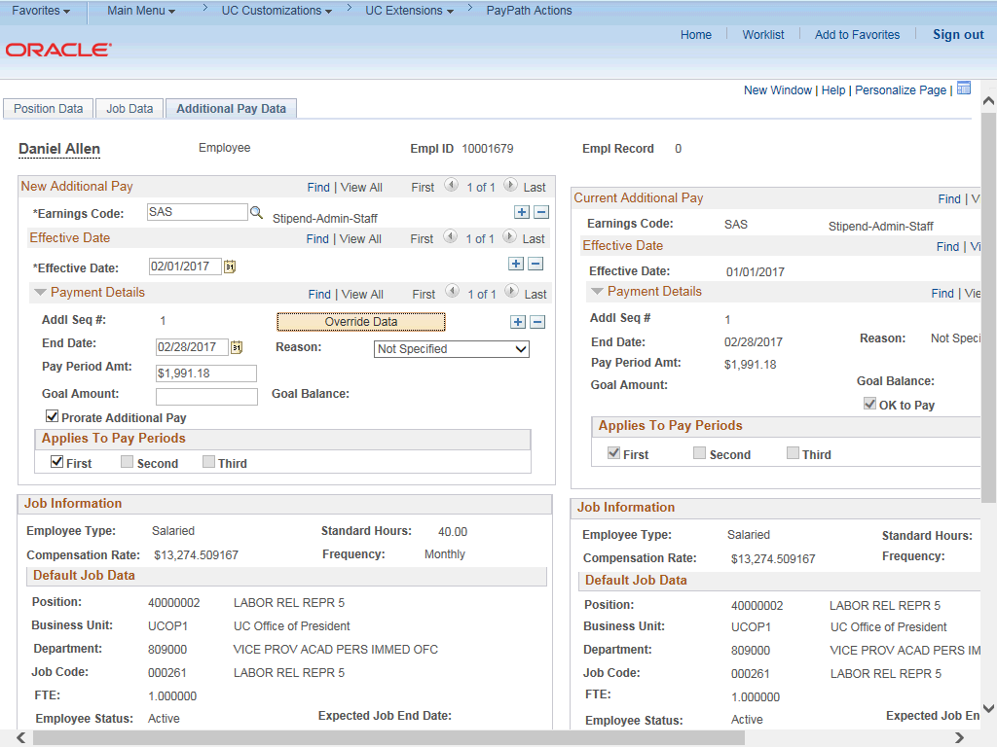

Step | Action
15. | The Payment Details fields open for editing. Update the fields, as needed.  In this example, the End Date and Pay Period Amt fields must be updated.
16. | Click in the End Date field.
17. | Enter the desired information into the End Date field.
18. | Click in the Pay Period Amt field.
19. | Enter the desired information into the Pay Period Amt field.
20. | Accept the default for the Applies to Pay Periods check boxes.  The First check box is selected for monthly employees. The First and Second check boxes are selected for biweekly employees. For biweekly employees, you may select which pay period(s) the additional pay should be paid.
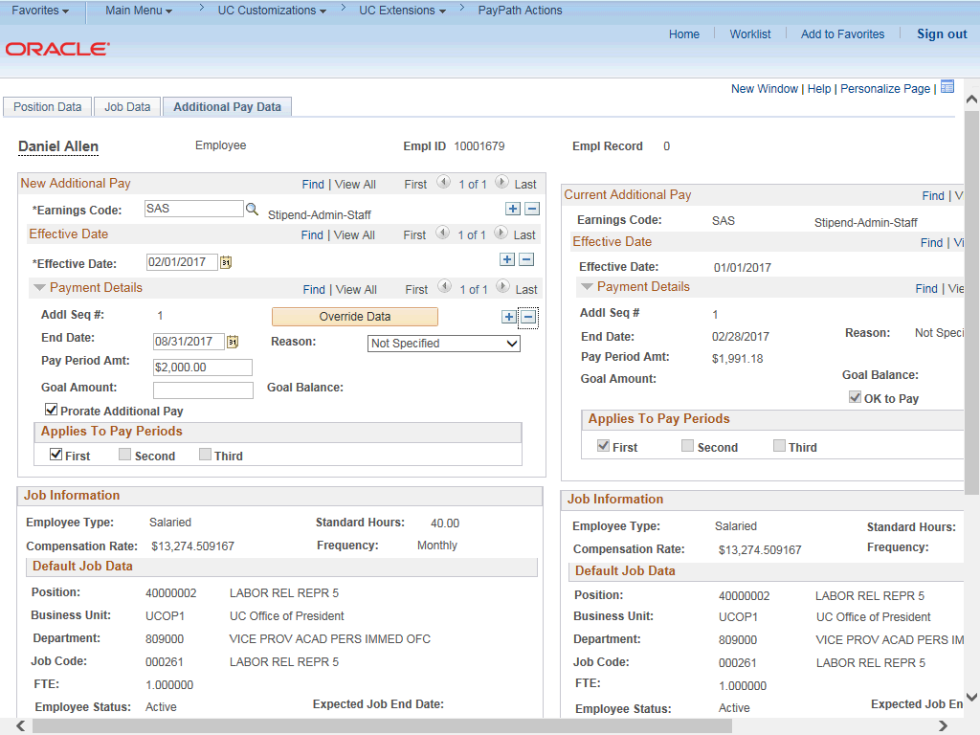

Step | Action
21. | Click the scroll bar.

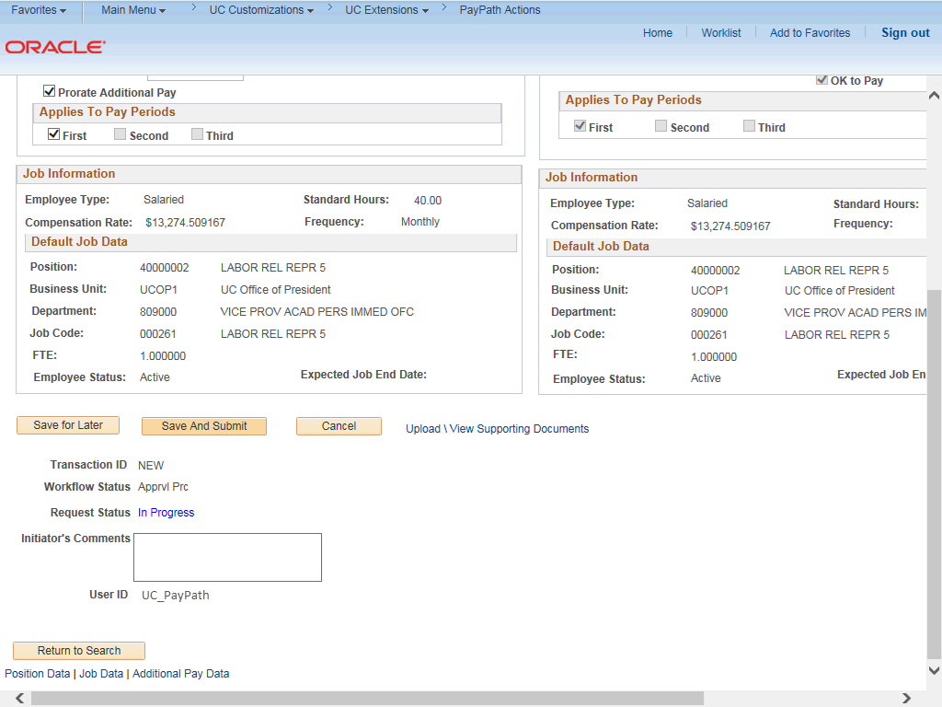

Step | Action
22. | Use the Upload \ View Supporting Documents link to attach supporting documentation, if applicable.
23. | Use the Initiator's Comments field, to further explain the transaction for the Approver, if applicable.
24. | Click the Save And Submit button.

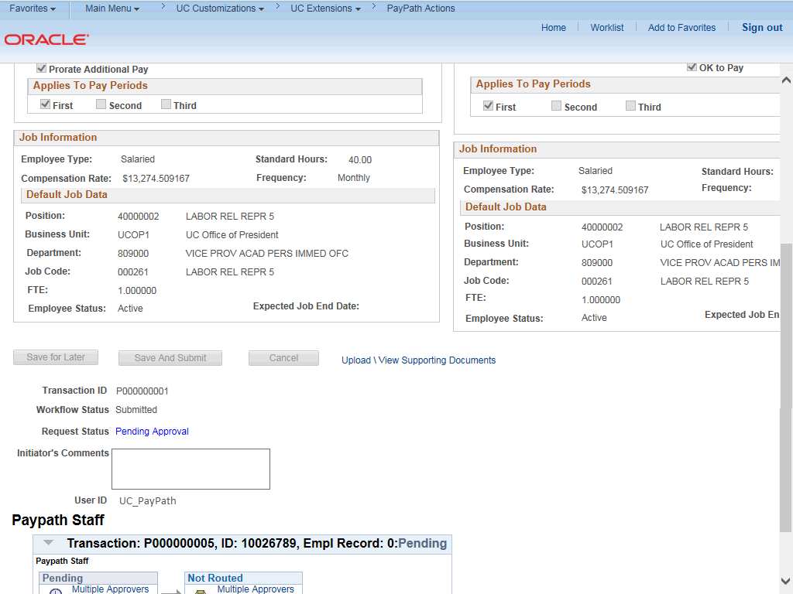

Step | Action
25. | The transaction is submitted for approval.
26. | You have updated a recurring additional pay PayPath transaction.  End of Procedure.

