Use this task to initiate an additional pay PayPath transaction for academic or staff employees. Navigation: PeopleSoft Menu > UC Customizations > UC Extensions > PayPath Actions Note: This page also may be available in Workcenter depending on your security access.
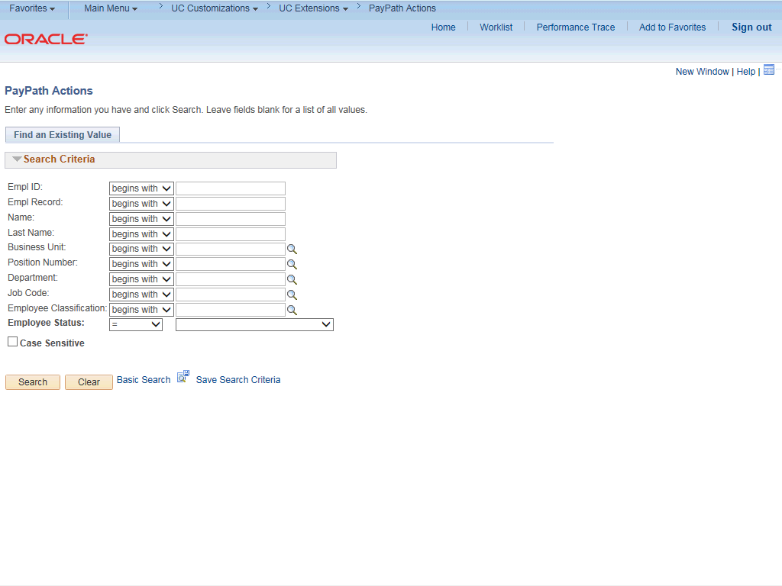

Step | Action
1. | After you navigate to the PayPath Actions component, the system displays the Find an Existing Value tab, which you use to search for the appropriate employee record.  Enter search criteria in one or more of the search fields on this page.
2. | Click in the Empl ID field.
3. | Enter the desired information into the Empl ID field.
4. | Click the Search button.

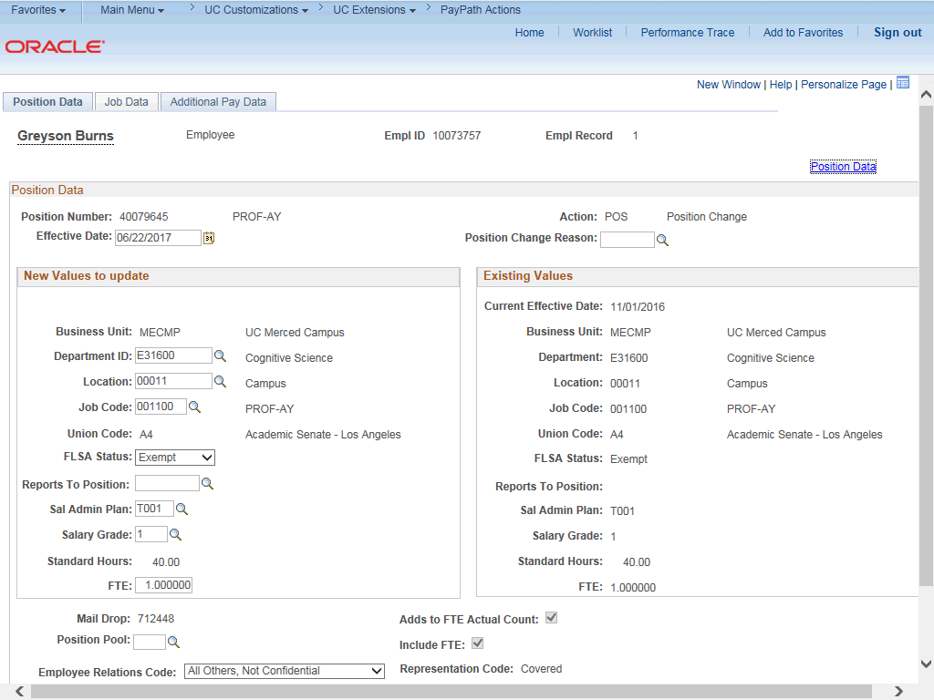

Step | Action
5. | The PayPath Actions page displays the Position Data tab. Navigate to the appropriate tab for the update you must enter. For this example, initiating additional pay, navigate to the Additional Pay tab.
6. | Click the Additional Pay Data tab.

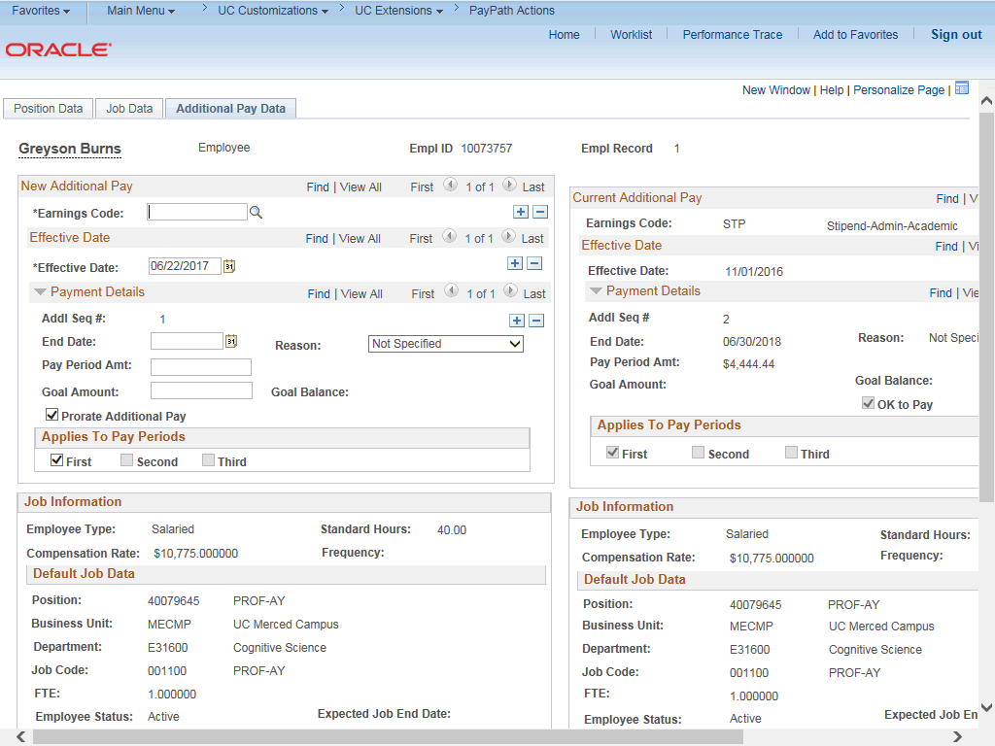

Step | Action
7. | Use the Additional Pay Data page to enter specific information about the payment.  New Additional Pay is entered on the left. If the employee has existing additional pay, it appears in the Current Additional Pay section on the right.
8. | Enter the Earnings Code, Effective Date and Pay Period Amount for the additional pay.  For one-time or recurring payments enter a Goal Amount or End Date. The additional payment stops when the goal amount or end date is reached.
9. | Click the Look up Earnings Code button.

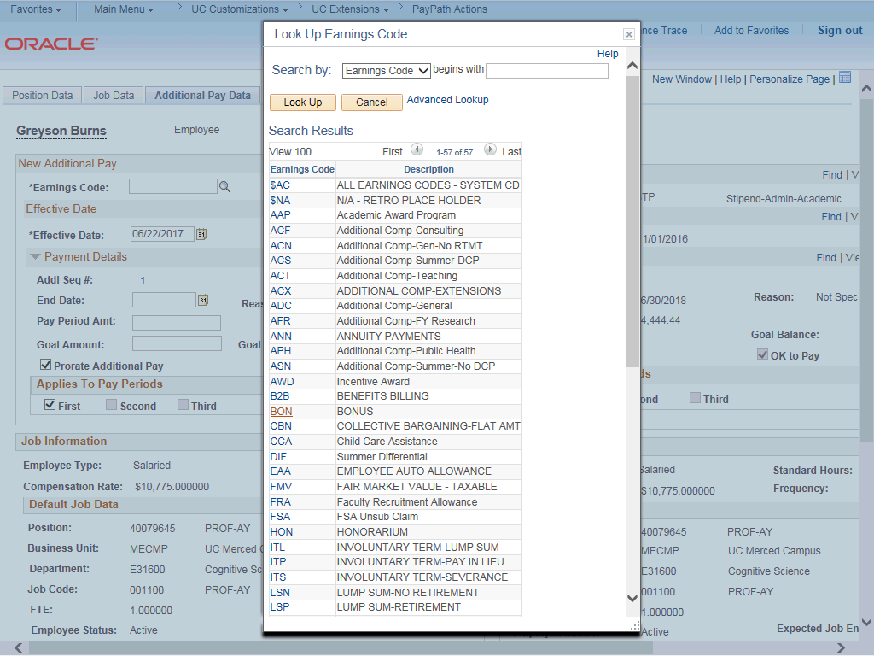

Step | Action
10. | The Earnings Codes that appear are based on the earnings program tied to the employee's paygroup. Select the appropriate Earnings Code.  For this example, click the ADC (Additional Comp-General) list item.
11. | The Effective Date field defaults to the system date (today's date). If needed, change the date to reflect the first day of the pay period that the additional pay should begin.  Click in the Effective Date field.
12. | Enter the desired information into the Effective Date field.
13. | Enter the per pay period amount of the additional pay. Click in the Pay Period Amt field.
14. | Enter the desired information into the Pay Period Amt field.
15. | Click the button to the right of the Reason field.

Step | Action
16. | Select the appropriate Reason.  For this example, click the New Additional Pay list item.
17. | The system continues to pay the amount indicated in the Pay Period Amt field until the Goal Amount is reached.  Click in the Goal Amount field.
18. | Enter the desired information into the Goal Amount field.
19. | The Prorate Additional Pay check box is based on the employee's JOB record. If the employee has a mid-period, effective-dated change on their JOB record, the system prorates the additional pay. The system does not prorate the additional pay based on the Effective Date of the Additional Pay record. It is encouraged to keep this box on.
20. | Accept the default for the Applies to Pay Periods check boxes.  The First check box is selected for monthly employees. The First and Second check boxes are selected for biweekly employees. For biweekly employees, you may select which pay period(s) the additional pay should be paid.
21. | In the Earnings Code section, you can add a row to enter another type of additional pay with a different Earnings Code.
22. | In the Effective Date section, you can add a row to enter another additional pay for the same Earnings Code but a different Effective Date.
23. | In the Payment Details section, you can add a row to enter another additional pay for the same Earnings Code on the same Effective Date but different payment information.

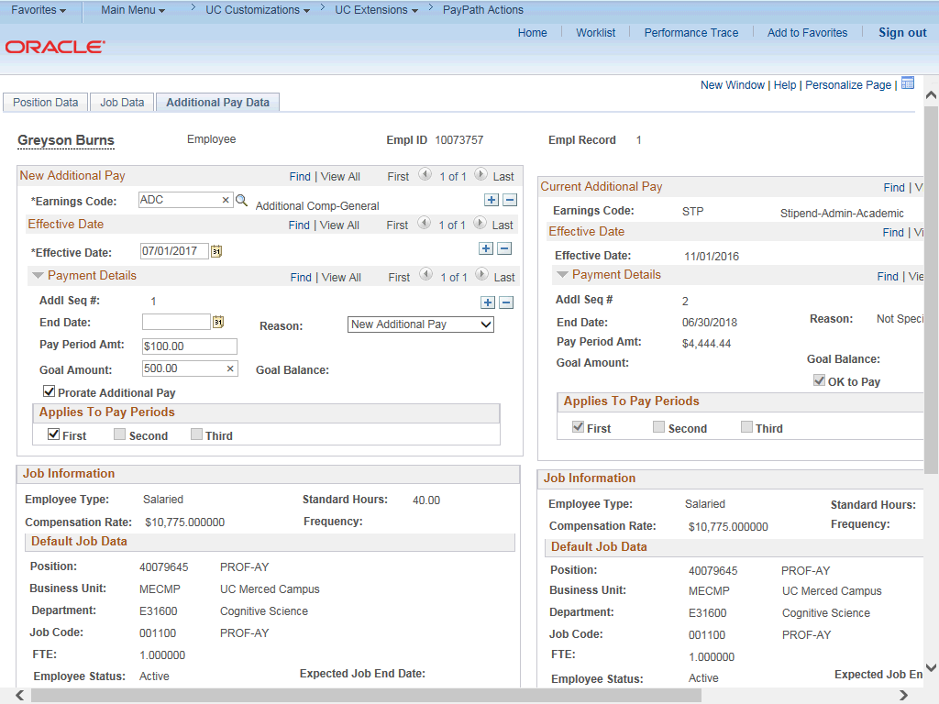

Step | Action
24. | Click the scroll bar.
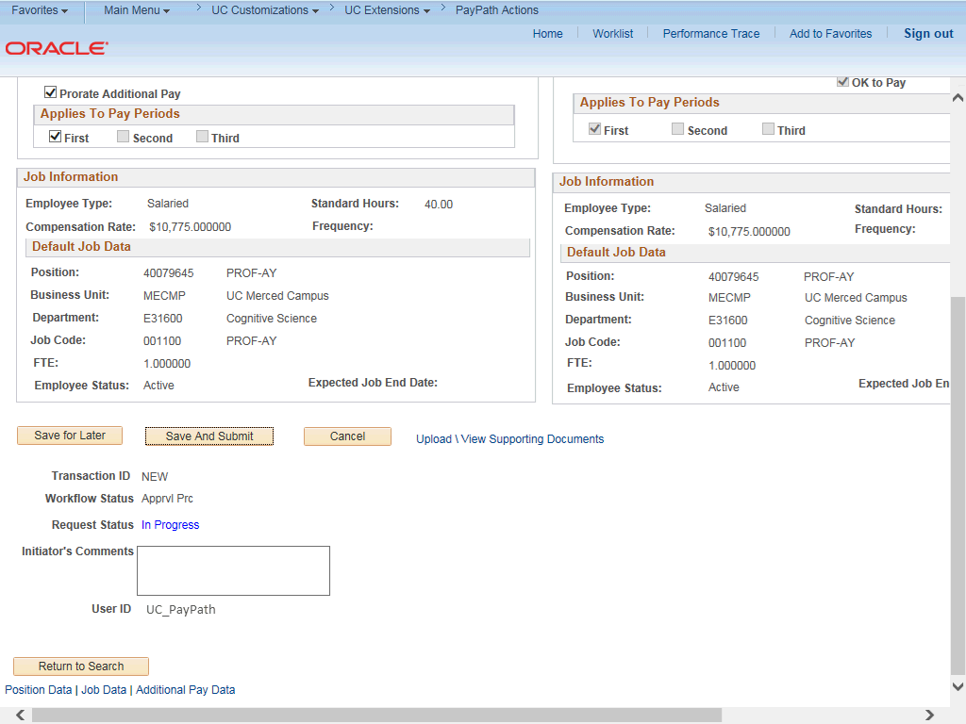

Step | Action
25. | Use the Upload \ View Supporting Documents link to attach supporting documentation, if applicable.
26. | Use the Initiator's Comments field, to further explain the transaction for the Approver, if applicable.
27. | Click the Save And Submit button.
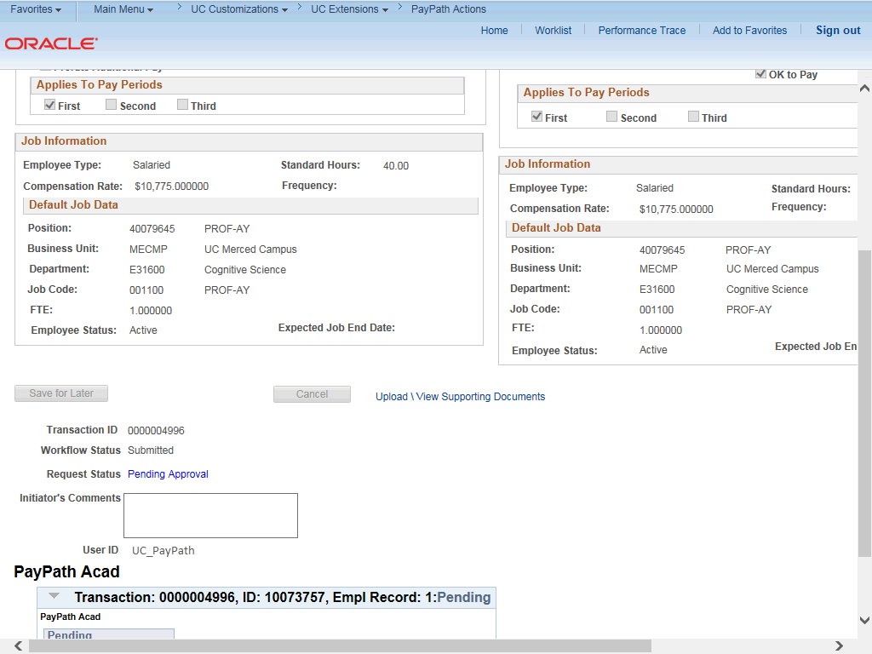

Step | Action
28. | The transaction is submitted for approval.
29. | You have initiated an additional pay PayPath transaction.  End of Procedure.

