Use this task to initiate a return from short work break PayPath transaction. The steps in this procedure can be used for academic or staff employees.

Navigation: PeopleSoft Menu > UC Customizations > UC Extensions > PayPath Actions Note: This page also may be available in Workcenter depending on your security access.
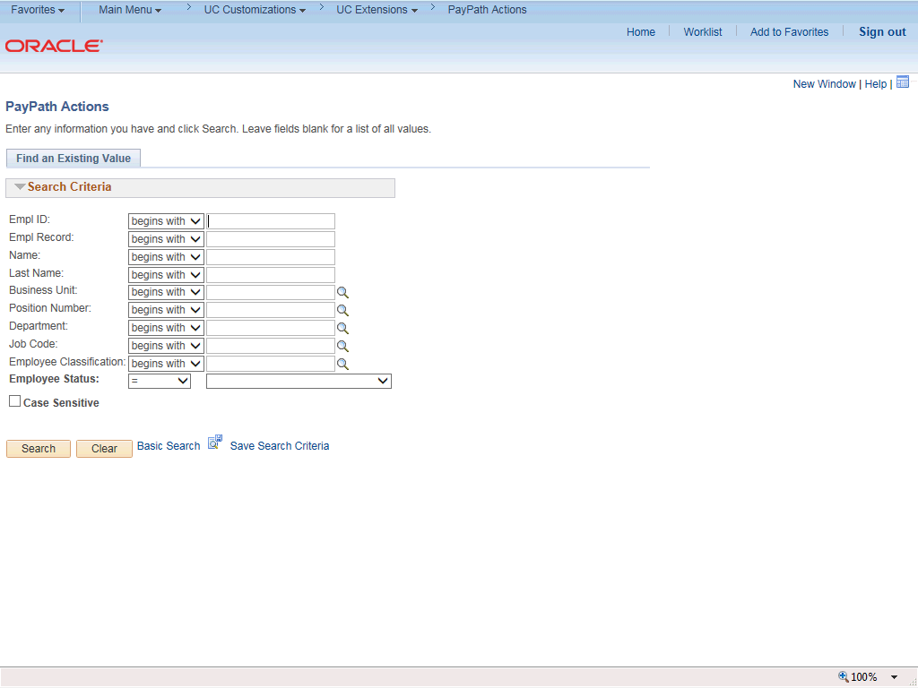

Step | Action
1. | After you navigate to the PayPath Actions component, the system displays the Find an Existing Value tab, which you use to search for the appropriate employee record.  Enter search criteria in one or more of the search fields on this page.
2. | Click in the Empl ID field.
3. | Enter the desired information into the Empl ID field.
4. | Click the Search button.

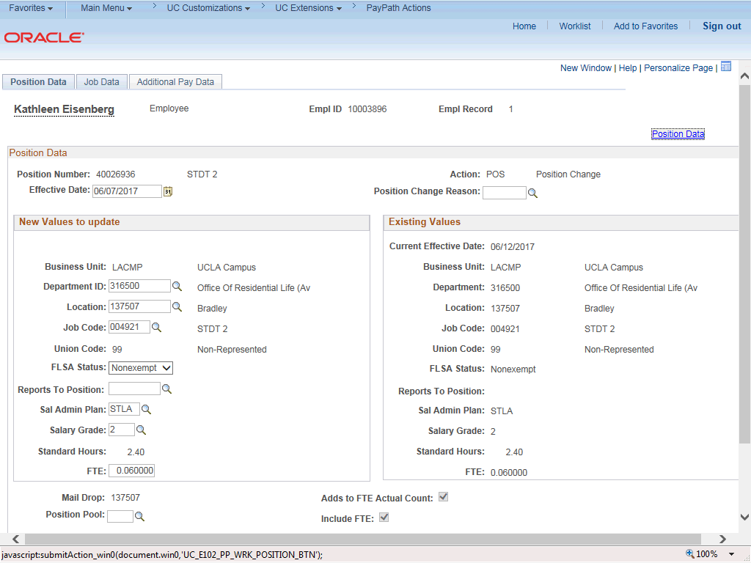

Step | Action
5. | The PayPath Actions page displays the Position Data tab. Navigate to the appropriate tab for the update you must enter. For this example, a return from short work break, navigate to the Job Data tab.
6. | Click the Job Data tab.

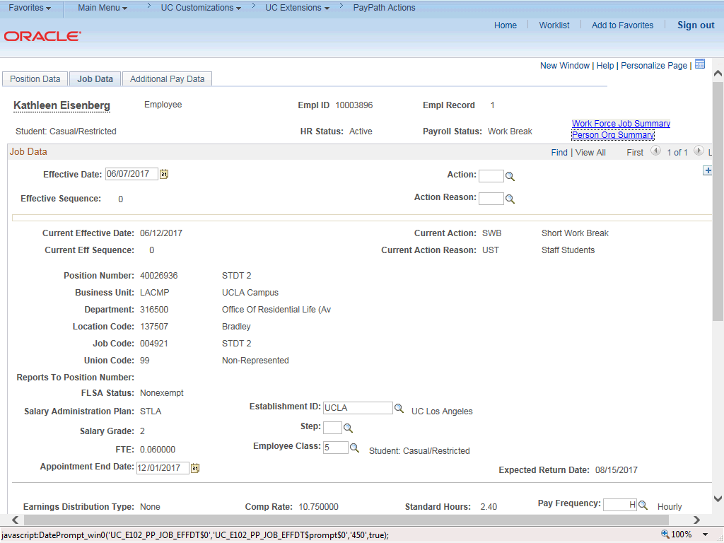

Step | Action
7. | Before entering the update, you must identify the Effective Date, Action and  Action Reason.
8. | The Effective Date field defaults to the system date (today's date). If needed, change the date to reflect the date the update should take effect.
9. | Click in the Effective Date field.
10. | Enter the desired information into the Effective Date field.
11. | Click the Look up Action button.

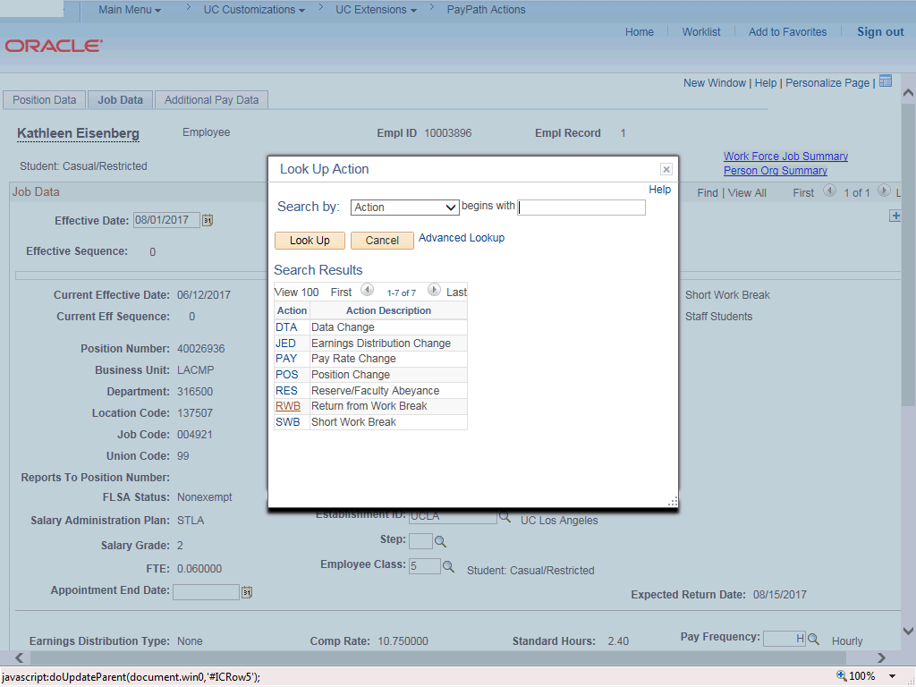

Step | Action
12. | Click the RWB (return from work break) list item.
13. | Click the Look up Action Reason button.

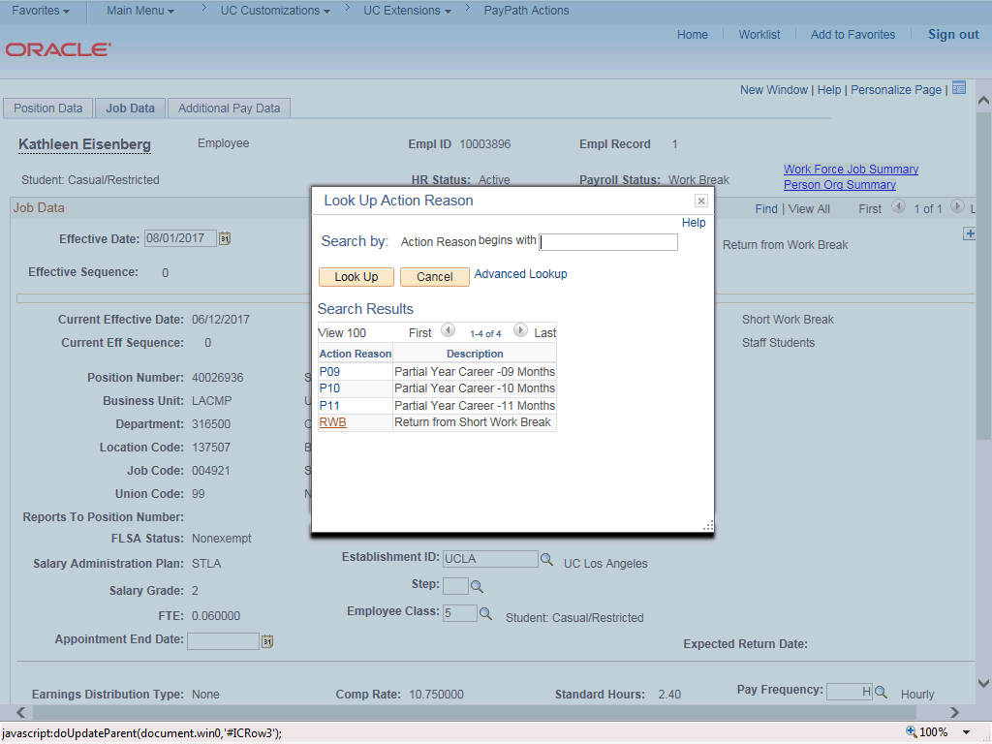

Step | Action
14. | Click the RWB (return from short work break) list item.
15. | Click the scroll bar.

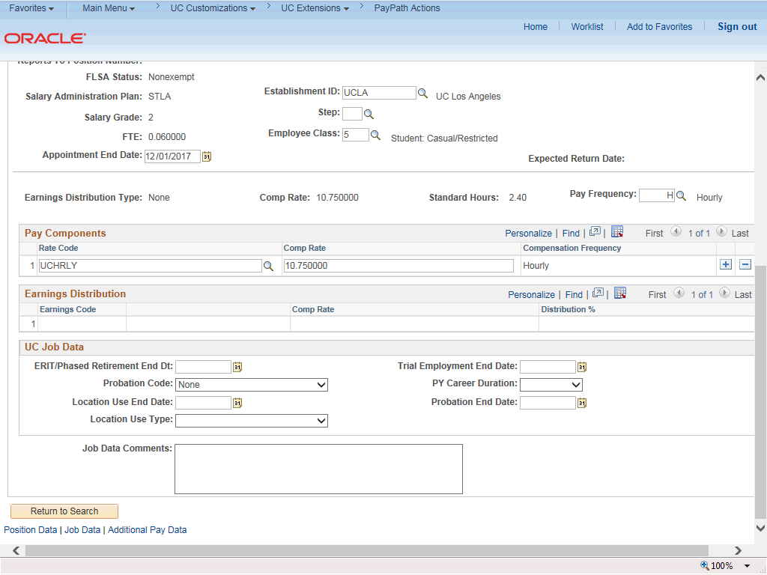

Step | Action
16. | For Job Data updates, enter a comment explaining the update. Click in the Job Data Comments field.
17. | Enter the desired information into the Job Data Comments field.
18. | Click the scroll bar.
19. | Click the Additional Pay Data tab.

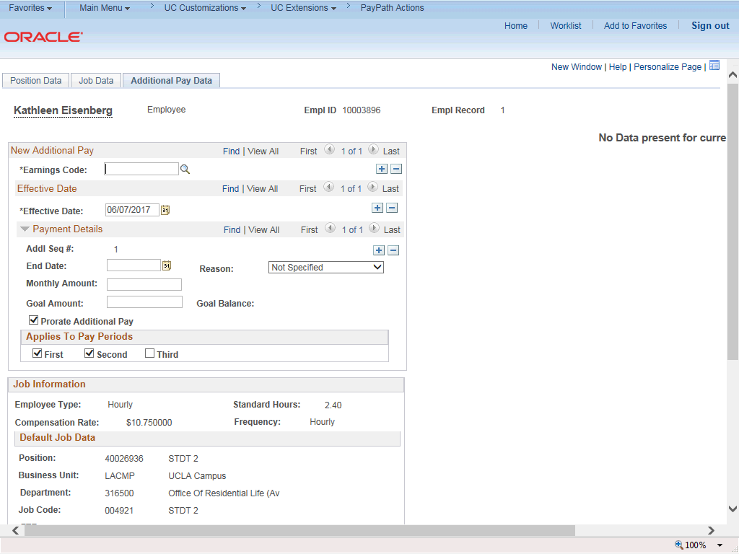

Step | Action
20. | Click the scroll bar.
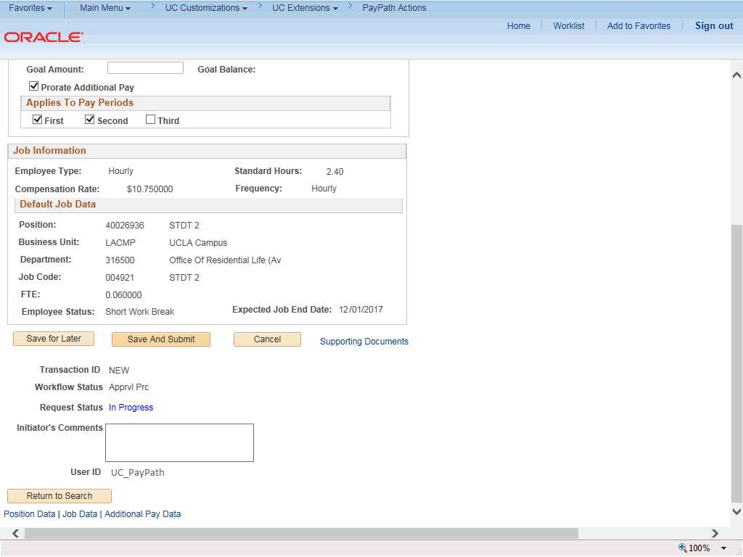

Step | Action
21. | Use the Supporting Documents link to attach supporting documentation, if applicable.
22. | Use the Initiator's Comments field, to further explain the transaction for the Approver, if applicable.
23. | Click the Save And Submit button.
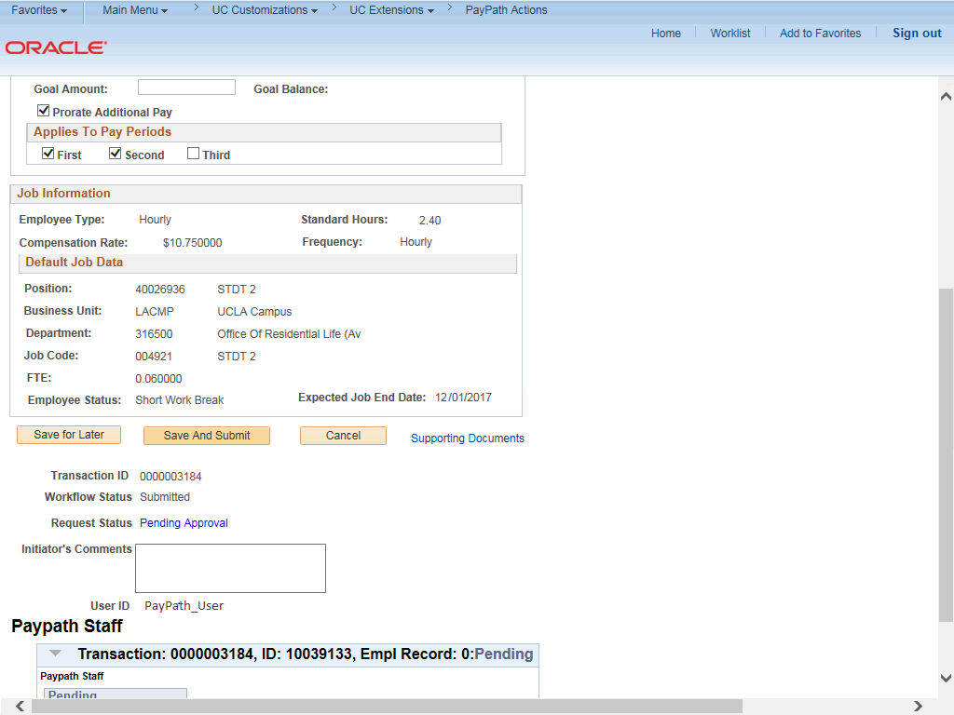

Step | Action
24. | The transaction is submitted for approval.
25. | You have initiated a return from a short work break PayPath transaction.  End of Procedure.

