Use this task to initiate a short work break PayPath transaction. The steps in this procedure can be used for academic or staff employees.

Navigation: PeopleSoft Menu > UC Customizations > UC Extensions > PayPath Actions Note: This page also may be available in Workcenter depending on your security access.
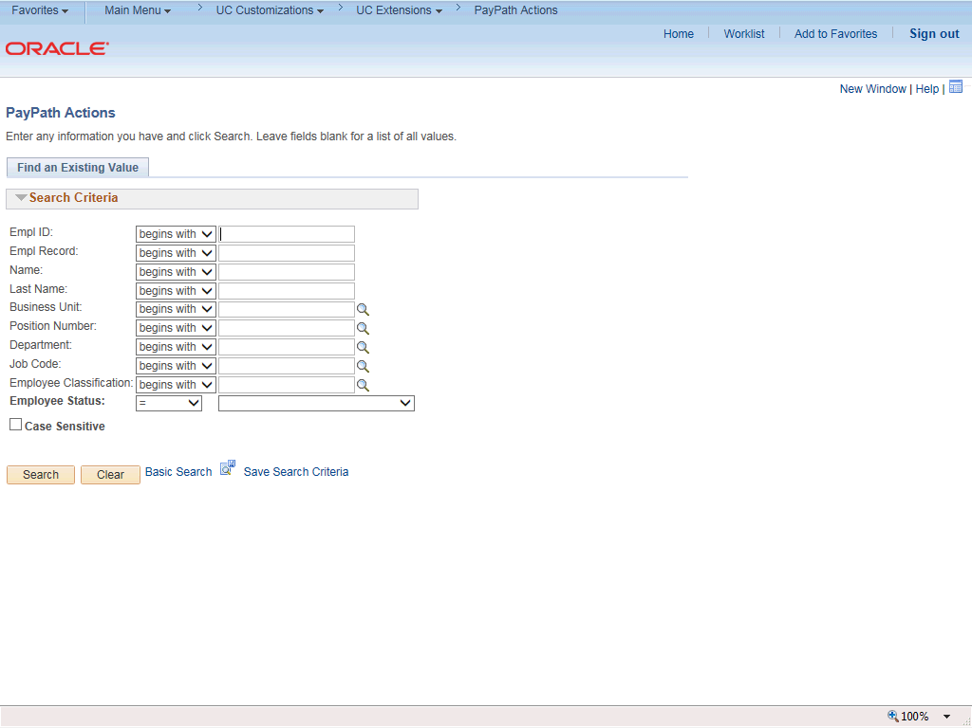

Step | Action
1. | After you navigate to the PayPath Actions component, the system displays the Find an Existing Value tab, which you use to search for the appropriate employee record.  Enter search criteria in one or more of the search fields on this page.
2. | Click in the Empl ID field.
3. | Enter the desired information into the Empl ID field.
4. | Click the Search button.

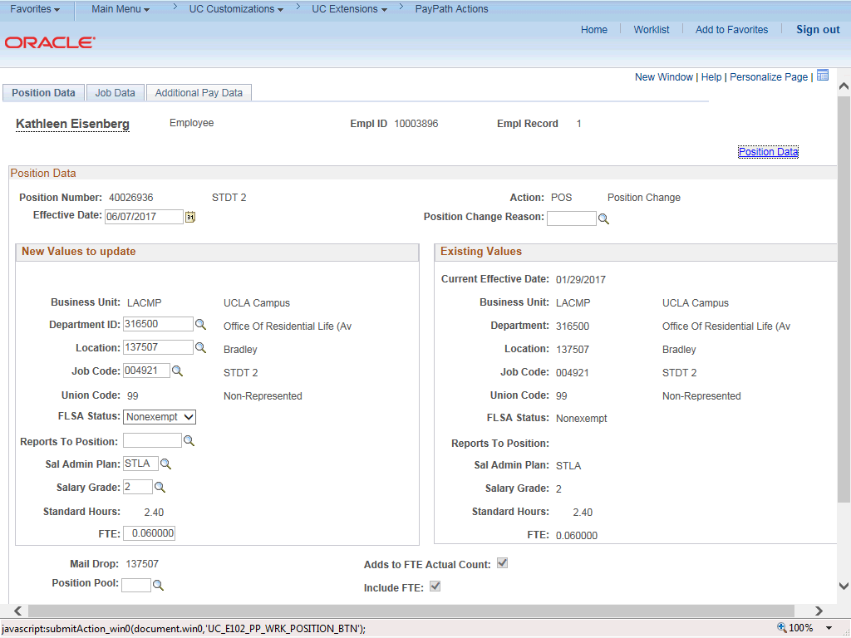

Step | Action
5. | The PayPath Actions page displays the Position Data tab. Navigate to the appropriate tab for the update you must enter. For this example, short work break, navigate to the Job Data tab.
6. | Click the Job Data tab.

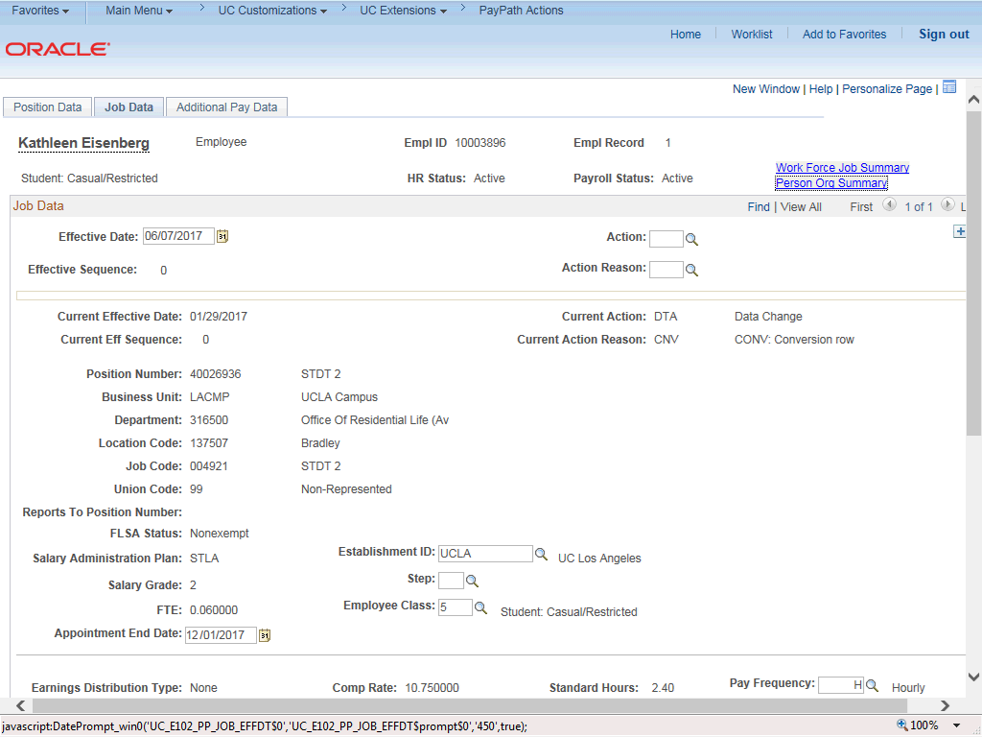

Step | Action
7. | Before entering the update, you must identify the Effective Date, Action and  Action Reason.
8. | The Effective Date field defaults to the system date (today's date). If needed, change the date to reflect the date the update should take effect.
9. | Click in the Effective Date field.
10. | Enter the desired information into the Effective Date field.
11. | Click the Look up Action button.

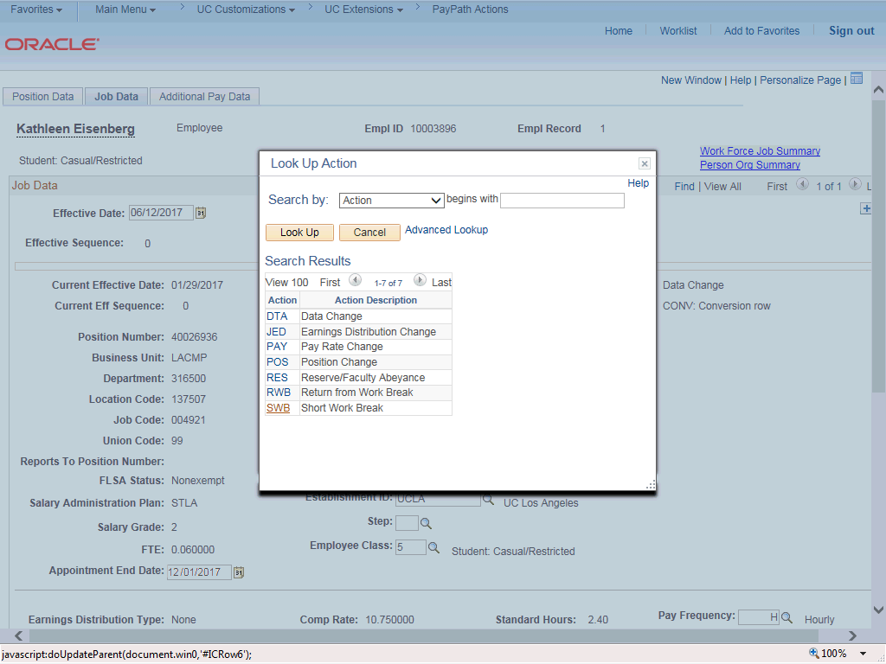

Step | Action
12. | Click the SWB (short work break) link.
13. | After the SWB Action is selected the Expected Return Date field appears. This field is required.
14. | Click the Look up Action Reason button.

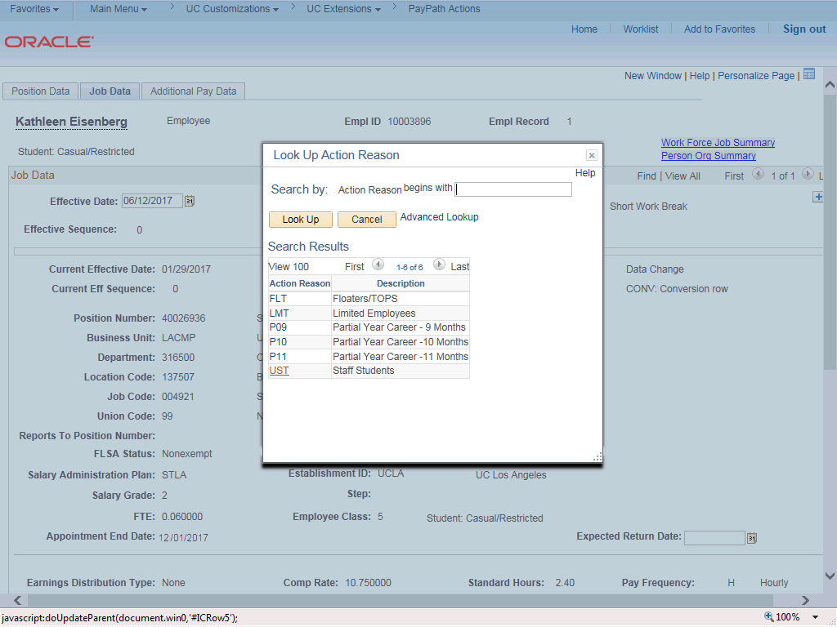

Step | Action
15. | Select the appropriate Action Reason code.  For this example, click the UST (staff students) list item.
16. | Click the scroll bar.
17. | Review the Appointment End Date field. If present, this date should not be prior to the Expected Return Date for the short work break.  If the Appointment End Date is before the Expected Return Date, then you must first extend the Appointment End Date (Effective Seq 0) then add a row to enter the short work break (Effective Seq 1).

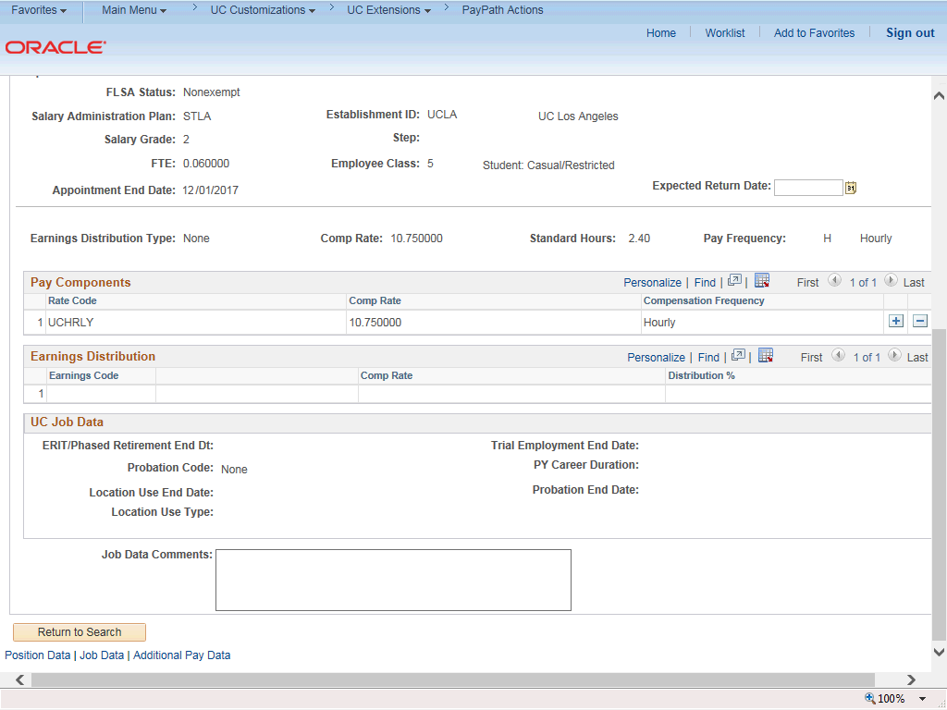

Step | Action
18. | Click in the Expected Return Date field.
19. | Enter the desired information into the Expected Return Date field.
20. | For Job Data updates, enter a comment explaining the update. Click in the Job Data Comments field.
21. | Enter the desired information into the Job Data Comments field.
22. | Click the scroll bar.
23. | Click the Additional Pay Data tab.

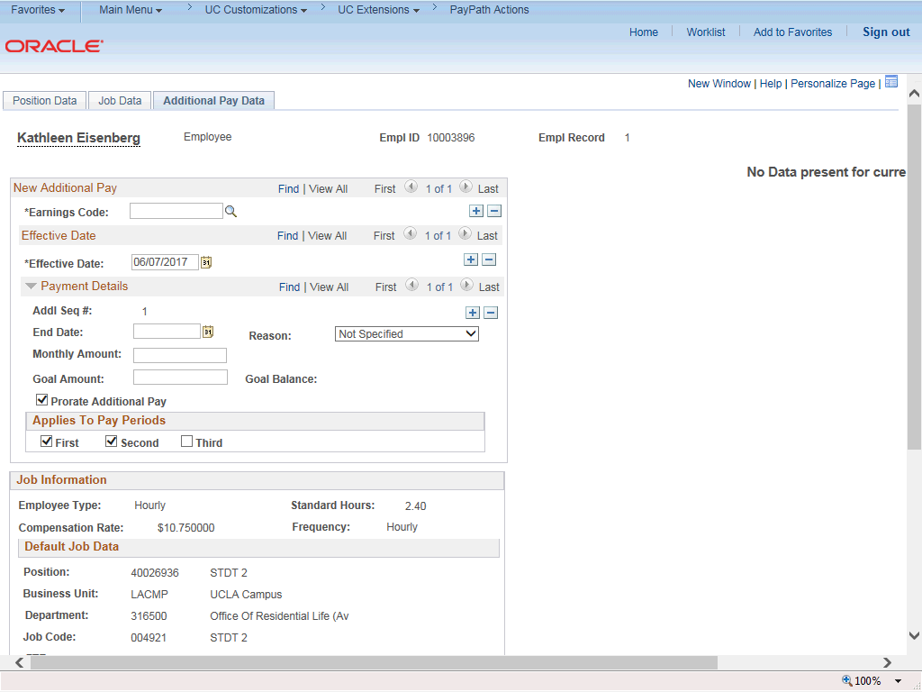

Step | Action
24. | Click the scroll bar.
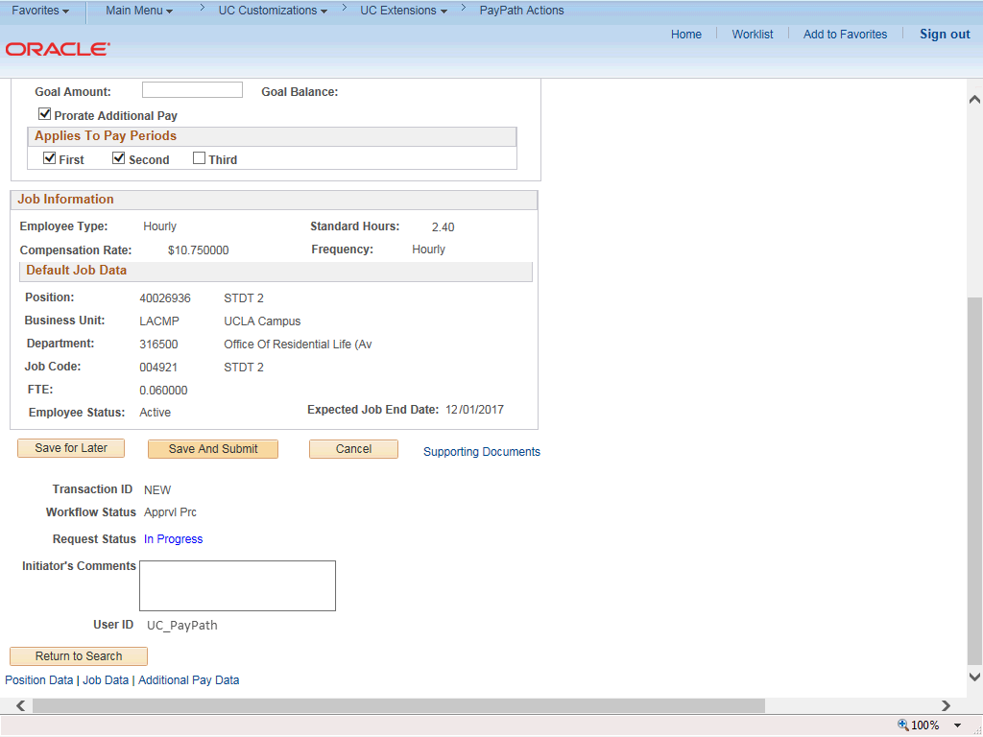

Step | Action
25. | Use the Supporting Documents link to attach supporting documentation, if applicable.
26. | Use the Initiator's Comments field, to further explain the transaction for the Approver, if applicable.
27. | Click the Save And Submit button.
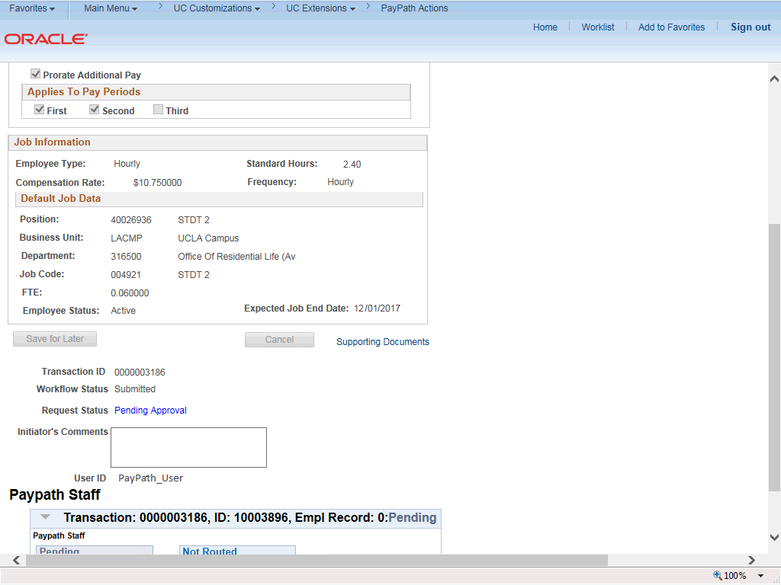

Step | Action
28. | The transaction is submitted for approval.
29. | You have initiated a short work break PayPath transaction.  End of Procedure.

