Use this task to initiate a return to regular job earnings distribution PayPath transaction. The steps in this procedure can be used for academic or staff employees.

Navigation: PeopleSoft Menu > UC Customizations > UC Extensions > PayPath Actions Note: This page also may be available in Workcenter depending on your security access.
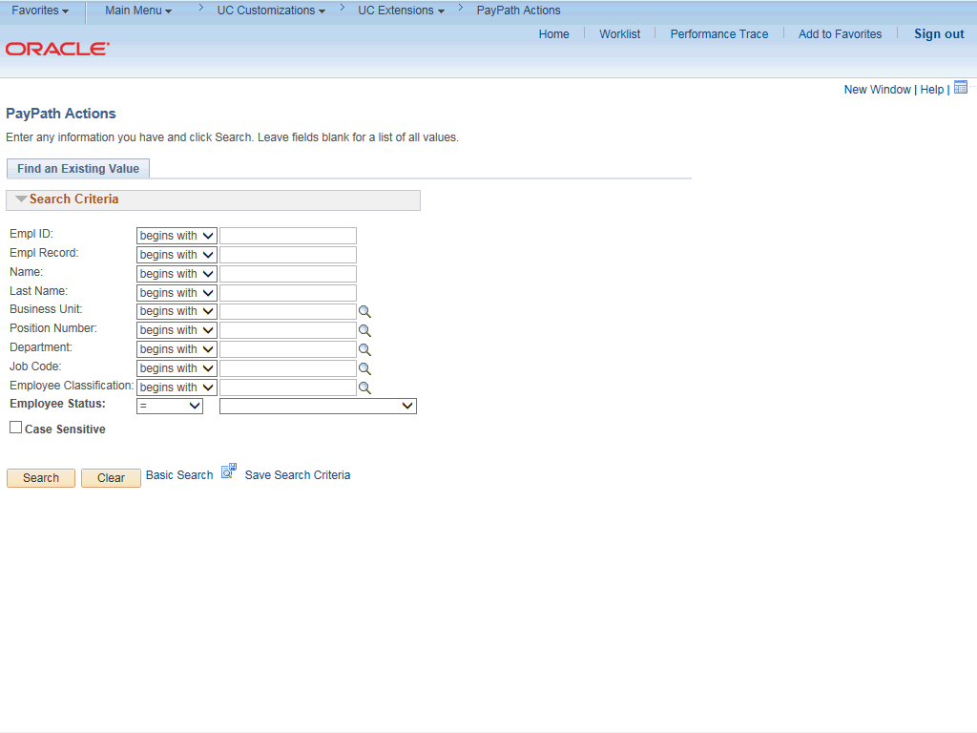

Step | Action
1. | After you navigate to the PayPath Actions component, the system displays the Find an Existing Value tab, which you use to search for the appropriate employee record.  Enter search criteria in one or more of the search fields on this page.
2. | Click in the Empl ID field.
3. | Enter the desired information into the Empl ID field.
4. | Click the Search button.

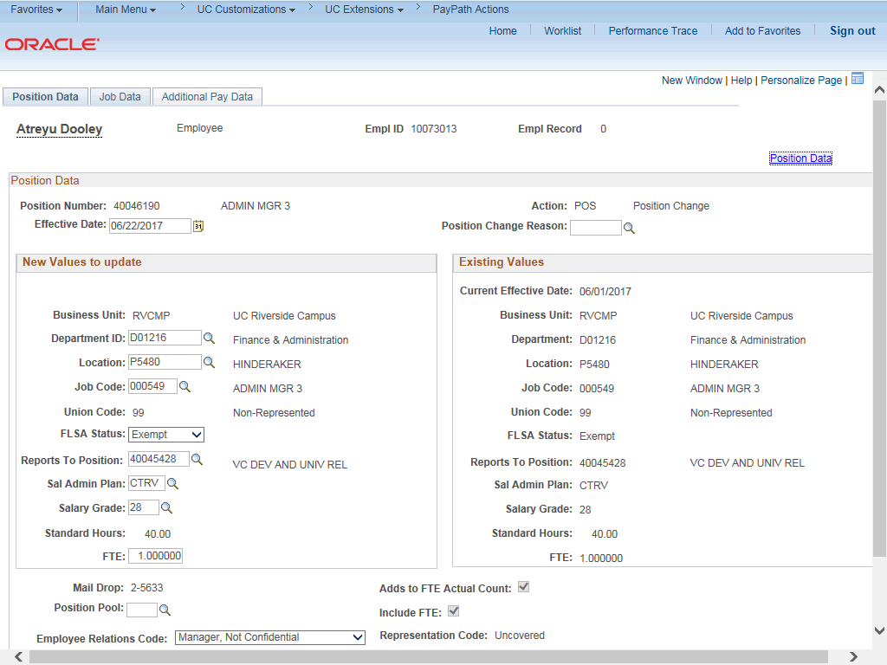

Step | Action
5. | The PayPath Actions page displays the Position Data tab. Navigate to the appropriate tab for the update you must enter. For this example, a return to normal job earnings distribution, navigate to the Job Data tab.
6. | Click the Job Data tab.

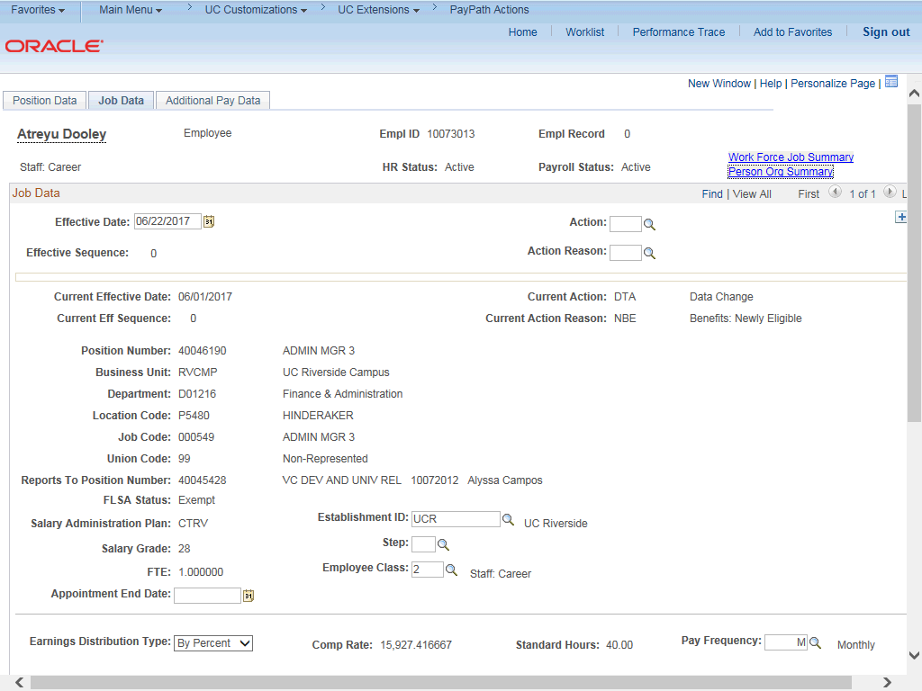

Step | Action
7. | Before entering the update, you must identify the Effective Date, Action and  Action Reason.
8. | The Effective Date field defaults to the system date (today's date). If needed, change the date to reflect the date the update should take effect.
9. | Click in the Effective Date field.
10. | Enter the desired information into the Effective Date field.
11. | Click in the Action field.
12. | Enter the desired information into the Action field.
13. | Click in the Action Reason field.
14. | Enter the desired information into the Action Reason field.

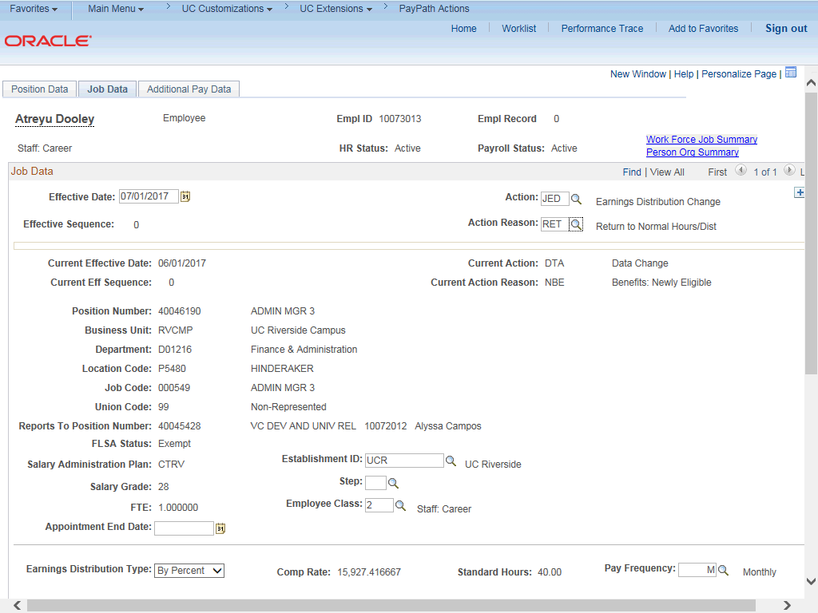

Step | Action
15. | Click the scroll bar.
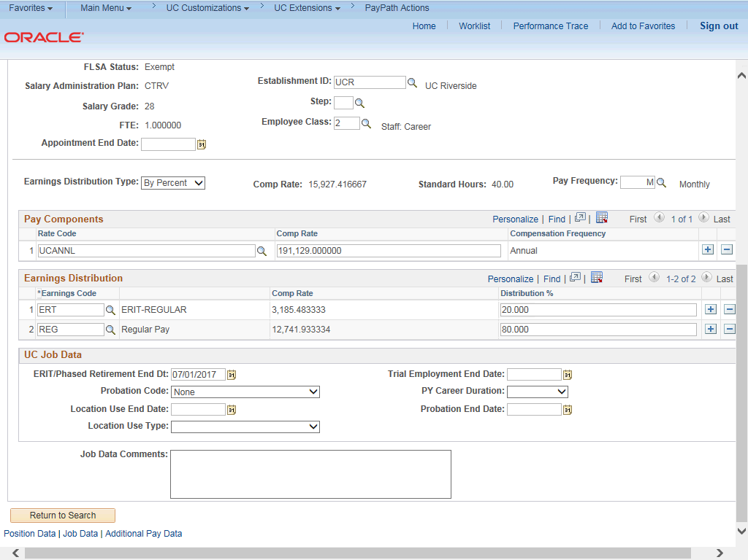

Step | Action
16. | If JED is distributed By Percent:  To return the JED to regular distribution, reset the Earnings Distribution Type to  None.  If JED is distributed By Amount:  You may need to manually re-enter the correct earnings distributions by amount.
17. | For this example, By Percent, click the button to the right of the Earnings Distribution Type field.
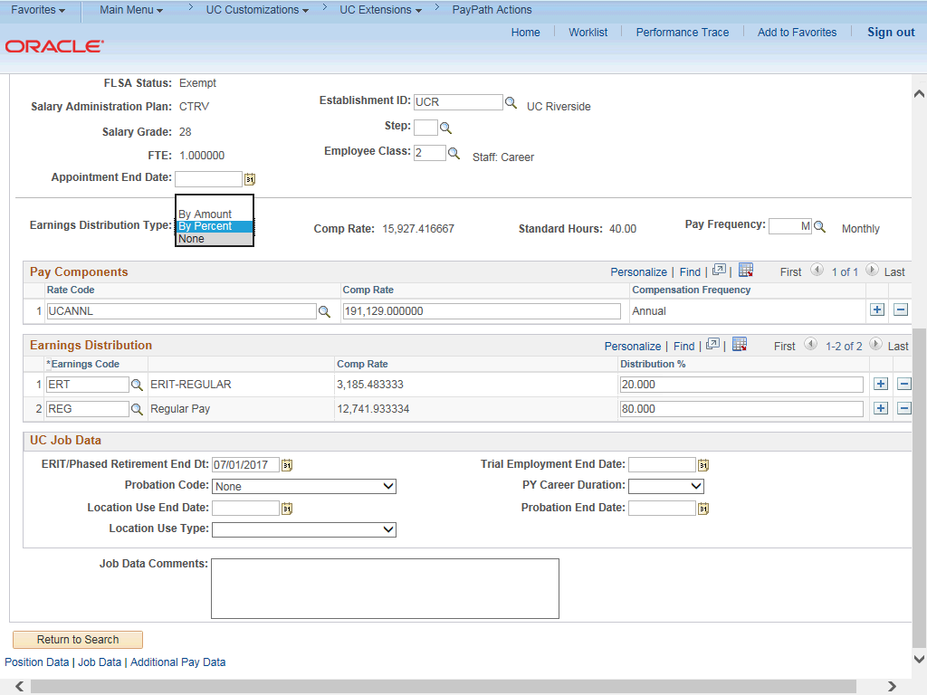

Step | Action
18. | Click the None list item.

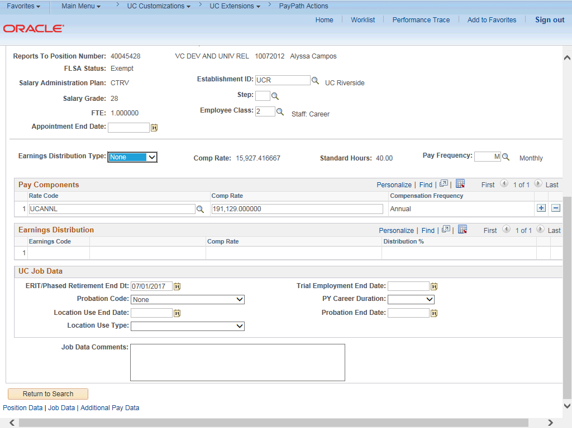

Step | Action
19. | UCPath automatically clears the Earnings Distribution section.  Note: The REG line is not needed.

Step | Action
20. | For staff employees:  If the JED is related to ERIT, clear the ERIT/Phased Retirement End Dt field. Click in the ERIT/Phased Retirement End Dt field.
21. | Press [Delete].
22. | For Job Data updates, enter a comment explaining the update. Click in the Job Data Comments field.
23. | Enter the desired information into the Job Data Comments field.
24. | Click the scroll bar.
25. | Click the Additional Pay Data tab.
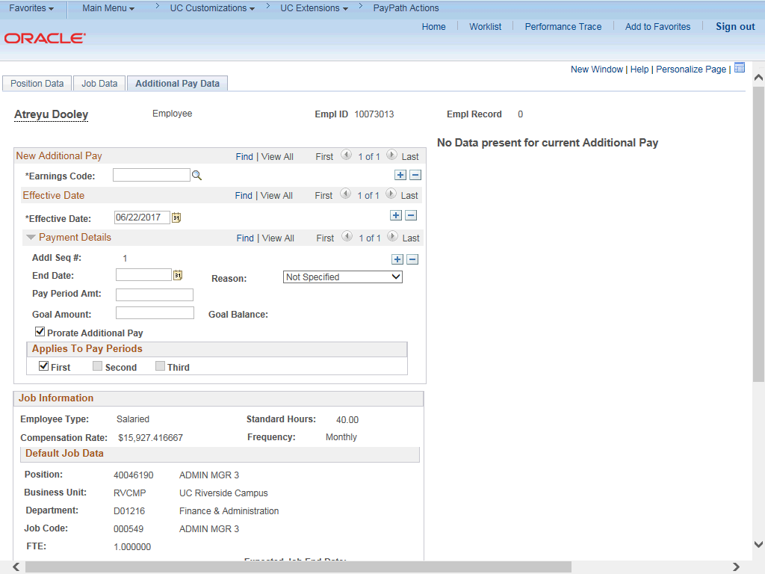

Step | Action
26. | Click the scroll bar.
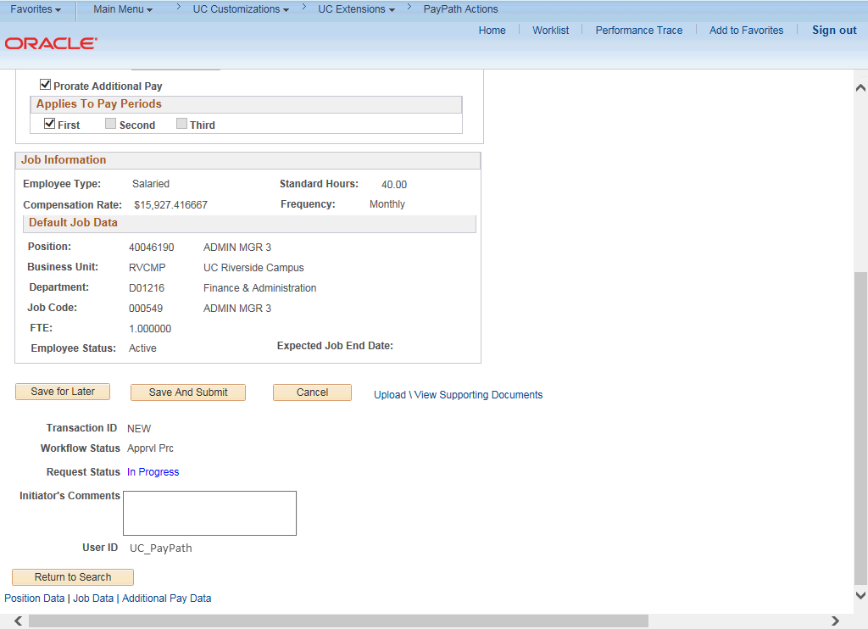

Step | Action
27. | Use the Supporting Documents link to attach supporting documentation, if applicable.
28. | Use the Initiator's Comments field, to further explain the transaction for the Approver, if applicable.
29. | Click the Save and Submit button.

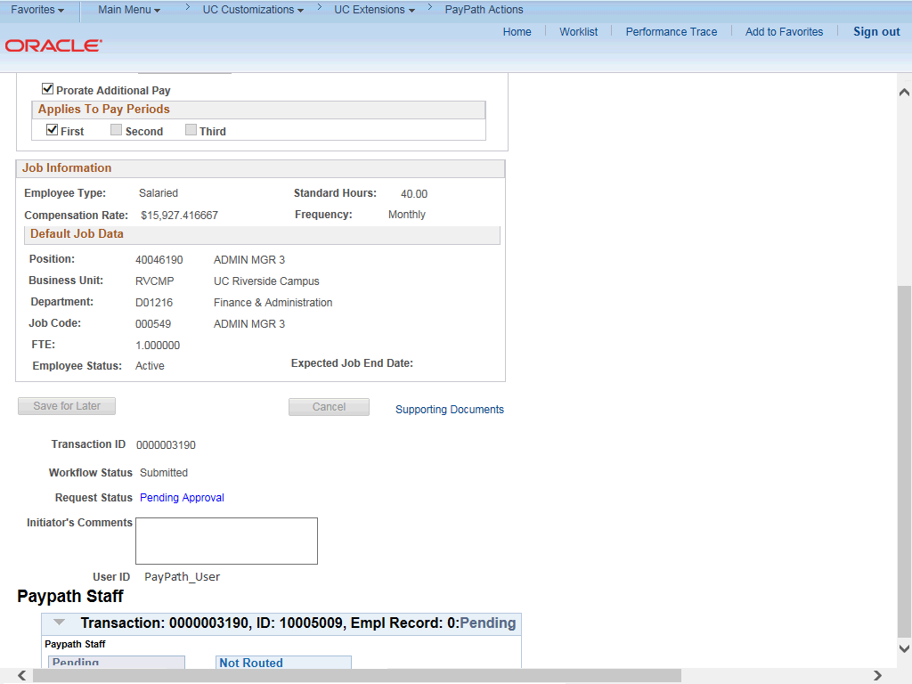

Step | Action
30. | The transaction is submitted for approval.
31. | You have initiated a return to regular job earnings distribution PayPath transaction.  End of Procedure.

