Use this task to initiate a job earnings distribution (JED) PayPath transaction for a staff employee.

Navigation: PeopleSoft Menu > UC Customizations > UC Extensions > PayPath Actions Note: This page also may be available in Workcenter depending on your security access.
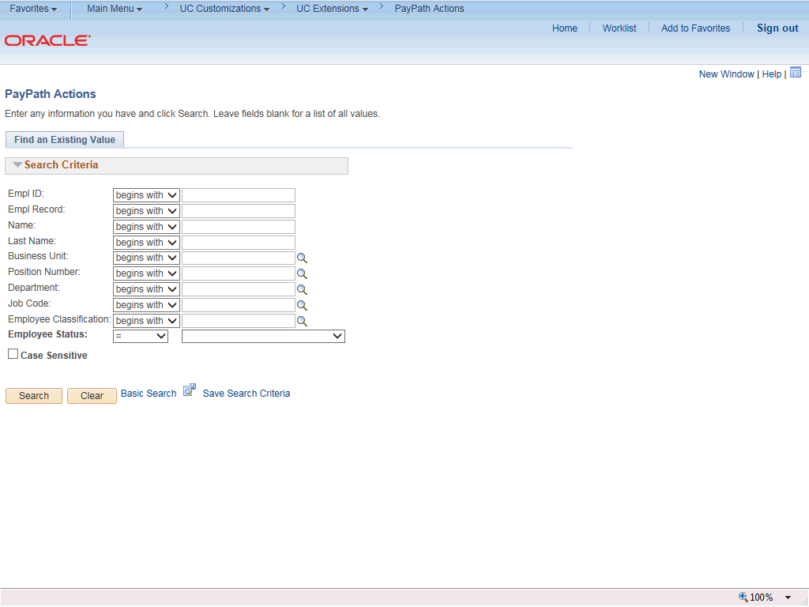

Step | Action
1. | After you navigate to the PayPath Actions component, the system displays the Find an Existing Value tab, which you use to search for the appropriate employee record.  Enter search criteria in one or more of the search fields on this page.
2. | Click in the Empl ID field.
3. | Enter the desired information into the Empl ID field.
4. | Click the Search button.

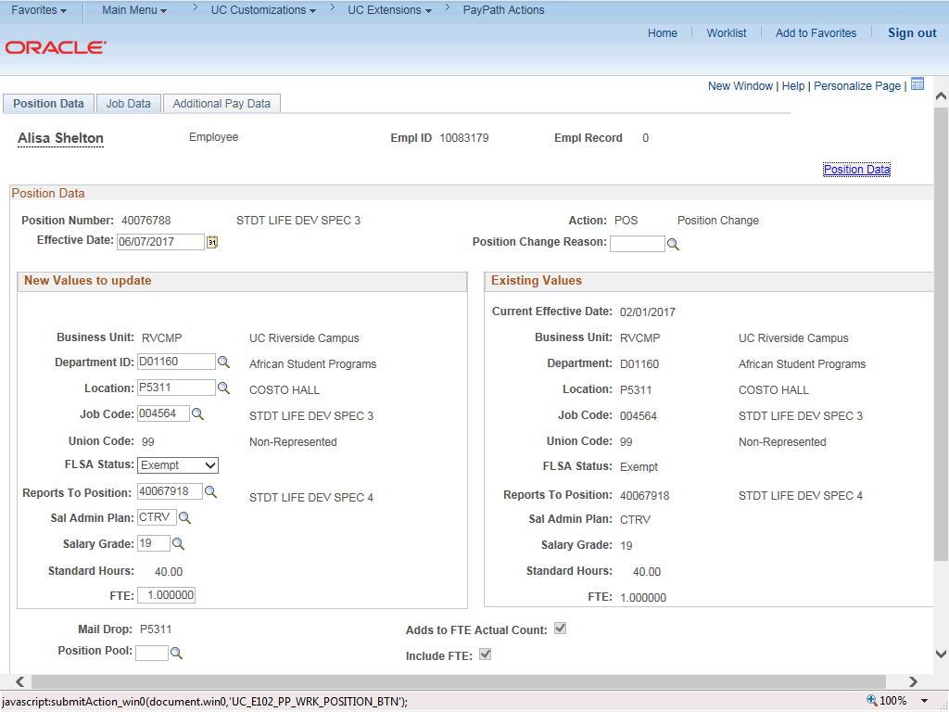

Step | Action
5. | The PayPath Actions page displays the Position Data tab. Navigate to the appropriate tab for the update you must enter. For this example, a JED change, navigate to the Job Data tab.
6. | Click the Job Data tab.

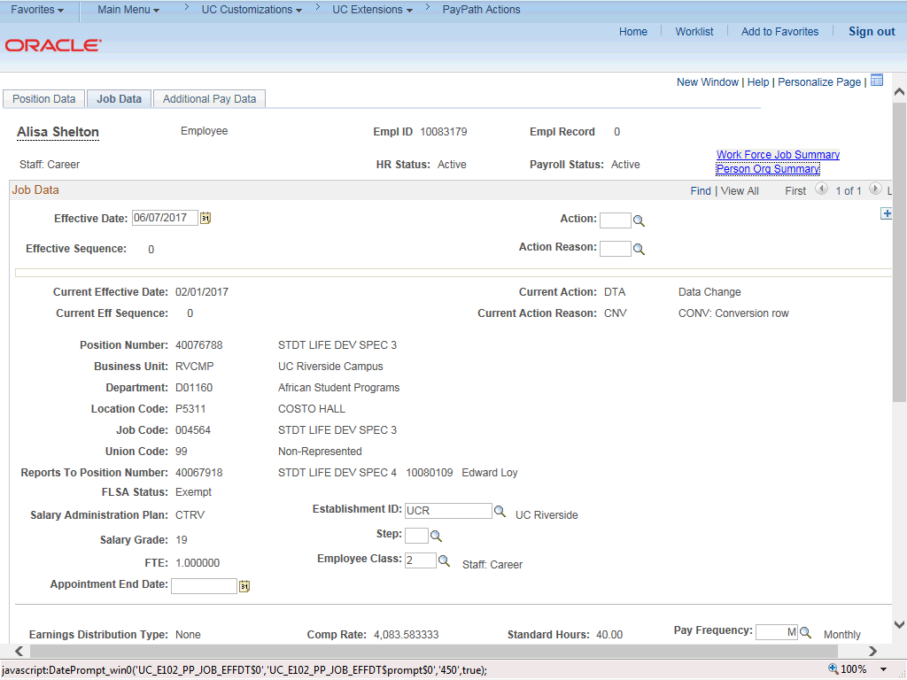

Step | Action
7. | Before entering the update, you must identify the Effective Date, Action and  Action Reason.
8. | The Effective Date field defaults to the system date (today's date). If needed, change the date to reflect the date the update should take effect.
9. | Click in the Effective Date field.
10. | Enter the desired information into the Effective Date field.
11. | Click in the Action field.
12. | Enter the desired information into the Action field.
13. | Click in the Action Reason field.
14. | Enter the desired information into the Action Reason field.

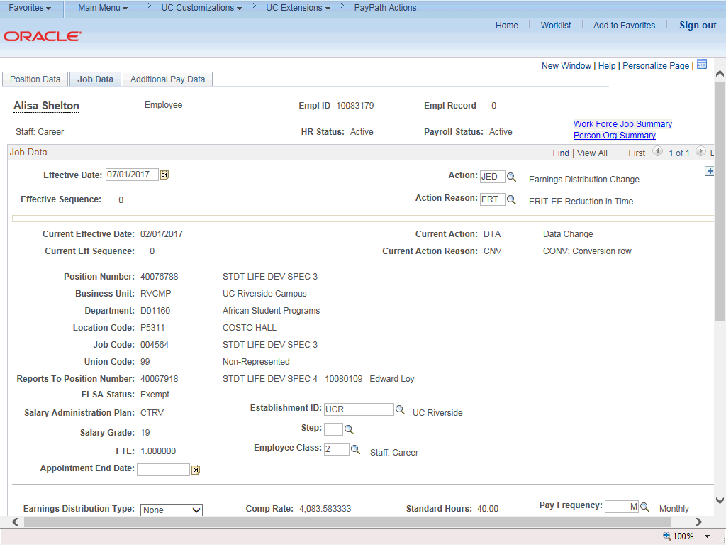

Step | Action
15. | Click the scroll bar.
16. | The Earnings Distribution Type field is editable based on the selected Action  code (JED).
17. | You can distribute earnings by percent or amount.  Click the button to the right of the Earnings Distribution Type field.
18. | For this example, click the By Percent list item.
19. | Use the Earnings Distribution section to enter the Earnings Code and the distribution percent or amount. The percent total must equal 100%. The Comp Rate amounts update automatically based on the Distribution % entered.
20. | For this example, the employee's regular pay (REG) is set to 80% and a new row is needed to add the ERIT at 20%.

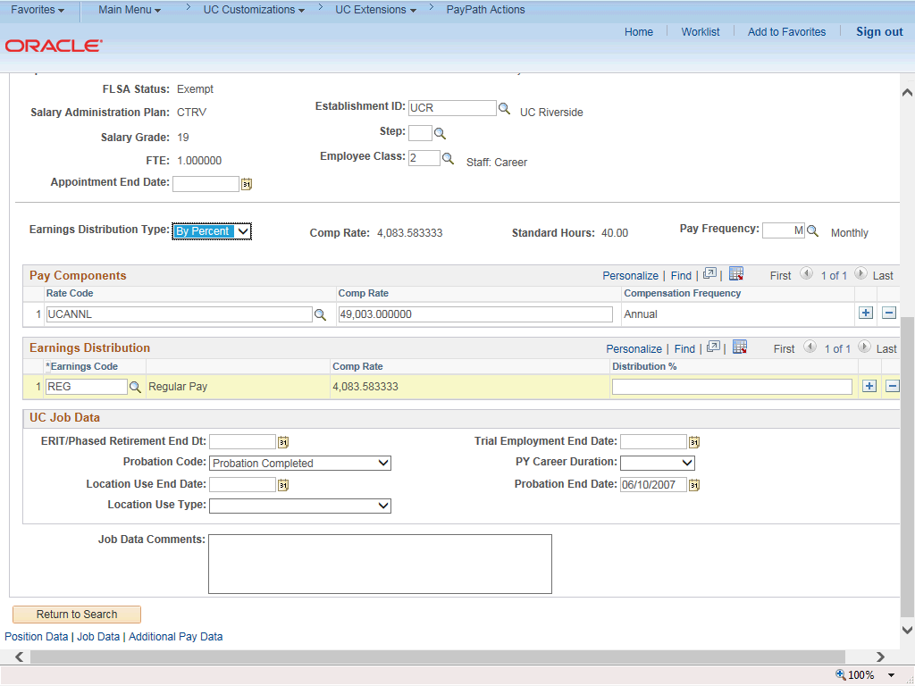

Step | Action
21. | Click in the Distribution % field.
22. | Enter the desired information into the Distribution % field.
23. | Click the Add a Row button.

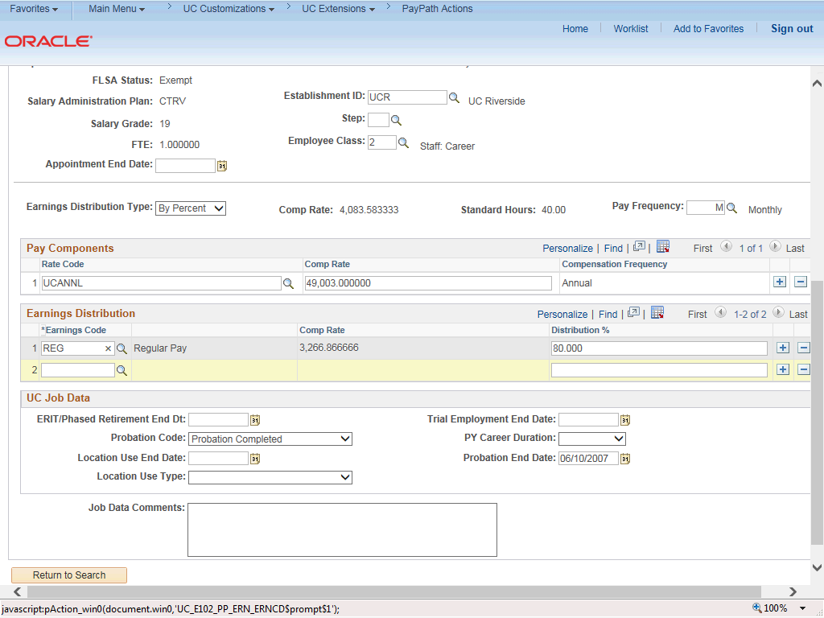

Step | Action
24. | Click in the Earnings Code field.
25. | Enter the desired information into the Earnings Code field.
26. | Click in the Distribution % field.
27. | Enter the desired information into the Distribution % field.

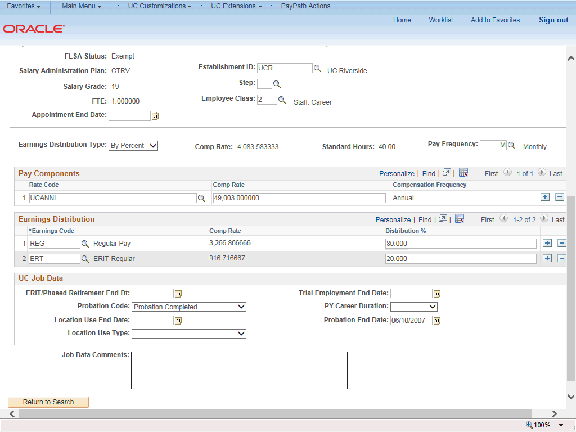

Step | Action
28. | The Comp Rate amounts are automatically calculated according the Distribution  %.
29. | Enter the appropriate end date for the ERIT.  Click in the ERIT/Phased Retirement End Dt field.
30. | Enter the desired information into the ERIT/Phased Retirement End Dt field.
31. | For Job Data updates, enter a comment explaining the update. Click in the Job Data Comments field.
32. | Enter the desired information into the Job Data Comments field.

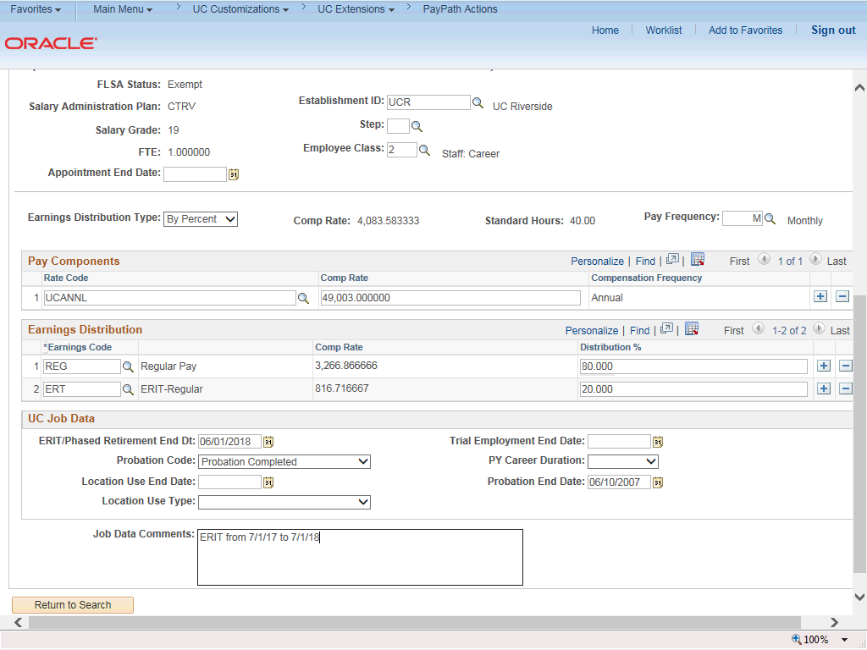

Step | Action
33. | Click the scroll bar.
34. | Click the Additional Pay Data tab.

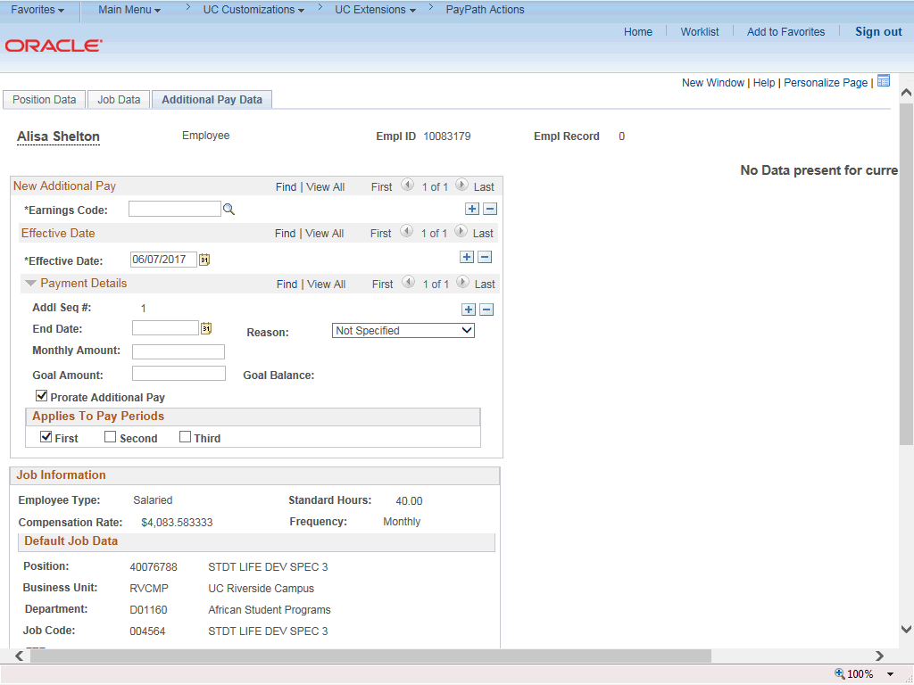

Step | Action
35. | Click the scroll bar.
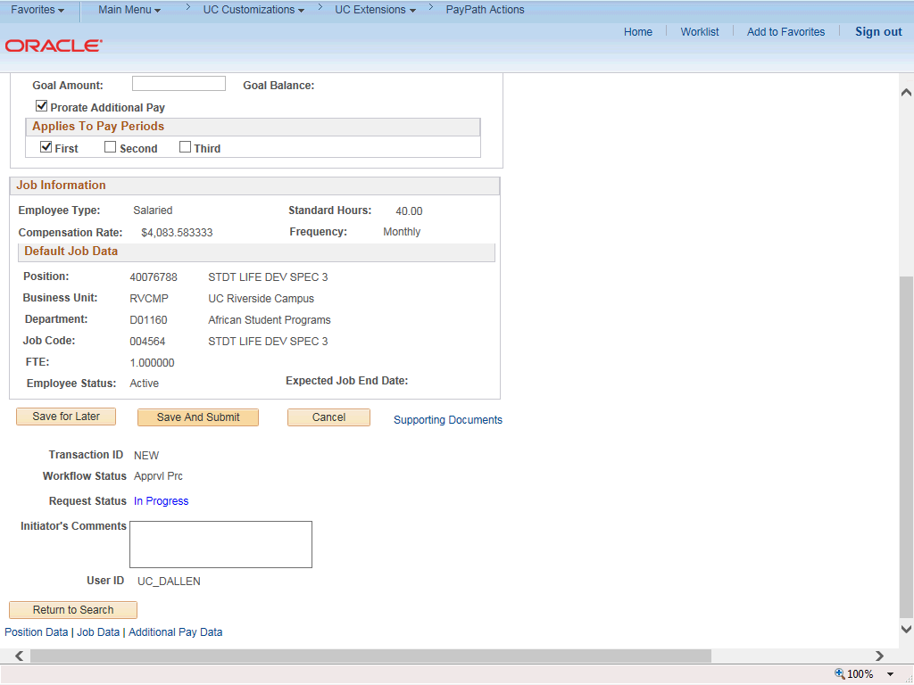

Step | Action
36. | Use the Supporting Documents link to attach supporting documentation, if applicable.
37. | Use the Initiator's Comments field, to further explain the transaction for the Approver, if applicable.
38. | Click the Save And Submit button.
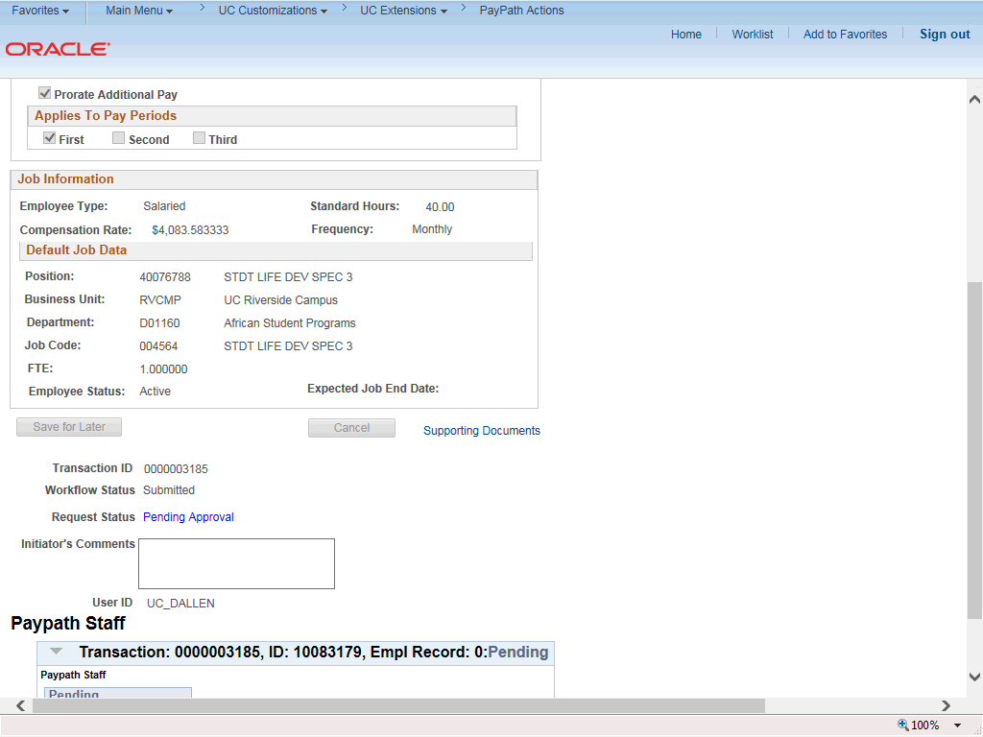

Step | Action
39. | The transaction is submitted for approval.
40. | You have initiated a job earnings distribution (JED) PayPath transaction for a staff employee.  End of Procedure.

