Use this task to initiate a job earnings distribution (JED) PayPath transaction for an academic employee.

Navigation: PeopleSoft Menu > UC Customizations > UC Extensions > PayPath Actions Note: This page also may be available in Workcenter depending on your security access.

Step | Action
1. | After you navigate to the PayPath Actions component, the system displays the Find an Existing Value tab, which you use to search for the appropriate employee record.  Enter search criteria in one or more of the search fields on this page.
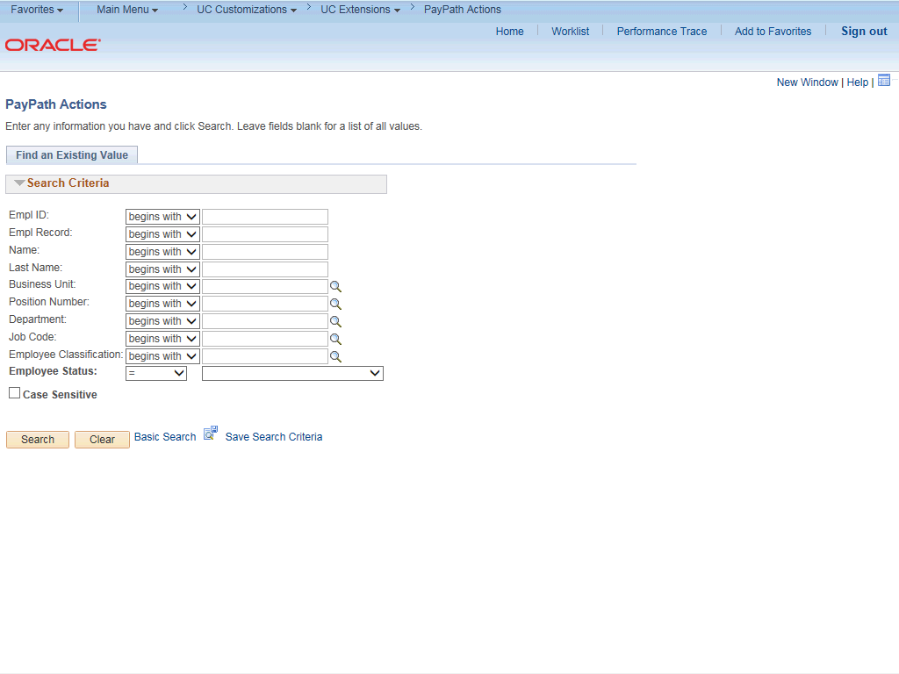

Step | Action
2. | Click in the Empl ID field.
3. | Enter the desired information into the Empl ID field.

Step | Action
4. | Click the Search button.
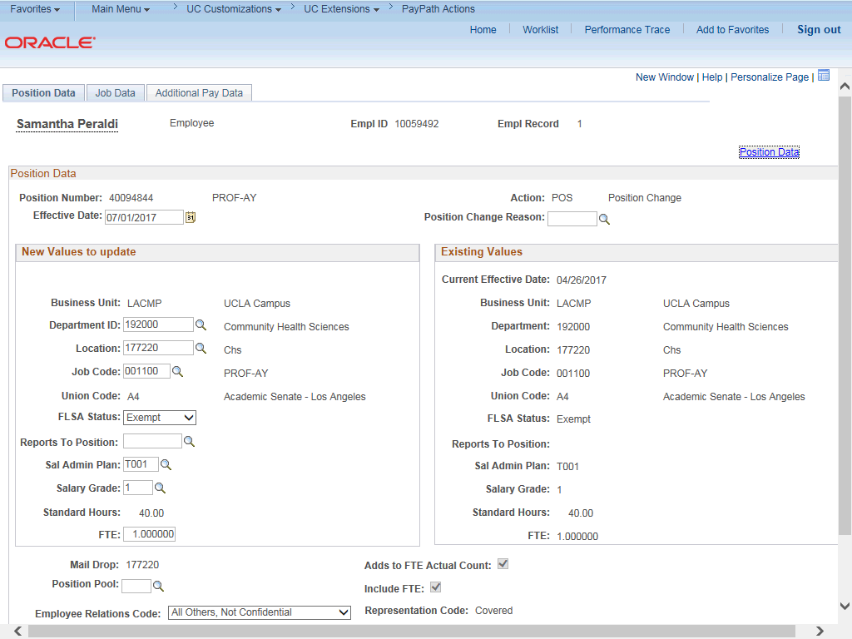

Step | Action
5. | The PayPath Actions page displays the Position Data tab. Navigate to the appropriate tab for the update you must enter. For this example, a JED change, navigate to the Job Data tab.
6. | Click the Job Data tab.

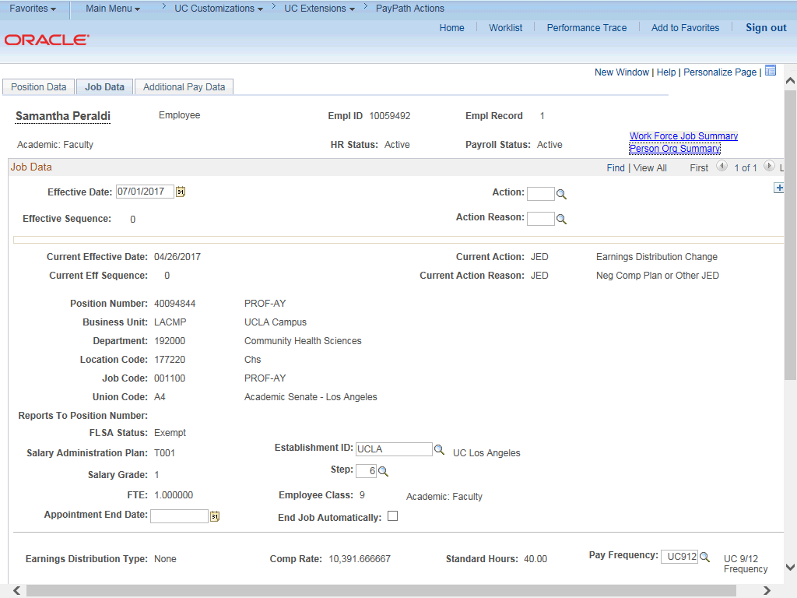

Step | Action
7. | Before entering the update, you must identify the Effective Date, Action and  Action Reason.
8. | The Effective Date field defaults to the system date (today's date). If needed, change the date to reflect the date the update should take effect.  For this example, accept the default.
9. | Click in the Action field.
10. | Enter the desired information into the Action field.
11. | Click in the Action Reason field.
12. | Enter the desired information into the Action Reason field.

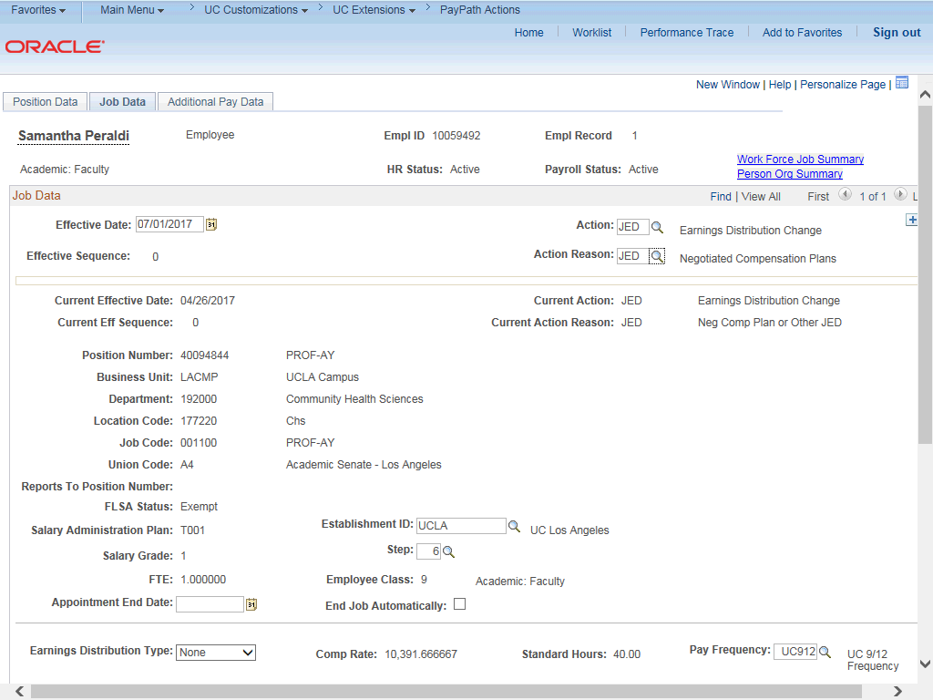

Step | Action
13. | Click the scroll bar.
14. | The Earnings Distribution Type field is editable based on the selected Action  code (JED).
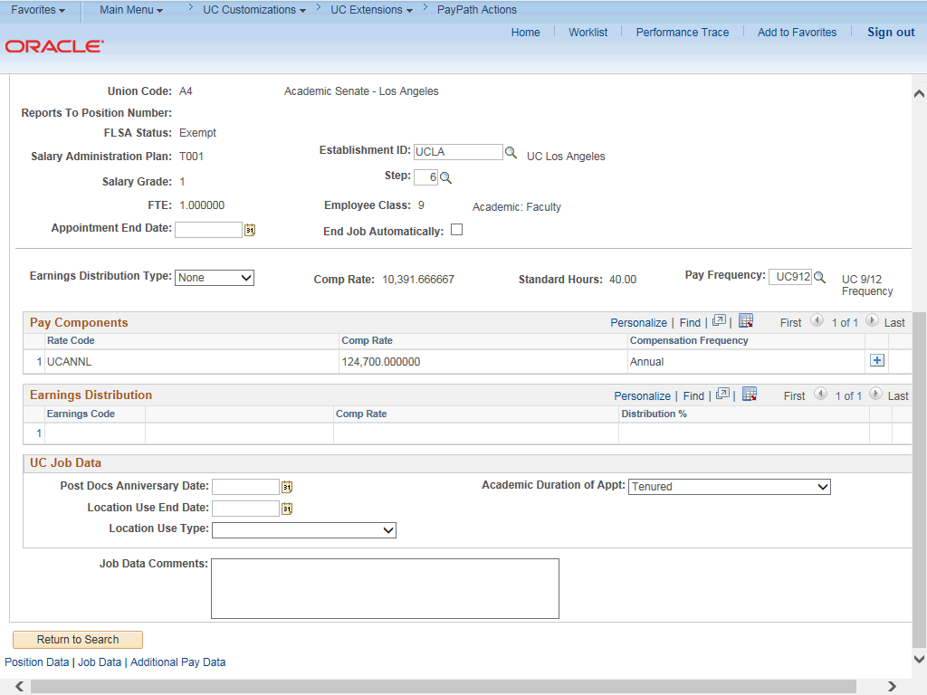

Step | Action
15. | You can distribute earnings by percent or amount.  Click the button to the right of the Earnings Distribution Type field.
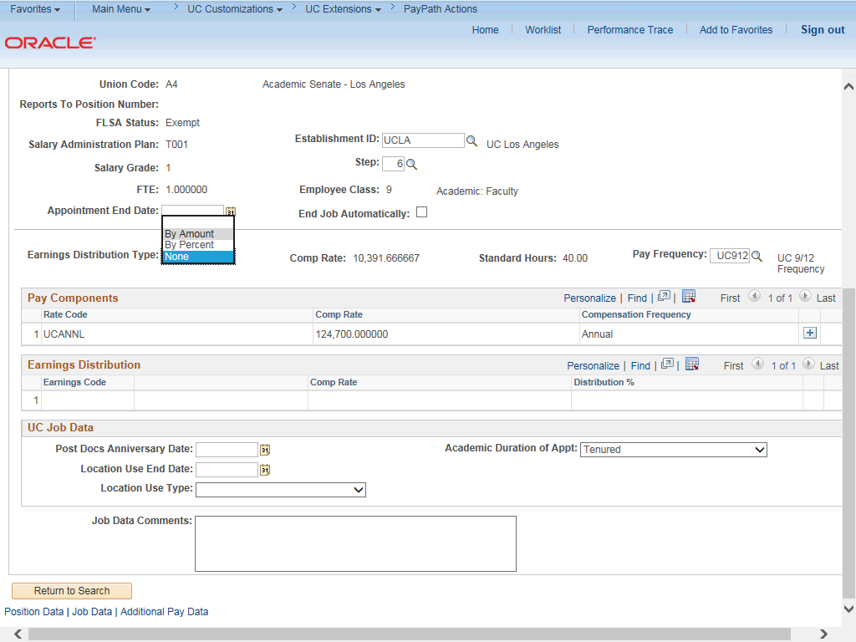

Step | Action
16. | For this example, click the By Amount list item.
17. | Use the Earnings Distribution section to enter the Earnings Code and the distribution percent or amount. The percent total must equal 100%.
18. | For this example, add the Negotiated Salary Trial Program (NSTP) Earnings Codes in the Earnings Distribution section.

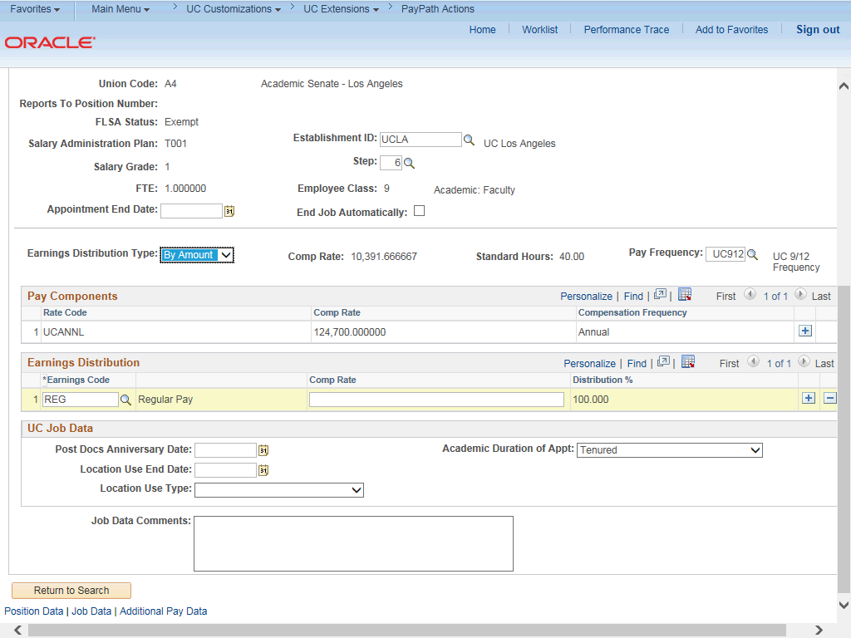

Step | Action
19. | Click in the Earnings Code field.
20. | Enter the desired information into the Earnings Code field.
21. | Enter the monthly compensation rate. Click in the Comp Rate field.
22. | Enter the desired information into the Comp Rate field.
23. | In the Pay Components section, click the Add a new row button.

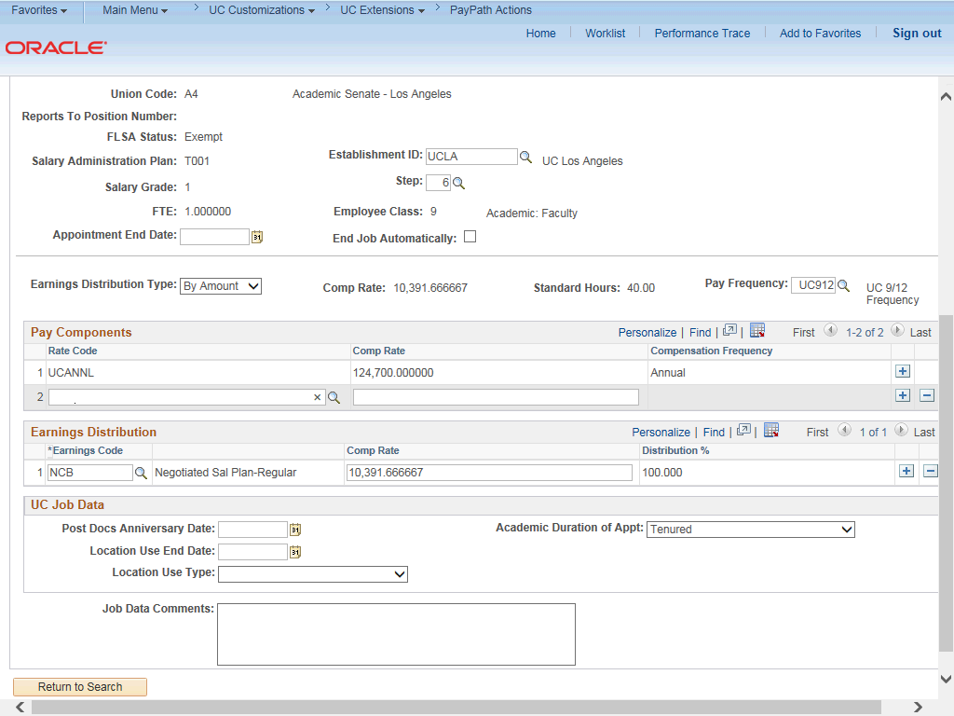

Step | Action
24. | Click in the Rate Code field.
25. | Enter the desired information into the Rate Code field.

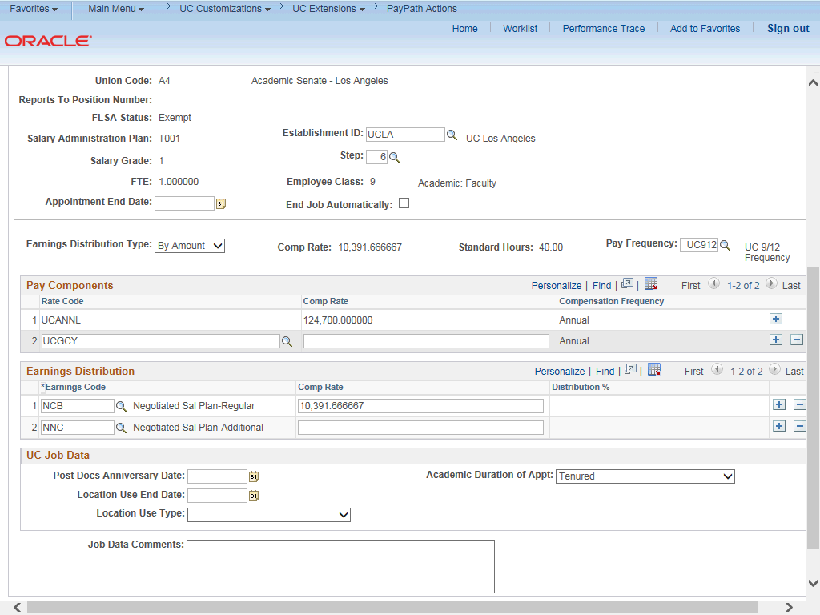

Step | Action
26. | A new Earning Distribution row with earn code NNC is automatically added as a result of adding the UCGCY Comp Rate Code.
27. | Enter the annual compensation rate. Click in the Comp Rate field.
28. | Enter the desired information into the Comp Rate field.

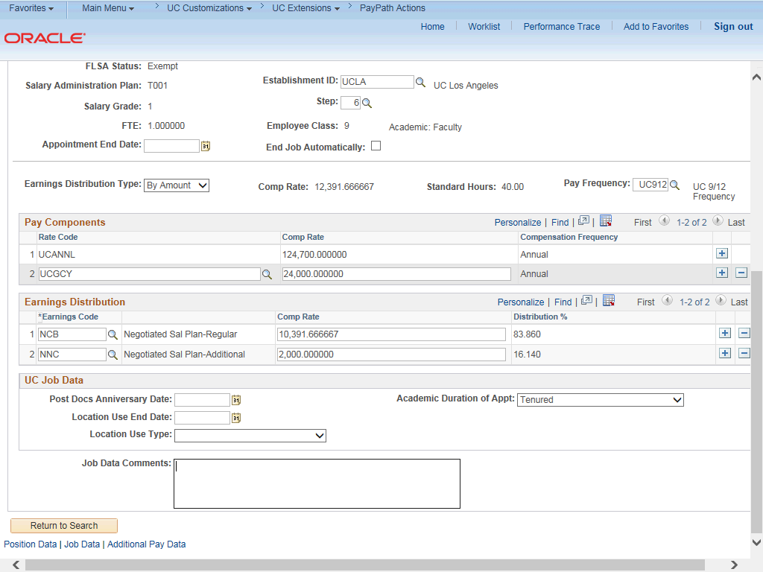

Step | Action
29. | After entering the annual Comp Rate for the UCGCY code, the monthly Comp Rate for the additional earn code, NNC, is automatically calculated and added to the Earnings Distribution section.
30. | For Job Data updates, enter a comment explaining the update. Click in the Job Data Comments field.
31. | Enter the desired information into the Job Data Comments field.
32. | Click the scroll bar.
33. | Click the Additional Pay Data tab.

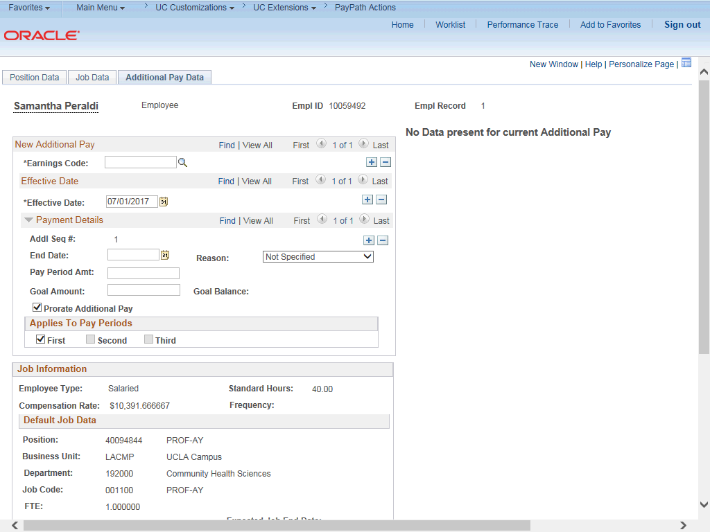

Step | Action
34. | Click the scroll bar.
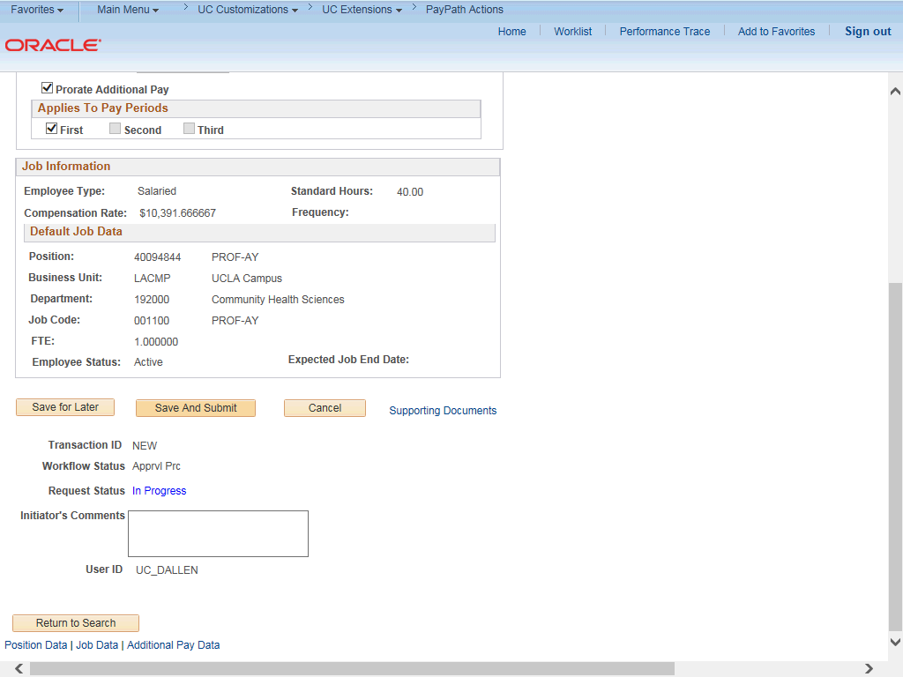

Step | Action
35. | Use the Supporting Documents link to attach supporting documentation, if applicable.
36. | Use the Initiator's Comments field, to further explain the transaction for the Approver, if applicable.
37. | Click the Save And Submit button.
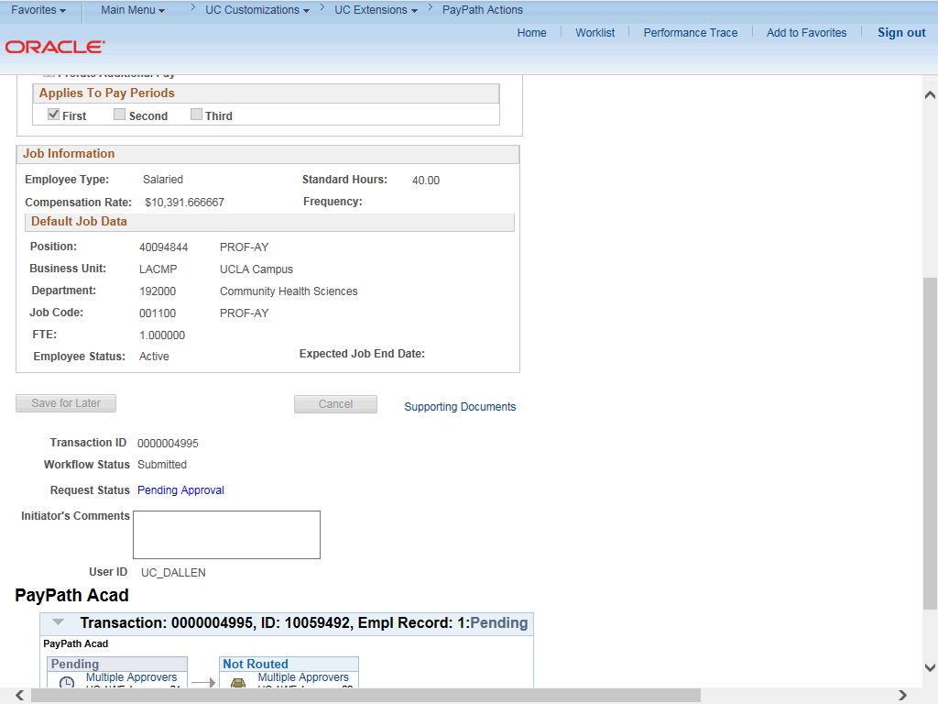

Step | Action
38. | The transaction is submitted for approval.
39. | You have initiated a Job Earnings Distribution (JED) PayPath transaction for an academic employee.  End of Procedure.

