Use this task to initiate a pay rate change PayPath transaction for a staff employee. Navigation: PeopleSoft Menu > UC Customizations > UC Extensions > PayPath Actions Note: This page also may be available in Workcenter depending on your security access.
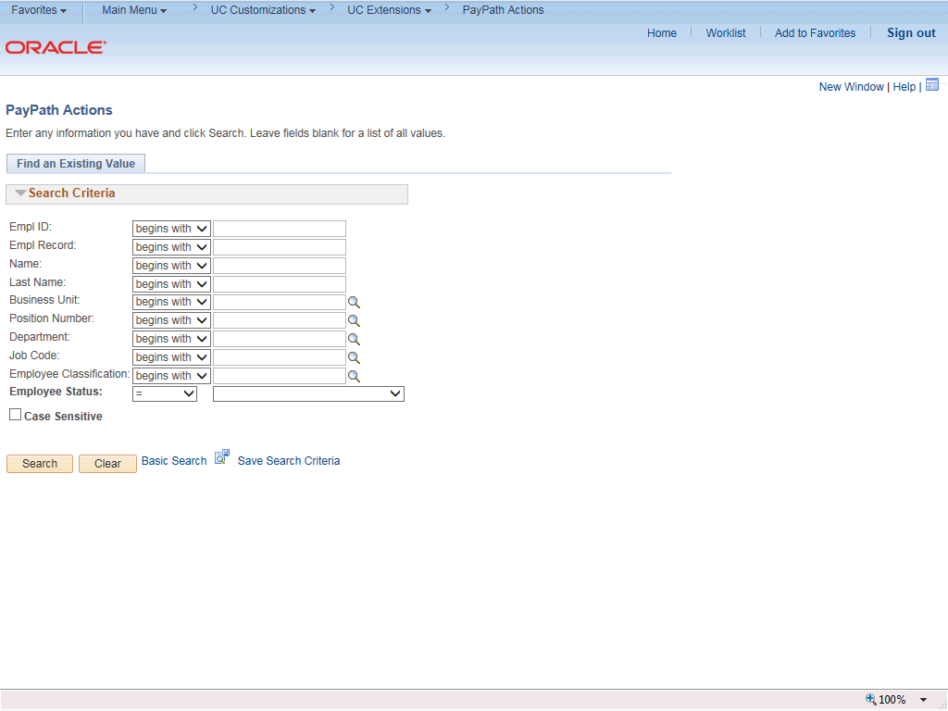

Step | Action
1. | After you navigate to the PayPath Actions component, the system displays the Find an Existing Value tab, which you use to search for the appropriate employee record.  Enter search criteria in one or more of the search fields on this page.
2. | Click in the Empl ID field.
3. | Enter the desired information into the Empl ID field.
4. | Click the Search button.

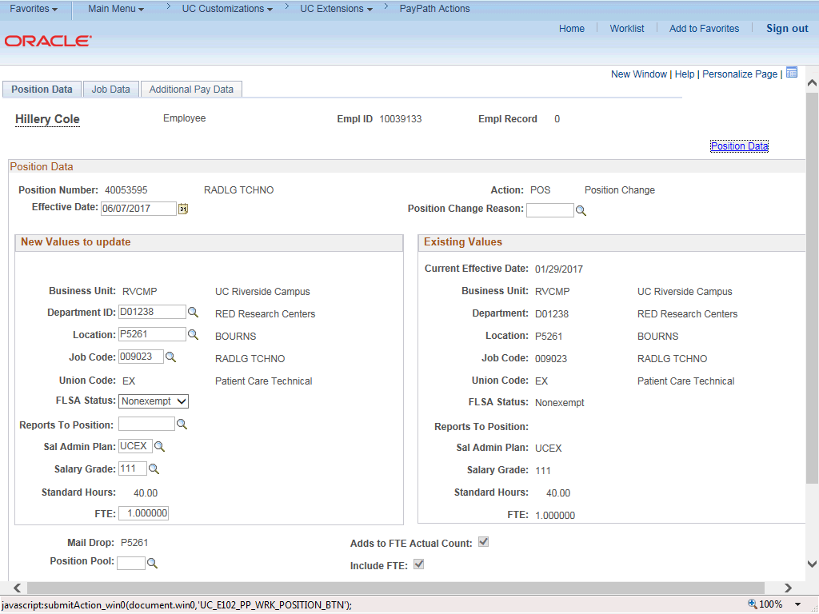

Step | Action
5. | The PayPath Actions page displays the Position Data tab. Navigate to the appropriate tab for the update you must enter. For this example, a pay rate change, navigate to the Job Data tab.
6. | Click the Job Data tab.

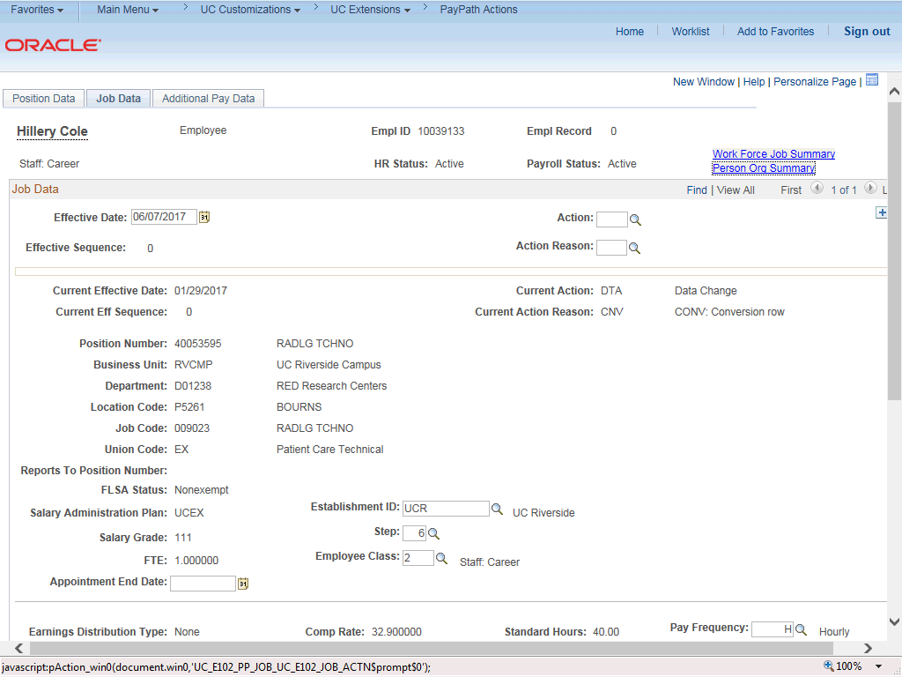

Step | Action
7. | Before entering the update, you must identify the Effective Date, Action and  Action Reason.
8. | The Effective Date field defaults to the system date (today's date). If needed, change the date to reflect the date the update should take effect.  For this example, accept the default.
9. | Click in the Action field.
10. | Enter the desired information into the Action field.
11. | Click in the Action Reason field.
12. | Enter the desired information into the Action Reason field.

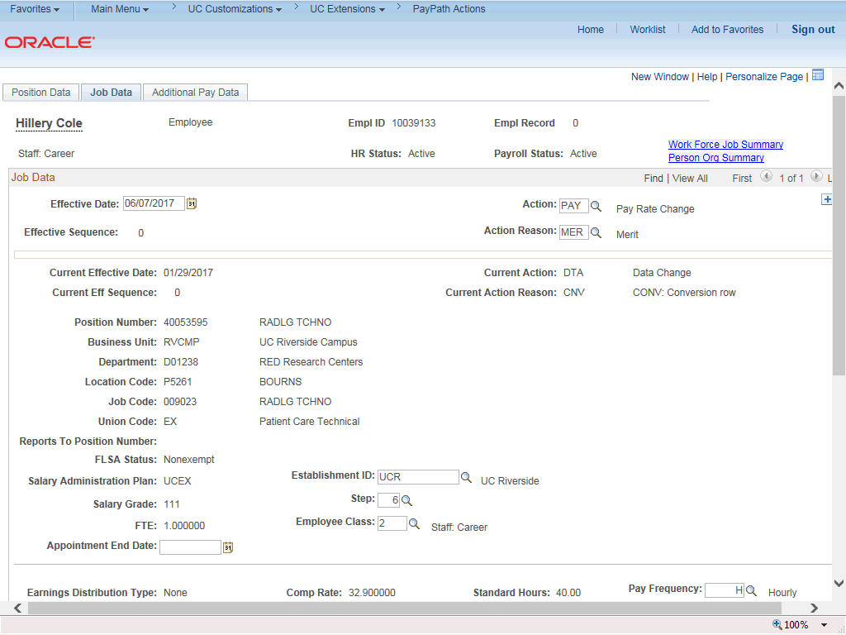

Step | Action
13. | Click the scroll bar.
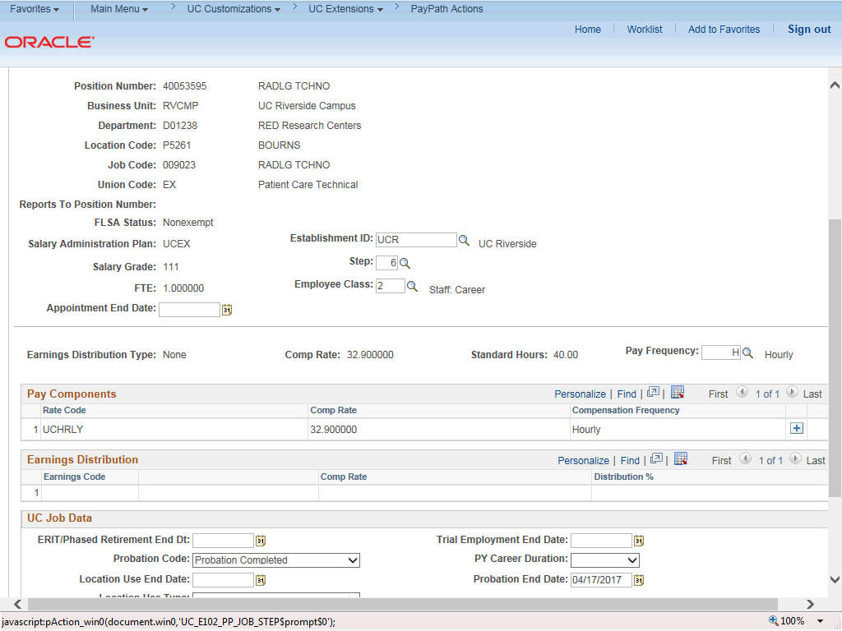

Step | Action
14. | Enter the appropriate information to update the employee's pay rate. For this example, the Step is updated, which automatically updates the employee's compensation information.
15. | Notice, the Comp Rate for Step 6 is currently 32.90. After the step is updated, the compensation rates are updated as well.
16. | Click the Look up Step button.
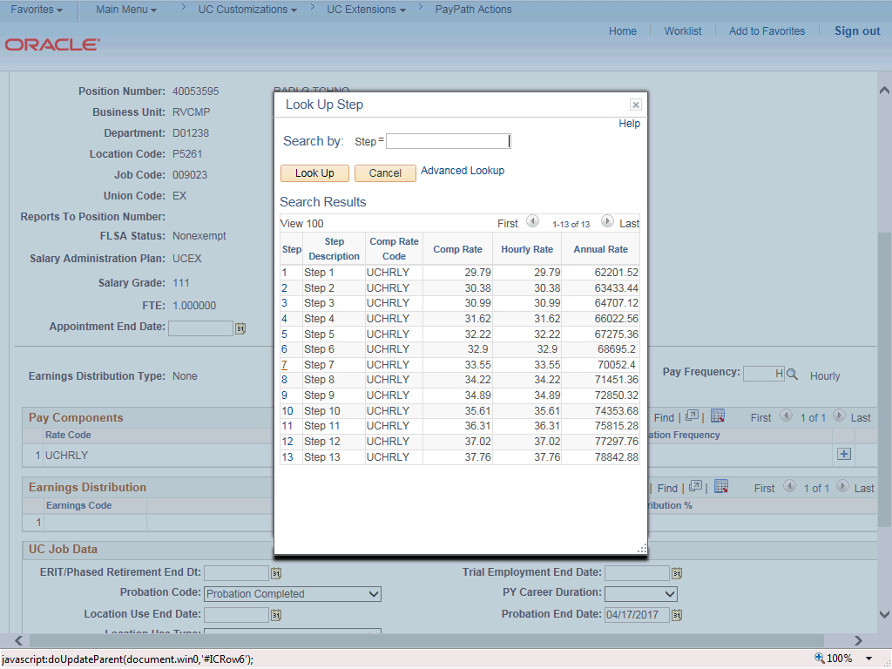

Step | Action
17. | For this example, click the 7 list item.

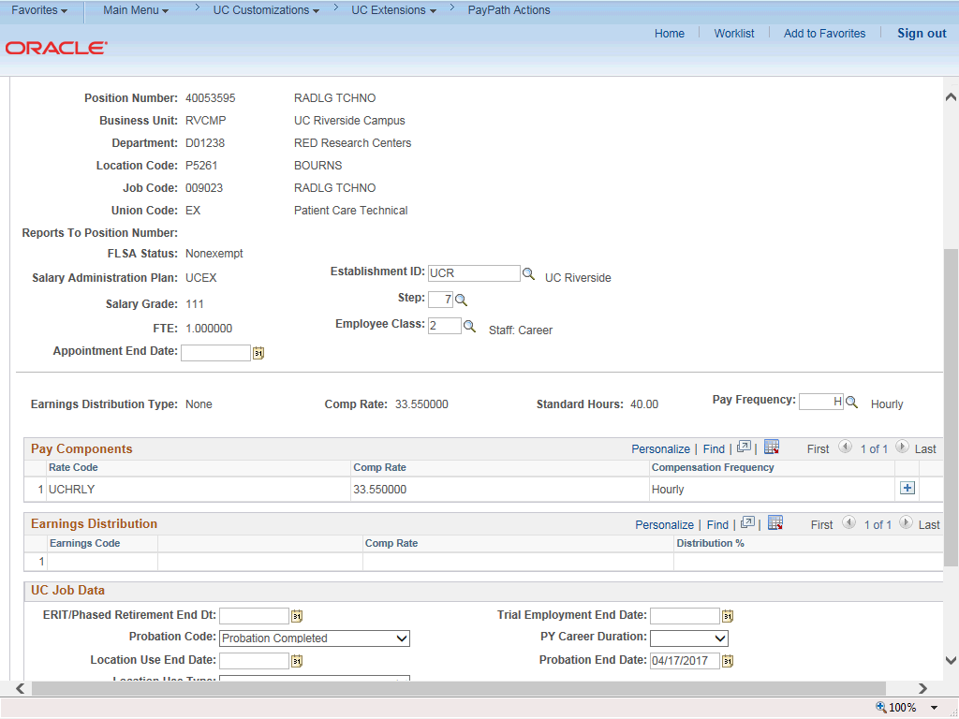

Step | Action
18. | The Comp Rate for Step 7 is updated to 33.55.
19. | Click the scroll bar.
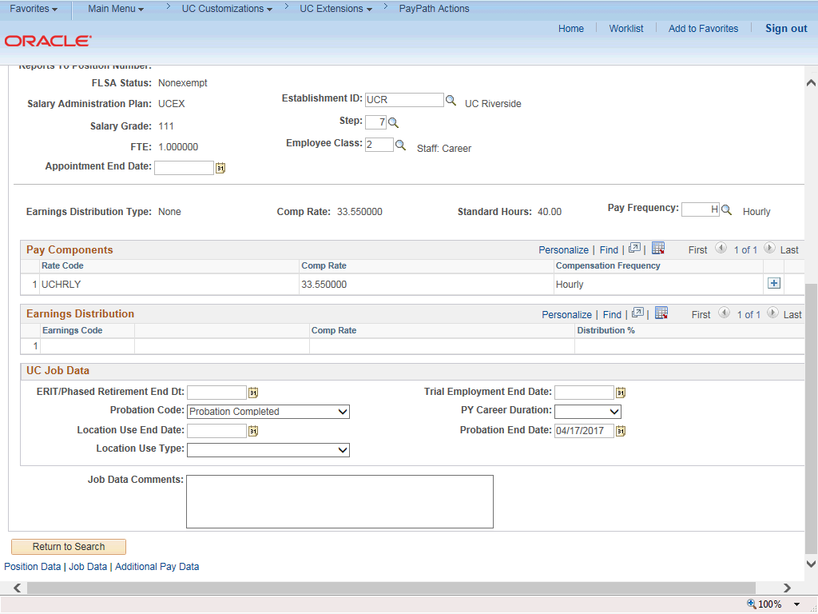

Step | Action
20. | For Job Data updates, enter a comment explaining the update. Click in the Job Data Comments field.
21. | Enter the desired information into the Job Data Comments field.
22. | Click the scroll bar.
23. | Click the Additional Pay Data tab.
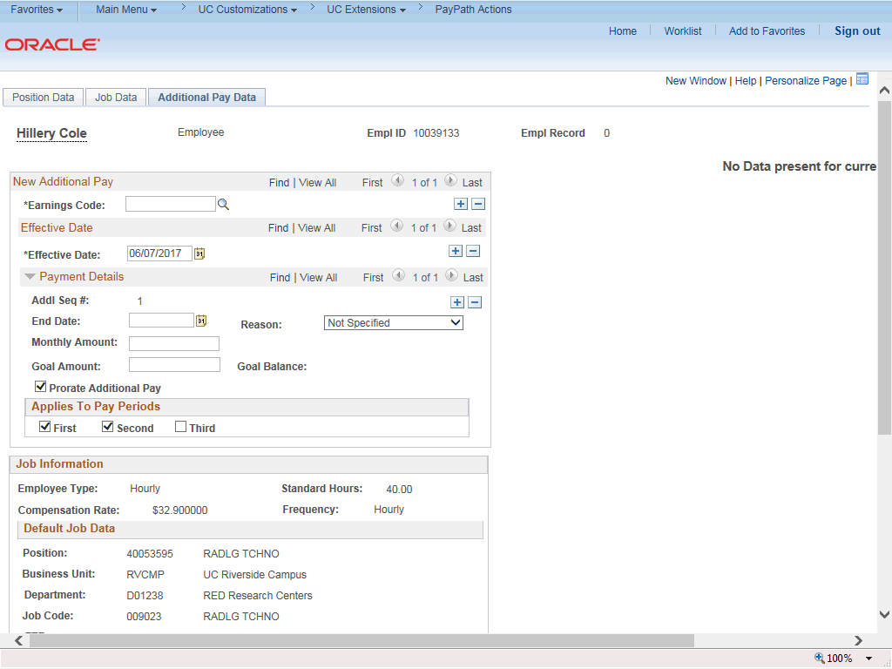

Step | Action
24. | Click the scroll bar.

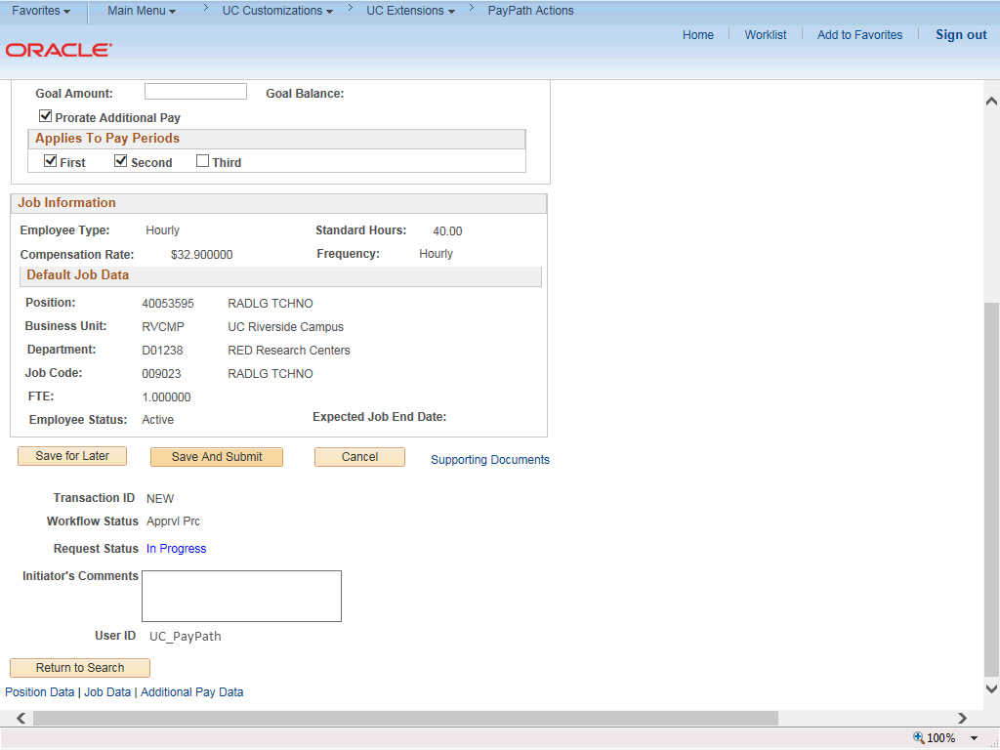

Step | Action
25. | Use the Supporting Documents link to attach supporting documentation, if applicable.
26. | Use the Initiator's Comments field, to further explain the transaction for the Approver, if applicable.
27. | Click the Save And Submit button.

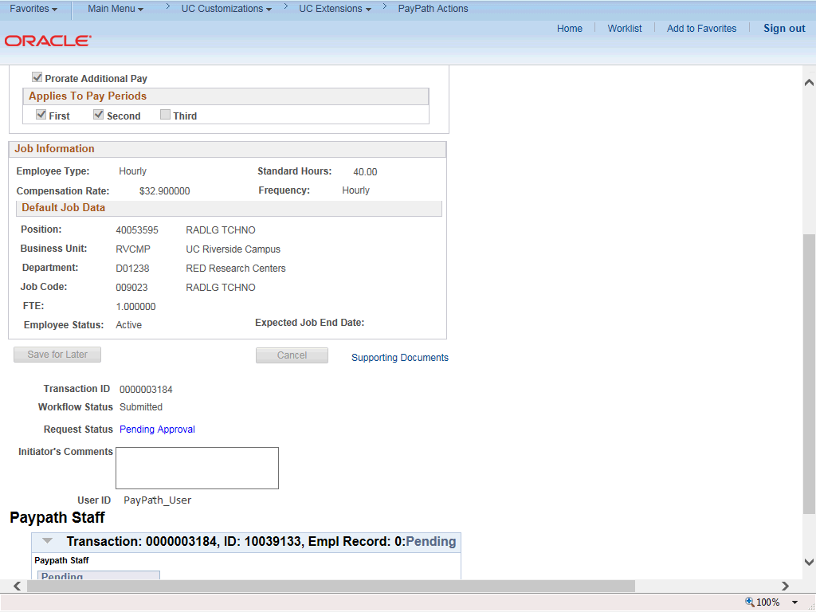

Step | Action
28. | The transaction is submitted for approval.
29. | You have initiated a pay rate change PayPath transaction for a staff employee.  End of Procedure.

