Use this task to initiate a pay rate change PayPath transaction for an academic employee. Navigation: PeopleSoft Menu > UC Customizations > UC Extensions > PayPath Actions Note: This page also may be available in Workcenter depending on your security access.
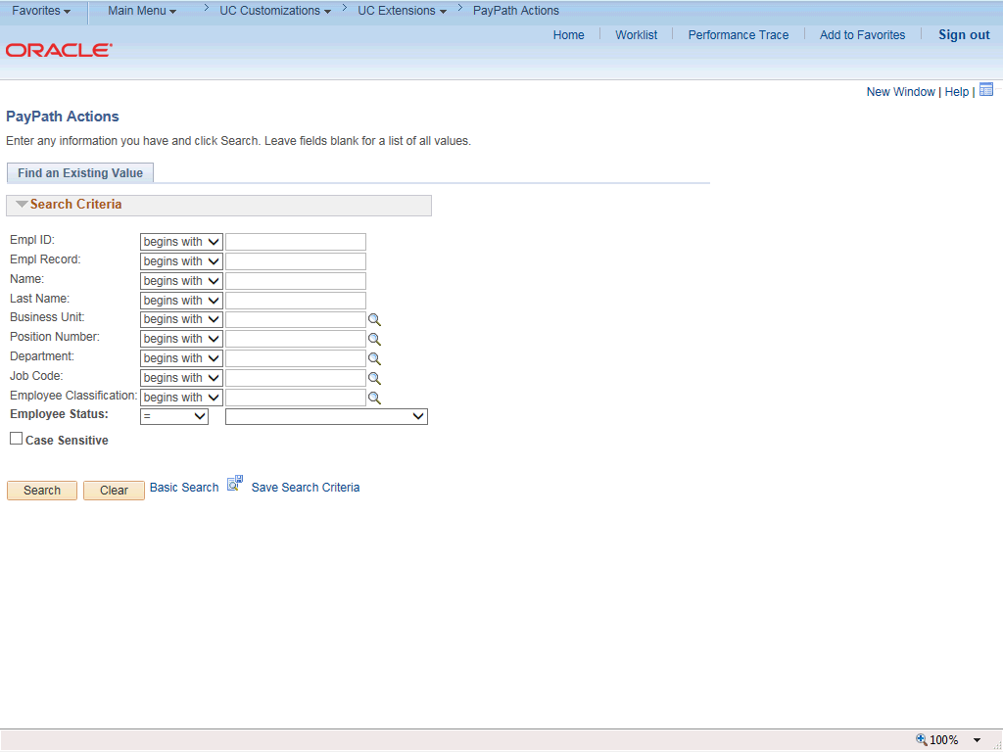

Step | Action
1. | After you navigate to the PayPath Actions component, the system displays the Find an Existing Value tab, which you use to search for the appropriate employee record.  Enter search criteria in one or more of the search fields on this page.
2. | Click in the Empl ID field.
3. | Enter the desired information into the Empl ID field.
4. | Click the Search button.

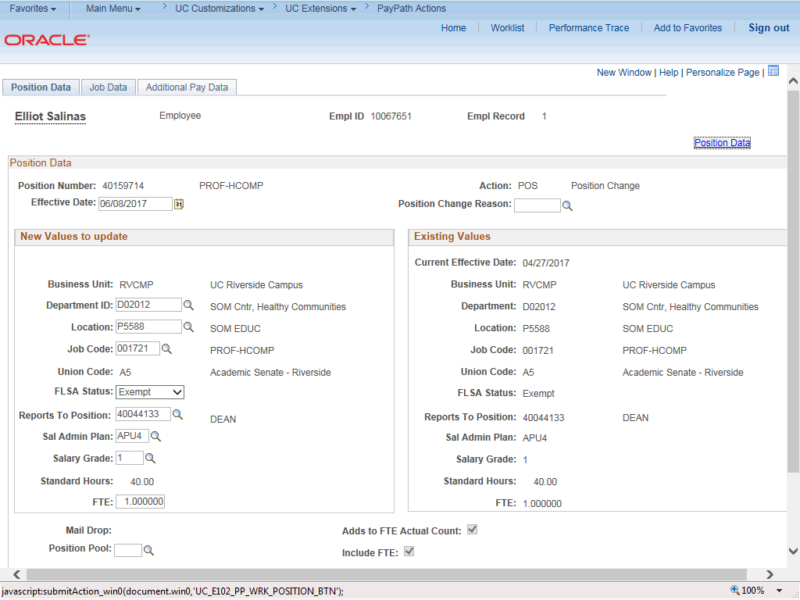

Step | Action
5. | The PayPath Actions page displays the Position Data tab. Navigate to the appropriate tab for the update you must enter. For this example, a pay rate change, navigate to the Job Data tab.
6. | Click the Job Data tab.

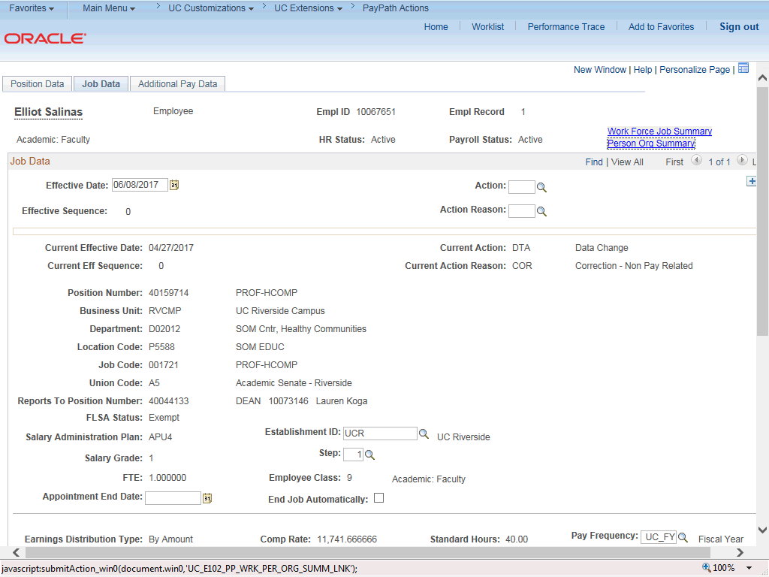

Step | Action
7. | Before entering the update, you must identify the Effective Date, Action and  Action Reason.
8. | The Effective Date field defaults to the system date (today's date). If needed, change the date to reflect the date the update should take effect.
9. | Click in the Effective Date field.
10. | Enter the desired information into the Effective Date field.
11. | Click in the Action field.
12. | Enter the desired information into the Action field.
13. | Click in the Action Reason field.
14. | Enter the desired information into the Action Reason field.

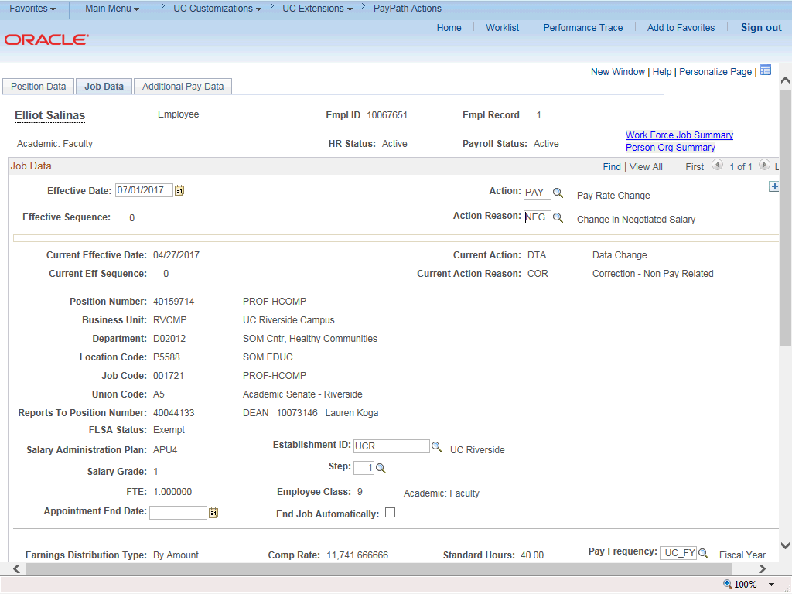

Step | Action
15. | Click the scroll bar.
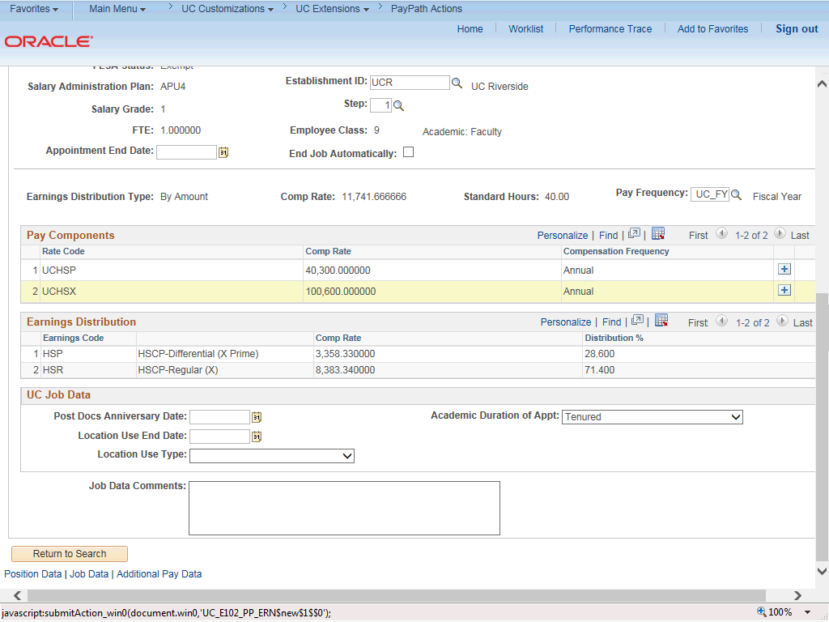

Step | Action
16. | For this example, add a new Comp Rate Code.
17. | In the Pay Components section, click the Add a New Row button.
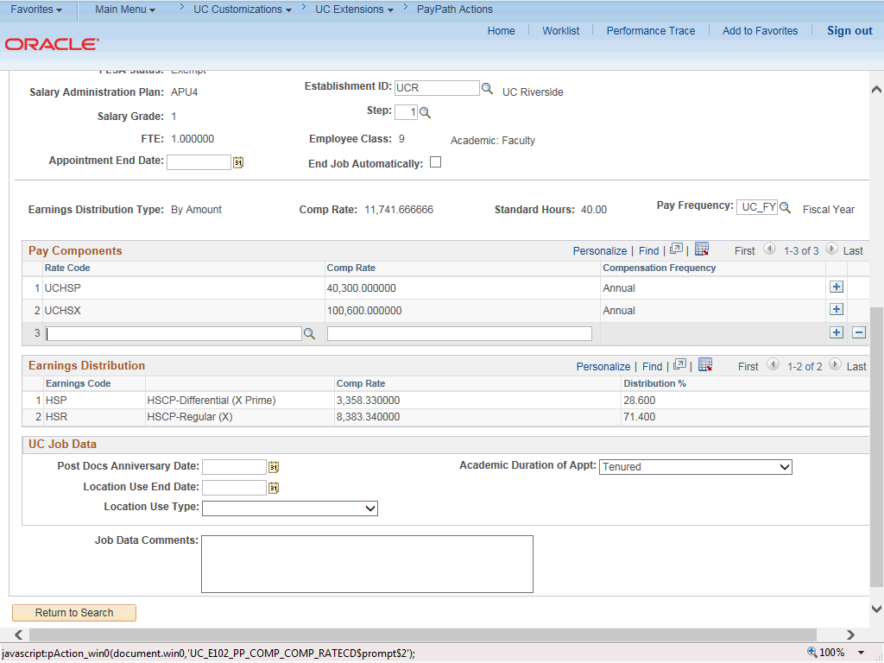

Step | Action
18. | Click the Look up Rate Code button.

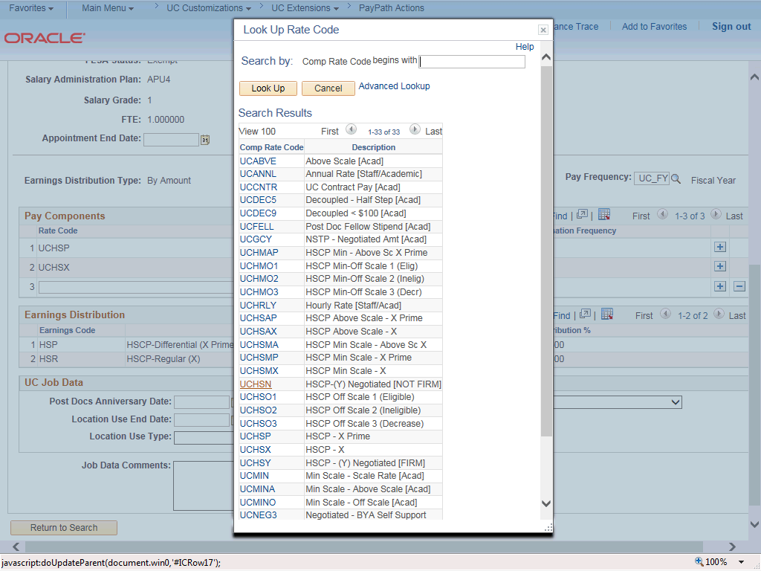

Step | Action
19. | For this example, select the HSCP-(Y) Negotiated [NOT FIRM]  code.  Click the UCHSN list item.

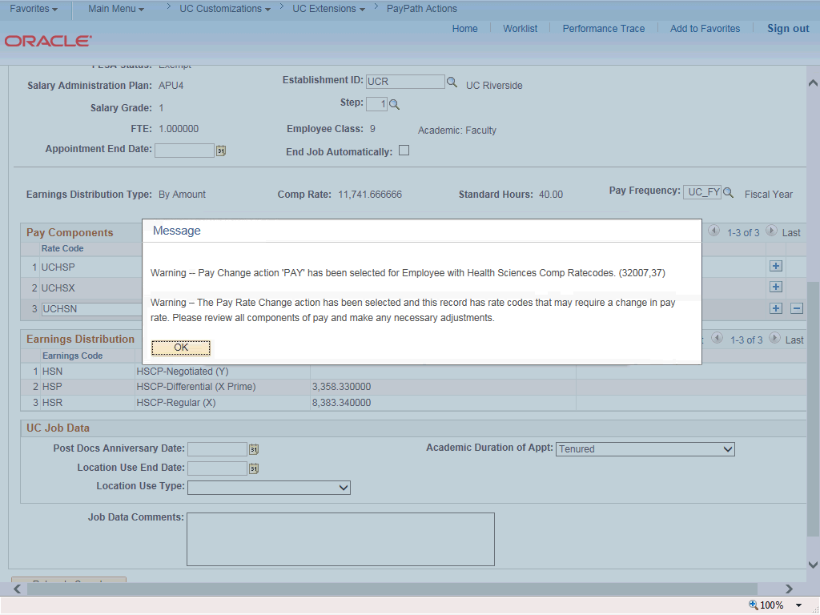

Step | Action
20. | Click the OK button.
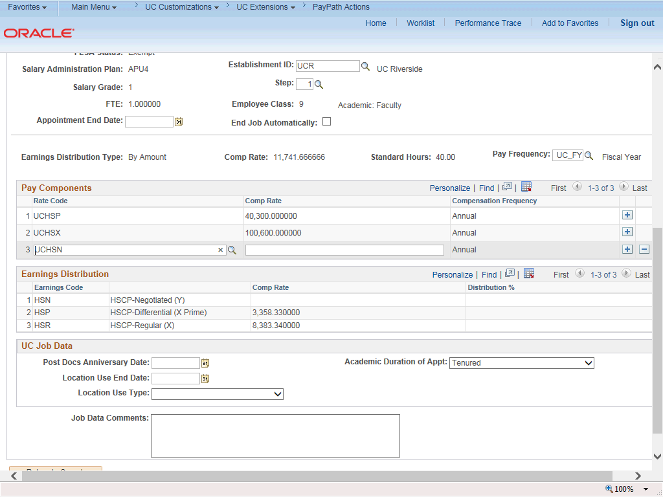

Step | Action
21. | When the UCHSN Rate Code is added to the Pay Components section, a new  Earnings Distribution row is automatically added for HSCP-Negotiated (Y).
22. | Click in the Comp Rate field.
23. | Enter the desired information into the Comp Rate field.
24. | When you exit the Pay Components Comp Rate field UCPath automatically updates the Earning Distribution Comp Rate field.  Press [Tab].
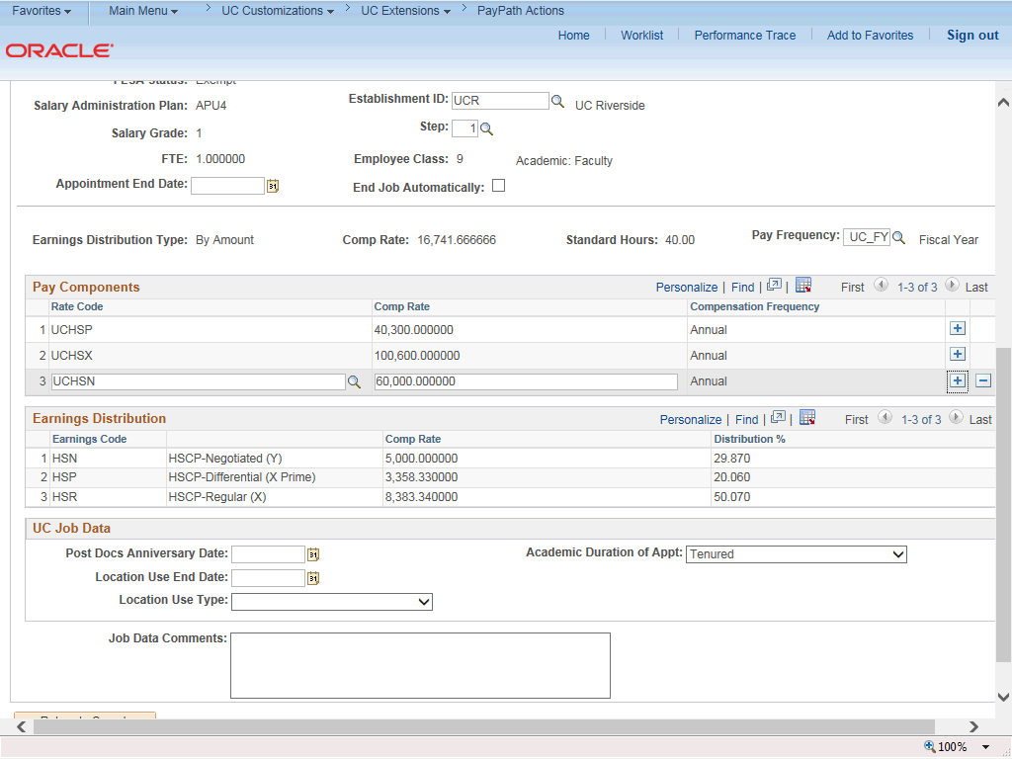

Step | Action
25. | For Job Data updates, enter a comment explaining the update. Click in the Job Data Comments field.
26. | Enter the desired information into the Job Data Comments field.

Step | Action
27. | Click the scroll bar.
28. | Click the Additional Pay Data tab.
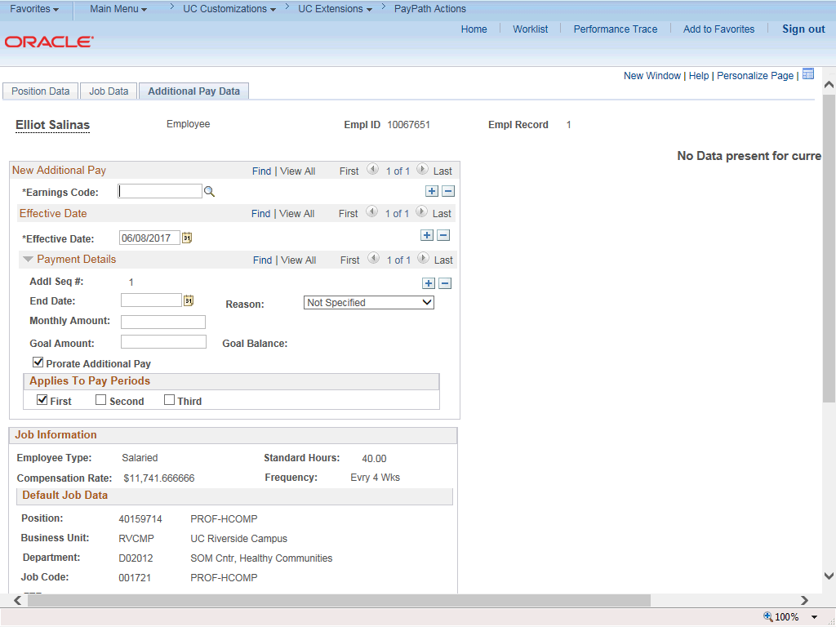

Step | Action
29. | Click the scroll bar.

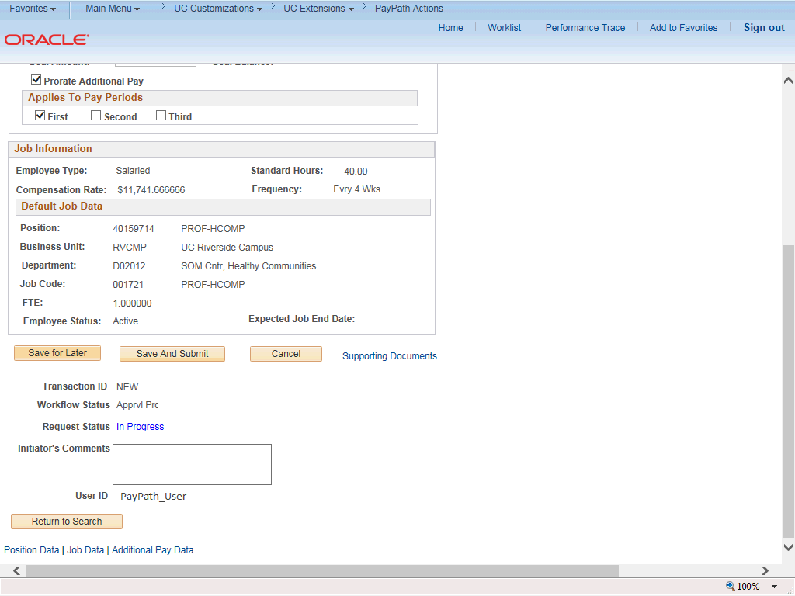

Step | Action
30. | Use the Supporting Documents link to attach supporting documentation, if applicable.
31. | Use the Initiator's Comments field, to further explain the transaction for the Approver, if applicable.
32. | Click the Save And Submit button.

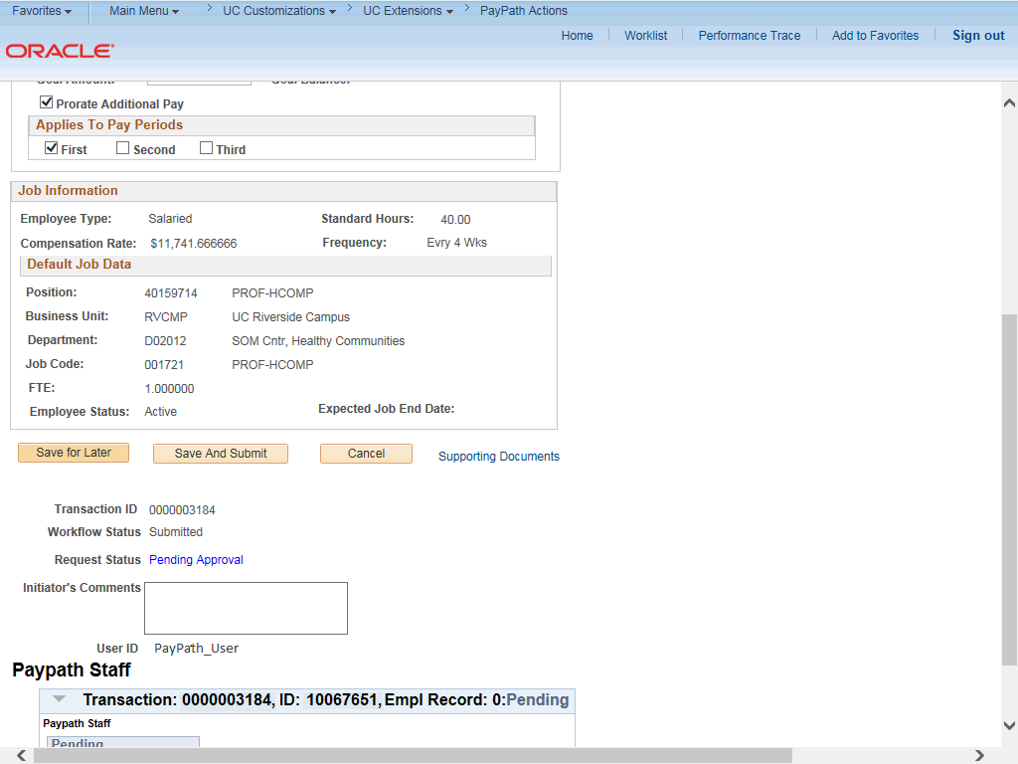

Step | Action
33. | The transaction is submitted for approval.
34. | You have initiated a pay rate change PayPath transaction for an academic employee.  End of Procedure.

