Use this task to initiate an FTE position data change PayPath transaction. This example demonstrates a reduction in time FTE change for a staff employee.

Navigation: PeopleSoft Menu > UC Customizations > UC Extensions > PayPath Actions Note: This page also may be available in Workcenter depending on your security access.
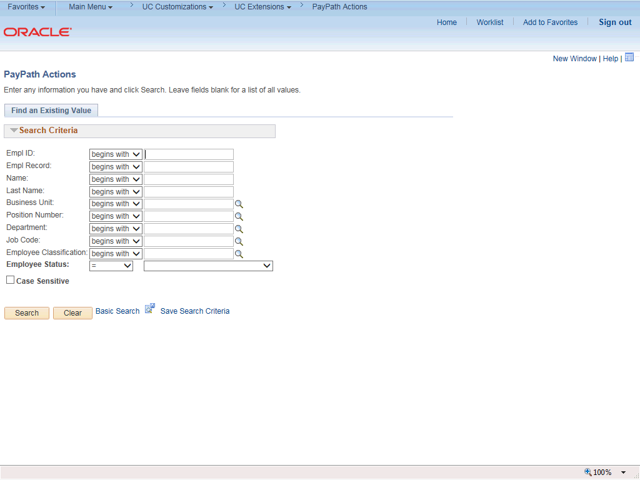

Step | Action
1. | After you navigate to the PayPath Actions component, the system displays the Find an Existing Value tab, which you use to search for the appropriate employee record.  Enter search criteria in one or more of the search fields on this page.
2. | Click in the Empl ID field.
3. | Enter the desired information into the Empl ID field.
4. | Click the Search button.

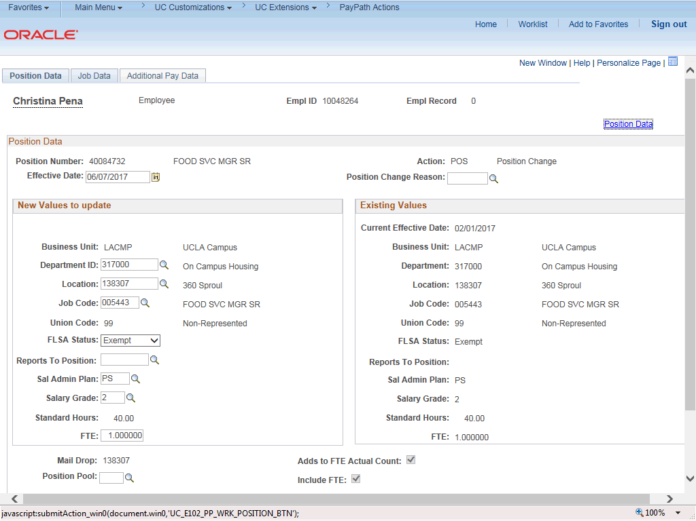

Step | Action
5. | The PayPath Actions page displays the Position Data tab. Navigate to the appropriate tab for the update you must enter. For this example, a position data change, stay on the Position Data tab.
6. | Before you enter the update, you must identify the Effective Date and  Position Change Reason.
7. | The Effective Date field defaults to the system date (today's date). If needed, change the date to reflect the date the update should take effect.  Click in the Effective Date field.
8. | Enter the desired information into the Effective Date field.
9. | Click the Look up Position Change Reason button.

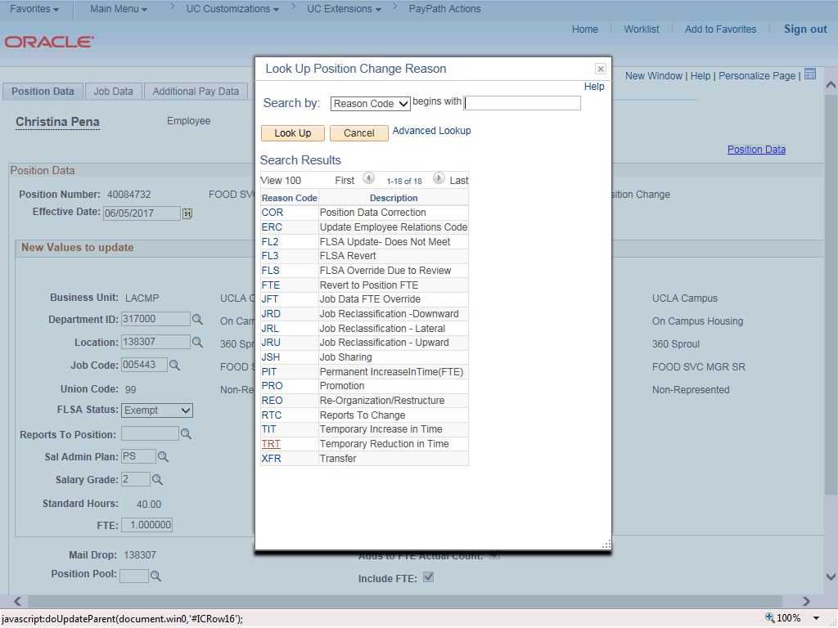

Step | Action
10. | For this example, select the Temporary Reduction in Time code. Click the TRT list item.
11. | Enter the reduced FTE in the FTE field. Click in the FTE field.
12. | Enter the desired information into the FTE field.

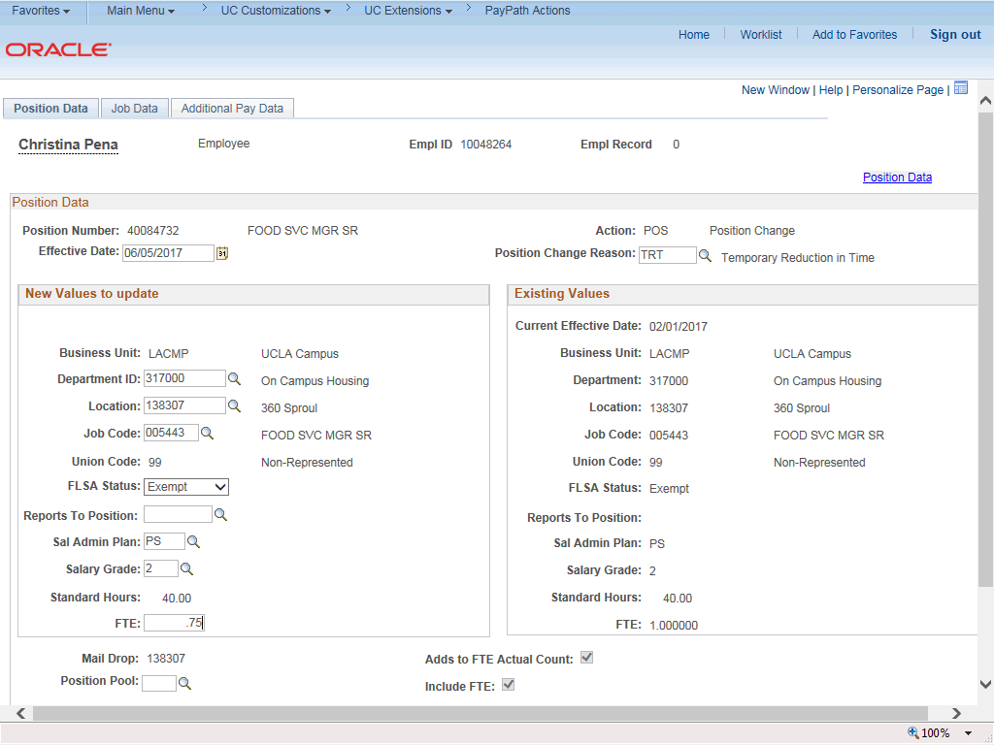

Step | Action
13. | Click the Job Data tab.
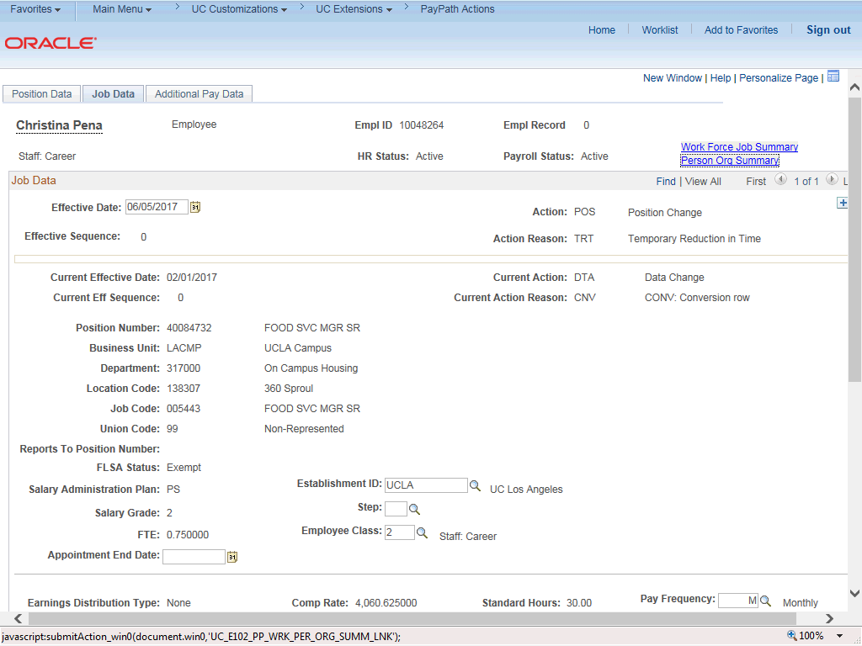

Step | Action
14. | Notice a new Job Data row has been added that includes the update from the Position Data tab. The new row includes the Effective Date, Action and Action Reason from the position data update.
15. | The new row also includes the updated FTE from the Position FTE.
16. | Click the scroll bar.
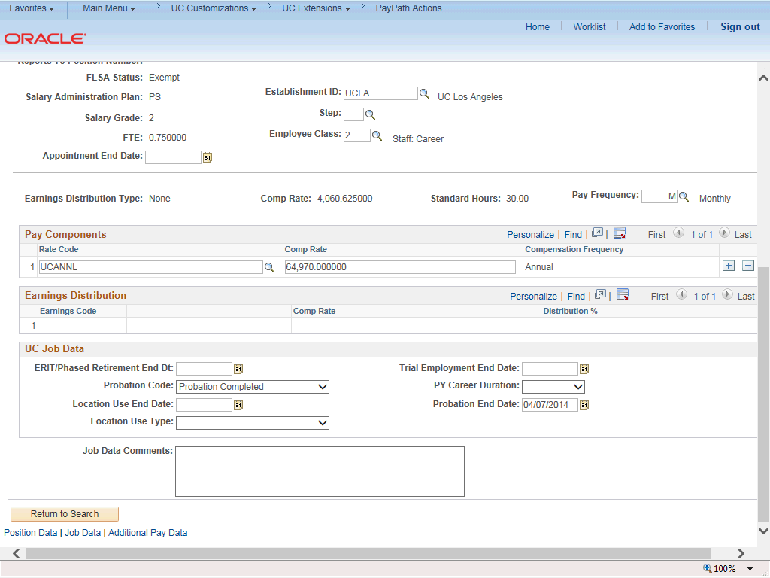

Step | Action
17. | The Pay Components section displays the updated Comp Rate amount based on the new FTE of .75.
18. | Click in the Job Data Comments field.
19. | Enter the desired information into the Job Data Comments field.
20. | Click the scroll bar.
21. | Click the Additional Pay Data tab.

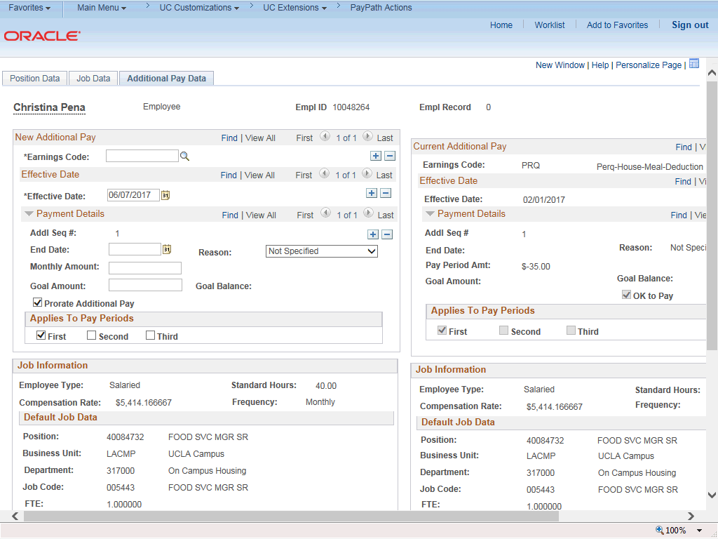

Step | Action
22. | Click the scroll bar.
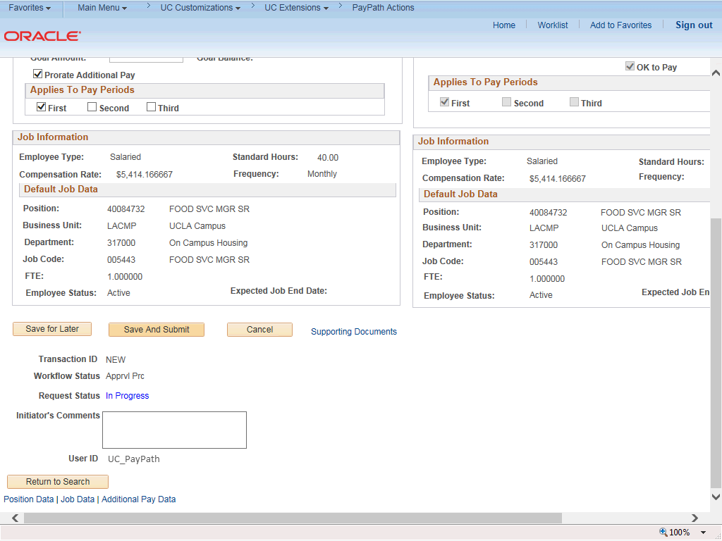

Step | Action
23. | Use the Supporting Documents link to attach supporting documentation, if applicable.
24. | Use the Initiator's Comments field, to further explain the transaction for the Approver, if applicable.
25. | Click the Save And Submit button.
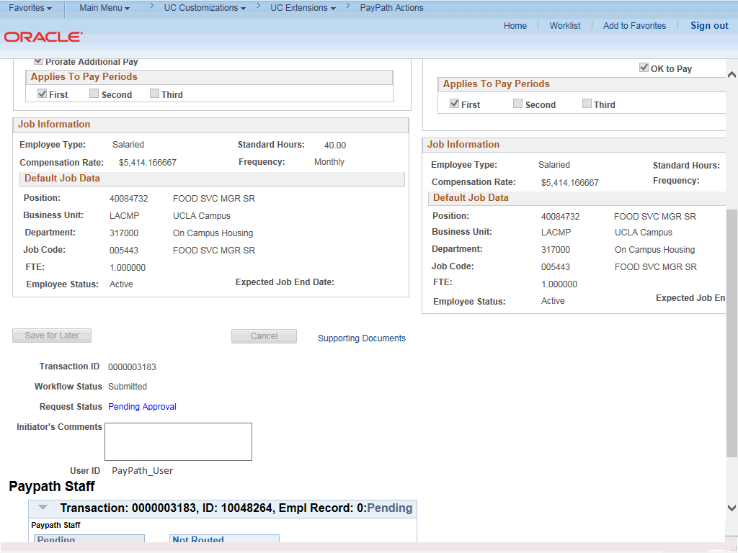

Step | Action
26. | The transaction is submitted for approval.
27. | You have initiated a position data change PayPath transaction for a staff employee.  End of Procedure.

