Use this task to initiate a position data change PayPath transaction. This example demonstrates a promotion for an academic employee.

Navigation: PeopleSoft Menu > UC Customizations > UC Extensions > PayPath Actions Note: This page also may be available in Workcenter depending on your security access.
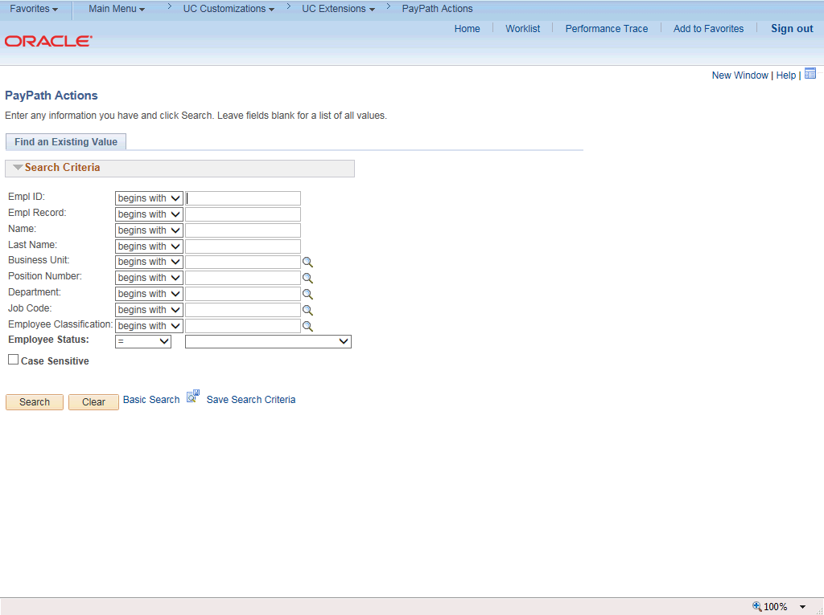

Step | Action
1. | After you navigate to the PayPath Actions component, the system displays the Find an Existing Value tab, which you use to search for the appropriate employee record.  Enter search criteria in one or more of the search fields on this page.
2. | Click in the Empl ID field.
3. | Enter the desired information into the Empl ID field.
4. | Click the Search button.

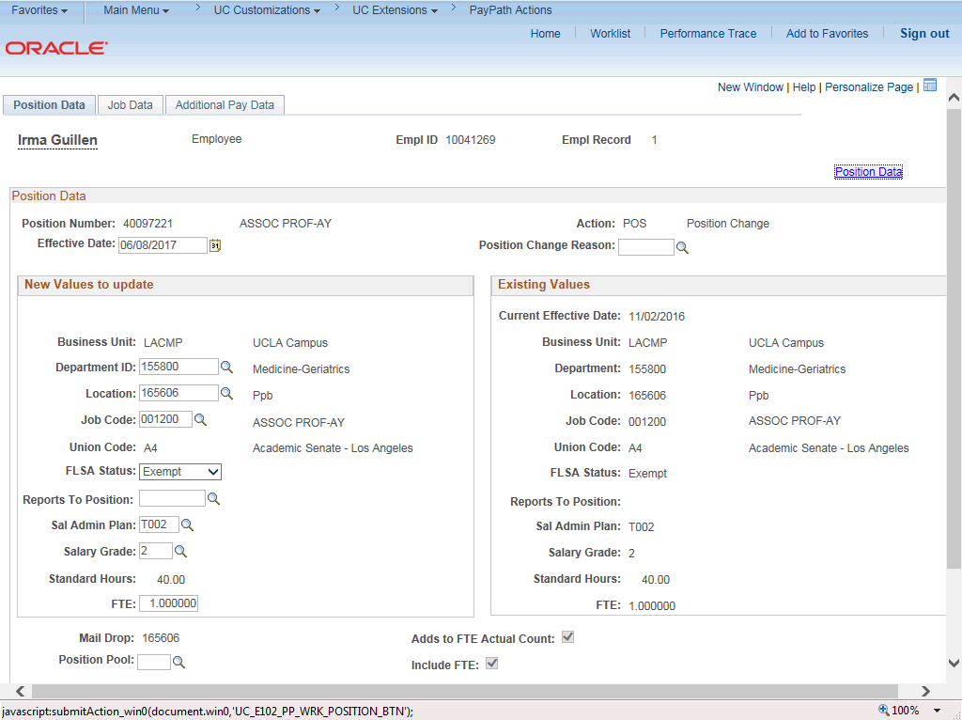

Step | Action
5. | The PayPath Actions page displays the Position Data tab. Navigate to the appropriate tab for the update you must enter. For this example, a position data change, stay on the Position Data tab.
6. | Before you enter the update, you must identify the Effective Date and  Position Change Reason.
7. | The Effective Date field defaults to the system date (today's date). If needed, change the date to reflect the date the update should take effect.  Click in the Effective Date field.
8. | Enter the desired information into the Effective Date field.
9. | Click the Look up Position Change Reason button.

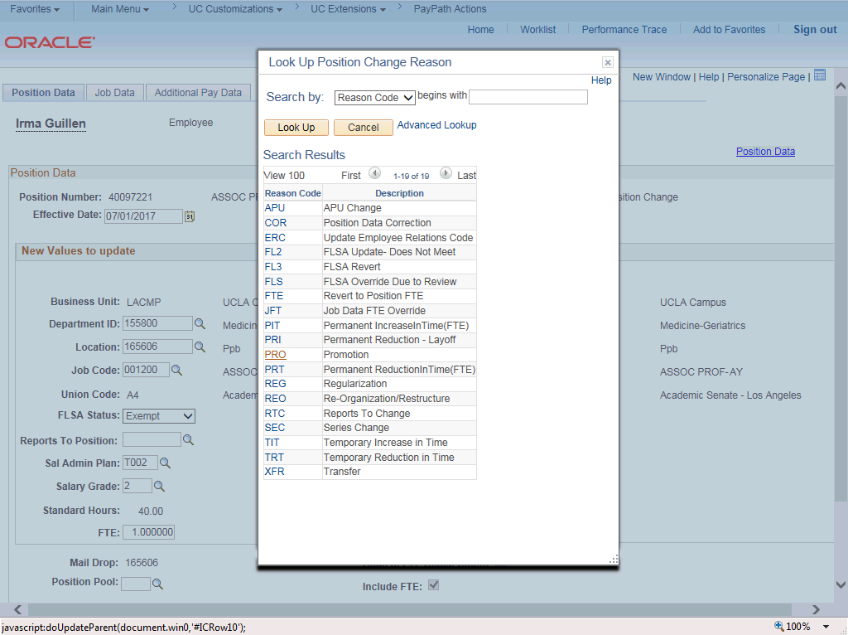

Step | Action
10. | For this example, select the Promotion code. Click the PRO list item.
11. | Enter the Job Code for the promotion. Click in the Job Code field.
12. | Enter the desired information into the Job Code field.

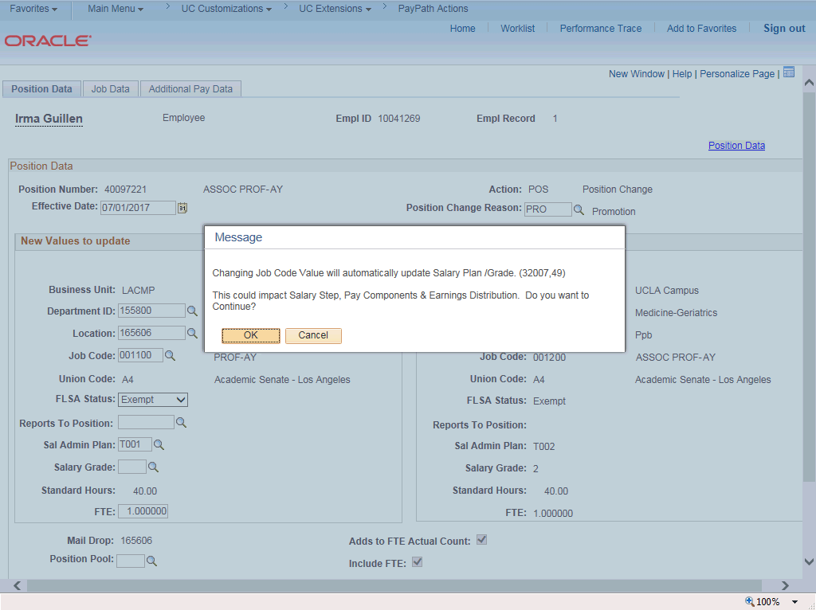

Step | Action
13. | UCPath displays a message indicating that the salary plan and grade will be updated. You may need to change step, pay components or earnings distribution information.  Click the OK button.
14. | If the Salary Admin Plan/Salary Grade has a salary step component configured and you or UCPath changes the Sal Admin Plan/Salary Grade fields, the Step and compensation data is removed from the Job Data tab.  UCPath automatically updates the Salary Admin Plan and Salary Grade fields based on the selected new job code. When there are multiple valid salary plans for the job code, you must enter the correct Salary Plan.
15. | The Salary Admin Plan and Salary Grade fields must be updated based on the selected job code. Because there is only one salary admin plan for this job code, UCPath automatically updates the field.
16. | The Salary Grade also must be updated based on the selected job code; however, if there is more than one option, the field is blank and you must select the appropriate value. If there is only one salary grade, UCPath automatically updates the field.
17. | Click the Look up Salary Grade button.

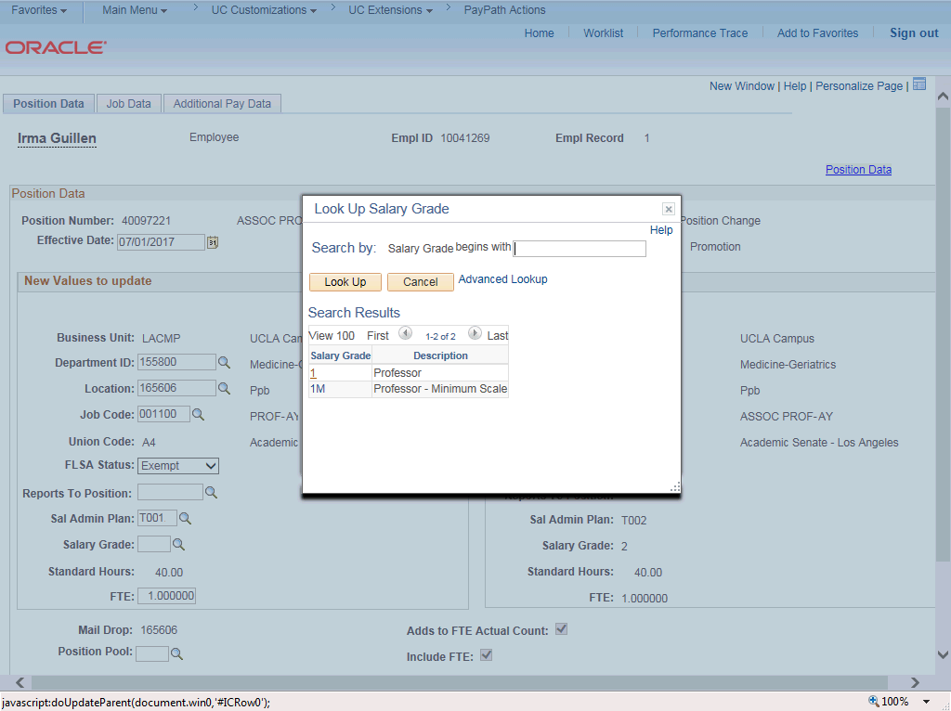

Step | Action
18. | Select the appropriate Salary Grade code. For this example, click the 1 link.

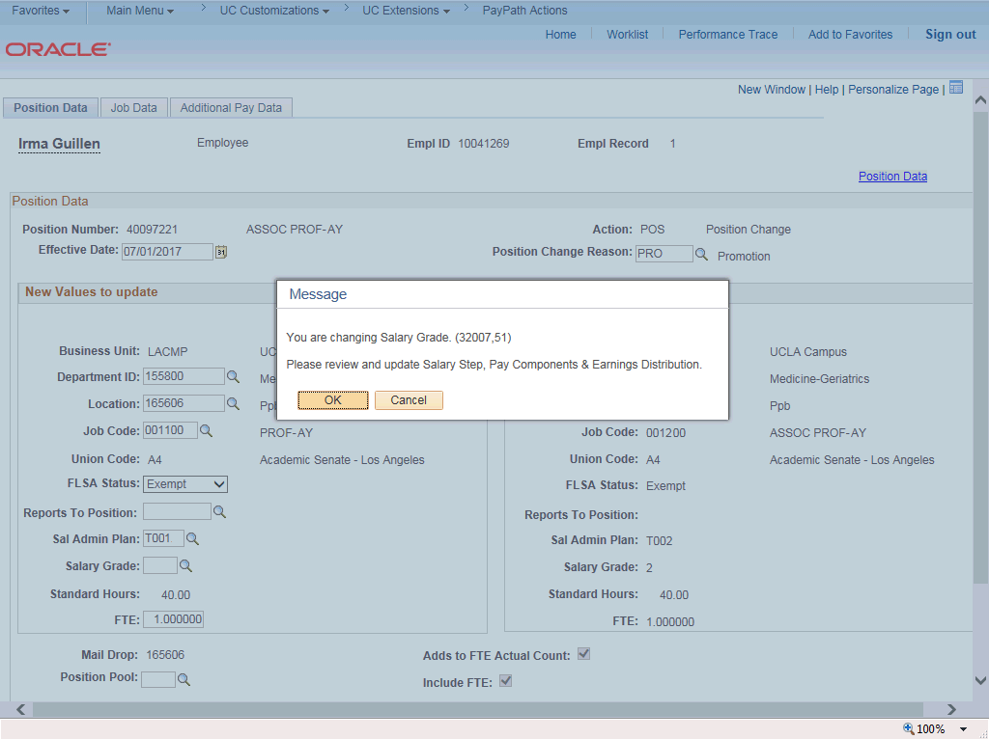

Step | Action
19. | Click the OK button.
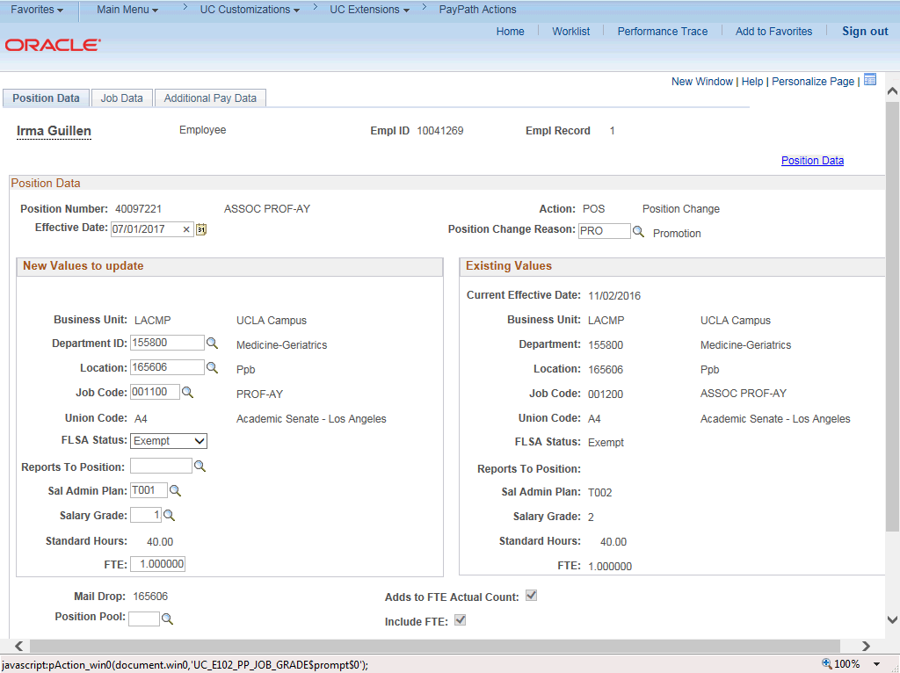

Step | Action
20. | Click the Job Data tab.
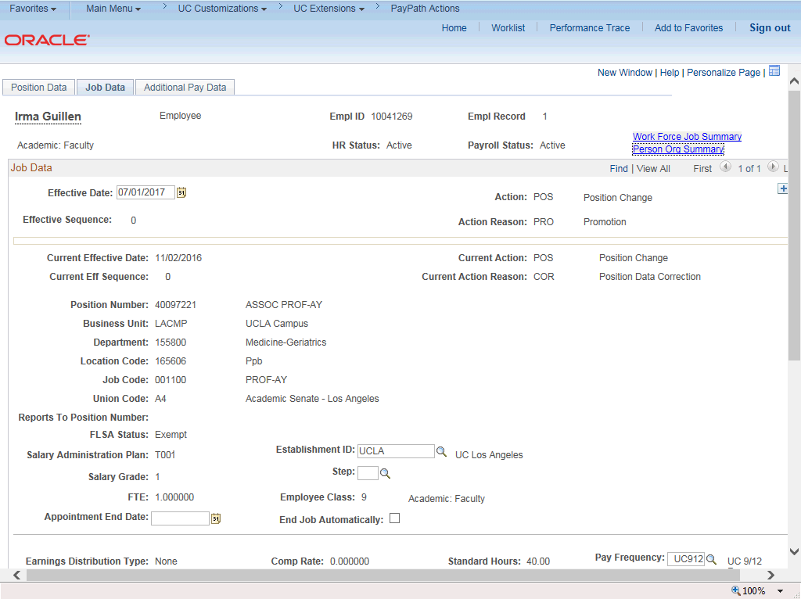

Step | Action
21. | Notice a new Job Data row has been added that includes the update from the Position Data tab. The new row includes the Effective Date, Action and Action Reason from the position data update.
22. | The updated Job Code, Salary Administration Plan and Salary Grade also appear.
23. | Click the scroll bar.
24. | To complete the promotion, the Step must be entered for the new job. After the step is entered, UCPath automatically updates the compensation information.  Click in the Step field.
25. | Enter the desired information into the Step field. For this example, enter 2.

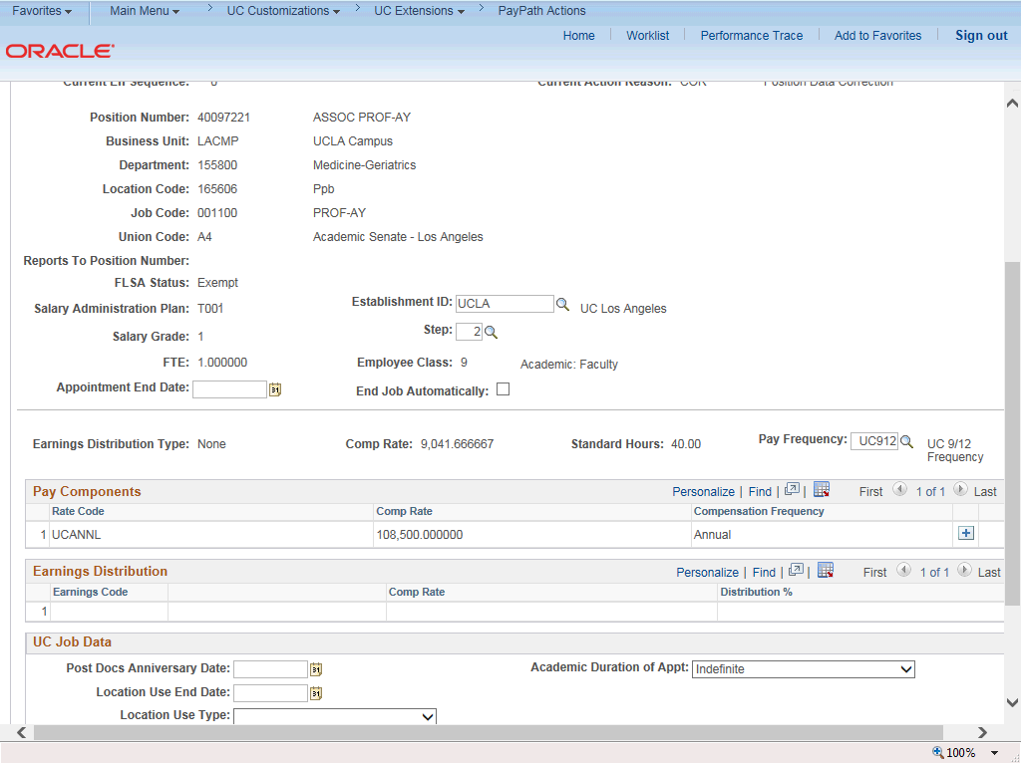

Step | Action
26. | UCPath automatically updates the Pay Components section based on the selected step.
27. | Click the scroll bar.
28. | Click the Additional Pay Data tab.

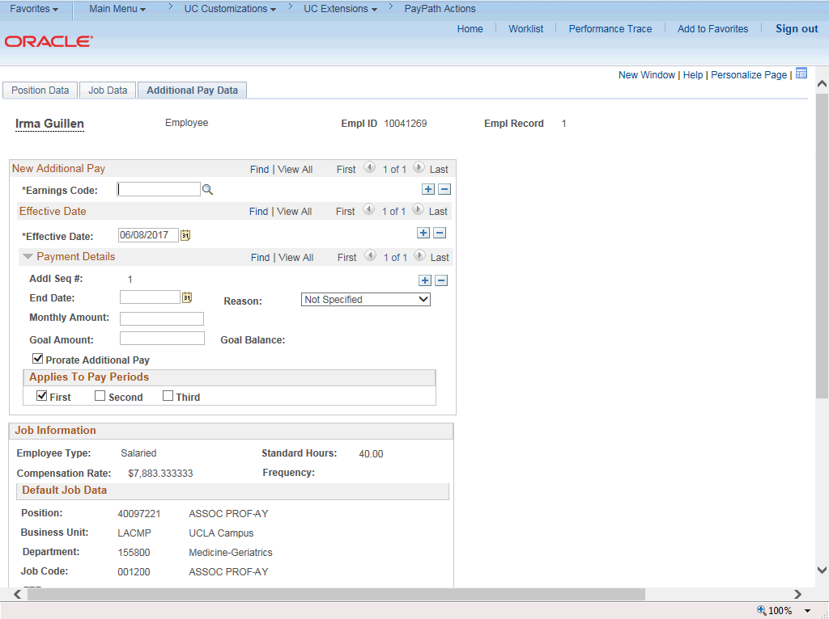

Step | Action
29. | Click the scroll bar.
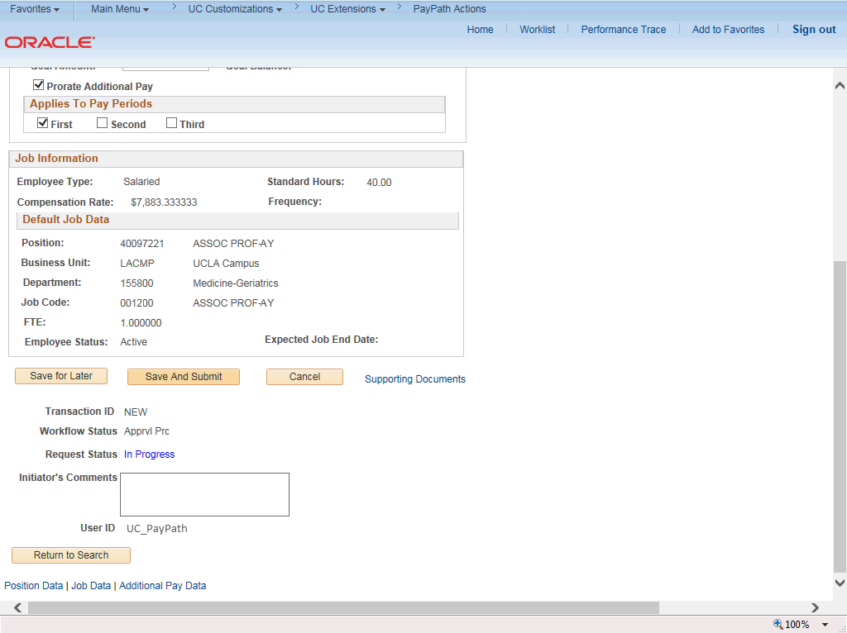

Step | Action
30. | Use the Supporting Documents link to attach supporting documentation, if applicable.
31. | Use the Initiator's Comments field, to further explain the transaction for the Approver, if applicable.
32. | Click the Save And Submit button.
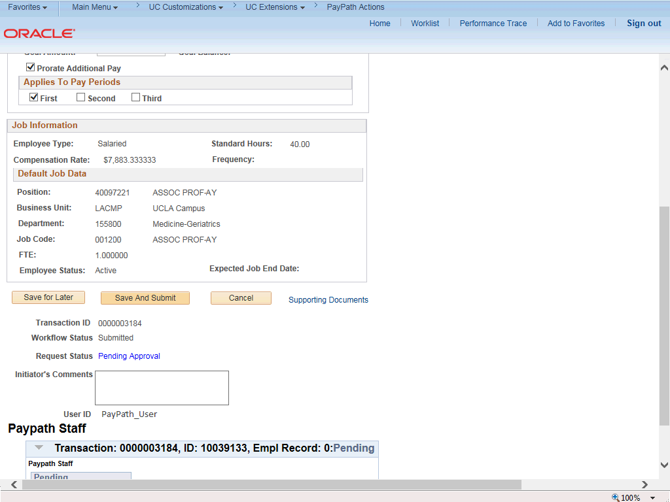

Step | Action
33. | The transaction is submitted for approval.
34. | You have initiated a position data change PayPath transaction for an academic employee.  End of Procedure.

