Use this task to initiate a position data change PayPath transaction. This example demonstrates a change in who the position reports to. The steps in this procedure can be used for academic or staff employees.

Navigation: PeopleSoft Menu > UC Customizations > UC Extensions > PayPath Actions Note: This page also may be available in Workcenter depending on your security access.
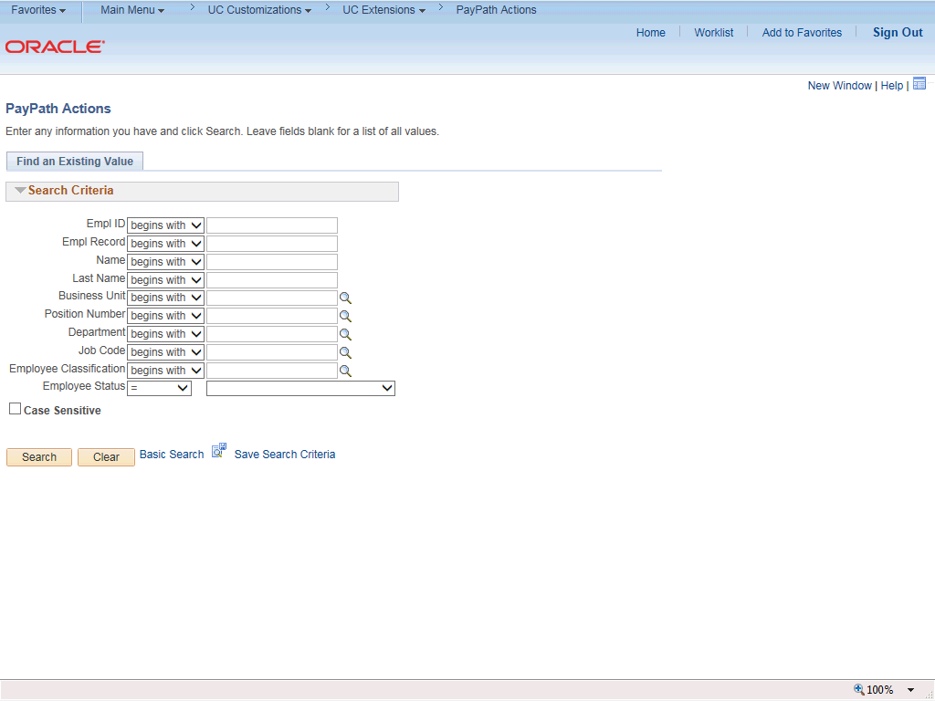

Step | Action
1. | After you navigate to the PayPath Actions component, the system displays the Find an Existing Value tab, which you use to search for the appropriate employee record.  Enter search criteria in one or more of the search fields on this page.
2. | Click in the Empl ID field.
3. | Enter the desired information into the Empl ID field.
4. | Click the Search button.

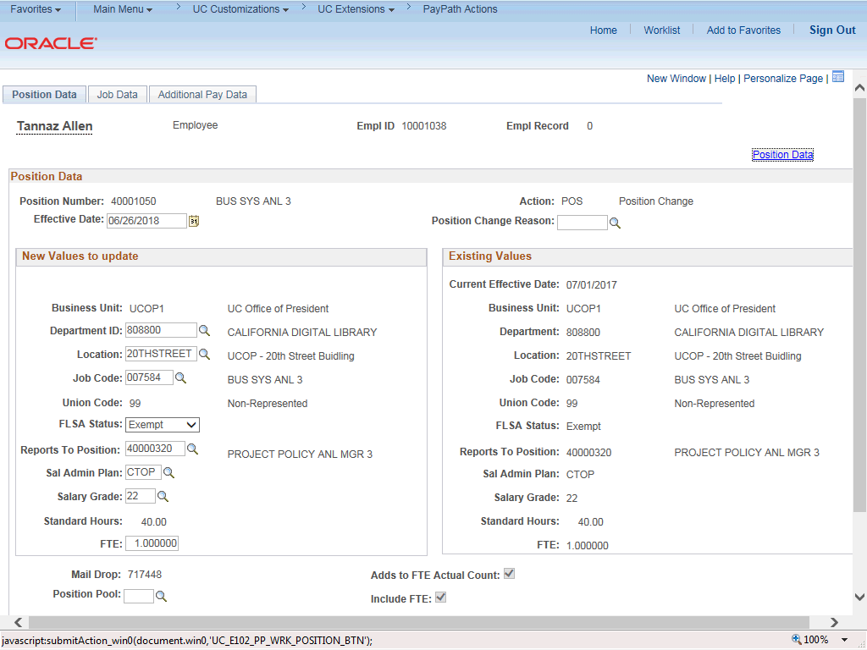

Step | Action
5. | The PayPath Actions page displays the Position Data tab. Navigate to the appropriate tab for the update you must enter. For this example, a change to the Reports To Position field, stay on the Position Data tab.
6. | Before you enter the update, you must identify the Effective Date and  Position Change Reason.
7. | The Effective Date field defaults to the system date (today's date). If needed, change the date to reflect the date the update should take effect.  Click in the Effective Date field.
8. | Enter the desired information into the Effective Date field.
9. | Click the Look up Position Change Reason button.

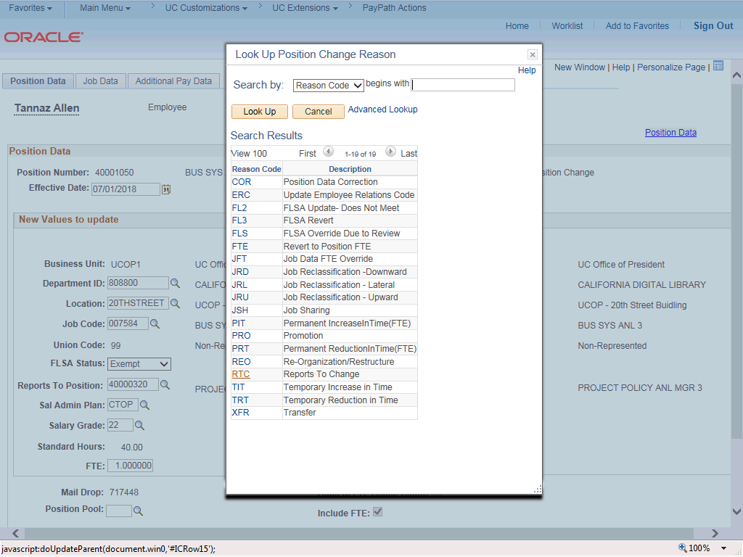

Step | Action
10. | For this example, click the Reports To Change code. Click the RTC link.
11. | Enter the new reports to position number. Click in the Reports To Position field.
12. | Enter the desired information into the Reports To Position field.

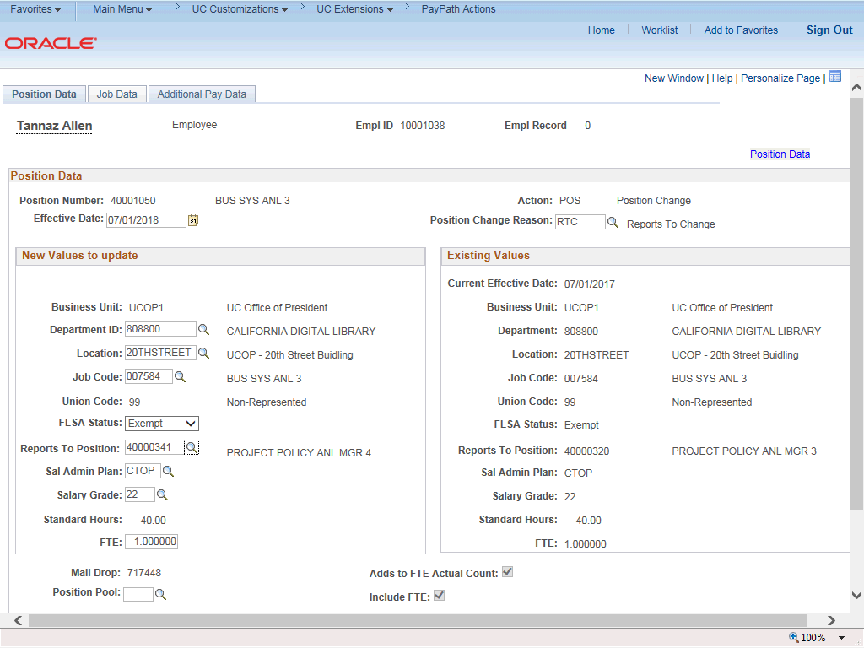

Step | Action
13. | Click the Additional Pay Data tab.
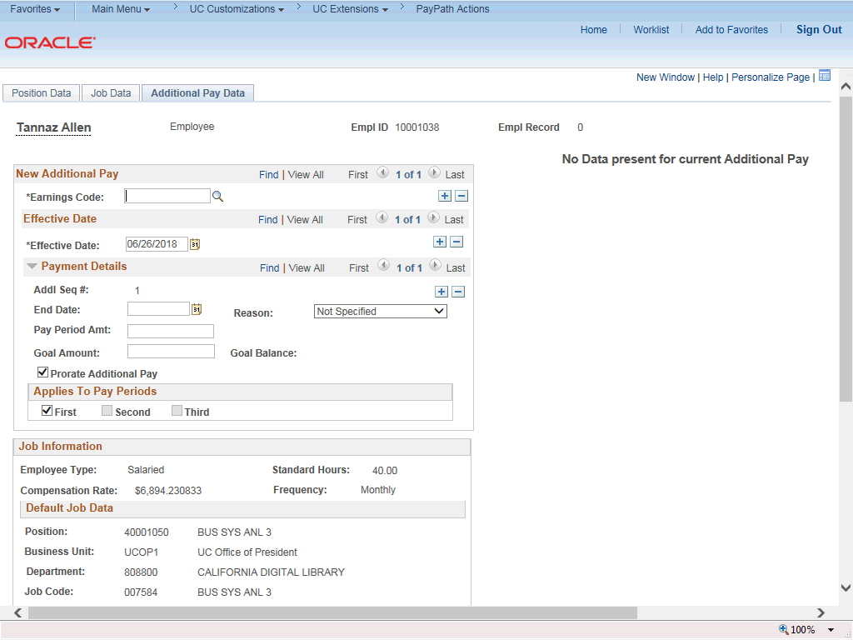

Step | Action
14. | Click the scroll bar.
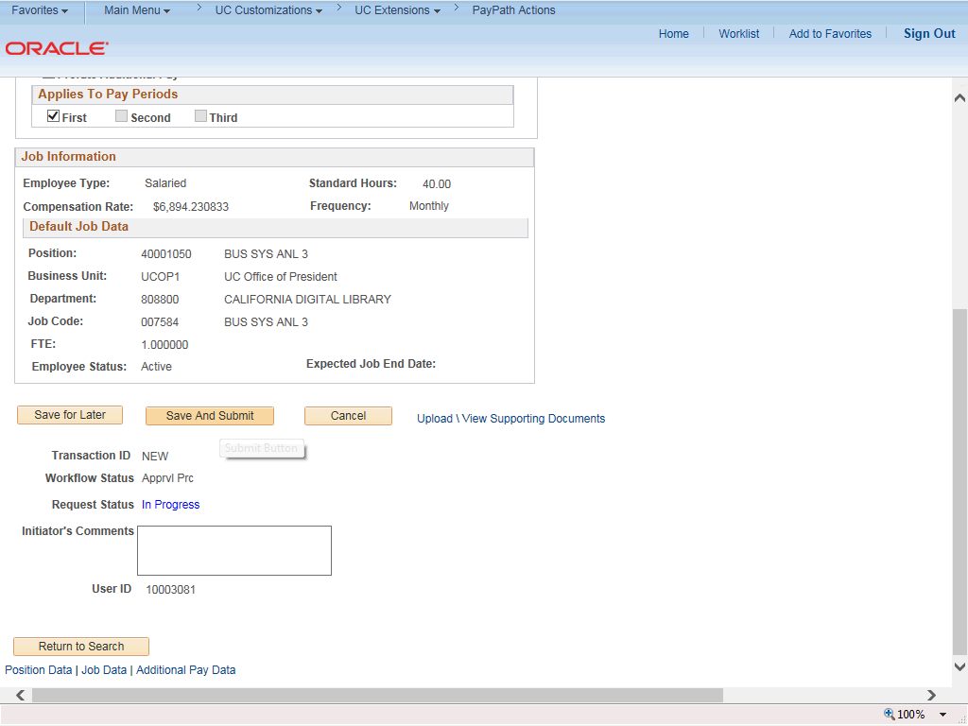

Step | Action
15. | Use the Upload \ View Supporting Documents link to attach supporting documentation, if applicable.
16. | Use the Initiator's Comments field to further explain the transaction for the Approver, if applicable.
17. | Click the Save And Submit button.

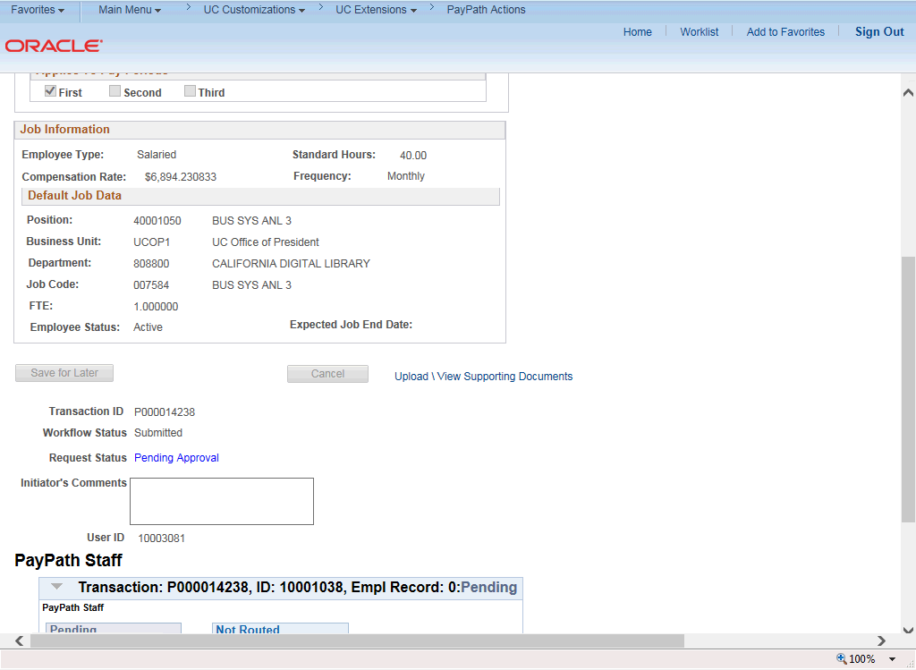

Step | Action
18. | The transaction is submitted for approval.
19. | You have initiated a position data change PayPath transaction.  End of Procedure.

