Use this task to initiate an involuntary termination template transaction. The steps in this procedure can be used for academic and staff employees. For termination reason of Death, UCPC WFA Production will terminate all employee jobs. For all other reasons, a separate termination template must be initiated for all applicable jobs.

Navigation: PeopleSoft Menu > Workforce Administration > Smart HR Template > Smart HR Transactions

Note: This page also may be available in Workcenter depending on your security access.

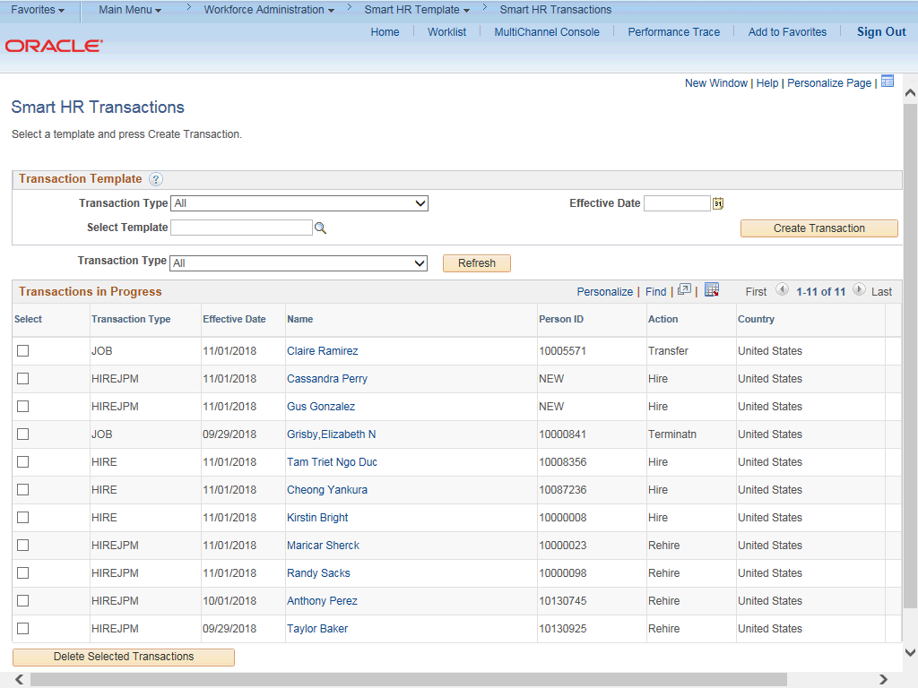

Step | Action
1. | Use the Smart HR Transactions page to select the appropriate template to begin the termination process.
2. | Note: The Transaction Type field is not used by UC. Click the Look up Select Template button.

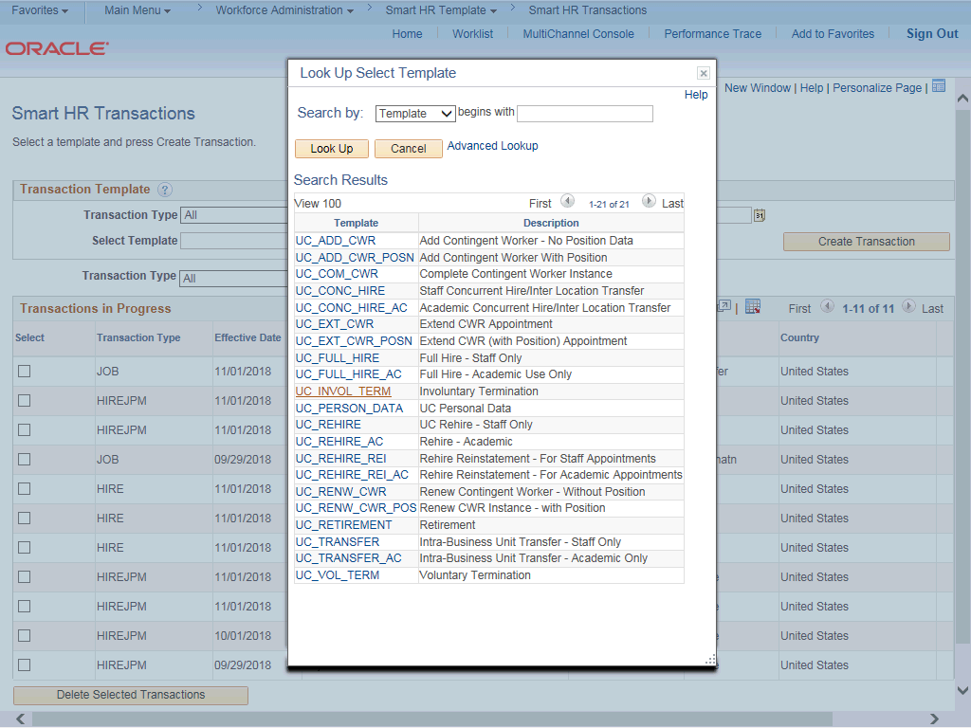

Step | Action
3. | Select the appropriate termination template. There are two termination templates, one for voluntary terminations and one for involuntary terminations.  Click the UC_INVOL_TERM link.
4. | Click in the Effective Date field.
5. | The Effective Date field is the effective date of the selected template action. The date you enter in this field automatically populates the Effective Date field on the Enter Transaction Details page. You can update the Effective Date on the Enter Transaction Details page if needed.  Enter the desired information into the Effective Date field.
6. | Click the Create Transaction button.

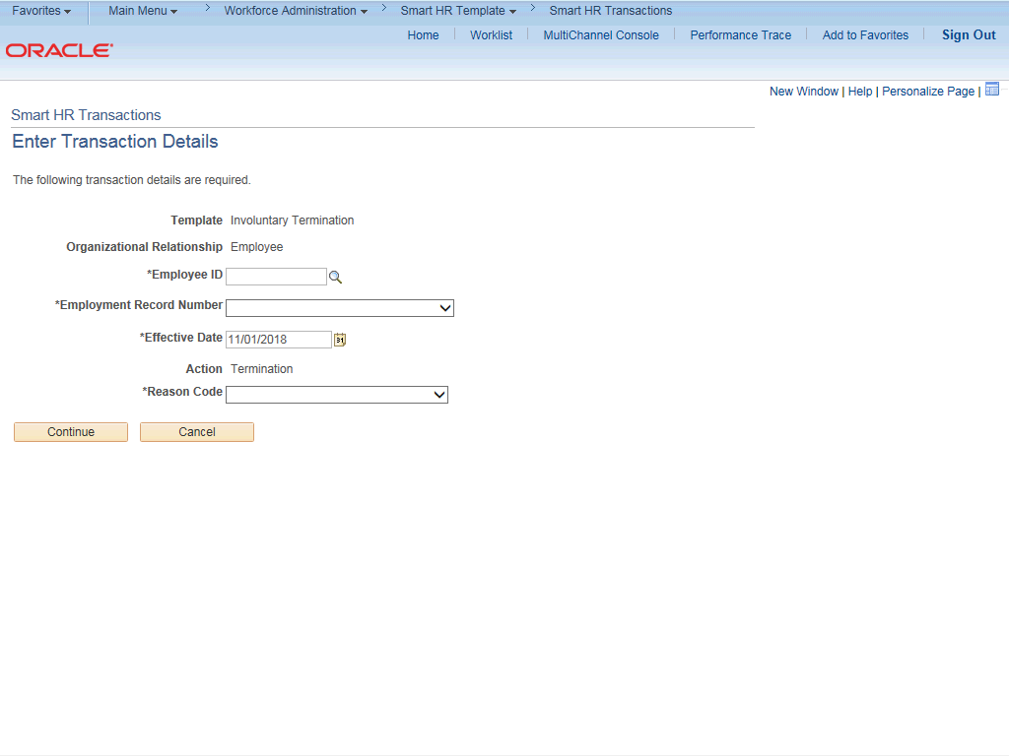

Step | Action
7. | In the Employee ID field, enter the employee’s ID number or use the lookup to search for and select it. You have access only to employee records within your business unit.  Click the Look up Employee ID button.

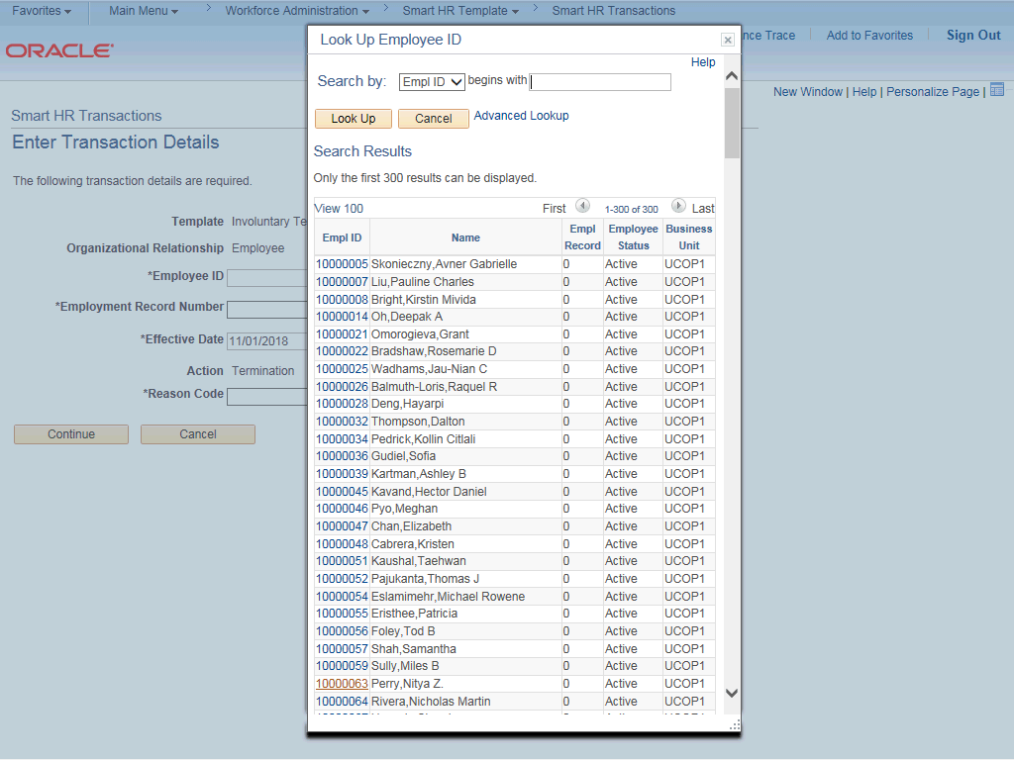

Step | Action
8. | Select the appropriate Employee ID.
9. | The Employment Record Number defaults to the first record number for which you have departmental access (in this example, 0). Select the correct Employment Record Number for the job to terminate.  For termination reason of Death, UCPC WFA Production will terminate all employee jobs. For all other reasons, a separate termination template must be initiated for all applicable jobs.  For this example, accept the default.
10. | The Effective Date is populated based on your entry on the previous page. Ensure that you entered the correct date on which the termination is effective. This date should be one day after the employee's last day of work.
11. | Click the button to the right of the Reason Code field.

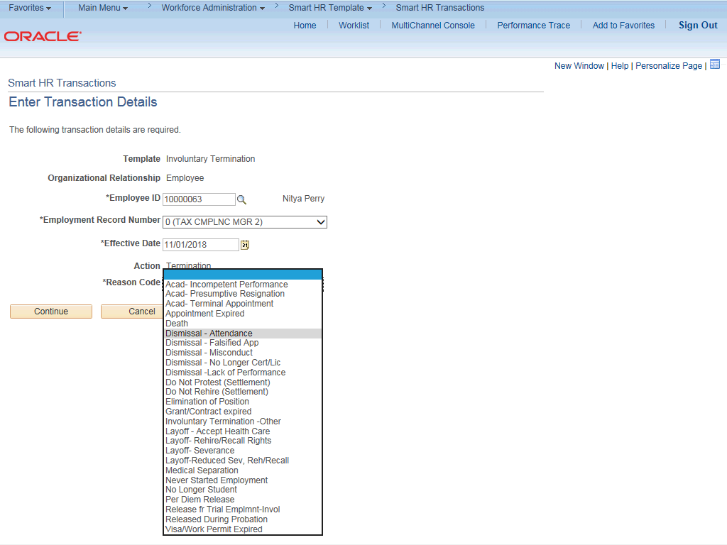

Step | Action
12. | Select the appropriate Reason Code.
13. | Click the Continue button.

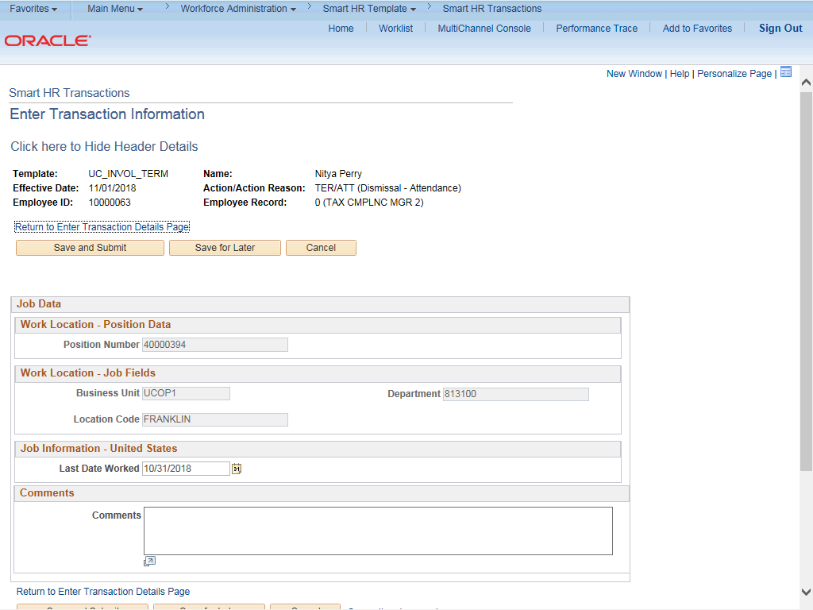

Step | Action
14. | The involuntary termination template appears.  The top of the page displays header data, which you can show/hide as needed.
15. | The employee's position number and work location data automatically populate for the selected employment record.
16. | The Last Date Worked field defaults to the work day prior to the Effective Date, but you can update it as necessary. If the Effective Date is a Monday, the Last Date Worked defaults to the previous Friday.  This date should always be a date earlier than the Effective Date you entered on the previous page.  For this example, accept the default.
17. | Use the Comments field to enter specific details or an explanation regarding the transaction. This field is referenced by UCPC WFA Production to assist with processing the transaction.
18. | Click the scroll bar.

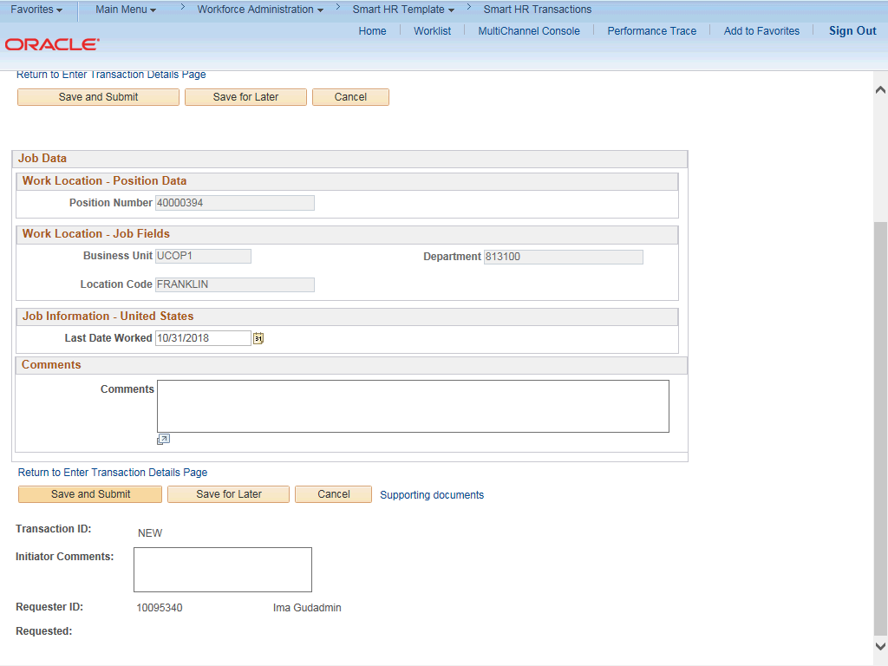

Step | Action
19. | Use the Supporting documents link to attach supporting documents.
20. | Enter comments for the approver in the Initiator Comments field.  Comments you enter here appear only with the request; they do not display on the employee’s record after the transaction is processed to completion.
21. | Click the Save and Submit button.

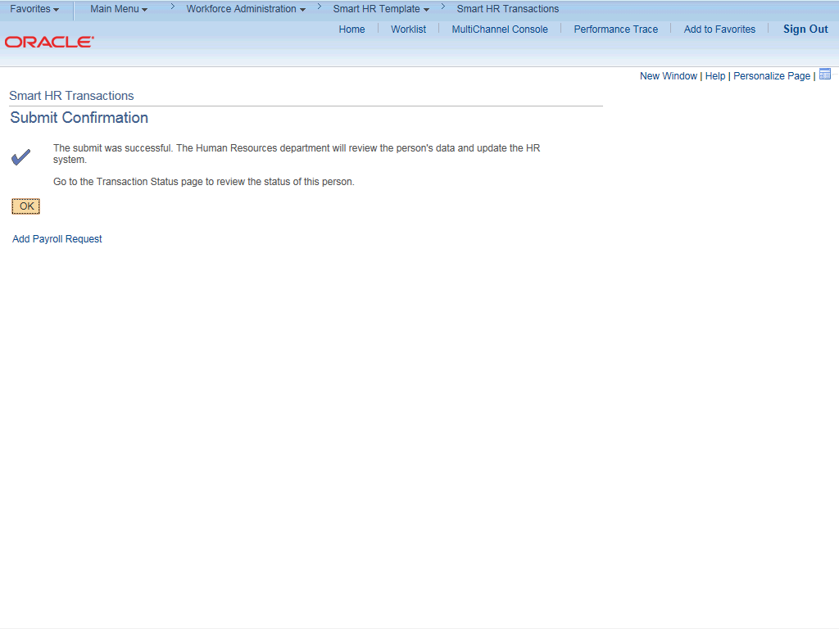

Step | Action
22. | Some Location's business process allows users to have the Template Initiator role as well as the Payroll Initiator role. In these cases, the Add Payroll Request link is available. This link allows direct access to the Payroll Requests page.  For specific steps on entering a payroll request or final pay, refer to the PHCMPAYL200: Additional Compensation and Pay Adjustment Requests course and applicable simulations.
23. | Click the OK button.

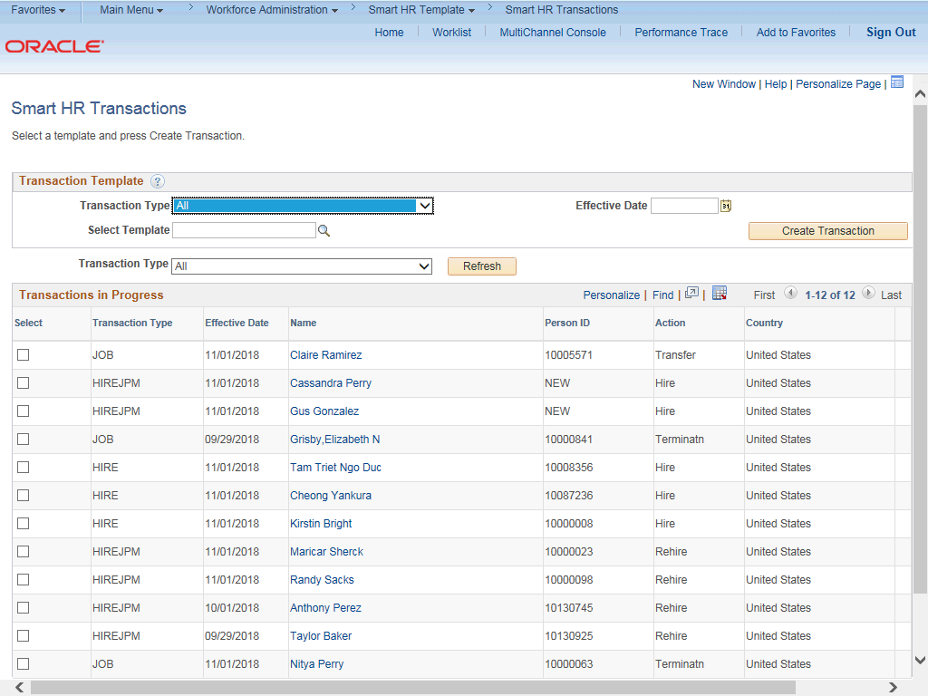

Step | Action
24. | The template transaction is routed for approval and appears in the Transactions in Progress section until it is processed.
25. | You have initiated an involuntary termination template transaction.  End of Procedure.

