Use this task to view the status of Smart HR Template transactions and TAM Prepare for Hire transactions that have completed Location AWE and have moved into UCPC WFA Production's queue. You can view all transactions submitted within the department(s) to which you have access.

This page displays transactions that are pending, processed, or cancelled by WFA Production. This page also displays template transactions that have been denied by a Location Approver.

Navigation: PeopleSoft Menu > Workforce Administration > Smart HR Template > Transaction Status

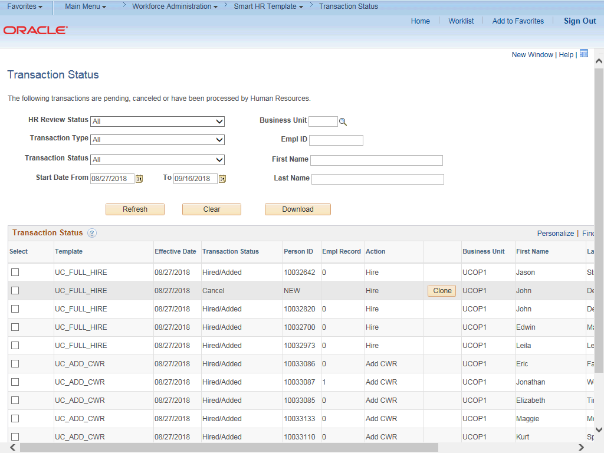

Step | Action
1. | Use the Transaction Status page to view the status of template and TAM transactions as well as other summary transaction information.  The default filters are set to All with a Start Date From that is 10 days prior to the current date and a To date that is 10 days after the current date.
2. | To view only TAM Prepare for Hire transactions, select  RecruitingHire/Rehire/Transfer from the Transaction Type drop-down list.
3. | The Download button allows you to export the transaction grid information into an Excel spreadsheet, including any comments entered by WFA Production.
4. | The Transaction Status grid displays the transactions that match the filters.

Step | Action
5. | The Template column identifies the template that was initiated. This column displayed RECRUITING for TAM transactions.
6. | The Effective Date column identifies the effective date entered on the transaction.
7. | The values you might see in the Transaction Status column include:  - Requested: Transaction was submitted but not yet processed by WFA Production.  - Completed: Transaction was processed by WFA Production.  - Hired/Added: Hire, Rehire or Concurrent Hire was processed by WFA Production.  - Cancel: Transaction was cancelled by WFA Production.  - Denied: Transaction was denied by Location Approver. (Displays for template transactions only.)
8. | The Person ID column identifies the employee associated with the transaction. This column displays NEW for hire transactions that are pending or cancelled. After the hire transaction is processed by UCPC the new employee ID displays.
9. | The Empl Record column identifies the employee job record to which the transaction applies.
10. | The Action column displays the action code for the transaction.
11. | The Clone button appears when:  - A template transaction was denied by a Location Approver. Locations can refer to the SS Smart HR Transactions page to view comments from the Approver about the denied transaction.  - A template transaction was cancelled by WFA Production. Refer to the Reason for Cancellation column on this page to view comments from WFA Production about the cancelled transaction.  Note: TAM transactions do not use the Clone functionality. If WFA Production cancels a TAM transaction, an email notification is sent to the Location Prepare for Hire Initiator and includes the reason for the cancellation. Details about the cancelled transaction can also be reviewed on this page in the Reason for Cancellation field. Locations can withdraw the TAM transaction in the Recruiting module, update and then resubmit.
12. | The Business Unit column identifies the employee's business unit.
13. | The Name columns identify the employee associated with the transaction.
14. | For this example, update the HR Review Status to display all Cancelled  Transactions.  Click the button to the right of the HR Review Status field.

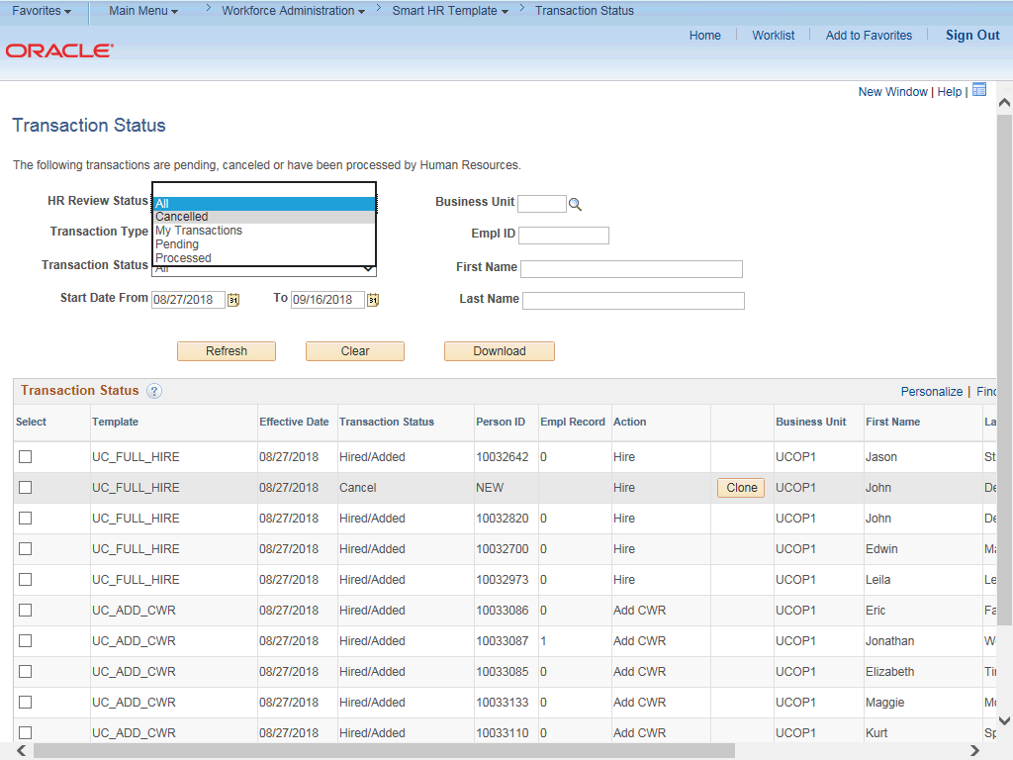

Step | Action
15. | Click the Cancelled list item.
16. | Click the Refresh button.

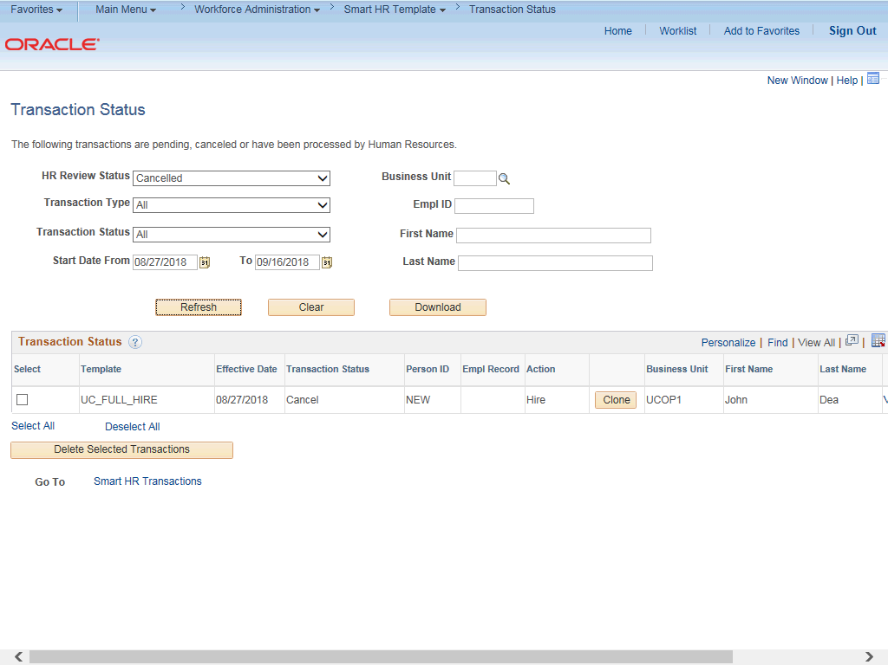

Step | Action
17. | The filter displays only one template transaction that has been cancelled within the dates indicated.
18. | Click the scroll bar.
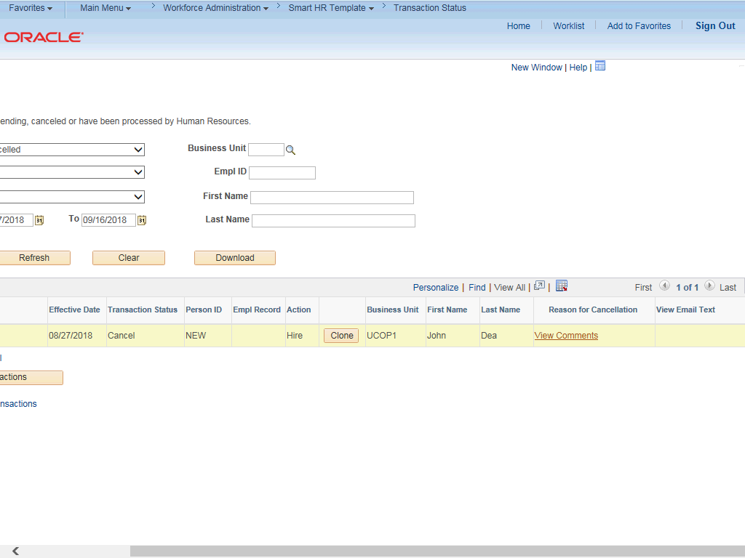

Step | Action
19. | When a transaction in cancelled, WFA Production enters a comment to explain why the transaction was cancelled. Location Template Initiators and Location Prepare for Hire Initiators use the View Comments link to view details about the reason for cancellation.  If needed, Location Template Initiators can Clone a template transaction to resubmit it with necessary corrections. The clone functionality is not available for TAM transactions.  Note: To view comments about a template transaction that was denied by a Location Approver you must navigate to the SS Smart HR Transactions page.
20. | The View Email Text column displays a View link if WFA Production sent an email to the Location Template Initiator about a template transaction.  Note: This functionality is not used for TAM transactions.
21. | Click the scroll bar.
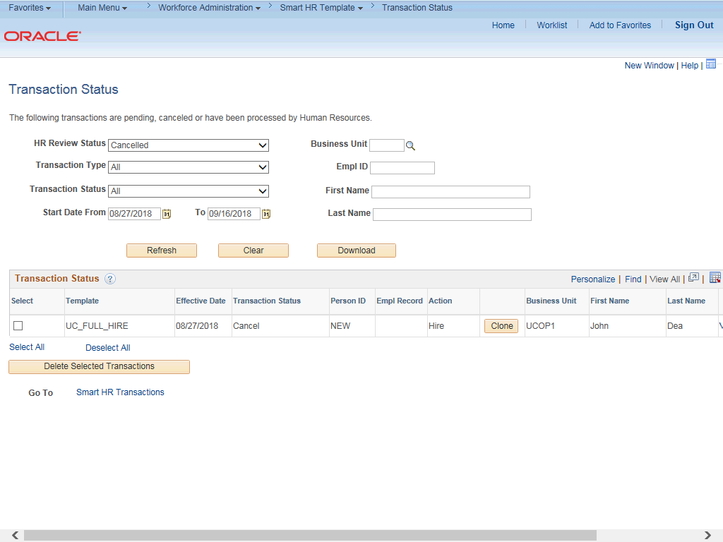

Step | Action
22. | For the next example, update the HR Review Status to display Processed  transactions.  Click the button to the right of the HR Review Status field.
23. | Click the Processed list item.
24. | Click the Refresh button.
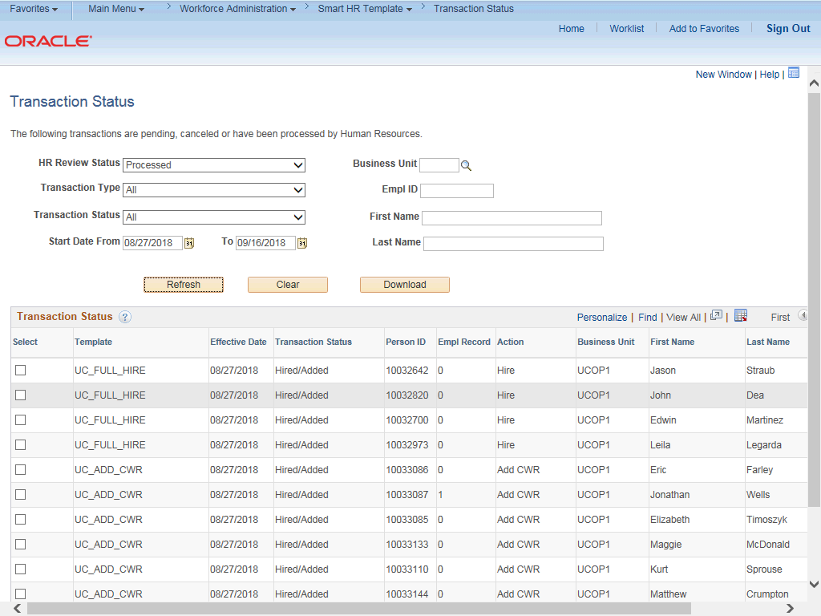

Step | Action
25. | The filter displays all the transactions that have been processed by WFA Production. This filter allows you to quickly view the new UCPath Employee ID (Person ID) for a new hire.
26. | Click the scroll bar.

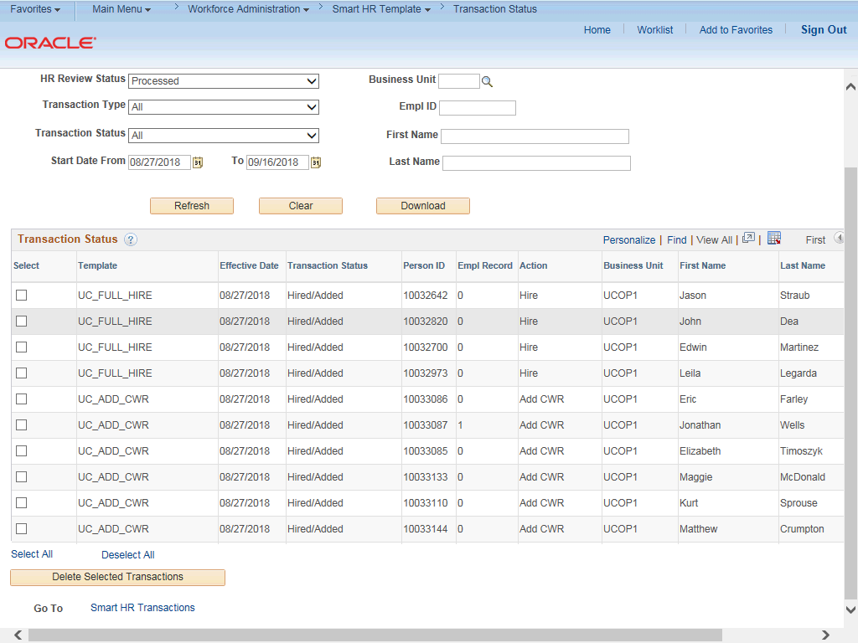

Step | Action
27. | Be cautious using the Delete Selected Transactions button. If you select the check box for a transaction and then click this button, the transaction will be deleted from the system. If the transaction has not been processed, it is deleted from WFA Production's queue and cannot be retrieved.
28. | You have viewed the status of Smart HR Template and TAM Prepare for Hire  Transactions.  End of Procedure.

