Use this task to update person profile information.

Navigation: PeopleSoft Menu > Workforce Development > Profile Management > Profiles >
Person Profiles

Note: This page also may be available in Workcenter depending on your security access.

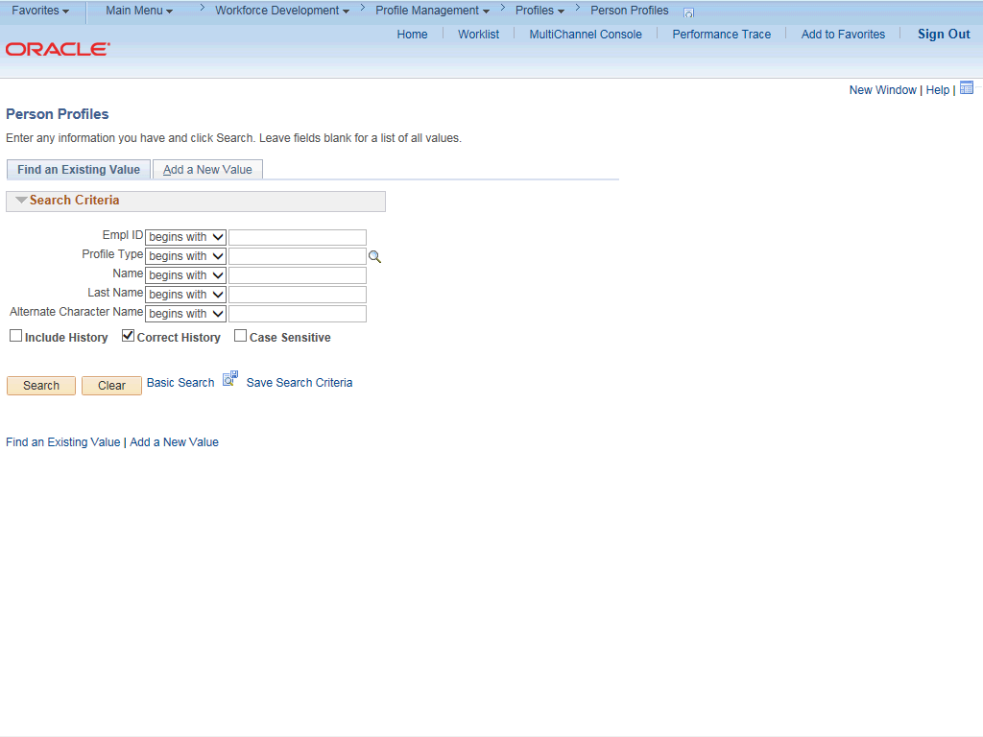

Step | Action
1. | After you navigate to the Person Profiles component, the system displays the Find an Existing Value tab, which you use to search for the appropriate employee record.  Enter search criteria in one or more of the search fields on this page.
2. | Click in the Empl ID field.
3. | Enter the desired information into the Empl ID field.
4. | Click the Search button.

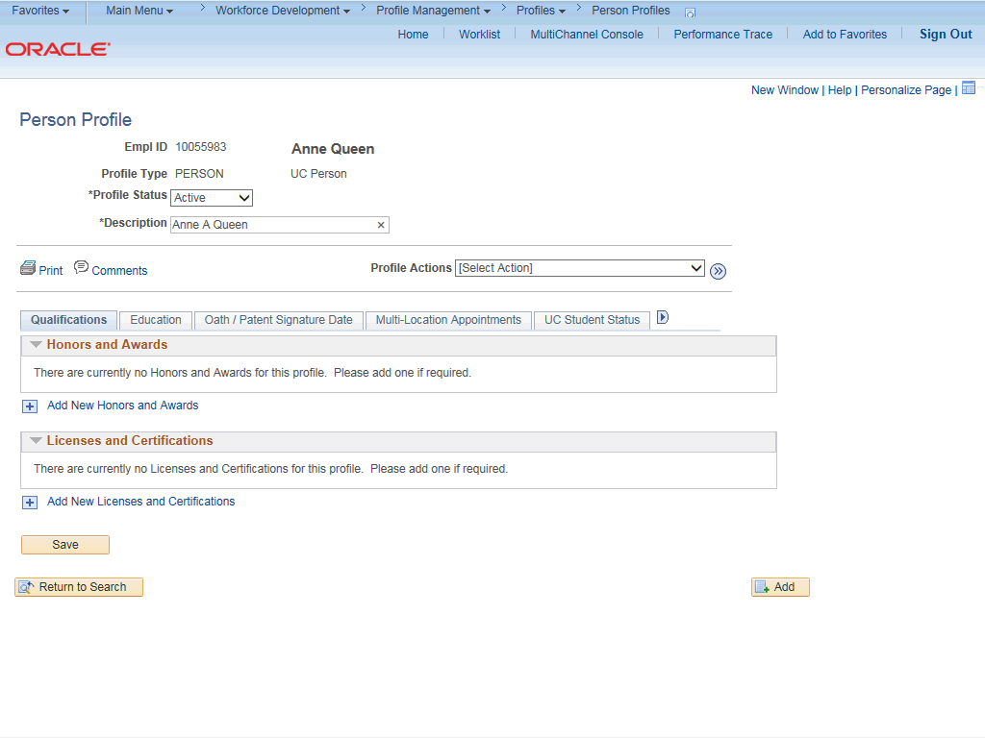

Step | Action
5. | The Person Profile page appears for the selected employee. There are several tabs available where you can update various types of information.  For this example, the following updates are made:  - Add a license  - Add I-9 tracker information
6. | Click the Add New Licenses and Certifications button.

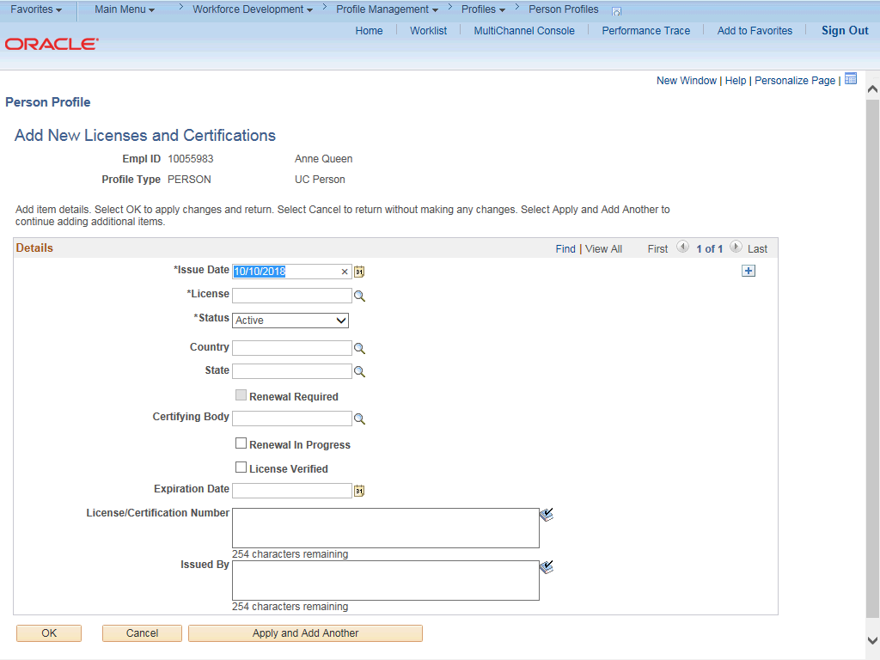

Step | Action
7. | Use this page to add various types of licenses and certifications.
8. | The Issue Date defaults to the system date (today's date). Enter the date when the employee acquired the license or certificate.
9. | Click in the Issue Date field.
10. | Enter the desired information into the Issue Date field.
11. | Click the Look up License button.

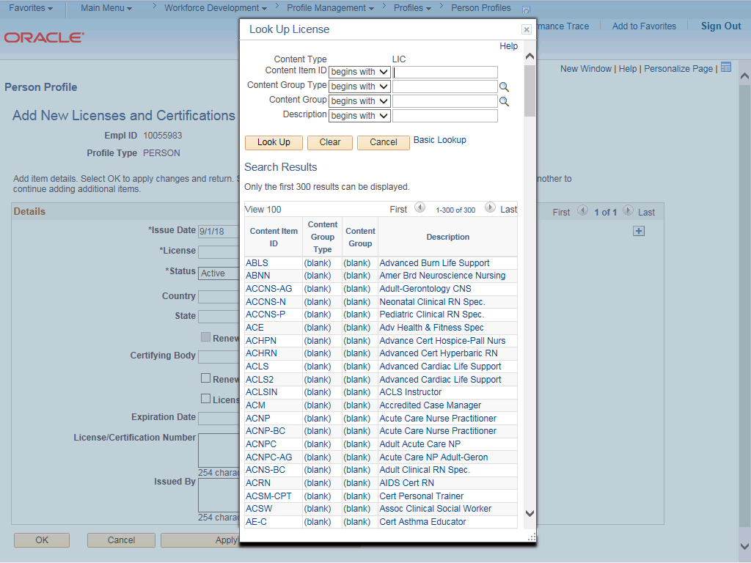

Step | Action
12. | Search for and select the appropriate license.  For this example, click the scroll bar.
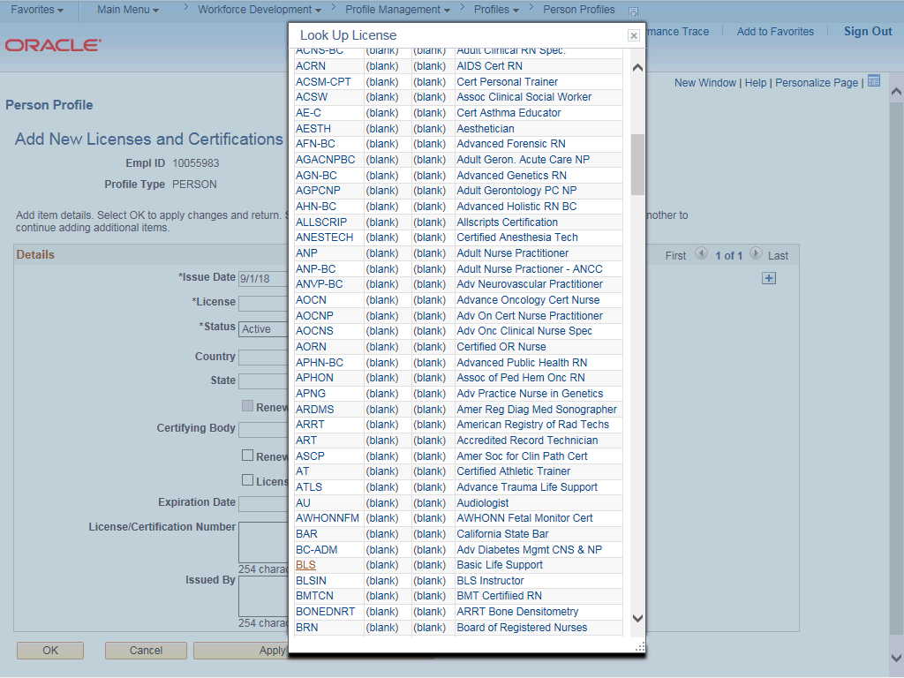

Step | Action
13. | For this example, click the BLS link.
14. | Complete the remaining fields as applicable.
15. | Click in the Country field.
16. | Enter the desired information into the Country field.
17. | Click in the State field.
18. | Enter the desired information into the State field.
19. | Click the License Verified option.
20. | Click in the Expiration Date field.
21. | Enter the desired information into the Expiration Date field.
22. | When you are finished entering data, click the OK button.
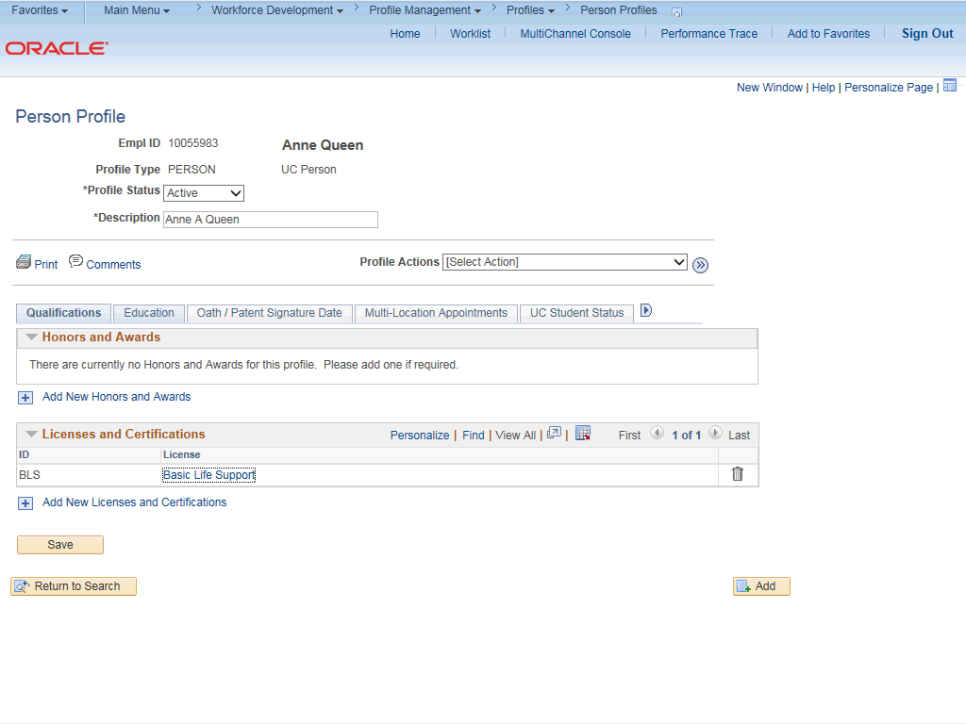

Step | Action
23. | The license appears in the Licenses and Certification section.
24. | Click the Education tab.
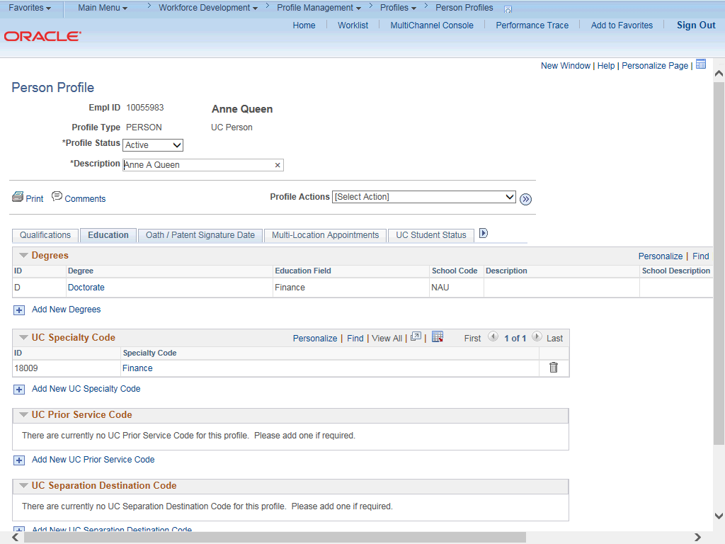

Step | Action
25. | The Education page displays an employee's degree and UC specialty code details.  Use this page to update existing degree information or add a new degree.
26. | Click the Oath / Patent Signature Date tab.

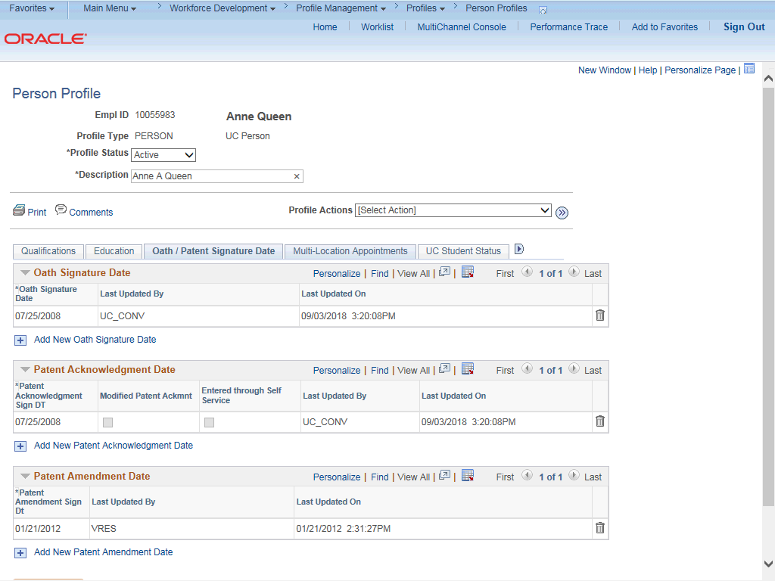

Step | Action
27. | View or update Oath Signature Date, Patent Acknowledgment Date or Patent Amendment Date information as needed.  This information is mandatory. Employees are not granted access to the UC system without updated information.
28. | Click the Multi-Location Appointments tab.

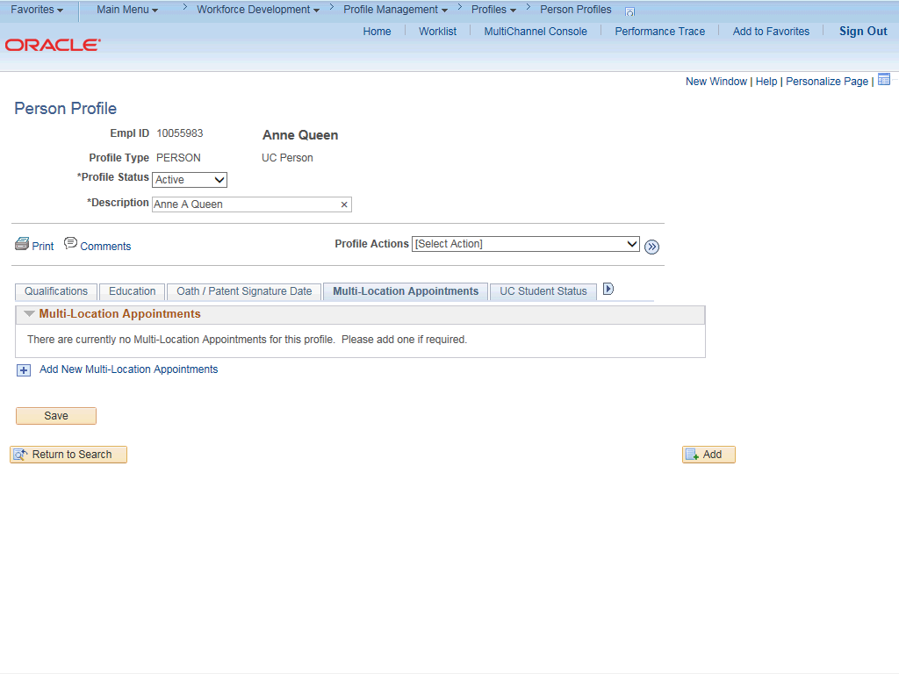

Step | Action
29. | The Multi-Location Appointments page is an option for Locations to track MLAs (it is not required to use this page). This page can be used to identify employees who have multiple and concurrent work assignments. The host location is responsible for maintaining this information.  View or update the Multi-Location Appointments information as needed.
30. | Click the UC Student Status tab.

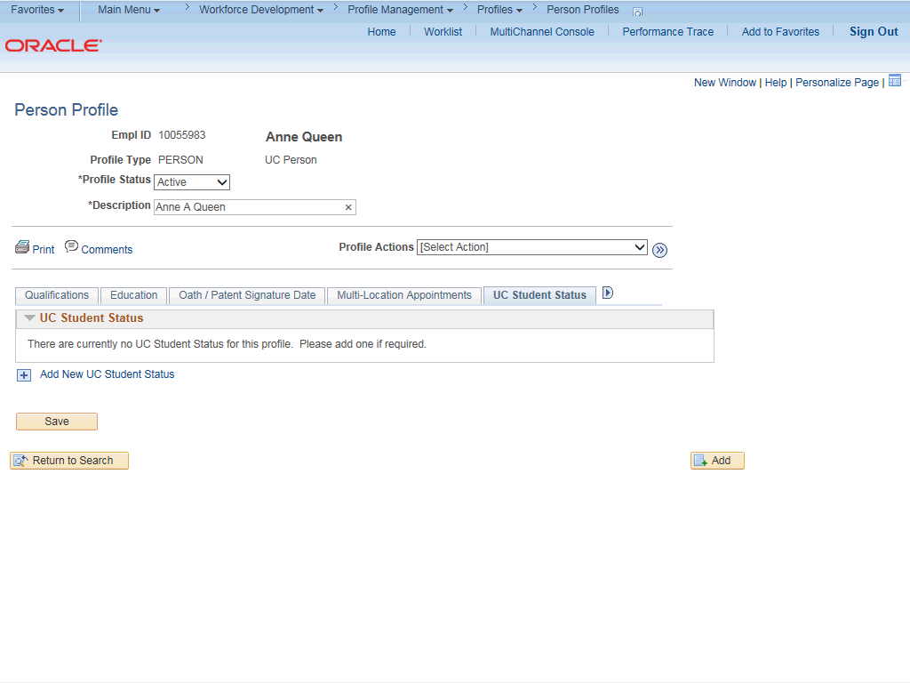

Step | Action
31. | The UC Student Status page identifies employees that are also UC students.  View or update UC Student Status information as needed.
32. | Click the Scroll Tabs Right button to view the remaining tabs.

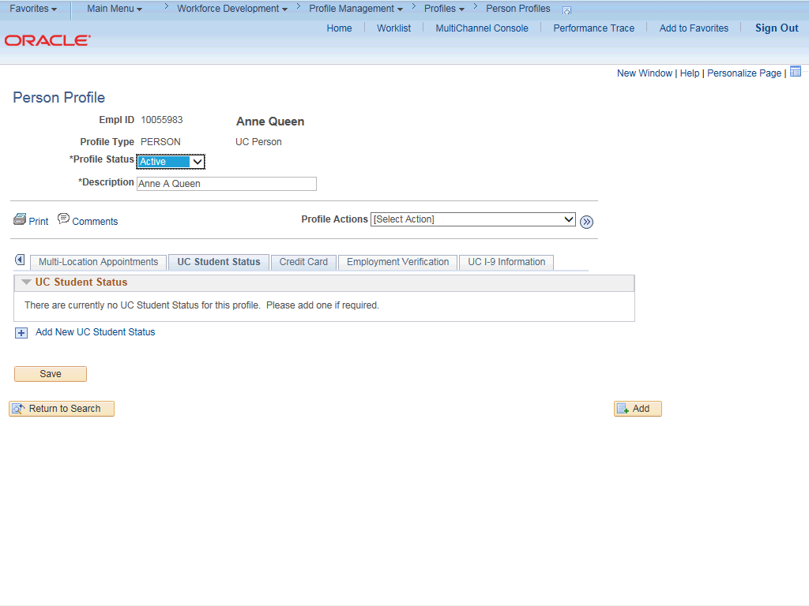

Step | Action
33. | Click the Credit Card tab.
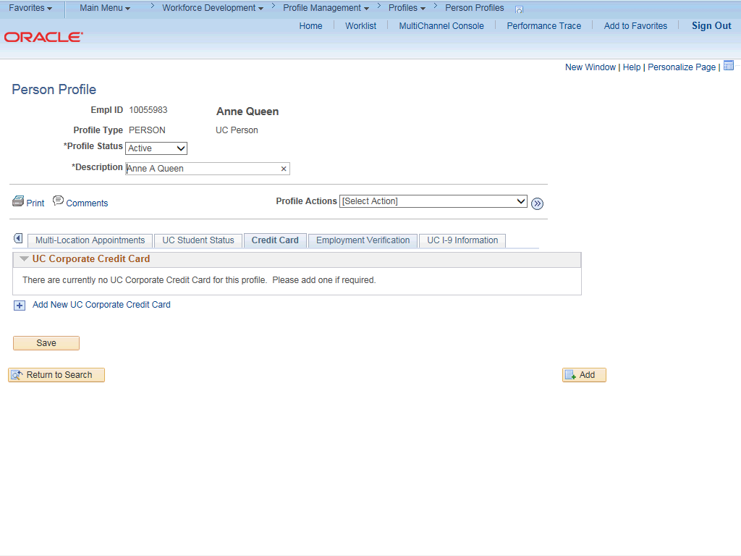

Step | Action
34. | View or update UC Corporate Credit Card information as needed.
35. | Click the Employment Verification tab.
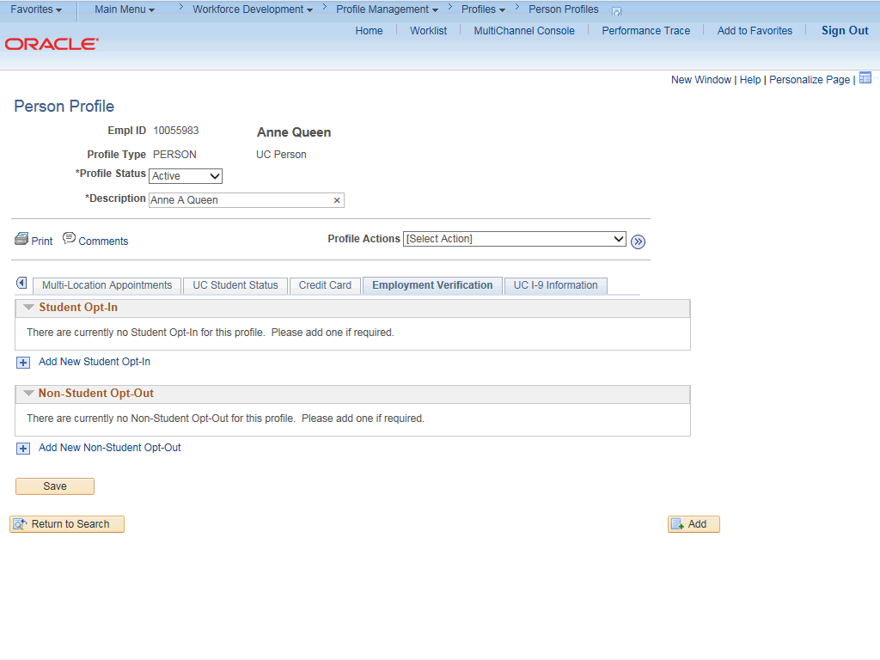

Step | Action
36. | View or update Student Opt-In or Non-Student Opt-Out information as needed.
37. | Click the UC I-9 Information tab.

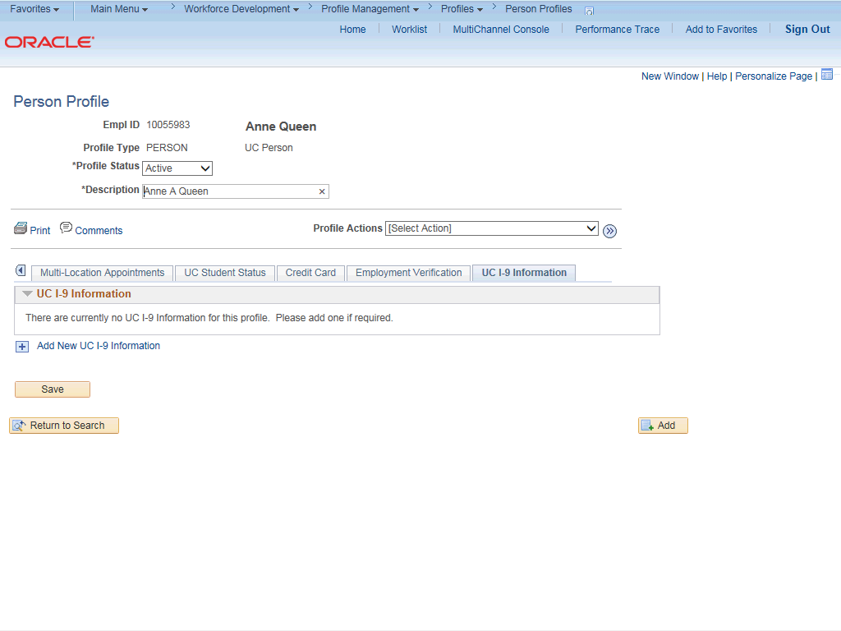

Step | Action
38. | If the employee has an existing tracker profile, you can add their information on this page.
39. | Click the Add New UC I-9 Information button.

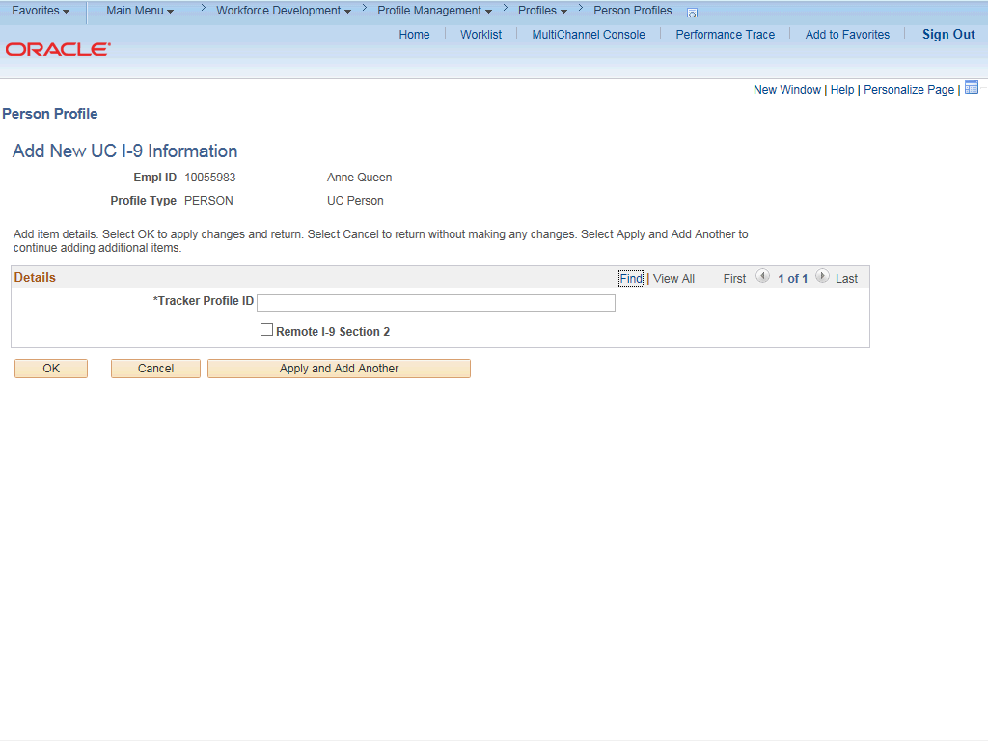

Step | Action
40. | Click in the Tracker Profile ID field.
41. | Enter the desired information into the Tracker Profile ID field.
42. | If the employee's I-9 section 2 needs to be completed remotely, click the Remote I- 9 Section 2 check box.
43. | Click the OK button.

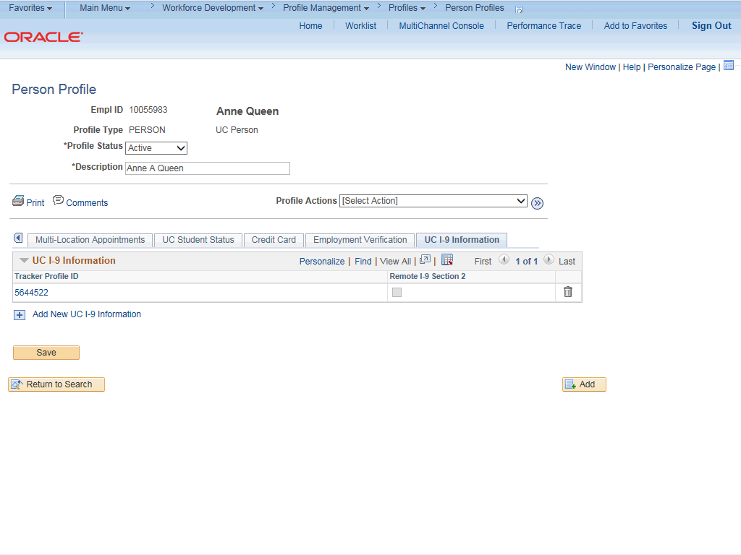

Step | Action
44. | When you are finished updating the person's profile information, click the Save button.

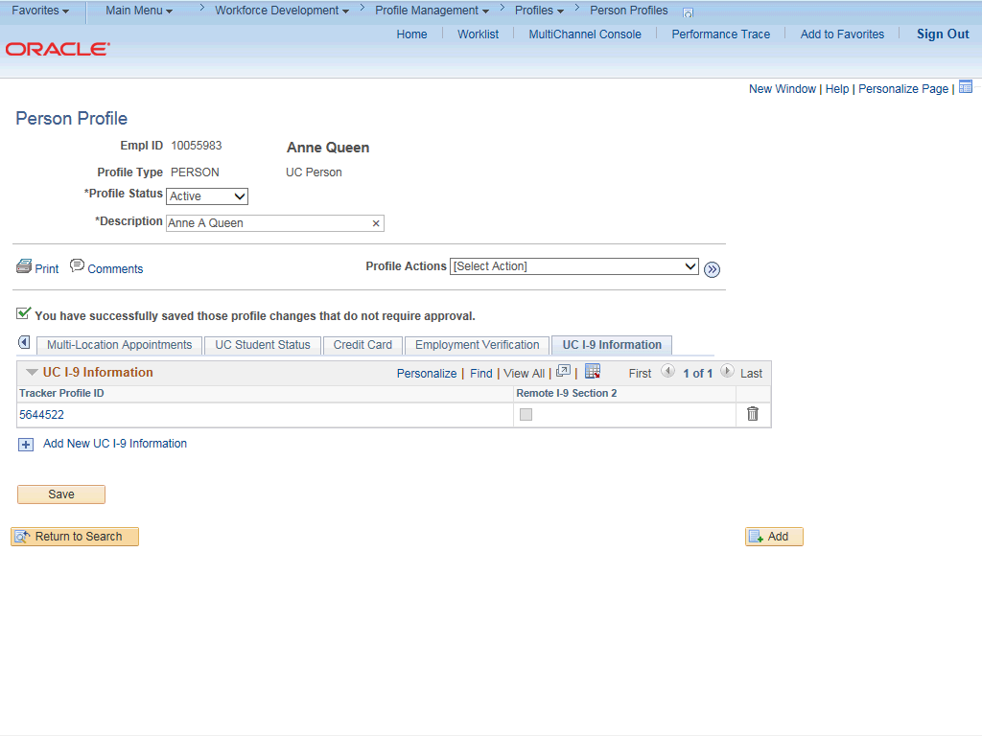

Step | Action
45. | You have updated person profile information.  End of Procedure.

