Use this task to initiate a reinstatement template transaction for an academic employee.

Navigation: PeopleSoft Menu > Workforce Administration > Smart HR Template > Smart HR Transactions

Note: This page also may be available in Workcenter depending on your security access.

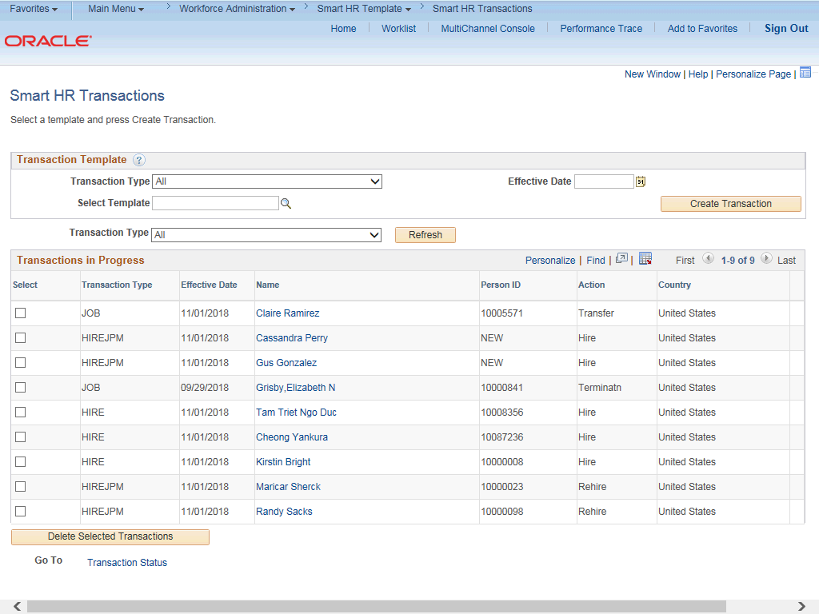

Step | Action
1. | Use the Smart HR Transactions page to initiate a reinstatement template transaction.
2. | Click the Look up Select Template button.  Note: The Transaction Type field is not used by UC.

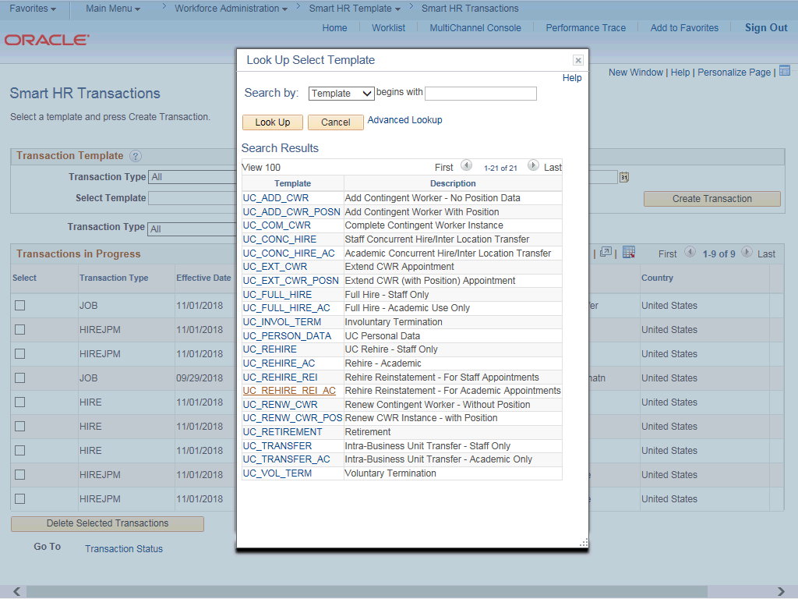

Step | Action
3. | Select the appropriate reinstatement template. Notice there are two reinstatement templates, one for staff and one for academic employees.  Click the UC_REHIRE_REI_AC link.
4. | The Effective Date of the reinstatement must be the same date as the Effective Date of the termination to ensure there is not gap in service.
5. | Click in the Effective Date field.
6. | The Effective Date field is the effective date of the selected template action. The date you enter in this field automatically populates the Effective Date field on the Enter Transaction Details page. You can update the Effective Date on the Enter Transaction Details page if needed.  Enter the desired information into the Effective Date field.
7. | Click the Create Transaction button.

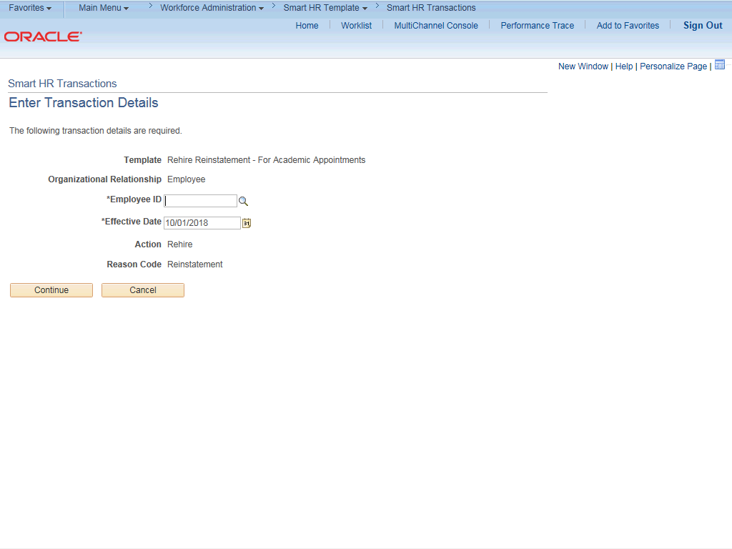

Step | Action
8. | In the Employee ID field, enter the employee’s ID number or use the lookup to search for and select it. You have access to employee records only within your business unit.  Click in the Employee ID field.
9. | Enter the desired information into the Employee ID field.
10. | The Effective Date is populated based on your entry on the previous page. Ensure that you entered the correct date on which employment begins.
11. | Click the Continue button.

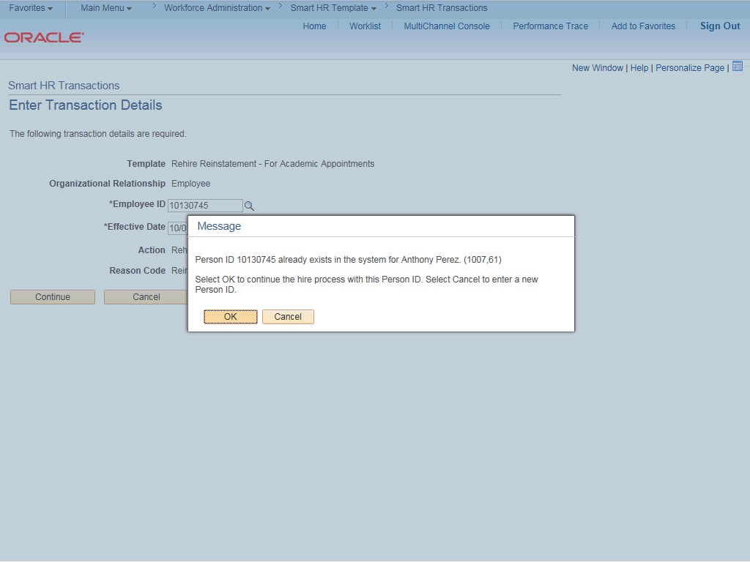

Step | Action
12. | UCPath displays a message indicating the individual already exists in the system.  Verify that the displayed employee ID and name correspond with the individual you are reinstating.  Click the OK button.

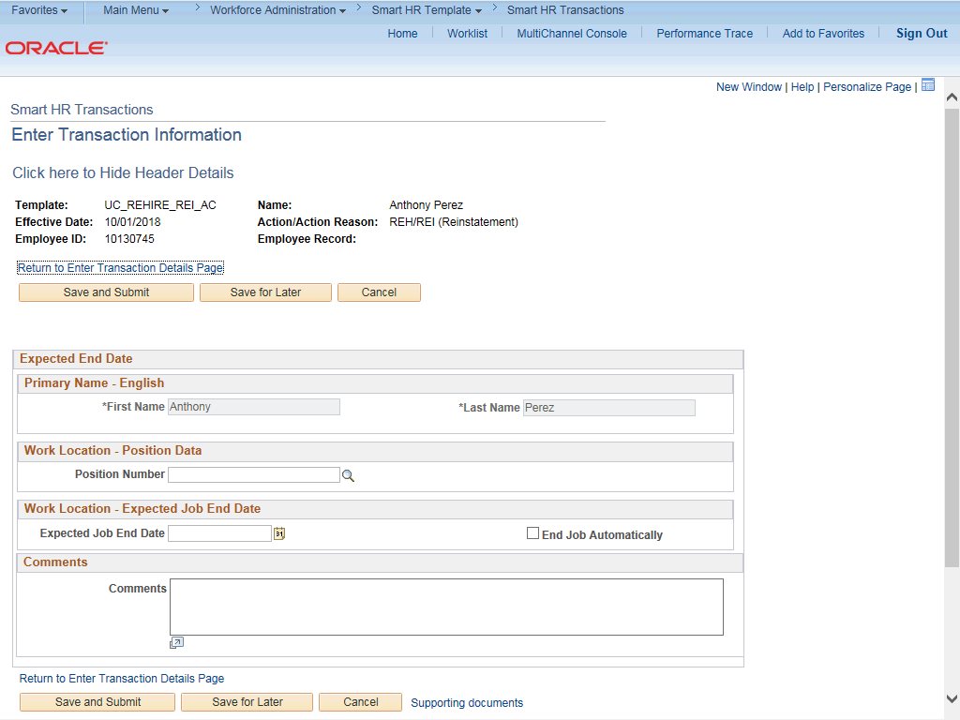

Step | Action
13. | The reinstatement template appears.  Header details appear at the top of the page. You can show/hide the header information as needed.
14. | The Position Number must be the same position the employee held before they were terminated.
15. | Click in the Position Number field.
16. | Enter the desired information into the Position Number field.
17. | Click in the Expected Job End Date field.
18. | Enter the desired information into the Expected Job End Date field.
19. | Click the End Job Automatically option.
20. | Use the Comments field to enter specific details or an explanation regarding the transaction.  This field is referenced by UCPC WFA Production to assist with the processing of the transaction.

Step | Action
21. | Click the Save and Submit button.
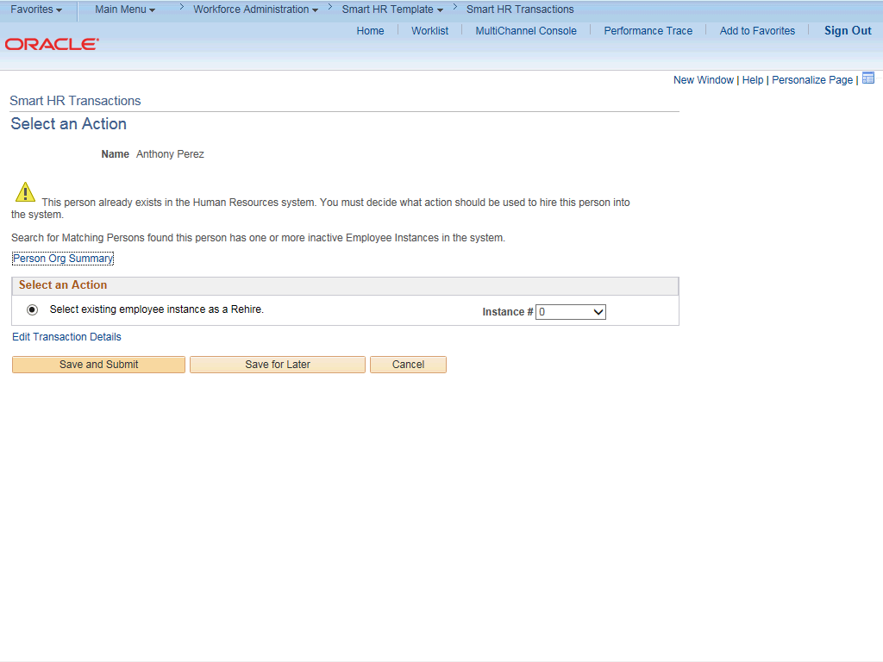

Step | Action
22. | Review the rehire warning message, which indicates this employee's record already exists in UCPath.
23. | If the employee has only one inactive employee record within your business unit, then that number is defaulted. If the employee has more than one inactive employee record within your business unit, then the lowest number defaults. If needed, select the record to add reinstatement action.  For this example, accept the default.
24. | Click the Save and Submit button.

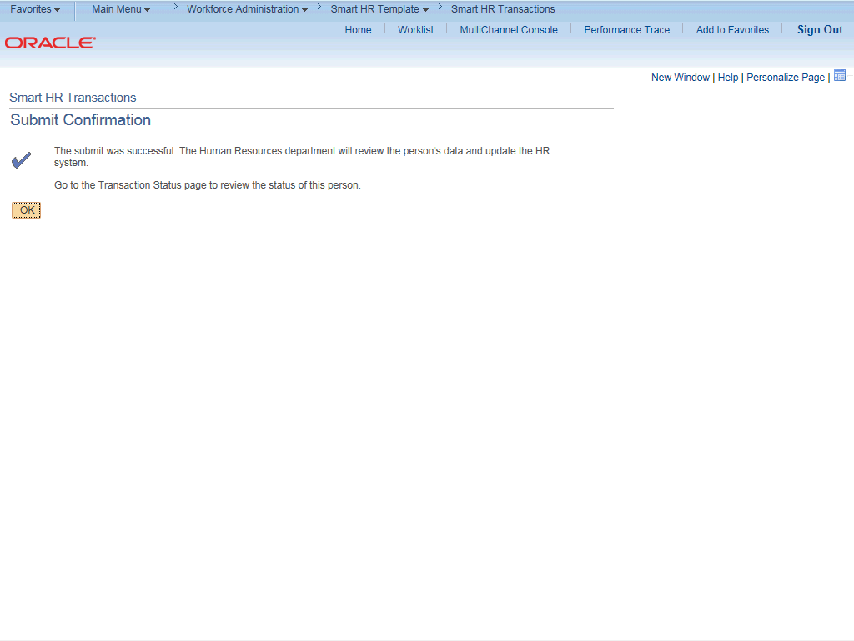

Step | Action
25. | Click the OK button.
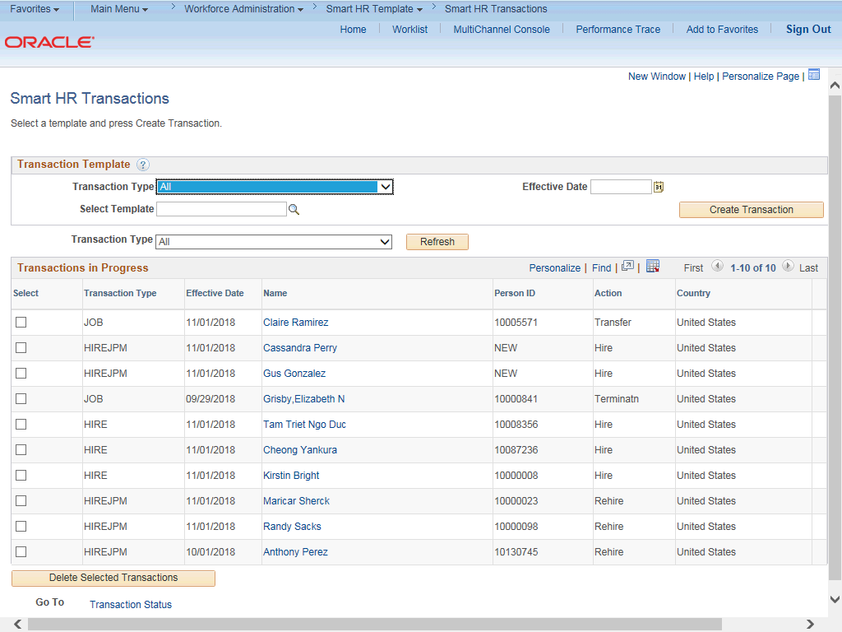

Step | Action
26. | The template transaction is routed for approval and appears in the Transactions in Progress section until it is processed.
27. | You have initiated a reinstatement template transaction for an academic employee.  End of Procedure.

