Use this task to initiate a rehire template transaction for a staff employee.

Navigation: PeopleSoft Menu > Workforce Administration > Smart HR Template > Smart HR Transactions

Note: This page also may be available in Workcenter depending on your security access.

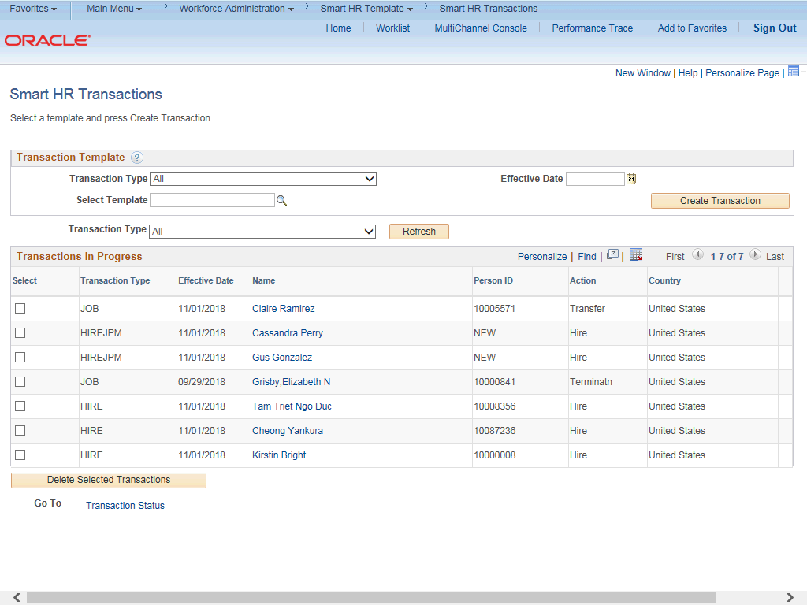

Step | Action
1. | Use the Smart HR Transactions page to initiate a rehire template transaction.
2. | Click the Look up Select Template button.  Note: The Transaction Type field is not used by UC.

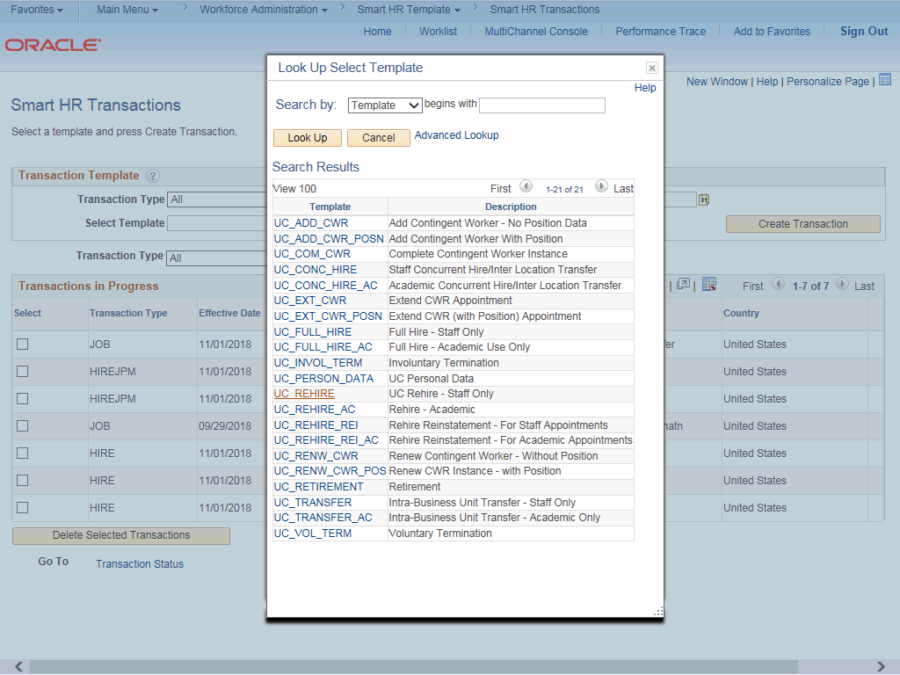

Step | Action
3. | Select the appropriate rehire template. Notice there are two rehire templates, one for staff and one for academic employees.  Click the UC_REHIRE list item.
4. | Click in the Effective Date field.
5. | The Effective Date field is the effective date of the selected template action. The date you enter in this field automatically populates the Effective Date field on the Enter Transaction Details page. You can update the Effective Date on the Enter Transaction Details page if needed.  Enter the desired information into the Effective Date field.
6. | Click the Create Transaction button.

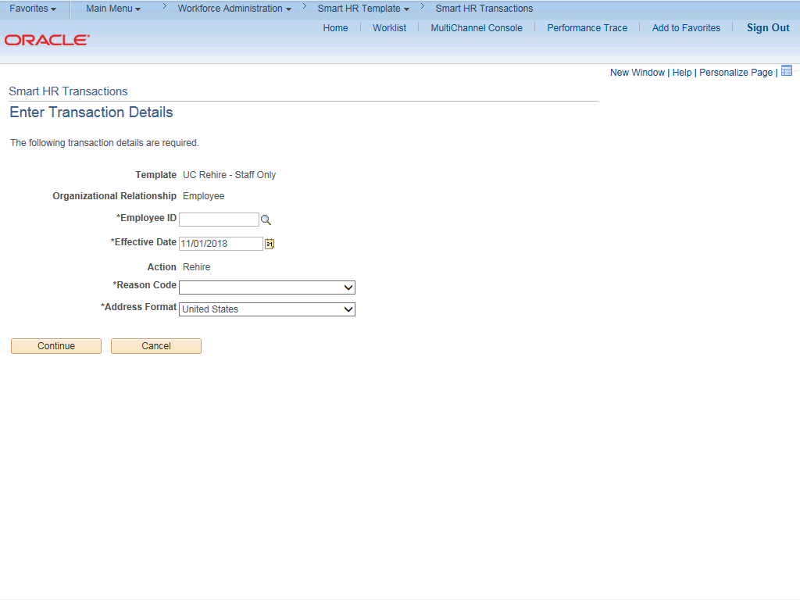

Step | Action
7. | In the Employee ID field, enter the employee’s ID number or use the lookup to search for and select it. You have access to employee records only within your business unit.  Click in the Employee ID field.
8. | Enter the desired information into the Employee ID field.
9. | The Effective Date is populated based on your entry on the previous page. Ensure that you entered the correct date on which employment begins.
10. | Click the button to the right of the Reason Code field.

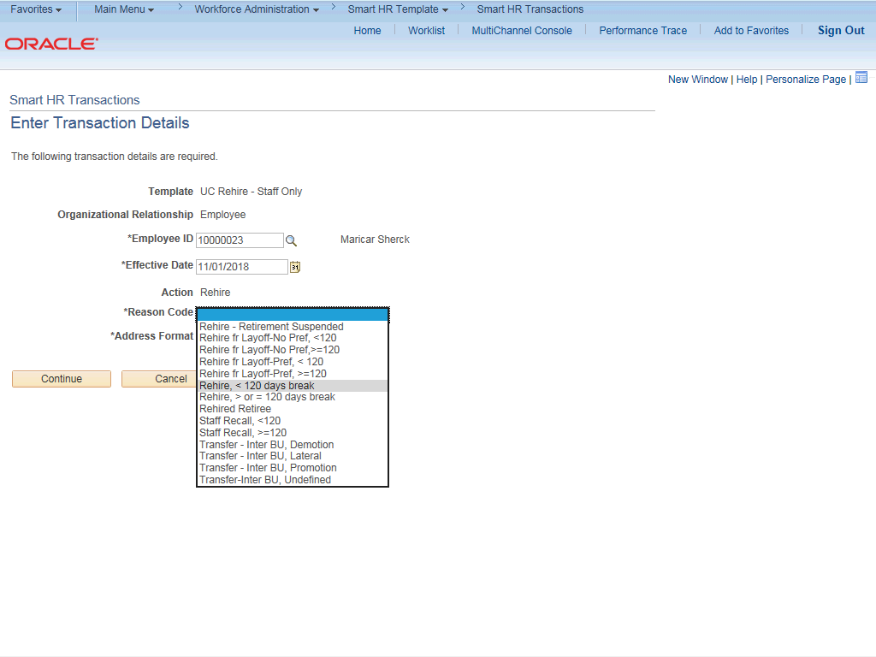

Step | Action
11. | Select the appropriate Reason Code. It is important to select an accurate reason as it may impact the employee’s benefits.  For this example, click the Rehire, < 120 days break list item.
12. | In the Address Format field, accept the default of United States or select the  Global option, if applicable.

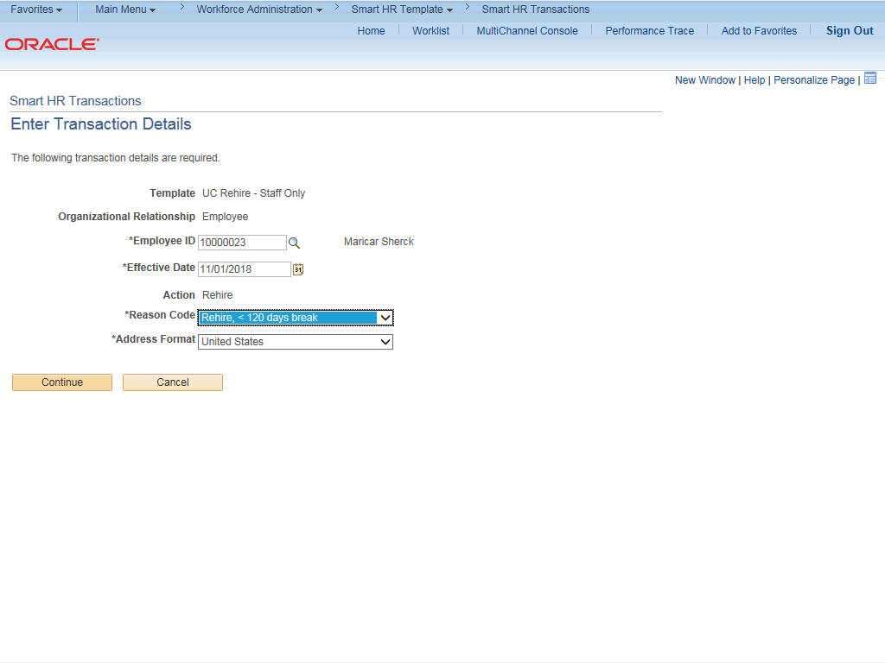

Step | Action
13. | Click the Continue button.
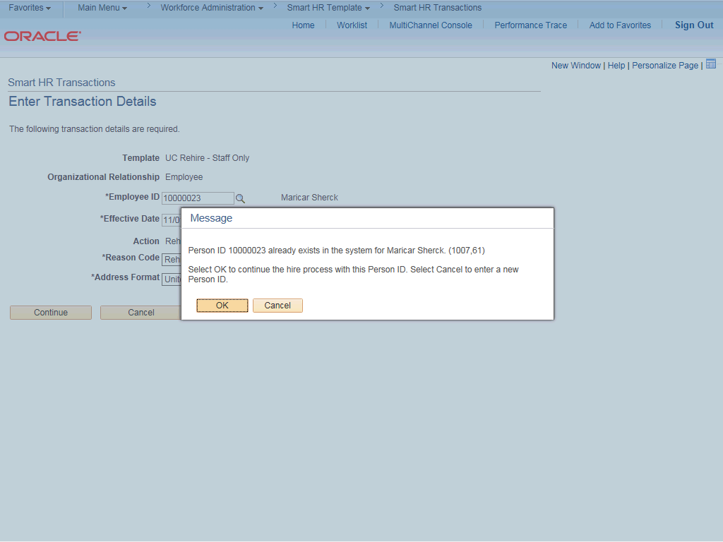

Step | Action
14. | UCPath displays a message indicating the individual already exists in the system.  Verify that the displayed employee ID and name correspond with the individual you are rehiring.  Click the OK button.
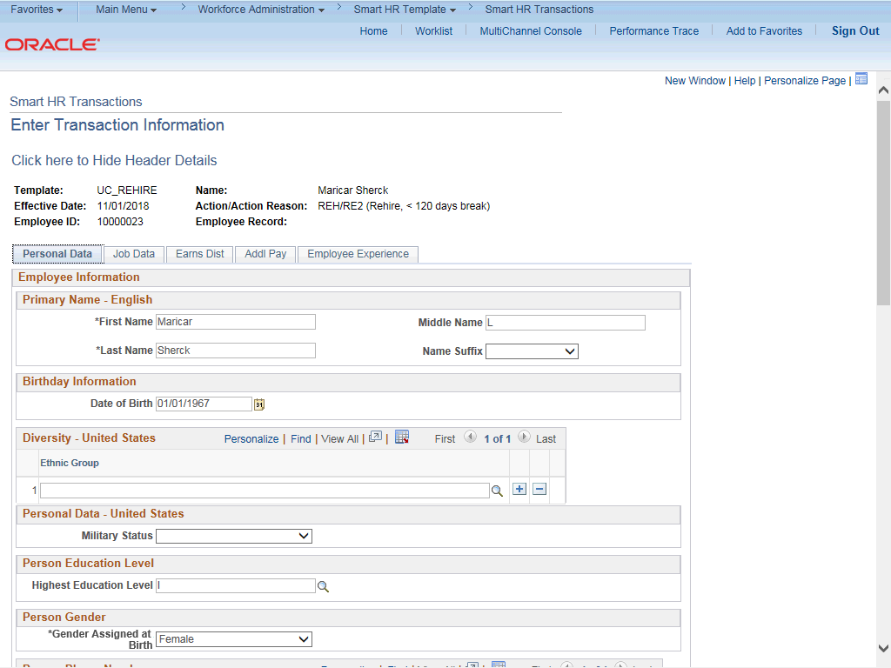

Step | Action
15. | The rehire template appears. Five tabs are available on this template: Personal Data, Job Data, Earns Dist, Addl Pay and Employee Experience.
16. | Header details appear above the tabs. You can show/hide the header information as needed.
17. | The employee's personal data automatically populates from the employee's existing personal data information.  The Diversity - United States, Personal Phone Number and Person Email Address sections do not display the employee's existing data. You must enter the information for these sections as necessary. Any new information entered in these sections will override the employee's existing personal data information.
18. | Click the scroll bar.

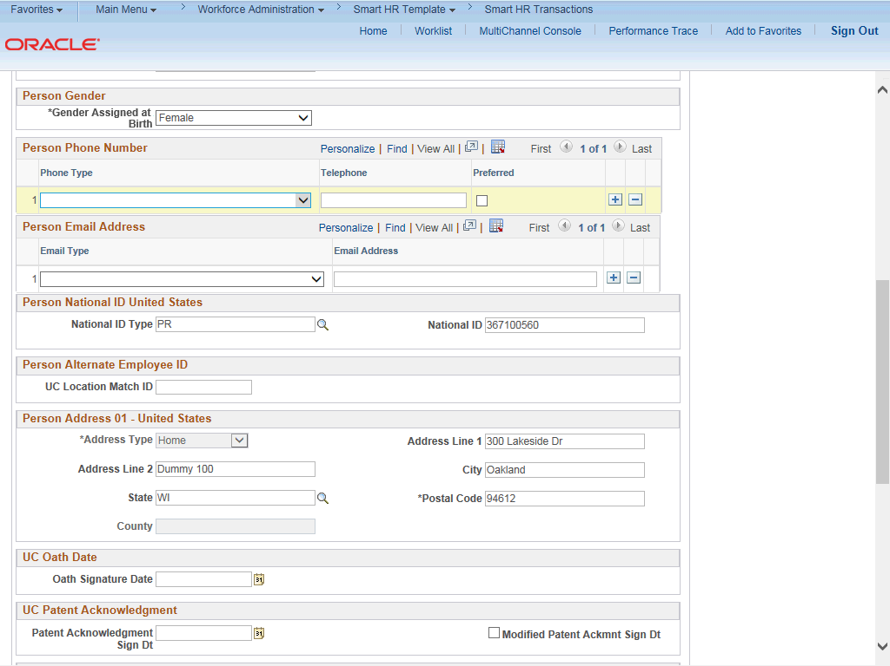

Step | Action
19. | Click the button to the right of the Phone Type field.
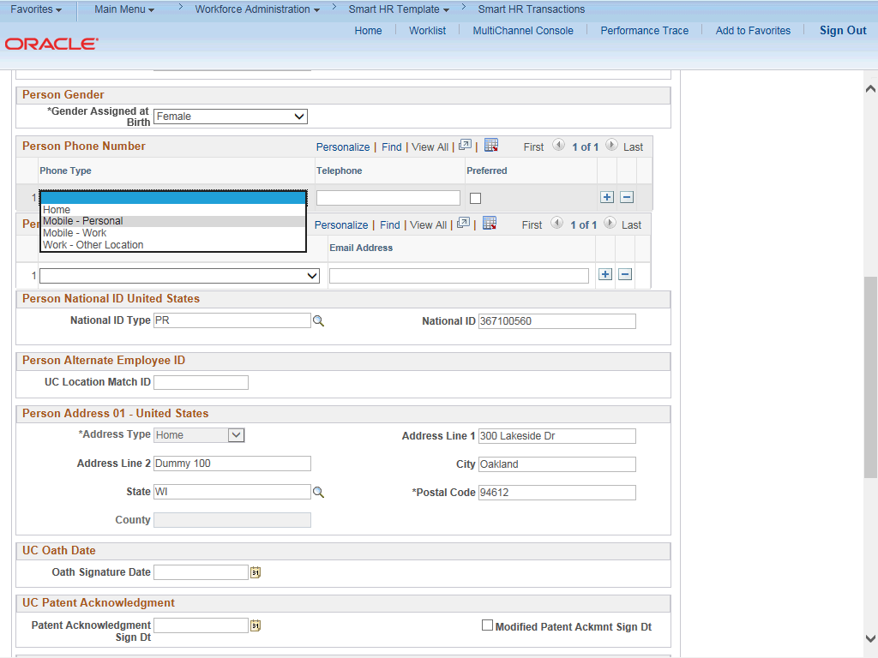

Step | Action
20. | Click in the Telephone field.
21. | Enter the desired information into the Telephone field.
22. | Click the Preferred option.
23. | Click the button to the right of the Email Type field.
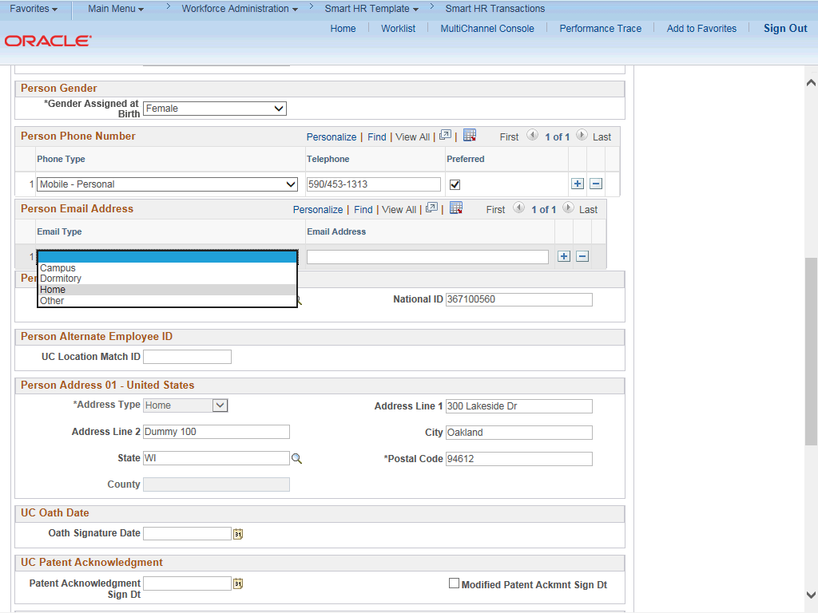

Step | Action
24. | Click in the Email Address field.
25. | Enter the desired information into the Email Address field.

Step | Action
26. | Confirm that the National ID field is populated with the employee's Social Security Number (SSN). If it is blank, every effort should be taken to include the SSN before submitting the template. Leaving the National ID field blank has downstream impacts.
27. | Click the scroll bar.
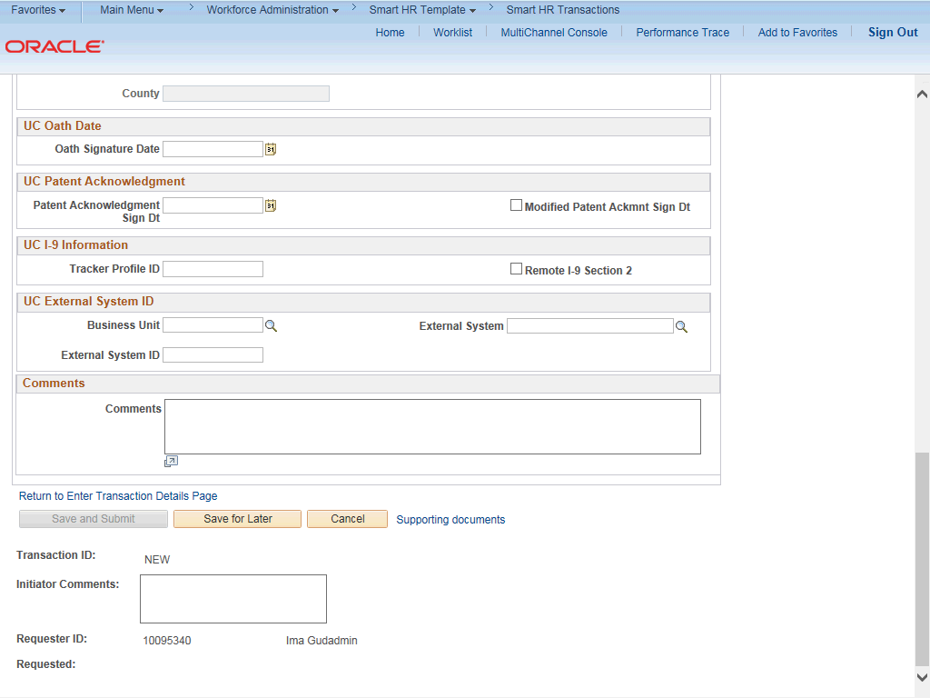

Step | Action
28. | If the rehire has an existing tracker profile, then you can add their Tracker Profile ID and indicate whether their I-9 section 2 was completed.
29. | If applicable, use the UC External System ID section to enter external system information to facilitate matching of IDs with IDM systems.  You must enter values for all three fields in this section. The Business Unit in this section must match the Business Unit associated with the Position Number you enter on the Job Data tab (the next tab).
30. | Use the Comments field to enter specific details or an explanation regarding the transaction. For example, this field can be used to indicate that the employee lives and works outside the US. For these employees, UCPC WFA Production will add the NRA Working Outside the US citizenship status on the Identification Data page.  This field is referenced by UCPC WFA Production to assist with the processing of the transaction.

Step | Action
31. | Click the scroll bar.
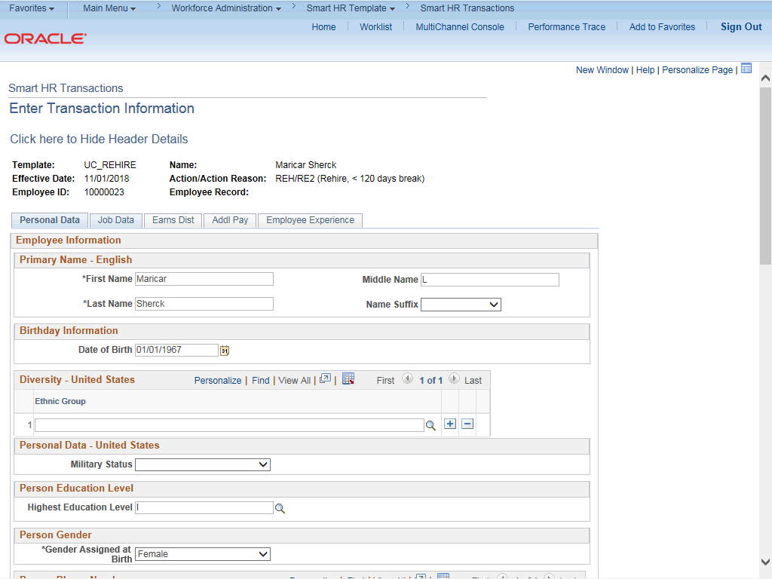

Step | Action
32. | Click the Job Data tab.

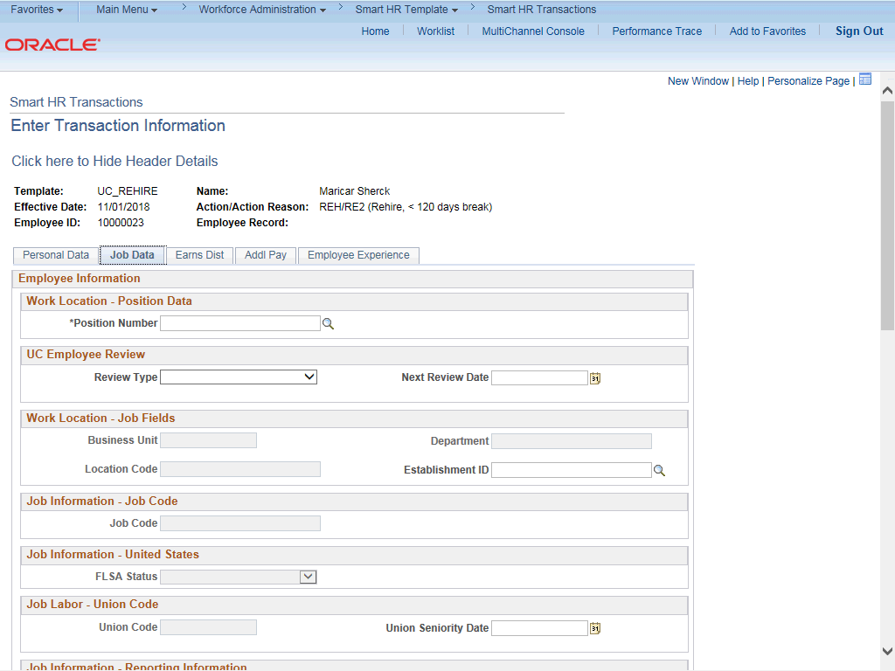

Step | Action
33. | Enter the position number or search for it using the look up. You have access only to position numbers within your business unit or related business unit.  Click in the Position Number field.
34. | Enter the desired information into the Position Number field.
35. | Press [Tab] to automatically populate the position-related fields.

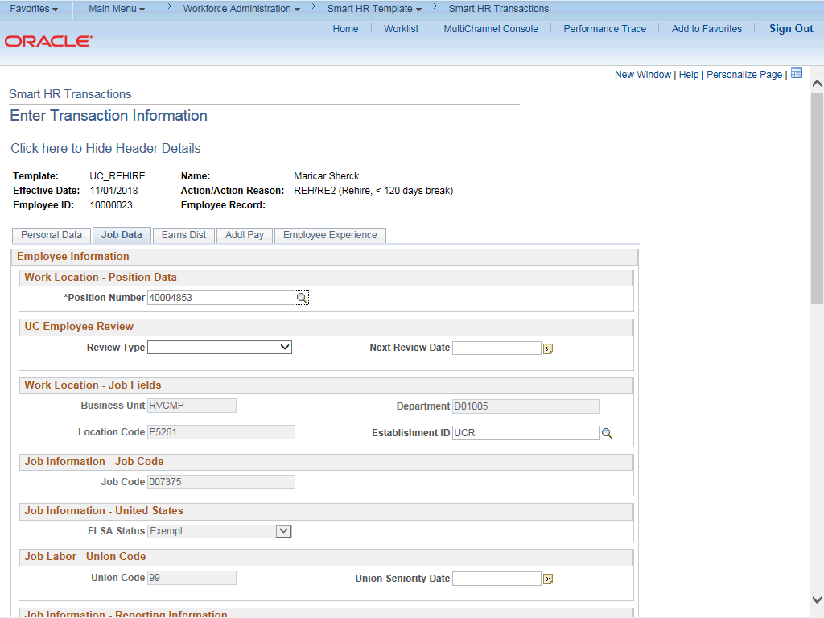

Step | Action
36. | Enter UC Employee Review information, if applicable.
37. | Click the scroll bar.
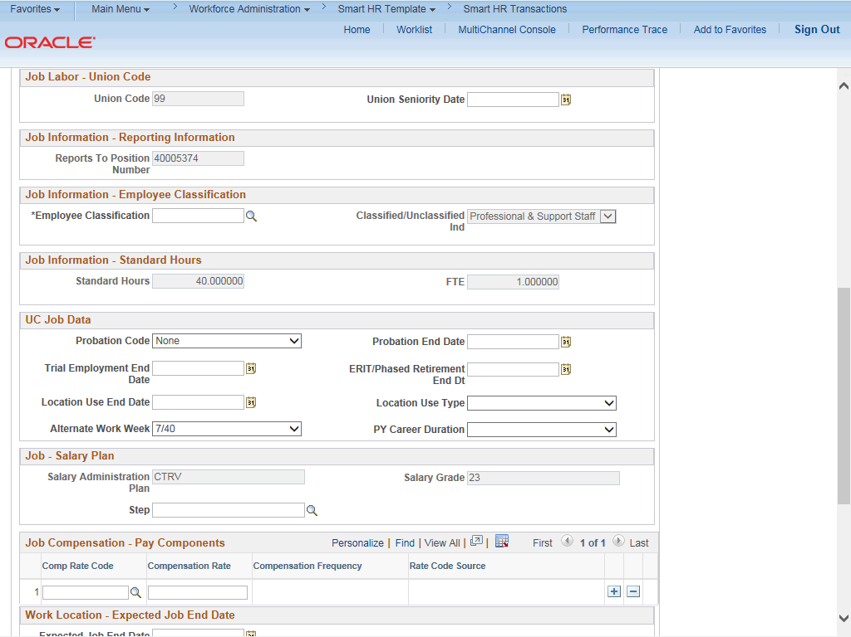

Step | Action
38. | For staff hires, you must enter an Employee Classification value. Click the Look up Employee Classification button.
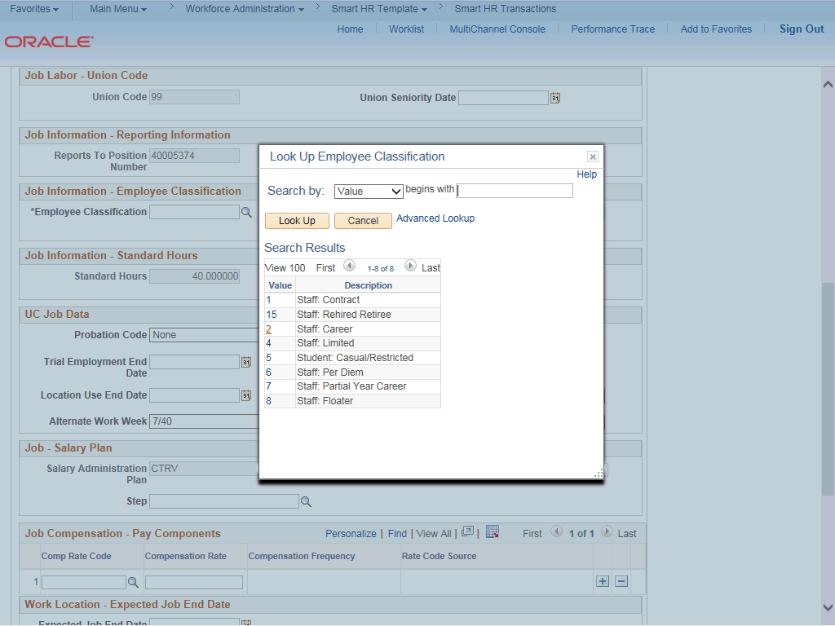

Step | Action
39. | Select the appropriate Employee Classification. For this example, click the 2 list item.
40. | In the UC Job Data section, enter or select the appropriate values as applicable.  The Probation Code field is required if:  - the Classified/Unclassified Ind field is Professional and Support Staff, and  - the Employee Class is Career or Partial Year Career.  The Probation Date field is required if the Probation Code field value is something other than Completed or Probation Completed, Other Job.
41. | Click the button to the right of the Probation Code field.

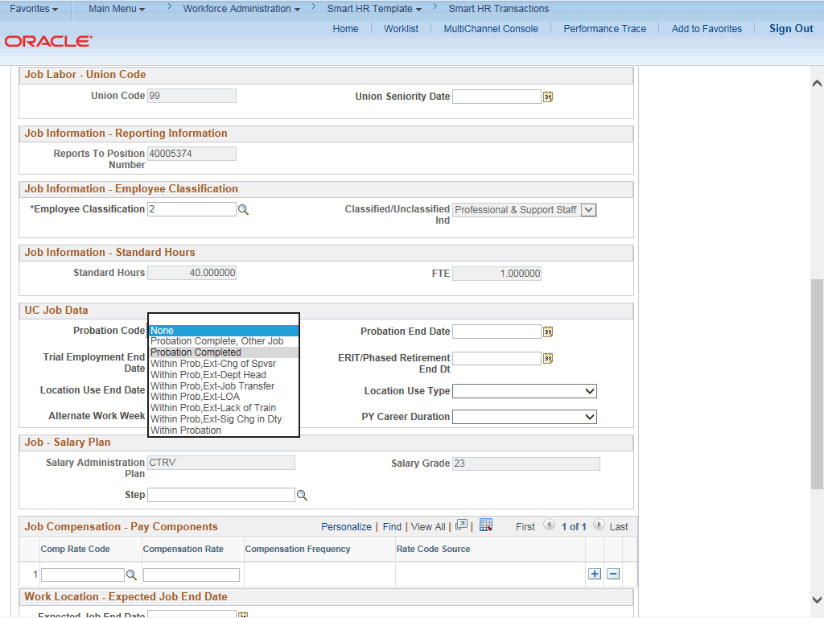

Step | Action
42. | For this example, click the Probation Completed list item.
43. | Click in the Probation End Date field.
44. | Enter the desired information into the Probation End Date field.
45. | Click the scroll bar.

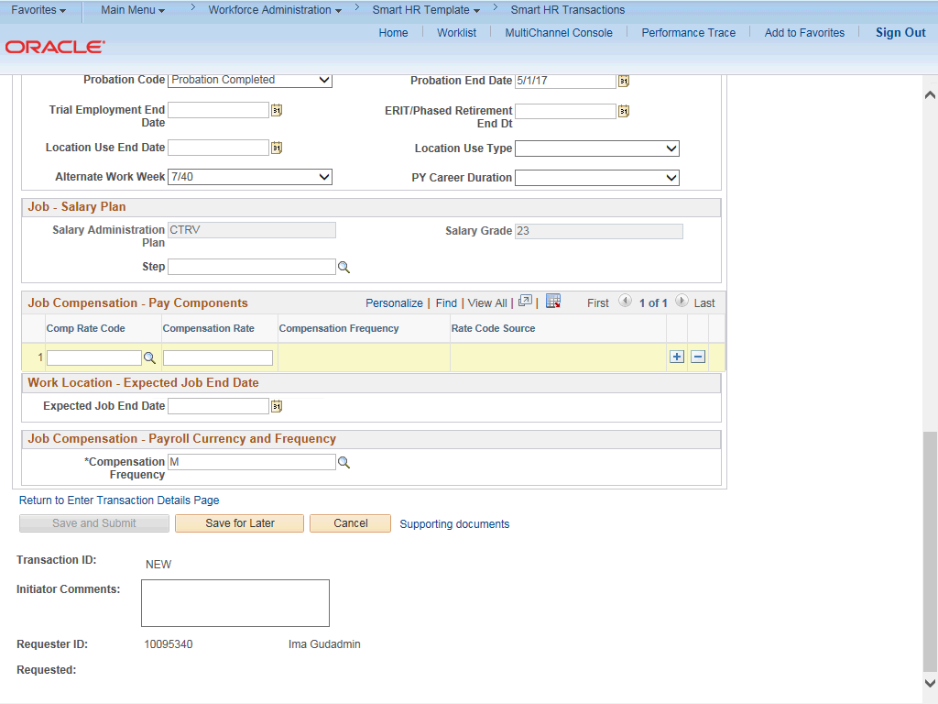

Step | Action
46. | Some job codes have steps associated with them. When a Step is entered, UCPath automatically updates the Job Compensation - Pay Components fields and the compensation information cannot be changed. Use caution when selecting the appropriate step value. For some jobs, there are half steps, so be sure to use the Look up icon and review the Hourly Rate to ensure you are selecting the correct step value.  Some job codes do not have steps associated with them, in which case the Job Compensation - Pay Components fields must be manually entered.  If the job has above scale component of pay, then step does not need to be selected. Enter applicable above scale comp rate codes in the Job Compensation- Pay Components section.
47. | For this example, the job code is not associated with steps so the compensation fields must be entered manually.  Click the Look up Comp Rate Code button.

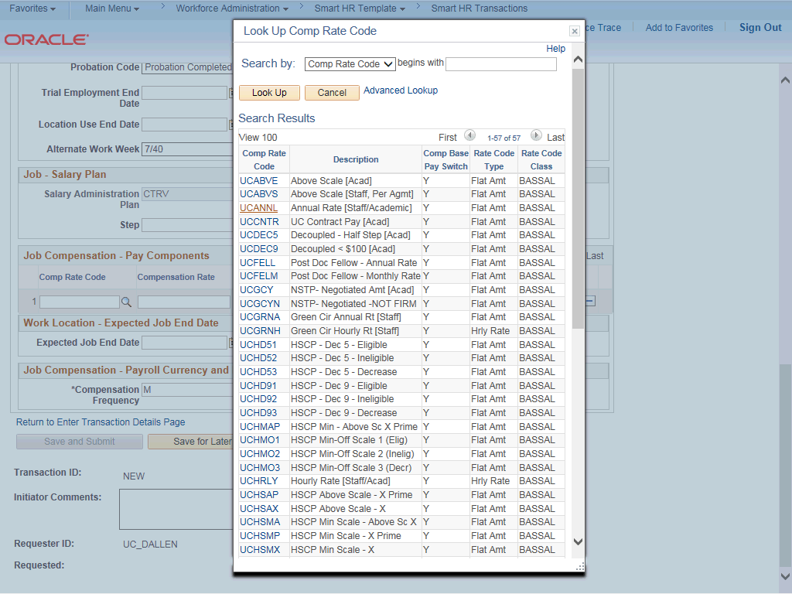

Step | Action
48. | Select the appropriate Comp Rate Code. For this example, click the UCANNL link.
49. | Click in the Compensation Rate field.
50. | Enter the desired information into the Compensation Rate field.
51. | If the employment is a short term assignment or temporary hire, enter the date the position ends in the Expected Job End Date field. Non-Academic employees are automatically terminated in UCPath on this date.  An expected end date is required for following employee classes:  - Staff: Contract  - Staff: Floater  - Staff: Rehired Retiree  - Academic: Post Docs  - Academic: Recall  - Academic: Academic Student  - Student: Casual/Restricted
52. | The payroll-related Compensation Frequency field automatically populates based on the job code. This field defines how the total compensation is paid out to the employee per paycheck.

Step | Action
53. | Click the scroll bar.
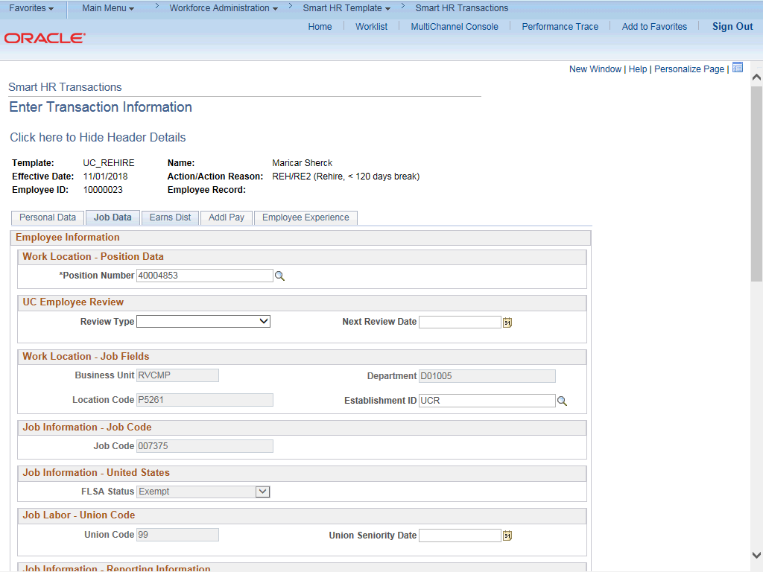

Step | Action
54. | Click the Earns Dist tab.

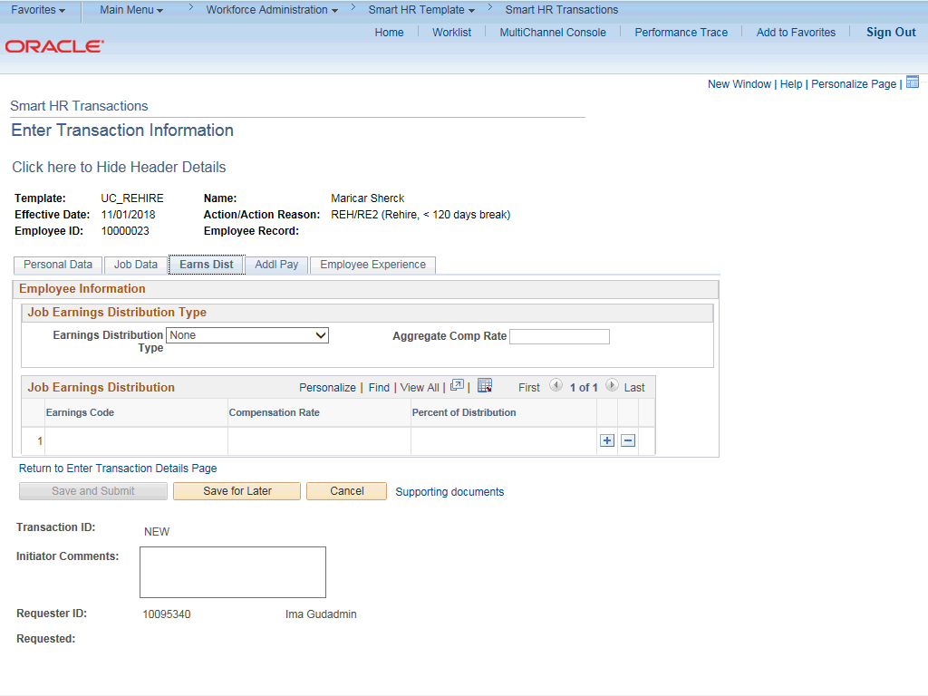

Step | Action
55. | In most cases, the Job Earnings Distribution section is automated. If the Comp Rate code entered on the Job Data tab has a mapped Earnings Code, the Job Earnings Distribution section is updated automatically.
56. | The Job Earnings Distribution section also can be used to manually enter distribution information. Use the Earnings Distribution Type field to enter distribution By Amount or By Percent. After the Earnings Distribution Type is selected, the Aggregate Comp Rate field is populated with the monthly amount.  - If By Amount is selected, the total of all compensation rates entered must add up to the monthly comp rate.  - If By Percent is selected, the total of all percentages entered must add up to 100%.
57. | Click the Addl Pay tab.

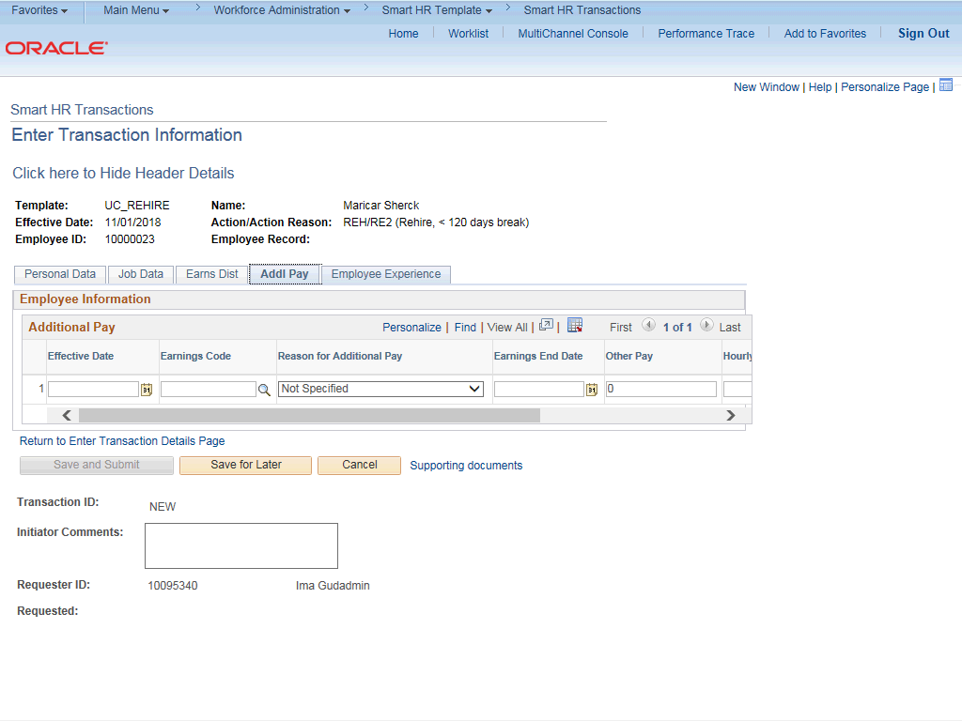

Step | Action
58. | There may be cases where an employee is paid a recurring flat amount. In this case, the compensation section is not populated on the Job Data tab. Instead, the Additional Pay section is used.  There may also be cases where neither compensation rate nor additional pay is entered. In those cases, it is recommended that you enter a comment to explain how the employee is to be paid.  It is recommended not to use this template for one time additional pay. Instead, use payroll's one time payments page.
59. | Click the Employee Experience tab.

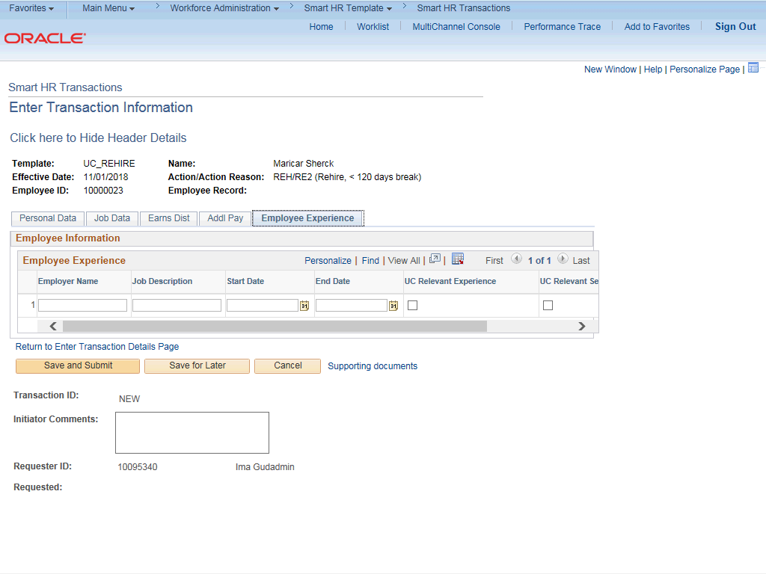

Step | Action
60. | For represented staff, use the fields on this page to enter data related to the employee's prior work experience. Having this information is helpful in determining new compensation rates for the employee who is being rehired.  The information entered in the Employee Experience section is copied to the employee's UC Employee Experience page after the template is fully processed by UCPC WFA Production.
61. | Use the Supporting documents link to attach supporting documents for the rehire.
62. | Enter comments for the Approver in the Initiator Comments field.  Comments you enter here appear only with the request; they do not appear on the employee’s record after the transaction is processed to completion. You can enter Initiator Comments on any of the tabs within this template.
63. | The Save and Submit button is not available until all required fields on each tab are completed.  Click the Save and Submit button.

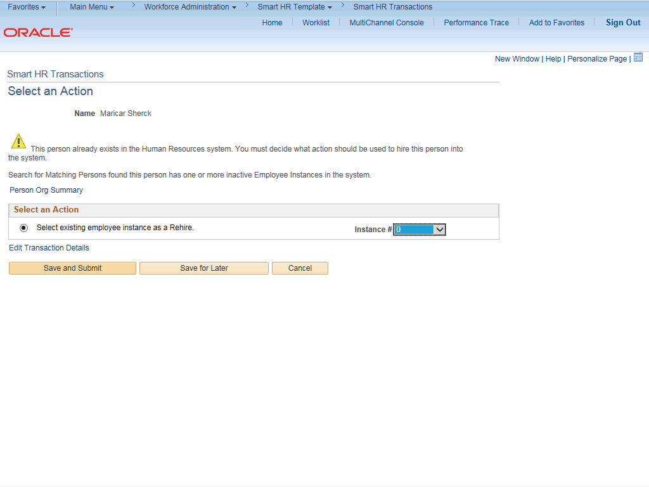

Step | Action
64. | Review the rehire warning message, which indicates this employee's record already exists in UCPath.
65. | If the employee has only one inactive employee record within your business unit, then that number is defaulted. If the employee has more than one inactive employee record within your business unit, then the lowest number defaults. If needed, select the record to add rehire action.  For this example, accept the default.
66. | Click the Save and Submit button.

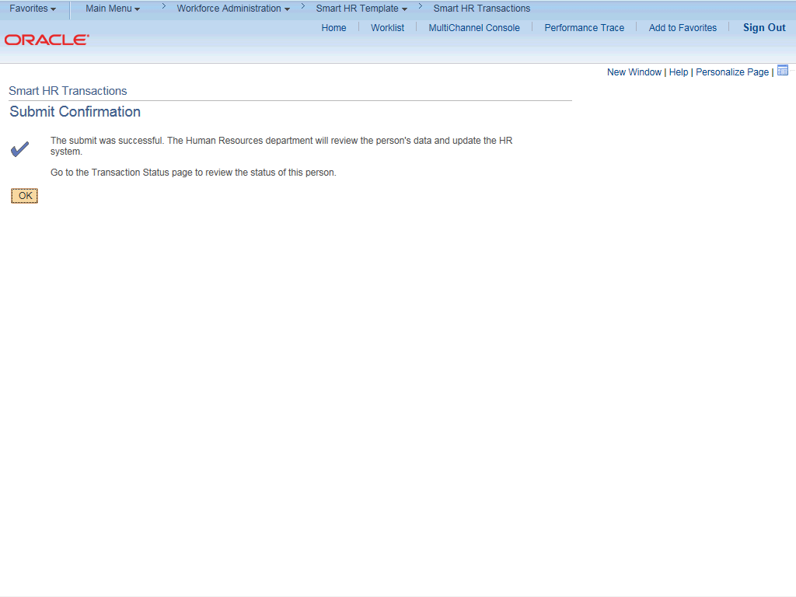

Step | Action
67. | Click the OK button.
68. | You have initiated a rehire template transaction for a staff employee.  End of Procedure.

