Use this task to initiate a rehire template transaction for an academic employee.

Navigation: PeopleSoft Menu > Workforce Administration > Smart HR Template > Smart HR Transactions

Note: This page also may be available in Workcenter depending on your security access.

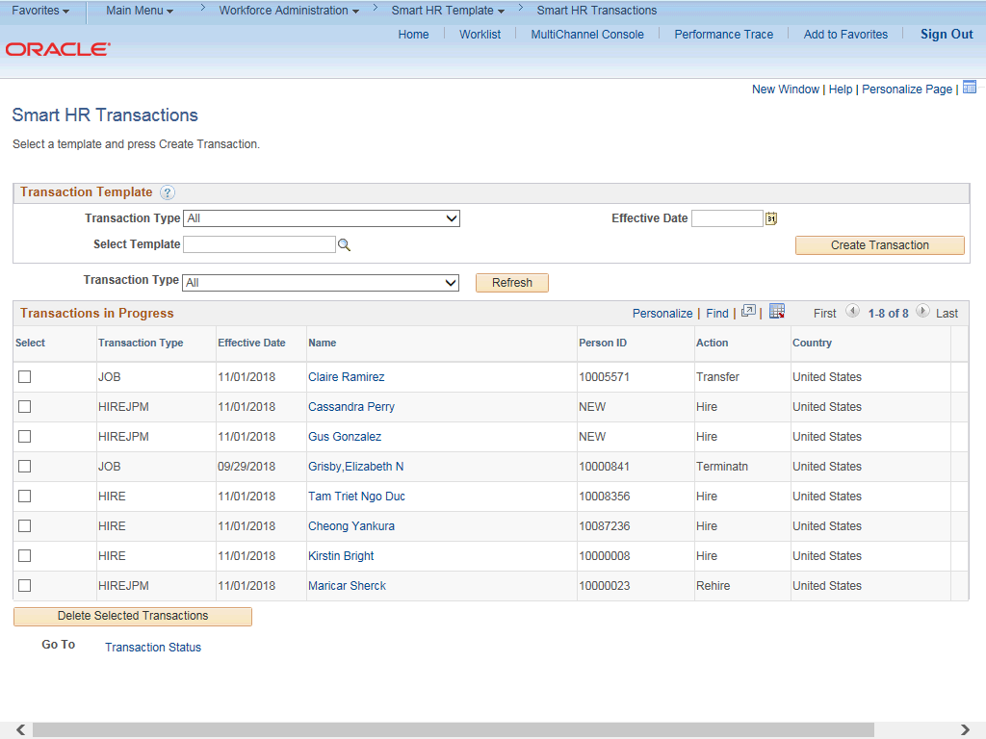

Step | Action
1. | Use the Smart HR Transactions page to initiate a rehire template transaction.
2. | Click the Look up Select Template button.  Note: The Transaction Type field is not used by UC.

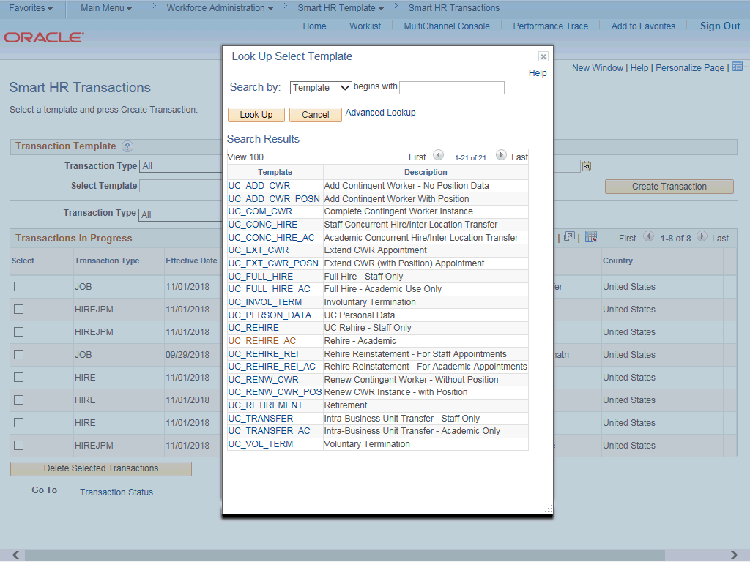

Step | Action
3. | Select the appropriate rehire template. Notice there are two rehire templates, one for staff and one for academic employees.  Click the UC_REHIRE_AC list item.
4. | Click in the Effective Date field.
5. | The Effective Date field is the effective date of the selected template action. The date you enter in this field automatically populates the Effective Date field on the Enter Transaction Details page. You can update the Effective Date on the Enter Transaction Details page if needed.  Enter the desired information into the Effective Date field.
6. | Click the Create Transaction button.

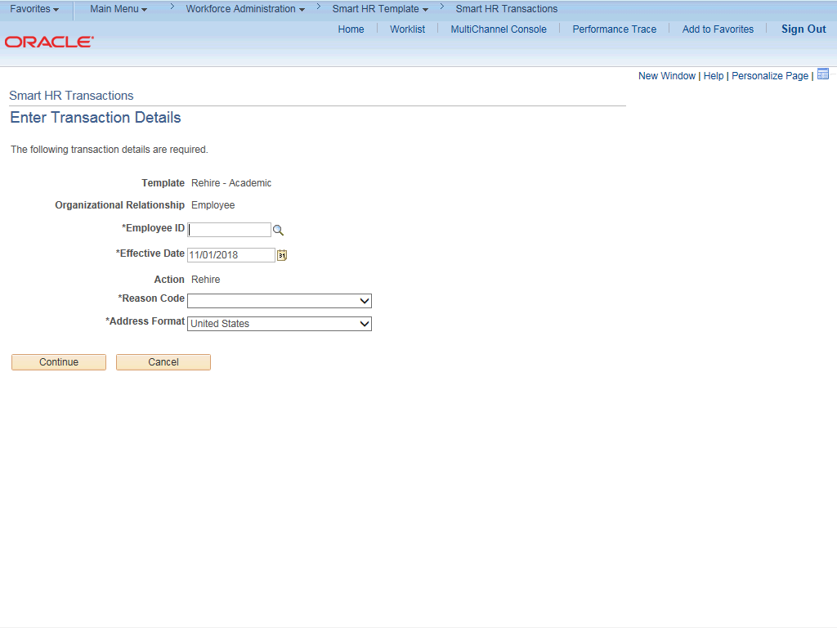

Step | Action
7. | In the Employee ID field, enter the employee’s ID number or use the lookup to search for and select it. You have access to employee records only within your business unit.  Click in the Employee ID field.
8. | Enter the desired information into the Employee ID field.
9. | The Effective Date is populated based on your entry on the previous page. Ensure that you entered the correct date on which employment begins.
10. | Click the button to the right of the Reason Code field.

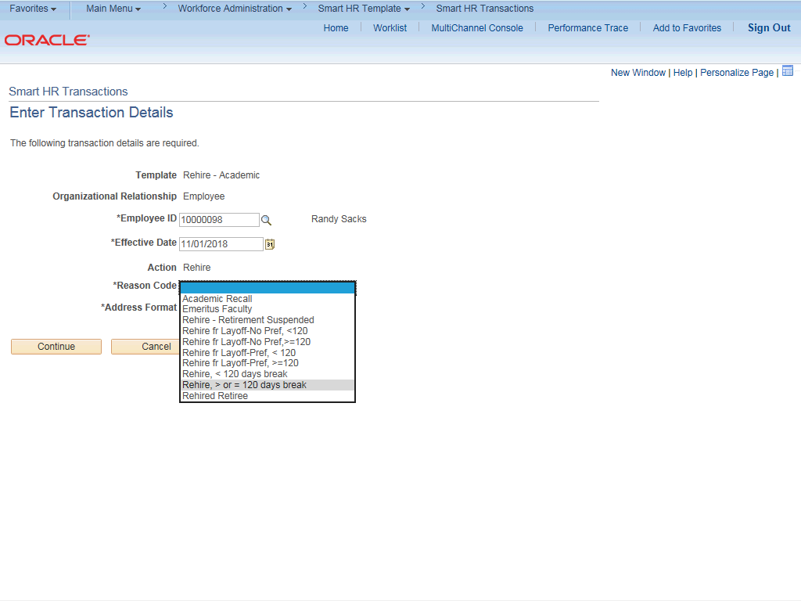

Step | Action
11. | Select the appropriate Reason Code. It is important to select an accurate reason as it may impact the employee’s benefits.  For this example, click the Rehire, > or = 120 days break list item.
12. | Click the Continue button.

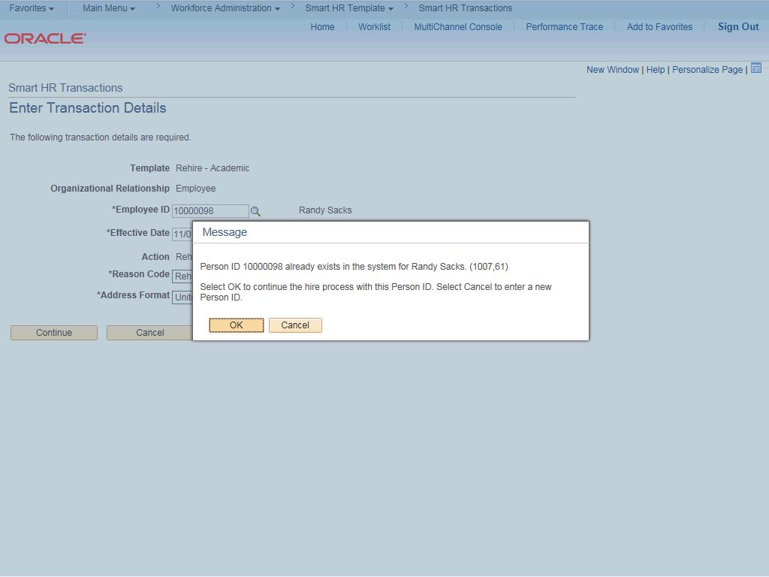

Step | Action
13. | UCPath displays a message indicating the individual already exists in the system.  Verify that the displayed employee ID and name correspond with the individual you are rehiring.  Click the OK button.

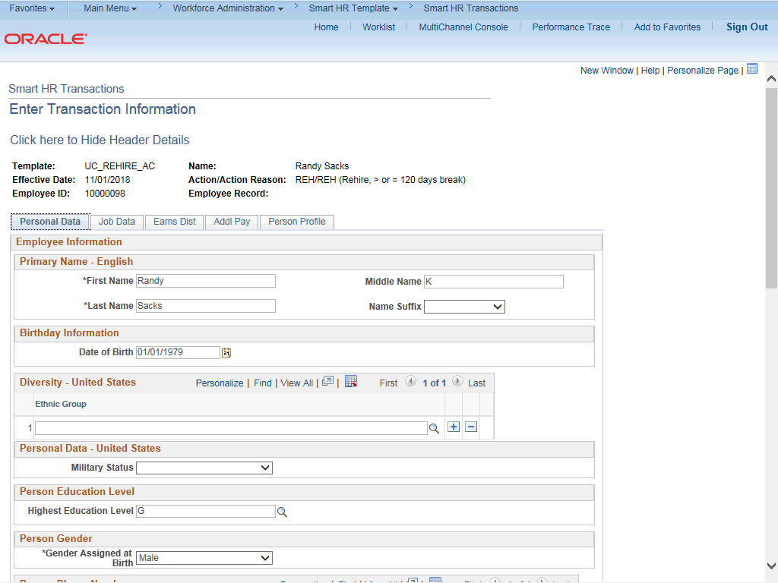

Step | Action
14. | The rehire template appears. Five tabs are available on this template: Personal Data, Job Data, Earns Dist, Addl Pay and Person Profile.
15. | Header details appear above the tabs. You can show/hide the header information as needed.
16. | The employee's personal data automatically populates from the employee's existing personal data information.  The Diversity - United States, Personal Phone Number and Person Email Address sections do not display the employee's existing data. You must enter the information for these sections as necessary. Any new information entered in these sections will override the employee's existing personal data information.
17. | Click the scroll bar.

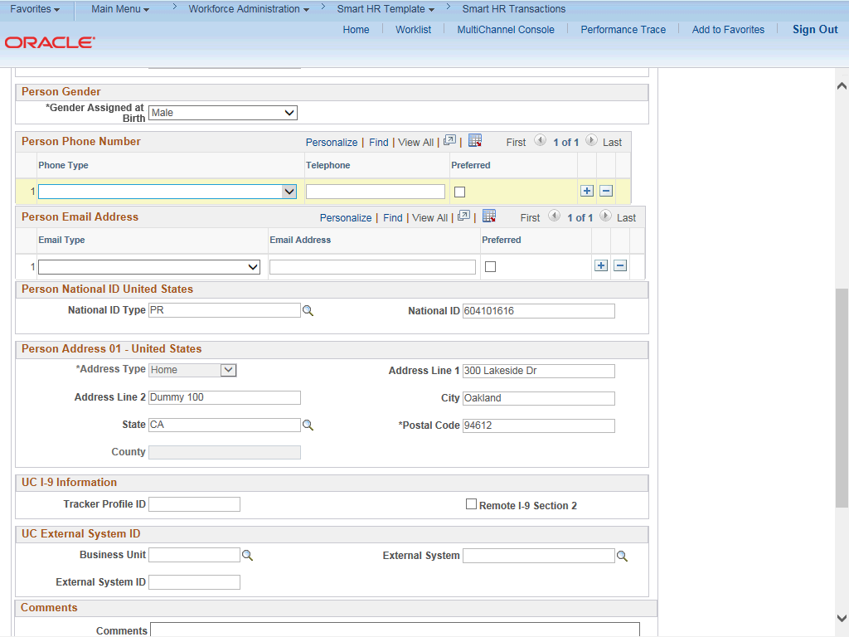

Step | Action
18. | Click the button to the right of the Phone Type field.
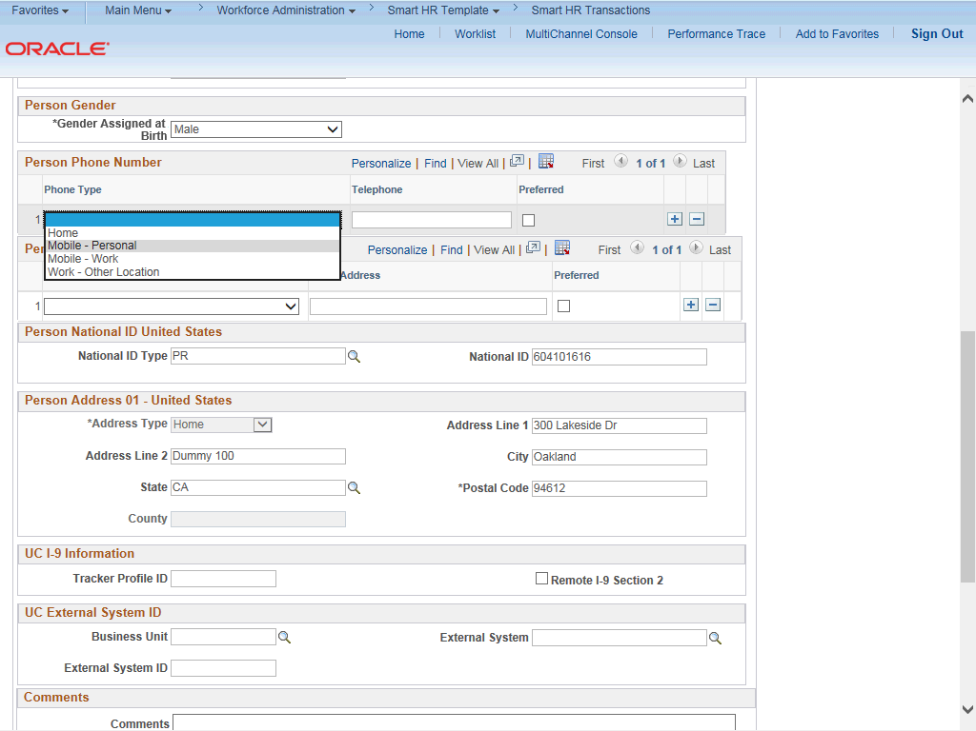

Step | Action
19. | Click in the Telephone field.
20. | Enter the desired information into the Telephone field.
21. | Click the Preferred option.
22. | Click the button to the right of the Email Type field.
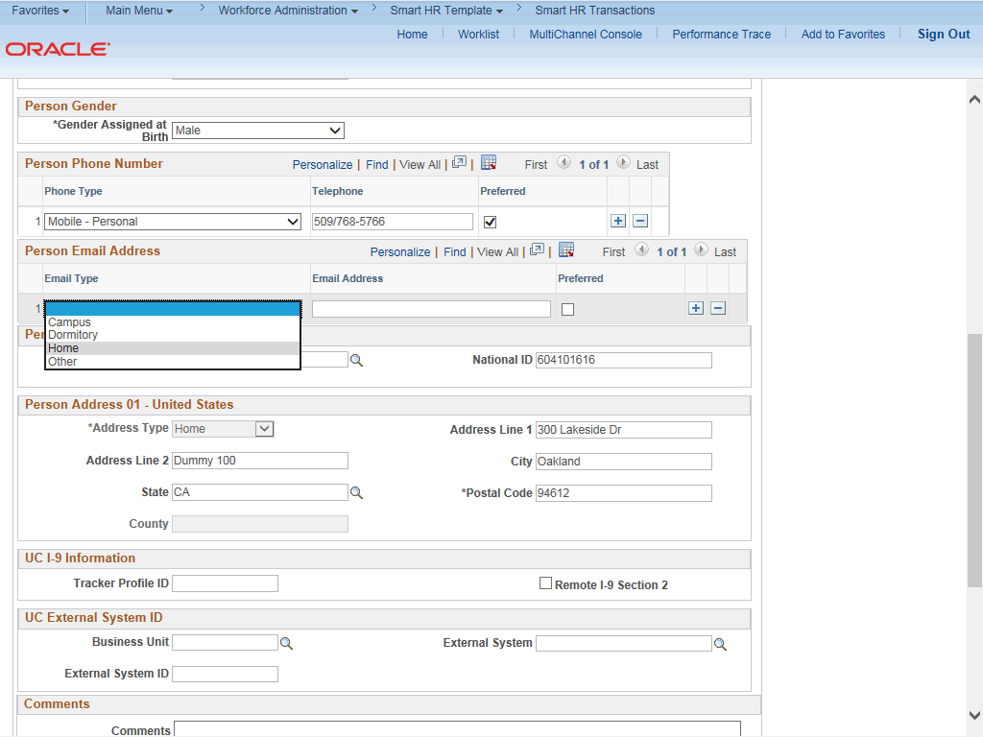

Step | Action
23. | For this example, click the Home list item.
24. | Click in the Email Address field.
25. | Enter the desired information into the Email Address field.

Step | Action
26. | Confirm that the National ID field is populated with the employee's Social Security Number (SSN). If it is blank, every effort should be taken to include the SSN before submitting the template. Leaving the National ID field blank has downstream impacts.
27. | Click the scroll bar.
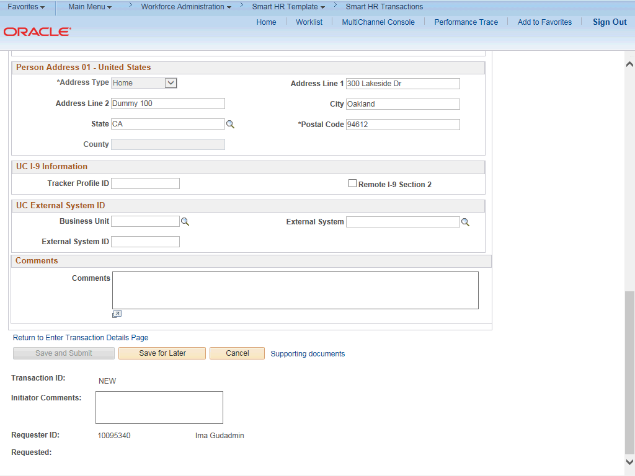

Step | Action
28. | If the rehire has an existing tracker profile, then you can add their Tracker Profile ID and indicate whether their I-9 section 2 was completed.
29. | If applicable, use the UC External System ID section to enter external system information to facilitate matching of IDs with IDM systems.  You must enter values for all three fields in this section. The Business Unit in this section must match the Business Unit associated with the Position Number you enter on the Job Data tab (the next tab).

Step | Action
30. | Use the Comments field to enter specific details or an explanation regarding the transaction. For example, this field can be used to:  - Enter details about a contract pay transaction, such as contract begin date and contract end date.  - Indicate that the employee lives and works outside the US. For these employees, UCPC WFA Production will add the NRA Working Outside the US citizenship status on the Identification Data page.  This field is referenced by UCPC WFA Production to assist with the processing of the transaction.
31. | Click the scroll bar.
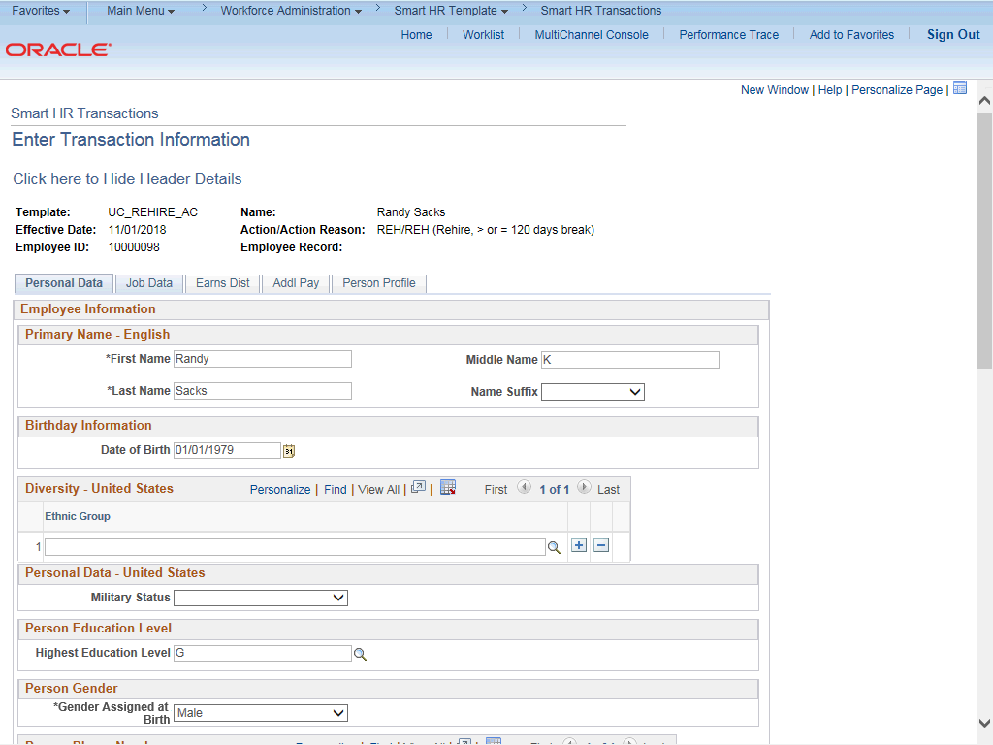

Step | Action
32. | Click the Job Data tab.

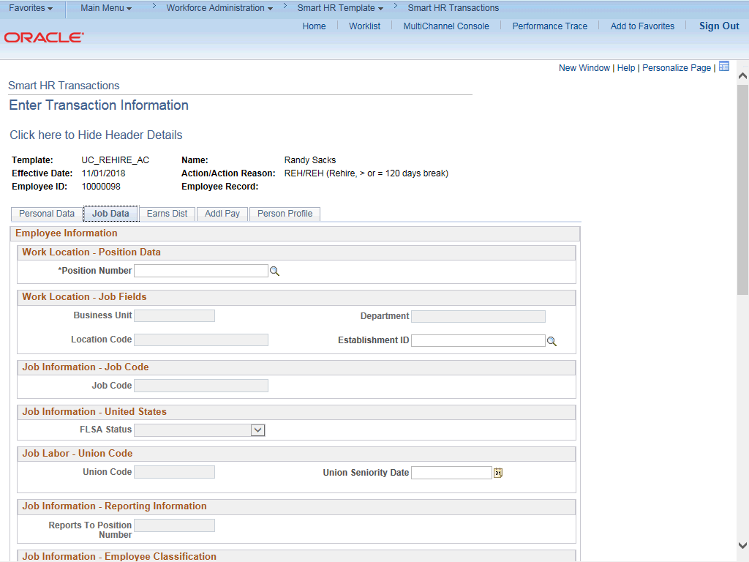

Step | Action
33. | Enter the position number or search for it using the look up. You have access only to position numbers within your business unit or related business unit.  Click in the Position Number field.
34. | Enter the desired information into the Position Number field.
35. | Press [Tab] to automatically populate the position-related fields.

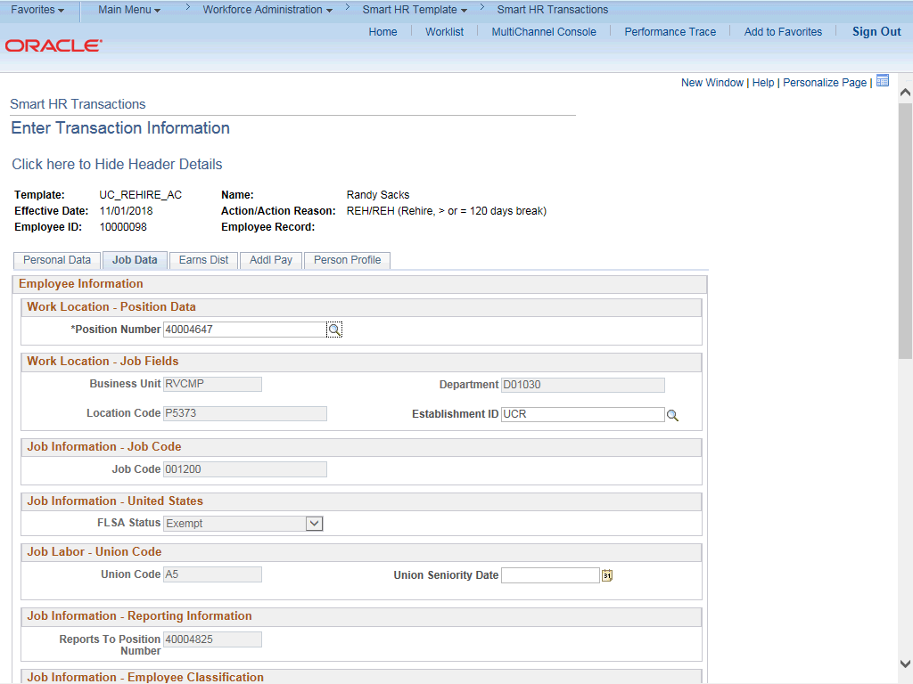

Step | Action
36. | Click the scroll bar.
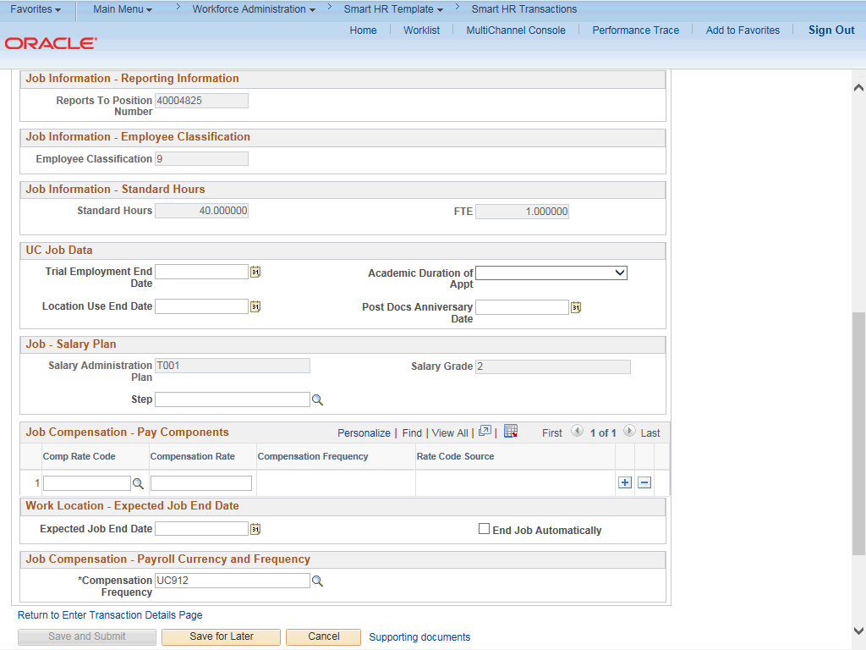

Step | Action
37. | For academic hires, the Employee Classification field automatically populates based on the job code and cannot be changed.
38. | In the UC Job Data section, enter or select the appropriate values as applicable.
39. | The Academic Duration of Appointment options allow Locations to track additional information relating to the Expected Job End Date field (when entered at the bottom of this page).  Academic Duration of Appt options include:  - Continuing (Unit 18)  - End Date (Academic Term Appts)  - Indefinite  - Potential Security  - Security (LSOE)  - Tenure Track (Ladder Rank)  - Tenured
40. | Post Docs Anniversary Date is used to help maintain years of experience for Post Docs and assists with calculating accruals for vacation and sick leave for Post Docs.
41. | Some job codes have steps associated with them. When a Step is entered, UCPath automatically updates the Job Compensation - Pay Components fields and the compensation information cannot be changed.  Some job codes do not have steps associated with them, in which case the Job Compensation - Pay Components fields must be manually entered.  If the job has above scale component of pay, then step does not need to be selected. Enter applicable above scale comp rate codes in Job Compensation- Pay Components section.  For contract-based pay hires, refer to the Initiate Contract Pay Template Transaction simulation for specific steps on contract pay entries.
42. | For this example, the job code is associated with steps. Click the Look up Step button.

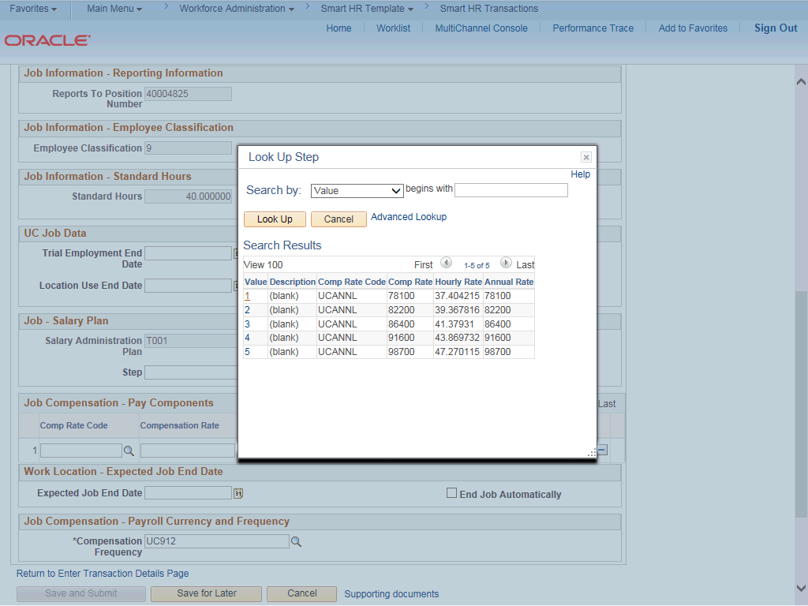

Step | Action
43. | Use caution when selecting the appropriate step value. For some jobs, there are half steps, so be sure to review the Hourly Rate to ensure you are selecting the correct step value.
44. | Select the appropriate Step.  For this example, click the 1 list item.
45. | The Comp Rate Code, Compensation Rate and Compensation Frequency fields are automatically populated based on the Step that was entered.  If necessary, you can enter additional pay components, if the employee has multiple components of pay (MCOP). Certain employees have MCOP because they have either an off-scale or negotiated/incentive component.

Step | Action
46. | If the employment is a short term assignment or temporary hire, enter the date the position ends in the Expected Job End Date field.  An Expected Job End Date should be entered for all academic employee classes, except:  3 - Academic Recall  - - Faculty  - - Non-Faculty  - - Academic Student  14 - Academic Contingent Worker  - - Emeriti  - - Deans/Faculty Administrators  - - Post Docs
47. | The payroll-related Compensation Frequency field automatically populates based on the job code. This field defines how the total compensation is paid out to the employee per paycheck.  This field can be changed for specific exceptions, such as contract based pay or to change to an academic frequency. Any time this field is changed from the default enter a Comment (on the first tab) to explain why the field was changed.
48. | Click the scroll bar.
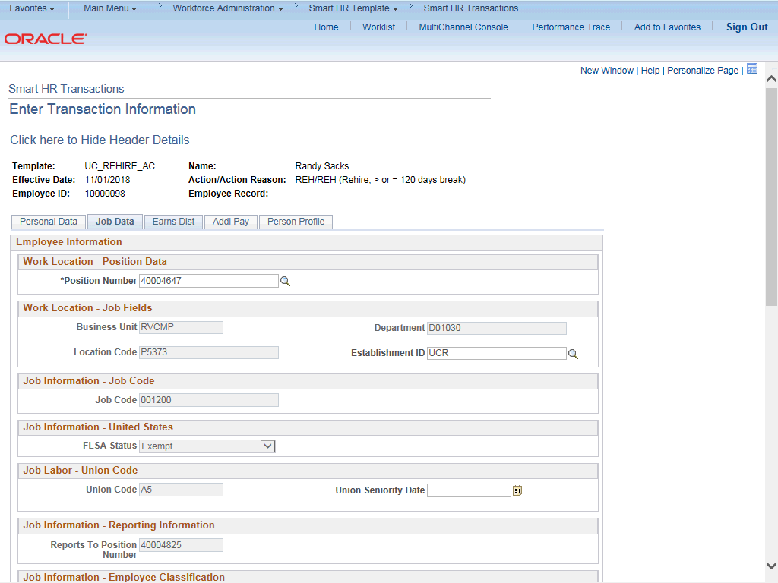

Step | Action
49. | Click the Earns Dist tab.
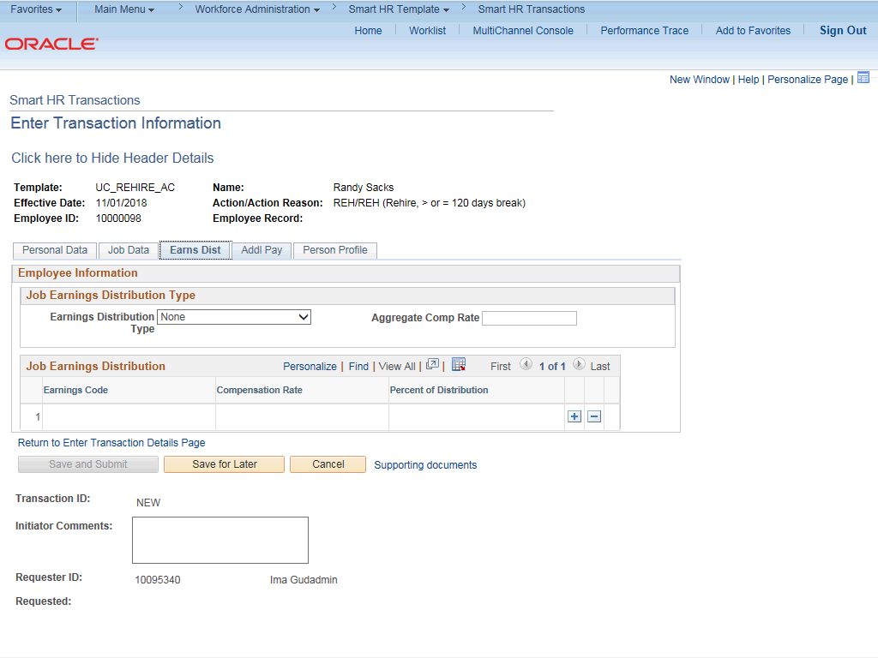

Step | Action
50. | In most cases, the Job Earnings Distribution section is automated. If the Comp Rate code entered on the Job Data tab has a mapped Earnings Code, the Job Earnings Distribution section is updated automatically.
51. | The Job Earnings Distribution section also can be used to manually enter distribution information. Use the Earnings Distribution Type field to enter distribution By Amount or By Percent. After the Earnings Distribution Type is selected, the Aggregate Comp Rate field is populated with the monthly amount.  - If By Amount is selected, the total of all compensation rates entered must add up to the monthly comp rate.  - If By Percent is selected, the total of all percentages entered must add up to 100%.
52. | For certain academic comp rate codes, such as Health Science Comp Plan, earnings codes are defaulted based on the Comp Rate Code entered in the  Job Compensation - Pay Components section. Also in those cases, the earning distribution type is By Amount and amounts are automatically calculated.
53. | Click the Addl Pay tab.

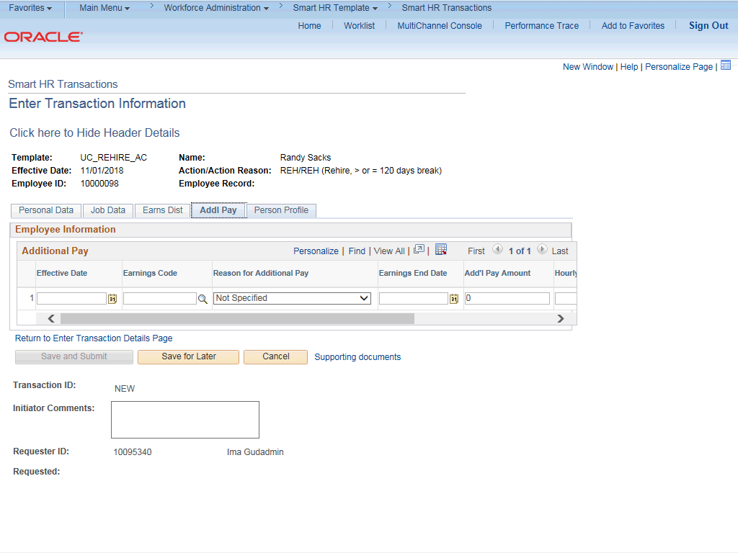

Step | Action
54. | There may be cases where an employee is paid a recurring flat amount. In this case, the compensation section is not populated on the Job Data tab. Instead, the Additional Pay section is used.  There may also be cases where neither compensation rate nor additional pay is entered. In those cases, it is recommended that you enter a comment to explain how the employee is to be paid.  It is recommended not to use this template for one time additional pay. Instead, use payroll's one time payments page.
55. | Click the Person Profile tab.

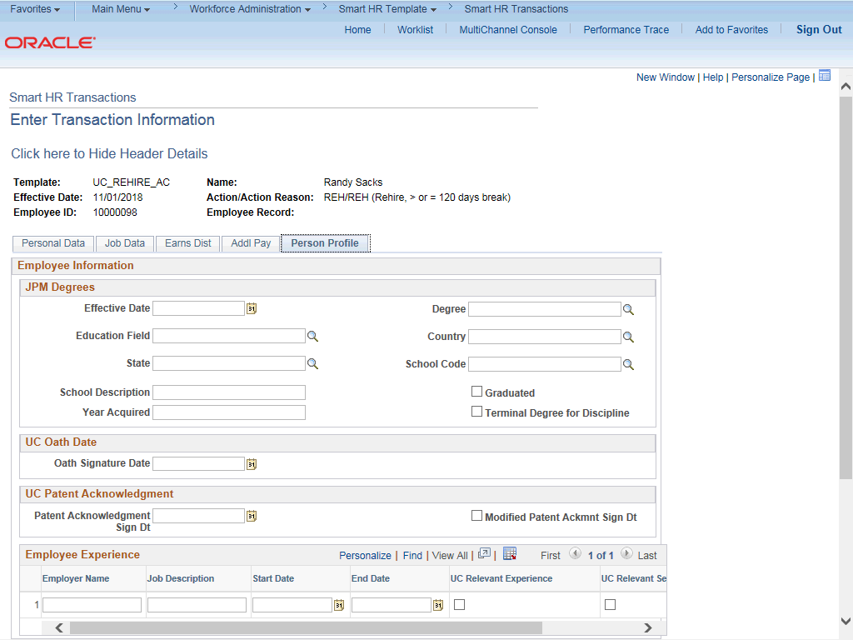

Step | Action
56. | Use the Person Profile page to enter the employee's Degrees, Oath Signature Date and Patent Acknowledgement signature date.  The information entered in the JPM Degrees, UC Oath Date and UC Patent Acknowledgement sections is copied to the employee's Person Profile component after the template is processed by UCPC WFA Production.  The information entered in the Employee Experience section is copied to the employee's UC Employee Experience page after the template is fully processed by UCPC WFA Production.
57. | Click the scroll bar.

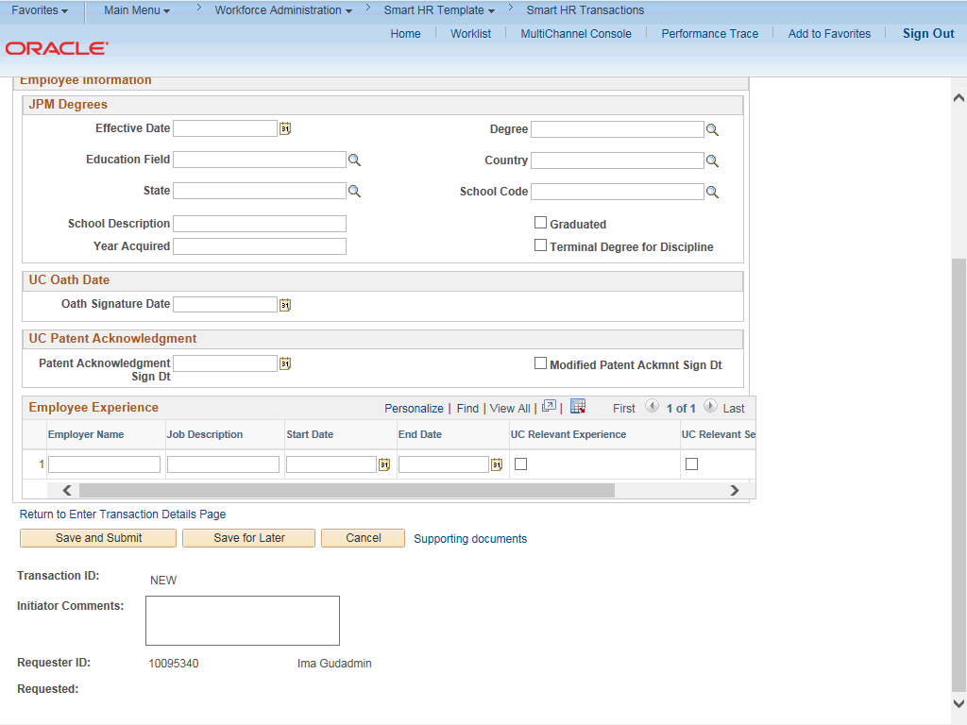

Step | Action
58. | Enter the date the employee signed the UC oath agreement. This date cannot be later than today's date.  Click in the Oath Signature Date field.
59. | Enter the desired information into the Oath Signature Date field.
60. | Enter the date on which the individual signed the UC patent acknowledgement. This date cannot be later than today's date.  Click in the Patent Acknowledgment Sign Dt field.
61. | Enter the desired information into the Patent Acknowledgment Sign Dt field.
62. | For post docs, use the fields in the Employee Experience section to enter data related to the employee's prior work experience. Having this information is helpful in determining new compensation rates for the employee who is being rehired.
63. | Use the Supporting documents link to attach supporting documents for the rehire.

Step | Action
64. | Enter comments for the Approver in the Initiator Comments field.  Comments you enter here appear only with the request; they do not appear on the employee’s record after the transaction is processed to completion. You can enter Initiator Comments on any of the tabs within this template.
65. | The Save and Submit button is not available until all required fields on each tab are completed.  Click the Save and Submit button.
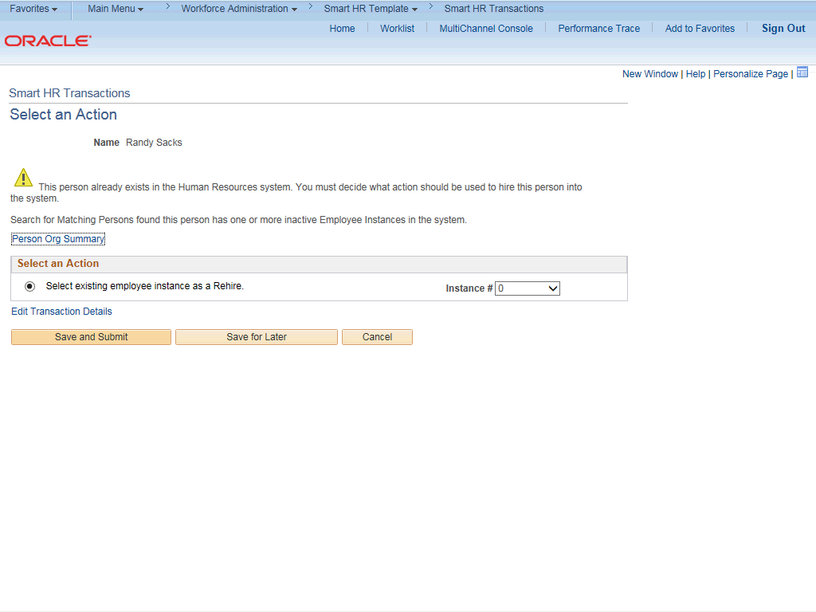

Step | Action
66. | Review the rehire warning message, which indicates this employee's record already exists in UCPath.
67. | If the employee has only one inactive employee record within your business unit, then that number is defaulted. If the employee has more than one inactive employee record within your business unit, then the lowest number defaults. If needed, select the record to add rehire action.  For this example, accept the default.
68. | Click the Save and Submit button.

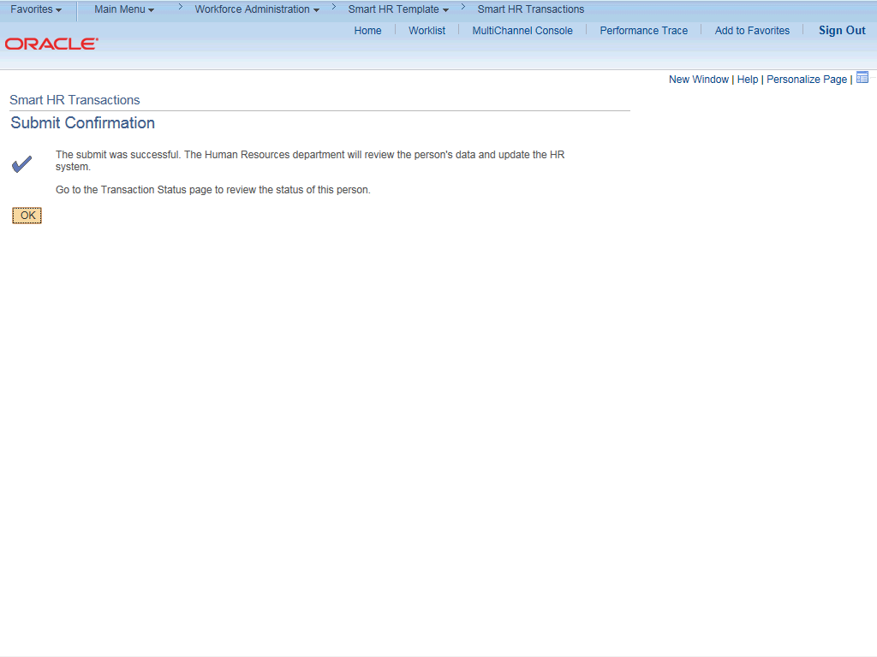

Step | Action
69. | Click the OK button.
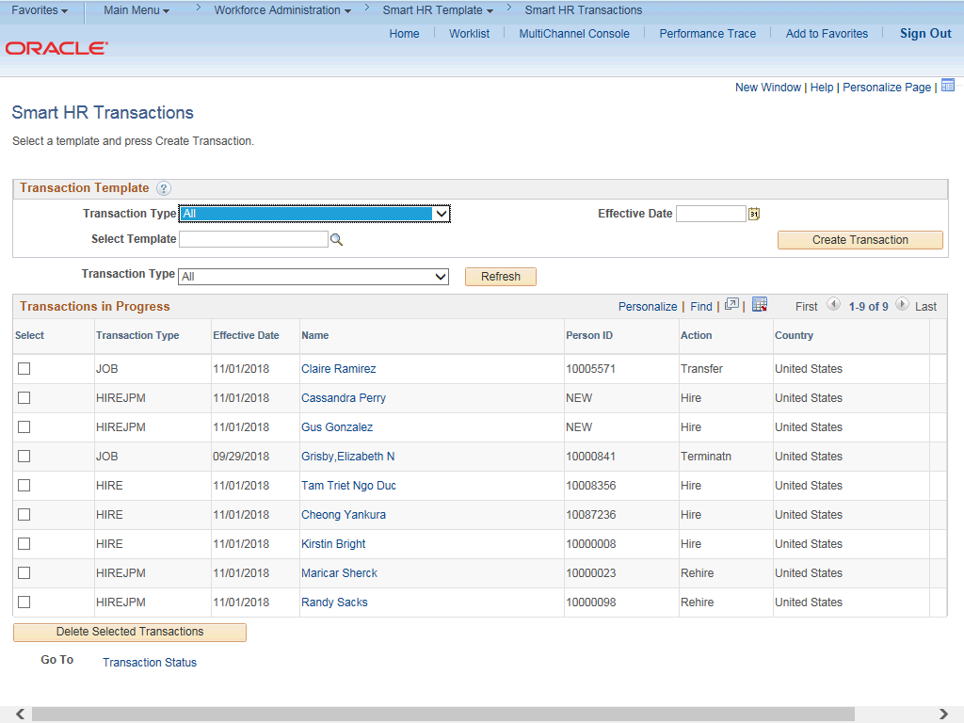

Step | Action
70. | The template transaction is routed for approval and appears in the Transactions in Progress section until it is processed.
71. | You have initiated a rehire template transaction for an academic employee.  End of Procedure.

