Use this task to initiate a full hire template transaction for an academic employee.

Navigation: PeopleSoft Menu > Workforce Administration > Smart HR Template > Smart HR Transactions

Note: This page also may be available in Workcenter depending on your security access.

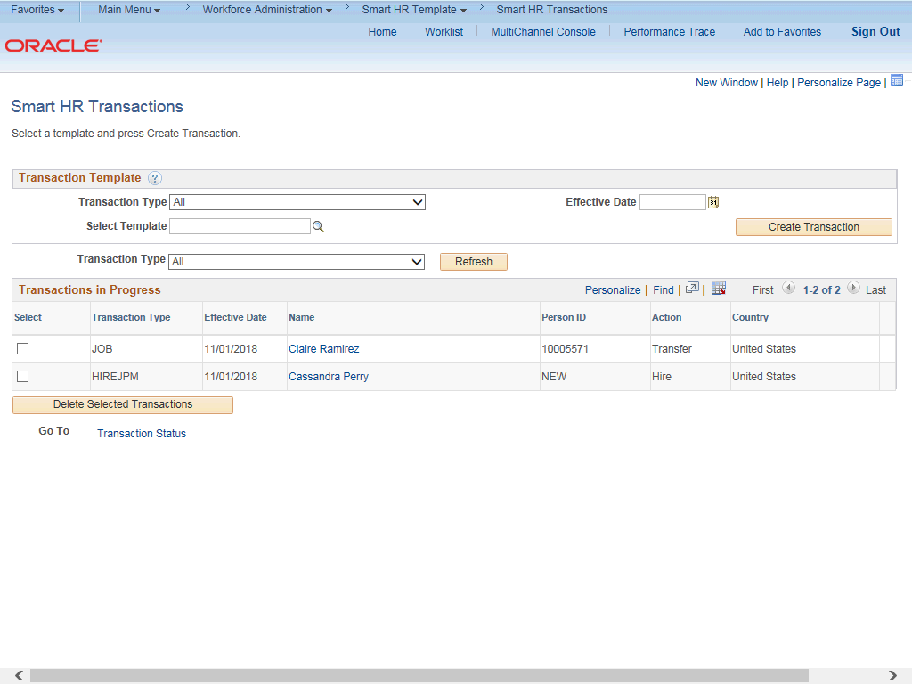

Step | Action
1. | Use the Smart HR Transactions page to initiate a full hire template transaction.
2. | Click the Look up Select Template button.  Note: The Transaction Type field is not used by UC.

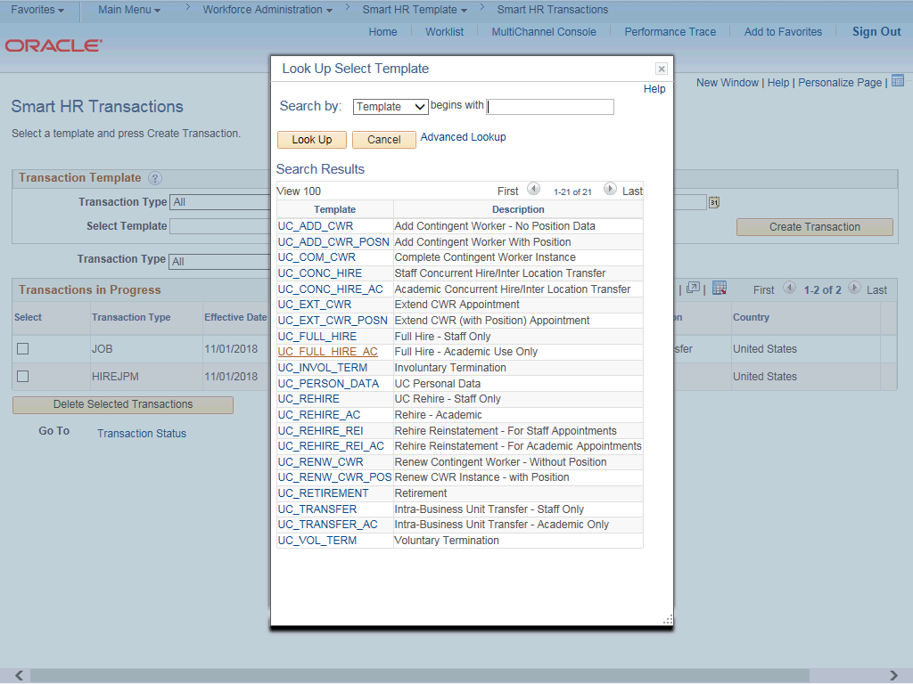

Step | Action
3. | Select the appropriate full hire template. Notice there are two full hire templates, one for staff and one for academic.  Click the UC_FULL_HIRE_AC list item.
4. | Click in the Effective Date field.
5. | The Effective Date field is the effective date of the selected template action. The date you enter in this field automatically populates the Effective Date field on the Enter Transaction Details page. You can update the Effective Date on the Enter Transaction Details page if needed.  Enter the desired information into the Effective Date field.
6. | Click the Create Transaction button.

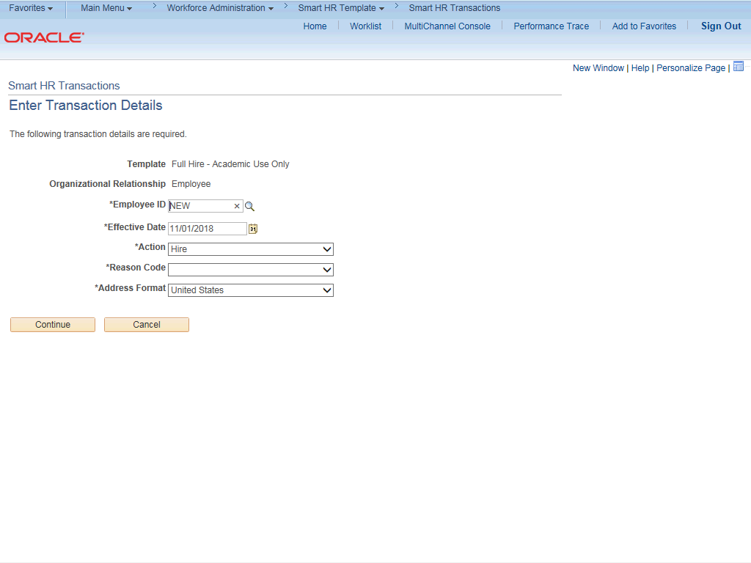

Step | Action
7. | In the Employee ID field, accept the default value of NEW.  After UCPC WFA Production processes the full hire template, the system automatically generates the next sequential UC Employee ID number for the employee.
8. | The Effective Date is populated based on your entry on the previous page. Ensure that you entered the correct hire date or the date the employee begins the job.  For this example, accept the default.
9. | Click the button to the right of the Reason Code field.

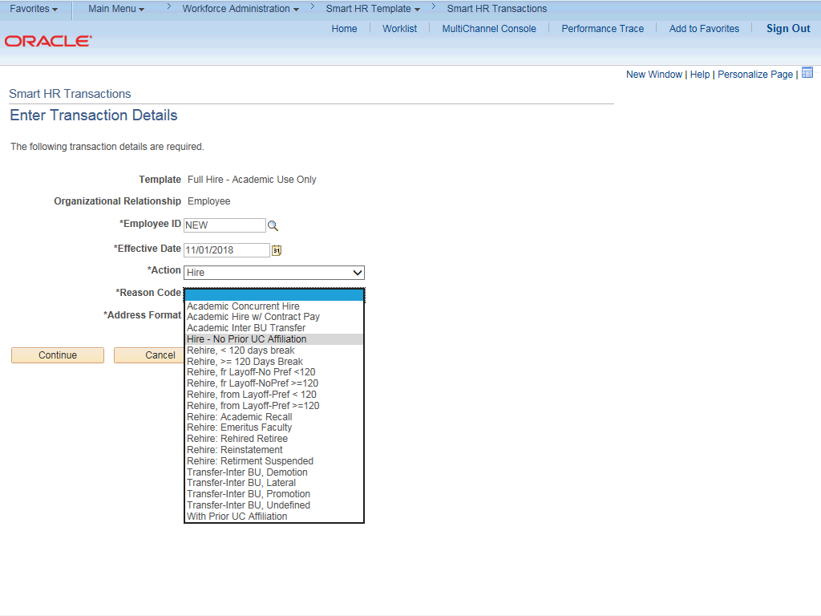

Step | Action
10. | Select the appropriate Reason Code.  For this example, click the Hire - No Prior UC Affiliation list item.
11. | In the Address Format field, accept the default of United States or select the  Global option, if applicable.
12. | Click the Continue button.

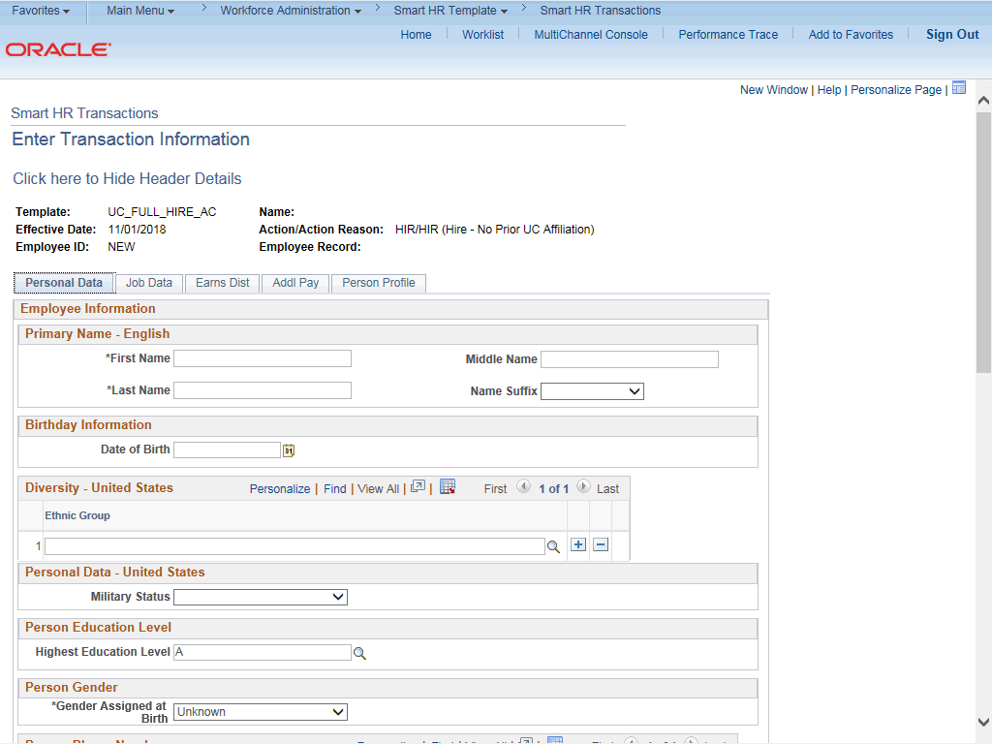

Step | Action
13. | The academic full hire template appears. There are five tabs on this template, Personal Data, Job Data, Earns Dist, Addl Pay and Person Profile. Fields that are required by the system are indicated with an asterisk *.
14. | Header details appear above the tabs. You can show/hide the header information as needed.
15. | Click in the First Name field.
16. | Enter the desired information into the First Name field.
17. | Click in the Last Name field.
18. | Enter the desired information into the Last Name field.
19. | The Date of Birth is required if the Effective Date of the template is prior to the current date. The Date of Birth is not required if the Effective Date of the template is on or after to the current date.  Click in the Date of Birth field.
20. | Enter the desired information into the Date of Birth field.

Step | Action
21. | Click the Look up Ethnic Group button.
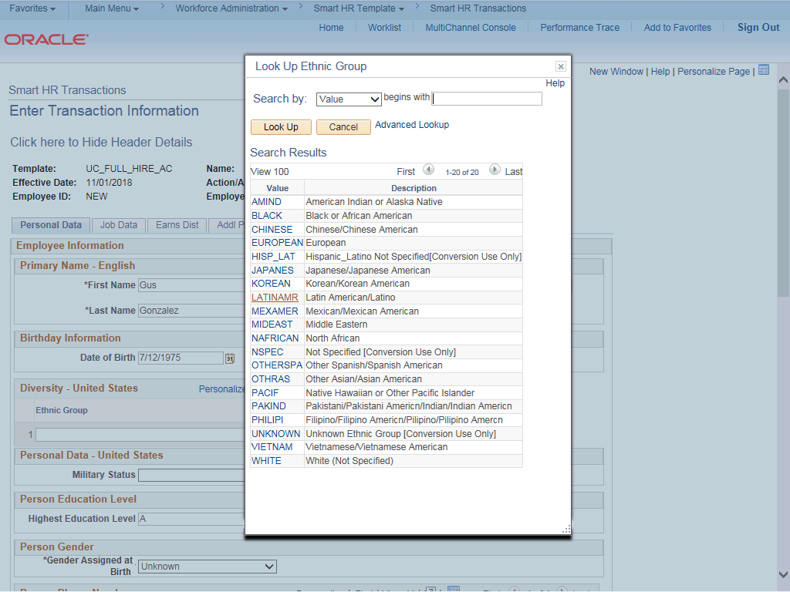

Step | Action
22. | Select the appropriate ethnicity.
23. | If the individual identifies with more than one ethnic group, click the Add a row  button.
24. | Select the appropriate Military Status, if known, or leave the field blank. Click the button to the right of the Military Status field.

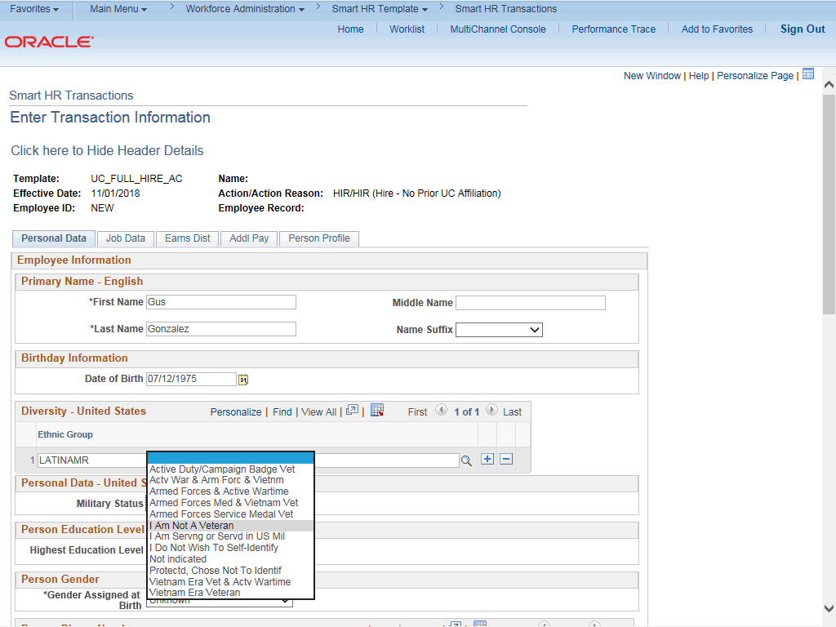

Step | Action
25. | For this example, click the I Am Not A Veteran list item.
26. | Select the Highest Education Level, if known, or accept the default of A (Not Indicated).  Click the Look up Highest Education Level button.

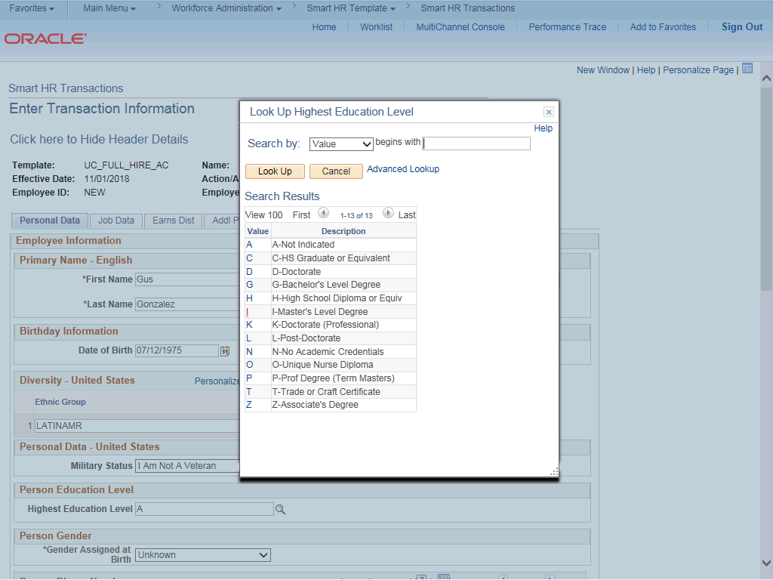

Step | Action
27. | For this example, choose appropriately.
28. | Click the scroll bar.

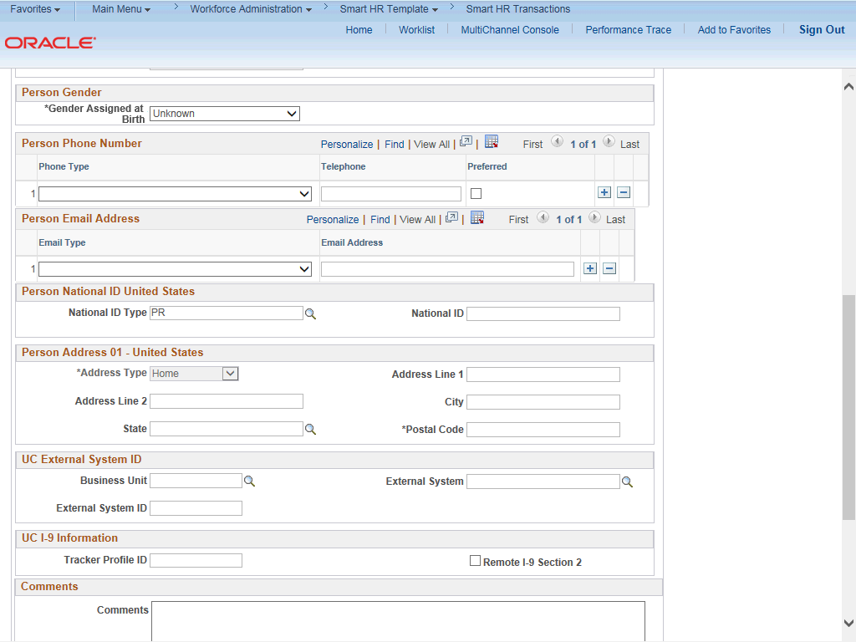

Step | Action
29. | Click the button to the right of the Gender field.
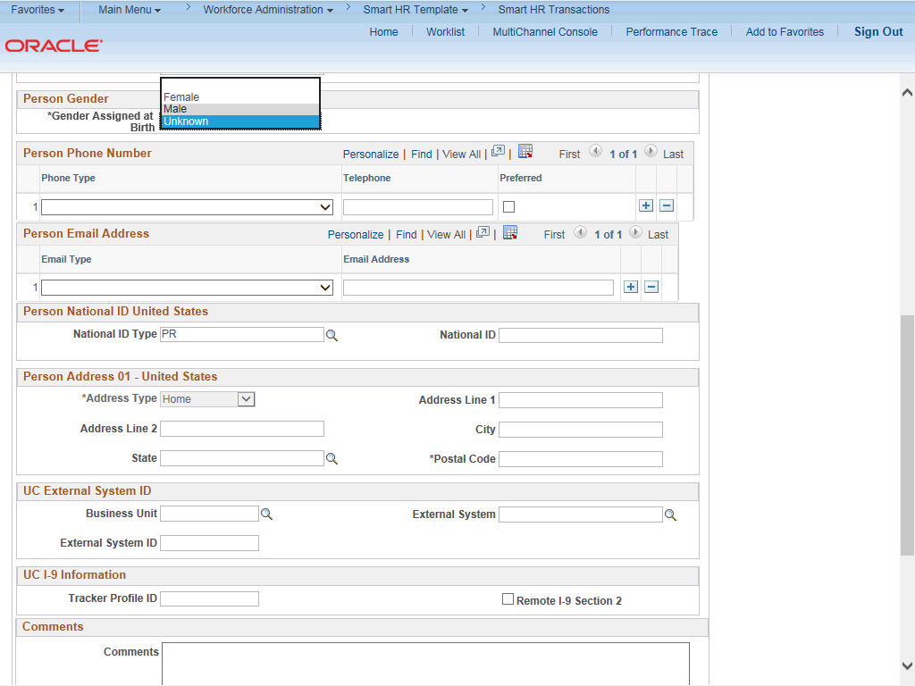

Step | Action
30. | Select the appropriate Gender.
31. | Click the button to the right of the Phone Type field.
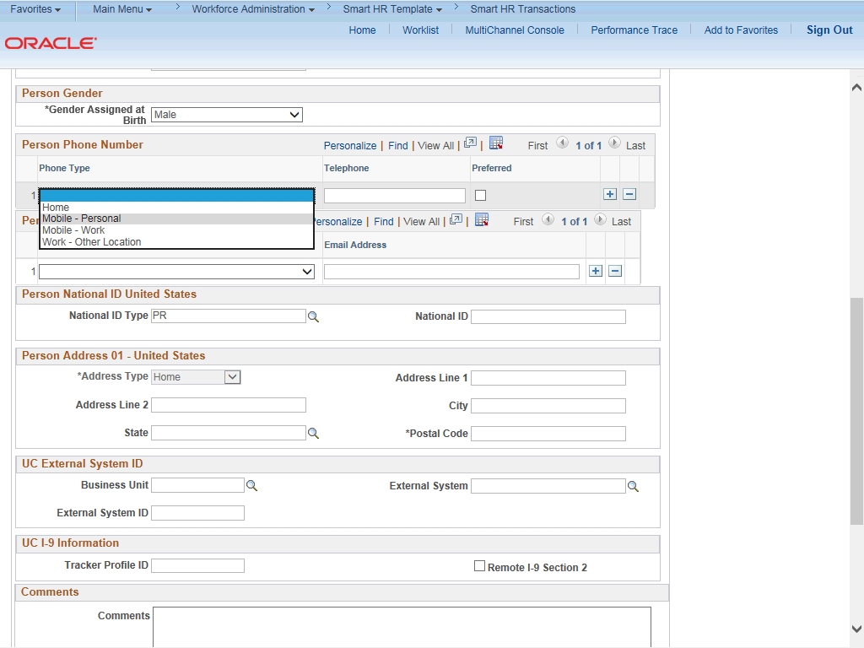

Step | Action
32. | Select the appropriate Phone Type.
33. | Click in the Telephone field.
34. | Enter the desired information into the Telephone field.

Step | Action
35. | A Preferred phone number must be identified by selecting the check box. Click the Preferred option.
36. | Click the button to the right of the Email Type field.
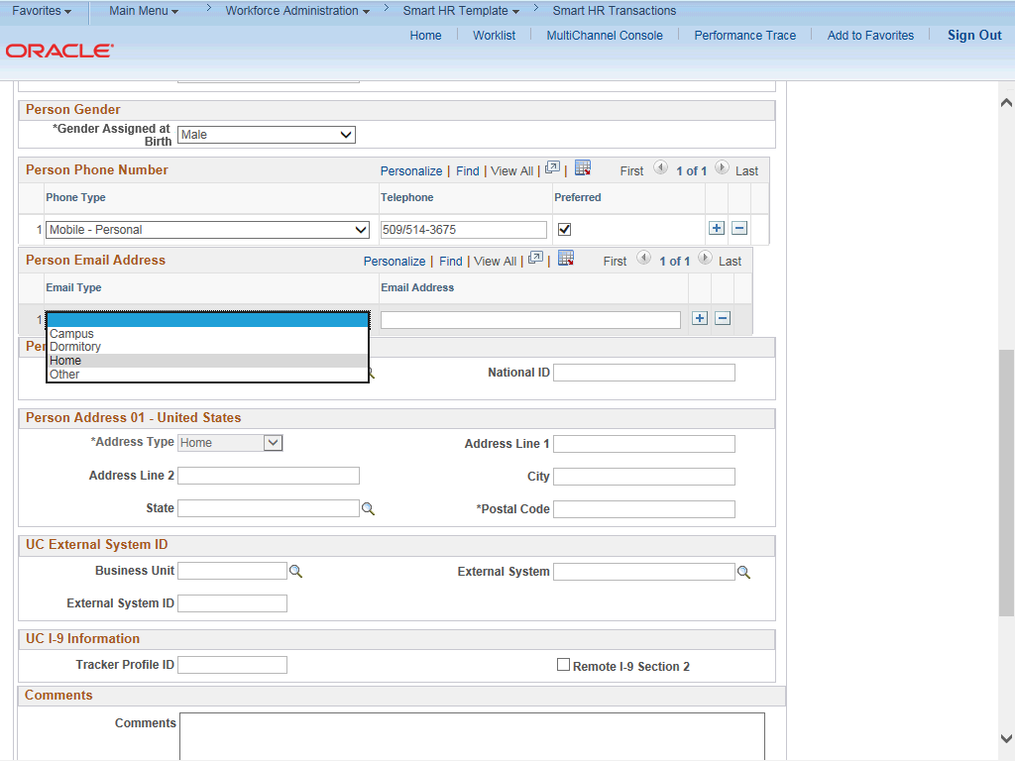

Step | Action
37. | Select the appropriate Email Type.
38. | Click in the Email Address field.
39. | Enter the desired information into the Email Address field.
40. | In the National ID Type field, accept the default of PR for Social Security Number (SSN).

Step | Action
41. | The National ID (SSN) is required if the Effective Date of the template is prior to the current date. The SSN is not required if the Effective Date of the template is on or after to the current date.  Every effort should be taken to include the SSN before submitting the template. Leaving the National ID field blank has downstream impacts. For example, it impacts the employees ability to enroll in benefits plans (including retirement).
42. | Click in the National ID field.
43. | Enter the Social Security number into the National ID field.
44. | Click in the Address Line 1 field.
45. | Enter the desired information into the Address Line 1 field.
46. | Click in the City field.
47. | Enter the desired information into the City field.
48. | Click in the State field.
49. | Enter the desired information into the State field.
50. | Click in the Postal Code field.
51. | Enter the desired information into the Postal Code field.
52. | Click the scroll bar.

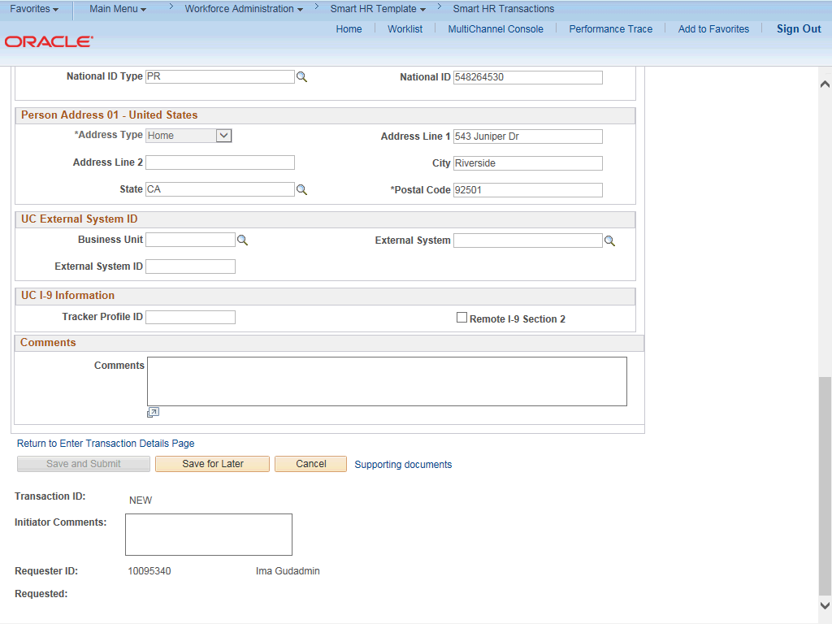

Step | Action
53. | If applicable, use the UC External System ID section to enter external system information to facilitate matching of IDs with IDM systems.  If providing the information, you must enter values for all three fields. The Business Unit in this section must match the Business Unit associated with the Position Number you enter on the Job Data tab (the next tab).
54. | If the new hire has an existing tracker profile, then you can add their Tracker Profile ID and indicate whether their I-9 section 2 needs to be completed remotely.  This information is copied to the employee's Person Profile component.
55. | Click in the Tracker Profile ID field.
56. | Enter the desired information into the Tracker Profile ID field.

Step | Action
57. | Use the Comments field to enter specific details or an explanation regarding the transaction. For example, this field can be used to:  - Enter details about a contract pay transaction, such as contract begin date and contract end date.  - Indicate that the employee lives and works outside the US. For these employees, UCPC WFA Production will add the NRA Working Outside the US citizenship status on the Identification Data page.  This field is referenced by UCPC WFA Production to assist with the processing of the transaction.
58. | Click the scroll bar.
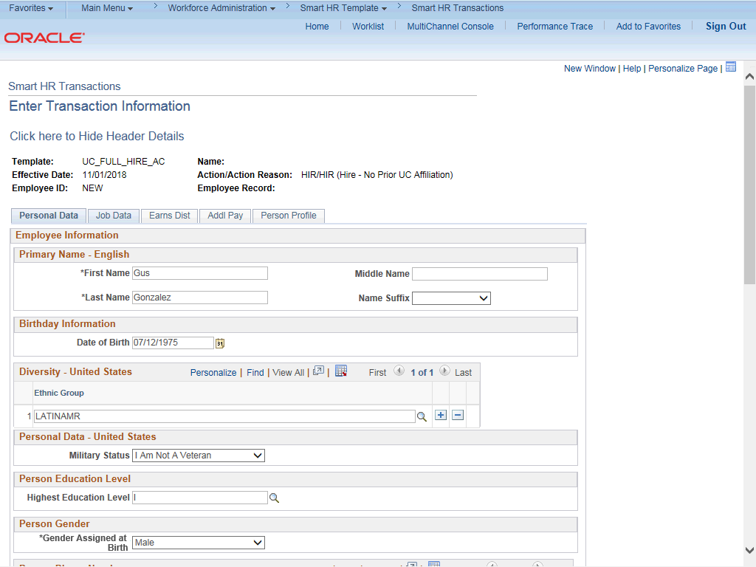

Step | Action
59. | Click the Job Data tab.

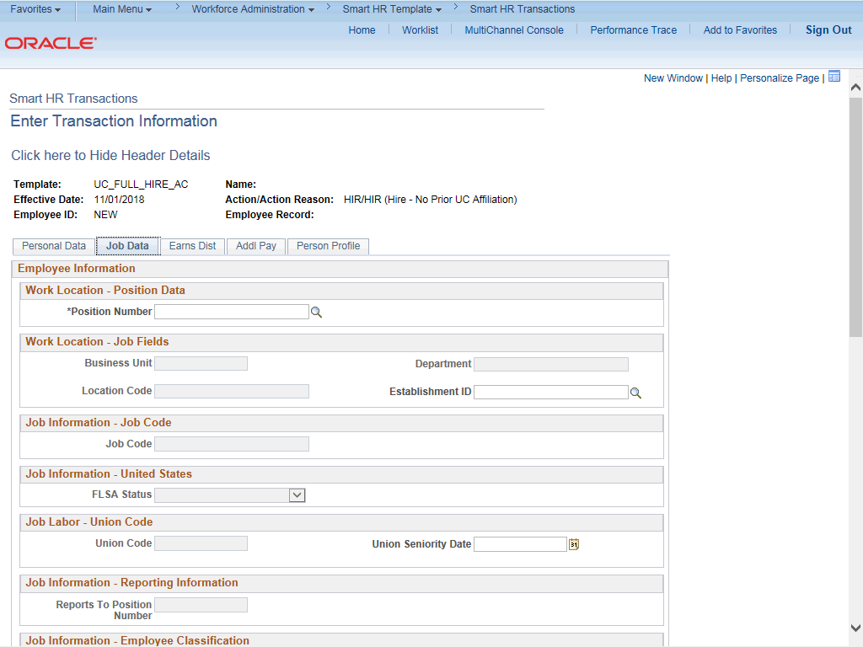

Step | Action
60. | Enter the position number or search for it using the look up. You only have access to position numbers within your business unit or related business unit.  Click in the Position Number field.
61. | Enter the desired information into the Position Number field.
62. | Press [Tab] to automatically populate the position-related fields.

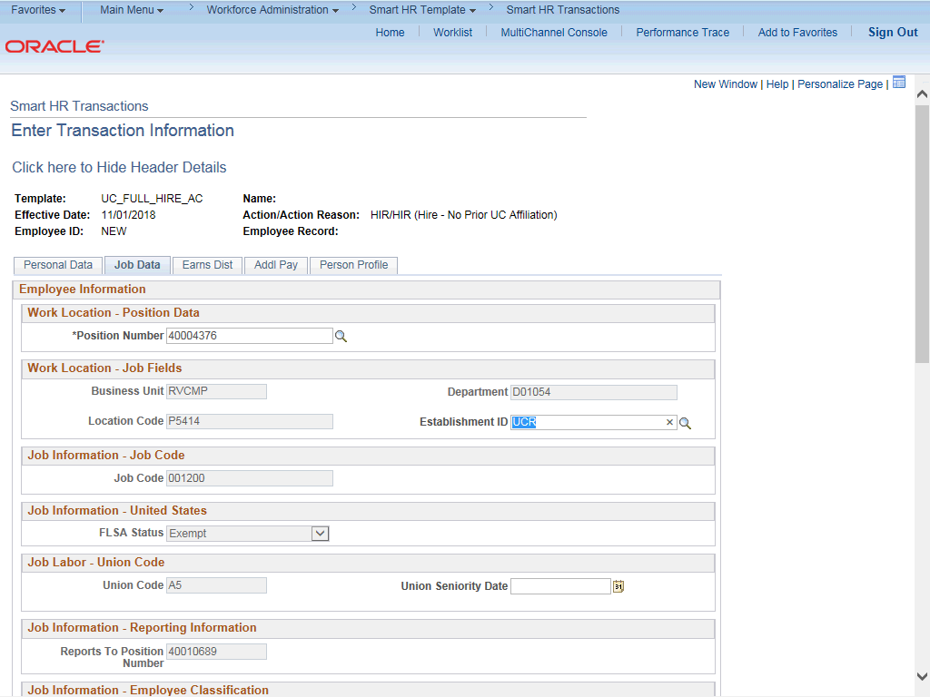

Step | Action
63. | Click the scroll bar.
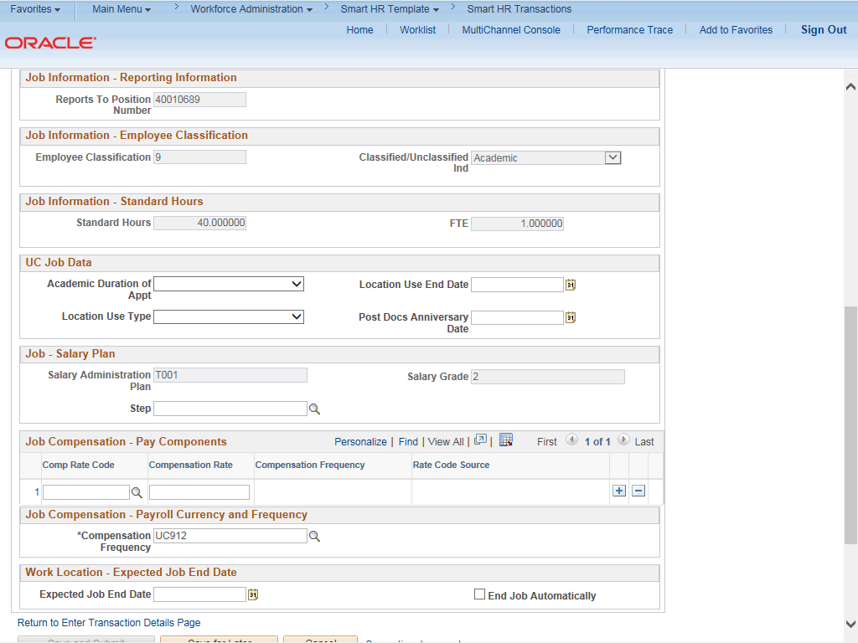

Step | Action
64. | For academic hires, the Employee Classification field automatically populates based on the job code and cannot be changed.
65. | In the UC Job Data section, enter or select the appropriate values as applicable.
66. | The Academic Duration of Appointment options allow Locations to track additional information relating to the Expected Job End Date field (when entered at the bottom of this page).  Academic Duration of Appt options include:  - Continuing (Unit 18)  - End Date (Academic Term Appts)  - Indefinite  - Potential Security  - Security (LSOE)  - Tenure Track (Ladder Rank)  - Tenured
67. | The Location Use Type and Location Use End Date fields allow Locations to track funding expiration and other location specific information separate from the Expected Job End Date field. If a Location Use Type is selected you should select a Location Use End Date.  Location Use Type options include:  - Funding End Date  - Review Remaining Budget  - Review Job  - NSTP Review  - Temporary Off-Scale  - Temporary Reduction in Time  - LA: Dual Employment Job  - Temporary Increase in Time
68. | Post Docs Anniversary Date is used to help maintain years of experience for Post Docs and assists with calculating accruals for vacation and sick leave for Post Docs.
69. | Some job codes have steps associated with them. When a Step is entered, UCPath automatically updates the Job Compensation - Pay Components fields and the compensation information cannot be changed.  Some job codes do not have steps associated with them, in which case the Job Compensation - Pay Components fields must be manually entered.  If the job has above scale component of pay, then step does not need to be selected. Enter applicable above scale comp rate codes in Job Compensation- Pay Components section.  For contract-based pay hires, refer to the Initiate Contract Pay Template Transaction topic for specific steps on contract pay entries.

Step | Action
70. | For this example, the job code is associated with steps. Click the Look up Step button.
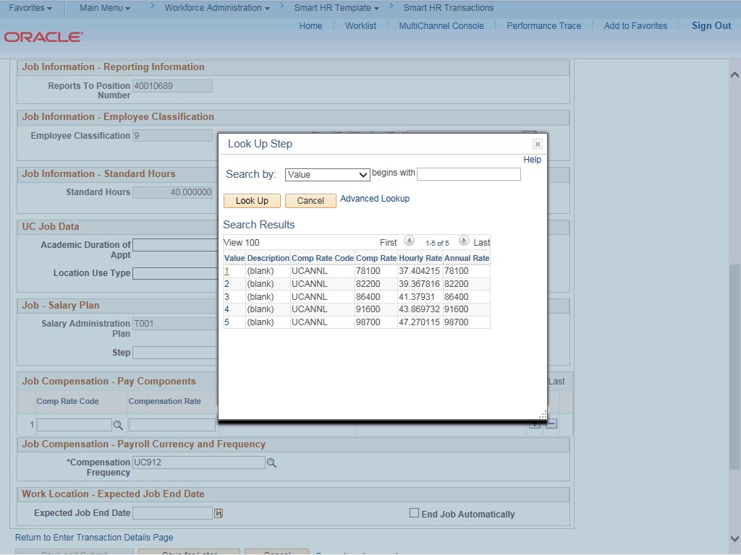

Step | Action
71. | Use caution when selecting the appropriate step value. For some jobs, there are half steps, so be sure to review the Hourly Rate to ensure you are selecting the correct step value.
72. | Select the appropriate Step.  For this example, click the 1 list item.
73. | The Comp Rate Code, Compensation Rate and Compensation Frequency fields are automatically populated based on the Step that was entered.
74. | You can add additional compensation rows by clicking the add a row (+) button. For example, if you need to add an offscale component.

Step | Action
75. | The payroll-related Compensation Frequency field automatically populates based on the job code.  The payroll-related Compensation Frequency field automatically populates based on the job code.  If the Compensation Frequency in the Job Compensation - Pay Components section is A, then the Compensation Frequency in the Job Compensation - Payroll Currency and Frequency section can be any of the following: B, M, UC912, UC_10, UC_11, UC_12, UC_9M or UC_FY.  If the Compensation Frequency in the Job Compensation - Pay Components section is H, then the Compensation Frequency in the Job Compensation - Payroll Currency and Frequency section should be H.  This field can be changed for specific exceptions, such as contract based pay or to change to an academic frequency. Any time this field is changed from the default enter a Comment (on the first tab) to explain why the field was changed.
76. | Click the scroll bar.
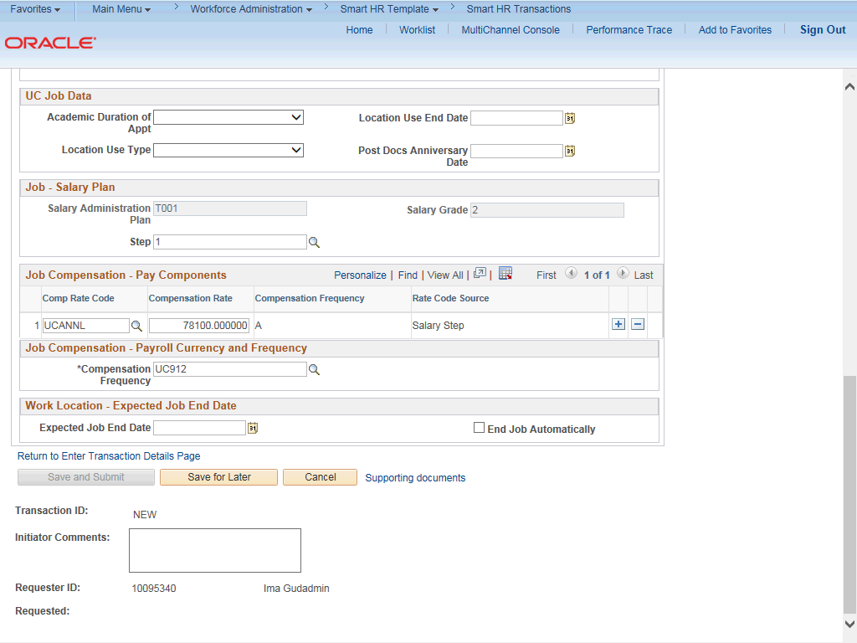

Step | Action
77. | If the employment is a short term assignment or temporary hire, enter the date the position ends in the Expected Job End Date field.  An expected end date should be entered for all academic employee classes, except:  3 - Academic Recall  - - Faculty  - - Non-Faculty  - - Academic Student  14 - Academic Contingent Worker  - - Emeriti  - - Deans/Faculty Administrators  - - Post Docs
78. | If the End Job Automatically check box is selected the UCPath Center will run a process to terminate the employee as of the Expected Job End Date.
79. | Click the scroll bar.
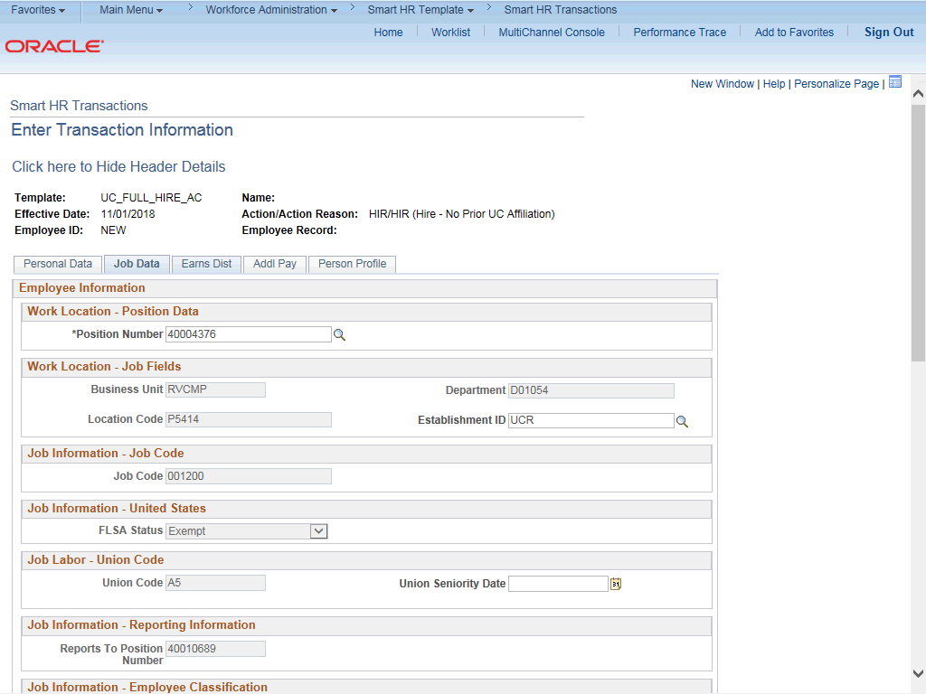

Step | Action
80. | Click the Earns Dist tab.

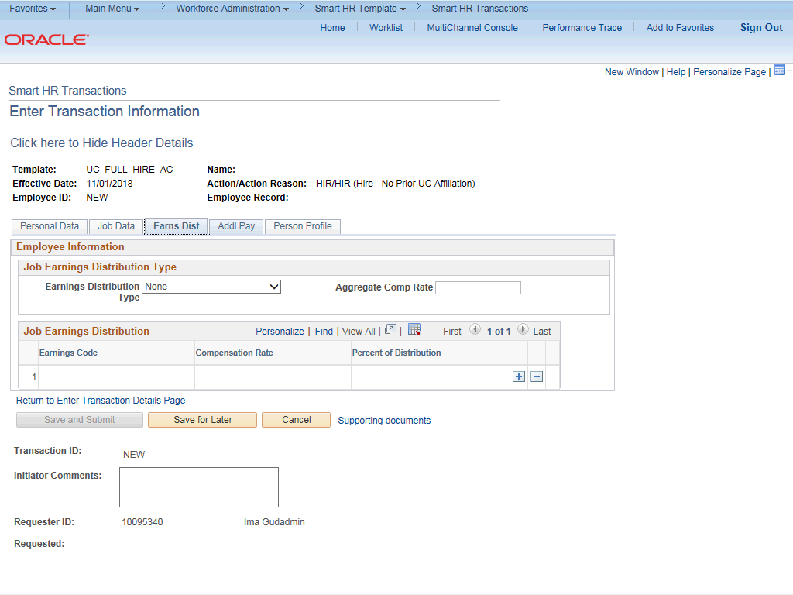

Step | Action
81. | In most cases, the Job Earnings Distribution section is automated. If the Comp Rate code entered on the Job Data tab has a mapped Earnings Code, the Job Earnings Distribution section is updated automatically.
82. | The Job Earnings Distribution section also can be used to manually enter distribution information. Use the Earnings Distribution Type field to enter distribution By Amount or By Percent. After the Earnings Distribution Type is selected, the Aggregate Comp Rate field is populated with the monthly amount.  - If By Amount is selected, the total of all compensation rates entered must add up to the monthly comp rate.  - If By Percent is selected, the total of all percentages entered must add up to 100%.
83. | For certain academic comp rate codes, such as Health Science Comp Plan, earnings codes are defaulted based on the Comp Rate Code entered on the Job Data tab.  Also in those cases, earning distribution type is By Amount and amounts are automatically calculated.
84. | Click the Addl Pay tab.

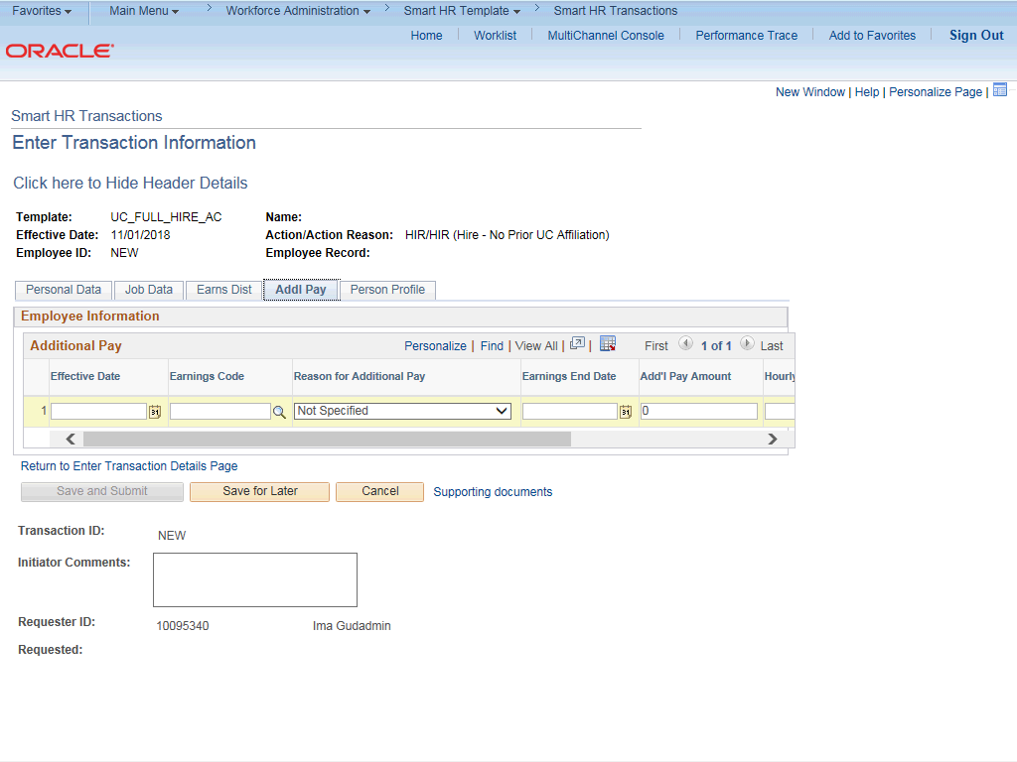

Step | Action
85. | There may be cases where an employee is paid a recurring flat amount. In these types of cases, the compensation section is not populated on the Job Data tab. Instead, the Additional Pay section is used.  There may also be cases where neither compensation rate nor additional pay is entered. In those cases, it is recommended that you enter a comment to explain how the employee is to be paid.  It is recommended not to use this template for one time additional pay. Instead, use payroll's one time payments page.
86. | In this example, you'll enter additional compensation details for the new hire. Click in the Effective Date field.
87. | Enter the desired information into the Effective Date field.
88. | Click the Look up Earnings Code button.

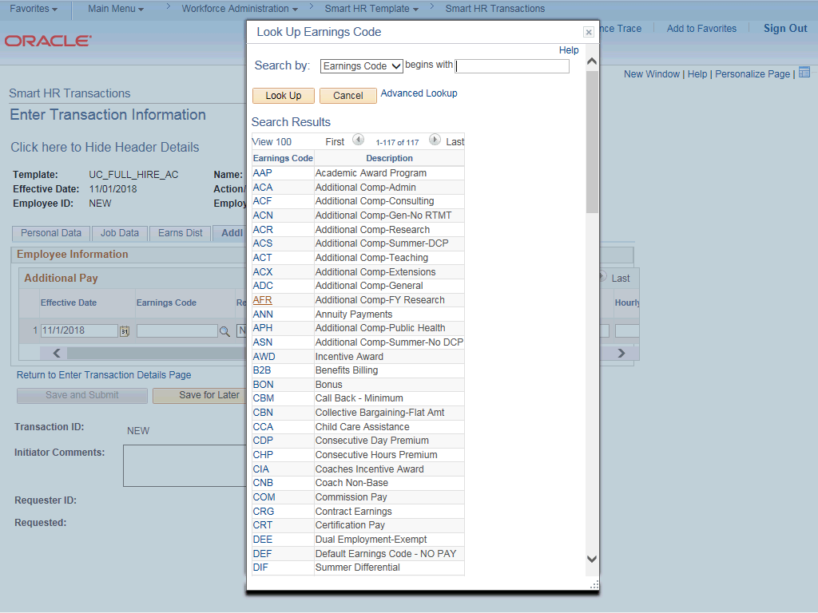

Step | Action
89. | Select the appropriate Earnings Code. For this example, click the AFR list item.
90. | Click in the Earnings End Date field.
91. | Enter the desired information into the Earnings End Date field.
92. | Click in the Add'l Pay Amount field.
93. | Enter the desired information into the Add'l Pay Amount field.
94. | Click the Person Profile tab.

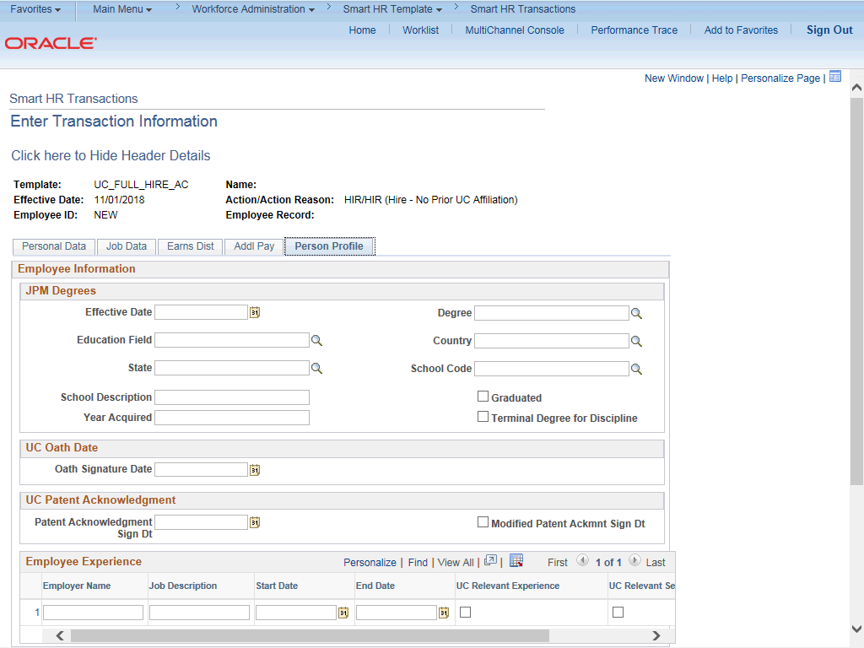

Step | Action
95. | Use the Person Profile page to enter the employee's Degrees, Oath Signature Date and Patent Acknowledgement signature date.  The information entered in the JPM Degrees, UC Oath Date and UC Patent Acknowledgement sections is copied to the employee's Person Profile component after the template is processed by UCPC WFA Production.  The information entered in the Employee Experience section is copied to the employee's UC Employee Experience page after the template is fully processed by UCPC WFA Production.
96. | Enter the date the employee signed the UC oath agreement. This date cannot be later than today's date.  Click in the Oath Signature Date field.
97. | Enter the desired information into the Oath Signature Date field.
98. | Enter the date on which the individual signed the UC patent acknowledgement. This date cannot be later than today's date.  Click in the Patent Acknowledgment Sign Dt field.

Step | Action
99. | Enter the desired information into the Patent Acknowledgment Sign Dt field.
100. | Click the scroll bar.
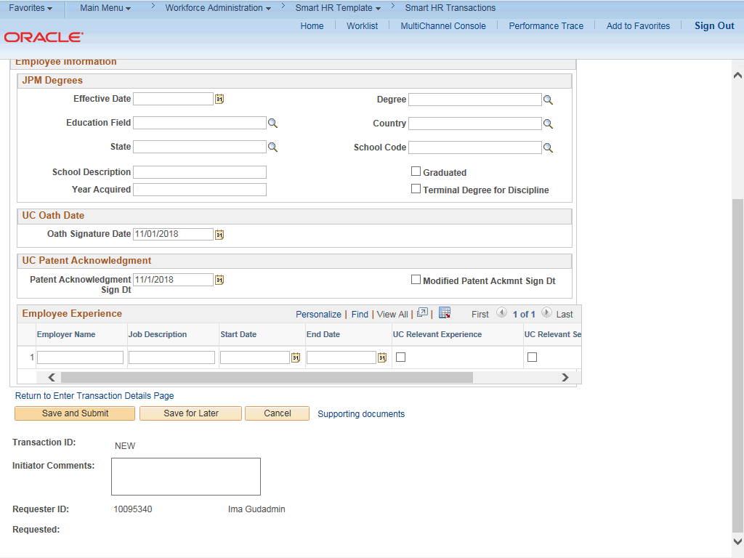

Step | Action
101. | Use the Supporting documents link to attach supporting documents for the new hire.  Click the Supporting documents link.

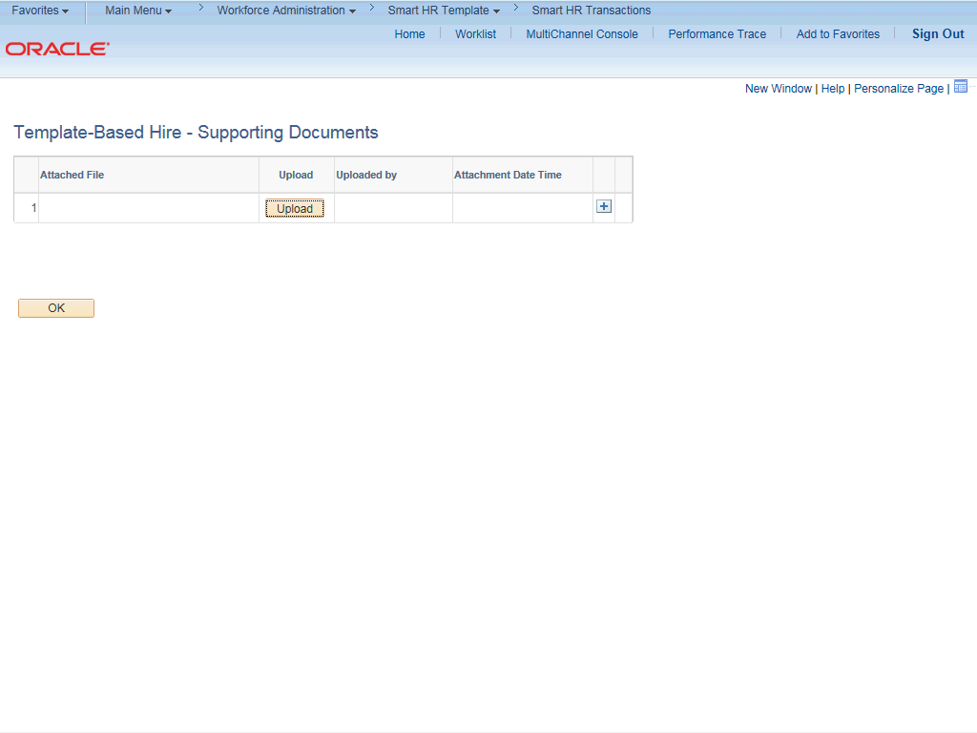

Step | Action
102. | Click the Upload button.
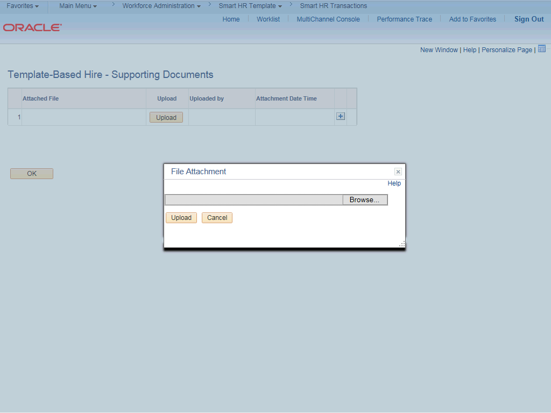

Step | Action
103. | Click the Browse... button.
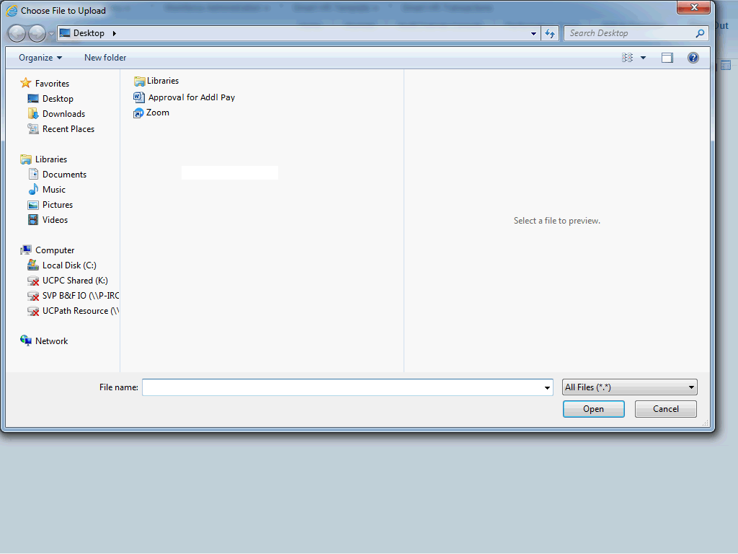

Step | Action
104. | Select the appropriate document to attach.

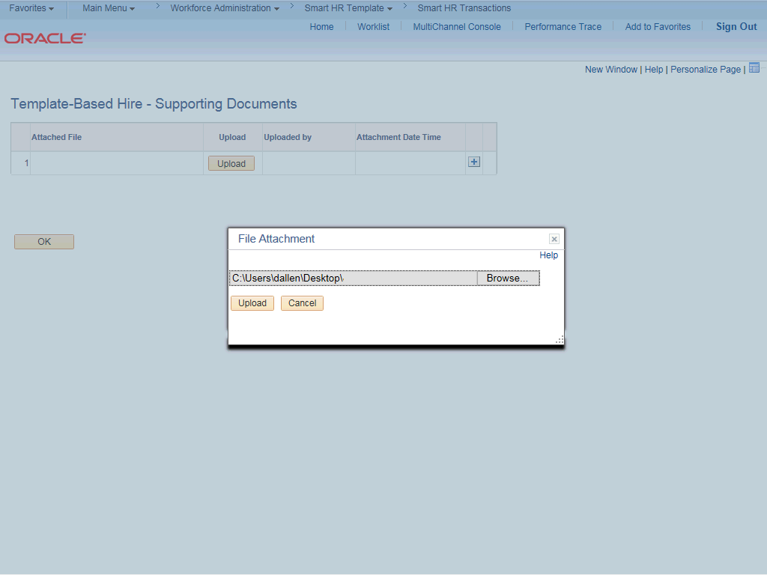

Step | Action
105. | Click the Upload button.
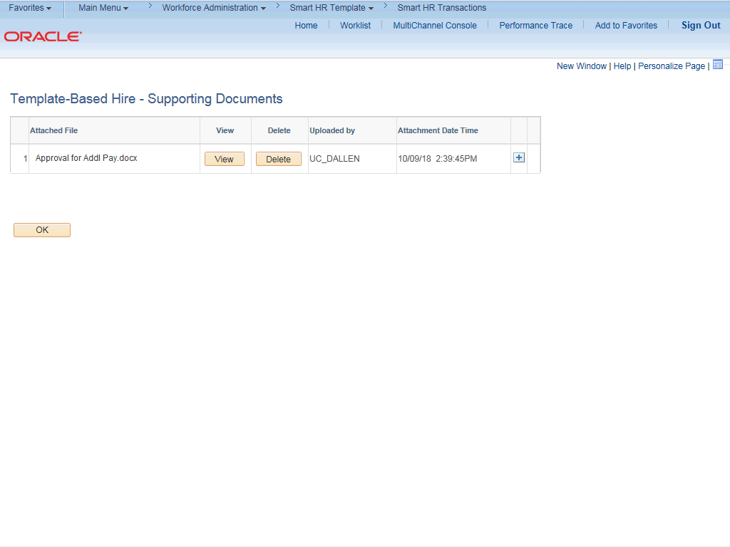

Step | Action
106. | You also can view and delete the attachments from this page.
107. | Click the OK button.
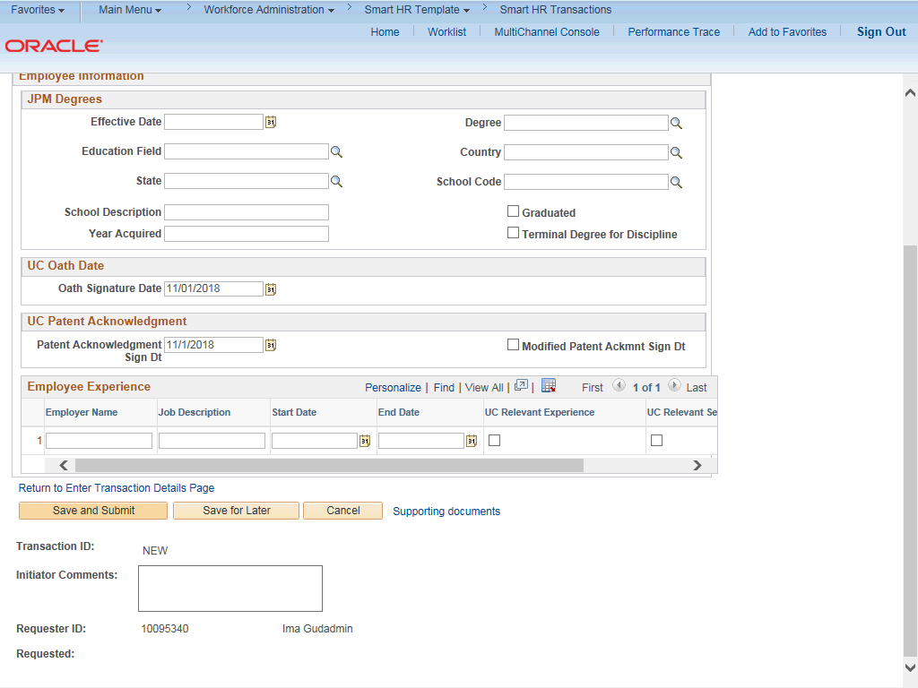

Step | Action
108. | Enter comments for the Approver in the Initiator Comments field.  Comments you enter here appear only with the request; they do not appear on the employee’s record after the transaction is processed to completion. You can enter Initiator Comments on any of the tabs within this template.
109. | The Save and Submit button is not available until all required fields on each tab are completed.  Click the Save and Submit button.

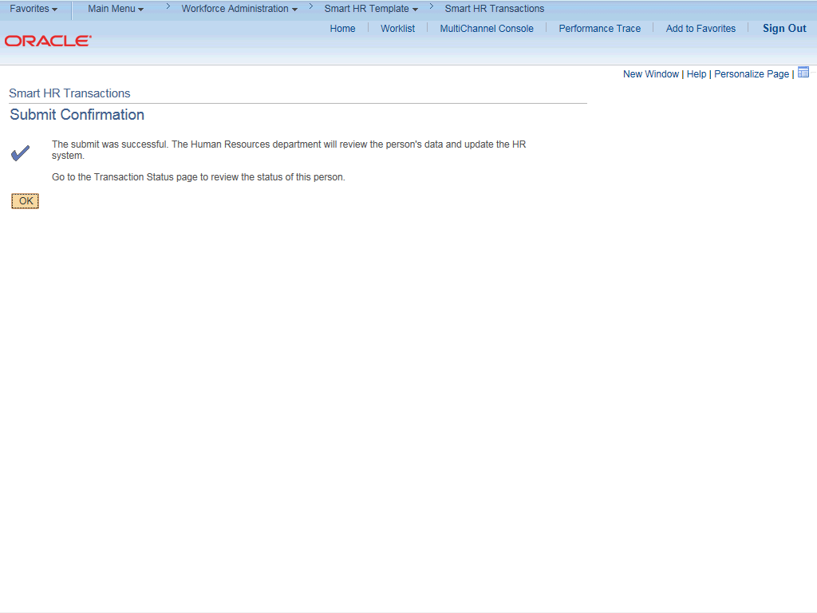

Step | Action
110. | Click the OK button.
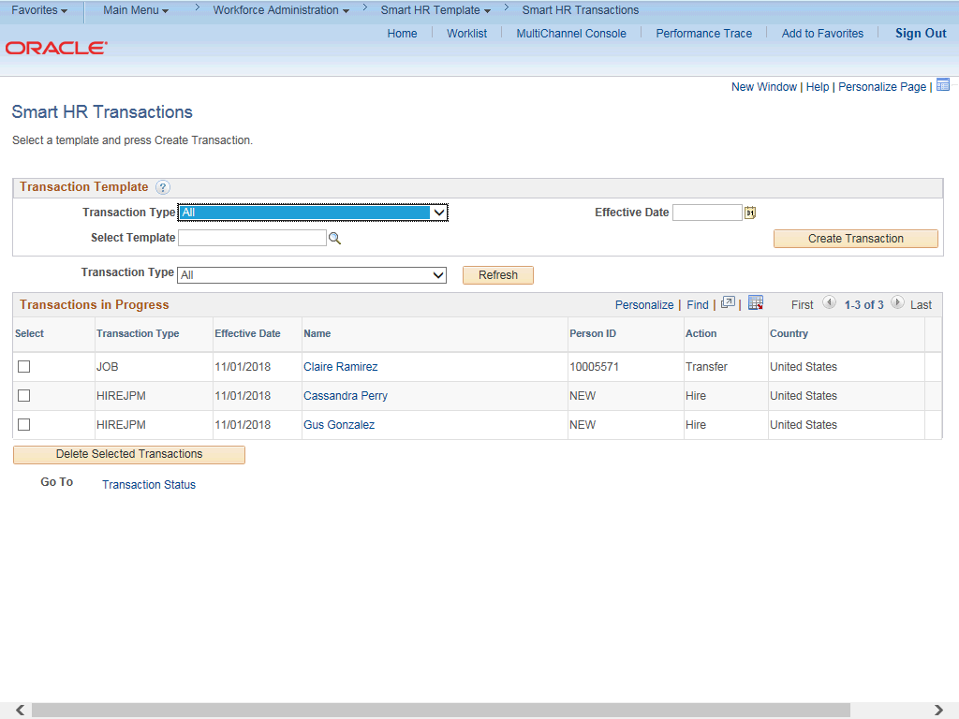

Step | Action
111. | The template transaction is routed for approval and appears in the Transactions in Progress section until it is processed.
112. | You have initiated a full hire template transaction for an academic employee.  End of Procedure.

