Use this task to initiate a full hire template transaction for a staff employee.

Navigation: PeopleSoft Menu > Workforce Administration > Smart HR Template > Smart HR Transactions

Note: This page also may be available in Workcenter depending on your security access.

Step | Action
1. | Use the Smart HR Transactions page to initiate a full hire template transaction.
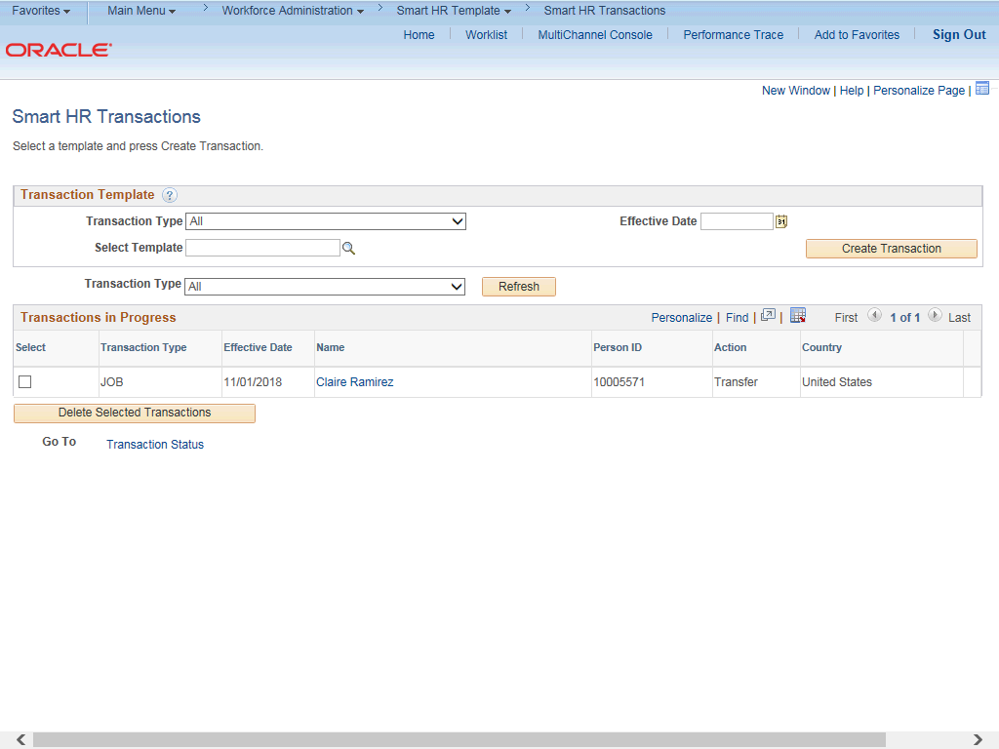

Step | Action
2. | Click the Look Up Select Template button.  Note: The Transaction Type field is not used by UC.

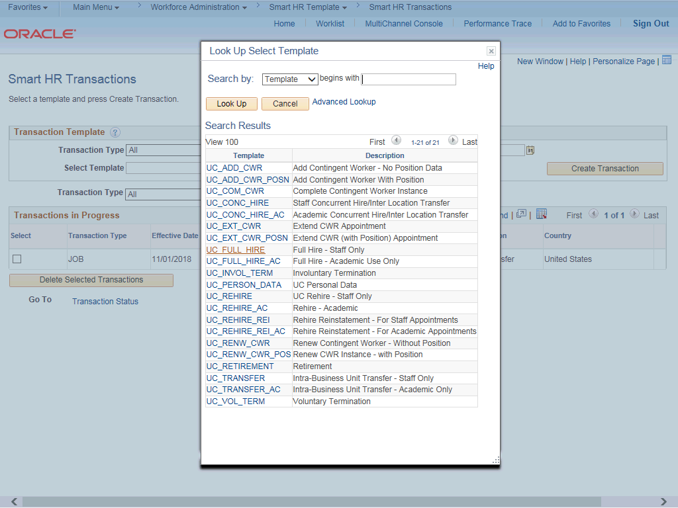

Step | Action
3. | Select the appropriate full hire template. Notice there are two full hire templates, one for staff and one for academic.  Click the UC_FULL_HIRE list item.
4. | Click in the Effective Date field.
5. | The Effective Date field is the effective date of the selected template action. The date you enter in this field automatically populates the Effective Date field on the Enter Transaction Details page. You can update the Effective Date on the Enter Transaction Details page if needed.  Enter the desired information into the Effective Date field.
6. | Click the Create Transaction button.

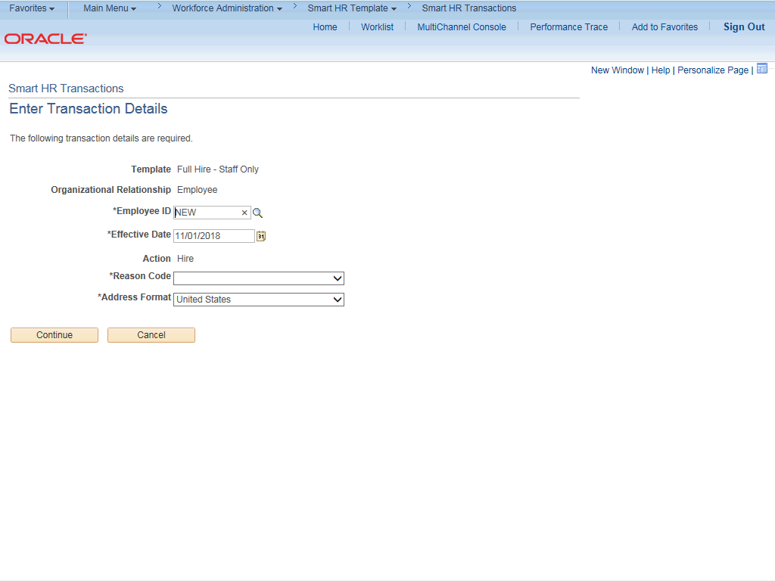

Step | Action
7. | In the Employee ID field, accept the default value of NEW.  After UCPC WFA Production processes the full hire template, the system automatically generates the next sequential UC Employee ID number for the employee.
8. | The Effective Date is populated based on your entry on the previous page. Ensure that you entered the correct hire date or the date the employee begins the job.  For this example, accept the default.
9. | Click the button to the right of the Reason Code field.

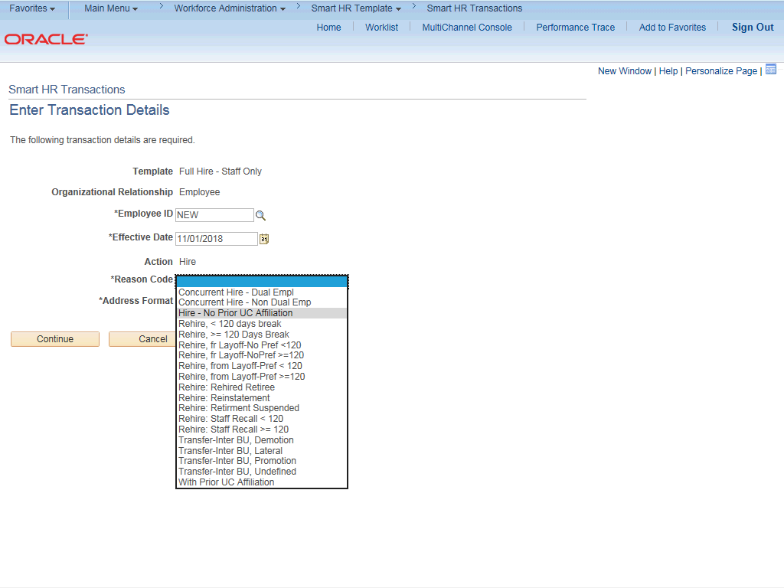

Step | Action
10. | Select the appropriate Reason Code.  For this example, click the Hire - No Prior UC Affiliation list item.
11. | In the Address Format field, accept the default of United States or select the  Global option, if applicable.
12. | Click the Continue button.

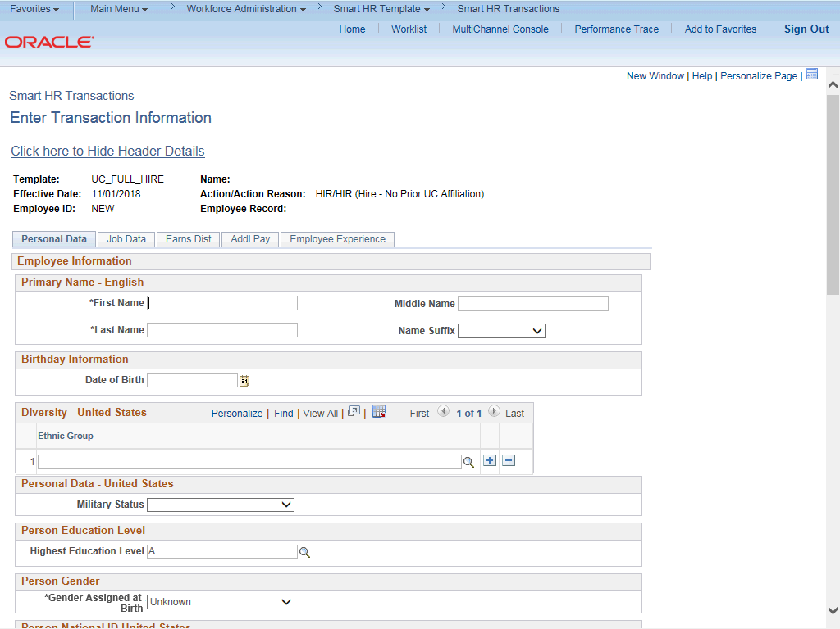

Step | Action
13. | The full hire template appears. There are five tabs on this template: Personal Data, Job Data, Earns Dist, Addl Pay and Employee Experience. Fields that are required by the system are indicated with an asterisk *.
14. | For this example, click the Click here to Hide Header Details link to hide the header details.
15. | Click in the First Name field.
16. | Enter the desired information into the First Name field.
17. | Click in the Last Name field.
18. | Enter the desired information into the Last Name field.
19. | The Date of Birth is required if the Effective Date of the template is prior to the current date. The Date of Birth is not required if the Effective Date of the template is on or after to the current date.  Click in the Date of Birth field.

Step | Action
20. | Enter the desired information into the Date of Birth field.
21. | Click the Look up Ethnic Group button.
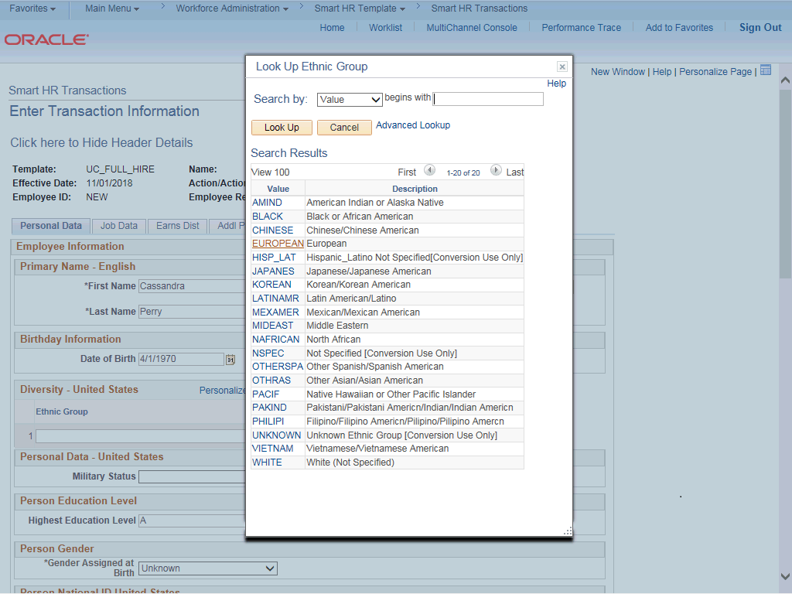

Step | Action
22. | Select the appropriate ethnicity.
23. | If the individual identifies with more than one ethnic group, click the Add a row  button and enter the additional ethnic group.
24. | Select the appropriate Military Status, if known, or leave the field blank. Click the button to the right of the Military Status field.

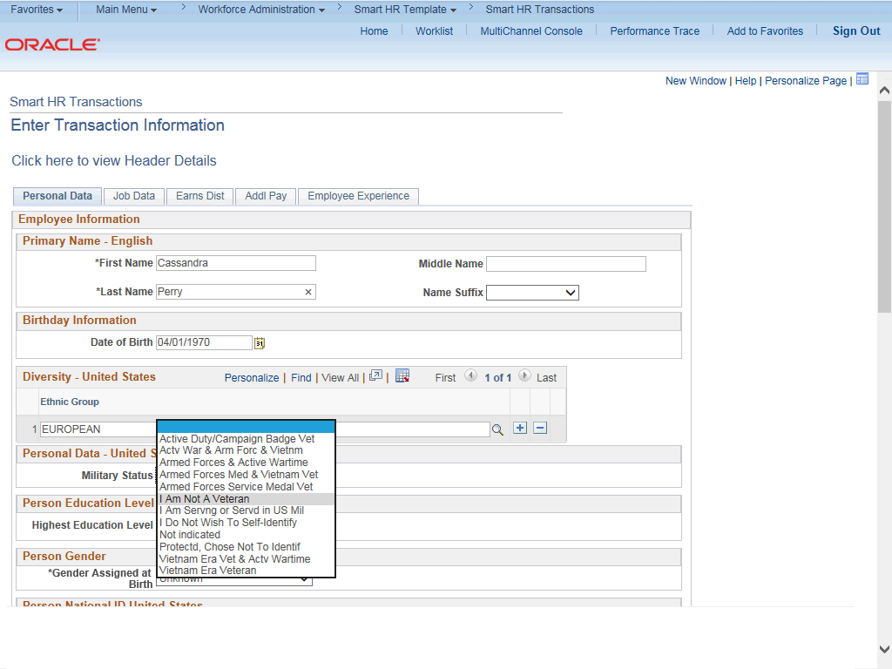

Step | Action
25. | Click the I Am Not A Veteran list item.
26. | Select the new hire's Highest Education Level, if known, or accept the default of  A (Not Indicated).  Click the Look up Highest Education Level button.

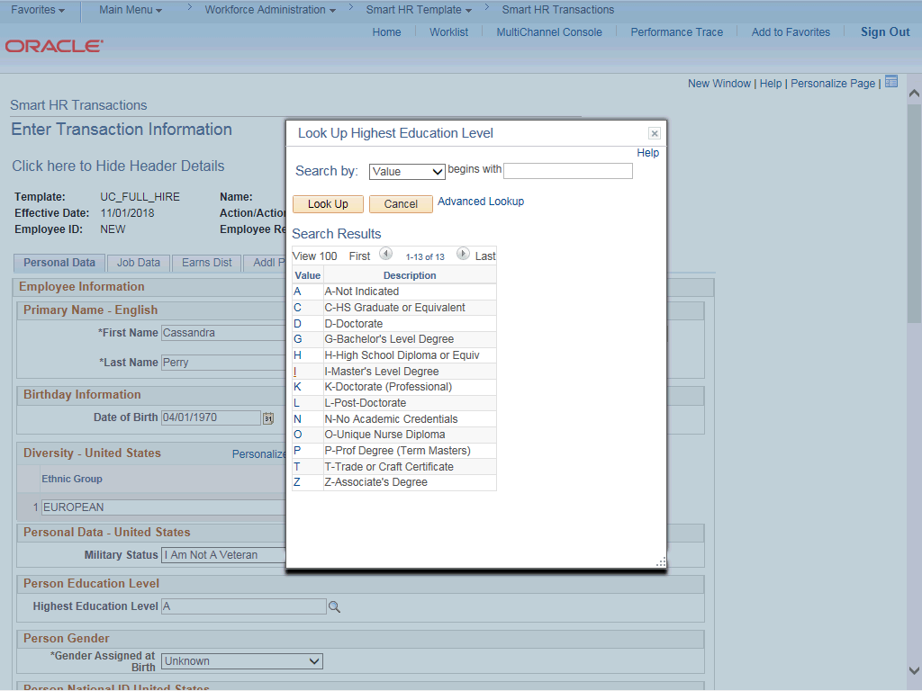

Step | Action
27. | For this example, Choose Appropriately.
28. | Click the scroll bar.

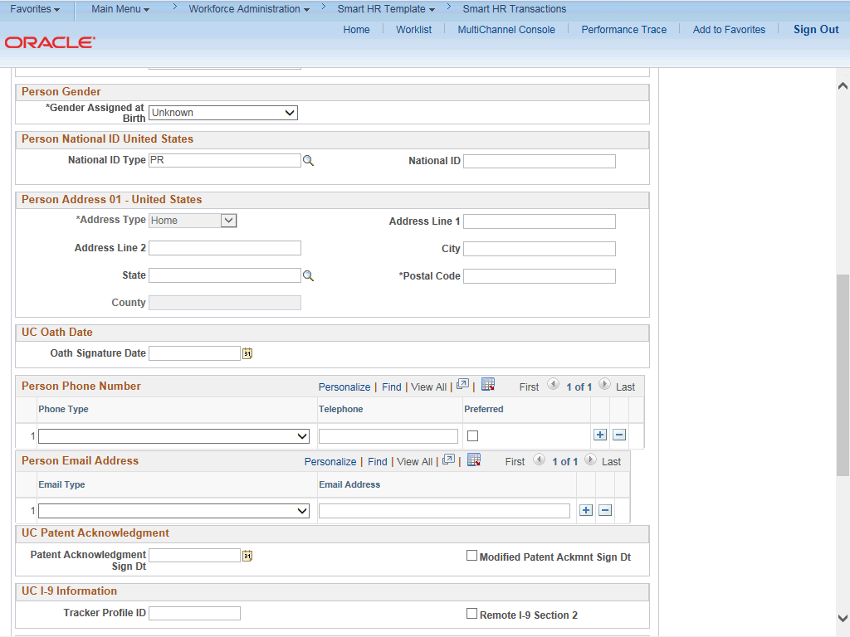

Step | Action
29. | Click the button to the right of the Gender field.
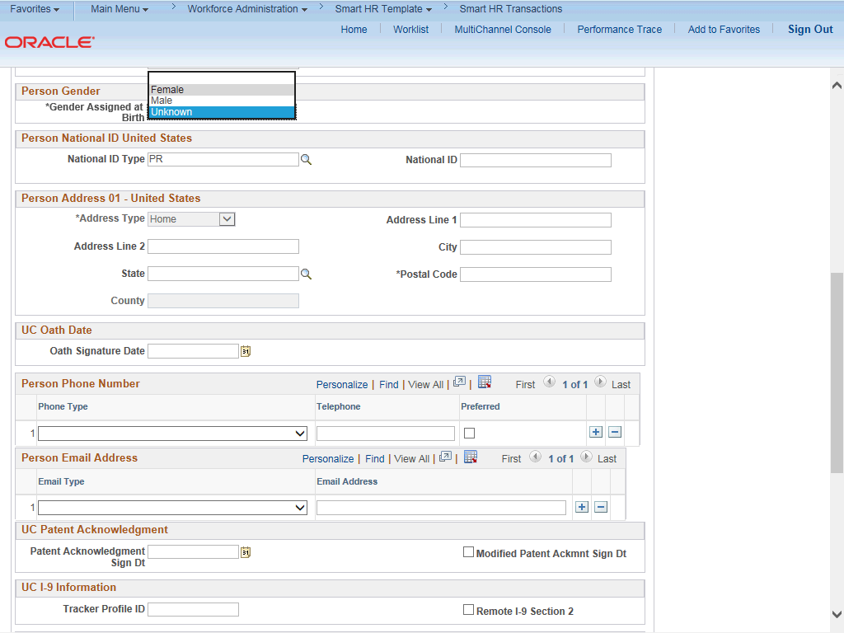

Step | Action
30. | Select the appropriate Gender.
31. | In the National ID Type field, accept the default of PR for Social Security Number (SSN).
32. | The National ID (SSN) is required if the Effective Date of the template is prior to the current date. The SSN is not required if the Effective Date of the template is on or after to the current date.  Every effort should be taken to include the SSN before submitting the template. Leaving the National ID field blank has downstream impacts. For example, it impacts the employees ability to enroll in benefits plans (including retirement).
33. | Click in the National ID field.
34. | Enter the Social Security number into the National ID field.
35. | Click in the Address Line 1 field.
36. | Enter the desired information into the Address Line 1 field.
37. | Click in the City field.
38. | Enter the desired information into the City field.
39. | Click in the State field.
40. | Enter the desired information into the State field.
41. | Click in the Postal Code field.
42. | Enter the desired information into the Postal Code field.
43. | Enter the date the new hire signed the UC oath agreement. This date cannot be later than the current date.  Click in the Oath Signature Date field.

Step | Action
44. | Enter the desired information into the Oath Signature Date field.
45. | Click the button to the right of the Phone Type field.
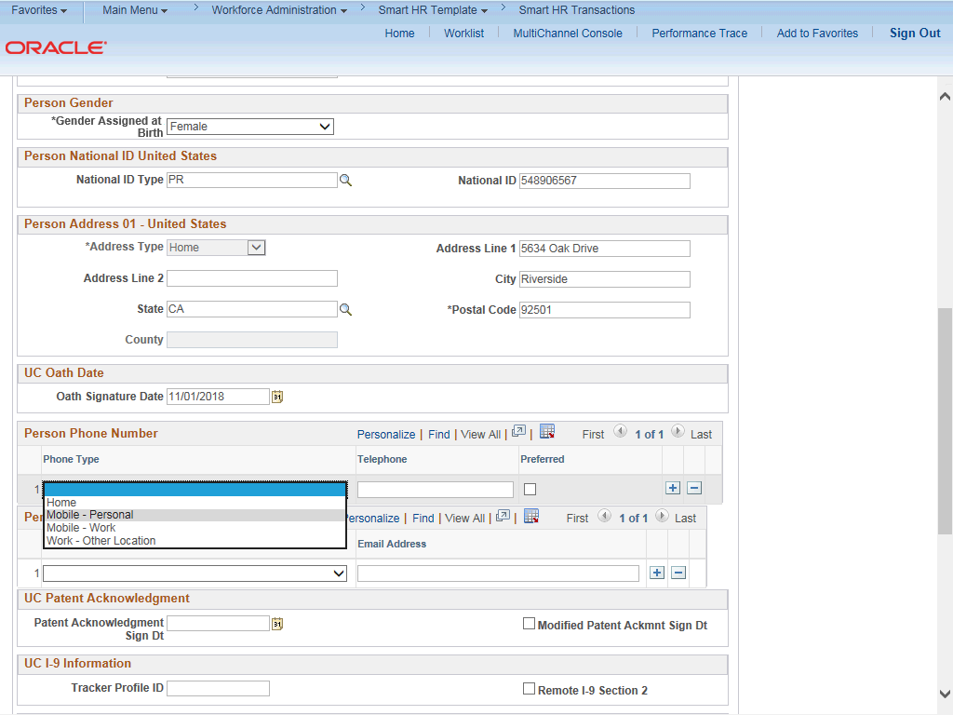

Step | Action
46. | Select the appropriate phone type.  For this example, click the Mobile - Personal list item.
47. | Click in the Telephone field.
48. | Enter the desired information into the Telephone field.
49. | A Preferred phone number must be identified by selecting the check box. Click the Preferred option.
50. | Click the button to the right of the Email Type field.

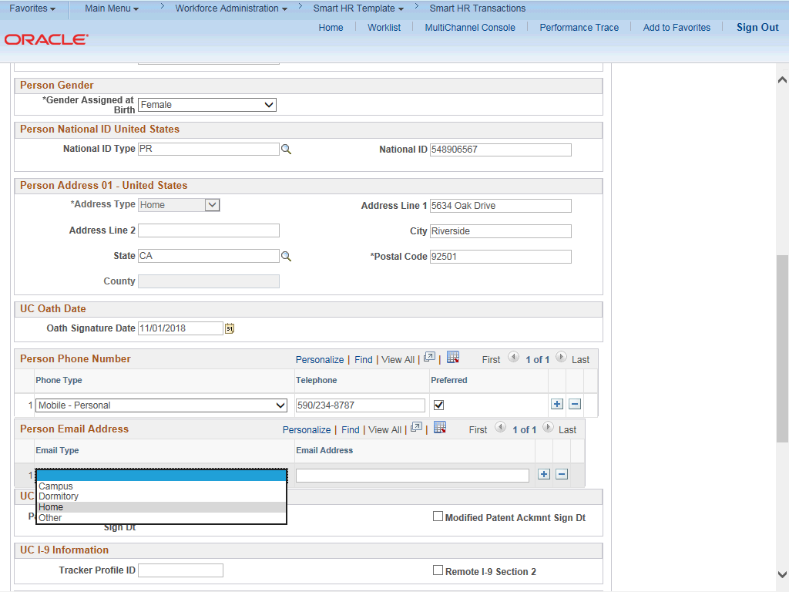

Step | Action
51. | Select the appropriate email type.
52. | Click in the Email Address field.
53. | Enter the desired information into the Email Address field.
54. | Enter the date on which the individual signed the UC patent acknowledgment. This date cannot be later than the current date.  Click in the Patent Acknowledgment Sign Dt field.
55. | Enter the desired information into the Patent Acknowledgment Sign Dt field.
56. | Select the Modified Patent Ackmnt Sign Dt check box to indicate the employee did not originally sign the standard Patent Acknowledgment form.
57. | Click the scroll bar.

Step | Action
58. | If the new hire has an existing tracker profile, then you can add their Tracker Profile ID and indicate whether their I-9 section 2 needs to be completed remotely.  This information is copied to the employee's Person Profile component.
59. | Click in the Tracker Profile ID field.
60. | Enter the desired information into the Tracker Profile ID field.
61. | If applicable, use the UC External System ID section to enter external system information to facilitate matching of IDs with IDM systems.  If providing the information, you must enter values for all three fields. The Business Unit in this section must match the Business Unit associated with the Position Number you enter on the Job Data tab (the next tab).
62. | Use the Comments field to enter specific details or an explanation regarding the transaction. For example, this field can be used to indicate that the employee lives and works outside the US. For these employees, UCPC WFA Production will add the NRA Working Outside the US citizenship status on the Identification Data page.  This field is referenced by UCPC WFA Production to assist with the processing of the transaction.
63. | Click the scroll bar.
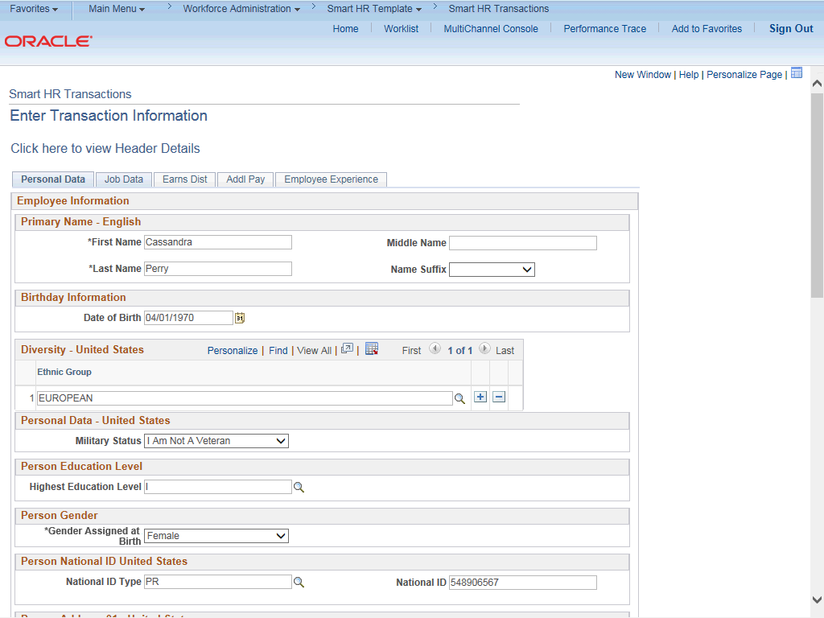

Step | Action
64. | Click the Job Data tab.
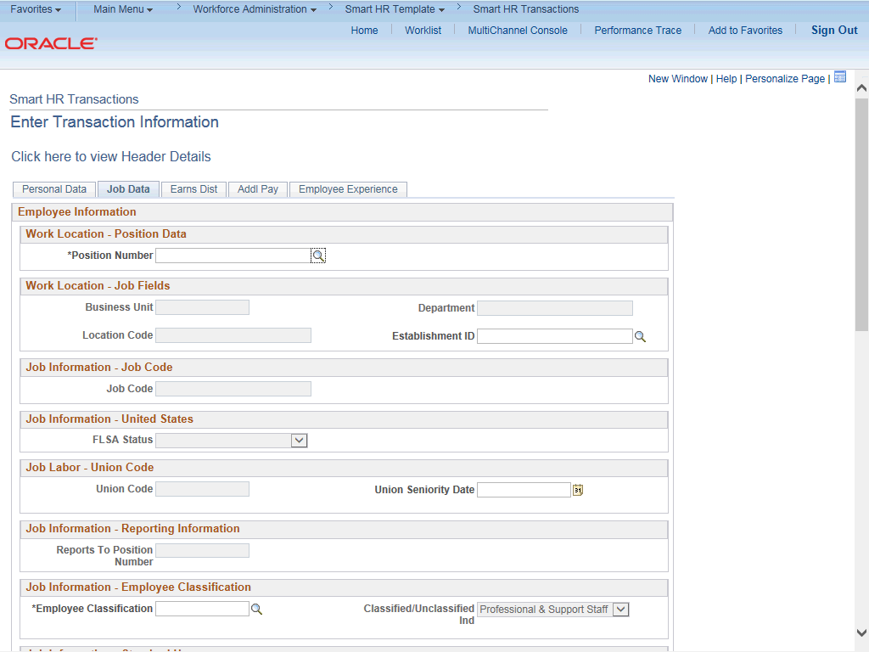

Step | Action
65. | Enter the position number or search for it using the look up. You only have access to position numbers within your business unit or related business unit.  Click in the Position Number field.
66. | Enter the desired information into the Position Number field.
67. | Press [Tab] to automatically populate the position-related fields.

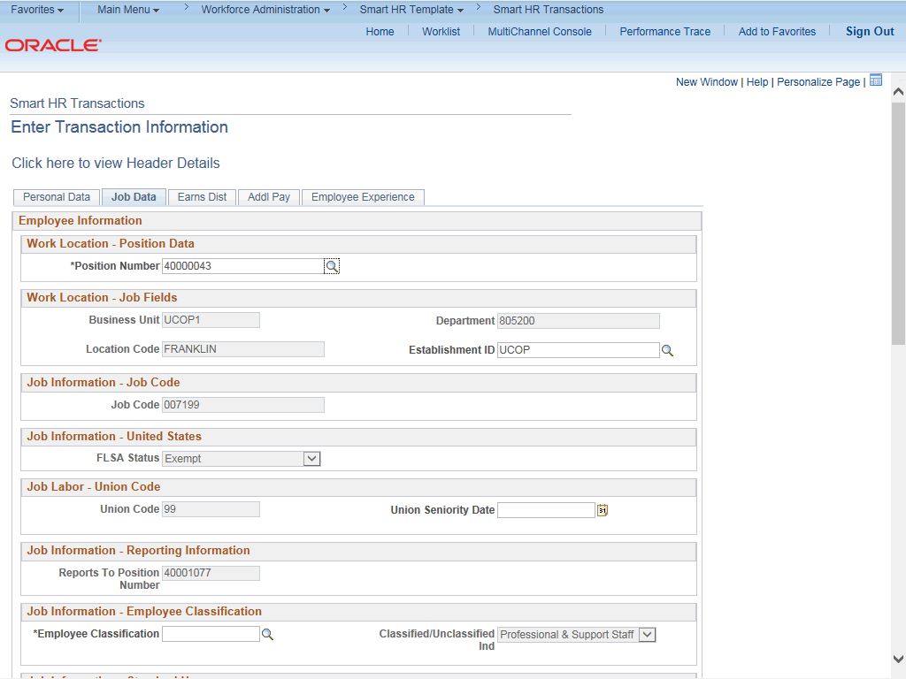

Step | Action
68. | Click the scroll bar.
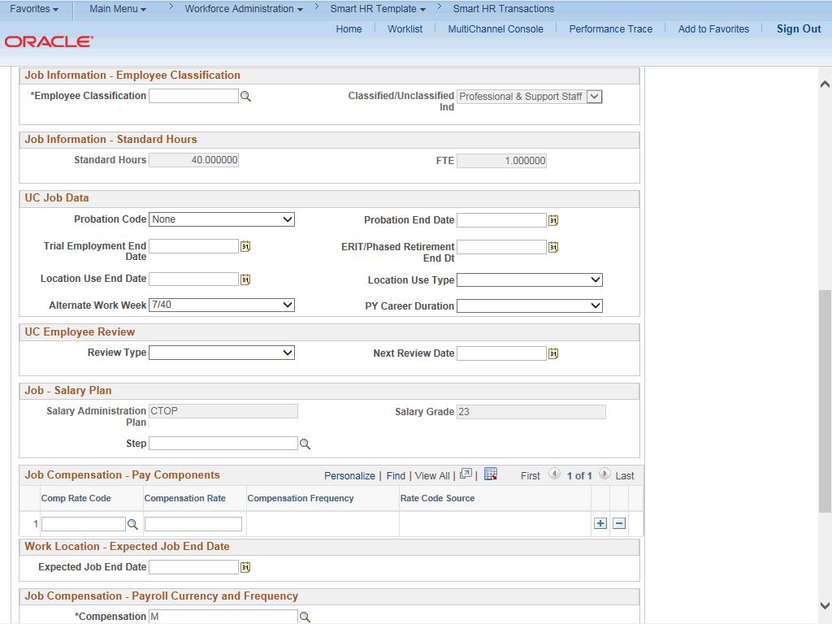

Step | Action
69. | For staff hires, the Employee Classification field must be entered. Click the Look up Employee Classification button.
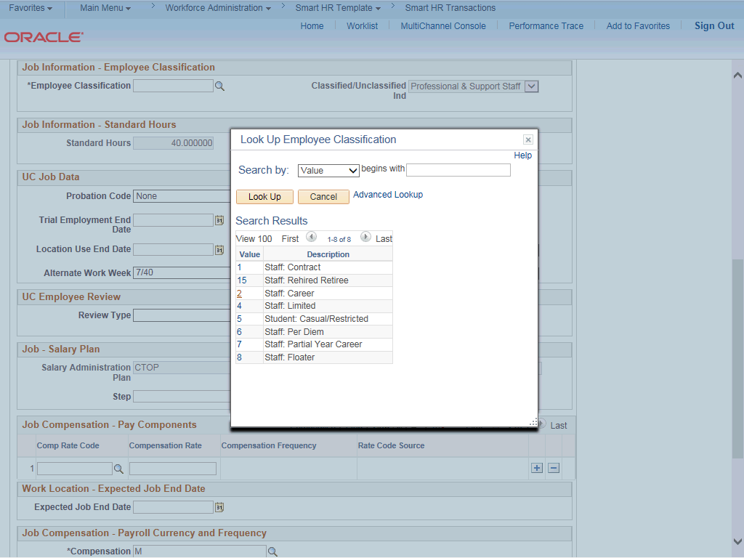

Step | Action
70. | Select the appropriate Employee Classification.  For this example, click the 2 (Staff: Career) list item.
71. | In the UC Job Data section, enter or select the appropriate values as applicable.
72. | The Probation Code field is required if:  - the Classified/Unclassified Ind field is Professional and Support Staff, and  - the Employee Class is Career or Partial Year Career.  The Probation End Date field is required if the Probation Code value is something other than Completed or Probation Completed, Other Job.
73. | Click the button to the right of the Probation Code field.

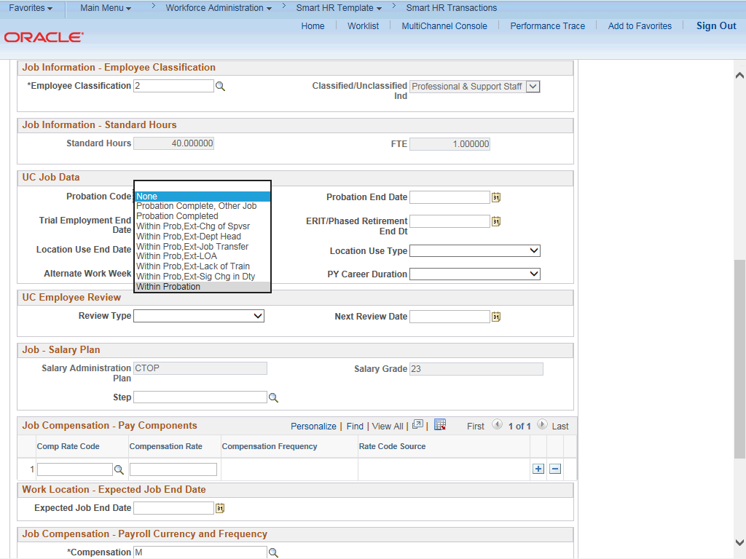

Step | Action
74. | Select the appropriate Probation Code.  For this example, click the Within Probation list item.
75. | Click in the Probation End Date field.
76. | Enter the desired information into the Probation End Date field.
77. | Location Use Type and the associated Location Use End Date are used for reporting purposes. If a Location Use Type is selected you should select a Location Use End Date.  Location Use Type options include:  - Funding End Date  - Review Remaining Budget  - Review Job  - NSTP Review  - Temporary Off-Scale  - Temporary Reduction in Time  - LA: Dual Employment Job  - Temporary Increase in Time
78. | Enter UC Employee Review information, if applicable.

Step | Action
79. | Some job codes have steps associated with them. When a Step is entered, UCPath automatically updates the Job Compensation - Pay Components fields and the compensation information cannot be changed. Use caution when selecting the appropriate step value. For some jobs, there are half steps, so be sure to use the Look up icon and review the Hourly Rate to ensure you are selecting the correct step value.  Some job codes do not have steps associated with them, in which case the Job Compensation - Pay Components fields must be manually entered.  If the job has above scale component of pay, then step does not need to be selected. Enter applicable above scale comp rate codes in Job Compensation- Pay Components section.
80. | For this example, click the Look up Comp Rate Code button.
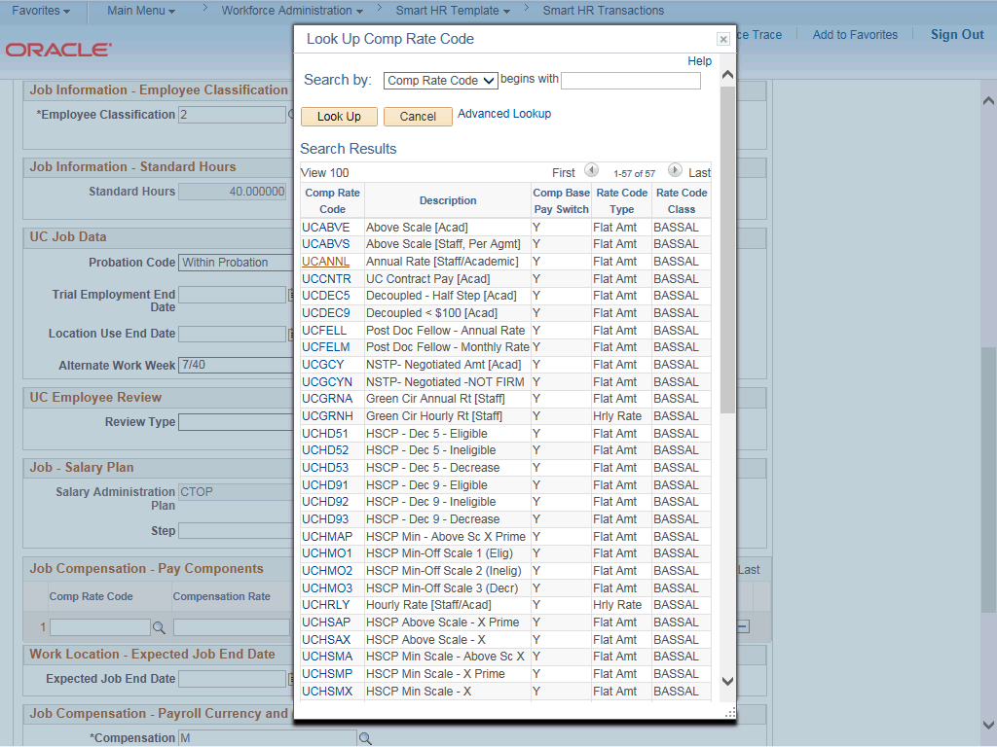

Step | Action
81. | Select the appropriate Rate Code.

Step | Action
82. | Click in the Compensation Rate field.
83. | Enter the desired information into the Compensation Rate field.
84. | If the employment is a short term assignment or temporary hire, enter the date the position ends in the Expected Job End Date field. Non-Academic employees are automatically terminated in UCPath on this date.  An expected end date is required for following employee classes:  - Staff: Contract  - Staff: Floater  - Staff: Limited  - Staff: Rehired Retiree  - Academic: Post Docs  - Academic: Recall  - Academic: Academic Student  - Student: Casual/Restricted
85. | Click the scroll bar.
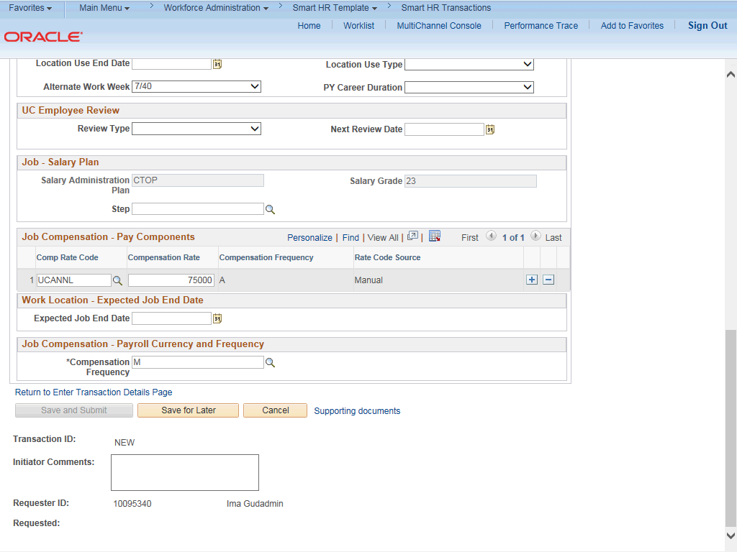

Step | Action
86. | The payroll-related Compensation Frequency field automatically populates based on the job code.  If the Compensation Frequency in the Job Compensation - Pay Components section is A, then the Compensation Frequency in the Job Compensation - Payroll Currency and Frequency section can be any of the following: B, M, UC912, UC_10, UC_11, UC_12, UC_9M or UC_FY.  If the Compensation Frequency in the Job Compensation - Pay Components section is H, then the Compensation Frequency in the Job Compensation - Payroll Currency and Frequency section should be H.
87. | Click the scroll bar.
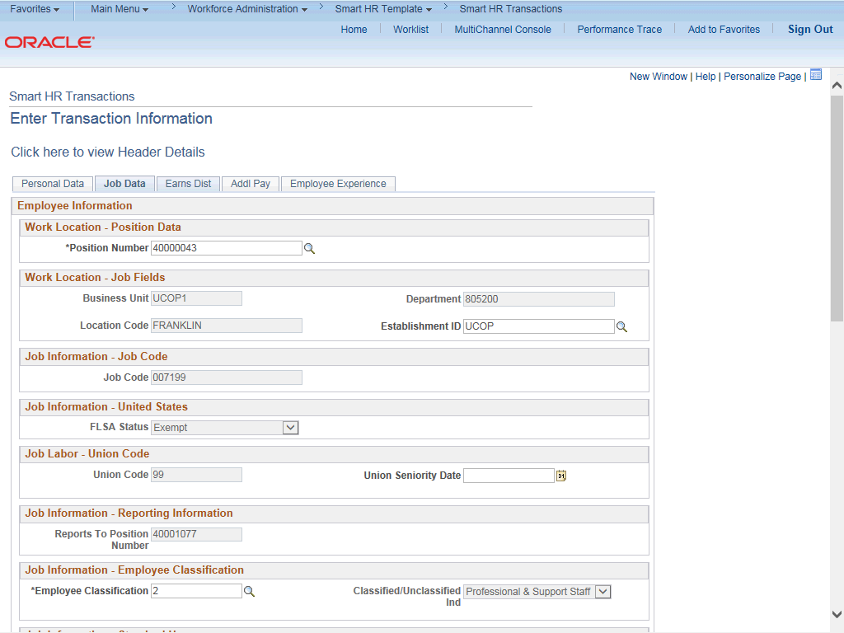

Step | Action
88. | Click the Earns Dist tab.

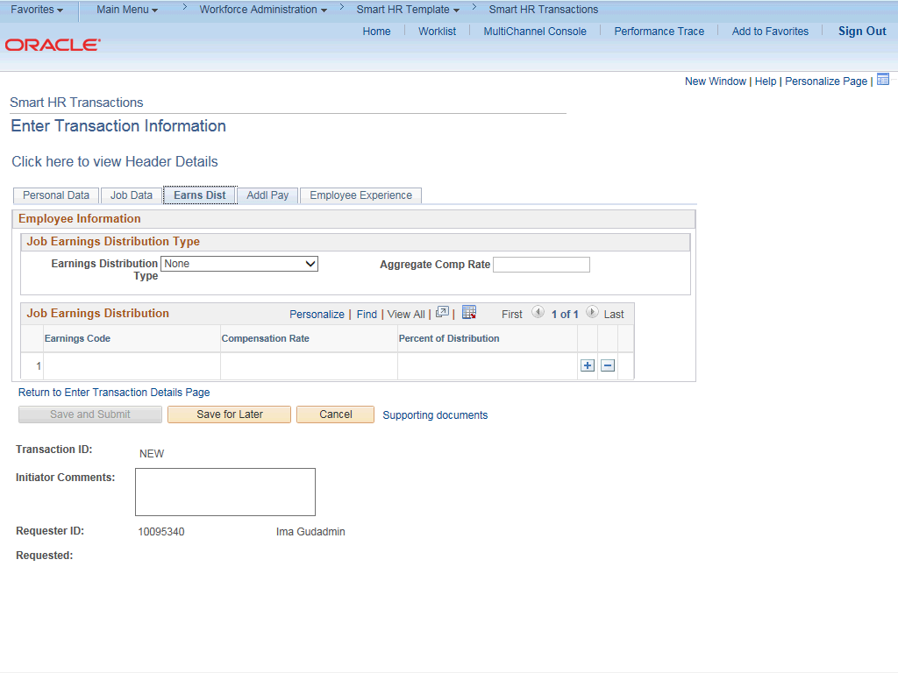

Step | Action
89. | In most cases, the Job Earnings Distribution section is automated. If the Comp Rate code entered on the Job Data tab has a mapped Earnings Code, the Job Earnings Distribution section is updated automatically.
90. | The Job Earnings Distribution section also can be used to manually enter distribution information. Use the Earnings Distribution Type field to enter distribution By Amount or By Percent. After the Earnings Distribution Type is selected, the Aggregate Comp Rate field is populated with the monthly amount.  - If By Amount is selected, the total of all compensation rates entered must add up to the monthly comp rate.  - If By Percent is selected, the total of all percentages entered must add up to 100%.
91. | Click the Addl Pay tab.

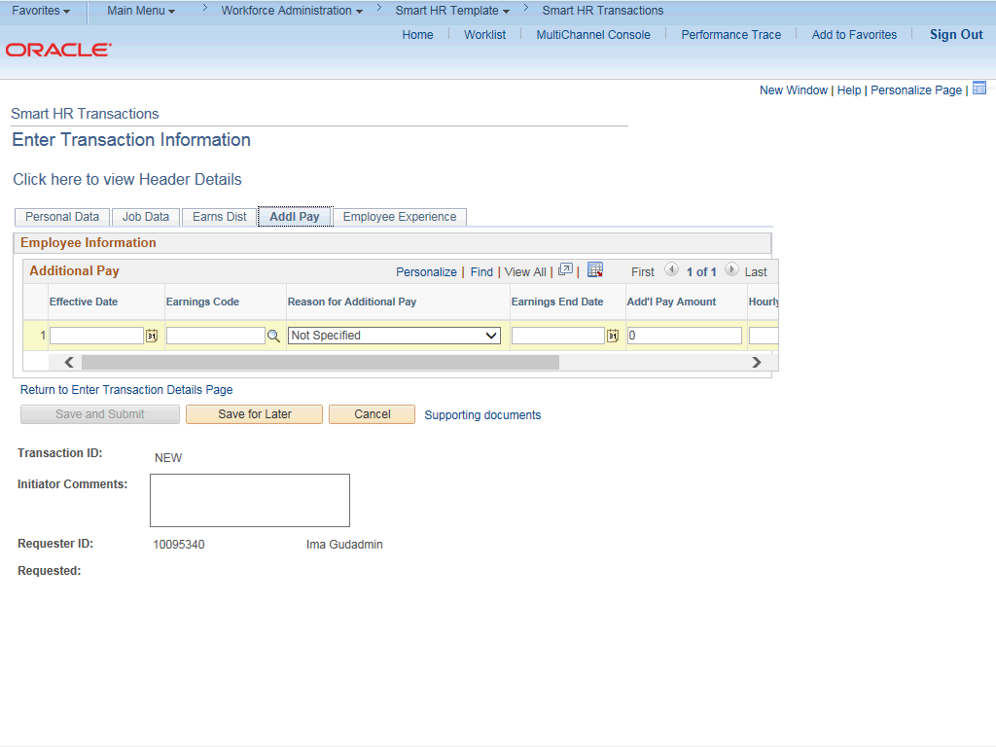

Step | Action
92. | There may be cases where an employee is paid a recurring flat amount. For recurring flat amount entry, the compensation section is not populated on the Job Data tab. Instead, the Additional Pay section is used.  There may also be cases where neither compensation rate nor additional pay is entered. In those cases, it is recommended that you enter a comment to explain how the employee is to be paid.  It is recommended not to use this template for one time additional pay. Instead, use payroll's one time payments page.
93. | In this example, you'll enter a new hire's bonus. Click in the Effective Date field.
94. | Enter the desired information into the Effective Date field.
95. | Click the Look up Earnings Code button.

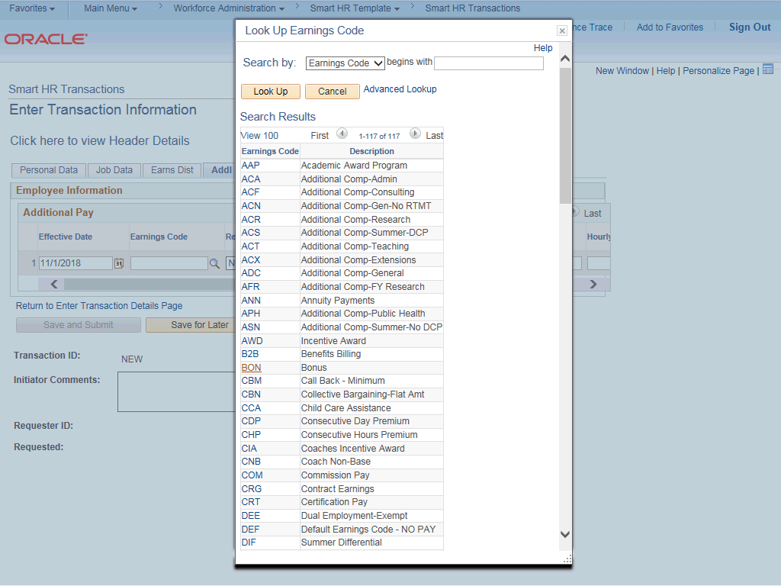

Step | Action
96. | Select the appropriate Earnings Code. For this example, click the BON list item.
97. | Click in the Add'l Pay Amount field.
98. | Enter the desired information into the Add'l Pay Amount field.
99. | Click the scroll bar.

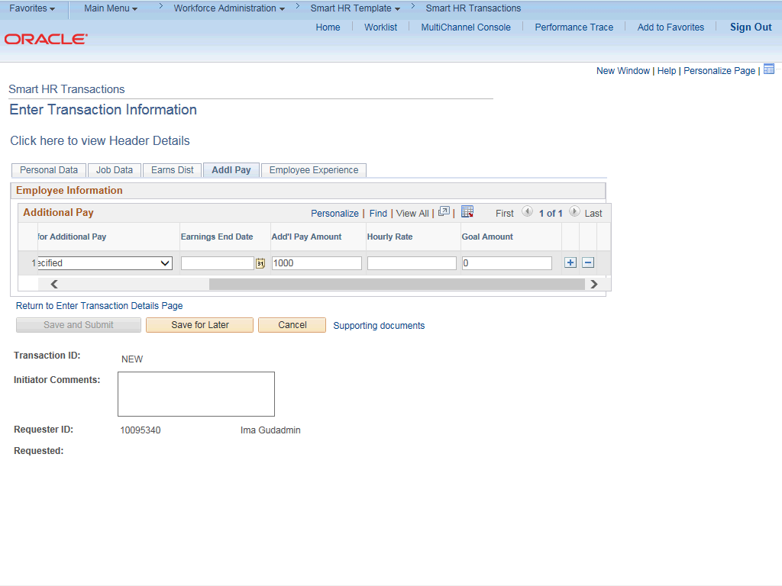

Step | Action
100. | Click in the Goal Amount field.
101. | Enter the desired information into the Goal Amount field.
102. | Click the Employee Experience tab.

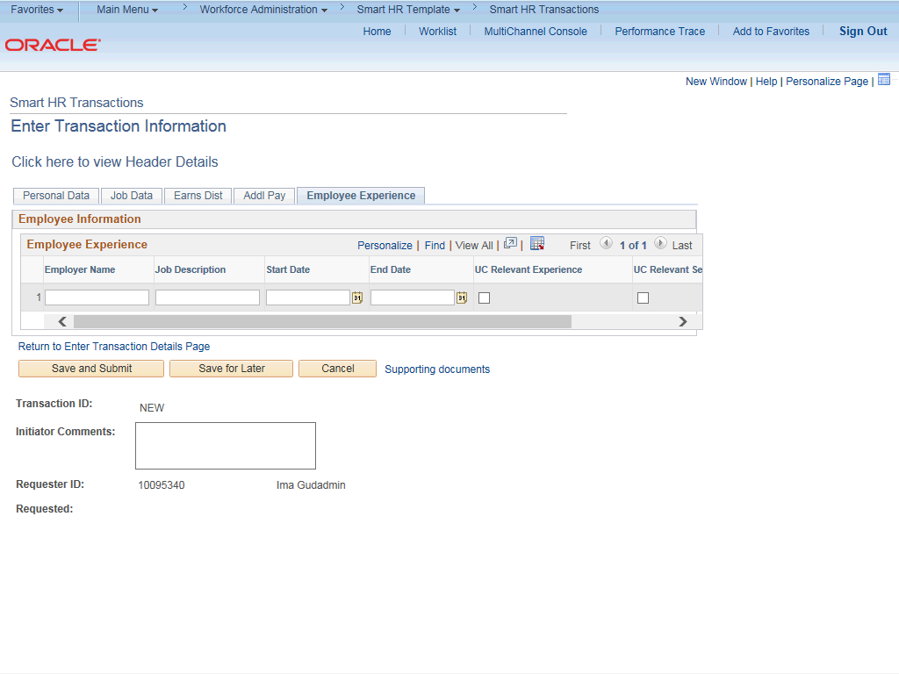

Step | Action
103. | For represented staff, use the fields on this page to enter data related to the employee's prior work experience. Having this information is helpful in determining new compensation rates for the new hire.  The information entered in the Employee Experience section is copied to the employee's UC Employee Experience page after the template is fully processed by UCPC WFA Production.
104. | Use the Supporting documents link to attach supporting documents for the new hire.  Click the Supporting documents link.

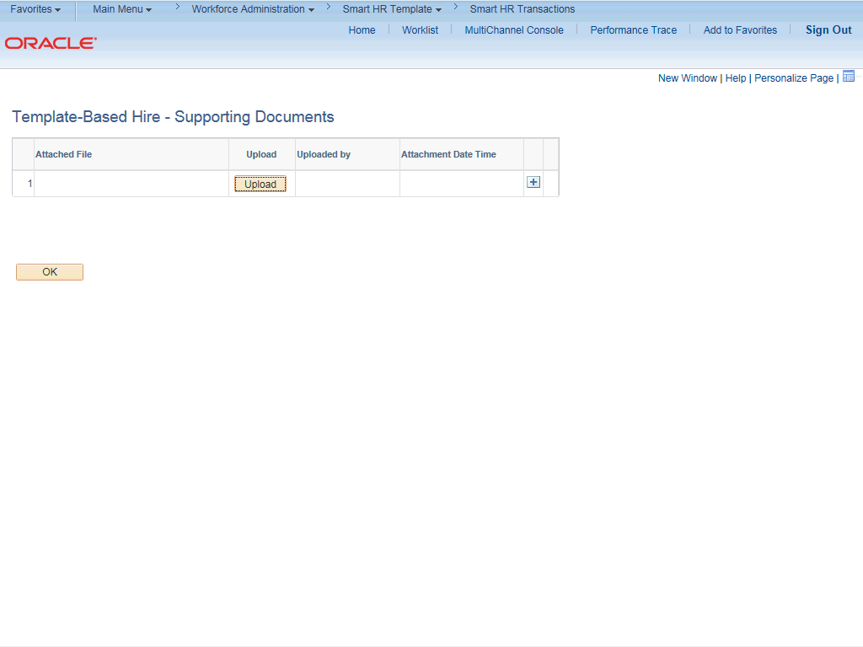

Step | Action
105. | Click the Upload button.
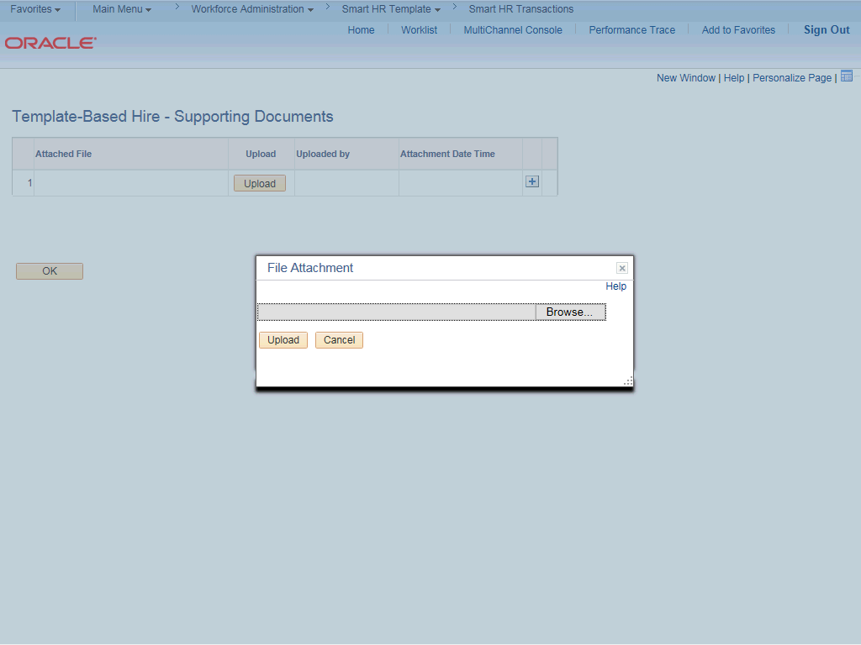

Step | Action
106. | Click the Browse... button.
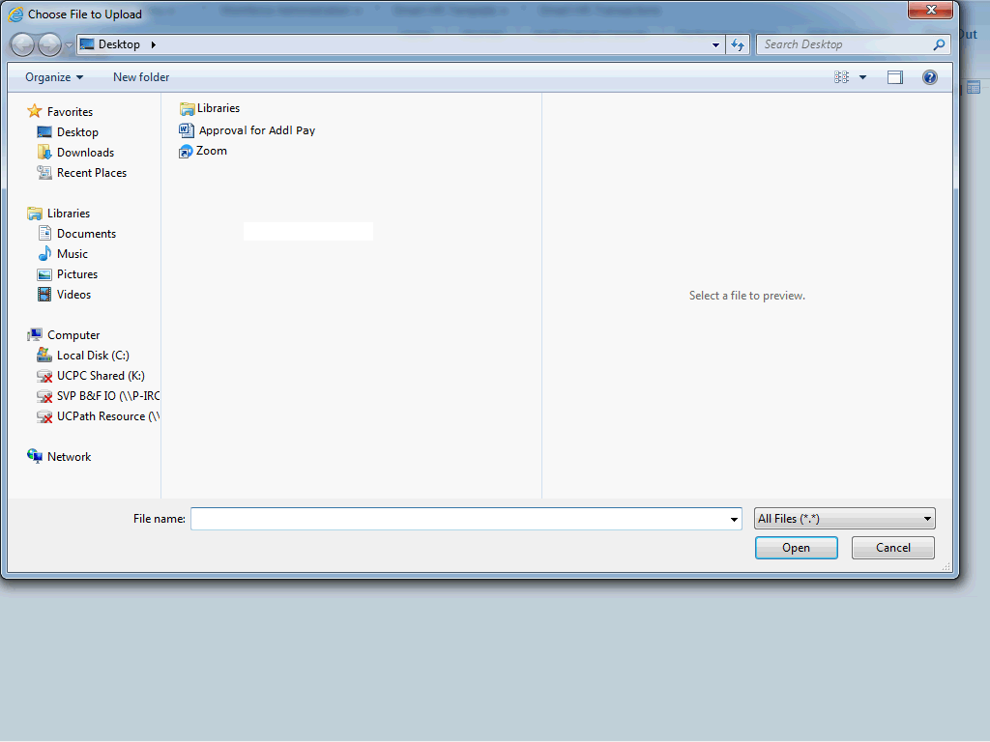

Step | Action
107. | Select the appropriate document to attach.

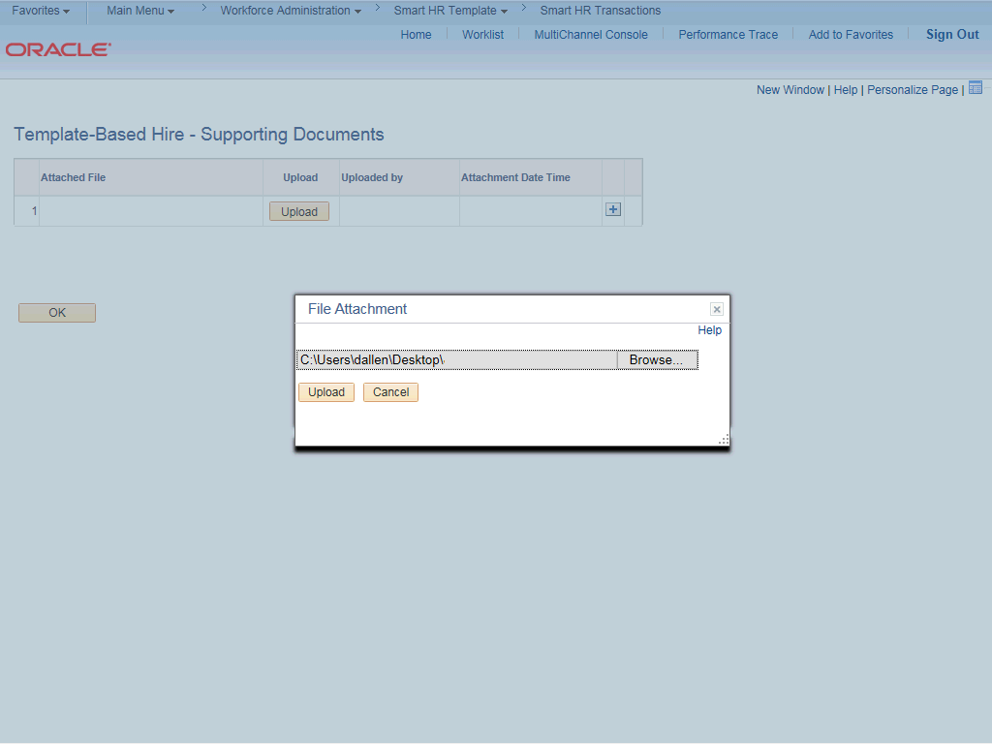

Step | Action
108. | Click the Upload button.
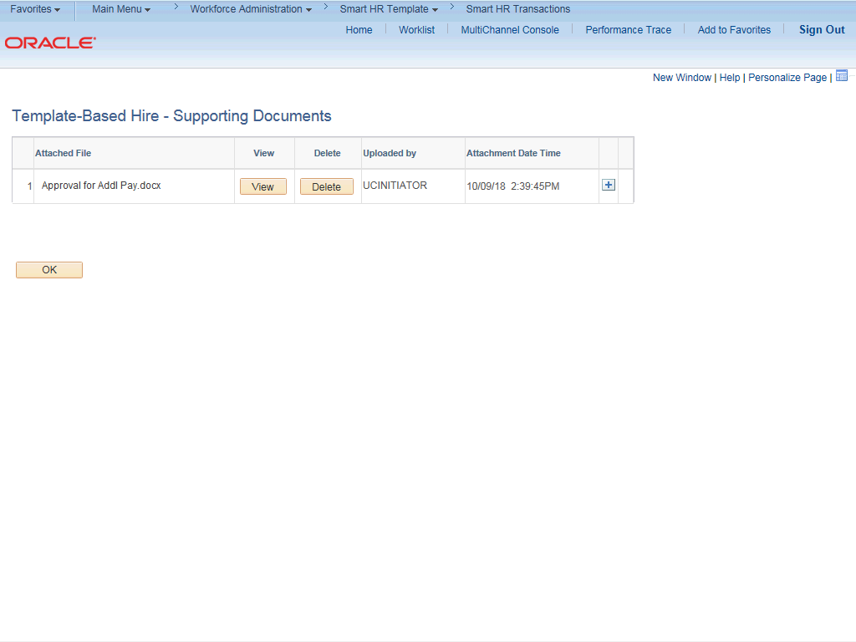

Step | Action
109. | You also can view and delete the attachments from this page.
110. | Click the OK button.

Step | Action
111. | Enter comments for the Approver in the Initiator Comments field.  Comments you enter here appear only with the request; they do not appear on the employee’s record after the transaction is processed to completion. You can enter Initiator Comments on any of the tabs within this template.
112. | The Save and Submit button is not available until all required fields on each tab are completed.  Click the Save and Submit button.

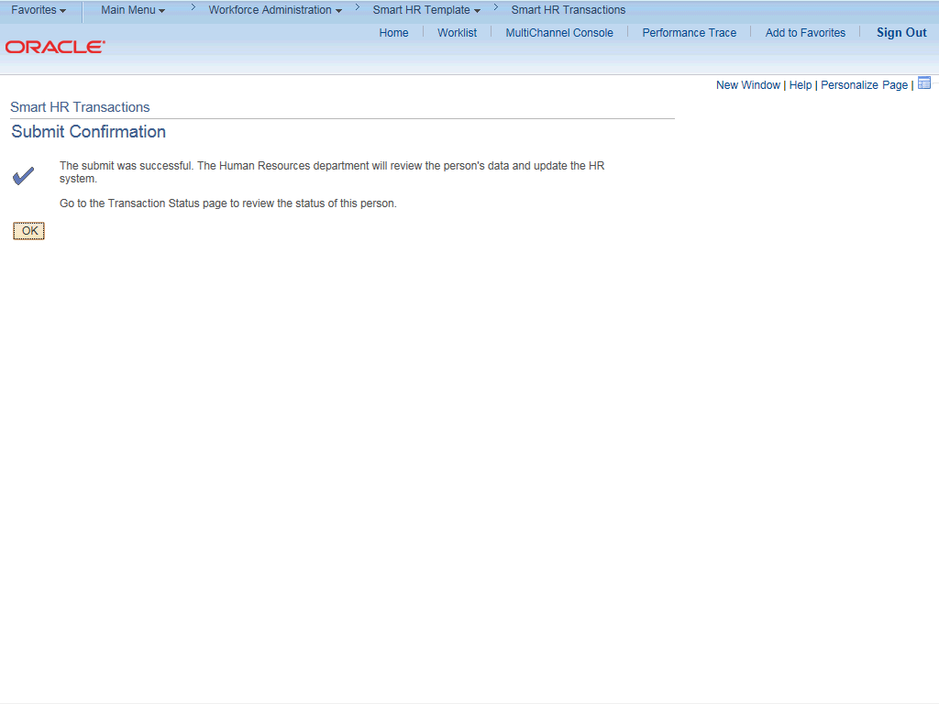

Step | Action
113. | Click the OK button.
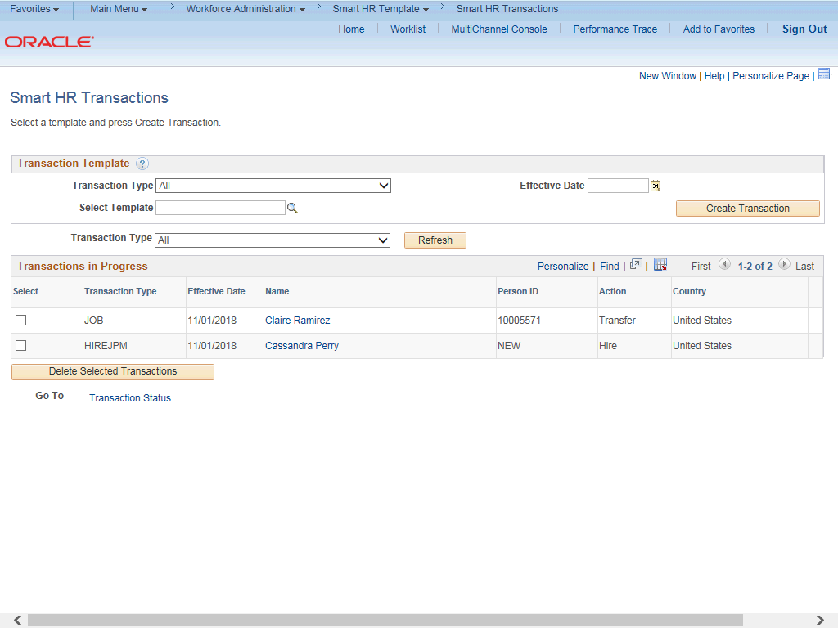

Step | Action
114. | The template transaction is routed for approval and appears in the Transactions in Progress section until it is processed.
115. | You have initiated a full hire template transaction for a staff employee.  End of Procedure.

