Use this task to initiate a full hire template transaction for an academic employee with prorated contract pay.

Navigation: PeopleSoft Menu > Workforce Administration > Smart HR Template > Smart HR Transactions

Note: This page also may be available in Workcenter depending on your security access.

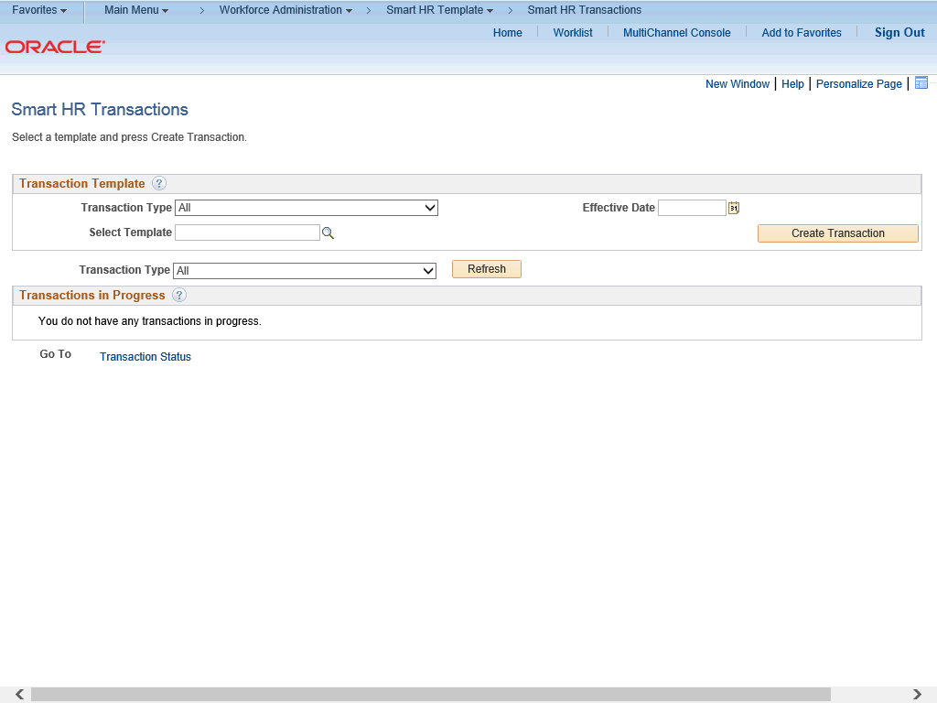

Step | Action
1. | Use the Smart HR Transactions page to initiate a full hire contract pay template transaction.
2. | Click the Look up Select Template button.  Note: The Transaction Type field is not used by UC.
3. | Click the UC_FULL_HIRE_AC list item.

Step | Action
4. | The Effective Date field is the effective date of the selected template action. The date you enter in this field automatically populates the Effective Date field on the Enter Transaction Details page. You can update the Effective Date on the Enter Transaction Details page if needed.  Click in the Effective Date field.
5. | Enter the desired information into the Effective Date field.
6. | Click the Create Transaction button.
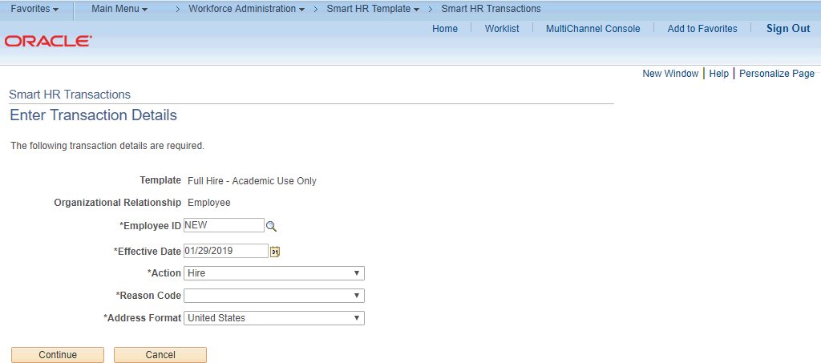

Step | Action
7. | In the Employee ID field, accept the default value of NEW.  After UCPC WFA Production processes the transaction, the system automatically generates the next sequential UC Employee ID number for the employee.
8. | The Effective Date is populated based on your entry on the previous page. Ensure that you entered the correct Effective Date.

Step | Action
9. | Click the button to the right of the Reason Code field.
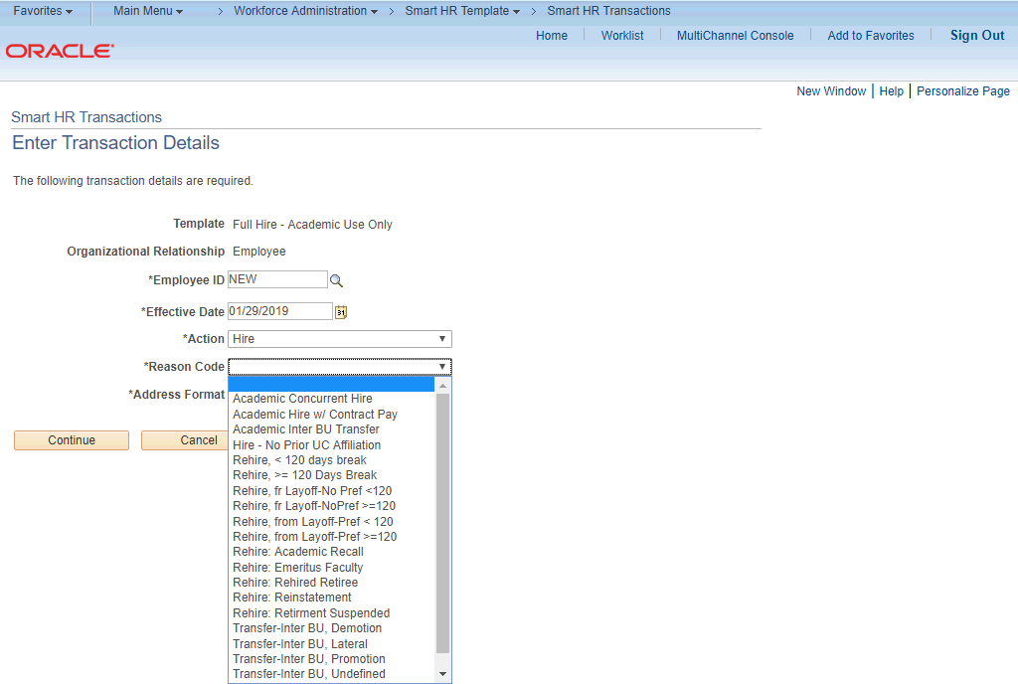

Step | Action
10. | Click the Academic Hire w/ Contract Pay list item.
11. | In the Address Format field, accept the default of United States or select the  Global option, if applicable.
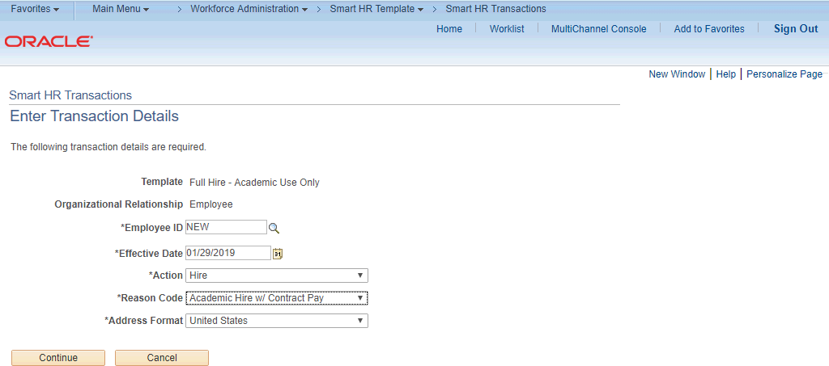

Step | Action
12. | Click the Continue button.

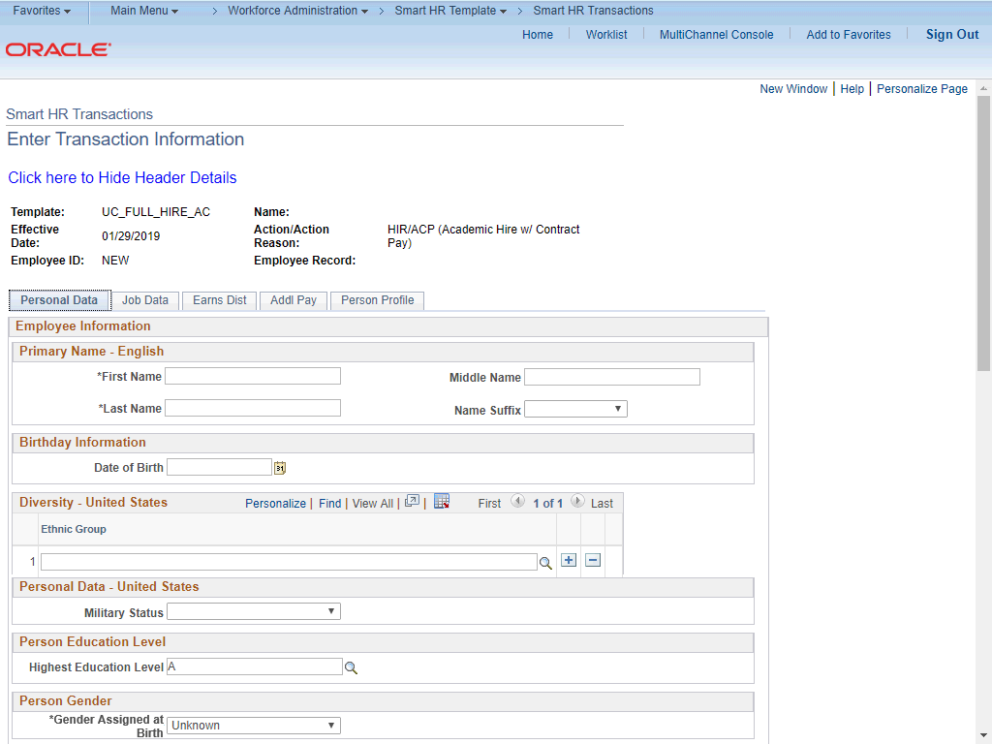

Step | Action
13. | The full hire template appears. This template includes five tabs: Personal Data, Job Data, Earns Dist, Addl Pay and Person Profile.  Fields that are required by the system are indicated with an asterisk *.
14. | Header details appear above the tabs. You can show/hide the header information as needed.
15. | Click in the First Name field.
16. | Enter the desired information into the First Name field.
17. | Click in the Last Name field.
18. | Enter the desired information into the Last Name field.
19. | Click in the Date of Birth field.
20. | Enter the desired information into the Date of Birth field.

Step | Action
21. | Click the Look up Ethnic Group button.
22. | Select the appropriate ethnicity.  For this example, click the MEXAMER list item.
23. | If the individual identifies with more than one ethnic group, click the Add a row  button and select the additional ethnic group.
24. | Select the appropriate Military Status, if known, or leave the field blank. Click the button to the right of the Military Status field.
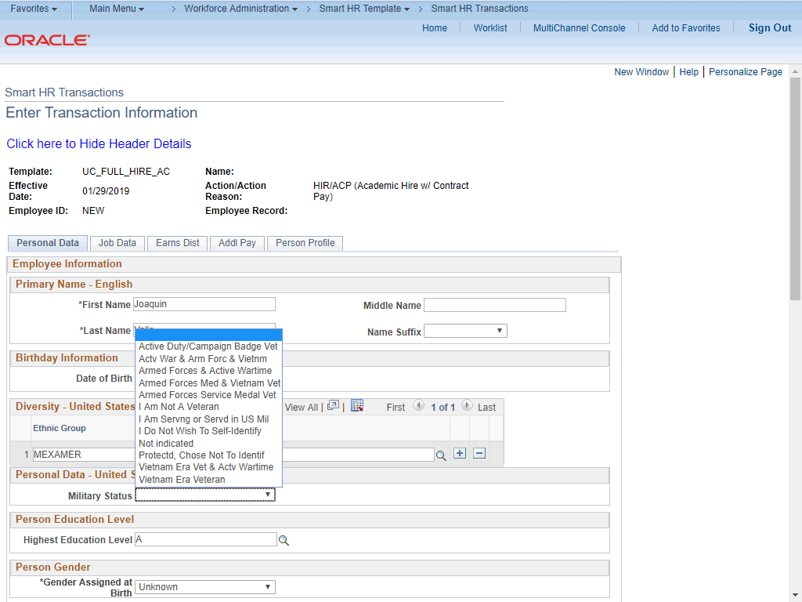

Step | Action
25. | For this example, click the I Am Not A Veteran list item.

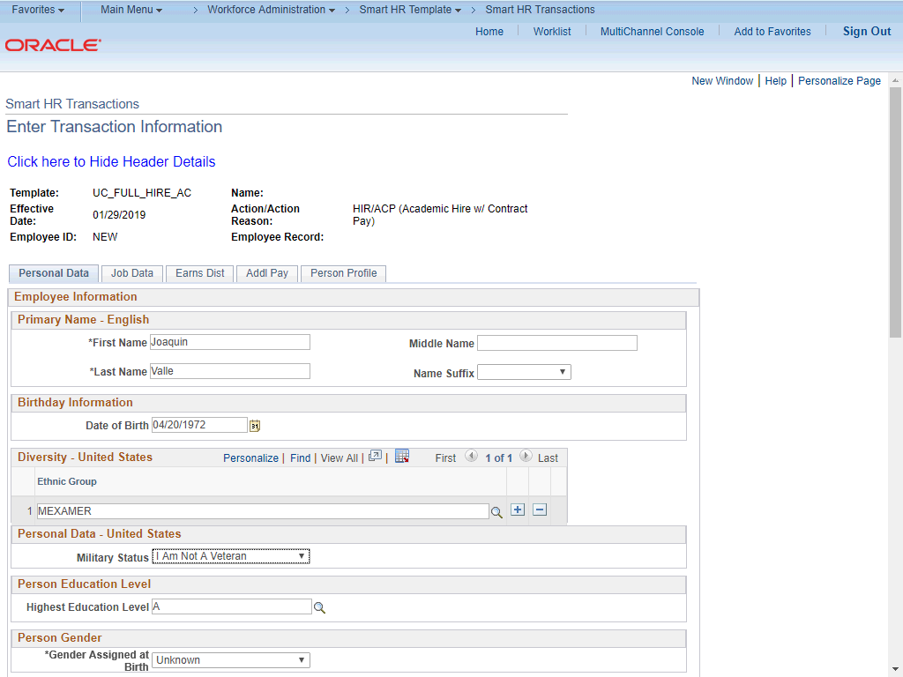

Step | Action
26. | Select the Highest Education Level, if known, or accept the default of A (Not Indicated).  Click in the Highest Education Level field.
27. | Enter the desired information into the Highest Education Level field.
28. | Click the button to the right of the Gender Assigned at Birth field.

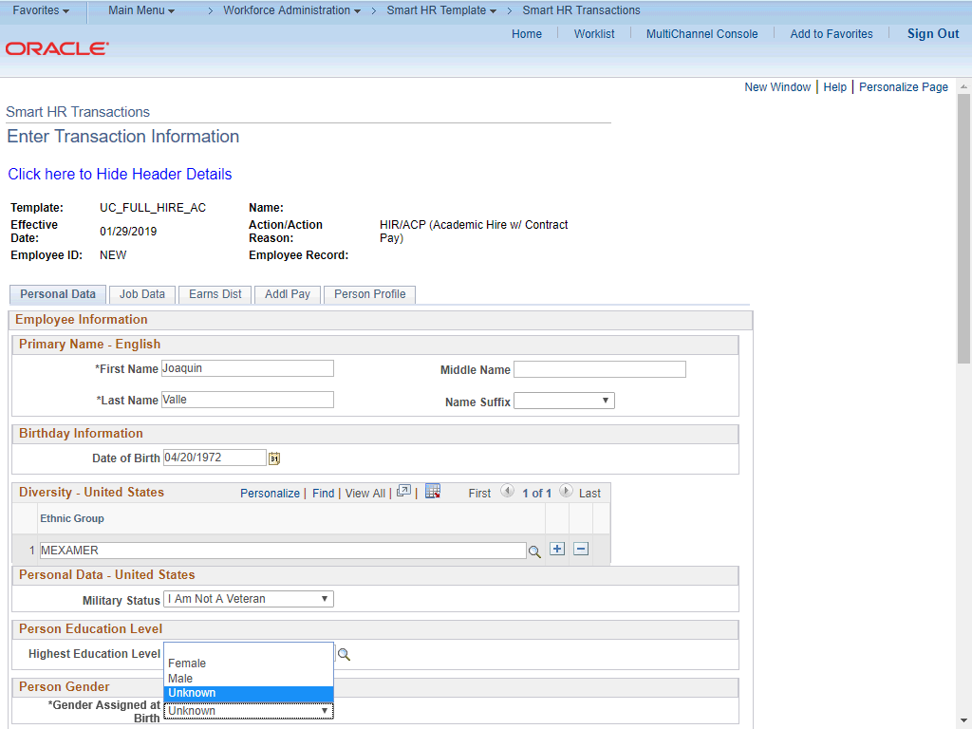

Step | Action
29. | Select the appropriate gender.  For this example, click the Male list item.

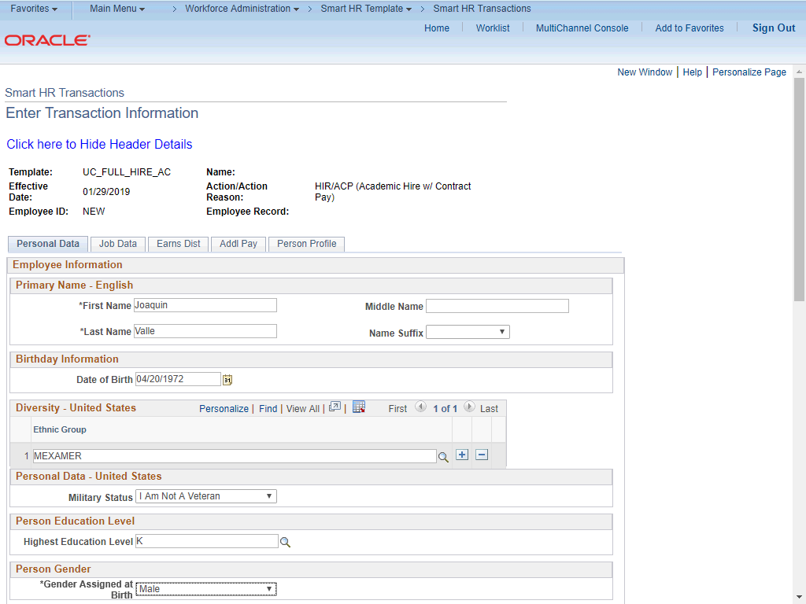

Step | Action
30. | If necessary, scroll down to display additional fields and page functions.  Click the scroll bar.
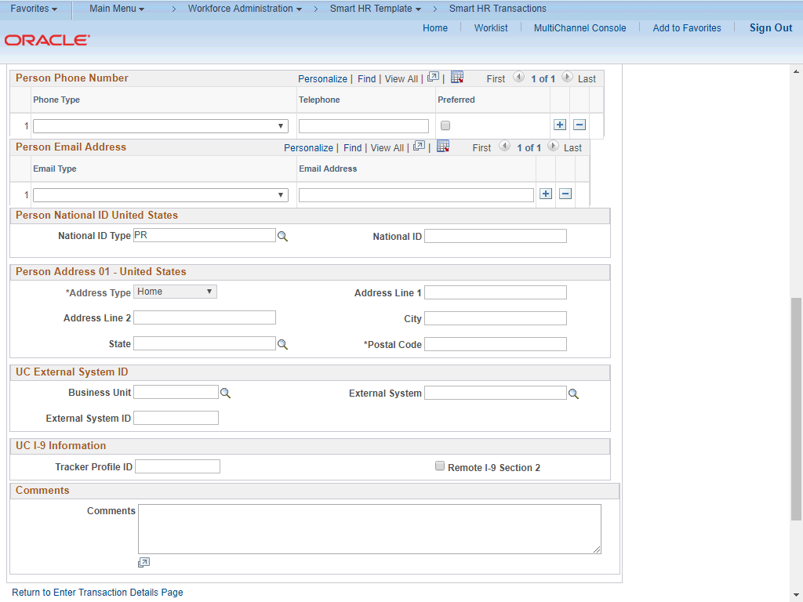

Step | Action
31. | Click the button to the right of the Phone Type field.
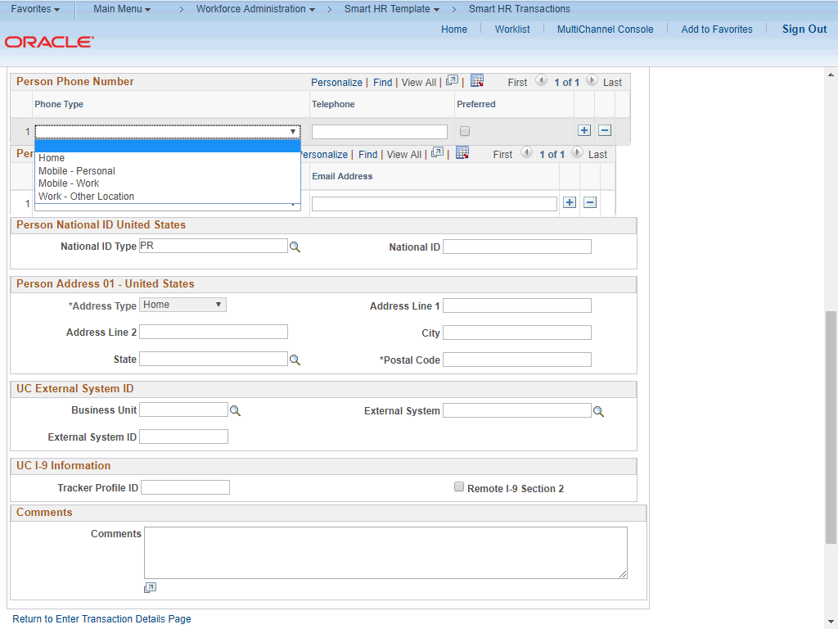

Step | Action
32. | Select the appropriate Phone Type.  For this example, click the Mobile - Personal list item.

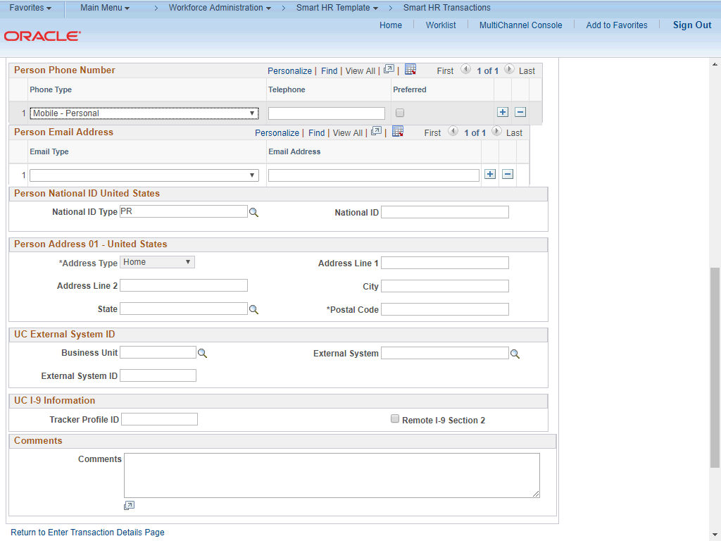

Step | Action
33. | Click in the Telephone field.
34. | Enter the desired information into the Telephone field.
35. | A Preferred phone number must be identified by selecting the check box. Click the Preferred option.
36. | Click the button to the right of the Email Type field.

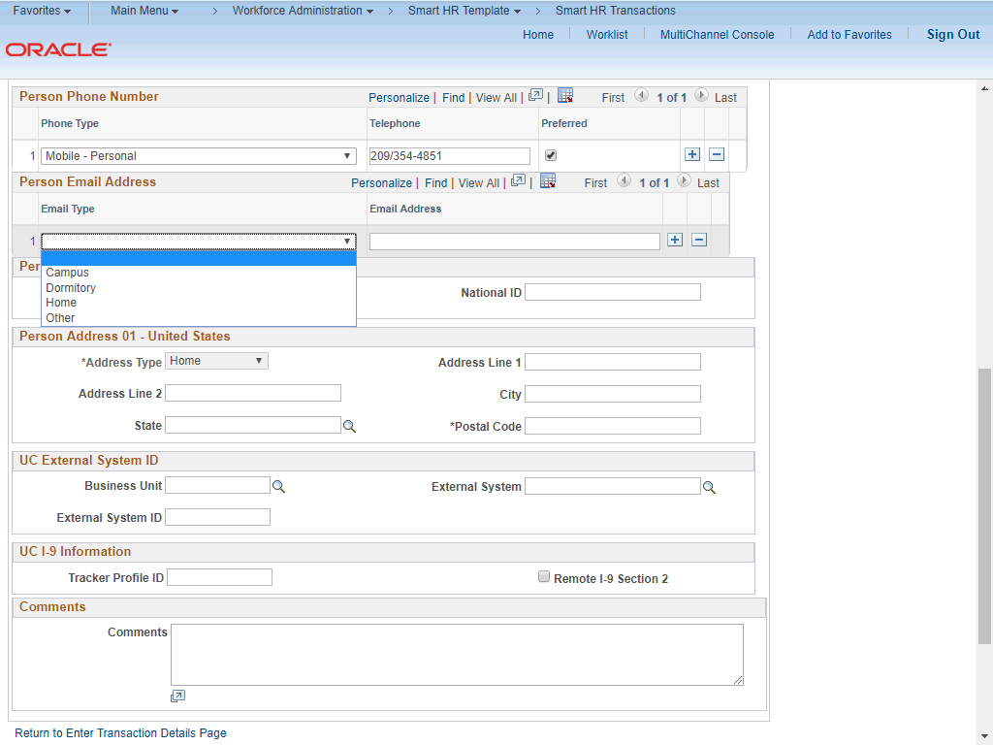

Step | Action
37. | Select the appropriate Email Type.  For this example, click the Home list item.

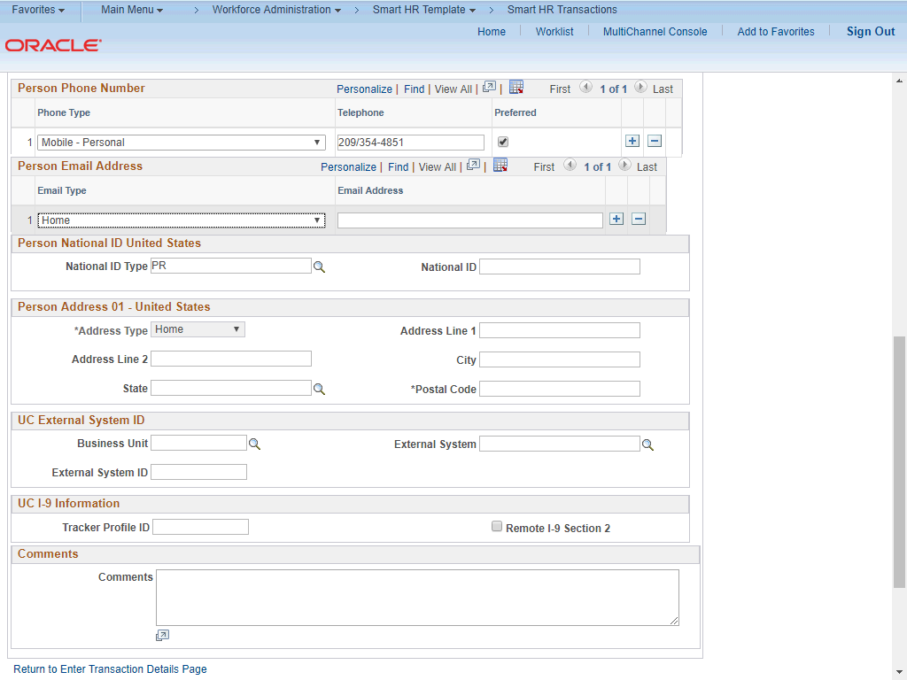

Step | Action
38. | Click in the Email Address field.
39. | Enter the desired information into the Email Address field.
40. | In the National ID Type field, accept the default of PR (for Social Security number).
41. | Click in the National ID field.
42. | Enter the desired information into the National ID field.
43. | Click in the Address Line 1 field.
44. | Enter the desired information into the Address Line 1 field.
45. | Click in the City field.
46. | Enter the desired information into the City field.

Step | Action
47. | Click in the State field.
48. | Enter the desired information into the State field.
49. | Click in the Postal Code field.
50. | Enter the desired information into the Postal Code field.
51. | Use the Comments field to enter specific details or an explanation regarding the transaction.  For contract pay entries you must enter the contract pay reason and the contract period begin and end dates.  This field is referenced by UCPC WFA Production to assist with the processing of the transaction.  Click in the Comments field.
52. | Enter the desired information into the Comments field. For example, you can enter Contract Pay. Late Start. Prorated. Contract Start Date: 1/29/2019. Contract End Date: 5/11/2019..
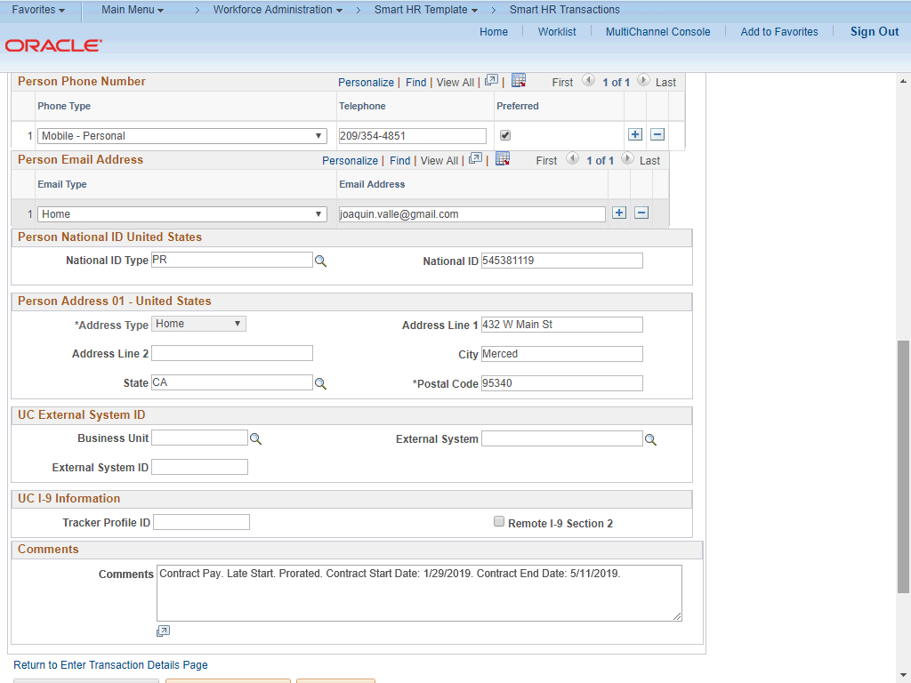

Step | Action
53. | If necessary, scroll down to display additional fields and page functions.  Click the scroll bar.
54. | Use the Supporting documents link to attach supporting documents for the new hire, if needed.
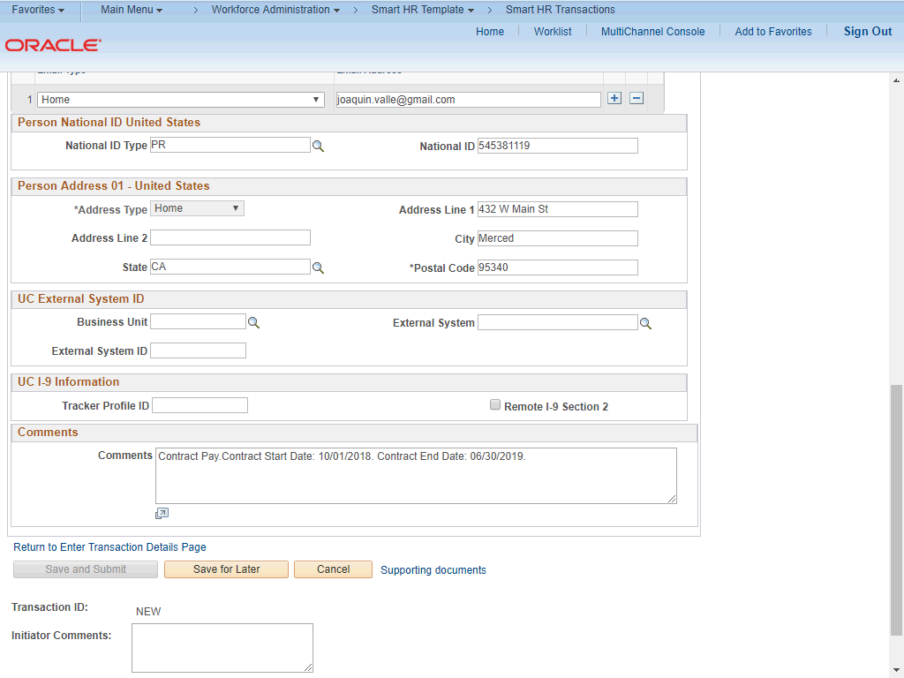

Step | Action
55. | If necessary, scroll up to the display the Job Data tab.  Click the scroll bar.

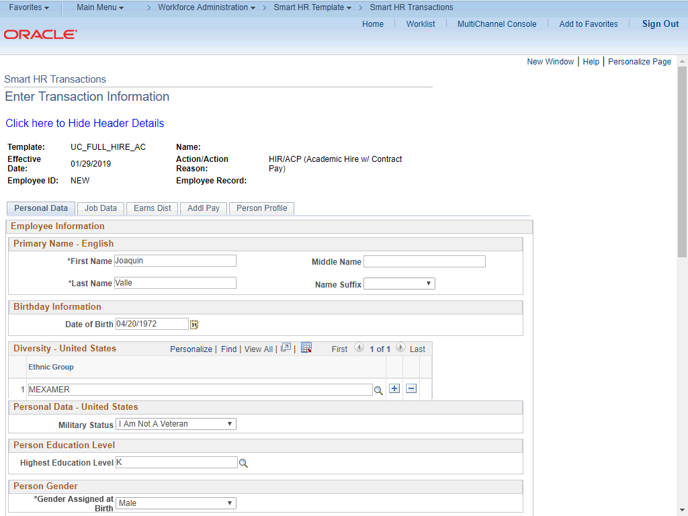

Step | Action
56. | Click the Job Data tab.
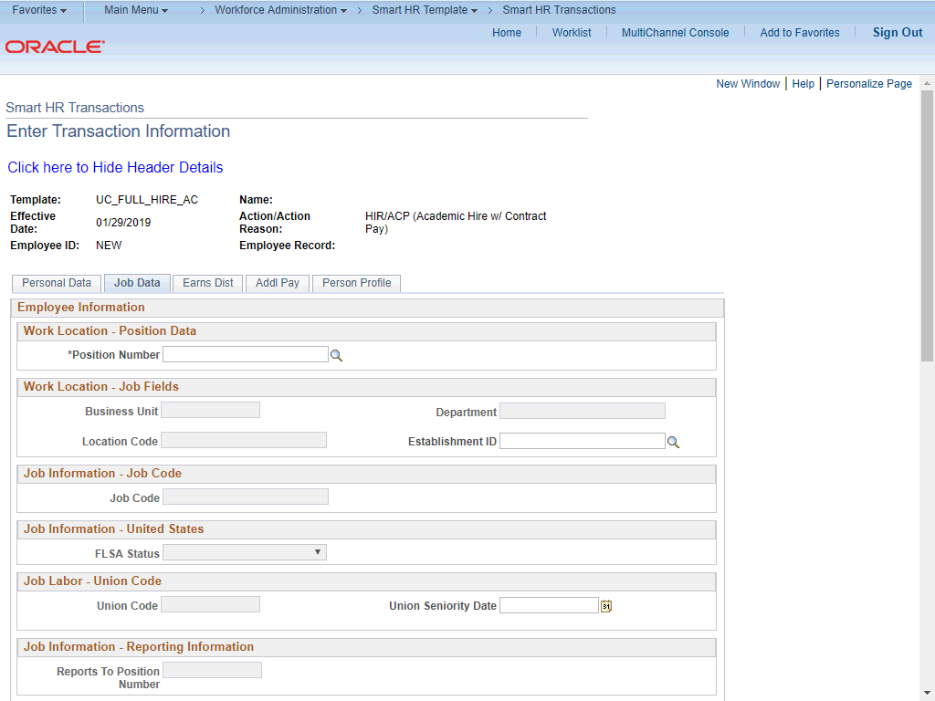

Step | Action
57. | Enter the position number or search for it using the look up button. You have access only to position numbers within your business unit or related business unit.  Click in the Position Number field.
58. | Enter the desired information into the Position Number field.
59. | Press [Tab] to automatically populate the position-related fields.
60. | Scroll down to display additional fields and page functions.  Click the scroll bar.
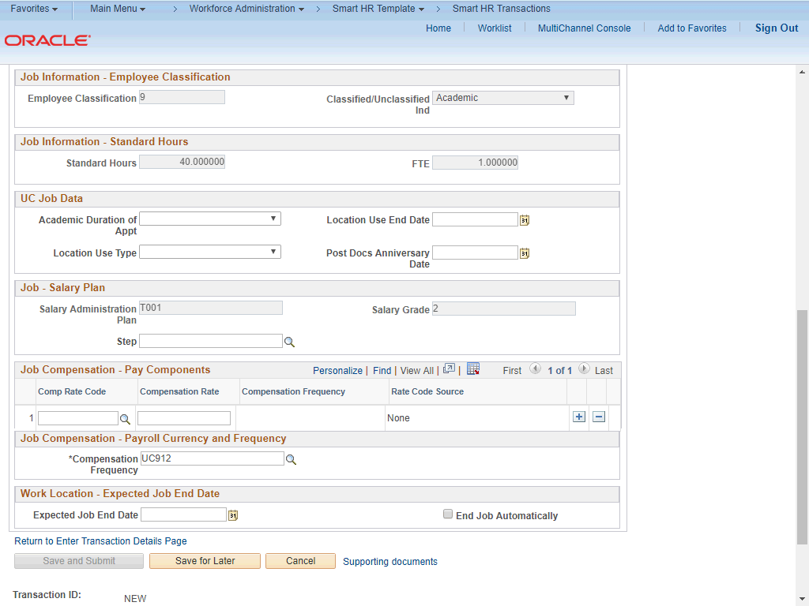

Step | Action
61. | For academic hires, the Employee Classification field automatically populates based on the job code and cannot be changed.

Step | Action
62. | Some job codes have steps associated with them. You should always check to see if a step exists in the list of values. When you enter or select a step, UCPath automatically populates the Job Compensation - Pay Components fields. If the contract pay must be prorated, you must override the Comp Rate Code by entering UCCNTR in the Comp Rate Code field.  Some job codes do not have steps associated with them, in which case the Job Compensation - Pay Components fields must be manually entered.  For this example, a step must be entered and the default Compensation Rate must be prorated for a late start contract pay.
63. | Click in the Step field.
64. | Enter the desired information into the Step field. For this example, enter 1.

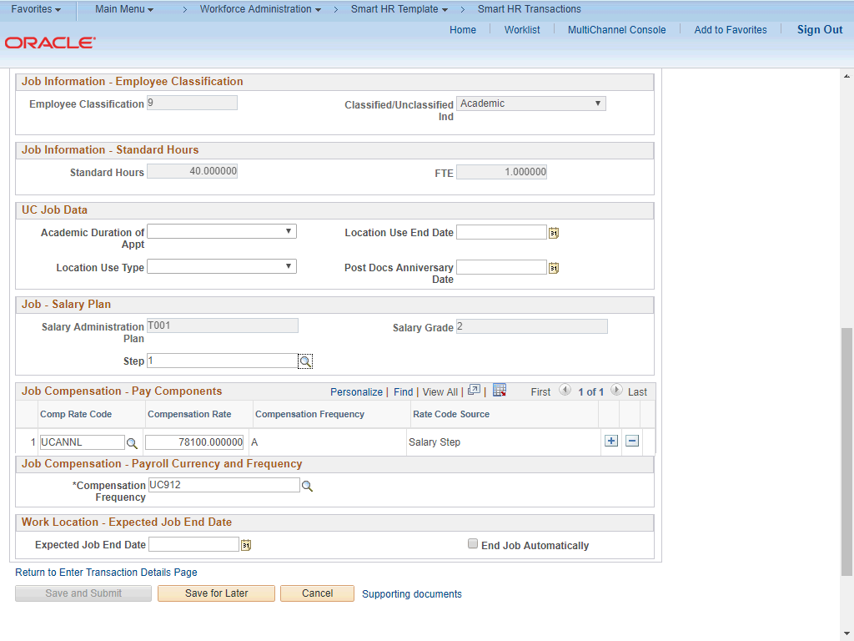

Step | Action
65. | After you enter the Step, the Comp Rate Code and Compensation Rate fields default. Delete the default compensation to enter the prorated contract pay:  - Delete the existing compensation row.  - Enter Comp Rate Code as UCCNTR.  - Enter the prorated Compensation Rate.  - Enter Compensation Frequency of C.  Note: If the employee is to receive the full compensation during the contract period, leave the default compensation and only change the Compensation Frequency to C.
66. | Click the Delete Row button.

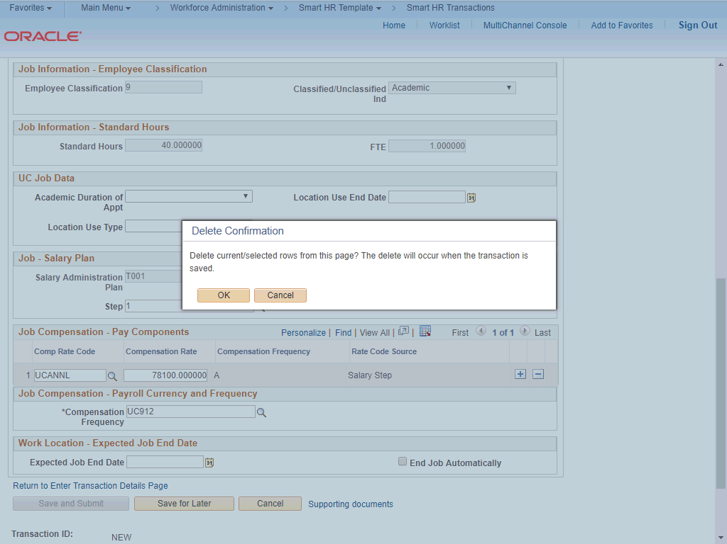

Step | Action
67. | Click the OK button.
68. | Click in the Comp Rate Code field.
69. | Enter UCCNTR into the Comp Rate Code field.
70. | Click in the Compensation Rate field.
71. | Enter the prorated compensation into the Compensation Rate field.
72. | The Compensation Frequency must be C for contract. Click the Look up Compensation Frequency button.
73. | Click the C (Contract) list item.

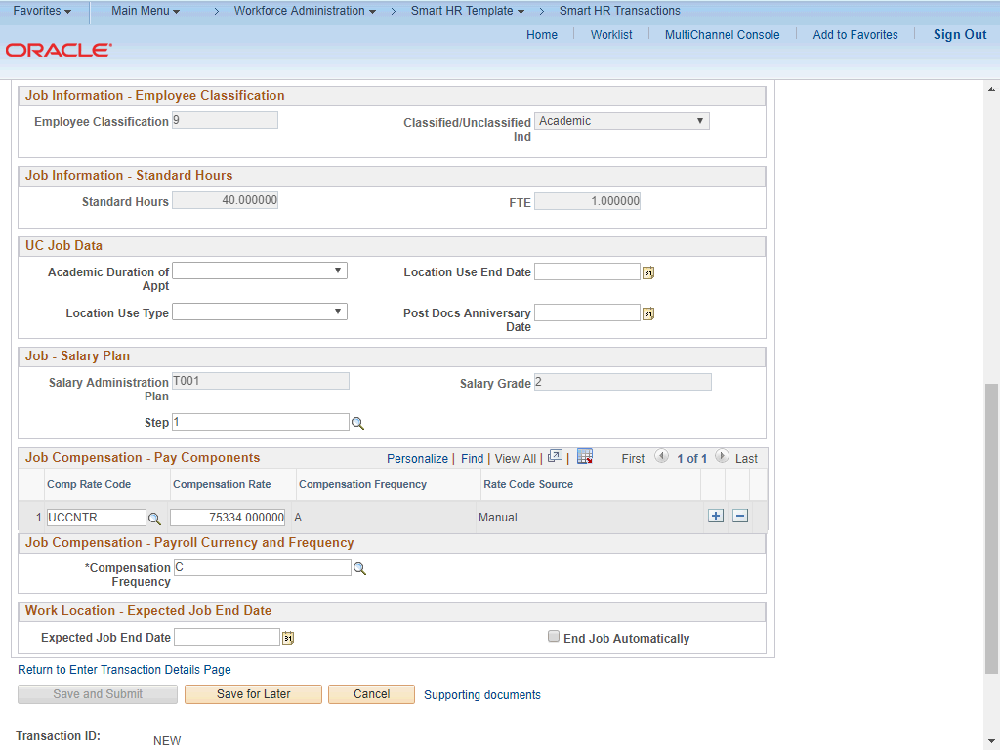

Step | Action
74. | If necessary, scroll up to display the Earns Dist tab.  Click the scroll bar.
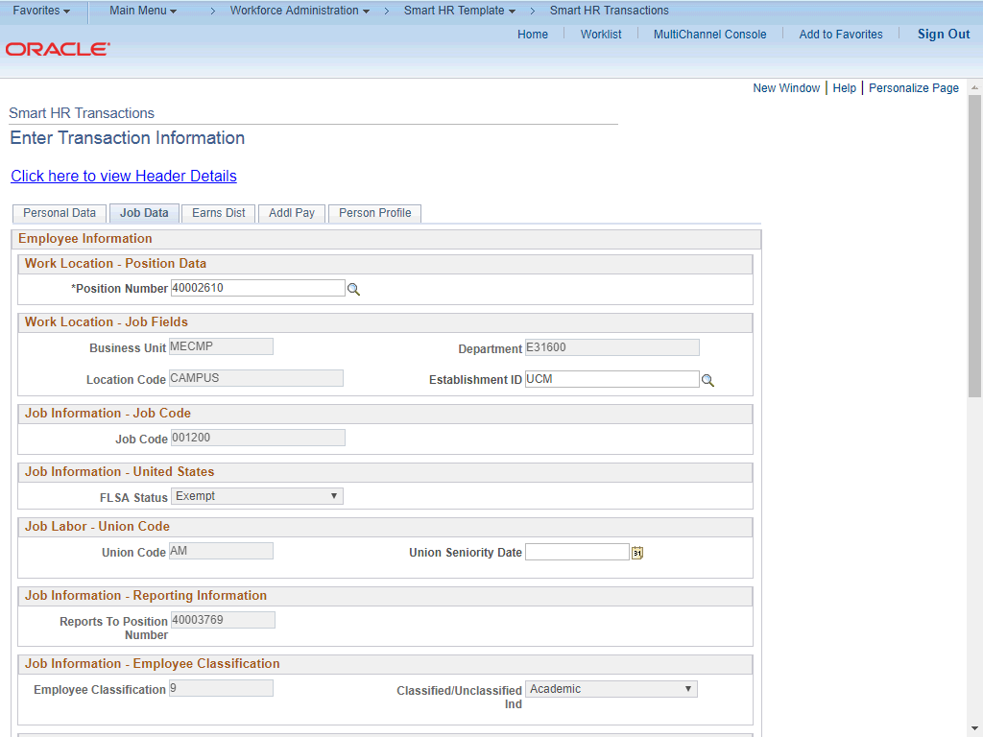

Step | Action
75. | Click the Earns Dist tab.
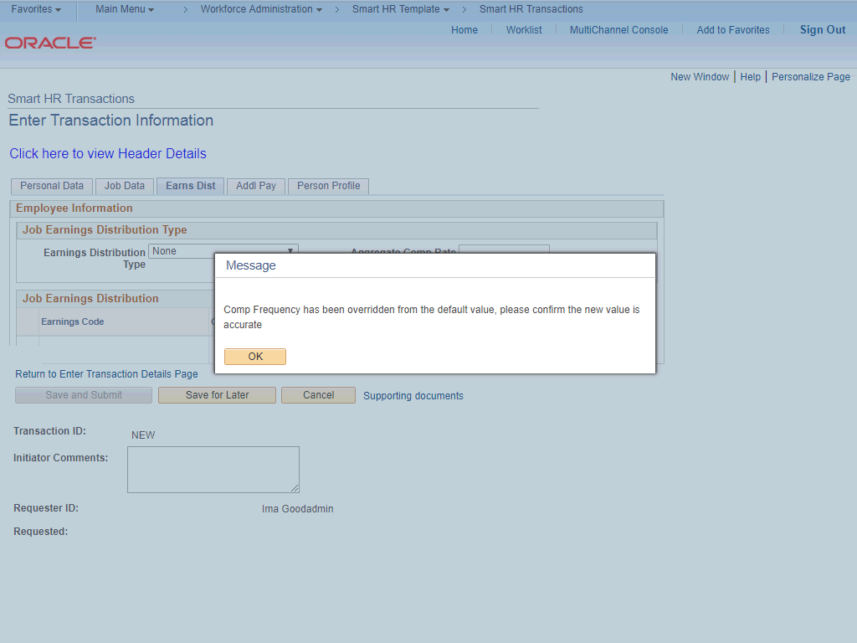

Step | Action
76. | The system displays a message prompting you to confirm the comp frequency update you made.  Click the OK button.

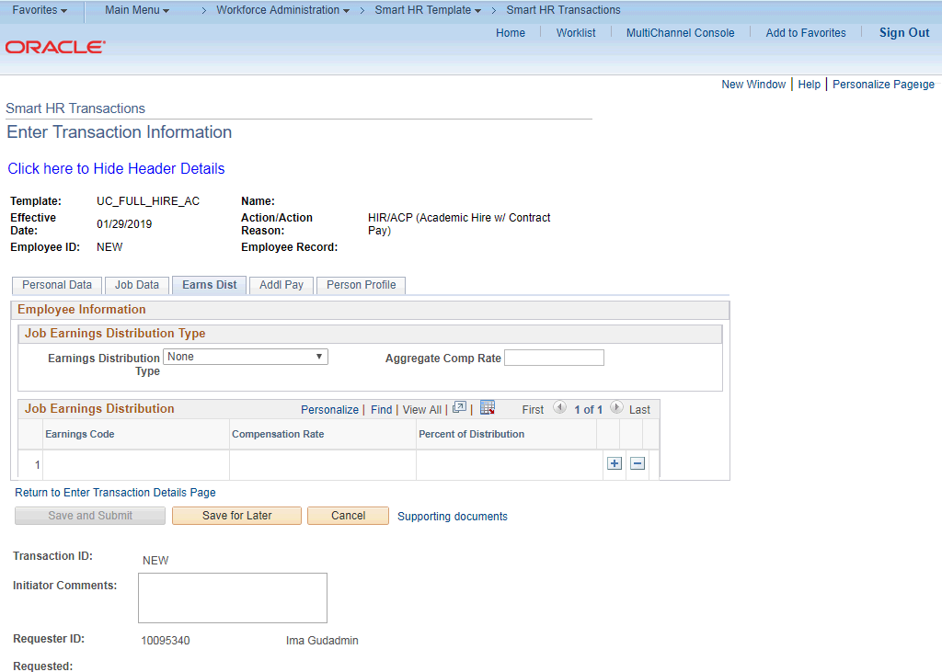

Step | Action
77. | In most cases, the Job Earnings Distribution section is automated. If the Comp Rate code entered on the Job Data tab has a mapped Earnings Code, the Job Earnings Distribution section is updated automatically.

Step | Action
78. | The Job Earnings page can be used to manually enter distribution information. Use the Earnings Distribution Type field to enter distribution By Amount or By Percent. After the Earnings Distribution Type is selected, the Aggregate Comp Rate field is populated with the monthly amount.  - If By Amount is selected, the total of all compensation rates entered must add up to the monthly comp rate.  - If By Percent is selected, the total of all percentages entered must add up to 100%.

Step | Action
79. | Click the Addl Pay tab.

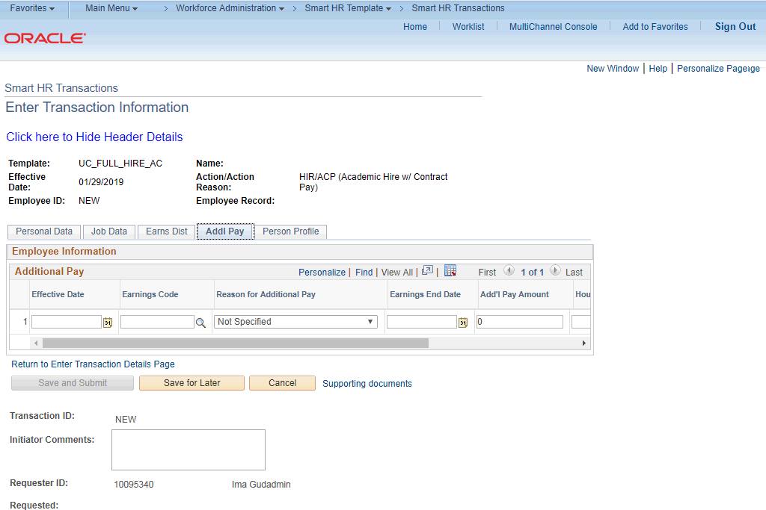

Step | Action
80. | There may be cases where an employee is paid a recurring flat amount. In these types of cases, the compensation section is not populated on the Job Data tab. Instead, the Additional Pay section is used.  There may also be cases where neither compensation rate nor additional pay is entered. In those cases, it is recommended that you enter a comment to explain how the employee is to be paid.  It is recommended not to use this template for one time additional pay. Instead, use payroll's one time payments page.
81. | Click the Person Profile tab.

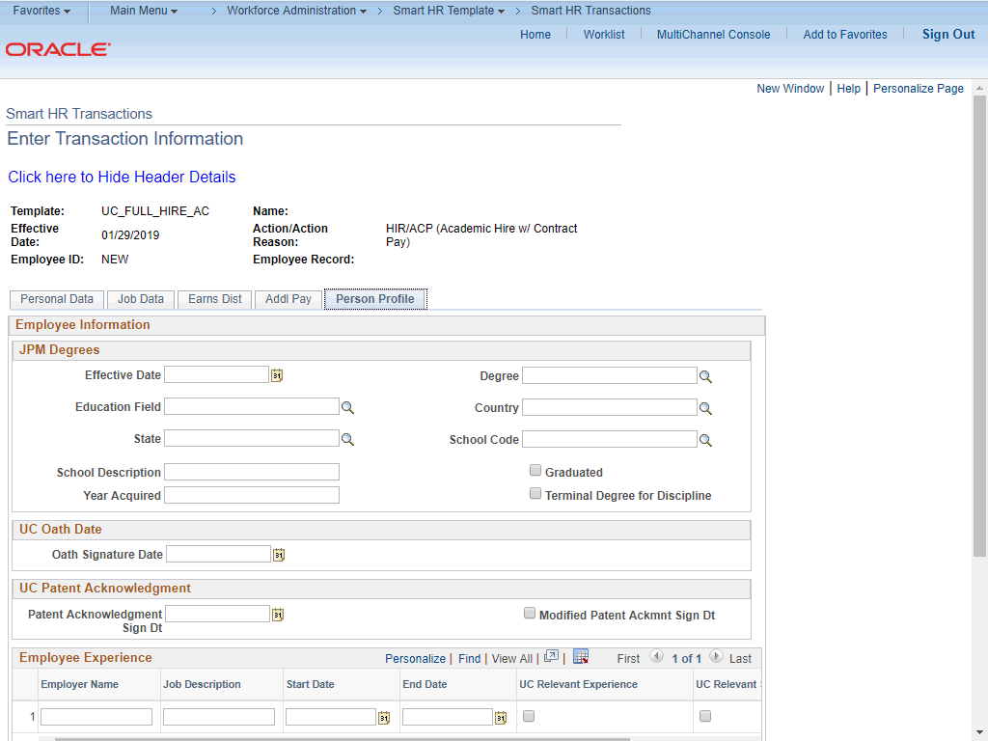

Step | Action
82. | Use the Person Profile page to enter the new hire's degree information, as well as their oath and patent acknowledgment signature dates.  Degree information is optional. The Graduate Divisions may want to enter this information for Post Docs at the time of hire.  The information entered in the JPM Degrees, UC Oath Date and UC Patent Acknowledgement sections is copied to the employee's Person Profile component after the template is processed by UCPC WFA Production.  The information entered in the Employee Experience section is copied to the employee's UC Employee Experience page after the template is fully processed by UCPC WFA Production.
83. | Click in the Effective Date field.
84. | Enter the desired information into the Effective Date field.
85. | Click in the Degree field.
86. | Enter the desired information into the Degree field.

Step | Action
87. | Enter the date the new hire signed the UC oath agreement. This date cannot be later than the current date.  Click in the Oath Signature Date field.
88. | Enter the desired information into the Oath Signature Date field.
89. | Enter the date on which the individual signed the UC patent acknowledgement. This date cannot be later than the current date.  Click in the Patent Acknowledgment Sign Dt field.
90. | Enter the desired information into the Patent Acknowledgment Sign Dt field.
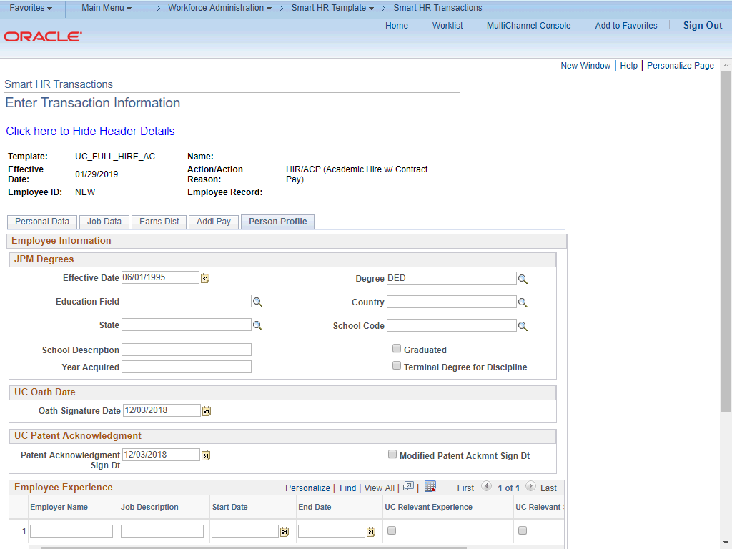

Step | Action
91. | If necessary, scroll down to display the Save and Submit button.  Click the scroll bar.

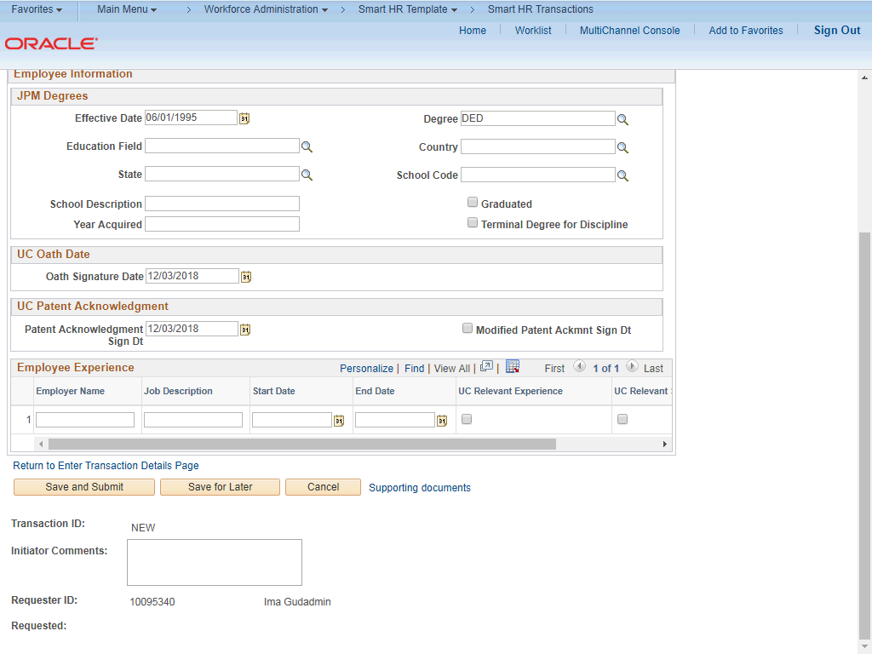

Step | Action
92. | The Save and Submit button is not available until all required fields on each tab are completed.  Click the Save and Submit button.

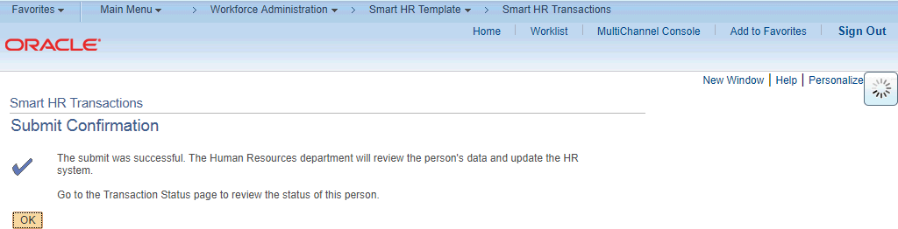

Step | Action
93. | Click the OK button.
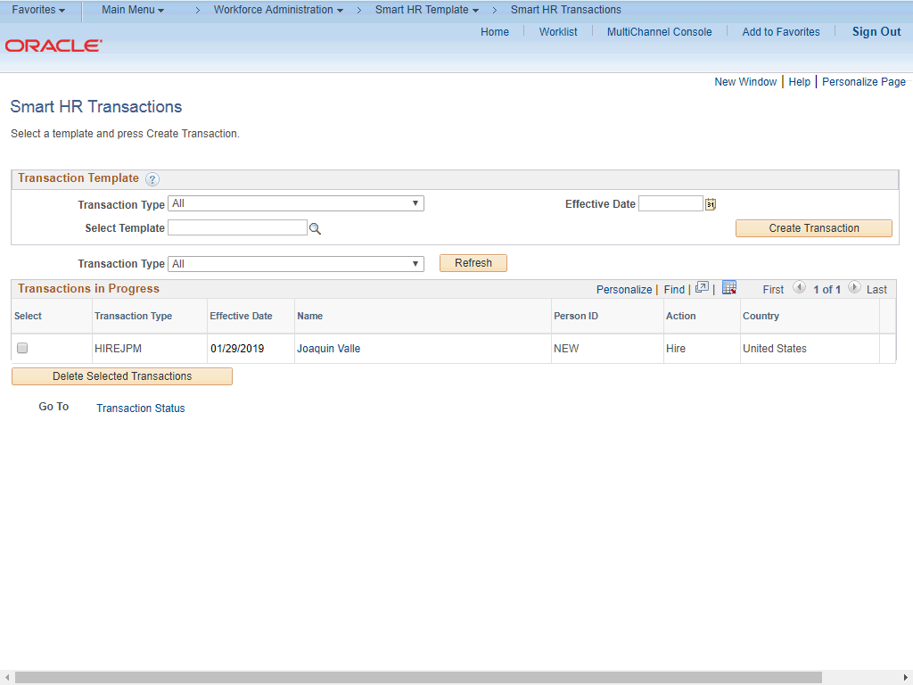

Step | Action
94. | The template transaction is routed for approval and appears in the Transactions in Progress section until it is processed.
95. | You have initiated a full hire template transaction for an academic employee with prorated contract pay.  End of Procedure.

