Use this task to initiate a concurrent hire template transaction for an academic employee.

Navigation: PeopleSoft Menu > Workforce Administration > Smart HR Template > Smart HR Transactions

Note: This page also may be available in Workcenter depending on your security access.

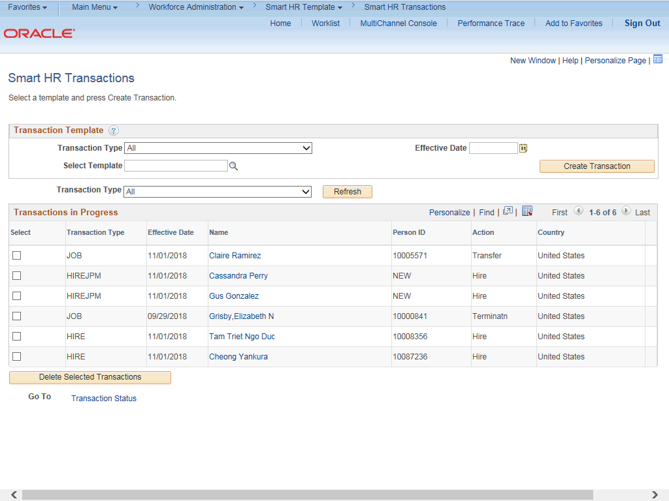

Step | Action
1. | Use the Smart HR Transactions page to initiate a concurrent hire template transaction.
2. | Click the Look up Select Template button.  Note: The Transaction Type field is not used by UC.

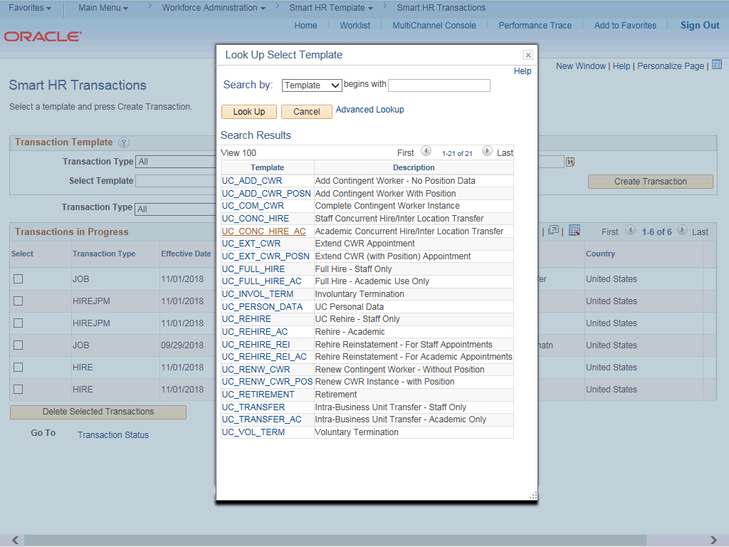

Step | Action
3. | Select the appropriate concurrent hire template. Notice there are two concurrent hire templates, one for staff and one for academic.  Click the UC_CONC_HIRE_AC list item.
4. | The Effective Date field is the effective date of the selected template action. The date you enter in this field automatically populates the Effective Date field on the Enter Transaction Details page. You can update the Effective Date on the Enter Transaction Details page if needed.  Click in the Effective Date field.
5. | Enter the desired information into the Effective Date field.
6. | Click the Create Transaction button.

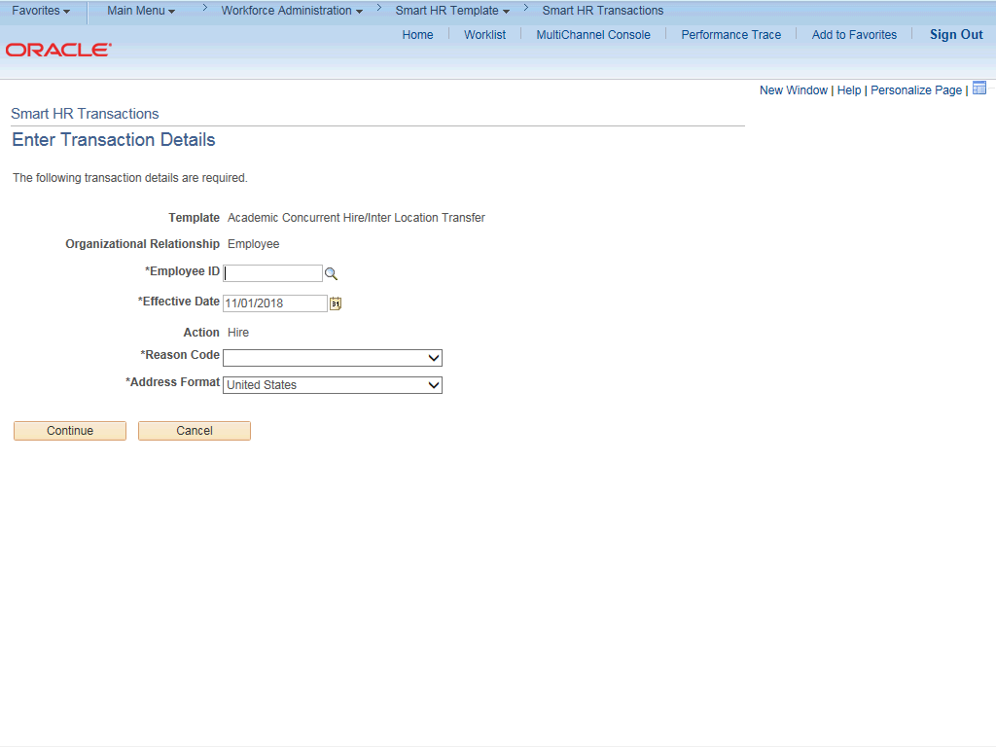

Step | Action
7. | In the Employee ID field, enter the employee’s ID number or use the lookup to search for and select it.  Click in the Employee ID field.
8. | Enter the desired information into the Employee ID field.
9. | The Effective Date is populated based on your entry on the previous page. Ensure that you entered the correct Effective Date.
10. | Click the button to the right of the Reason Code field.

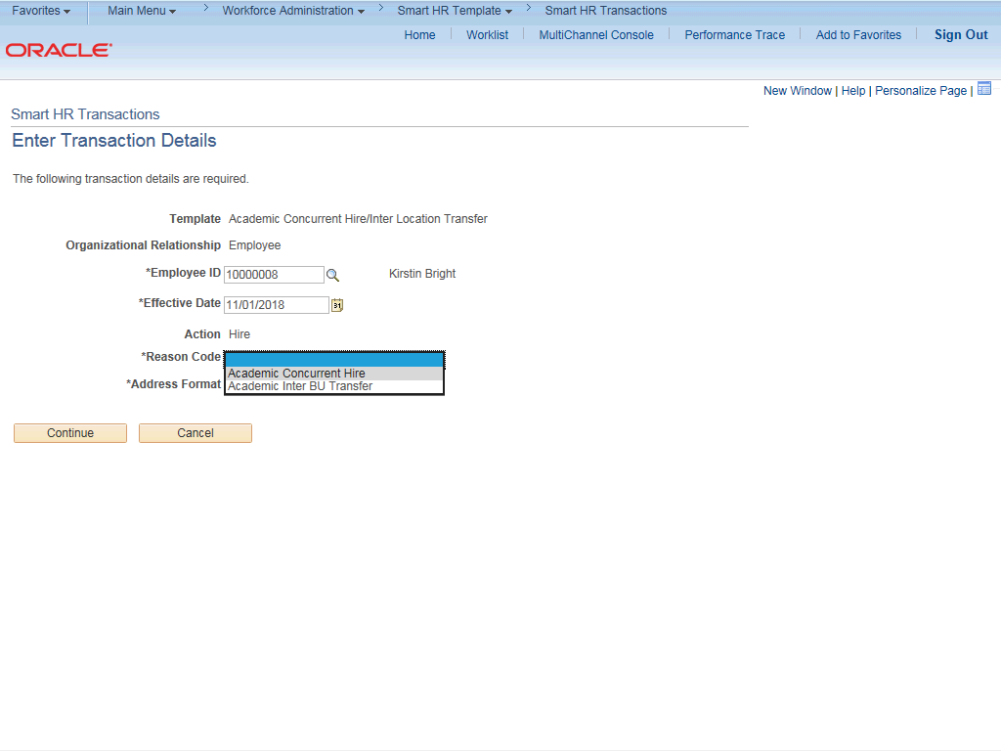

Step | Action
11. | Click the Academic Concurrent Hire list item.
12. | In the Address Format field, accept the default of United States or select the  Global option, if applicable.

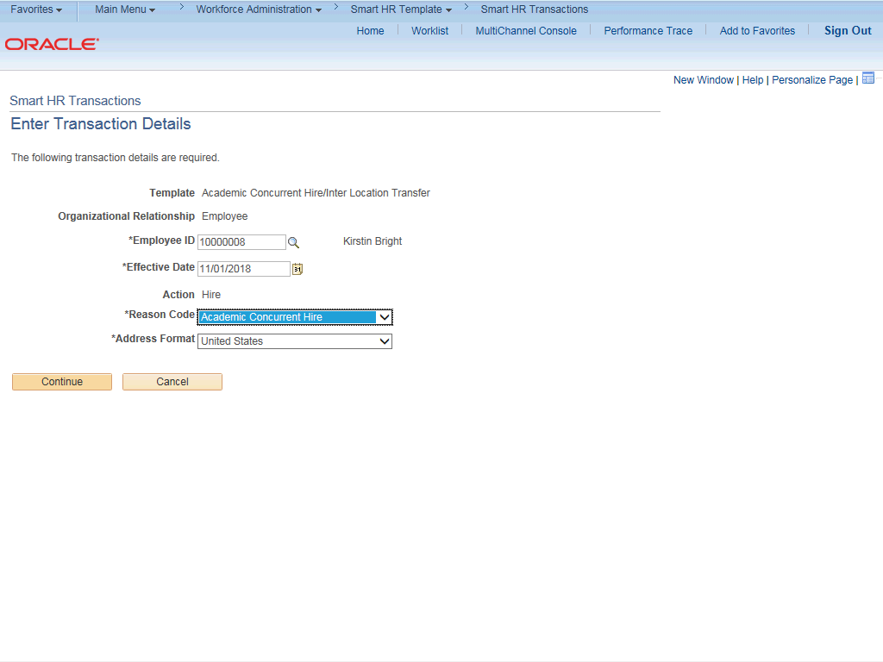

Step | Action
13. | Click the Continue button.
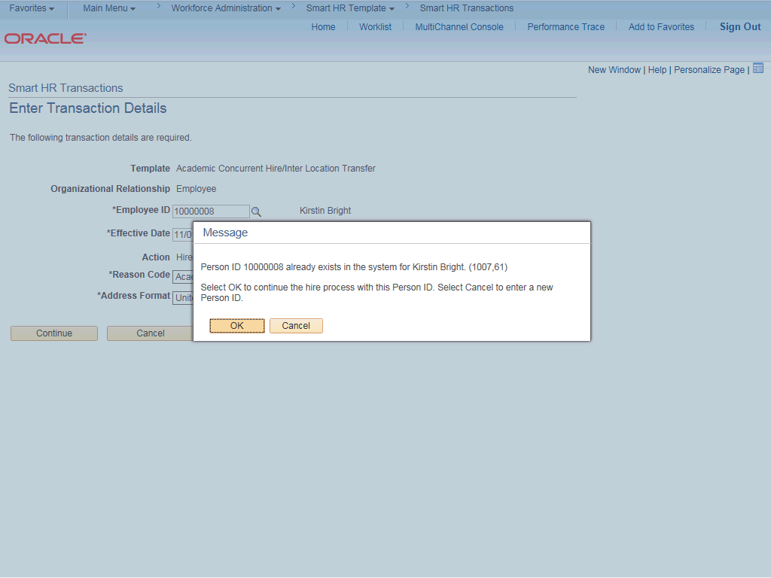

Step | Action
14. | UCPath displays a message indicating the individual already exists in the system.  Verify that the displayed employee ID and name correspond with the individual you are hiring into a concurrent job.  Click the OK button.
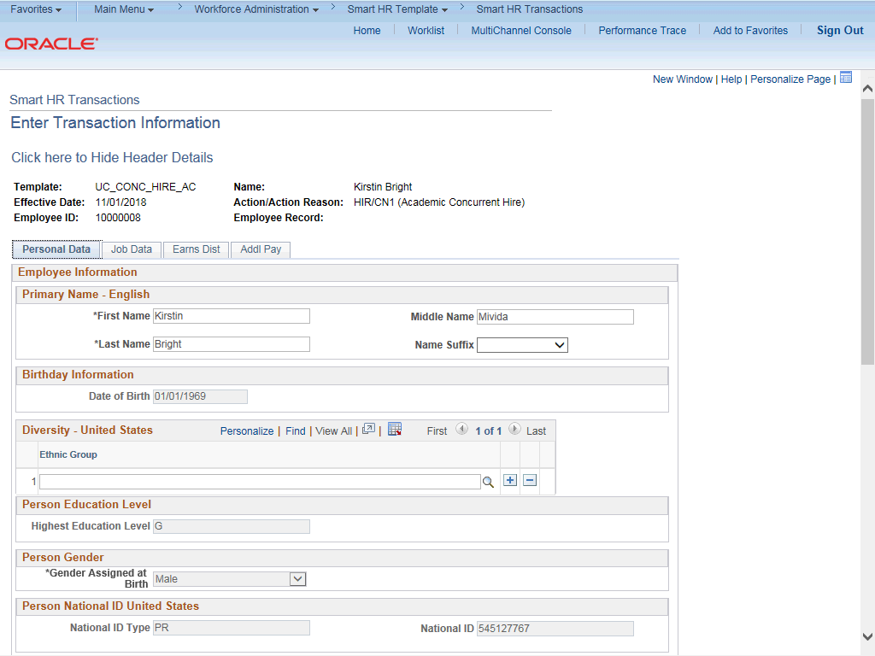

Step | Action
15. | The concurrent hire template appears. Four tabs are available on this template:  Personal Data, Job Data, Earns Dist and Addl Pay.  The employee's personal data automatically populates from the employee's existing personal data information. If a change is required for personal data, it should be submitted using Employee Self Service or the Personal Data Change Template.
16. | Header details appear above the tabs. You can show/hide the header information as needed.
17. | Click the scroll bar.

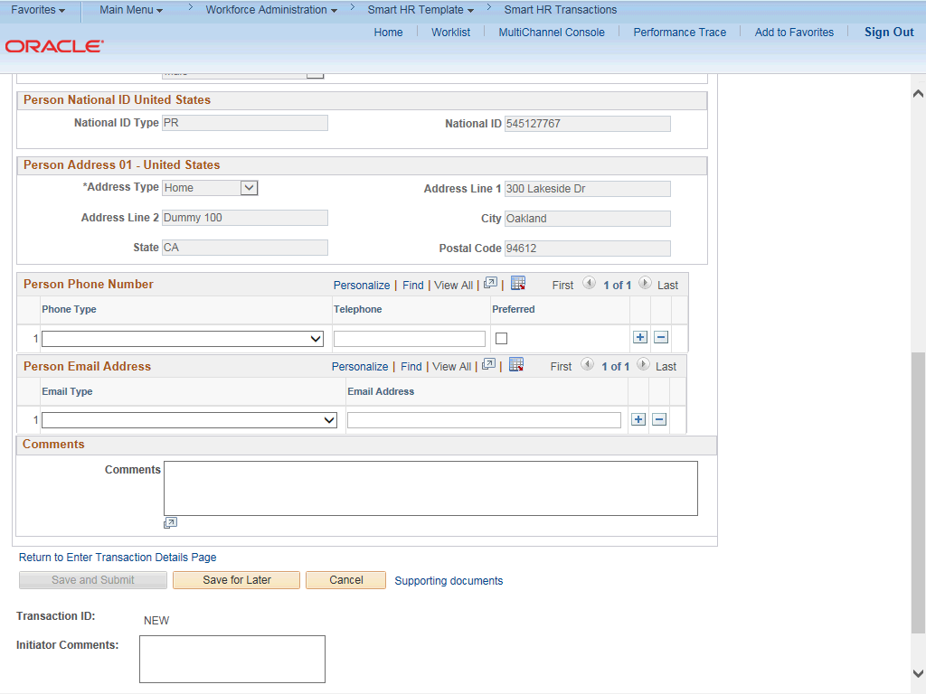

Step | Action
18. | Use the Comments field to enter specific details or an explanation regarding the transaction. For example, this field can be used to:  - Enter comments to have UCPC WFA Production override the Pay Group on the new concurrent job to align with the existing job. (However, if the existing job's pay group needs to be overridden to align with the job on the template, you need to submit an inquiry.)  - Enter details about a contract pay transaction, such as contract begin date and contract end date.  - Indicate that the employee lives and works outside the US. For these employees, UCPC WFA Production will add the NRA Working Outside the US citizenship status on the Identification Data page.  This field is referenced by UCPC WFA Production to assist with the processing of the transaction.
19. | Click the scroll bar.

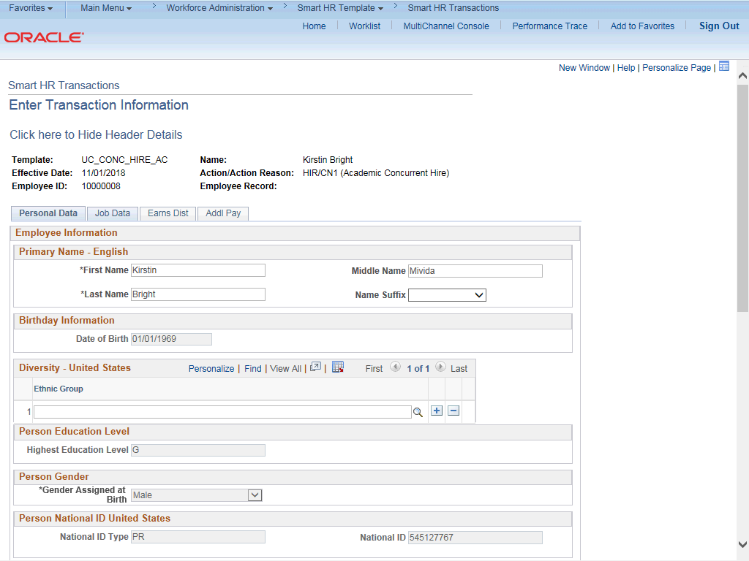

Step | Action
20. | Click the Job Data tab.
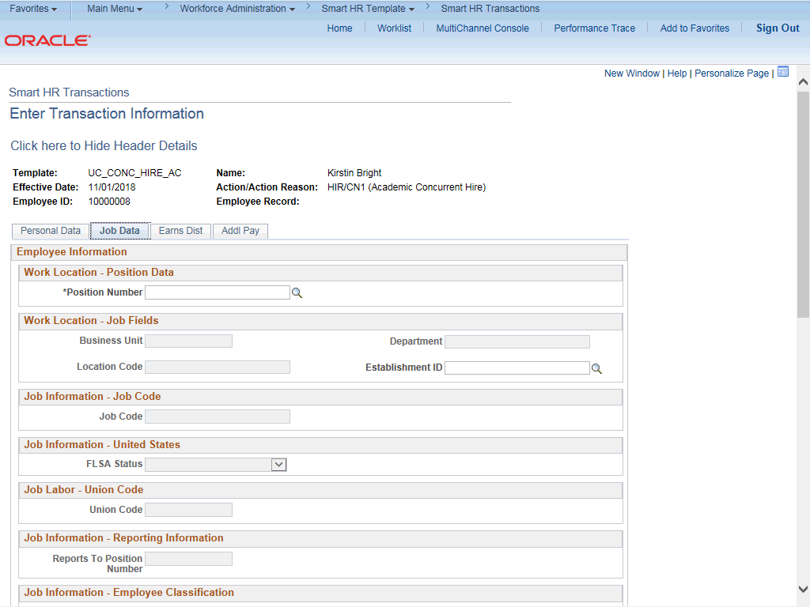

Step | Action
21. | Enter the position number of the concurrent job or search for it using the look up. You only have access to position numbers within your business unit or related business unit.  Click in the Position Number field.
22. | Enter the desired information into the Position Number field.
23. | Press [Tab] to automatically populate the position-related fields.
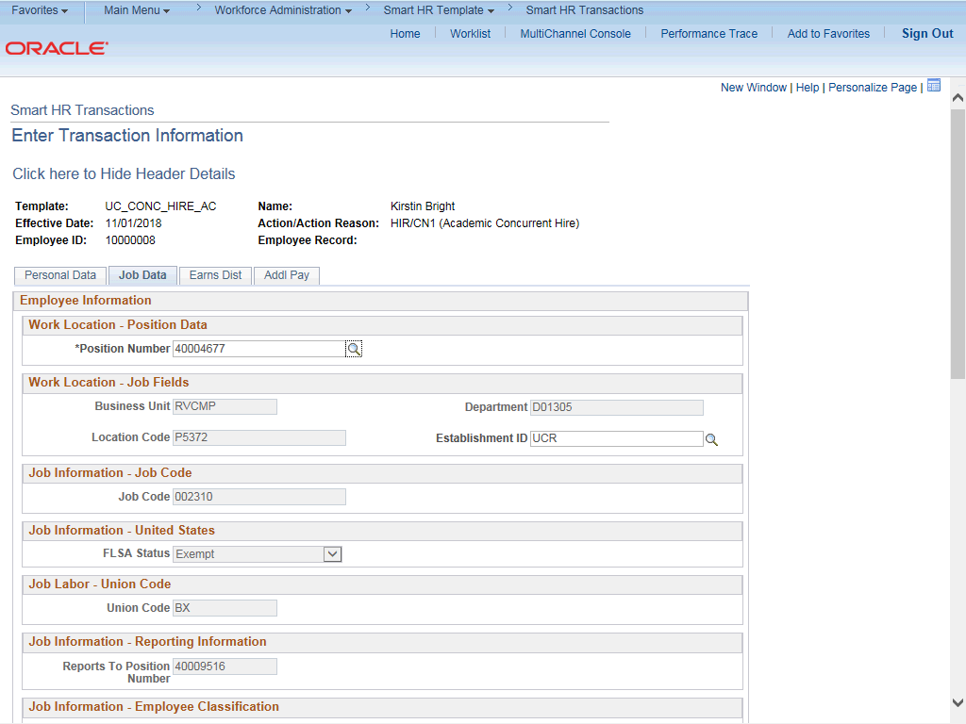

Step | Action
24. | Click the scroll bar.

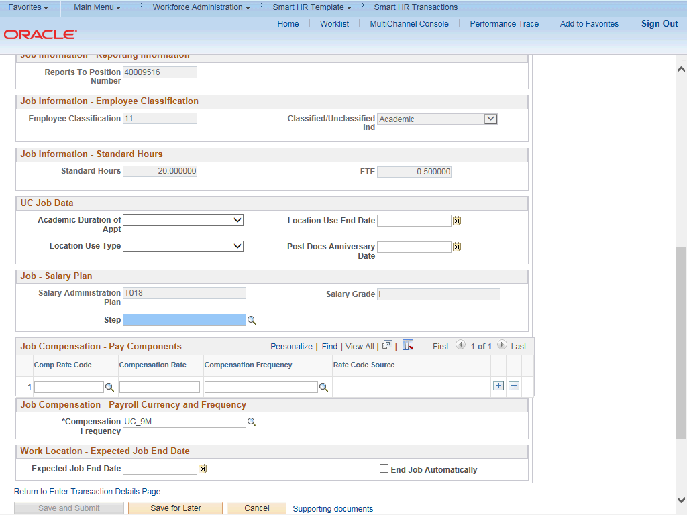

Step | Action
25. | For academic hires, the Employee Classification field automatically populates based on the job code and cannot be changed.
26. | In the UC Job Data section, enter or select the appropriate values as applicable.
27. | The Academic Duration of Appointment options allow Locations to track additional information relating to the Expected Job End Date field (when entered at the bottom of this page).  Academic Duration of Appt options include:  - Continuing (Unit 18)  - End Date (Academic Term Appts)  - Indefinite  - Potential Security  - Security (LSOE)  - Tenure Track (Ladder Rank)  - Tenured

Step | Action
28. | The Location Use Type and Location Use End Date fields allow Locations to track funding expiration and other location specific information separate from the Expected Job End Date field. If a Location Use Type is selected you should select a Location Use End Date.  Location Use Type options include:  - Funding End Date  - Review Remaining Budget  - Review Job  - NSTP Review  - Temporary Off-Scale  - Temporary Reduction in Time  - LA: Dual Employment Job  - Temporary Increase in Time
29. | Post Docs Anniversary Date is used to help maintain years of experience for Post Docs and assists with calculating accruals for vacation and sick leave for Post Docs.
30. | Some job codes have steps associated with them. When a Step is entered, UCPath automatically updates the Job Compensation - Pay Components fields and the compensation information cannot be changed.  Some job codes do not have steps associated with them, in which case the Job Compensation - Pay Components fields must be manually entered.  If the job has above scale component of pay, then step does not need to be selected. Enter applicable above scale comp rate codes in the Job Compensation - Pay Components section.  For contract-based pay hires, refer to the Initiate Contract Pay Template Transaction simulation for specific steps on contract pay entries.
31. | For this example, the job code is associated with steps. Click the Look up Step button.
32. | Use caution when selecting the appropriate step value. For some jobs, there are half steps, so be sure to review the Hourly Rate to ensure you are selecting the correct step value.

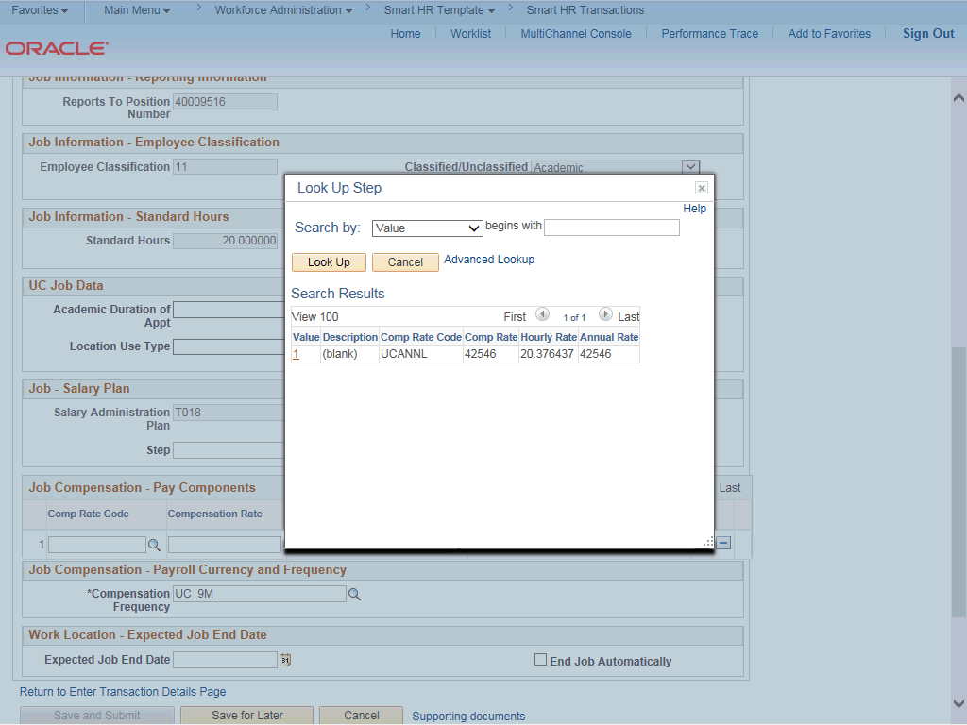

Step | Action
33. | Select the appropriate Step.  For this example, click the 1 list item.
34. | The Comp Rate Code, Compensation Rate and Compensation Frequency fields are automatically populated based on the Step that was entered.
35. | The payroll-related Compensation Frequency field automatically populates based on the job code. This field defines how the total compensation is paid out to the employee per paycheck.  This field is changed only for specific exceptions, such as contract based pay. Any time this field is changed from the default enter a Comment (on the first tab) to explain why the field was changed.
36. | Click the scroll bar.

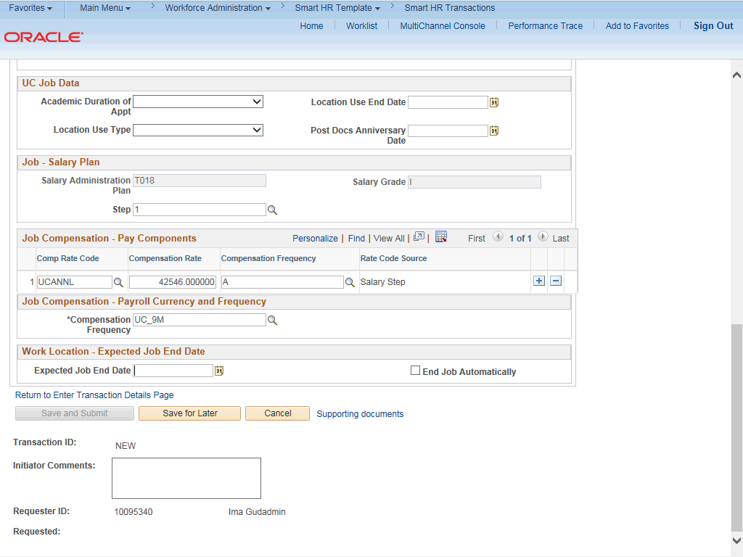

Step | Action
37. | If the employment is a short term assignment or temporary hire, enter the date the position ends in the Expected Job End Date field.  An expected end date should be entered for all academic employee classes, except:  3 - Academic Recall  - - Faculty  - - Non-Faculty  - - Academic Student  14 - Academic Contingent Worker  - - Emeriti  - - Deans/Faculty Administrators  - - Post Docs
38. | Click in the Expected Job End Date field.
39. | Enter the desired information into the Expected Job End Date field
40. | If you select the End Job Automatically check box, the UCPath Center runs a process to terminate the employee as of the Expected Job End Date.
41. | Click the scroll bar.

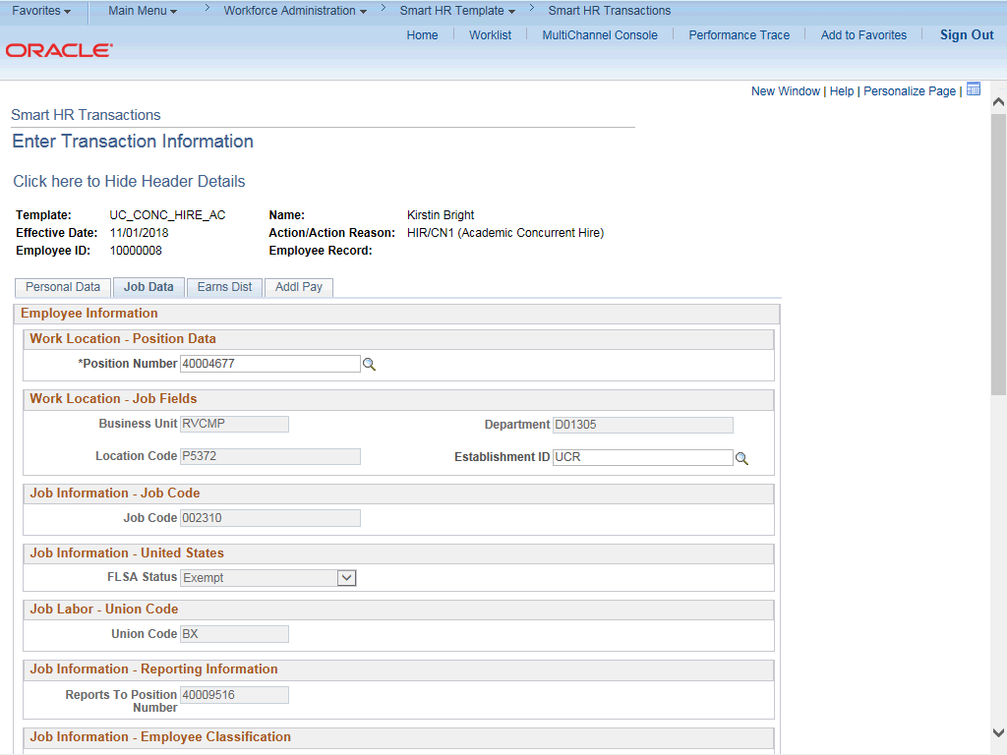

Step | Action
42. | Click the Earns Dist tab.
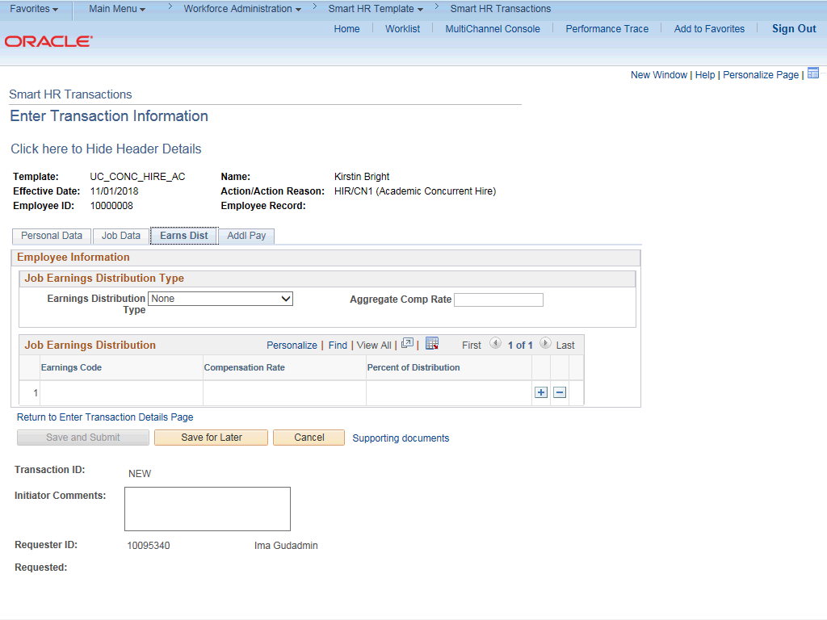

Step | Action
43. | In most cases, the Job Earnings Distribution section is automated. If the Comp Rate code entered on the Job Data tab has a mapped Earnings Code, the Job Earnings Distribution section is updated automatically.
44. | The Job Earnings Distribution section also can be used to manually enter distribution information. Use the Earnings Distribution Type field to enter distribution By Amount or By Percent. After the Earnings Distribution Type is selected, the Aggregate Comp Rate field is populated with the monthly amount.  - If By Amount is selected, the total of all compensation rates entered must add up to the monthly comp rate.  - If By Percent is selected, the total of all percentages entered must add up to 100%.
45. | For certain academic comp rate codes, such as Health Science Comp Plan, earnings codes are defaulted based on the Comp Rate Code entered in Job Compensation  - Pay Components section. Also, in those cases, earning distribution type is By Amount and amounts are automatically calculated.
46. | Click the Addl Pay tab.
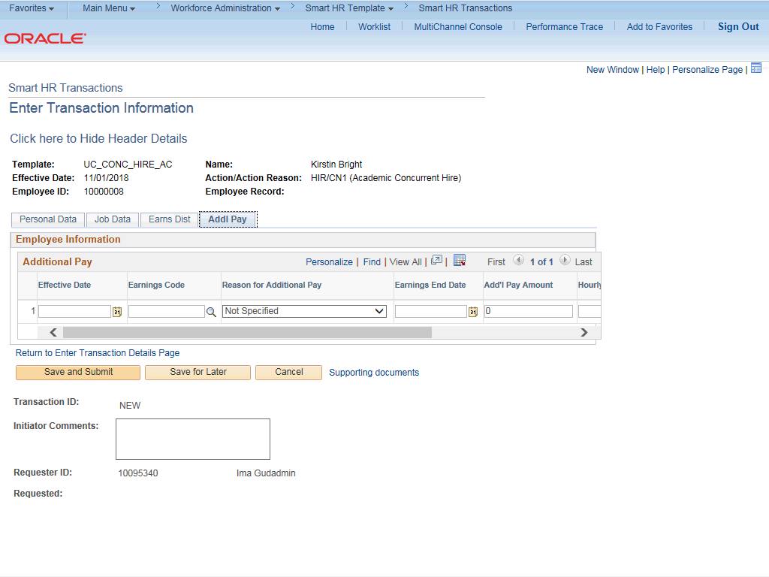

Step | Action
47. | There may be cases where an employee is paid a recurring flat amount. In this case, the compensation section is not populated on the Job Data tab. Instead, the Additional Pay section is used.  There also may be cases where neither compensation rate nor additional pay is entered. In those cases, it is recommended that you enter a comment that explains how the employee will be paid.  It is recommended not to use this template for one time additional pay. Instead, use payroll's one time payments page.
48. | Use the Supporting documents link to attach supporting documents for the concurrent hire.
49. | Enter comments for the Approver in the Initiator Comments field.  Comments you enter here appear only with the request; they do not appear on the employee’s record after the transaction is processed to completion. You can enter Initiator Comments on any of the tabs within this template.
50. | The Save and Submit button is not available until all required fields on each tab are completed.  Click the Save and Submit button.
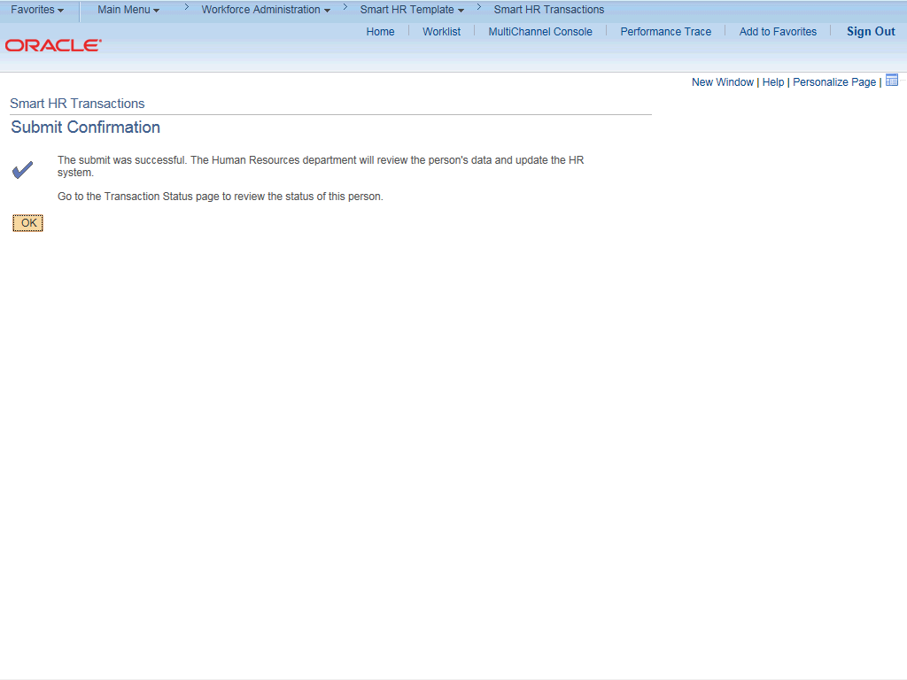

Step | Action
51. | Click the OK button.
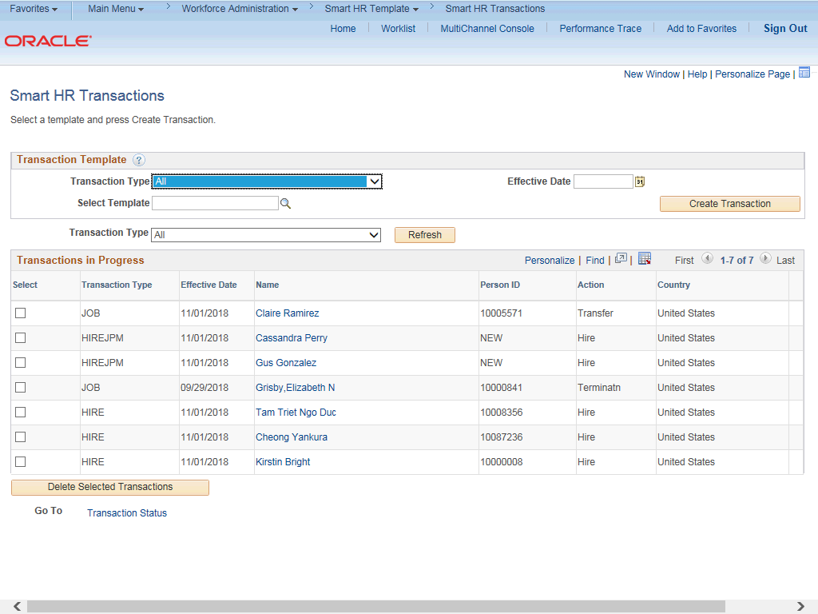

Step | Action
52. | The template transaction is routed for approval and appears in the Transactions in Progress section until it is processed.
53. | You have initiated a concurrent hire template transaction for an academic employee.  End of Procedure.

