Use this task to clone a template transaction. The cloning function is available when:
- A template transaction was denied by a Location Approver.
- A template transaction was cancelled by UCPC WFA Production.

Navigation: PeopleSoft Menu > Workforce Administration > Smart HR Template > Transaction Status

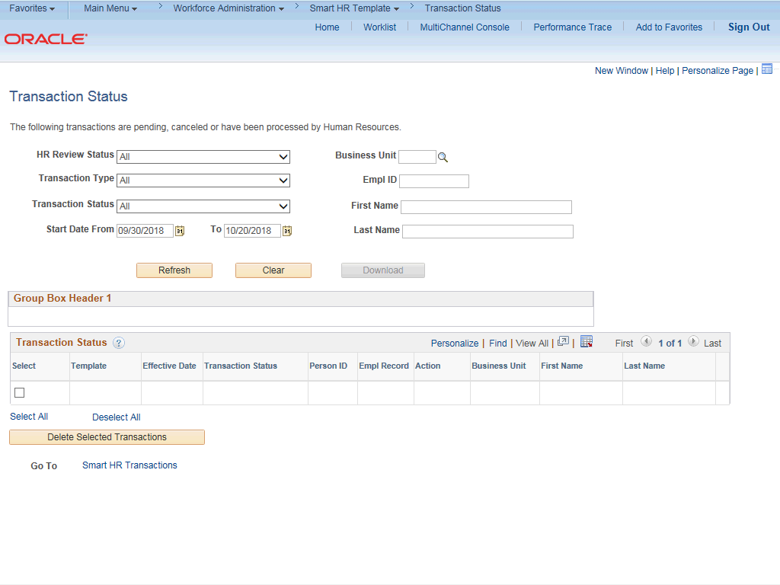

Step | Action
1. | Use the Template Status page to search for cancelled or denied template transactions that you can clone, update and resubmit for processing.  Template transactions must have a Transaction Status of Cancel or Denied to be cloned.
2. | You can narrow the search by the HR Review Status. Click the button to the right of the HR Review Status field.

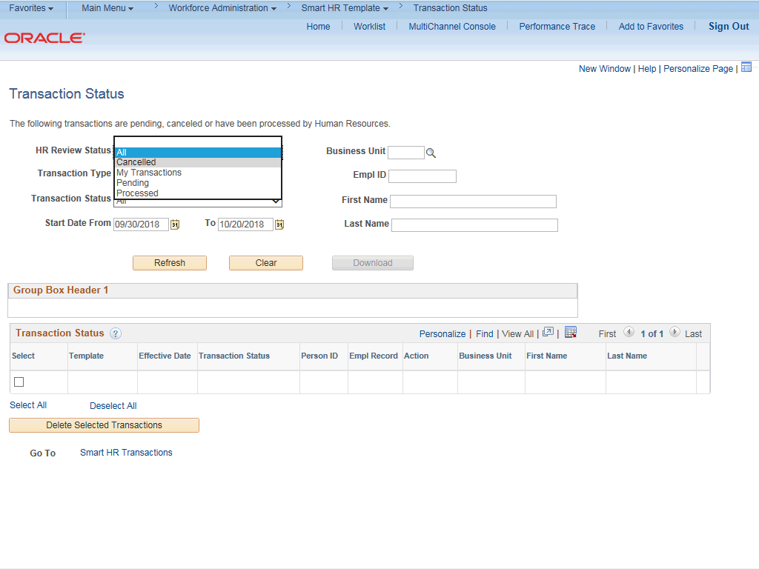

Step | Action
3. | Click the Cancelled list item.
4. | You can also narrow the list by the transaction type.  Click the button to the right of the Transaction Type field.

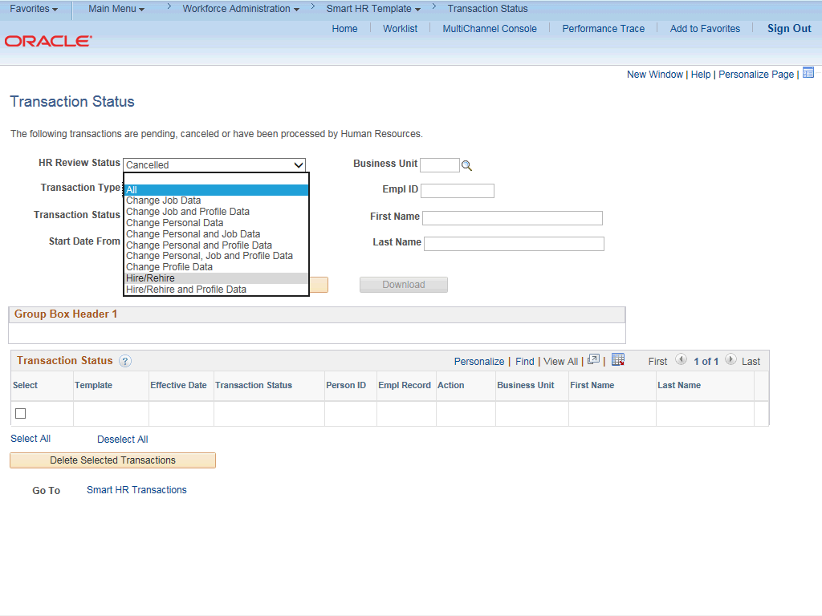

Step | Action
5. | For this example, click the Hire/Rehire list item.
6. | The Start Date From field defaults a date that is 10 days prior to the current date. The Start Date To field defaults a date that is 10 days after the current date.  The Effective Date of the transaction you are searching for must fall within these dates.
7. | Click the Refresh button.

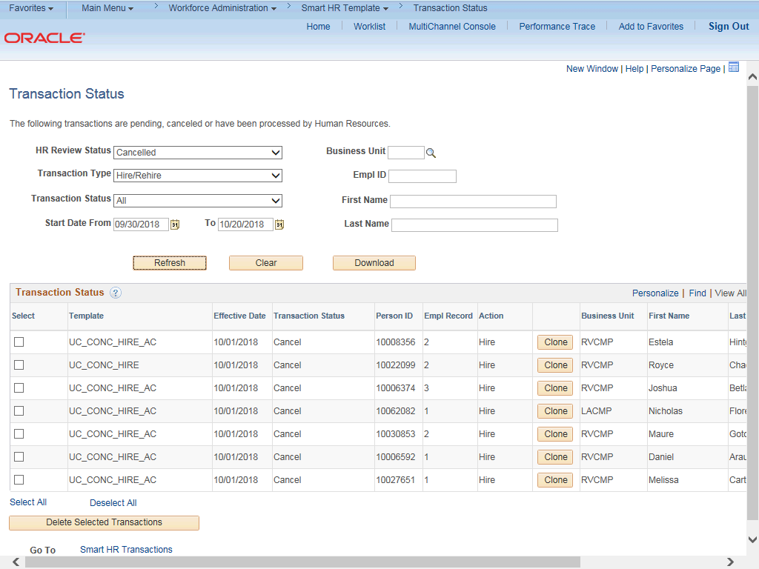

Step | Action
8. | The template transactions that meet the search criteria appear. The Clone button is available only for transactions with a Transaction Status of Cancel or Denied.  The Clone button appears when:  - A template transaction was denied by a Location Approver. Refer to the SS Smart HR Transactions page to view comments from the Approver about the denied transaction.  - A template transaction was cancelled by UCPC WFA Production. Refer to the Reason for Cancellation column on this page to view comments from WFA Production about the cancelled transaction.
9. | Click the scroll bar.
10. | When a transaction is cancelled, WFA Production enters a comment to explain why the transaction was cancelled. Template Initiators can View Comments and, if needed, Clone the transaction to resubmit it with necessary corrections.  Note: To view comments about a transaction that was denied by a Location Approver you must navigate to the SS Smart HR Transactions page and review the Approver Comments field.

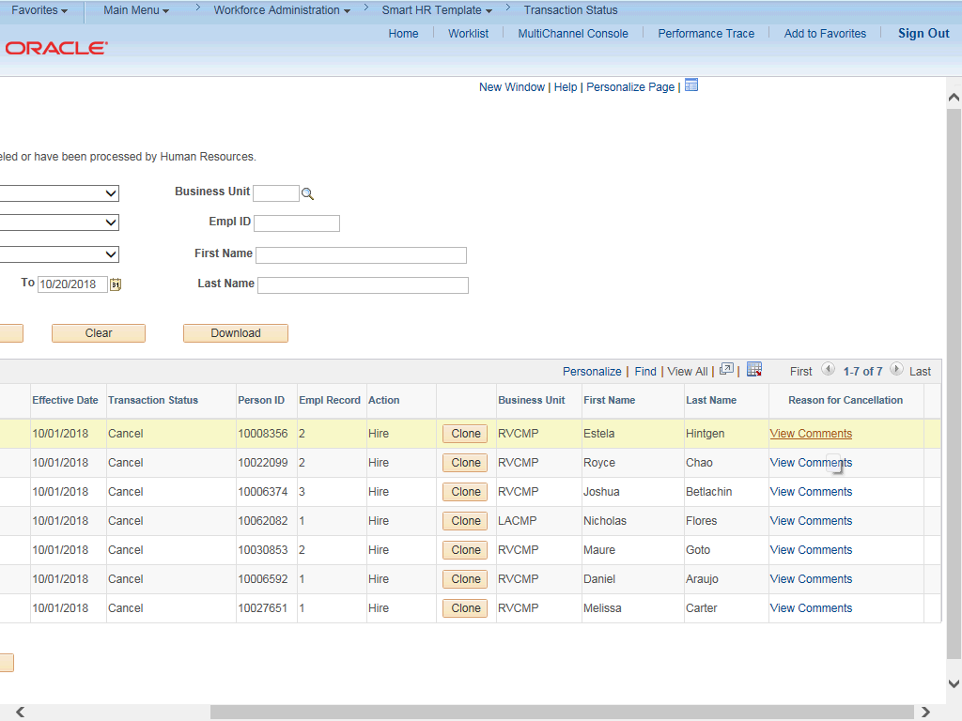

Step | Action
11. | Click the View Comments link.
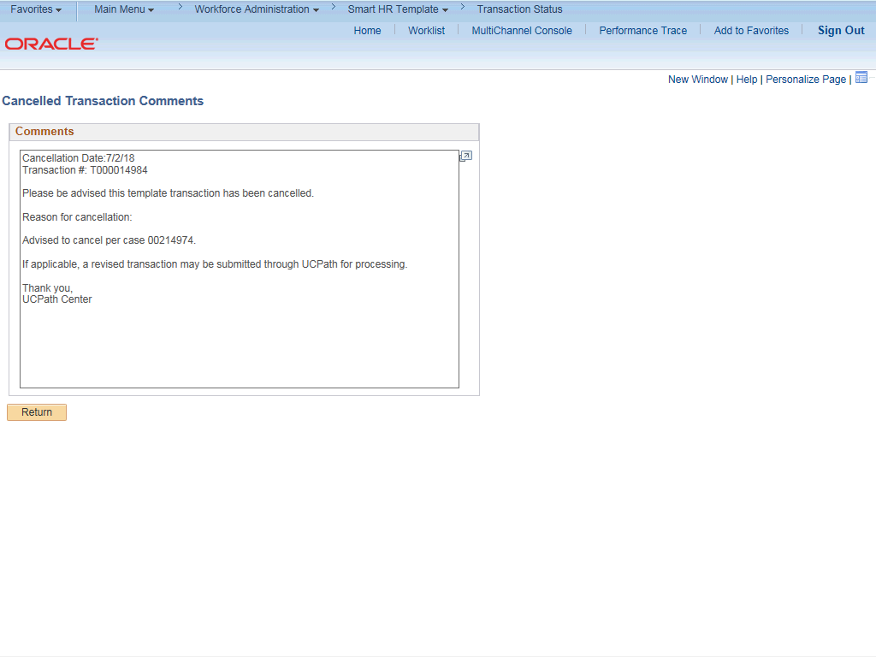

Step | Action
12. | Review the comment. This is helpful information for correcting the template transaction or identifying the supporting documentation that is needed.
13. | Click the Return button.
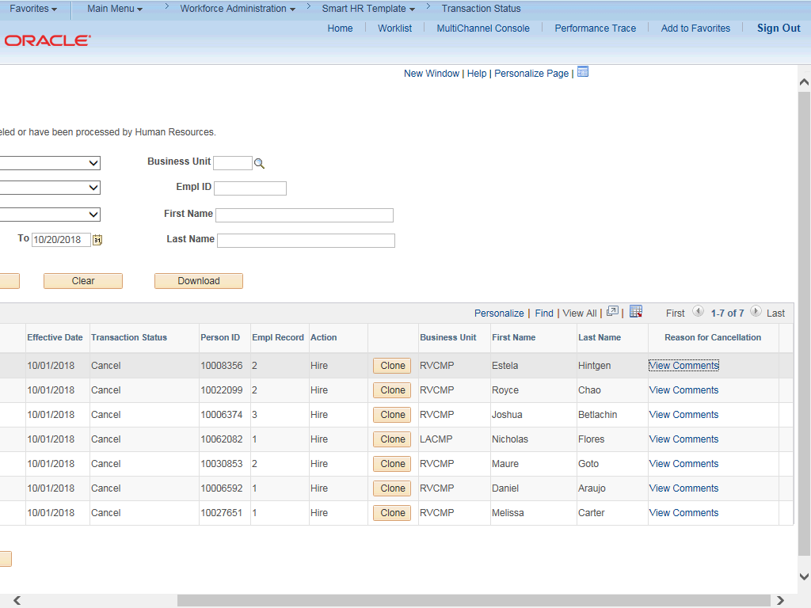

Step | Action
14. | Click the scroll bar.

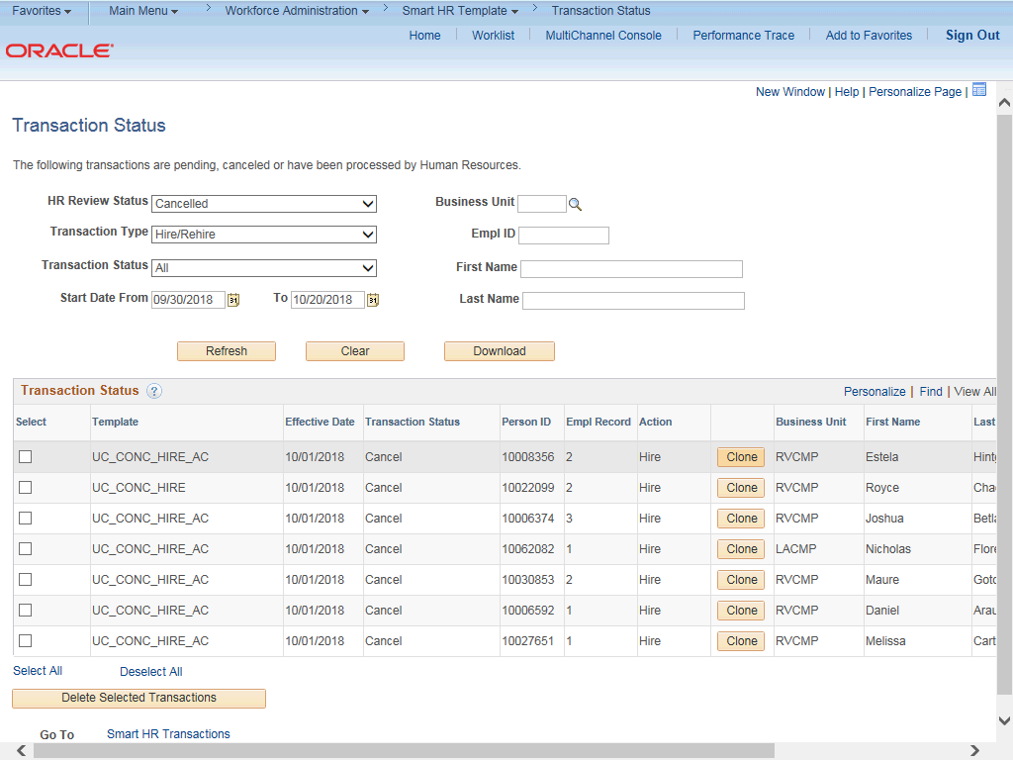

Step | Action
15. | Use the Clone button to copy the existing template information into a new template.  For this example, Choose appropriate template.  Click the Clone button.
16. | After the template transaction is cloned, the Clone button is no longer available.

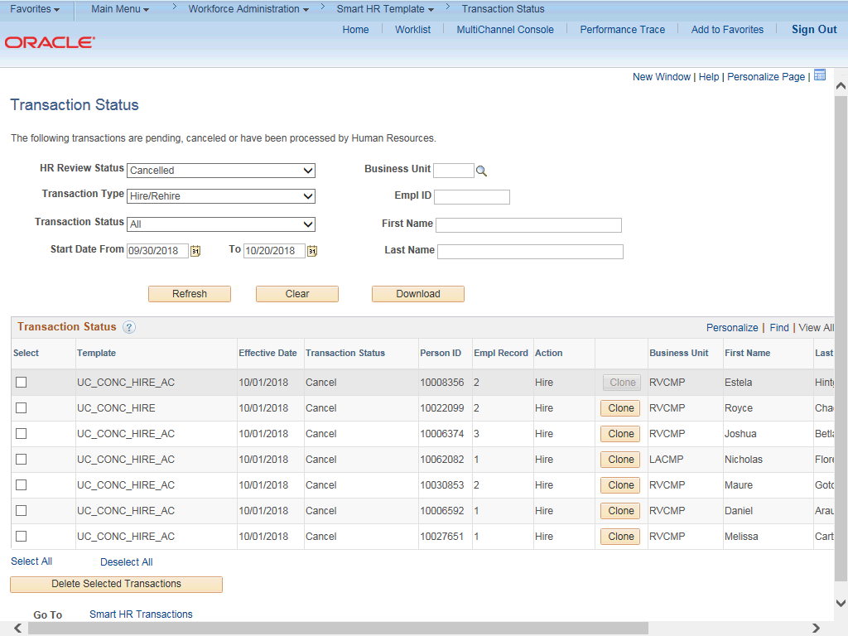

Step | Action
17. | To access the cloned template navigate to the Smart HR Transactions page. Click the Smart HR Transactions link.

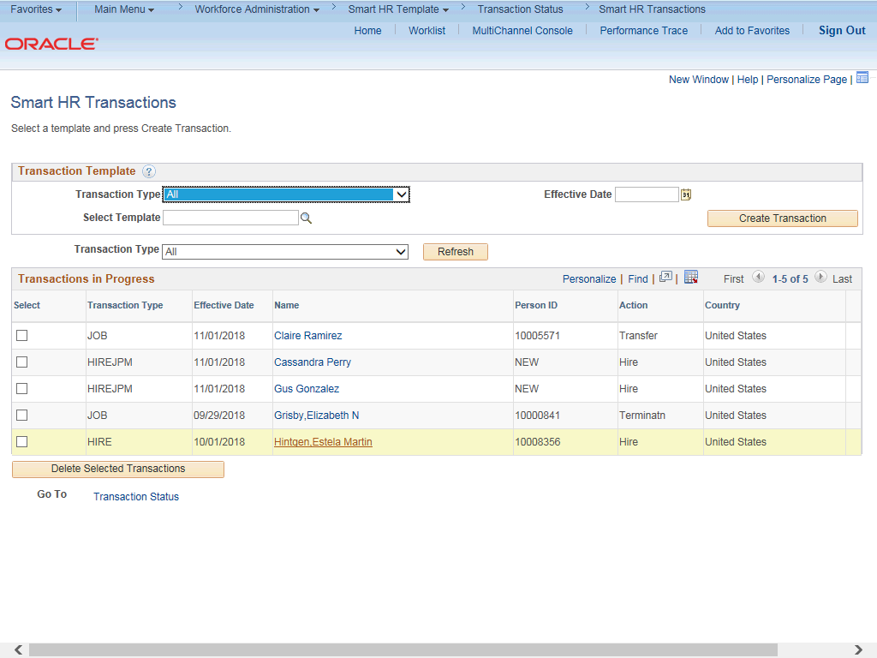

Step | Action
18. | The cloned template appears in the Transactions in Progress section. Click the  Name link to open the template and update as needed.

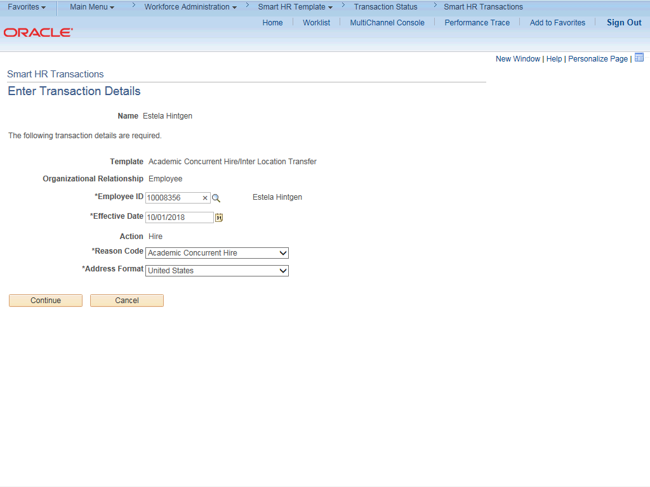

Step | Action
19. | Update the fields on the Enter Transaction Details page as needed.  For this example, the Effective Date must be updated.
20. | Click in the Effective Date field.
21. | Enter the desired information into the Effective Date field.
22. | Click the Continue button.

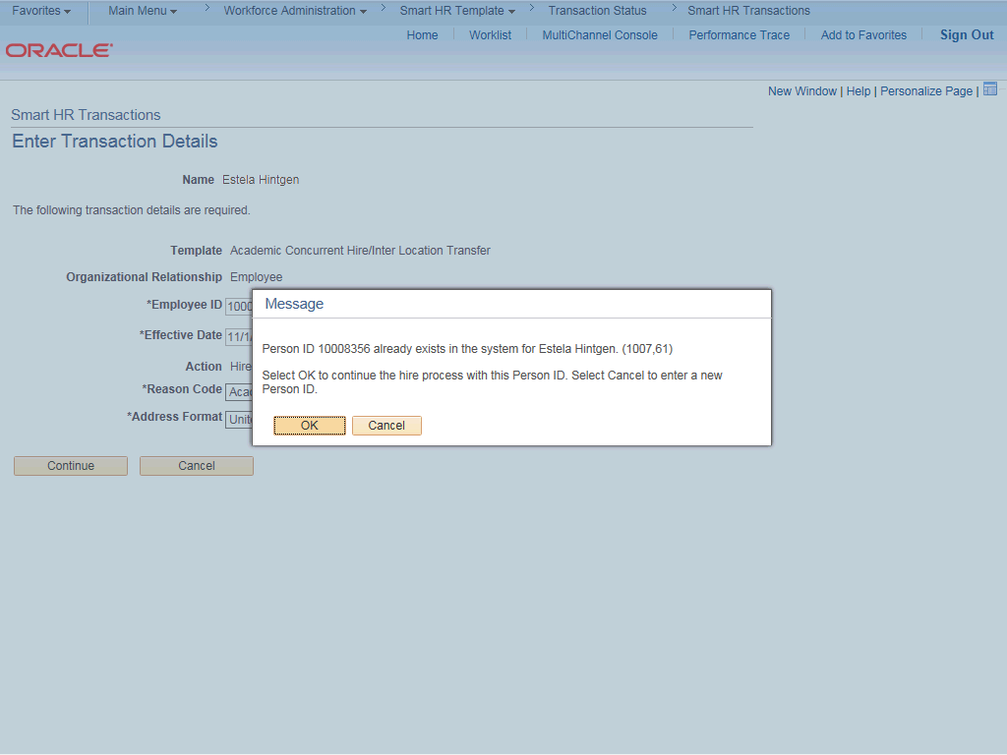

Step | Action
23. | Click the OK button.
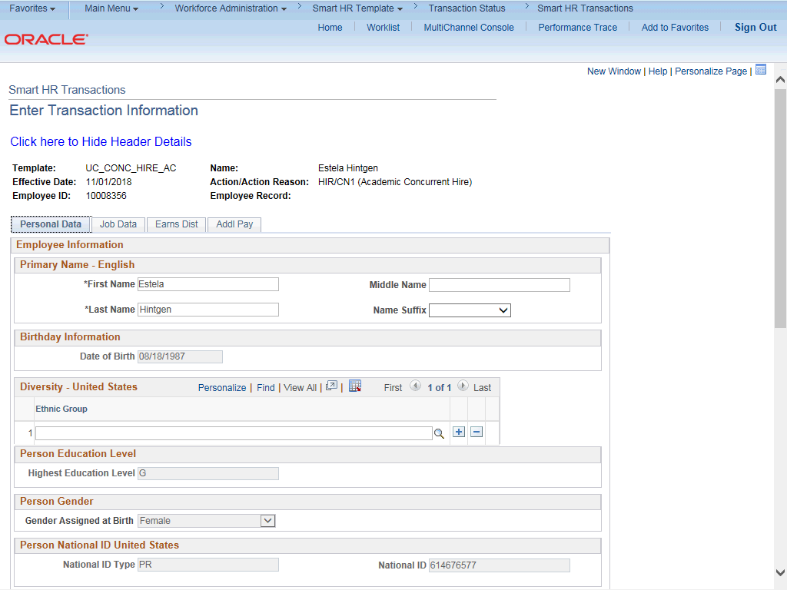

Step | Action
24. | Update the employee's Personal Data as needed.
25. | Click the scroll bar.
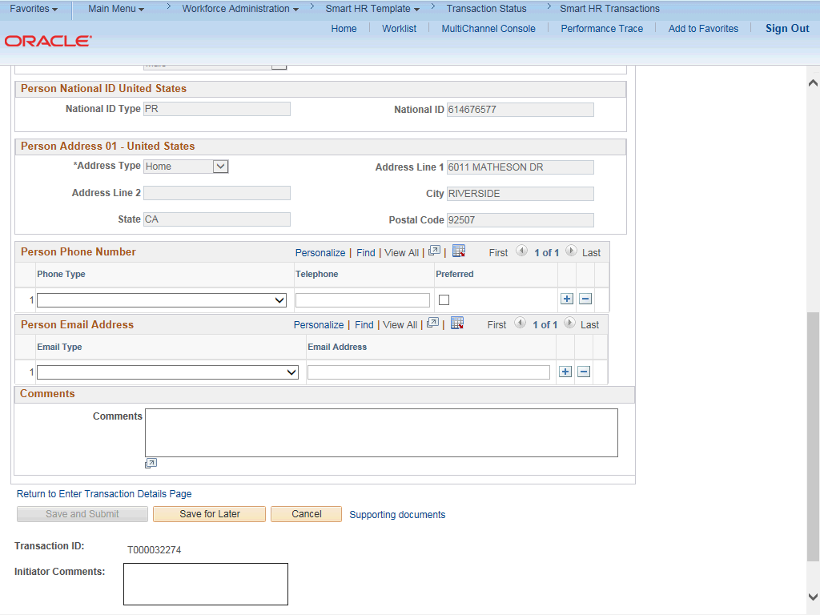

Step | Action
26. | Click in the Comments field.
27. | Enter the desired information into the Comments field.
28. | Click the scroll bar.

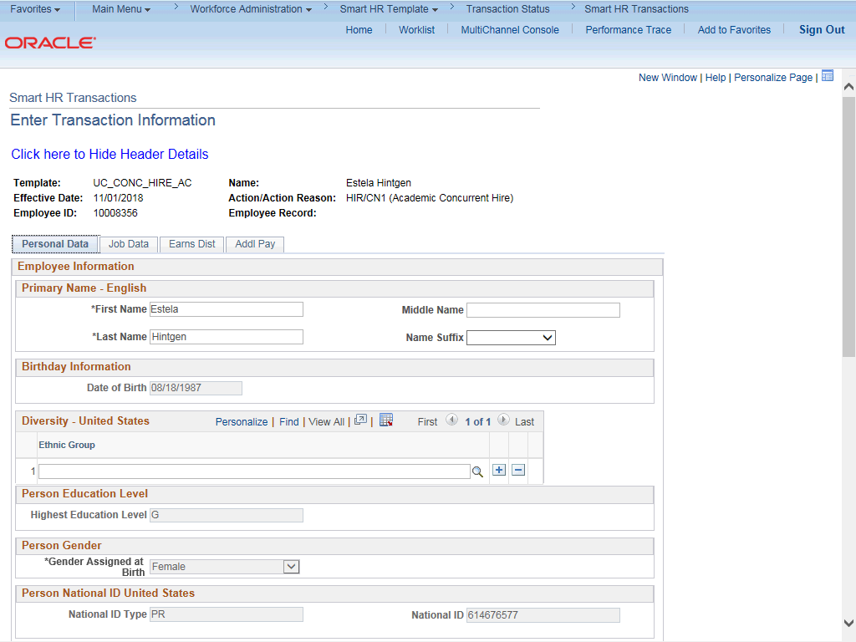

Step | Action
29. | Click the Job Data tab.
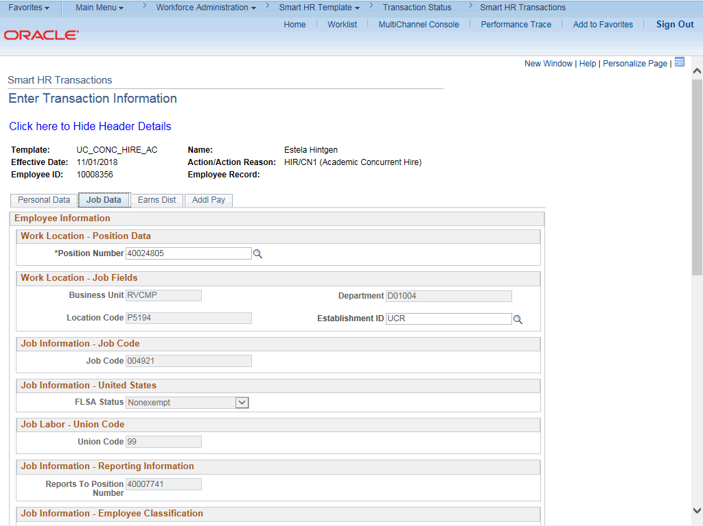

Step | Action
30. | Update the employee's Job Data as needed.
31. | Click the scroll bar.
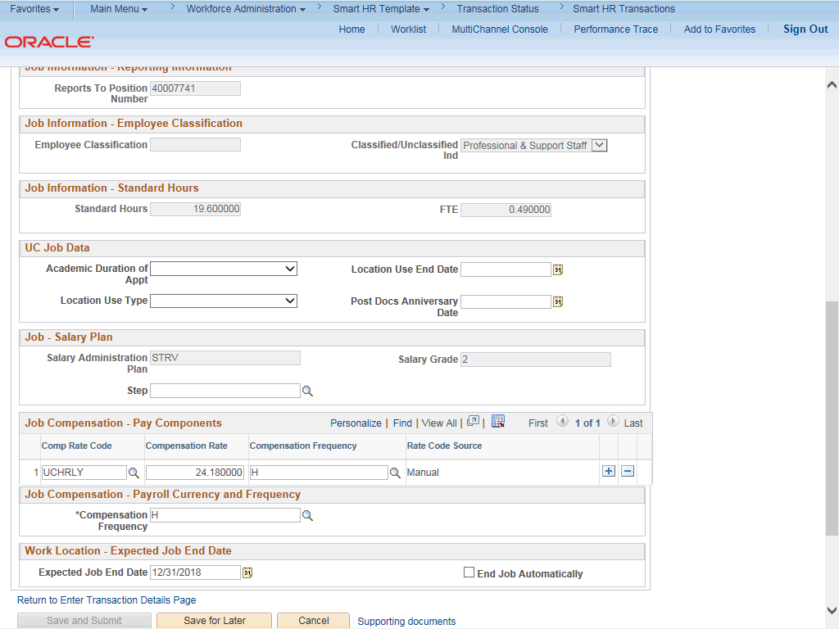

Step | Action
32. | Click the scroll bar.

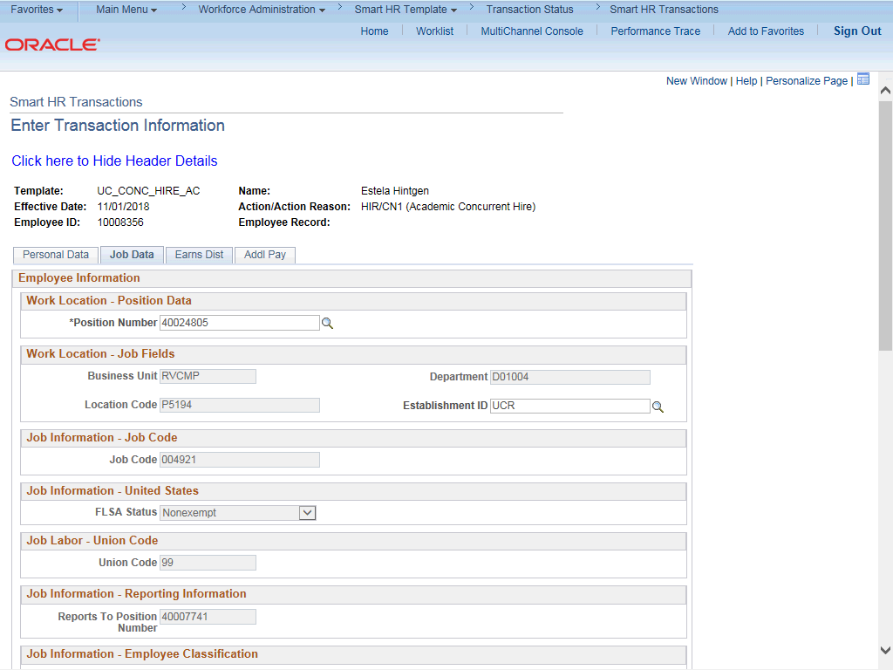

Step | Action
33. | Click the Earns Dist tab.
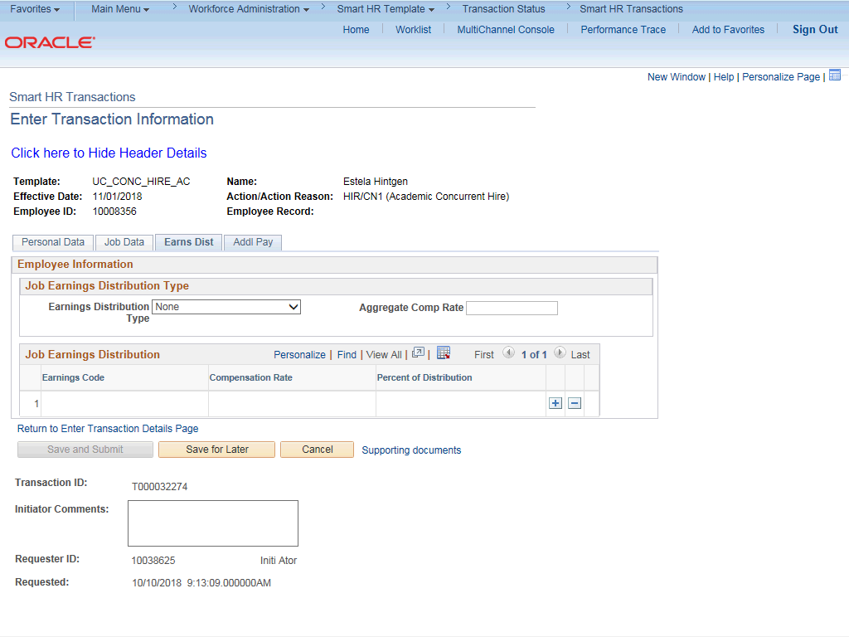

Step | Action
34. | Update the employee's Job Earnings Distribution information as needed.
35. | Click the Addl Pay tab.
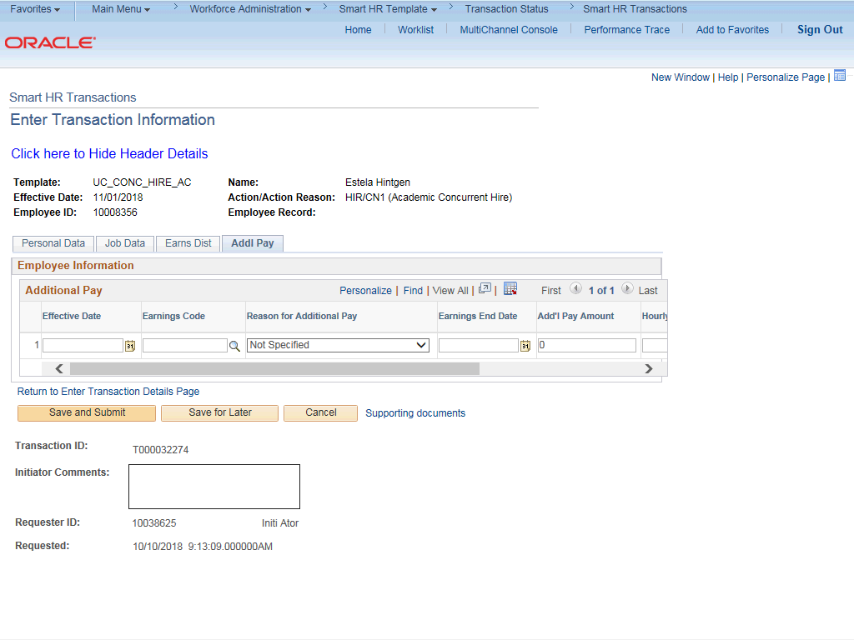

Step | Action
36. | Update the employee's Additional Pay information as needed.
37. | Use the Supporting Documents link to add attachments as needed.
38. | Click the Save and Submit button.

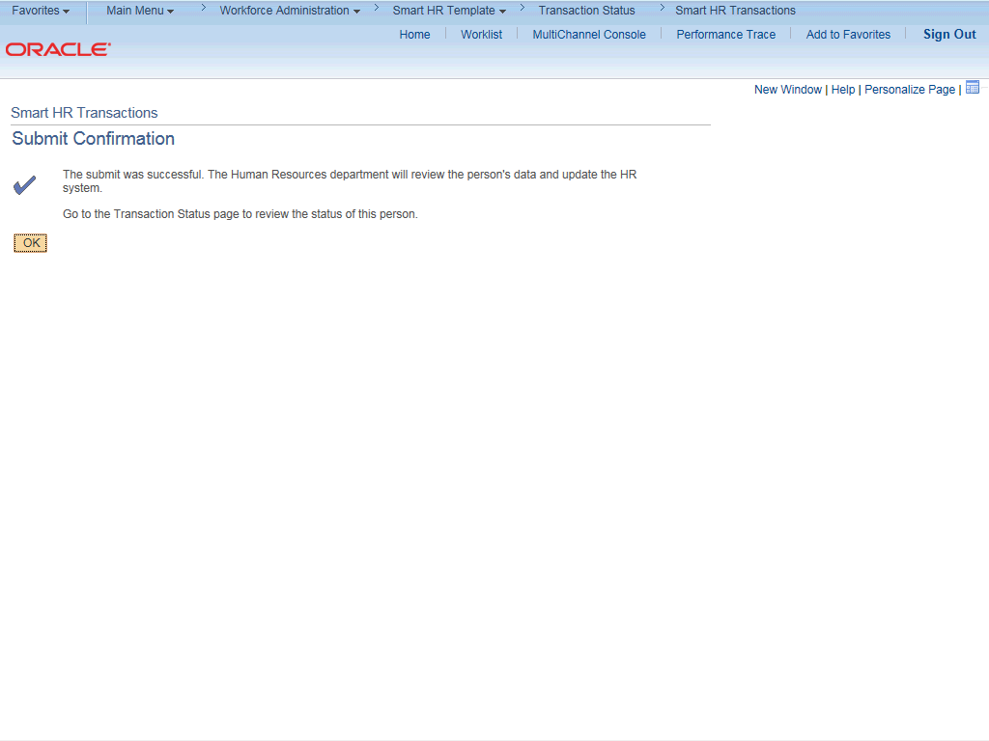

Step | Action
39. | Click the OK button.
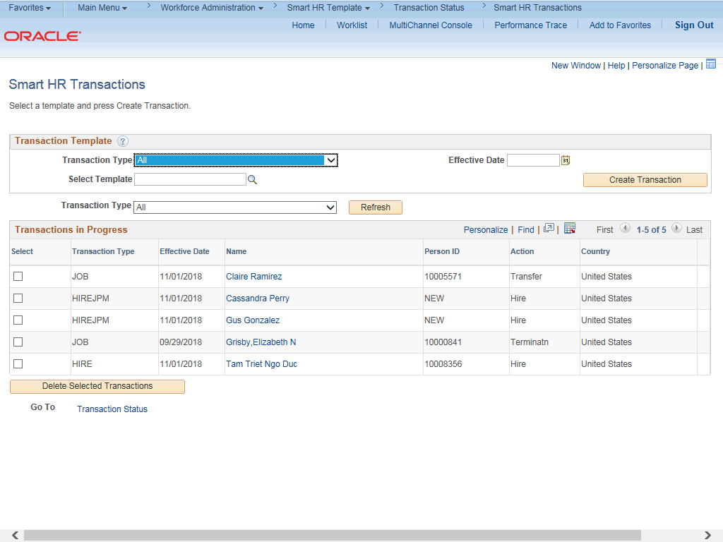

Step | Action
40. | You have cloned a template transaction that has been cancelled or denied.  End of Procedure.

